Exercise Statistics for Natural Resources
Andrea Clemente Ureña
2025-05-22

Introduction
- The dataset ChickWeight contains body weight measurements of baby chicks over time.
- It includes observations from chicks fed with four different diets.
- Measurements were taken from birth to day 21, approximately every two days.
- The dataset has 1785 observations and the following key variables:
  - weight: Numeric. The body weight of each chick in grams.
  - Time: Numeric. The number of days since birth when the weight was recorded.
  - Chick: Factor. A unique identifier for each chick. Chicks are grouped by diet and sorted by their final weight.
  - Diet: Factor. Indicates which of the four experimental diets the chick received.
- The chicks are grouped and ordered in a way that facilitates longitudinal analysis and comparison between diets.
- This dataset is particularly useful for exploring growth trends, dietary effects, and modeling with GLM, GLMM, and GAM techniques.

Numerical and Graphical Summary
library(dplyr)
##
## Attaching package: 'dplyr'
## The following objects are masked from 'package:stats':
##
## filter, lag
## The following objects are masked from 'package:base':
##
## intersect, setdiff, setequal, union
library(ggplot2)
data(ChickWeight)
# structure and summary
str(ChickWeight)
## Classes 'nfnGroupedData', 'nfGroupedData', 'groupedData' and 'data.frame': 578 obs. of 4 variables:
## $ weight: num 42 51 59 64 76 93 106 125 149 171 ...
## $ Time : num 0 2 4 6 8 10 12 14 16 18 ...
## $ Chick : Ord.factor w/ 50 levels "18"<"16"<"15"<..: 15 15 15 15 15 15 15 15 15 15 ...
## $ Diet : Factor w/ 4 levels "1","2","3","4": 1 1 1 1 1 1 1 1 1 1 ...
## - attr(*, "formula")=Class 'formula' language weight ~ Time | Chick
## .. ..- attr(*, ".Environment")=<environment: R_EmptyEnv>
## - attr(*, "outer")=Class 'formula' language ~Diet
## .. ..- attr(*, ".Environment")=<environment: R_EmptyEnv>
## - attr(*, "labels")=List of 2
## ..$ x: chr "Time"
## ..$ y: chr "Body weight"
## - attr(*, "units")=List of 2
## ..$ x: chr "(days)"
## ..$ y: chr "(gm)"
summary(ChickWeight)
## weight Time Chick Diet
## Min. : 35.0 Min. : 0.00 13 : 12 1:220
## 1st Qu.: 63.0 1st Qu.: 4.00 9 : 12 2:120
## Median :103.0 Median :10.00 20 : 12 3:120
## Mean :121.8 Mean :10.72 10 : 12 4:118
## 3rd Qu.:163.8 3rd Qu.:16.00 17 : 12
## Max. :373.0 Max. :21.00 19 : 12
## (Other):506
The ChickWeight dataset contains 578 observations of 50 chicks, each measured repeatedly over time.
- weight: Chick body weight in grams, ranging from 35g to 373g.
- Time: Number of days since birth, ranging from 0 to 21 days.
- Chick: Ordered factor. A unique identifier for each chick. Measurements are grouped by chick.
- Diet: Factor with 4 levels, indicating the experimental diet.
Some key insights from the dataset: - The average chick weight is approximately 122g. - Most chicks were measured around every 2 days, starting from day 0 up to day 21. - Diet groups are unbalanced — Diet 1 has more observations than the others. - The dataset is ideal for longitudinal modeling, such as GLMMs or GAMs, because each chick has multiple measurements over time.
ChickWeight %>%
group_by(Diet) %>%
summarise(
Count = n(),
Mean_Weight = mean(weight),
SD_Weight = sd(weight),
Max_Weight = max(weight),
Min_Weight = min(weight)
)
## # A tibble: 4 × 6
## Diet Count Mean_Weight SD_Weight Max_Weight Min_Weight
## <fct> <int> <dbl> <dbl> <dbl> <dbl>
## 1 1 220 103. 56.7 305 35
## 2 2 120 123. 71.6 331 39
## 3 3 120 143. 86.5 373 39
## 4 4 118 135. 68.8 322 39
ggplot(ChickWeight, aes(x = Diet, y = weight, fill = Diet)) +
geom_boxplot() +
scale_fill_manual(values = c("#A8DADC", "#C1FFC1", "#FFFACD", "#FFC0CB")) +
labs(title = "Boxplot of Chick Weights by Diet",
y = "Weight (g)", x = "Diet") +
theme_minimal()
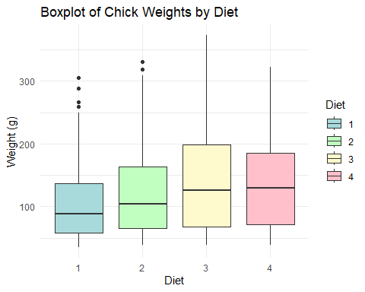 Key Points:
- Diet 3 resulted in the heaviest chicks on average (142.95g) and had the highest maximum weight (373g), but also showed the largest variation in weights.
- Diet 1 had the lowest average weight (102.6g) and the highest number of observations.
- The minimum weight was similar across all diets (~35–39g), but maximum weights varied, suggesting a strong effect of diet on growth.
- Standard deviation was highest for Diet 3, indicating that chick weights under this diet were more spread out.
ggplot(ChickWeight, aes(x = weight)) +
geom_histogram(bins = 30, fill = "lightgreen", color = "white") +
labs(title = "Distribution of Chick Weights",
x = "Weight (g)", y = "Count") +
theme_minimal()
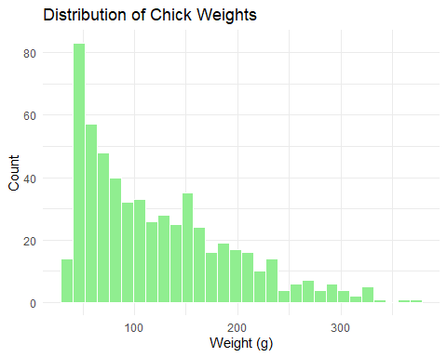 The histogram of chick weights shows a right-skewed distribution:
- Most chicks have lower weights, especially in the early days.
- A few chicks reached much higher weights, creating a “long tail” on the right.
- This suggests the distribution is not perfectly normal, which may affect linear modeling assumptions.
ChickWeight %>%
group_by(Diet) %>%
summarise(correlation = cor(Time, weight))
## # A tibble: 4 × 2
## Diet correlation
## <fct> <dbl>
## 1 1 0.816
## 2 2 0.818
## 3 3 0.898
## 4 4 0.952
Key Points:
- All diets show a strong positive correlation between age and weight, as expected — chicks grow over time.
- Diets 3 and 4 show the strongest correlation, suggesting a more consistent growth pattern across time for those diets.
- Diets 1 and 2 show slightly weaker correlation, possibly due to greater variability or outliers in chick growth.
- This supports the idea that diet affects not just weight, but how predictably chicks grow over time.
These correlations justify including Time as a predictor in subsequent models, and considering Diet as a potential modifier of growth trajectory.
ggplot(ChickWeight, aes(x = Time, y = weight, color = Diet)) +
stat_summary(fun = mean, geom = "line", size = 1.2) +
labs(title = "Average Weight Over Time by Diet",
x = "Time (days)", y = "Average Weight (g)") +
theme_minimal() +
scale_color_manual(values = c("#A8DADC", "#C1FFC1", "#FFFACD", "#FFC0CB"))
## Warning: Using `size` aesthetic for lines was deprecated in ggplot2 3.4.0.
## ℹ Please use `linewidth` instead.
## This warning is displayed once every 8 hours.
## Call `lifecycle::last_lifecycle_warnings()` to see where this warning was
## generated.
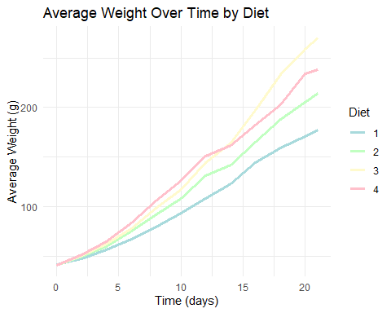 Key Points
- This line plot shows the average weight of chicks over time for each diet group.
- Diet 3 results in the fastest and highest weight gain, indicating a strong effect of this diet on growth.
- Diet 4 also shows steady improvement, placing it second in growth performance.
- Diet 2 and Diet 1 show more modest, linear growth patterns, with Diet 1 being the least effective in promoting weight gain.
- The divergence in the lines over time suggests increasing differences in weight outcomes between diets as chicks age.
- This plot helps visually confirm that diet significantly impacts chick growth, and motivates including interaction terms or non-linear effects in the modeling stage.

Build a linear model using GLM using step and add function for variable selection
# Null modelt
glm_null <- glm(weight ~ 1, data = ChickWeight)
# Full model
glm_full <- glm(weight ~ Time * Diet, data = ChickWeight)
# Stepwise model selection
glm_step <- step(glm_null,
scope = list(lower = glm_null, upper = glm_full),
direction = "both")
## Start: AIC=6572.12
## weight ~ 1
##
## Df Deviance AIC
## + Time 1 872212 5876.8
## + Diet 3 2758693 6546.4
## <none> 2914556 6572.1
##
## Step: AIC=5876.8
## weight ~ Time
##
## Df Deviance AIC
## + Diet 3 742336 5789.6
## <none> 872212 5876.8
## - Time 1 2914556 6572.1
##
## Step: AIC=5789.61
## weight ~ Time + Diet
##
## Df Deviance AIC
## + Time:Diet 3 661532 5729.0
## <none> 742336 5789.6
## - Diet 3 872212 5876.8
## - Time 1 2758693 6546.4
##
## Step: AIC=5729
## weight ~ Time + Diet + Time:Diet
##
## Df Deviance AIC
## <none> 661532 5729.0
## - Time:Diet 3 742336 5789.6
summary(glm_step)
##
## Call:
## glm(formula = weight ~ Time + Diet + Time:Diet, data = ChickWeight)
##
## Coefficients:
## Estimate Std. Error t value Pr(>|t|)
## (Intercept) 30.9310 4.2468 7.283 1.09e-12 ***
## Time 6.8418 0.3408 20.076 < 2e-16 ***
## Diet2 -2.2974 7.2672 -0.316 0.75202
## Diet3 -12.6807 7.2672 -1.745 0.08154 .
## Diet4 -0.1389 7.2865 -0.019 0.98480
## Time:Diet2 1.7673 0.5717 3.092 0.00209 **
## Time:Diet3 4.5811 0.5717 8.014 6.33e-15 ***
## Time:Diet4 2.8726 0.5781 4.969 8.92e-07 ***
## ---
## Signif. codes: 0 '***' 0.001 '**' 0.01 '*' 0.05 '.' 0.1 ' ' 1
##
## (Dispersion parameter for gaussian family taken to be 1160.583)
##
## Null deviance: 2914556 on 577 degrees of freedom
## Residual deviance: 661532 on 570 degrees of freedom
## AIC: 5729
##
## Number of Fisher Scoring iterations: 2
newdata <- expand.grid(
Time = seq(min(ChickWeight$Time), max(ChickWeight$Time), length.out = 100),
Diet = levels(ChickWeight$Diet)
)
newdata$pred <- predict(glm_step, newdata = newdata)
# Plot predicted values
library(ggplot2)
ggplot(newdata, aes(x = Time, y = pred, color = Diet)) +
geom_line(size = 1.2) +
labs(title = "Predicted Weight over Time by Diet (GLM Stepwise)",
x = "Time (days)", y = "Predicted Weight (g)") +
theme_minimal()
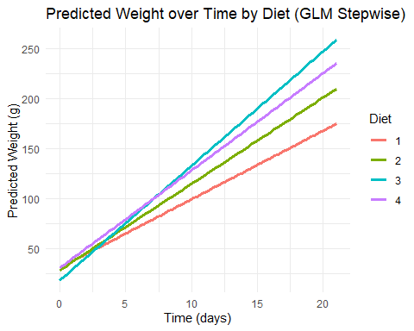
# Residual plot
plot(glm_step$fitted.values, resid(glm_step),
xlab = "Fitted values", ylab = "Residuals",
main = "Residuals vs Fitted")
abline(h = 0, col = "red")
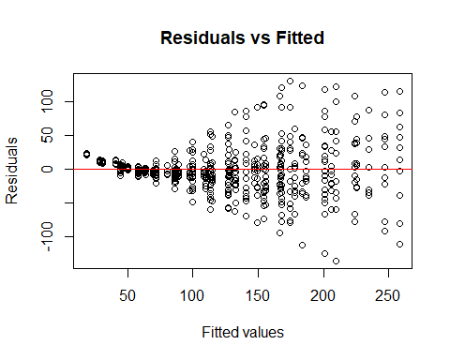 The final model is: weight ~ Time + Diet + Time:Diet
Model fit:
- The AIC decreased from 6572 (null model) to 5729, indicating a substantially better fit as variables were added.
- The residual deviance dropped from 2,914,556 to 661,532, showing the model explains a large portion of the variation in weight.
Main effects:
- Time has a strong positive effect on weight (p < 0.001), indicating that chicks gain weight as time increases.
- The effect of Diet alone is less clear: none of the individual Diet coefficients are statistically significant at the 5% level, though Diet 3 shows a marginal effect (p = 0.081).
Interactions (Time:Diet):
- There are significant interactions between Time and all diets except Diet 1 (the reference level).
- This suggests that the rate of weight gain over time depends on the Diet.
- In particular:
  - Diet 3 shows the strongest interaction (p < 0.001), meaning chicks on Diet 3 gain weight faster over time.
  - Diet 4 and Diet 2 also show significant time interactions (p < 0.01), with moderate increases in growth rate.
Residual analysis:
- The residuals are centered around zero, as expected.
- However, there is a visible pattern: residuals are tightly clustered at lower fitted values and become more spread out at higher fitted values.
- This suggests increasing variance, a common issue in growth models, which could indicate heteroscedasticity.
- While the model still captures the main trends well, this pattern may violate the assumption of constant variance and could be explored further (e.g., with weighted regression or transformation).

Build a GLMM model
library(lme4)
## Warning: package 'lme4' was built under R version 4.3.2
## Loading required package: Matrix
## Warning: package 'Matrix' was built under R version 4.3.2
glmm_model <- lmer(weight ~ Time * Diet + (1 | Chick), data = ChickWeight)
glmm_model
## Linear mixed model fit by REML ['lmerMod']
## Formula: weight ~ Time * Diet + (1 | Chick)
## Data: ChickWeight
## REML criterion at convergence: 5466.905
## Random effects:
## Groups Name Std.Dev.
## Chick (Intercept) 23.36
## Residual 25.36
## Number of obs: 578, groups: Chick, 50
## Fixed Effects:
## (Intercept) Time Diet2 Diet3 Diet4 Time:Diet2
## 31.5143 6.7115 -2.8807 -13.2640 -0.4016 1.8977
## Time:Diet3 Time:Diet4
## 4.7114 2.9506
ggplot() +
geom_line(data = ChickWeight, aes(x = Time, y = weight, group = Chick), alpha = 0.2, color = "black") +
geom_line(data = newdata, aes(x = Time, y = pred, color = Diet), size = 1.5) +
labs(title = "Individual Growth Trajectories and GLMM Predicted Means",
x = "Time (days)", y = "Weight (g)") +
theme_minimal()
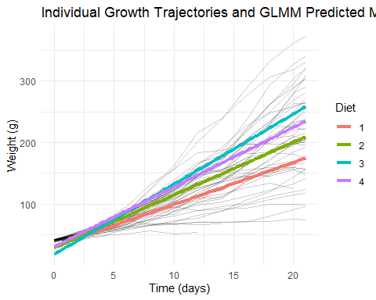 The GLMM results show that including a random intercept for each chick improves the model by accounting for repeated measures on the same individuals. The fixed effects (Time and Diet) remain significant, and the diet-time interactions persist.
The plot for the GLMM displays a large number of semi-transparent lines representing individual chick growth trajectories. Overlaid on these are smoother lines for each diet, representing the average trend.
- The individual lines demonstrate substantial variability among chicks.
- The average lines show that Diet 3 again leads to the highest growth, while Diet 1 remains the slowest.
- This model captures both population-level trends and individual variability.

Build a GAM model.
library(mgcv)
## Loading required package: nlme
##
## Attaching package: 'nlme'
## The following object is masked from 'package:lme4':
##
## lmList
## The following object is masked from 'package:dplyr':
##
## collapse
## This is mgcv 1.8-42. For overview type 'help("mgcv-package")'.
gam_model <- gam(weight ~ s(Time, by=Diet) + Diet, data = ChickWeight)
summary(gam_model)
##
## Family: gaussian
## Link function: identity
##
## Formula:
## weight ~ s(Time, by = Diet) + Diet
##
## Parametric coefficients:
## Estimate Std. Error t value Pr(>|t|)
## (Intercept) 104.276 2.265 46.044 < 2e-16 ***
## Diet2 16.610 3.812 4.358 1.56e-05 ***
## Diet3 36.325 3.812 9.530 < 2e-16 ***
## Diet4 30.636 3.831 7.996 7.25e-15 ***
## ---
## Signif. codes: 0 '***' 0.001 '**' 0.01 '*' 0.05 '.' 0.1 ' ' 1
##
## Approximate significance of smooth terms:
## edf Ref.df F p-value
## s(Time):Diet1 1.891 2.350 177.9 <2e-16 ***
## s(Time):Diet2 1.613 1.995 181.2 <2e-16 ***
## s(Time):Diet3 2.294 2.846 228.0 <2e-16 ***
## s(Time):Diet4 1.051 1.100 406.9 <2e-16 ***
## ---
## Signif. codes: 0 '***' 0.001 '**' 0.01 '*' 0.05 '.' 0.1 ' ' 1
##
## R-sq.(adj) = 0.777 Deviance explained = 78.1%
## GCV = 1148.5 Scale est. = 1126.9 n = 578
gam_model
##
## Family: gaussian
## Link function: identity
##
## Formula:
## weight ~ s(Time, by = Diet) + Diet
##
## Estimated degrees of freedom:
## 1.89 1.61 2.29 1.05 total = 10.85
##
## GCV score: 1148.49
newdata <- expand.grid(
Time = seq(min(ChickWeight$Time), max(ChickWeight$Time), length.out = 100),
Diet = levels(ChickWeight$Diet))
pred <- predict(gam_model, newdata = newdata, se.fit = TRUE)
newdata$fit <- pred$fit
newdata$se <- pred$se.fit
ggplot(newdata, aes(x = Time, y = fit, color = Diet, fill = Diet)) +
geom_line(size = 1) +
geom_ribbon(aes(ymin = fit - 2*se, ymax = fit + 2*se), alpha = 0.2, color = NA) +
labs(title = "GAM Prediction of Weight by Time and Diet",
x = "Time (days)", y = "Estimated weight") +
theme_minimal(base_size = 14) +
theme(legend.position = "bottom")
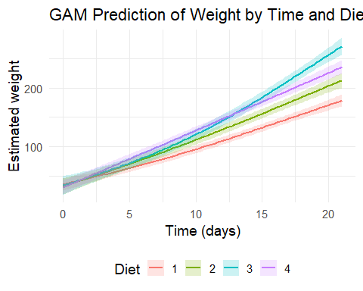 The GAM analysis reveals that the relationship between Time and weight is non-linear and varies by diet. Each diet is modeled with a separate smoothing function, allowing for more flexibility in capturing growth patterns.
The GAM plot illustrates smooth curves (not straight lines) for each diet:
- The curves show how weight increases over time, sometimes accelerating or leveling off.
- Diet 3 again shows the most pronounced and consistent growth.
- Diet 1 has a slower and more irregular trajectory.
- The inclusion of confidence bands helps visualize the uncertainty of the fit.
This model is particularly effective in uncovering complex, non-linear growth dynamics that simpler models may miss.

