CFRA Project- Agroecology Evidence Hub Report

1. Introduction
Short introduction about the project and the WP2.
AE/RA practices. Agroecological and regenerative agricultural practices, such as compost, intercropping or reduced tillage, that aim to sustain production while improving soil health, biodiversity and the use of natural resources.
Why it is important this analysis as part of wp2?

The aim of this analysis is to build an evidence-based portfolio of promising AE/RA practices to produce foods relevant to school-meal programmes in each project country, specifying the crops and contexts in which they deliver positive outcomes. Using the priority areas identified by the subnational scenarios developed within the project (see XX Report) as the contexts of interest, the analysis synthesises primary studies comparing AE/RA with conventional practices to (i) identify the practices associated with positive effects on yield, profitability, soil health, resilience, biodiversity and climate mitigation; (ii) identify practice and crop combinations that deliver positive outcomes across several of these dimensions simultaneously; and (iii) assess the strength of the evidence supporting each practice; (iv) highlight where evidence is lacking.

2. Methodology

2.1 Building the evidence base
This analysis draws on the Agroecology Evidence Hub, a database developed by the Alliance of Bioversity International and CIAT under the CGIAR Multifunctional Landscapes (MFL) Science Program. The Hub was not designed specifically for this project, but its data are well suited to identify which agroecological and regenerative agricultural (AE/RA) practices could improve the production of nutritious and diverse foods for school meals in the project countries, and with what benefits and trade-offs. It brings together results from field experiments that compare AE/RA practices with conventional practices across agronomic, economic, environmental and social outcomes, which earlier global reviews had already extracted from the scientific literature.
The current version of the Hub combines four global datasets (Jones et al. 2021; Sánchez et al. 2022; Paut et al. 2024; Rosenstock et al. 2024) and harmonises them into a common dataset structure. These datasets were chosen because members of the team were involved in developing them, which ensured a good understanding of how the data were collected and harmonised. The Hub will be extended with further datasets in the near future, so the evidence for each country can be updated as new studies are added.
From these datasets, we selected the comparisons from studies conducted in any of the nine project countries that compared an AE/RA practice with a conventional practice on a crop relevant to school meals, and that reported the location of the study site. After applying this selection, the evidence base comprised [n] comparisons from [n] studies (Fig. S1). A comparison is a single result in which a study measured the same outcome under an AE/RA practice and under a conventional practice, for example maize yield with and without compost in one season. A single study can contribute several comparisons when it reports several outcomes, compares several treatments against a common control, or measures the same contrast across sites, years, crops or soil depths. The evidence includes [n] AE/RA practices from [n] management domains (Table S1), [n] crops from [n] food groups (Table S2), and [n] outcome indicators grouped into eight dimensions of farm performance (Table S3).

2.2 Identifying priority areas for nutritious and sustainable food systems
Within the project, scenarios were developed for each project country to map where nutritional gaps and food-system problems occur (see XX Report). Each scenario groups areas that share a common problem (e.g., declining maize yields on degraded soils, or lack of plant-based foods in arid areas), and proposes AE/RA practices to address it. To locate these areas, each scenario mapped a set of biophysical, agronomic, nutritional and socio-economic conditions that signal the problem, and ranked areas from high to low priority according to how many of these conditions they met, or to the share of priority cropland that they contained. For this analysis, we focused only on high-priority areas, meaning the two highest priority levels.

2.2.1 Linking evidence to high-priority areas
To learn which AE/RA practices could improve conditions in each scenario, and which benefits and trade-offs could be associated with them, we used the evidence from studies conducted under similar conditions. We first selected the studies located within the high-priority areas of each scenario. As the high-priority areas of different scenarios can overlap, the same study could inform more than one scenario.
We then checked whether this evidence was sufficient to represent the high-priority areas. To describe the conditions of these high-priority areas, we used agroecological-zones, which divide the land into classes with similar climate and soils (GAEZ v4; FAO & IIASA, 2021), and we considered as main zones those classes covering at least 10% of the high-priority area. The evidence was considered sufficient when the scenario had at least 100 comparisons in total, and at least one study in each main agroecological zone within the high-priority areas. In that case, only the comparisons located within the high-priority areas were used for the synthesis.
When the evidence was insufficient, we added studies from outside the high-priority areas, but from the same main-agroecological zones. We searched first elsewhere in the same country and, only if needed, in neighbouring countries sharing a border with it. Main-agroecological zones that still has no studies, and scenarios with fewer than 100 comparisons, were reported as evidence gaps and described with the available information.

2.3 Identifying promising AE/RA practices for each scenario
To identify which AE/RA practices could improve food production in each scenario, we summarised their benefits and trade-offs across the eight dimensions of farm performance (productivity, profitability, soil health, input efficiency, resilience to pests, labour demand, biodiversity and climate mitigation).
Each selected study contributed one or more comparisons between an AE/RA practice and a conventional practice. For each comparison, we first checked whether the AE/RA practice performed better or worse than the conventional practice. A comparison was counted as positive when the outcome improved under the AE/RA practice, negative when it worsened, and neutral when there was no difference. For outcomes where a lower value is better, such as costs, emissions, pest damage, erosion or labour, a decrease was counted as an improvement.
We then grouped the comparisons by food group, AE/RA practice and management domain, and outcome dimension within each scenario. For example, all comparisons of maize–legume intercropping against maize monoculture that measured cereal yield form one group. A practice had a positive effect when it improves the outcome in at least 65% of comparisons, a negative effect when it did so in 35% or fewer, and a neutral effect in between, meaning the results were mixed or showed no clear change. The evidence was considered strong when a result was based on at least 50 comparisons from at least 3 studies, and limited otherwise.
Finally, for each scenario, we described in more detail the practices with positive effects supported by strong evidence. This covered the crops and management involved, the outcomes they improved, and any trade-offs, with particular attention to practices that improved several outcome domains at once.

3. Results

3.1 Zambia

3.2 Kenya
Two scenarios in Kenya show where nutrition and food systems problems are more severe (see Report xx). We xxxx.

3.2.1 Scenario 2A: Soil fertility restoration
Scenario 2A covers the maize belt of western Kenya and the Rift Valley, extending into central and eastern Kenya, where maize production is stagnating. Years of continuous maize and heavy use of synthetic fertilizer have acidified soils that were already acidic, so maize yields are declining despite subsidised fertilizer. To address this problem, the scenario proposes AE/RA practices to restore soil fertility, in particular integrating cereals with nitrogen-fixing legumes, which can also produce plant protein for school meals (Table 2A.1).

Table 2A.1. Description of scenarios of identifying priority areas for nutritious and sustainable food systems in Kenya.
 | 2A: Soil fertility restoration
Main problem | Stagnating maize yields on soils acidified by continuous maize cropping and heavy use of synthetic fertilizer; diets low in plant protein and micronutrients.
Conditions mapped | Soil acidity on active cropland; maize dominance (over 50% of cereal area); declining maize yields (2013–2021); high synthetic fertilizer use.
What is needed? | Restore soil fertility and reduce dependence on synthetic fertilizers, while maintaining cereal production. Diversify production with plant-protein crops for school meal procurement.
Which AE/RA practices can help? | Adding compost or manure, alone or combined with synthetic fertilizer, to raise cereal yields and restore soil health.  Incorporating crop residues and tree prunings to improve soil health in cereal fields.  Intercropping cereals with legumes (common bean, groundnut, pigeon pea, cowpea) to produce plant protein without reducing maize yields.  Push-pull (cereals with Desmodium) to raise cereal yields and control Striga and stem borers.
Food for school meals | Maize; pulses and legumes.

3.2.1.1 What evidence on AE/RA practices exists, and where
The high-priority areas of Scenario 2A cover 32 counties in western, central and eastern Kenya, including six Core Priority counties (Figure 2A.1a). Evidence on AE/RA practices was available for 22 of these counties, with 2,950 comparisons from 67 studies (Figure 2A.1.b). The evidence was concentrated in western Kenya and around Embu and Machakos; no evidence was available for two Core Priority counties, Bomet, and Elgeyo-Marakwet, and little for the northern Rift Valley (Table 2A.S1).
The evidence was sufficient, as it exceeded 100 comparisons and included studies in each of the three main agroecological zones of these areas (Table 2A.S2), so the analysis relied only on evidence from within the high-priority areas. Most studies are recent, published after 2010 (Figure 2A.S1). The evidence covered five food groups, 16 AE/RA practices from six management domains, and eight outcome dimensions (Figure 2A.S2).
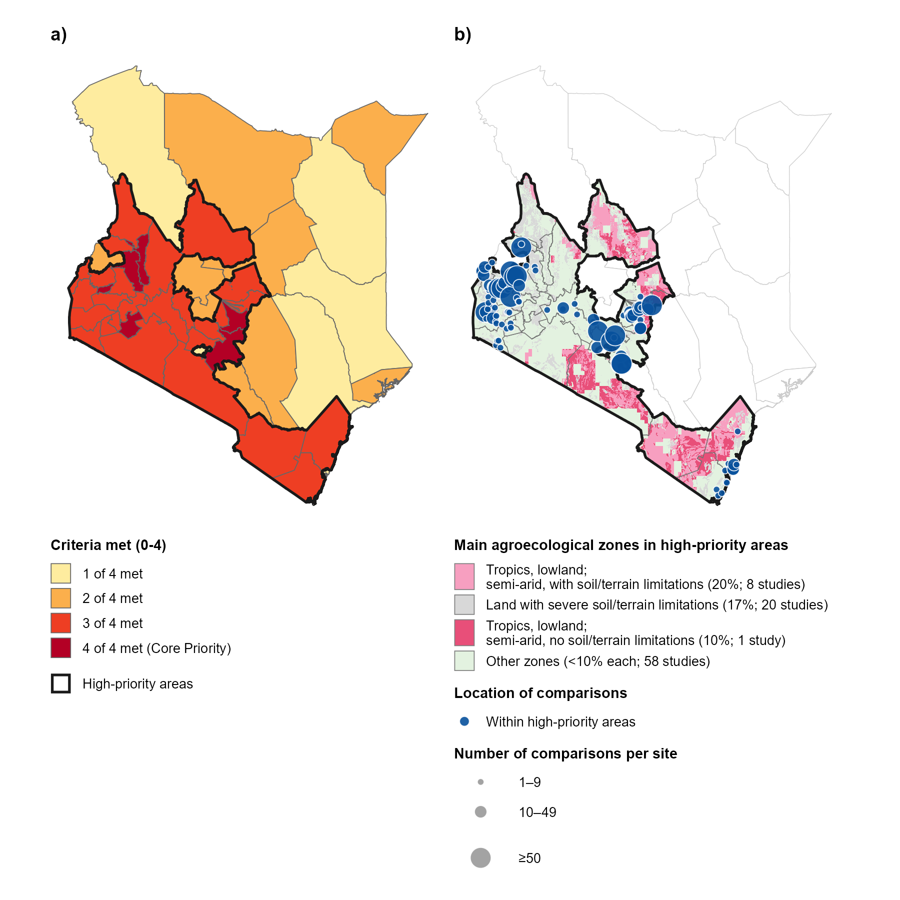

Figure 1. a) High-priority areas of Scenario 2A in Kenya; and b) location of the evidence on AE/RA practices within the high-priority areas. In panel a, counties are shaded by the number of the four screening criteria they meet (i.e., severe soil acidity on active cropland; maize dominance over 50% of cereal harvested area; a declining maize yield trend in 2013–2021; and a synthetic fertilizer application rate in the top tertile of county means). Counties meeting three or four criteria form the high-priority areas, outlined in black. In panel b, blue circles show the study sites of the 2,950 comparisons from 67 studies used in this analysis, sized by the number of comparisons per site. Background colours show the main agroecological zones, those covering at least 10% of the high-priority areas, and the legend gives the share of the high-priority areas each zone covers and the number of studies in it. Other zones, each covering less than 10% of the high-priority areas, are shown in light green.

3.2.1.2 Promising AE/RA practices for soil fertility restoration
The evidence points to two groups of AE/RA practices that can restore soil fertility and address the declining maize yields in these high-priority areas. These practices are adding organic matter to the soil and intercropping cereals with pulses and legumes, which can also produce plant protein for school meals.
Adding organic matter to the soil, such as compost, animal manure or crop residues, helps restore soil fertility and raises cereal yields (Fig. 2A.2a). Compost and manure increased maize and sorghum yields compared with no fertilizer, and improved soil health by increasing soil nutrients, organic matter and soil macrofauna, such as earthworms (Tables 2A.S2–S4). Mixed fertilizers, which combine manure or biochar with mineral fertilizer, increased maize and sorghum yields more consistently and raised soil nitrogen and soil moisture (Table 2A.S3). Incorporating crop residues or tree prunings into maize fields, instead of removing them, increased soil nitrogen and organic carbon, and tended to increase cereal yields (Table 2A.S4). These benefits suggest that farmers in these areas could reduce their dependence on costly synthetic fertilizer by replacing it with organic fertilizers, or combining it with them, without compromising cereals yields and while improving soil health and biodiversity.
Intercropping cereals with legumes allows farmers to produce additional food without reducing cereal yields (Fig. 2A.2a). Intercrops of maize with pulses and legumes, such as common bean, groundnut, pigeon pea, cowpea or mung bean, maintained or increased maize yields compared with maize grown alone (Table 2A.S6). Push-pull systems, in which finger millet, maize, or sorghum are intercrop with Desmodium spp., forage legumes, increased cereal yields and reduce the number of Striga plants, a parasitic weed, and the damage caused by stem borers. Intercrops of maize with green manure legumes (Crotalaria and velvet bean) increased maize yields, while intercropping with the nitrogen-fixing tree Gliricidia sepium increased them. Together, these AE/RA practices could support school-meal programmes by increasing the supply of maize, the staple of most school meals, and by adding legumes and pulses as a local source of plant protein. Legumes intercropped with cereals can also improve soil fertility by fixing nitrogen from the air (Muoni et al. 2022), and push-pull, which controls pests without chemicals, could reduce pesticide residues in food served to schoolchildren (Khan et al. 2011).
Pulse and legume yields also responded well to organic inputs (Figure 2A.3b). Applying compost or manure to common bean increased its yields compared with no fertilizer application (Table 2A.S7a). However, pigeon pea and common bean yielded less when intercropped with maize than when grown alone (Table 2A.S7b), which is expected as the legume is planted at a lower density and competes with maize for light, water and nutrients. Incorporating crop residues and tree prunings into these maize-legume intercrops reduced pigeon pea yields further (Table 2A.S7c), while raising maize yields (Table 2A.S6). These results point to trade-offs for legume production, because intercrops give more maize and some legumes from the same field, while legumes grown alone give more plant protein for school meals. Local varieties gave mixed results, as local soybean varieties yielded less than improved varieties and local cowpea varieties yielded about the same (Table 2A.S7d). These varieties may have other benefits, such as adaptation to local conditions, that were not assessed in this synthesis.
For vegetables, supplemental irrigation increased the yields of kale and cabbage compared with rainfed production (Figure 2A.2c; Table 2A.S8). Drip irrigation delivers small amounts of water directly to the plant roots, which makes it suited to smallholder vegetable gardens where water is limited. Evidence on other practices for vegetables, such as organic fertilizers and intercropping, was too limited to draw conclusions.
The evidence also has important gaps. For food groups other than cereals, pulses and legumes, evidence was scarce. Vegetables were studied almost only under irrigation, roots and tubers and nuts and seeds had few results with no effect supported by strong evidence, and no study measured fruits (Figure 2A.2c–e). This limits what can be concluded about how these practices contribute to diverse and nutritious diets. Most studies measured crop yields, while effects on profitability, labour demand and climate mitigation were rarely assessed, although these determine whether farmers can adopt the practices. Few studies compared organic inputs directly with synthetic fertilizer, so the potential to reduce synthetic fertilizer use needs further testing. Finally, most studies were located outside the main agro-ecological zones of the high-priority areas, particularly the semi-arid zones, so the results may not fully apply where the need is greatest.
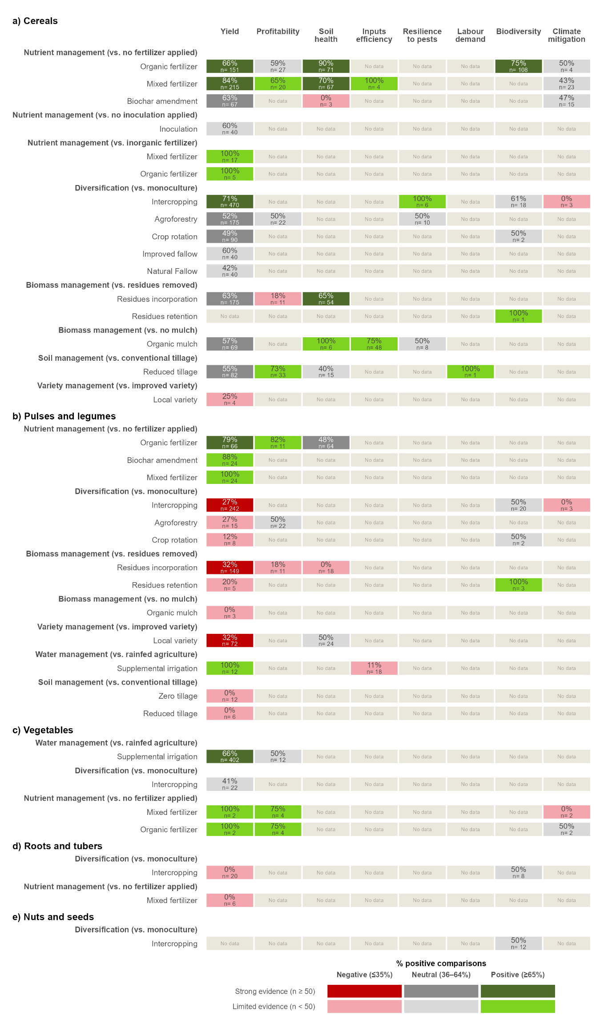

Figure 2A.2. Evidence synthesis on the effects of AE/RA practices on eight outcome dimensions for a) cereals; b) pulses and legumes; c) vegetables; d) roots and tubers; and e) nuts and seeds in the high-priority areas of Scenario 2A. Each row compares an AE/RA practice with the control named in the bold heading above it. AE/RA practices are grouped by practice domain. Each cell shows the percentage of comparisons with a positive effect and the number of comparisons. Colours show the direction of the effect, positive (≥65% of comparisons positive), neutral (36–64%) or negative (≤35%), and the strength of the evidence, strong (≥50 comparisons, darker shades) or limited (<50, lighter shades). Food groups, management domains and practices are ordered by the number of positive effects with strong evidence. No data means that no study assessed that outcome.

3.2.2 Scenario 2B: Arid pastoral micro-gardens
Scenario 2B covers the arid and semi-arid lands of northern and eastern Kenya, where pastoralism is the main livelihood and diets rely heavily on livestock products. Severe water scarcity, recurrent food crises and conflict over water and grazing land limit crop production, leaving diets short of vegetables and other plant-based foods. To address this problem, the scenario proposes small home gardens that produce vegetables with little water, which can also include drought-tolerant legumes such as cowpea as a source of plant protein for household consumption (Table 2A.1).

Table 2A.1. Description of scenarios of identifying priority areas for nutritious and sustainable food systems in Kenya.
 | 2A: Soil fertility restoration | 2B: Arid pastoral home gardens
Main problem | Stagnating maize yields on soils acidified by continuous maize cropping and heavy use of synthetic fertilizer; diets low in plant protein and micronutrients. | Shortage of plant-based foods in diets that rely heavily on livestock, under severe water scarcity, recurrent food crises and resource conflict
Conditions mapped | Soil acidity on active cropland; maize dominance (over 50% of cereal area); declining maize yields (2013–2021); high synthetic fertilizer use. | High livestock density; severe water risk; deficit in plant-based food production; acute food insecurity (IPC Phase 3 or above); resource conflict (arid and semi-arid counties only).
What is needed | Restore soil fertility and reduce dependence on synthetic fertilizers, while maintaining cereal production. Diversify production with plant-protein crops for school meal procurement. | Produce vegetables and plant-protein foods locally with very little water, to diversify diets and supply school meal programmes through public procurement.
Food for school meals | Maize; pulses and legumes. | Vegetables; pulses and legumes.

Scenario 2B (Arid pastoral micro-gardens) targets the arid and semi-arid lands (ASAL) of northern and eastern Kenya, where pastoralism is the main livelihood and cropland is scarce. Only the 23 ASAL counties were assessed, against five screening criteria, namely high livestock density, severe agricultural water risk, a deficit in plant-based food production, acute food insecurity (IPC Phase 3 or above), and resource-conflict events. Its high-priority areas comprise six arid and semi-arid counties. Mandera is the only Core Priority county, meeting all five screening criteria, and Embu, Garissa, Isiolo, Turkana and West Pokot meet four (Fig. 2B.1a).
In these high-priority areas, the food-system problem is the shortage of plant-based foods in diets that rely heavily on livestock. High livestock numbers and access to animal products mask deficits in vegetables, legumes and the micronutrients they provide. Severe water scarcity, recurrent food crises and conflict over water and grazing resources limit food production. Mandera, Garissa, Isiolo and Turkana are in acute food crisis, classified as Phase 3 (Crisis) or above under the Integrated Food Security Phase Classification (IPC), whereas Embu and West Pokot have the same structural risks without an acute crisis. Existing cultivation is limited to small patches near rivers, boreholes and seasonal water points, such as the 3,291 ha of cropland along the Daua River in Mandera.
To address these problems, the scenario proposes household micro-gardens that produce vegetables with little water, such as keyhole gardens irrigated with filtered household greywater and drip kits. These gardens would grow drought-tolerant indigenous leafy vegetables, such as amaranth and spider plant, together with cowpea and moringa as sources of plant protein.
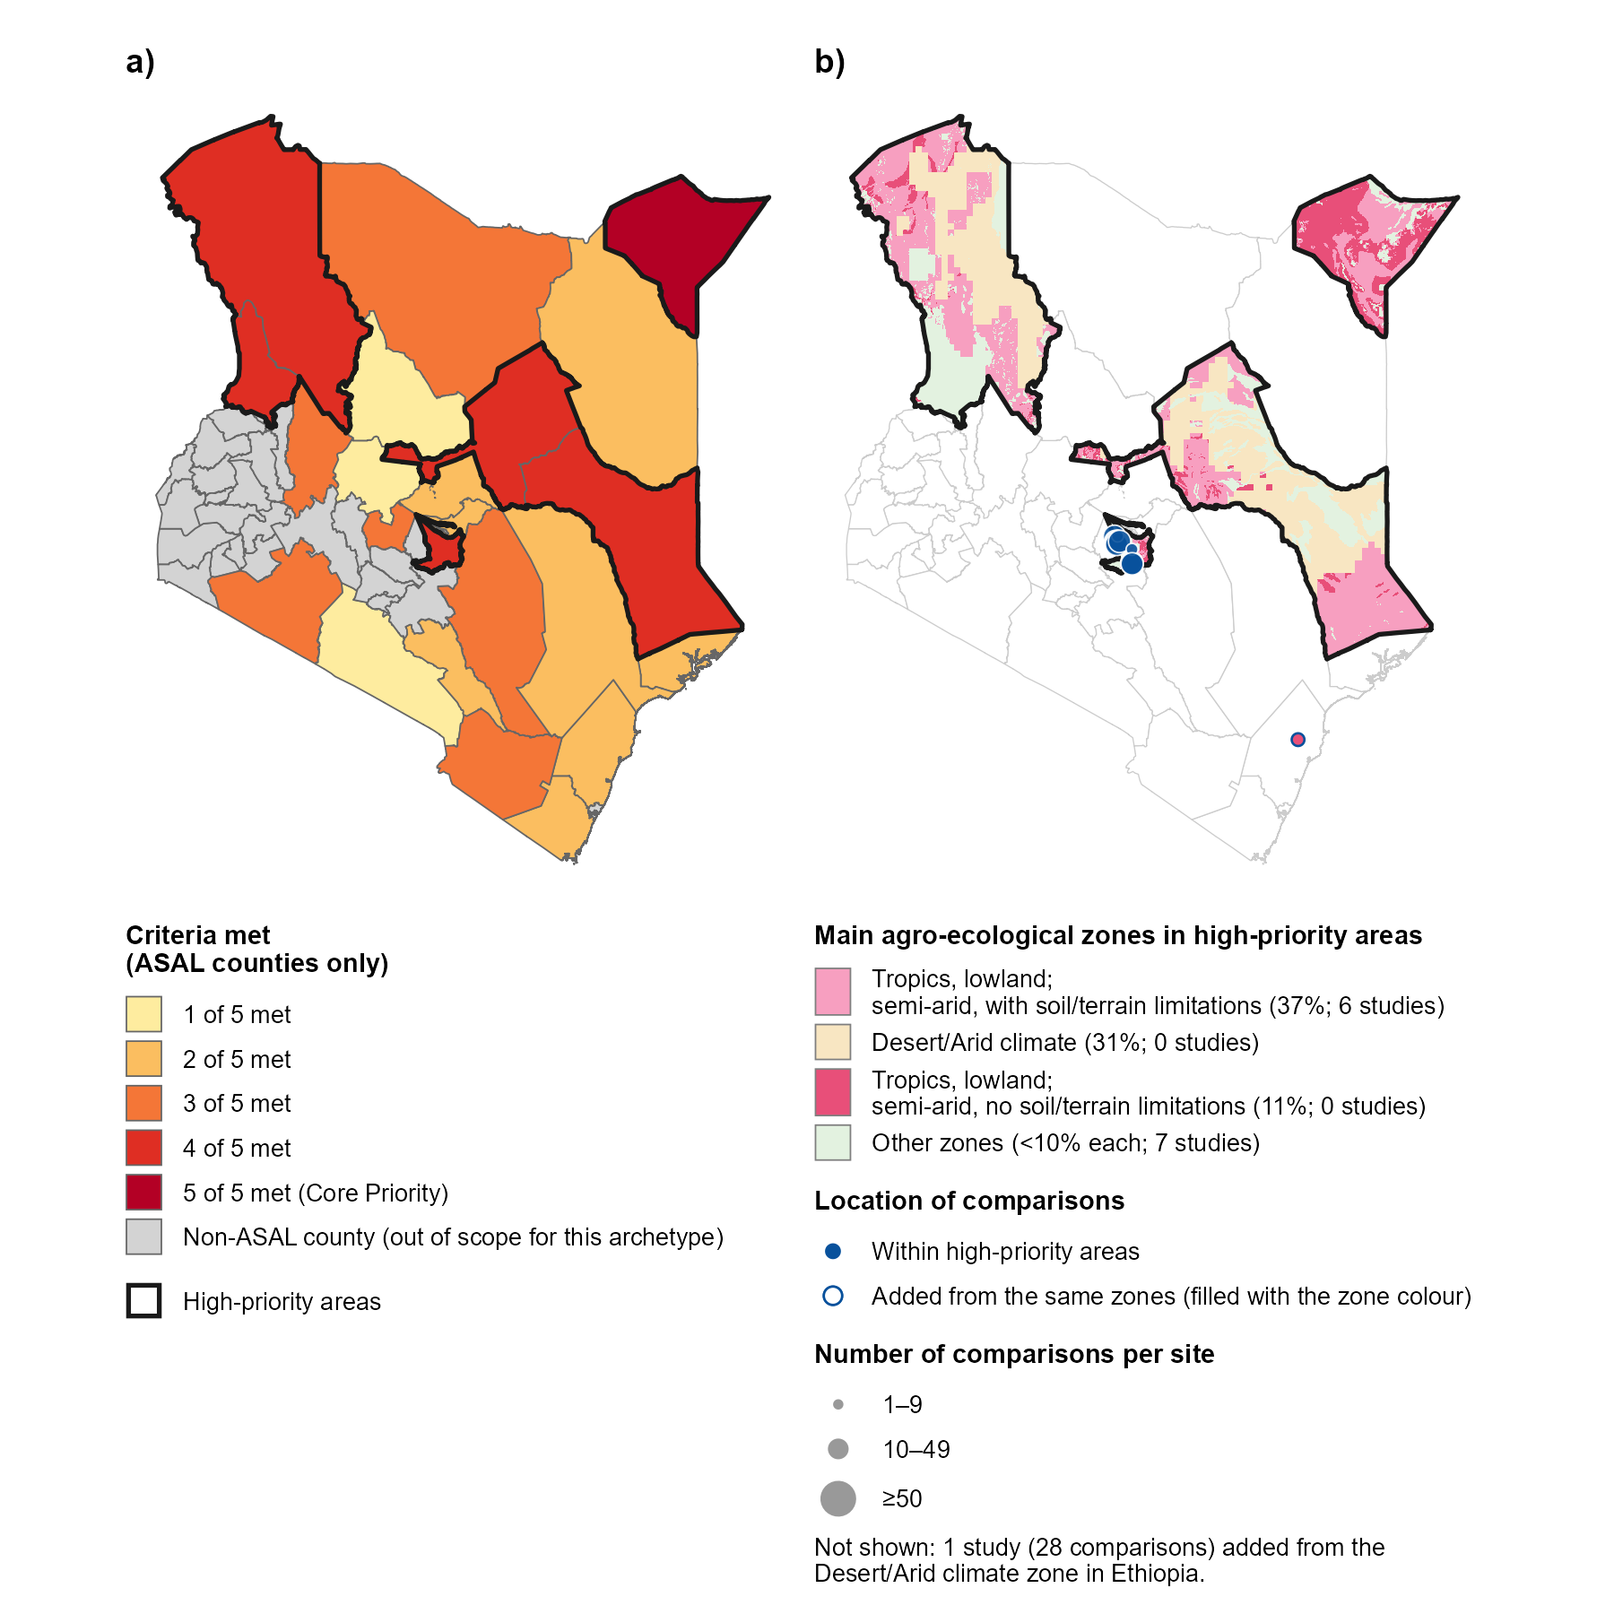

Figure 2B.1. a) High-priority areas of Scenario 2B in Kenya; and b) their main agroecological zones with the study sites of the comparisons used in the synthesis. In panel a, the 23 arid and semi-arid land (ASAL) counties are shaded by the number of the five screening criteria they meet (i.e., high livestock density; severe agricultural water risk; plant-based food deficit; acute food insecurity, IPC Phase 3 or above; and resource-conflict events), and non-ASAL counties are shown in grey as out of scope. Counties meeting five or four criteria form the high-priority areas, outlined in black. In panel b, colours show the GAEZ v4 agroecological zones covering at least 10% of the high-priority areas (main agroecological zones), and the legend gives the percentage of the high-priority areas each zone covers and the number of studies located in it. Other zones, each covering less than 10% of the high-priority areas, are shown in light green. Blue circles show the study sites of the study sites of the 235 comparisons from 10 studies located within the high-priority areas. The circles with a bleu outline, filled with the colour of its zone, shows the site of the comparison added from the same zones elsewhere in Kenya (tropics, lowland, semi-arid, with no soil/terrain limitations). The 28 comparisons from one study added from the desert/arid zone in Ethiopia are not shown. Circles are sized by the number of comparisons per site. Studies with sites in more than one zone are counted in each.

3.2.2.1 Evidence distribution and gaps
Within the high-priority areas of Scenario 2B, the evidence base comprised 235 comparisons from 10 studies. All of them came from Embu, one of the six high-priority counties, and no study was in Mandera, Garissa, Isiolo, Turkana or West Pokot (Figure 2B.1b). Three main agroecological zones cover these high-priority areas, but the evidence covered only the semi-arid tropical lowlands with soil/terrain limitations, with 86 comparisons (6 studies). The remaining comparisons (149 of 235) came from small humid zones in western Embu, which together cover less than 1% of the high-priority areas of this scenario (Table 2B.S1). This evidence exceeded the threshold of 100 comparisons but was not representative of the conditions in these areas. The evidence was therefore extended for the two main agroecological zones lacking studies. One comparison (1 study) was added from semi-arid tropical lowlands without soil/terrain limitations located in Kilifi County, on the coast of Kenya. As no Kenyan study was located in the desert/arid zone, 28 comparisons (1 study) were added from this zone in northern Ethiopia. The synthesis for this scenario was therefore based on 264 comparisons from 12 studies, published between 1997 and 2023, 10 of them since 2010 (Fig. 2B.S1).
The evidence covered five food groups, 9 AE/RA practices from five management domains, and five outcome dimensions. Cereals were the best represented food group (Figure 2B.2a), with all comparisons on maize, including baby corn (179 comparisons, 9 studies). Data on vegetables came from cabbage, garlic, onion and tomato (46 comparisons, 2 studies), and data on pulses and legumes from common bean and soybean (46 comparisons, 2 studies). Roots and tubers were represented by potato, nuts and seeds by sunflower, and no study assessed fruits. Residues incorporation and mixed fertilizer contributed the most comparisons (Figure 2B.2b), all from studies in Embu. Intercropping, zero tillage, supplemental irrigation, organic mulch, biochar amendment and organic fertilizer were each assessed in a single study.
Yield was the best represented outcome dimension (Figure 2B.2c), mostly measured as crop yield (158 comparisons, 11 studies), with fewer data on biomass yield. Data on soil health came from soil nitrogen, moisture and organic carbon; and data on biodiversity from the abundance of natural enemies of pests in a single study. Profitability was measured mostly as net return and total cost (15 comparisons, 2 studies), and labour demand in a single comparison. No study assessed input efficiency, resilience to pests or climate mitigation.
The only evidence from the semi-arid tropical lowlands without soil/terrain limitations was one comparison of organic fertilizer with no fertilizer on maize yield. While the only evidence from the desert/arid zone came from one study comparing zero tillage with conventional tillage on the yield of garlic, cabbage, onion and tomato in northern Ethiopia.
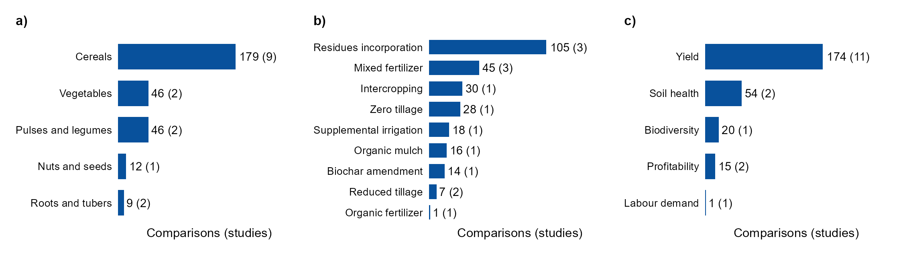

Figure 2B.2. Number of comparisons and studies (in parentheses) by a) food group; b) agroecological or regenerative agricultural (AE/RA) practice; and c) outcome dimension for Scenario 2B in Kenya, including the comparisons located within the high-priority areas and those added from the same main agroecological zones. Bars are ordered by the number of comparisons.

3.2.2.2 Evidence synthesis on the effect of AE/RA practices
None of the practices proposed by the scenario, such as household micro-gardens, keyhole gardens, greywater irrigation, indigenous leafy vegetables or moringa, was assessed in these areas.

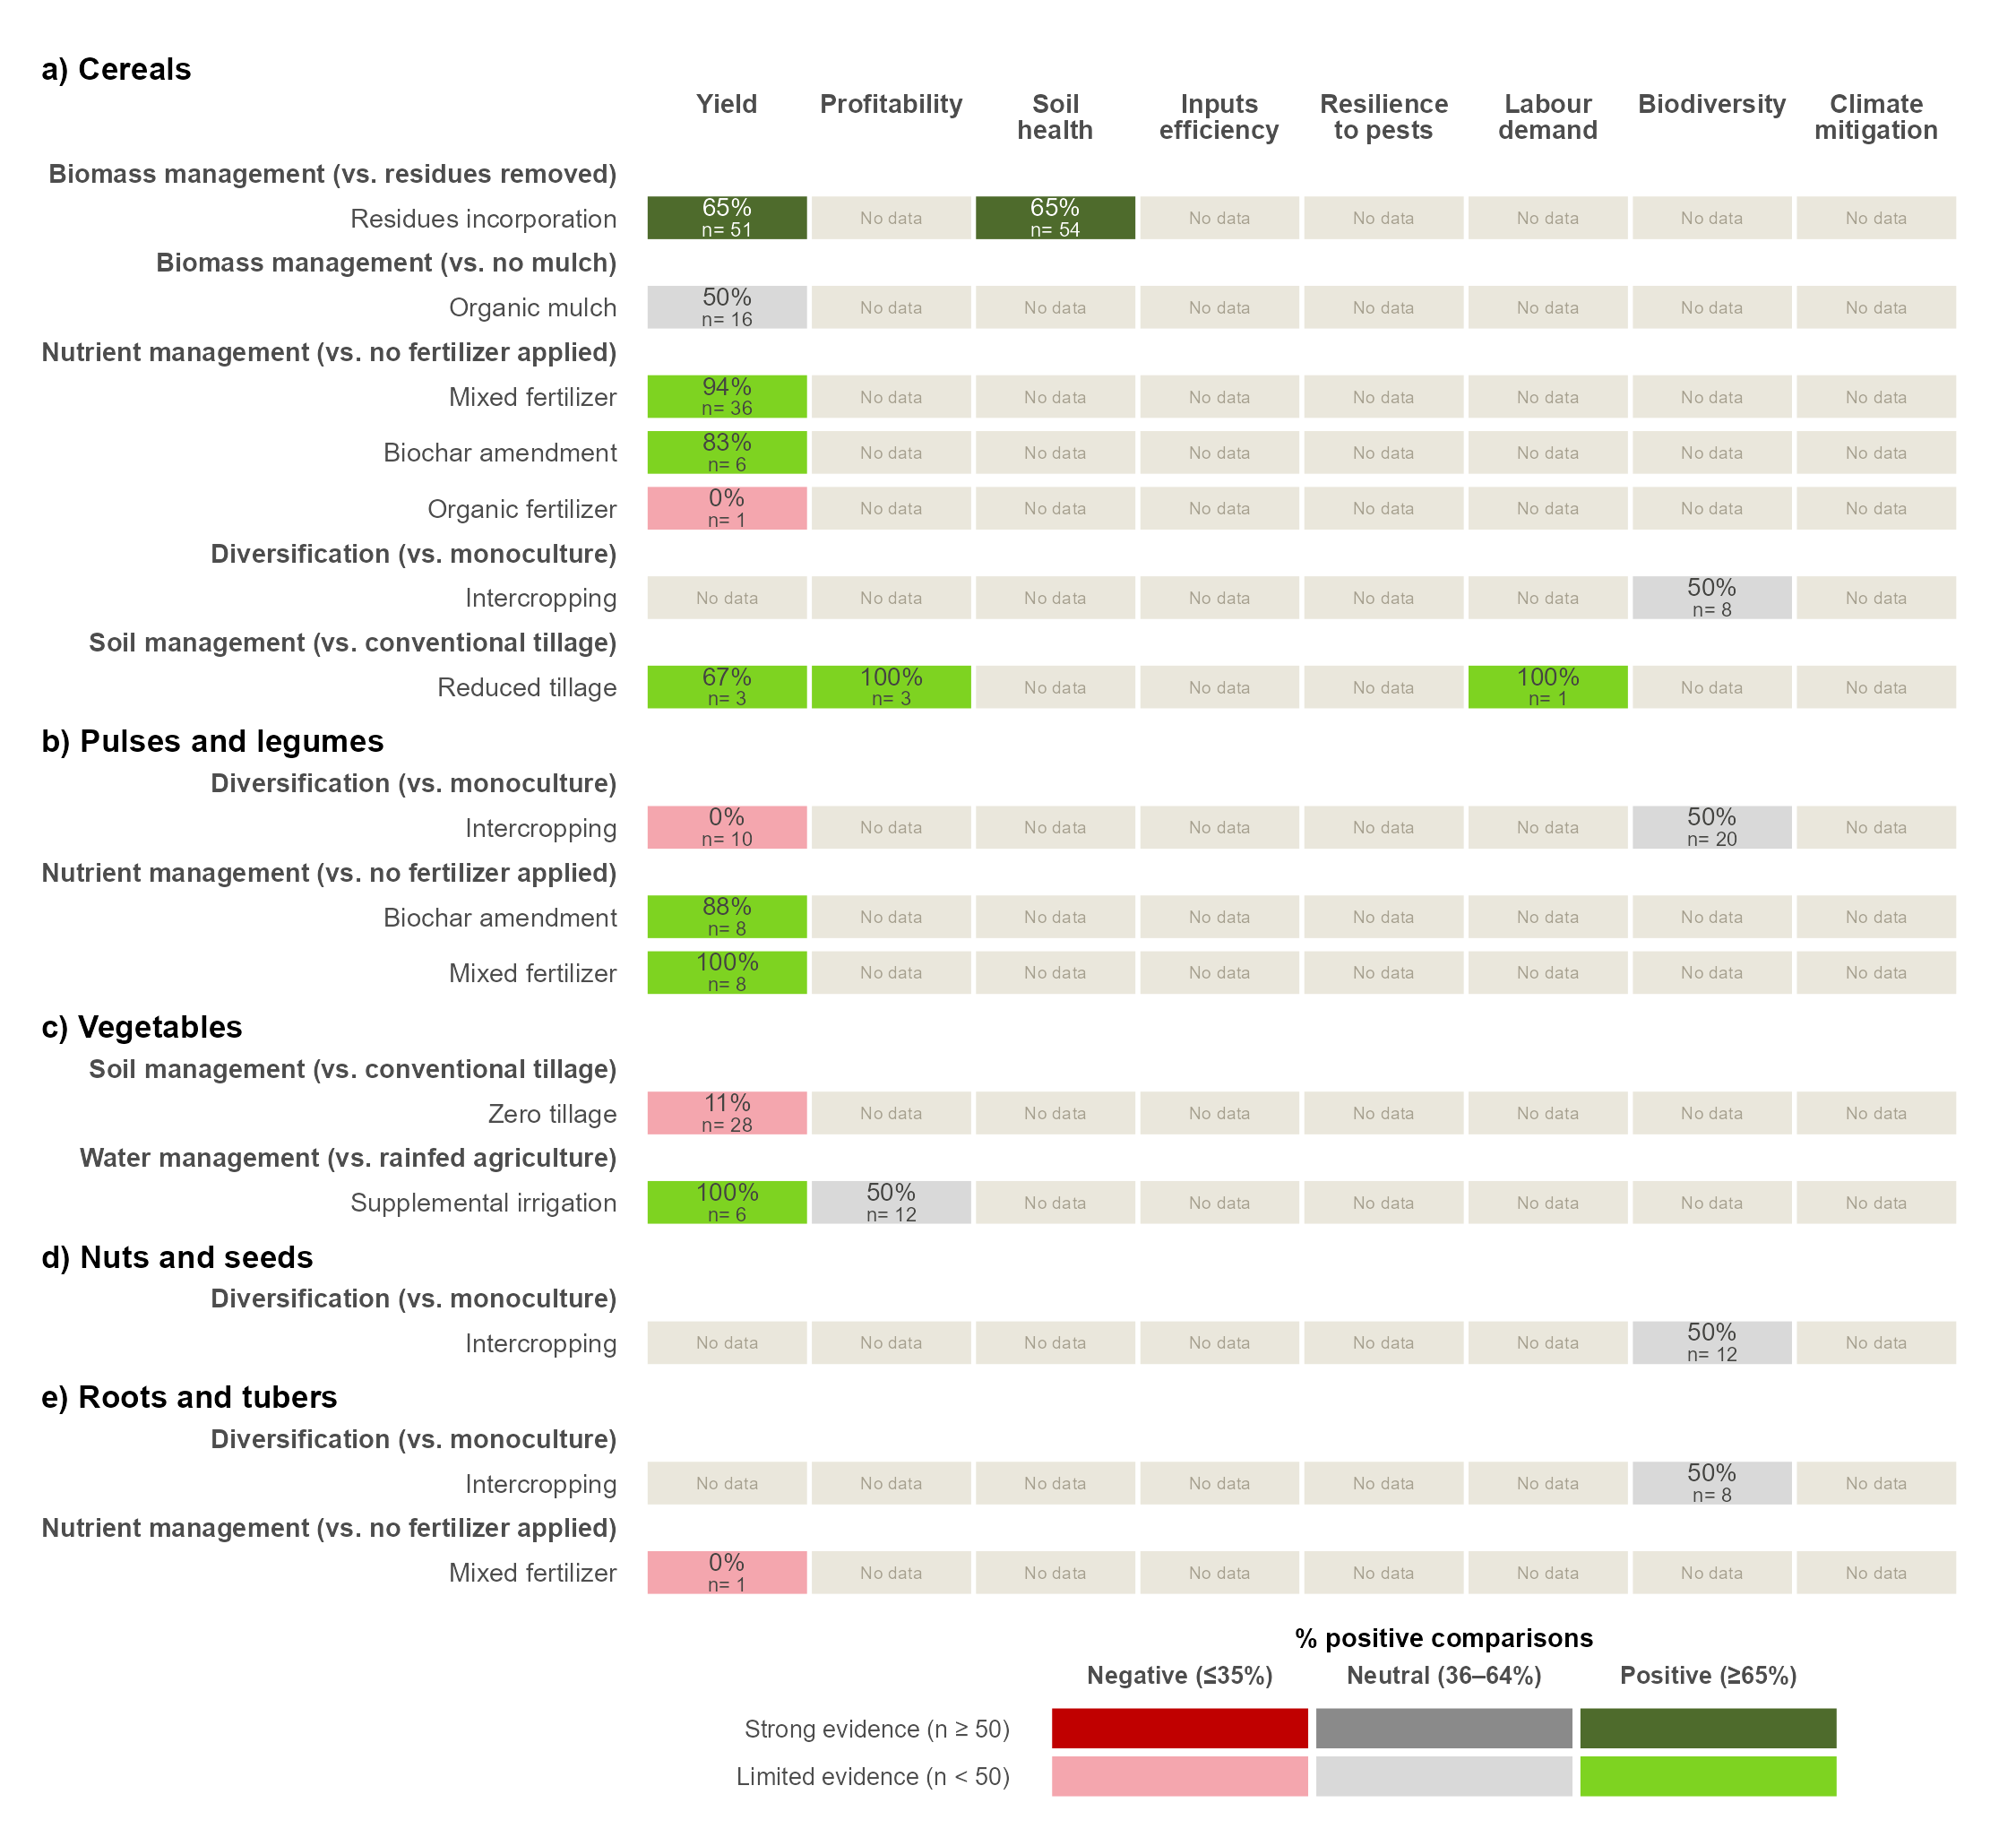

Figure 2B.3. Evidence synthesis on the effects of AE/RA practices on eight farm outcome dimensions for a) cereals; b) pulses and legumes; c) vegetables; d) nuts and seeds; and e) roots and tubers for Scenario 2B in Kenya, including the comparisons located within the high-priority areas and those added from the same main agroecological zones. Each row compares an AE/RA practice with the control named in the bold heading above it. AE/RA practices are grouped by practice domain. Each cell shows the percentage of comparisons with a positive effect and the number of comparisons. Colours show the direction of the effect, positive (≥65% of comparisons positive), neutral (36–64%) or negative (≤35%), and the strength of the evidence, strong (≥50 comparisons, darker shades) or limited (<50, lighter shades). Food groups, management domains and practices are ordered by the number of positive effects with strong evidence. No data means that no study assessed that outcome.

3.3 Ethiopia

The evidence available in the priority areas: number of studies and effect sizes.
Element | 2A-Soil restoration | 2B- Arid micro-gardens
Main problems | Soil acidity, falling yields, heavy fertilizer use | Water scarcity, too few plant foods, food crises
Context | Humid/sub-humid highlands, maize-based systems, smallholders | Arid/semi-arid, pastoral, very little cropland
Candidate practices | Liming, legume intercropping, improved fallows, biomass transfer, integrated soil fertility management | Home or keyhole gardens, water harvesting, drip irrigation, drought-tolerant crops, agroforestry (moringa)
Priority outcomes | Yield, soil health, profitability | Water-use efficiency, diet diversity, resilience
Food group linked to the diet gap | Pulses and protein | Vegetables and protein

4. References
FAO & IIASA (2021). Global Agro-Ecological Zones version 4 (GAEZ v4). Food and Agriculture Organization of the United Nations, Rome, and International Institute for Applied Systems Analysis, Laxenburg.
Agegnehu G, Amede T, Erkossa T, et al (2021) Extent and management of acid soils for sustainable crop production system in the tropical agroecosystems: a review. Acta Agriculturae Scandinavica, Section B — Soil & Plant Science 71:852–869. https://doi.org/10.1080/09064710.2021.1954239
Jones SK, Sánchez AC, Juventia SD, Estrada-Carmona N (2021) A global database of diversified farming effects on biodiversity and yield. Sci Data 8:212. https://doi.org/10.1038/s41597-021-01000-y
Laub M, Corbeels M, Mathu Ndungu S, et al (2023) Combining manure with mineral N fertilizer maintains maize yields: Evidence from four long-term experiments in Kenya. Field Crops Research 291:108788. https://doi.org/10.1016/j.fcr.2022.108788
Muoni T, Jonsson M, Duncan AJ, et al (2022) Effects of management practices on legume productivity in smallholder farming systems in sub‐Saharan Africa. Food and Energy Security 11:e366. https://doi.org/10.1002/fes3.366
Paut R, Garreau L, Ollivier G, et al (2024) A global dataset of experimental intercropping and agroforestry studies in horticulture. Sci Data 11:5. https://doi.org/10.1038/s41597-023-02831-7
Rosenstock TS, Steward P, Joshi N, et al (2024) Effects of changing farming practices in African agriculture. Sci Data 11:958. https://doi.org/10.1038/s41597-024-03805-z
Sánchez AC, Kamau HN, Grazioli F, Jones SK (2022) Financial profitability of diversified farming systems: A global meta-analysis. Ecological Economics 201:107595. https://doi.org/10.1016/j.ecolecon.2022.107595

5. Supplementary information

Figure SX. Prisma diagram

Table S1. Agroecological or regenerative agricultural (AE/RA) practices included in the analysis, grouped by management domain, with a description of each practice.
Management domains | AE/RA practice description
Biomass management | Organic mulch: A layer of organic material (crop or tree residues, prunings, leaves, weeds, cut grass or straw, produced on-site or brought in) is spread over the soil surface without being mixed in. It conserves soil moisture, buffers soil temperature, suppresses weeds, protects against erosion and gradually recycles nutrients to the soil.
 | Residues incorporation: Crop or tree residues (straw, stubble, prunings, leaves and other plant parts left after harvest or pruning) are mixed into the soil, usually by tillage, instead of being removed, burned or left on the surface. A form of crop residue management that returns organic matter and nutrients to the soil.
 | Residues retention: Crop or tree residues left after harvest or pruning are kept in the field where they fall, standing or laid on the surface, instead of being removed or burned. A form of crop residue management that keeps a protective surface cover to reduce wind and water erosion, conserve water and reduce evaporation, while returning organic matter and nutrients to the soil.
Diversification (spatial) | Agroforestry: Woody perennials (trees, shrubs, palms or bamboos) are deliberately grown on the same land as crops and/or livestock, within or around plots, for example scattered trees, alley cropping, hedgerows, boundary plantings, windbreaks, shaded perennial systems or silvopasture. Trees provide products (fruit, timber, fodder, fuel) as well as services such as shade, microclimate regulation, soil protection, nutrient cycling and habitat.
 | Intercropping: Two or more crop species are grown in the same field at the same time, for all or a significant part of their growth cycles, in mixed, row, strip or relay arrangements. Complementarity between species is used to make better use of light, water and nutrients, increase total productivity per unit area, and reduce pest, disease and weed pressure.
Diversification (temporal) | Crop rotation: Different crop species are grown in a planned sequence on the same field over successive seasons or years, instead of repeating the same crop (monoculture) or an unplanned sequence. Rotations often combine cereals, legumes, root crops or green manures. They break pest, disease and weed cycles, improve soil fertility (especially when legumes fix nitrogen), balance the use of nutrients and water from different soil depths, improve soil structure and organic matter, and spread production risk.
 | Natural fallow: Cropland is left uncultivated for one or more seasons and vegetation (grasses, shrubs or trees) regrows spontaneously, without planting. The regrowth restores soil organic matter and fertility, recycles nutrients, protects the soil from erosion, breaks weed, pest and disease cycles and provides habitat for biodiversity. Includes grass, bush and forest fallows.
 | Improved fallow: During the fallow period, cropland is deliberately planted with fast-growing species, usually legumes such as trees, shrubs or herbaceous plants (e.g., Sesbania, Tephrosia, Gliricidia, Cajanus, Crotalaria, Mucuna), instead of being left to regrow naturally. This restores soil fertility faster than natural fallow through biological nitrogen fixation, biomass and nutrient inputs, and deep nutrient recycling. It also suppresses weeds (including Striga) and protects the soil. The fallow biomass is often cut and left on the surface or incorporated before the next crop.
Nutrient management | Biochar amendment: Biochar is added to the soil, either alone or mixed with compost, manure or fertilizers. Biochar is a carbon-rich solid made by heating biomass (crop residues, wood, manure or other organic waste) with little or no oxygen (pyrolysis). It improves soil structure, water-holding capacity, cation exchange capacity and pH (especially in acidic soils), increases nutrient retention and use efficiency, supports soil microbial activity and stores carbon in the soil for the long term.
 | Inoculation: Seeds, seedlings or soil are treated with beneficial microorganisms, such as rhizobia, arbuscular mycorrhizal fungi, or plant growth-promoting bacteria and fungi, to establish or boost useful plant–microbe associations. It improves biological nitrogen fixation, nutrient (especially P) uptake, root health and plant tolerance to stress, and can reduce the need for synthetic inputs.
 | Mixed fertilizers: Organic fertilizers or amendments (manure, compost, crop residues, green manure) are applied together with mineral fertilizers, in the same season or as a planned combination, to meet crop nutrient needs. The organic component builds soil organic matter, improves soil structure and nutrient retention, and increases how efficiently the mineral nutrients are used, while mineral fertilizers supply readily available nutrients.
 | Organic fertilizers: Nutrients are supplied to crops from materials of plant or animal origin, such as animal manure, compost, vermicompost, slurry, biosolids, green manure or plant-based preparations, instead of synthetic mineral fertilizers. Nutrients are released gradually as the materials decompose, while the added organic matter improves soil structure, water-holding capacity, biological activity and long-term fertility.
Soil management | Reduced tillage: Soil disturbance is reduced compared with conventional tillage (e.g., mouldboard ploughing) by cutting the number, depth or intensity of tillage operations, or by tilling only part of the field (strip, zone or planting-hole tillage). It includes minimum tillage and no-till, where seeds are sown directly into untilled soil. Less disturbance protects soil structure and aggregates, reduces erosion and evaporation, slows organic matter decomposition, supports soil biological activity and cuts fuel and labour costs.
 | Zero tillage: Crops are sown directly into untilled soil, with no ploughing, harrowing or other soil preparation before planting. Disturbance is limited to the narrow opening made for the seed, and the soil surface and any crop residues are left in place. It protects soil structure and aggregates, reduces erosion and evaporation, slows organic matter decomposition, supports soil biological activity and cuts fuel, labour and time costs.
Variety management | Local variety: Crop varieties developed and maintained by farmers in a particular area are grown. These include traditional varieties, landraces and farmer-selected populations, usually multiplied from farm-saved or locally exchanged seed, instead of commercially bred improved varieties or hybrids. Local varieties are often genetically diverse and adapted to local soils, climate, pests and low-input conditions. They help with yield stability, resilience to stress, dietary and cultural preferences, seed autonomy and conservation of agrobiodiversity.
Water management | Supplemental drip irrigation: Limited amounts of water are applied to mainly rainfed crops through a drip system (pipes with emitters that deliver water slowly to the root zone) at critical growth stages or during dry spells, when rainfall alone isn't enough. The aim is to stabilize yields rather than meet the full crop water demand. Water goes directly to the root zone, which reduces evaporation, runoff and deep percolation losses, increases water use efficiency, limits weed growth between rows, and lowers pest and disease pressure from wet foliage.

Table S3. Food groups.
Food groups | Crops included
Cereals:

Table S2. Outcome dimensions.
Outcome dimension description | Included outcomes
Biodiversity:
Climate mitigation
Inputs efficiency
Labour demand
Profitability
Resilience to pests
Soil health
Productivity

5.1 Ethiopia

5.2 Kenya

5.2.1 Scenario 2A: Soil fertility restoration

Table 2A.S1.

Table 2A.S2. Agroecological zones of the high-priority areas of Scenario 2A in Kenya, with the number of studies and comparisons in each zone. Zones are those of the Global Agro-Ecological Zones (GAEZ v4), and main zones are those covering at least 10% of the high-priority areas. Studies and comparisons are shown for those located within the high-priority areas, and for those added from the same main zones elsewhere in Kenya and in neighbouring project countries. No comparisons were added for this scenario, because the evidence within the high-priority areas met both sufficiency criteria. Comparisons with sites in more than one zone are counted in each, so totals can be lower than the sum of the rows.
Agroecological zone | Share of high-priority areas (%) | Main zone | Studies (High-priority areas) | Comparisons (High-priority areas) | Studies (Same zones, same country) | Comparisons (Same zones, same country) | Studies (Same zones, neighbouring countries) | Comparisons (Same zones, neighbouring countries)
Tropics, lowland; semi-arid, with soil/terrain limitations | 19.5 | Yes | 8 | 219 | 0 | 0 | 0 | 0
Land with severe soil/terrain limitations | 17.2 | Yes | 19 | 424 | 0 | 0 | 0 | 0
Tropics, lowland; semi-arid, no soil/terrain limitations | 10.4 | Yes | 1 | 1 | 0 | 0 | 0 | 0
Tropics, highland; humid, with soil/terrain limitations | 9.8 | No | 11 | 485 | 0 | 0 | 0 | 0
Tropics, lowland; sub-humid, with soil/terrain limitations | 9.3 | No | 2 | 13 | 0 | 0 | 0 | 0
Tropics, lowland; humid, with soil/terrain limitations | 5.1 | No | 18 | 591 | 0 | 0 | 0 | 0
Tropics, highland; sub-humid, with soil/terrain limitations | 5 | No | 16 | 865 | 0 | 0 | 0 | 0
Tropics, lowland; sub-humid, no soil/terrain limitations | 4.6 | No | 1 | 1 | 0 | 0 | 0 | 0
Tropics, highland; humid, no soil/terrain limitations | 4.3 | No | 3 | 50 | 0 | 0 | 0 | 0
Tropics, lowland; humid, no soil/terrain limitations | 2.5 | No | 6 | 225 | 0 | 0 | 0 | 0
Tropics, highland; sub-humid, no soil/terrain limitations | 2.2 | No | 2 | 19 | 0 | 0 | 0 | 0
Dominantly water | 2.1 | No | 1 | 5 | 0 | 0 | 0 | 0
Desert/Arid climate | 2 | No | 0 | 0 | 0 | 0 | 0 | 0
Dominantly very steep terrain | 1.8 | No | 0 | 0 | 0 | 0 | 0 | 0
Dominantly hydromorphic soils | 1.3 | No | 2 | 30 | 0 | 0 | 0 | 0
Tropics, highland; semi-arid, with soil/terrain limitations | 1.1 | No | 0 | 0 | 0 | 0 | 0 | 0
Tropics, highland; semi-arid, no soil/terrain limitations | 0.7 | No | 0 | 0 | 0 | 0 | 0 | 0
Ample irrigated soils | 0.5 | No | 0 | 0 | 0 | 0 | 0 | 0
Cold, no permafrost; wet, with soil/terrain limitations | 0.4 | No | 0 | 0 | 0 | 0 | 0 | 0
Dominantly built-up land | 0 | No | 1 | 64 | 0 | 0 | 0 | 0
Total | 100 |  | 67 | 2950 | 0 | 0 | 0 | 0

Figure 2A.S1. Number of studies by year of publication in the high-priority areas of Scenario 2A in Kenya.
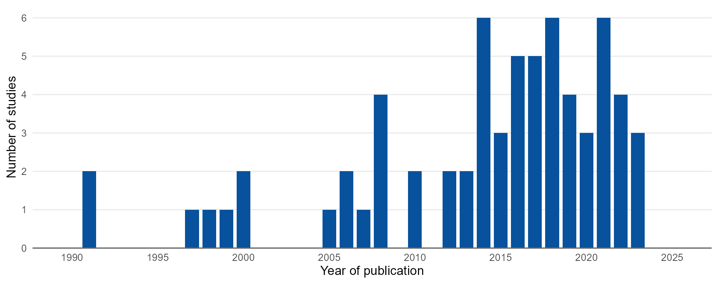

Figure 2A.2. Number of comparisons and studies (in parentheses) by a) food group; b) agroecological or regenerative agricultural (AE/RA) practice; and c) outcome dimension in the high-priority areas of Scenario 2A in Kenya. Bars are ordered by the number of comparisons.
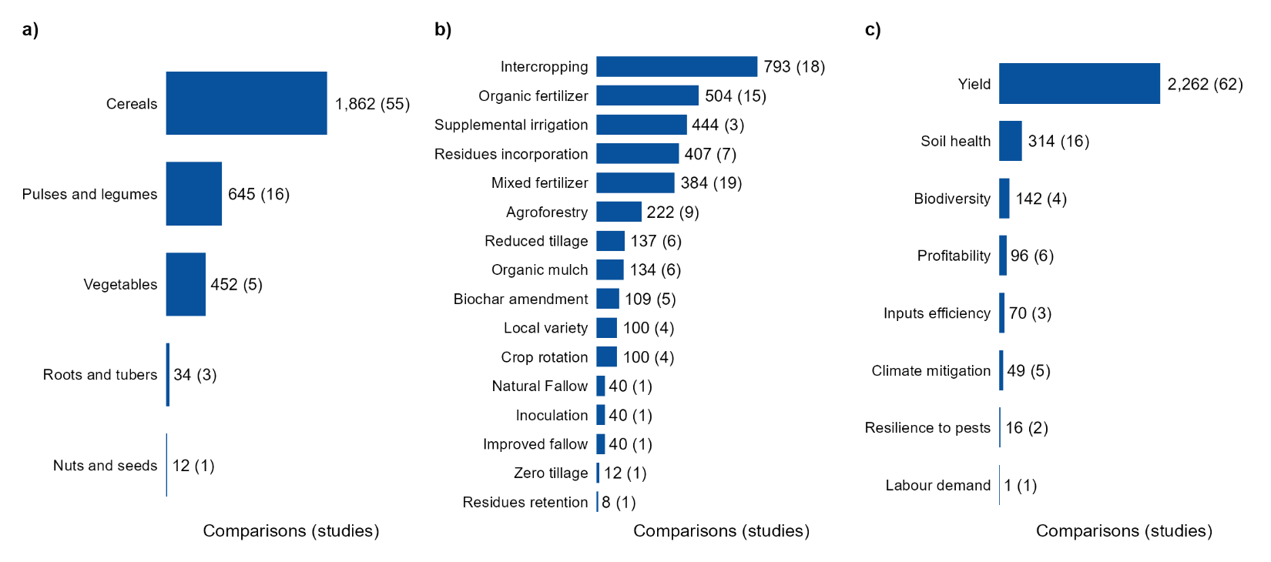

Table 2A.S3. Effects of organic fertilizers relative to no fertilizer on a) cereal yield, b) soil health in cereal systems and c) biodiversity in cereal systems in the high-priority areas of Scenario 2A. Positive, neutral and negative comparisons are those in which the outcome under organic fertilizer was higher than, equal to or lower than in the unfertilized control. Yield results are shown by measured crop, soil health results by main crop, and soil macrofauna results by measured taxa and cropping system, in all cases together with the type of organic input and the outcome measured. Organic (Other) refers to sawdust, and a missing companion species indicates a sole crop.
a) Cereal yields, by measured crop, companion species and type of organic input.
Measured crop | Companion species | Organic input | Outcome measured | Studies | Comparisons | Positive comparisons | Neutral comparisons | Negative comparisons | % positive comparisons
Maize | - | Biosolids | Yield | 1 | 3 | 3 | 0 | 0 | 100
Maize | - | Compost | Yield | 2 | 33 | 32 | 0 | 1 | 97
Maize | - | Manure | Yield | 6 | 23 | 20 | 1 | 2 | 87
Maize | Common Bean + Leucaena leucocephala | Manure | Yield | 1 | 20 | 2 | 0 | 18 | 10
Maize | - | Organic (Other) | Yield | 1 | 36 | 12 | 0 | 24 | 33
Sorghum | - | Manure | Yield | 2 | 36 | 30 | 0 | 6 | 83
b) Soil health in cereal systems, by main crop, companion species and type of organic input.
Main crop | Companion species | Organic input | Outcome measured | Studies | Comparisons | Positive comparisons | Neutral comparisons | Negative comparisons | % positive comparisons
Maize | - | Compost | Soil NH4 | 1 | 10 | 10 | 0 | 0 | 100
Maize | - | Compost | Soil NO3 | 1 | 10 | 10 | 0 | 0 | 100
Maize | - | Compost | Soil Organic Carbon | 1 | 10 | 10 | 0 | 0 | 100
Maize | - | Compost | Soil Total Nitrogen | 1 | 10 | 10 | 0 | 0 | 100
Maize | - | Manure | Soil NH4 | 1 | 2 | 2 | 0 | 0 | 100
Maize | - | Manure | Soil NO3 | 1 | 2 | 2 | 0 | 0 | 100
Maize | - | Manure | Soil Organic Carbon | 3 | 8 | 8 | 0 | 0 | 100
Maize | - | Manure | Soil Organic Carbon (Change) | 1 | 1 | 1 | 0 | 0 | 100
Maize | - | Manure | Soil Total Nitrogen | 4 | 10 | 7 | 2 | 1 | 70
Sorghum | - | Manure | Soil Organic Carbon | 1 | 4 | 2 | 0 | 2 | 50
Sorghum | - | Manure | Soil Total Nitrogen | 1 | 4 | 2 | 1 | 1 | 50
c) Biodiversity in cereal systems, by measured taxa, cropping system and type of organic input.
Measured taxa | Cropping system | Organic input | Outcome measured | Studies | Comparisons | Positive comparisons | Neutral comparisons | Negative comparisons | % positive comparisons
Araneae | Maize | Compost | Abundance | 1 | 10 | 8 | 2 | 0 | 80
Araneae | Maize | Manure | Abundance | 1 | 2 | 2 | 0 | 0 | 100
Blattodea | Maize | Compost | Abundance | 1 | 10 | 3 | 7 | 0 | 30
Blattodea | Maize | Manure | Abundance | 1 | 2 | 0 | 2 | 0 | 0
Chilopoda | Maize | Compost | Abundance | 1 | 10 | 7 | 3 | 0 | 70
Chilopoda | Maize | Manure | Abundance | 1 | 2 | 1 | 1 | 0 | 50
Coleoptera | Maize | Compost | Abundance | 1 | 10 | 10 | 0 | 0 | 100
Coleoptera | Maize | Manure | Abundance | 1 | 2 | 2 | 0 | 0 | 100
Diplopoda | Maize | Compost | Abundance | 1 | 10 | 2 | 8 | 0 | 20
Diplopoda | Maize | Manure | Abundance | 1 | 2 | 0 | 2 | 0 | 0
Hymenoptera | Maize | Compost | Abundance | 1 | 10 | 10 | 0 | 0 | 100
Hymenoptera | Maize | Manure | Abundance | 1 | 2 | 2 | 0 | 0 | 100
Isoptera | Maize | Compost | Abundance | 1 | 10 | 10 | 0 | 0 | 100
Isoptera | Maize | Manure | Abundance | 1 | 2 | 2 | 0 | 0 | 100
Oligochaeta | Maize | Compost | Abundance | 1 | 10 | 10 | 0 | 0 | 100
Oligochaeta | Maize | Manure | Abundance | 1 | 2 | 2 | 0 | 0 | 100
Orthoptera | Maize | Compost | Abundance | 1 | 10 | 9 | 1 | 0 | 90
Orthoptera | Maize | Manure | Abundance | 1 | 2 | 1 | 1 | 0 | 50

Table 2A.S4. Effects of mixed fertilizers, combining an organic input with mineral fertilizer, relative to no fertilizer on a) cereal yield, and b) soil health in cereal systems in the high-priority areas of Scenario 2A. Positive, neutral and negative comparisons are those in which the outcome under mixed fertilizer was higher than, equal to or lower than in the unfertilized control. Results are shown by measured crop for yield and by main crop for soil health, together with the companion species, the type of mixed input and the outcome measured. Organic (Other) refers to sawdust, and a missing companion species indicates a sole crop.
a) Cereal yields, by measured crop, companion species and type of mixed input.
Measured crop | Companion species | Mixed input | Outcome measured | Studies | Comparisons | Positive comparisons | Neutral comparisons | Negative comparisons | % positive comparisons
Maize | - | Biochar + Inorganic Fertilizer | Yield | 3 | 41 | 31 | 0 | 10 | 76
Maize | Soybean | Biochar + Inorganic Fertilizer + Inorganic Micronutrients Inputs | Yield | 1 | 26 | 26 | 0 | 0 | 100
Maize | - | Inorganic Fertilizer + Inorganic Micronutrients Inputs + Manure | Yield | 1 | 2 | 2 | 0 | 0 | 100
Maize | - | Inorganic Fertilizer + Manure | Yield | 6 | 58 | 56 | 1 | 1 | 97
Maize | - | Inorganic Fertilizer + Organic (Other) | Yield | 1 | 36 | 22 | 0 | 14 | 61
Sorghum | - | Inorganic Fertilizer + Manure | Yield | 2 | 52 | 43 | 1 | 8 | 83
b) Soil health in cereal systems, by main crop, companion species and type of mixed input.
Main crop | Companion species | Mixed input | Outcome measured | Studies | Comparisons | Positive comparisons | Neutral comparisons | Negative comparisons | % positive comparisons
Maize | - | Biochar + Inorganic Fertilizer | Soil Organic Carbon | 1 | 3 | 0 | 0 | 3 | 0
Maize | - | Inorganic Fertilizer + Manure | Soil Moisture | 1 | 41 | 30 | 0 | 11 | 73
Maize | - | Inorganic Fertilizer + Manure | Soil Organic Carbon | 3 | 7 | 6 | 0 | 1 | 86
Maize | - | Inorganic Fertilizer + Manure | Soil Organic Carbon (Change) | 1 | 1 | 1 | 0 | 0 | 100
Maize | - | Inorganic Fertilizer + Manure | Soil Total Nitrogen | 3 | 7 | 6 | 0 | 1 | 86
Sorghum | - | Inorganic Fertilizer + Manure | Soil Organic Carbon | 1 | 4 | 1 | 0 | 3 | 25
Sorghum | - | Inorganic Fertilizer + Manure | Soil Total Nitrogen | 1 | 4 | 3 | 0 | 1 | 75

Table 2A.S5. Effects of residues incorporation relative to residue removal on soil health in cereal systems in the high-priority areas of Scenario 2A. Positive, neutral and negative comparisons are those in which the outcome under residues incorporation was higher than, equal to or lower than under residue removal. Results are shown by main crop, companion species, type of residue and outcome measured. Residues are classified by whether they came from a nitrogen-fixing crop. A missing companion species indicates a sole crop.
Main crop | Companion species | Residues type | Outcome measured | Studies | Comparisons | Positive comparisons | Neutral comparisons | Negative comparisons | % positive comparisons
Maize | - | Crop Residue Incorporation (N fixing) | Soil Organic Carbon | 1 | 2 | 2 | 0 | 0 | 100
Maize | - | Crop Residue Incorporation (N fixing) | Soil Total Nitrogen | 1 | 2 | 2 | 0 | 0 | 100
Maize | - | Crop Residue Incorporation (Non N fixing) | Soil Moisture | 1 | 4 | 2 | 0 | 2 | 50
Maize | - | Crop Residue Incorporation (Non N fixing) | Soil NH4 | 1 | 4 | 1 | 0 | 3 | 25
Maize | - | Crop Residue Incorporation (Non N fixing) | Soil NO3 | 1 | 4 | 4 | 0 | 0 | 100
Maize | - | Crop Residue Incorporation (Non N fixing) | Soil Organic Carbon | 1 | 1 | 1 | 0 | 0 | 100
Maize | - | Crop Residue Incorporation (Non N fixing) | Soil Total Nitrogen | 2 | 5 | 2 | 1 | 2 | 40
Maize | - | Tree Prunings Incorporated (Non N fixing) | Soil Moisture | 1 | 8 | 4 | 0 | 4 | 50
Maize | - | Tree Prunings Incorporated (Non N fixing) | Soil NH4 | 1 | 8 | 4 | 2 | 2 | 50
Maize | - | Tree Prunings Incorporated (Non N fixing) | Soil NO3 | 1 | 8 | 8 | 0 | 0 | 100
Maize | - | Tree Prunings Incorporated (Non N fixing) | Soil Total Nitrogen | 1 | 8 | 5 | 3 | 0 | 62

Table 2A.S6. Effects of intercropping relative to monoculture on cereal yield in the high-priority areas of Scenario 2A. Positive, neutral and negative comparisons are those in which the cereal yield under intercropping was higher than, equal to or lower than under monoculture. Results are shown by measured cereal, intercrop type and companion species, the latter being the species grown with the measured cereal in the intercrop. Intercrops are classified by whether they included a nitrogen-fixing species, and push-pull systems.
Measured crop | Companion species | Intercrop type | Outcome measured | Studies | Comparisons | Positive comparisons | Neutral comparisons | Negative comparisons | % positive comparisons
Finger Millet | Desmodium intortum | With a nitrogen-fixing species | Yield | 1 | 7 | 7 | 0 | 0 | 100
Maize | Brachiaria hybrid + Desmodium intortum | Push-pull | Yield | 1 | 56 | 56 | 0 | 0 | 100
Maize | Common Bean | With a nitrogen-fixing species | Yield | 5 | 51 | 39 | 7 | 5 | 76
Maize | Common Bean + Pearl Millet | With a nitrogen-fixing species | Yield | 1 | 4 | 0 | 0 | 4 | 0
Maize | Common Bean + Pearl Millet + Sorghum | With a nitrogen-fixing species | Yield | 1 | 4 | 0 | 0 | 4 | 0
Maize | Cowpea | With a nitrogen-fixing species | Yield | 2 | 19 | 18 | 0 | 1 | 95
Maize | Crotalaria ochroleuca | With a nitrogen-fixing species | Yield | 1 | 18 | 14 | 1 | 3 | 78
Maize | Crotalaria ochrolueca | With a nitrogen-fixing species | Yield | 1 | 16 | 16 | 0 | 0 | 100
Maize | Desmodium intortum | With a nitrogen-fixing species | Yield | 2 | 19 | 19 | 0 | 0 | 100
Maize | Gliricidia sepium | With a nitrogen-fixing species | Yield | 1 | 84 | 45 | 0 | 39 | 54
Maize | Groundnut | With a nitrogen-fixing species | Yield | 3 | 30 | 23 | 0 | 7 | 77
Maize | Mung Bean | With a nitrogen-fixing species | Yield | 2 | 22 | 15 | 1 | 6 | 68
Maize | Pigeon Pea | With a nitrogen-fixing species | Yield | 2 | 96 | 63 | 7 | 26 | 66
Maize | Tick Clover sp | With a nitrogen-fixing species | Yield | 1 | 4 | 3 | 0 | 1 | 75
Maize | Velvet Bean | With a nitrogen-fixing species | Yield | 1 | 12 | 7 | 0 | 5 | 58
Maize | Pearl Millet | Without a nitrogen-fixing species | Yield | 1 | 4 | 0 | 0 | 4 | 0
Maize | Sorghum | Without a nitrogen-fixing species | Yield | 1 | 4 | 1 | 0 | 3 | 25
Maize | Tomato | Without a nitrogen-fixing species | Yield | 1 | 2 | 1 | 0 | 1 | 50
Pearl Millet | Common Bean + Maize | With a nitrogen-fixing species | Yield | 1 | 4 | 0 | 0 | 4 | 0
Pearl Millet | Common Bean + Maize + Sorghum | With a nitrogen-fixing species | Yield | 1 | 4 | 0 | 0 | 4 | 0
Pearl Millet | Maize | Without a nitrogen-fixing species | Yield | 1 | 4 | 0 | 0 | 4 | 0
Sorghum | Desmodium intortum | With a nitrogen-fixing species | Yield | 1 | 6 | 6 | 0 | 0 | 100

Table 2A.S7. Effects of a) organic fertilizers relative to no fertilizer, b) intercropping relative to sole legume crops, c) crop residue incorporation relative to residue removal and d) local relative to improved varieties on the yield of pulses and legumes in the high-priority areas of Scenario 2A. Positive, neutral and negative comparisons are those in which the legume yield under the AE/RA practice was higher than, equal to or lower than under the control. Results are shown by measured crop and outcome measured, together with the type of organic input, the companion species, the type of residue and the variety compared, respectively. A missing companion species indicates a sole crop.
a) Organic fertilizers relative to no fertilizer, by measured crop, companion species and type of organic input.
Measured crop | Companion species | Organic input | Outcome measured | Studies | Comparisons | Positive comparisons | Neutral comparisons | Negative comparisons | % positive comparisons
Common Bean | - | Compost | Yield | 1 | 64 | 50 | 0 | 14 | 78
Common Bean | Leucaena leucocephala + Maize | Manure | Yield | 1 | 2 | 2 | 0 | 0 | 100
b) Intercropping relative to sole legume crops, by measured crop, companion species and intercrop type.
Measured crop | Companion species | Intercrop type | Outcome measured | Studies | Comparisons | Positive comparisons | Neutral comparisons | Negative comparisons | % positive comparisons
Common Bean | Maize | With a nitrogen-fixing species | Yield | 1 | 4 | 2 | 0 | 2 | 50
Common Bean | Maize + Pearl Millet | With a nitrogen-fixing species | Yield | 1 | 4 | 2 | 0 | 2 | 50
Common Bean | Maize + Pearl Millet + Sorghum | With a nitrogen-fixing species | Yield | 1 | 4 | 2 | 0 | 2 | 50
Common Bean | Baby Corn | With a nitrogen-fixing species | Yield | 1 | 2 | 0 | 0 | 2 | 0
Common Bean | Baby Corn + Sunflower | With a nitrogen-fixing species | Yield | 1 | 2 | 0 | 0 | 2 | 0
Common Bean | Potato | With a nitrogen-fixing species | Yield | 1 | 2 | 0 | 0 | 2 | 0
Common Bean | Potato + Sunflower | With a nitrogen-fixing species | Yield | 1 | 2 | 0 | 0 | 2 | 0
Common Bean | Sunflower | With a nitrogen-fixing species | Yield | 1 | 2 | 0 | 0 | 2 | 0
Pigeon Pea | Maize | With a nitrogen-fixing species | Yield | 1 | 216 | 60 | 8 | 148 | 28
Soybean | Maize | With a nitrogen-fixing species | Yield | 1 | 4 | 0 | 0 | 4 | 0
c) Crop residue incorporation relative to residue removal, by measured crop, companion species and type of residue.
Measured crop | Companion species | Type of residue | Outcome measured | Studies | Comparisons | Positive comparisons | Neutral comparisons | Negative comparisons | % positive comparisons
Common Bean | Maize | Crop Residue Incorporation (Non N fixing) | Yield | 1 | 3 | 2 | 0 | 1 | 67
Common Bean | Leucaena leucocephala + Maize | Tree Prunings Incorporated (Unspecified) | Yield | 1 | 2 | 1 | 0 | 1 | 50
Pigeon Pea | Maize | Crop Residue Incorporation (Unspecified) | Yield | 1 | 144 | 44 | 3 | 97 | 31
d) Local relative to improved varieties, by measured crop, companion species and local variety.
Measured crop | Companion species | Local variety | Outcome measured | Studies | Comparisons | Positive comparisons | Neutral comparisons | Negative comparisons | % positive comparisons
Cowpea | - | Cowpea (Accession 20) | Yield | 1 | 12 | 4 | 0 | 8 | 33
Cowpea | - | Cowpea (Accession 25) | Yield | 1 | 12 | 11 | 0 | 1 | 92
Cowpea | - | Cowpea (Accession 6) | Yield | 1 | 12 | 0 | 0 | 12 | 0
Soybean | - | Soybean (Nyala) | Yield | 2 | 36 | 8 | 0 | 28 | 22

Table 2A.S8. Effects of supplemental drip irrigation relative to rainfed agriculture on the yield of vegetables in the high-priority areas of Scenario 2A. Positive, neutral and negative comparisons are those in which the vegetable yield under supplemental irrigation was higher than, equal to or lower than under rainfed conditions. Results are shown by measured crop, companion species, irrigation method and outcome measured. A missing companion species indicates a sole crop.
Measured crop | Companion species | Irrigation method | Outcome measured | Studies | Comparisons | Positive comparisons | Neutral comparisons | Negative comparisons | % positive comparisons
Cabbage | - | Drip Irrigation | Yield | 1 | 6 | 6 | 0 | 0 | 100
Kale | - | Drip Irrigation | Yield | 1 | 396 | 261 | 17 | 118 | 66

5.2.2 Scenario 2B: Arid pastoral micro-gardens

Table 2B.S1. Agroecological zones of the high-priority areas of Scenario 2B in Kenya, with the number of studies and comparisons in each zone. Zones are those of the Global Agro-Ecological Zones (GAEZ v4), and main zones are those covering at least 10% of the high-priority areas. Studies and comparisons are shown for those located within the high-priority areas, and for those added from the same main zones elsewhere in Kenya and in neighbouring project countries. No comparisons were added for this scenario, because the evidence within the high-priority areas met both sufficiency criteria. Comparisons with sites in more than one zone are counted in each, so totals can be lower than the sum of the rows.
Agroecological zone | Share of high-priority areas (%) | Main zone | Studies (High-priority areas) | Comparisons (High-priority areas) | Studies (Same zones, same country) | Comparisons (Same zones, same country) | Studies (Same zones, neighbouring countries) | Comparisons (Same zones, neighbouring countries)
Tropics, lowland; semi-arid, with soil/terrain limitations | 37.2 | Yes | 6 | 86 | 0 | 0 | 0 | 0
Desert/Arid climate | 31.5 | Yes | 0 | 0 | 0 | 0 | 1 | 28
Tropics, lowland; semi-arid, no soil/terrain limitations | 11 | Yes | 0 | 0 | 1 | 1 | 0 | 0
Land with severe soil/terrain limitations | 7 | No | 0 | 0 | 0 | 0 | 0 | 0
Dominantly hydromorphic soils | 7 | No | 0 | 0 | 0 | 0 | 0 | 0
Tropics, lowland; sub-humid, with soil/terrain limitations | 2.6 | No | 0 | 0 | 0 | 0 | 0 | 0
Dominantly water | 1.3 | No | 0 | 0 | 0 | 0 | 0 | 0
Dominantly very steep terrain | 0.8 | No | 0 | 0 | 0 | 0 | 0 | 0
Tropics, lowland; sub-humid, no soil/terrain limitations | 0.5 | No | 0 | 0 | 0 | 0 | 0 | 0
Tropics, lowland; humid, with soil/terrain limitations | 0.5 | No | 5 | 132 | 0 | 0 | 0 | 0
Tropics, highland; humid, with soil/terrain limitations | 0.3 | No | 2 | 17 | 0 | 0 | 0 | 0
Tropics, lowland; humid, no soil/terrain limitations | 0.1 | No | 0 | 0 | 0 | 0 | 0 | 0
Total | 100 |  | 10 | 235 | 1 | 1 | 1 | 28

Figure 2B.S1. Number of studies by year of publication in the high-priority areas of Scenario 2B in Kenya.
