7.2 Proposed Country-Specific Policy Archetypes

Using this methodological framework, the model will aim to generate distinct, highly targeted subnational policy archetypes for each deep-dive country:

2. Kenya: Addressing the Agro-Ecological Divide
Archetype 2A: Yield Stagnation Amelioration and Regenerative Soil Restoration
In the western region and Rift Valley, despite heavy synthetic fertilizer subsidies, soils are increasingly exhausted. The historical over-reliance on continuous maize cultivation and acidifying fertilizers (such as DAP) has driven soil pH down to strongly acidic levels, effectively locking nutrients away from crop roots and leading to a paradox of high input costs but declining harvests. The objective of this archetype is to target districts locked in this cycle of yield stagnation for the deployment of regenerative agroecological systems.
Filtering high-resolution iSDAsoil acidity data (30m) through the Digital Earth Africa Cropland Extent mask (10m) identifies active smallholder plots affected by severe soil degradation. These plots are flagged for the gradual replacement of synthetic fertilizer subsidies with soil-restoring legume intercropping and localized extension services. Integrating acid-tolerant, nitrogen-fixing pulses into these maize systems can buffer soil chemistry while producing plant protein that can be procured for local Home-Grown School Feeding (HGSF) programs, addressing regional micronutrient deficiencies.
This is not a novel intervention for Kenya's highland maize belt: soil-acidity liming and lime-phosphate amendment already have a documented, on-farm track record in the country, including a 2025 nine-county survey and controlled field trials directly covering several of the counties this archetype identifies (discussed further in Section 8).
Three refinements to this practice would likely increase its effectiveness, environmental sustainability, and contribution to healthy diets, each grounded in evidence from comparable acid-soil, smallholder contexts. First, on effectiveness: a 2025 continent-wide analysis found that liming is profitable across roughly 6.2 to 8.8 million hectares of Sub-Saharan African cropland, but that profitability is unevenly distributed and crop-specific (Silva et al., 2025), and Rwanda's own national liming program, evaluated against 261 households, found that liming maize and beans, the staple pairing that also dominates Archetype 2A's target counties, was only profitable for smallholders once lime was subsidized by 50%, whereas Irish potato returned a profit unsubsidized (Jaleta et al., 2024). Where a soil test confirms that lime is needed, Archetype 2A's practice could therefore be paired with a partial lime subsidy channeled through Kenya's existing synthetic fertilizer subsidy infrastructure, rather than treating lime as a cost smallholders are expected to absorb unassisted. Partner feedback noted, however, that lime is a soil amendment rather than an agroecological practice. The county soil analysis in Section 8 finds very strong acidity on almost none of the target cropland, so lime is treated as a targeted complement to organic matter and legumes, not as the core of the response.
Second, on sustainability: the archetype's regenerative component can specifically incorporate the improved-fallow and biomass-transfer system (Sesbania sesban, Crotalaria grahamiana, Tithonia diversifolia) developed by ICRAF, KARI, KEFRI, and TSBF and disseminated through farmer-to-farmer networks in western Kenya, the same landscape as several of this archetype's Core Priority counties (Kiptot et al., 2006). Third, on healthy diets: naming soybean specifically, rather than pulses generically, as the intercropped legume gives the archetype a direct dietary-protein pathway; Kenyan trial evidence shows that soybean nodulation and nitrogen fixation increase significantly when lime is combined with rhizobial inoculation, particularly on the strongly acidic soils this archetype targets (Bakari et al., 2020).
Proposed Spatial Variables: Declining Cereal Yield Trends (EarthStat; FAO) + High Synthetic Fertilizer Application Rates (IFDC; World Bank) + Severe Soil Acidity (iSDAsoil pH rasters) + Maize Crop Dominance derived from Harvested Area (IFPRI) + Active Cropland Extent Mask (10m ESA/DE Africa) + Acute Food Insecurity Trajectories (IPC Phase 3+).
Proposed Context Layers: Soil organic carbon and very strong acidity (pH < 5.0) on the acidic cropland (iSDAsoil, 30 m) + HWSD v1.2 soil qualities for nutrient availability, nutrient retention, excess salts and toxicities + Multidimensional Poverty Index (UNDP/OPHI) + Travel Time to Urban Centres (Nelson et al., 2019) + Female and Male Mean Years of Schooling (IHME) + Child Stunting (IHME). These layers do not change which counties are flagged; they describe what kind of response each county needs.
Archetype 2B: Arid Pastoral Micro-Gardens
In the arid northern counties, high livestock and animal-protein access can mask plant-based micronutrient gaps. The objective is to target these pastoral zones for decentralized, water-smart household agricultural infrastructure, such as greywater keyhole gardens, cultivating drought-tolerant indigenous greens (e.g., amaranth, spider plant) rather than water-intensive conventional vegetables, to close micronutrient deficits without straining depleted aquifers. Because agriculture is sparse across these areas, the model uses 10-meter cropland mapping to detect small, isolated patches of existing cultivation, typically clustered near seasonal water points or boreholes. These existing micro-oases serve as candidate sites for introducing and scaling micro-garden infrastructure.
This is not an untested concept for Kenya's arid counties: small-scale, low-water household food production already has a documented track record in the region, most notably a UNHCR/WFP-supported multi-storey garden programme that reached more than 5,000 households in Dadaab, one county over from Mandera, alongside Mandera's own active government-led irrigation expansion along the Daua River (discussed further in Section 8).
Three refinements to this practice would likely increase its effectiveness, environmental safety, and contribution to healthy diets, each grounded in evidence from comparable arid, low-water contexts. First, on effectiveness: low-head drip irrigation kits (the MoneyMaker line and similar, already commercially available in Kenya) have been shown to raise water-use efficiency by roughly 80% over conventional hand-watering (Ngigi, 2008), which matters directly in Mandera and its neighboring near-miss counties, where the archetype's own screening criteria confirm water risk is severe; separate field evaluation in Kenya has also found that the cheapest kits are built from materials that shorten their working life to under three years against a claimed seven, so scaling drip components alongside keyhole gardens should be paired with local spare-parts and repair access, not a one-time kit handout (Kulecho & Weatherhead, 2006).
Second, on environmental safety: the evidence on greywater reuse is source-specific: kitchen greywater carries oils, food residue, and higher pathogen loads that make it unsuitable for direct food-crop irrigation, while bathroom and laundry greywater, run through a simple household-scale sand-and-gravel or biochar filter, is a substantially safer choice for edible gardens (Hamidi, 2025). Archetype 2B's design should specify bathroom- and laundry-sourced, filtered greywater rather than treating all household greywater as interchangeable.
Third, on healthy diets: pairing the amaranth-and-spider-plant palette with moringa, introduced as a drought-resilient, income-generating tree crop under World Vision's IMARA climate-resilience programme in Turkana, one of this archetype's own near-miss counties, where a farmer group has scaled a moringa enterprise from a quarter-acre to 17 acres (Daily Nation, 2026), and where the same programme also reaches two of the archetype's other near-miss counties, Isiolo and West Pokot, under the same livelihood-diversification model (World Vision International, n.d.); and with cowpea, a dual-purpose drought-tolerant legume whose leaves carry substantially more protein (roughly 28–42% of dry matter in fresh leaves) than the leafy greens proposed, would give the garden a direct route to closing the protein gap the archetype's own plant-food-deficit criterion is built to detect, not just a micronutrient one (Owade et al., 2020).
Proposed Spatial Variables: High Livestock Density (FAO TLU) + Severe Overall Water Risk (WRI Aqueduct) + Plant-Based Food Deficits (Inverted SSR) + Acute Food Insecurity Classifications (IPC Phase 3+) + Geo-located Resource Conflict Events (ACLED) + Active Cropland Extent Mask (10m ESA/DE Africa).
Proposed Context Layers: Excess Salts in the Soil (HWSD v1.2 soil quality 5) + Multidimensional Poverty Index (UNDP/OPHI) + Travel Time to Urban Centres (Nelson et al., 2019) + Female and Male Mean Years of Schooling (IHME). As for Archetype 2A, these layers inform the design of the response, not the selection of counties.

8. Preliminary Results: Deep-Dive Countries
Following the partner feedback session of 16 October 2026, each Kenyan archetype is now presented as two maps instead of one. The first map shows the agricultural problem: how many screening criteria each county meets, next to the soil condition that shapes the response (organic carbon for Archetype 2A, salt limits for Archetype 2B). The second map shows the socio-economic context the response must fit: multidimensional poverty, isolation from urban centres, and schooling for women and men.
Splitting the layers this way keeps each map readable. The same priority counties are outlined on every panel, so the two maps can be read side by side. The context layers do not change which counties are flagged.
Archetype 2A: Yield Stagnation Amelioration and Regenerative Soil Restoration
This is not a novel intervention for Kenya's highland maize belt: soil-acidity liming and lime-phosphate amendment already have a documented, on-farm track record in the country, including a 2025 nine-county survey and controlled field trials directly covering several of the counties this archetype identifies (discussed further below).
The spatial evaluation of Archetype 2A (Figure 17) identifies the western Kenya and Rift Valley counties where soil acidity, active cropland, declining maize yields, and high synthetic fertilizer rates converge. Screening all 47 counties against these four hard criteria, the model flags six as Core Priority: Uasin Gishu, Elgeyo-Marakwet, Vihiga, Machakos, Embu, and Bomet each meet all four conditions simultaneously. A further 26 counties meet three of the four criteria, 9 meet two, and 6 meet only one, giving the map a graduated screening score rather than a blunt in/out classification.
Downscaling severe soil acidity through the 10-meter WorldCereal cropland mask confirms the expected geographic pattern: acidic, actively farmed cropland concentrates heavily in the western maize belt, led by Kakamega (33,839 ha), Bungoma (27,136 ha), Nakuru (20,947 ha), Kericho (12,547 ha), and Busia (11,950 ha). This spatial clustering validates the underlying biophysical assumption behind Archetype 2A: the same high-rainfall, historically maize-dominant counties that received the heaviest subsidized fertilizer application are now the ones showing the most acidified, active farmland.
Acute food insecurity (IPC Phase 3+) is retained as contextual information rather than a screening filter, because Kenya's IPC analysis covers only 23 arid and semi-arid counties and does not assess the western maize belt at all. None of the six Core Priority counties currently carry an IPC classification, which is consistent with the archetype's underlying logic: this is a chronic soil-degradation and yield-stagnation problem in food-producing counties, rather than an acute food-crisis one.
An additional gender-disaggregated educational lens (IHME LMIC Education, 2000–2017) tests each county's absolute level of female educational attainment against a fixed threshold of 6 years, corresponding to primary-school completion, as described in Section 7.1. Ten of Kenya's 47 counties fall below this threshold, all of them in the arid and semi-arid periphery: West Pokot, Samburu, Garissa, Isiolo, Lamu, Mandera, Marsabit, Tana River, Turkana, and Wajir. None of the six Archetype 2A Core Priority counties are among them; female mean years of schooling among 20–24-year-olds in Uasin Gishu, Elgeyo-Marakwet, Vihiga, Machakos, Embu, and Bomet ranges from 9.3 to 10.3 years, comfortably above the threshold.
Archetype 2A's yield-stagnation problem therefore appears to be a technical one, rooted in soil acidity and fertilizer misapplication in the historically better-educated highland maize belt, rather than one compounded by educational or gender inequity in the same counties. This finding is reported as context rather than a screening criterion, consistent with how IPC is treated above.
A second independent lens tests child stunting prevalence (IHME Global Child Growth Failure, 2000–2019) against the WHO ‘very high’ severity threshold of 30% of children under five. This bears directly on the IPC gap noted above: of the nine Archetype 2A-relevant counties that carry no IPC classification at all (Trans Nzoia, Uasin Gishu, Bungoma, Kakamega, Kericho, Nakuru, Nandi, Vihiga, and Busia), six clear the WHO ‘very high’ stunting threshold. For most of these counties, IPC’s silence in the western maize belt therefore reflects an absence of measurement, not an absence of risk.
Like the gender-education lens, this finding is reported as context rather than folded into the four hard-filter criteria: schooling for women and men is now mapped in the socio-economic context map (Figure 18), while stunting is reported here in the text. Neither lens alters the Core Priority classification.
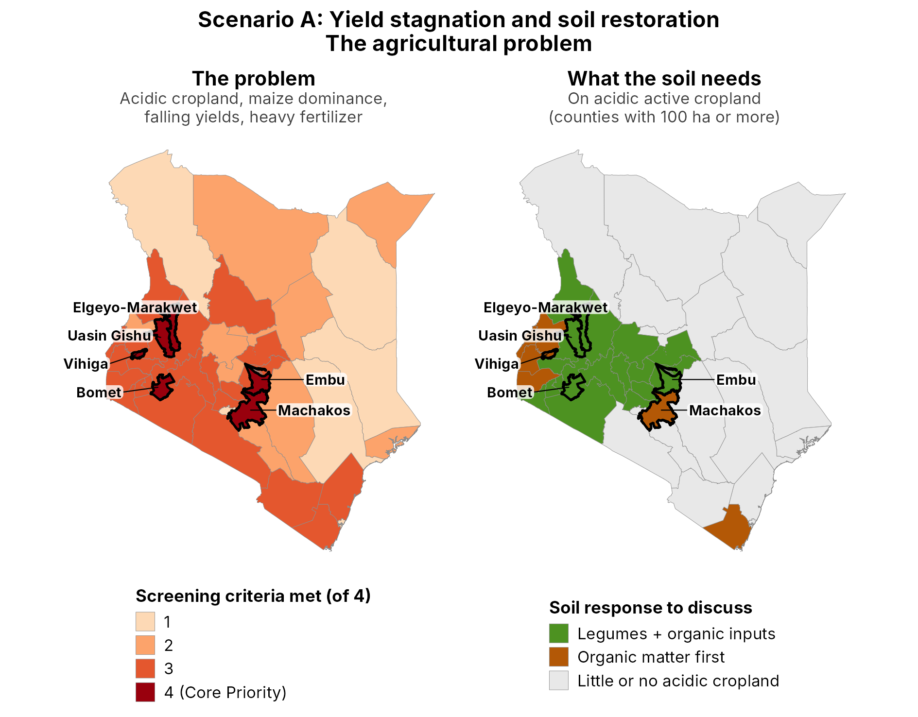
Figure 17. Archetype 2A (Scenario A): the agricultural problem. Left: counties shaded by how many of the four hard-filter criteria they meet (severe soil acidity on active cropland, maize dominance, a declining maize yield trend 2013–2021, and a high synthetic fertilizer rate). The six Core Priority counties meet all four and are outlined on both panels. Right: the soil response suggested for each county's acidic active cropland (pH ≤ 5.5; counties with at least 100 ha), based on iSDAsoil topsoil organic carbon and pH at 30 m (Hengl et al., 2021). ‘Organic matter first’ marks counties where organic carbon is below 15 g/kg on at least half of the acidic cropland; the other counties are marked ‘Legumes + organic inputs’. No county met the condition for targeted lime (pH below 5.0 on at least half of the acidic cropland).
Soil constraints beyond acidity
Partners noted that agricultural lime is a soil amendment rather than an agroecological practice, and asked whether the acidic cropland also has other soil limits. To answer this, the active acidic cropland (pH ≤ 5.5) was overlaid with two further iSDAsoil layers at 30 m (Hengl et al., 2021): topsoil organic carbon below 15 g/kg (1.5%), and very strong acidity below pH 5.0, used here as a proxy for likely aluminium toxicity. The 15 g/kg cutoff is an analytical choice for this screen. County means on the acidic cropland range from about 12 to 25 g/kg, and a stricter 10 g/kg cutoff flagged almost no land.
Very strong acidity is almost absent. Less than 3% of the acidic cropland falls below pH 5.0 in every county, and the share is zero everywhere except Baringo (2.2%). The target soils are therefore strongly, not very strongly, acidic.
Low organic carbon, by contrast, covers more than half of the acidic cropland in eight counties with at least 100 ha of it: Kakamega (94%), Bungoma (73%), Busia (100%), Siaya (98%), Vihiga (64%), Machakos (99%), Homa Bay (52%) and Kwale (100%). Two Core Priority counties fall in this group, Vihiga and Machakos, with mean organic carbon of 14.2 and 12.1 g/kg. Uasin Gishu, Elgeyo-Marakwet, Embu and Bomet have more organic carbon (17.6 to 24.9 g/kg) and little or no low-carbon cropland.
The coarser HWSD v1.2 soil qualities (1 km; FAO/IIASA/ISRIC/ISSCAS/JRC, 2012) confirm that salt and toxicity are not constraints in the Core Priority counties: each affects at most 4% of the soil area (Machakos). HWSD does flag severe nutrient-availability limits on half of Vihiga's soil area and on 16% of Embu's, which supports a nutrient-replenishment response in Vihiga in particular.
Each county with at least 100 ha of acidic cropland was assigned one of three soil responses (Figure 17, right panel). ‘Organic matter first’ applies where low organic carbon covers at least half of the acidic cropland, ‘Organic matter + targeted lime’ where very strong acidity does, and ‘Legumes + organic inputs’ elsewhere. No county met the targeted-lime condition. Lime therefore moves from the core of Archetype 2A's response to a targeted complement, used where a field soil test shows it is needed.
This matters for the yield-stagnation logic. Long cropping with too little nutrient and organic-matter replenishment leaves many African smallholder soils in a ‘non-responsive’ state, where extra fertilizer gives little yield gain (Tittonell & Giller, 2013). Organic residues also ease acid-soil constraints directly: as they decompose they can raise soil pH temporarily, bind aluminium and reduce phosphorus fixation, which can lower the lime and phosphate fertilizer needed (Haynes & Mokolobate, 2001).
Socio-economic context
The socio-economic map (Figure 18) shows that the Archetype 2A Core Priority counties are among the least deprived in Kenya. Their Multidimensional Poverty Index ranges from 0.064 in Uasin Gishu to 0.139 in Elgeyo-Marakwet (UNDP & OPHI, 2024), well below the 0.30 cutoff used for high poverty elsewhere in this project.
Most of their area lies within an hour of a town or city (Nelson et al., 2019). Deep isolation, more than an hour from any urban centre, covers none of Uasin Gishu or Vihiga, 4–8% of Machakos, Bomet and Embu, and 34% of Elgeyo-Marakwet. Travel time is only a proxy, however: in rural Kenya, distance to infrastructure often does not capture farmers' real access to markets (Chamberlin & Jayne, 2013), so county partners should confirm where input and output markets actually work.
Following partner feedback, the education lens now covers men as well as women (Local Burden of Disease Educational Attainment Collaborators, 2020). Only two counties have low schooling for men (below six years), Marsabit and Turkana, and women's schooling is low there too. In eight more counties only women fall below six years, and in nine others women are at least one year behind men without falling below the threshold. All six Core Priority counties are above six years for both women and men.
Women's land ownership was considered as a further layer, but the Kenya DHS 2022 does not publish it by county. Nationally, only 3.1% of women aged 15–49 own land alone and 21.5% jointly, against 24.3% and 6.8% of men; three in four women own no land (KNBS & ICF, 2023). Options that ask farmers to invest in a plot over several seasons, such as soil building or tree planting, should therefore be designed with both spouses and with attention to women's use rights.
Taken together, this context favours market-linked options in Archetype 2A. Farmers can reach input dealers, compost and lime suppliers, and buyers for legumes, including school-feeding procurement, and standard extension materials are likely to work. The main gap is agronomic rather than social.
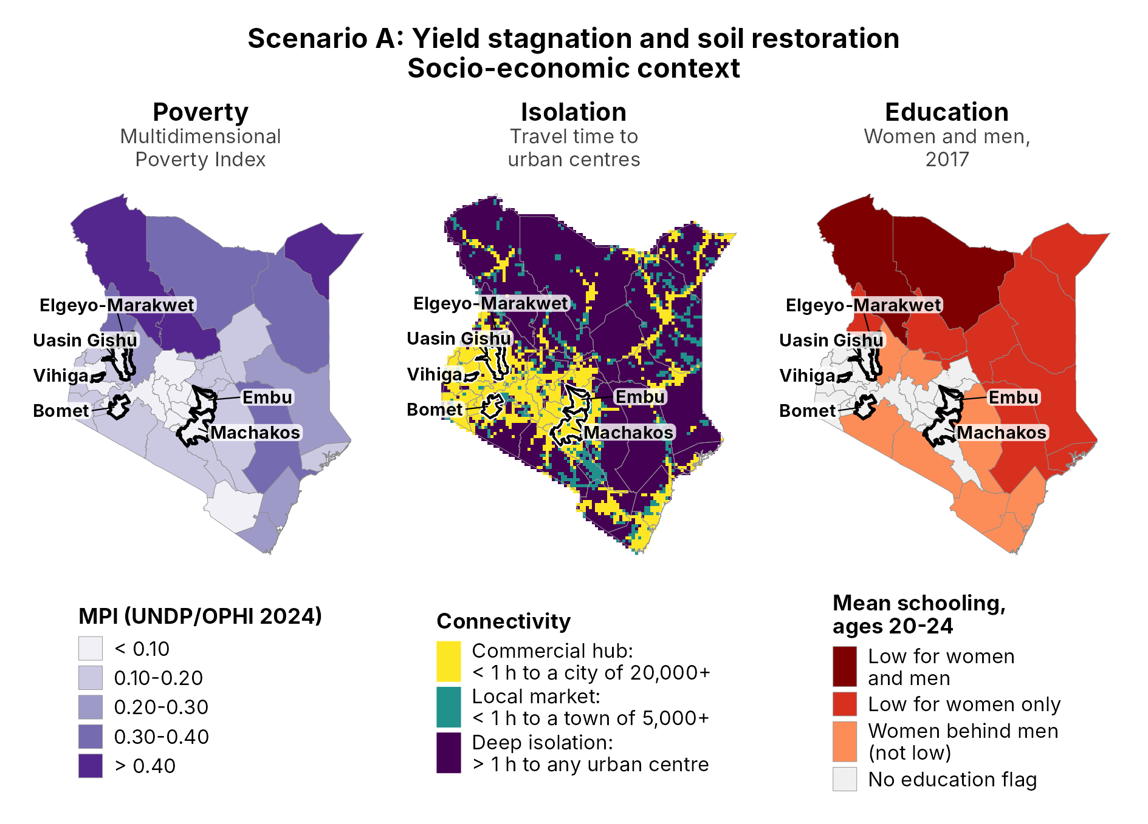
Figure 18. Archetype 2A (Scenario A): socio-economic context. Left: Multidimensional Poverty Index by county (UNDP & OPHI, 2024). Centre: travel time to urban centres, scored as in Figure 1: commercial hub (under 1 hour to a city of 20,000 or more), local market (under 1 hour to a town of 5,000 or more) and deep isolation (more than 1 hour to any urban centre) (Nelson et al., 2019). Right: mean years of schooling of women and men aged 20–24 in 2017, tested against six years, the length of primary school (Local Burden of Disease Educational Attainment Collaborators, 2020). Core Priority counties are outlined on every panel.
Independent field and survey evidence from Kenya corroborates both the geographic pattern and the intervention logic underlying Archetype 2A. A 2025 nine-county survey led by the Strathmore Agri-Food Innovation Centre, covering Bungoma, Trans-Nzoia, Kakamega, Nakuru, Bomet, Embu, Narok, Kitui, and Makueni, found that farmers who limed acidic plots harvested 63% more maize on average and earned over KES 12,000 more per acre than farmers on unlimed land (Strathmore Agri-Food Innovation Centre, 2025), directly implicating two of the model's six Core Priority counties, Bomet and Embu, in documented, on-farm yield gains from the very intervention Archetype 2A proposes.
A controlled field trial at Kuinet in Uasin Gishu, another Core Priority county, found that combining diammonium phosphate with agricultural lime raised maize yields from 1.36 t/ha on untreated plots to 6.19 t/ha, more than a fourfold increase (Nekesa et al., 2011). Machakos, the model's sixth Core Priority county, has its own documented history of on-farm legume cover-cropping and sub-soiling trials aimed at rebuilding degraded soil fertility for maize production (Karuma, 2009). At the national scale, press reporting describes soil acidity as a widespread constraint affecting more than 11 Kenyan counties (Business Daily Africa, 2019).
Read together, this evidence suggests that Archetype 2A is not proposing an untested intervention in unfamiliar counties, but rather proposing to scale, target, and better fund a remedy already proven, county by county, in the very landscape the model identifies.
Beyond confirming that Archetype 2A's practice is already validated locally, this evidence also points to three concrete refinements that would strengthen it. A 2025 continent-wide analysis found that liming is profitable across 6.2 to 8.8 million hectares of Sub-Saharan African cropland, but that profitability is unevenly distributed and depends on which crop is limed (Silva et al., 2025); Rwanda's own national liming program, evaluated against 261 households, found that liming maize and beans, the staple pairing that also dominates Archetype 2A's target counties, was only profitable for smallholders once lime was subsidized by 50%, whereas Irish potato returned a profit unsubsidized (Jaleta et al., 2024). Where a soil test confirms that lime is needed, this suggests Archetype 2A's design could bundle a partial lime subsidy into Kenya's existing fertilizer-subsidy channel, rather than treating lime procurement as a cost smallholders are expected to absorb on top of the input costs the archetype is otherwise trying to redirect.
On the archetype's regenerative component, legume intercropping can draw on a directly relevant, already-proven local precedent: an ICRAF, KARI, KEFRI, and TSBF program of improved short-duration fallows (Sesbania sesban, Crotalaria grahamiana) and Tithonia diversifolia biomass transfer was disseminated through farmer-to-farmer networks in western Kenya, the same landscape as several of the model's Core Priority counties (Kiptot et al., 2006).
Finally, naming soybean specifically as the intercropped legume gives Archetype 2A a direct route to improving household dietary protein intake alongside soil restoration: Kenyan trial evidence shows soybean nodulation and nitrogen fixation rise significantly when lime is combined with rhizobial inoculation on strongly acidic soils, the exact condition this archetype screens for (Bakari et al., 2020). Together, these refinements would make Archetype 2A a fully specified, subsidy-supported, dietary-protein-linked practice with a documented adoption record in its own target counties.
Beyond soybean, evidence from other Kenyan legume-intercropping trials points to options that could extend Archetype 2A’s menu, especially where soil degradation is most severe. A staggered maize-legume arrangement tested across two Central Kenya highland sites found common bean the most profitable legume where soil was already fertile, but on the poorer of the two sites, cowpea and groundnut outperformed it, delivering 12–37% higher net benefit; cowpea’s nitrogen balance was also neutral, against a negative balance for bean and groundnut, making it the more sustainable choice on the most acidified, least-recovered plots (Mucheru-Muna et al., 2010).
Within the archetype’s own near-miss landscape, a 2021–2023 trial in Kisumu, Siaya, and Vihiga, one of the model’s six Core Priority counties, found that intercropping pigeon pea into existing push-pull systems suppressed Striga weed without reducing maize yield, while adding grain, fodder, and firewood, through the same farmer networks and extension channels that already run push-pull technology across western Kenya (Buleti et al., 2025).
Two further findings are promising but more distant from this archetype’s own counties and should be read as hypotheses for a local trial rather than settled evidence. A 31-season trial at icipe’s Mbita Point station in western Kenya, not itself one of Archetype 2A’s core or near-miss counties but in comparable acid, smallholder maize country, found that intercropping desmodium, a fodder rather than food legume, raised maize grain yields to 3.1–5.0 Mg/ha across three seasons, against 0.4–1.8 Mg/ha in monocrop, through higher available soil nitrogen and phosphorus (Ndayisaba et al., 2021); it would sit alongside, not replace, a food legume such as soybean or cowpea.
Separately, an undergraduate field study across 30 on-farm trials in Kisii and Migori counties, not a peer-reviewed trial, found that soil pH significantly affects climbing bean germination and establishment (Williams, 2016), reinforcing the case for sequencing lime before legume introduction.
Options to discuss by county
The soil and socio-economic layers point to a menu of options for each Core Priority county (Table 7.2). These are options for discussion with county governments, not prescriptions: the final mix will depend on county priorities, budgets and past experience. All of them build on integrated soil fertility management, which combines organic inputs, fertilizer and improved varieties, adapted to local conditions (Vanlauwe et al., 2010).
In the ‘organic matter first’ counties (Vihiga and Machakos among the Core Priority counties), the first step is to rebuild soil organic matter: compost and farmyard manure, keeping crop residues on the field, and green manure from hedgerow shrubs. Leaf biomass of the shrub Tithonia diversifolia contains on average about 3.5% N, 0.37% P and 4.1% K, and in some western Kenya trials it gave maize yields higher than mineral fertilizer at the same nutrient rates. Cutting and carrying it is labour-intensive, so it pays best on high-value crops such as vegetables (Jama et al., 2000). Improved fallows and biomass transfer have already spread farmer to farmer in western Kenya (Kiptot et al., 2006).
In the ‘legumes + organic inputs’ counties (Uasin Gishu, Elgeyo-Marakwet, Embu and Bomet), organic carbon is moderate and acidity is strong but not extreme. Here the existing proposal fits well: maize–legume intercrops or rotations, combined with manure or compost and smaller, better-targeted fertilizer doses. Soybean responds to rhizobial inoculation on these soils (Bakari et al., 2020), and cowpea or groundnut perform better than common bean on the poorer plots (Mucheru-Muna et al., 2010).
Lime remains an option where a field test shows very strong acidity. Because lime pays only on part of Sub-Saharan Africa's acid cropland (Silva et al., 2025), soil testing should come before any lime subsidy.
Table 7.2. Archetype 2A: options to discuss for the six Core Priority counties. Soil values refer to the active acidic cropland (iSDAsoil, 30 m); isolation is the share of county area more than one hour from any urban centre.
County | Soil on acidic cropland | Socio-economic context | Options to discuss
Uasin Gishu | Organic carbon 21.6 g/kg; almost no low-carbon land; no salt limits | MPI 0.06; no deep isolation; no education flag | Legume intercrops or rotations (soybean with inoculant, bean); manure or compost; links to legume buyers and school feeding
Elgeyo-Marakwet | Organic carbon 23.7 g/kg; no low-carbon land | MPI 0.14; 34% of area deeply isolated; no education flag | Legumes + organic inputs; local supply of seed and inoculant for isolated areas; farmer-to-farmer extension
Vihiga | Organic carbon 14.2 g/kg; low carbon on 64%; HWSD severe nutrient limits on 50% of soil area | MPI 0.08; no deep isolation; no education flag | Organic matter first: compost, manure, residue retention, tithonia biomass; then legumes, e.g. pigeon pea in push-pull plots (Buleti et al., 2025)
Machakos | Organic carbon 12.1 g/kg; low carbon on 99% | MPI 0.07; 4% deeply isolated; no education flag | Organic matter first: compost, manure, residue retention, legume cover crops (Karuma, 2009); then drought-tolerant legumes
Embu | Organic carbon 17.6 g/kg; low carbon on 7%; HWSD severe nutrient limits on 16% | MPI 0.08; 8% deeply isolated; no education flag | Legumes + organic inputs; cowpea or groundnut on poorer plots (Mucheru-Muna et al., 2010)
Bomet | Organic carbon 24.9 g/kg; almost no low-carbon land | MPI 0.10; 8% deeply isolated; no education flag | Legumes + organic inputs; lime only where a soil test shows very strong acidity

Archetype 2B: Arid Pastoral Micro-Gardens
This is not an untested concept for Kenya's arid counties: small-scale, low-water household food production already has a documented track record in the region, most notably a UNHCR/WFP-supported multi-storey garden programme that reached more than 5,000 households in Dadaab, one county over from Mandera, alongside Mandera's own active government-led irrigation expansion along the Daua River (discussed further below).
The spatial evaluation of Archetype 2B (Figure 19) screens Kenya's 23 officially designated Arid and Semi-Arid Land (ASAL) counties against five hard-filter criteria: high livestock density, severe agricultural water risk, plant-based food deficits (using the internationally comparable SSR < 1.0 threshold), acute food insecurity (IPC Phase 3+), and geo-located resource-conflict events. Only Mandera meets all five conditions simultaneously and is flagged Core Priority, combining hyper-aridity with substantial river-valley livestock populations and an active IPC Phase 3 classification.
A further five counties meet four of the five criteria, splitting into two distinct near-miss profiles. Garissa, Isiolo, and Turkana are already at IPC Phase 3 and show severe water risk, plant-food deficits, and conflict events, but their livestock density falls short of the ASAL-relative threshold, since sparse nomadic herds ranging across vast rangeland register a lower density than the settled herds of higher-carrying-capacity semi-arid margins, even though the underlying crisis is real.
Embu and West Pokot show the opposite pattern: high livestock density, severe water risk, plant-food deficits, and conflict events are all present, but both counties currently sit at IPC Phase 2 (Stressed) rather than Phase 3+, meaning the structural risk factors are in place without (yet) a triggering acute food crisis. Kiambu and Machakos coincidentally clear four of the five numeric thresholds as well, but neither is IPC-assessed as an ASAL county, so both are treated as out of scope regardless of score.
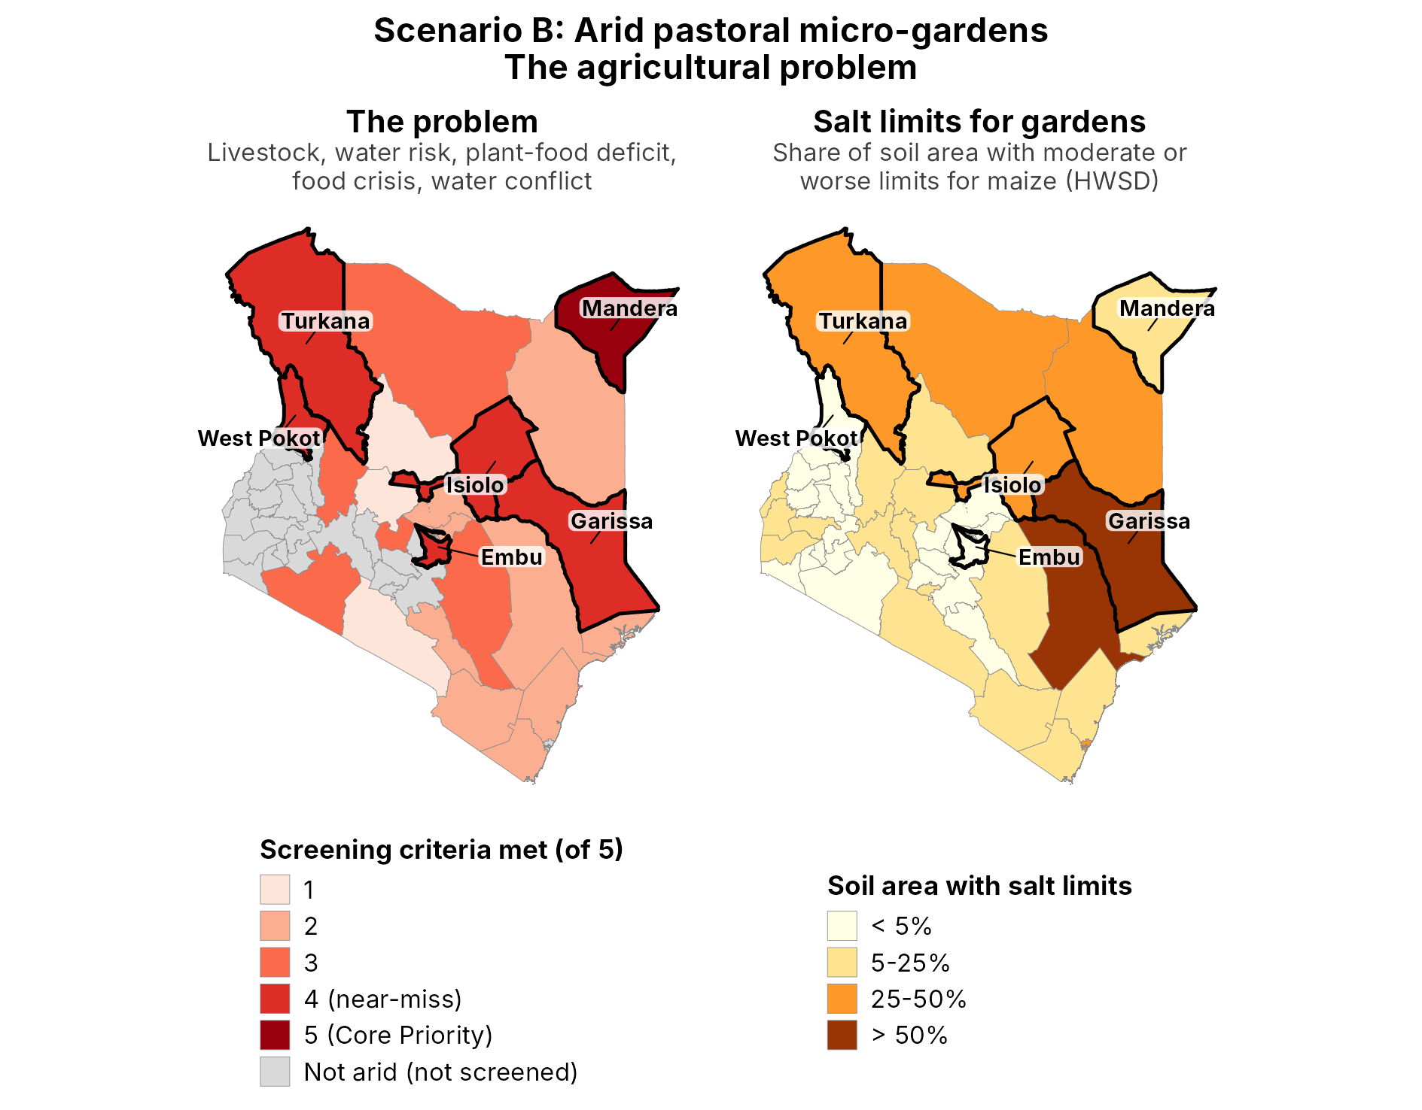
Figure 19. Archetype 2B (Scenario B): the agricultural problem. Left: the 23 Arid and Semi-Arid Land (ASAL) counties shaded by how many of the five hard-filter criteria they meet (high livestock density, severe water risk, plant-based food deficit, acute food insecurity at IPC Phase 3+, and resource-conflict events). Mandera meets all five (Core Priority); Garissa, Isiolo, Turkana, Embu and West Pokot meet four (near-miss). All six are outlined on both panels. Grey counties fall outside the ASAL classification. Right: share of each county's soil area with moderate or worse salt limits for maize, from the HWSD v1.2 soil quality for excess salts (FAO/IIASA/ISRIC/ISSCAS/JRC, 2012).
Salt limits for gardens
Partners asked for a soil salinity layer. The HWSD v1.2 soil quality for excess salts rates each 1 km soil unit by how much salt limits maize, from none to very severe (FAO/IIASA/ISRIC/ISSCAS/JRC, 2012). Salt limits concentrate in the arid north and east: at least a quarter of the soil area has moderate or worse limits in Garissa, Isiolo, Marsabit, Tana River, Turkana, Wajir and Mombasa (Figure 19, right panel).
Among the Archetype 2B priority counties, salt matters most in Garissa (53% of soil area with moderate or worse limits, 36% severe or worse), Isiolo (39% and 19%) and Turkana (38% and 15%). It is minor in Mandera (5%), West Pokot (3%) and Embu (3%). Mandera's gardens can build on its riverine soils, while gardens in Garissa, Isiolo and Turkana need to be designed around salt.
HWSD is coarse and rates limits for maize, not for vegetables. It also does not measure the salinity of the irrigation water itself, which adds salts to the root zone (Ayers & Westcot, 1985). Borehole and pan water should therefore be tested before gardens are scaled.
Where salt limits are high, three design choices help. Gardens can be built as raised or contained beds, such as keyhole or sack gardens, filled with compost and soil brought from outside, so roots grow in the imported mix rather than the saline native soil. Drip or frequent light watering keeps a steady downward movement of water and salts away from the roots, although salt can build up at the surface between emitters and needs flushing before replanting (Ayers & Westcot, 1985).
Crop choice also matters. In the FAO salt-tolerance tables, cowpea (yield threshold 4.9 dS/m) and sorghum (6.8 dS/m) are moderately tolerant, spinach and tomato are moderately sensitive, and bean, onion and carrot are sensitive (Ayers & Westcot, 1985). Cowpea, already proposed for its protein-rich leaves (Owade et al., 2020), is therefore a good fit for the saltier counties.
Socio-economic context
The socio-economic map (Figure 20) shows the opposite picture to Archetype 2A. Poverty is high: the Multidimensional Poverty Index is 0.50 in Turkana, 0.46 in Mandera and 0.36 in West Pokot, all above the 0.30 cutoff, with Garissa just below (0.29) and Isiolo at 0.20 (UNDP & OPHI, 2024).
Most of these counties are deeply isolated: 89% of Isiolo's area, 85% of Turkana's, 83% of Garissa's, 70% of Mandera's and 56% of West Pokot's lies more than an hour from any urban centre (Nelson et al., 2019). Connected areas follow the main roads and a few towns.
Schooling shows a strong gender gap. Women aged 20–24 average 2.7 years of schooling in Mandera against 7.0 for men, 3.2 against 6.2 in Garissa, 4.0 against 7.2 in Isiolo and 5.5 against 6.5 in West Pokot. In Turkana both are low, at 2.9 and 4.6 years (Local Burden of Disease Educational Attainment Collaborators, 2020).
Embu is again the outlier: low poverty (0.08), little isolation (8%) and no education gap. It meets the agricultural criteria, but its social context is closer to the Archetype 2A counties, and its acidic cropland falls in the ‘legumes + organic inputs’ class. It may be better treated as a semi-arid extension of the 2A highlands than as an arid pastoral county.
This context shapes the design. Deep isolation means gardens must rely on local inputs: saved or locally multiplied seed of indigenous vegetables, compost from household and livestock waste, and drip kits with local spare parts and repair skills (Kulecho & Weatherhead, 2006). High poverty argues for low-cost designs with no recurring purchases. Because women's schooling is low, training should be practical and demonstration-based rather than written; farmer field schools in East Africa raised production and income among women and low-literacy farmers (Davis et al., 2012). The national land-ownership gap noted for Archetype 2A applies here too.
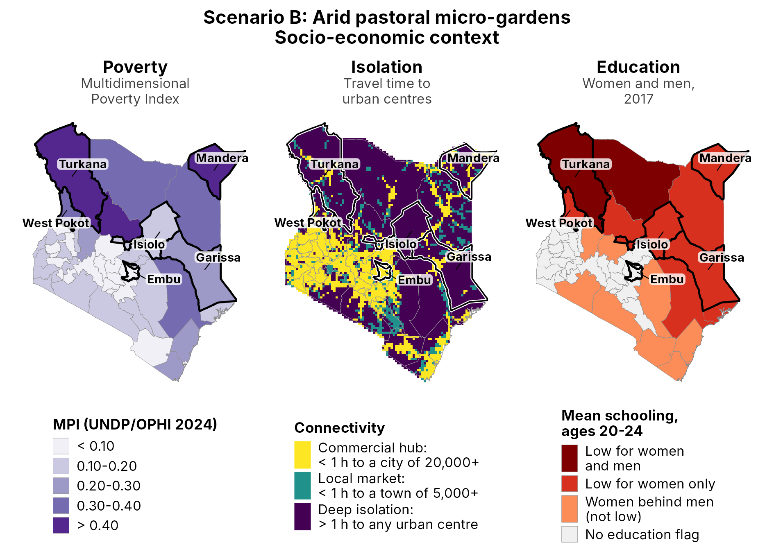
Figure 20. Archetype 2B (Scenario B): socio-economic context. Left: Multidimensional Poverty Index by county (UNDP & OPHI, 2024). Centre: travel time to urban centres, scored as in Figure 1: commercial hub (under 1 hour to a city of 20,000 or more), local market (under 1 hour to a town of 5,000 or more) and deep isolation (more than 1 hour to any urban centre) (Nelson et al., 2019). Right: mean years of schooling of women and men aged 20–24 in 2017, tested against six years, the length of primary school (Local Burden of Disease Educational Attainment Collaborators, 2020). Core Priority and near-miss counties are outlined on every panel.
Within Mandera, the 10-meter WorldCereal active cropland mask identifies 3,291 hectares of active farmland, consistent with the county's known riverine irrigation belts along the Dawa River. This cropland layer is used descriptively rather than as a screening criterion, isolating the small, scattered “micro-oasis” patches of existing cultivation that represent the most viable candidate sites for keyhole-garden infrastructure.
These modeled cultivation patterns align with real, ongoing investment in Mandera's irrigation infrastructure. County and national government reporting describes an active irrigation expansion program along the Daua/Dawa River, including 7.1 kilometers of newly built or rehabilitated concrete canals across six irrigation schemes and roughly 2,145 additional acres of farmland opened through bush clearing (Kenya News Agency, 2025), alongside a second phase of the Yabicho A Irrigation Project adding 100 further acres for 200 farming households displaced by recurrent flash floods along the river (County Government of Mandera, 2026). Both efforts target the same riverine micro-oasis pattern the 10-meter WorldCereal mask detects, reinforcing that Mandera's existing 3,291 hectares of active cropland are concentrated in a small number of intensively managed, floodplain-adjacent sites rather than spread evenly across the county, precisely the kind of compact, already-irrigated footprint that keyhole-garden infrastructure could extend into surrounding households at comparatively low marginal cost.
A parallel household-scale precedent already operates one county over: in Dadaab, Garissa County, the project's own highest-scoring near-miss county for Archetype 2B, a UNHCR/WFP-supported multi-storey garden (MSG) programme, delivered through GTZ with Canadian government financing, was taken up by more than 5,000 refugee households growing leafy vegetables, tomatoes, okra, and eggplant in stacked cereal-sack planters irrigated with as little as five litres of water twice daily (Corbett, 2006). The same low-water, small-footprint logic, applied to Mandera's existing irrigated micro-oases, would extend a design already validated at household scale in the immediately adjacent ASAL landscape rather than introducing an unfamiliar technology.
Beyond confirming that Archetype 2B's practice already has a validated household-scale precedent in the immediately adjacent Dadaab landscape, this evidence also points to three concrete refinements. On effectiveness, low-head drip irrigation kits, commercially available in Kenya through suppliers such as KickStart, raise water-use efficiency by roughly 80% over hand-watering (Ngigi, 2008), directly relevant given the severe water risk that qualifies Mandera and its near-miss counties for this archetype in the first place; however, separate field evaluation in Kenya found that the cheapest kits are built from materials that cut their working life to under three years against a claimed seven, so any scale-up should budget for local repair and spare-parts access rather than a one-time distribution (Kulecho & Weatherhead, 2006).
On environmental safety, the practice's ‘greywater’ component should be source-specific: kitchen greywater carries oils, food residue, and higher pathogen loads unsuitable for direct food-crop irrigation, whereas bathroom and laundry greywater, passed through a simple household-scale sand-and-gravel or biochar filter, is markedly safer for edible gardens (Hamidi, 2025), a distinction the design should state explicitly.
On healthy diets, the amaranth-and-spider-plant palette can be extended with moringa, which World Vision's IMARA climate-resilience programme has introduced as a drought-resilient, income-generating tree crop in Turkana, one of this archetype's own five near-miss counties, where a farmer group has scaled production from a quarter-acre to 17 acres (Daily Nation, 2026), and the same programme also reaches two of the archetype's other near-miss counties, Isiolo and West Pokot (World Vision International, n.d.); and with cowpea, a dual-purpose drought-tolerant legume whose leaves carry substantially more protein, roughly 28 to 42% of dry matter in fresh leaves, than the proposed leafy greens (Owade et al., 2020). Both additions target the archetype's own plant-based food-deficit screening criterion more directly than micronutrient-rich greens alone, since that criterion is built around a staple/protein self-sufficiency ratio, not a micronutrient one.
Beyond amaranth, spider plant, moringa, and cowpea, two further species and one further precedent are worth testing in Mandera’s keyhole gardens. Seventeen Bambara groundnut landraces collected across five western Kenya counties (Vihiga, Kakamega, Bungoma, Busia, and Kisumu) showed crude protein of 21–26%, strong iron and potassium content, and what the study’s authors describe as “good drought tolerance attributes,” recommending the legume for food security in drought-prone areas (Chelangat et al., 2023); because the landraces were collected and tested in humid western Kenya rather than in ASAL conditions, Bambara groundnut is a candidate for a small Mandera pilot plot rather than a proven ASAL performer.
The stacked micro-garden technique itself has a second, independent Kenyan precedent beyond Dadaab: a JKUAT-, KARI-, and ICRAF-supported sack-garden programme in Embu grew kale, spinach, cabbage, and root vegetables under mixed rainfed-irrigated water on under 10 hectares (Kahiga, 2012); Embu is sub-humid Eastern Kenya rather than ASAL, so this speaks to the viability of the stacking method rather than to arid-specific crop choice.
African nightshade (locally “managu,” Solanum scabrum and S. villosum) is a further candidate. A review of the related species Solanum retroflexum in South Africa’s Venda region found it needs little fertilizer, thrives under drought, and exceeds both spinach and kale in protein and iron per 100 g (its calcium and potassium content is comparable to or lower than theirs) (Sivakumar et al., 2020). The underlying field evidence is South African rather than Kenyan, and drawn from a closely related but different nightshade species, so this should be read as a reasonable proxy for the Kenyan varieties’ likely performance rather than a direct local finding; a small comparison plot alongside the amaranth and spider plant beds would confirm whether it holds up under Mandera’s specific soil and water conditions.
Options to discuss by county
As for Archetype 2A, the layers point to a menu of options per county rather than one design (Table 7.3). Water source, salt, distance to markets and who will manage the garden differ sharply between counties, and county governments are best placed to combine the options with their own plans, such as Mandera's irrigation expansion.
Table 7.3. Archetype 2B: options to discuss for the Core Priority and near-miss counties. Salt values are the share of soil area with moderate or worse salt limits (HWSD v1.2); isolation is the share of county area more than one hour from any urban centre; schooling is mean years for women and men aged 20–24.
County | Salt limits | Socio-economic context | Options to discuss
Mandera (Core) | 5% moderate or worse | MPI 0.46; 70% deeply isolated; schooling 2.7 years women vs 7.0 men | Extend gardens from irrigated plots along the Daua River; keyhole or multi-storey gardens; amaranth, spider plant, cowpea; practical training aimed at women
Garissa | 53% moderate or worse; 36% severe | MPI 0.29; 83% deeply isolated; 3.2 vs 6.2 years | Contained beds with imported soil and compost; salt-tolerant crops such as cowpea; test water first; build on the Dadaab multi-storey gardens (Corbett, 2006)
Isiolo | 39% moderate or worse; 19% severe | MPI 0.20; 89% deeply isolated; 4.0 vs 7.2 years | Contained beds; cowpea and moringa (World Vision International, n.d.); water testing
Turkana | 38% moderate or worse; 15% severe | MPI 0.50; 85% deeply isolated; low for women and men (2.9 and 4.6 years) | Contained beds; moringa farmer groups (Daily Nation, 2026); demonstration-based training for women and men
West Pokot | 3% moderate or worse | MPI 0.36; 56% deeply isolated; 5.5 vs 6.5 years | In-ground keyhole gardens; drip kits with local repair; links to the IMARA programme
Embu | 3% moderate or worse | MPI 0.08; 8% deeply isolated; no education flag | Consider Archetype 2A options (legumes + organic inputs) alongside water-smart gardens in the drier lowlands

References
Ayers, R. S., & Westcot, D. W. (1985). Water quality for agriculture (FAO Irrigation and Drainage Paper 29 Rev. 1). Food and Agriculture Organization of the United Nations. https://www.fao.org/3/t0234e/T0234E00.htm
Bakari, R., Mungai, N., Thuita, M., & Masso, C. (2020). Impact of soil acidity and liming on soybean (Glycine max) nodulation and nitrogen fixation in Kenyan soils. Acta Agriculturae Scandinavica, Section B: Soil and Plant Science, 70(8), 667–678. https://doi.org/10.1080/09064710.2020.1833976
Buleti, S., Kuyah, S., Were, S., & Gichua, M. (2025). Pigeon pea: A companion crop for boosting maize growth and striga control in push-pull farming systems in Western Kenya. Journal of Agriculture, Science and Technology, 24(1), 32–49. https://doi.org/10.4314/jagst.v24i1.3
Business Daily Africa. (2019). Soil acidity spells doom for future of Kenya agriculture. https://www.businessdailyafrica.com/bd/data-hub/soil-acidity-spells-doom-for-future-of-kenya-agriculture-2268334
Chamberlin, J., & Jayne, T. S. (2013). Unpacking the meaning of ‘market access’: Evidence from rural Kenya. World Development, 41, 245–264. https://doi.org/10.1016/j.worlddev.2012.06.004
Chelangat, M., Muturi, P., Gichimu, B., Gitari, J., & Mukono, S. (2023). Nutritional and phytochemical composition of Bambara groundnut (Vigna subterranea [L.] Verdc) landraces in Kenya. International Journal of Agronomy, 2023, Article 9881028. https://doi.org/10.1155/2023/9881028
Corbett, M. (2006). Multi-storey gardens to support food security. Field Exchange, Issue 29. Emergency Nutrition Network (ENN). https://www.ennonline.net/fex/29/en/multi-storey-gardens-support-food-security
County Government of Mandera. (2026). Mandera Launches Phase II of Yabicho A Irrigation Project. https://mandera.go.ke/mandera-launches-phase-ii-of-yabicho-a-irrigation-project/
Daily Nation. (2026). Pastoralists turn to moringa 'wonder crop' to cushion climate shocks. https://nation.africa/kenya/climate/pastoralists-turn-to-moringa-wonder-crop-to-cushion-climate-shocks-5431132
Davis, K., Nkonya, E., Kato, E., Mekonnen, D. A., Odendo, M., Miiro, R., & Nkuba, J. (2012). Impact of farmer field schools on agricultural productivity and poverty in East Africa. World Development, 40(2), 402–413. https://doi.org/10.1016/j.worlddev.2011.05.019
FAO/IIASA/ISRIC/ISSCAS/JRC. (2012). Harmonized World Soil Database (version 1.2). FAO, Rome, Italy, and IIASA, Laxenburg, Austria.
Hamidi, M. N. (2025). Greywater reuse for irrigation: A critical review of suitability, treatment, and risks. Science of the Total Environment, 975, 179272. https://doi.org/10.1016/j.scitotenv.2025.179272
Haynes, R. J., & Mokolobate, M. S. (2001). Amelioration of Al toxicity and P deficiency in acid soils by additions of organic residues: A critical review of the phenomenon and the mechanisms involved. Nutrient Cycling in Agroecosystems, 59, 47–63. https://doi.org/10.1023/A:1009823600950
Hengl, T., Miller, M. A. E., Križan, J., Shepherd, K. D., Sila, A., Kilibarda, M., ... & Crouch, J. (2021). African soil properties and nutrients mapped at 30 m spatial resolution using two-scale ensemble machine learning. Scientific Reports, 11, 6130. https://doi.org/10.1038/s41598-021-85639-y
Jaleta, M., Silva, J. V., Ruganzu, V., Mvuyekure, S. M., Mujanama, E., Voss, R., Chamberlin, J., & Baudron, F. (2024). Is agricultural lime a profitable investment for African smallholders? Evidence from Rwanda. African Journal of Agricultural and Resource Economics, 19(1). https://afjare.org/is-agricultural-lime-a-profitable-investment-for-african-smallholders-evidence-from-rwanda/
Jama, B., Palm, C. A., Buresh, R. J., Niang, A., Gachengo, C., Nziguheba, G., & Amadalo, B. (2000). Tithonia diversifolia as a green manure for soil fertility improvement in western Kenya: A review. Agroforestry Systems, 49(2), 201–221.
Kahiga, P. (Comp.). (2012). Multistorey gardens [Kenya] (WOCAT Technology Database). World Overview of Conservation Approaches and Technologies. https://qcat.wocat.net/en/wocat/technologies/view/permalink/4724
Karuma, A. N. (2009). Effects of legume cover crops and sub-soiling on soil properties and maize growth in Machakos District, Kenya [MSc thesis, University of Nairobi]. Indexed by AGRIS, FAO. https://agris.fao.org/search/ru/records/68d2a397b3b40a20d618896b
Kenya News Agency. (2025). Mandera implements transformative irrigation projects to combat climate change. https://www.kenyanews.go.ke/mandera-implements-transformative-irrigation-projects-to-combat-climate-change/
Kiptot, E., Franzel, S., Hebinck, P., & Richards, P. (2006). Sharing seed and knowledge: Farmer to farmer dissemination of agroforestry technologies in western Kenya. Agroforestry Systems, 68, 167–179. https://doi.org/10.1007/s10457-006-9007-8
KNBS & ICF. (2023). Kenya Demographic and Health Survey 2022: Volume 1. Nairobi, Kenya, and Rockville, Maryland, USA: KNBS and ICF. https://dhsprogram.com/publications/publication-fr380-dhs-final-reports.cfm
Kulecho, I. K., & Weatherhead, E. K. (2006). Adoption and experience of low-cost drip irrigation in Kenya. Irrigation and Drainage, 55(4), 435–444. https://doi.org/10.1002/ird.261
Local Burden of Disease Educational Attainment Collaborators. (2020). Mapping disparities in education across low- and middle-income countries. Nature, 577, 235–238. https://doi.org/10.1038/s41586-019-1872-1
Mucheru-Muna, M., Pypers, P., Mugendi, D., Kung’u, J., Mugwe, J., Merckx, R., & Vanlauwe, B. (2010). A staggered maize-legume intercrop arrangement robustly increases crop yields and economic returns in the highlands of Central Kenya. Field Crops Research, 115(2), 132–139. https://doi.org/10.1016/j.fcr.2009.10.013
Ndayisaba, P. C., Kuyah, S., Midega, C. A. O., Mwangi, P. N., & Khan, Z. R. (2021). Intercropping desmodium and maize improves nitrogen and phosphorus availability and performance of maize in Kenya. Field Crops Research, 263, Article 108067. https://doi.org/10.1016/j.fcr.2021.108067
Nekesa, A.O., Okalebo, J.R., Othieno, C.O., Thuita, M.N., Bationo, A., & Waswa, B.S. (2011). The Potential of Increased Maize and Soybean Production in Uasin Gishu District, Kenya, Resulting from Soil Acidity Amendment Using Minjingu Phosphate Rock and Agricultural Lime. In Innovations as Key to the Green Revolution in Africa (pp. 343-348). Springer, Dordrecht. https://doi.org/10.1007/978-90-481-2543-2_34
Nelson, A., Weiss, D. J., van Etten, J., Heinimann, A., Oloo, M. S., Mellor, J., ... & Kummu, M. (2019). A suite of global accessibility indicators. Scientific Data, 6(1), 266. https://doi.org/10.1038/s41597-019-0265-5
Ngigi, S. N. (2008). Technical evaluation and development of low-head drip irrigation systems in Kenya. Irrigation and Drainage, 57(4), 450–462. https://doi.org/10.1002/ird.360
Owade, J. O., Abong', G., Okoth, M., & Mwang'ombe, A. W. (2020). A review of the contribution of cowpea leaves to food and nutrition security in East Africa. Food Science & Nutrition, 8(1), 36–47. https://doi.org/10.1002/fsn3.1337
Silva, J. V., Aramburu-Merlos, F., Baudron, F., et al. (2025). Soil acidity remediation in sub-Saharan Africa requires targeted investments. Nature Food, 6, 799–808. https://doi.org/10.1038/s43016-025-01194-z
Sivakumar, D., Phan, A. D. T., Slabbert, R. M., Sultanbawa, Y., & Remize, F. (2020). Phytochemical and nutritional quality changes during irrigation and postharvest processing of the underutilized vegetable African nightshade. Frontiers in Nutrition, 7, Article 576532. https://doi.org/10.3389/fnut.2020.576532
Strathmore Agri-Food Innovation Centre (SAFIC). (2025). The Lime That Brought Life: How a Simple Soil Fix is Transforming Maize Farming in Kenya. Strathmore University. https://safic.strathmore.edu/the-lime-that-brought-life-how-a-simple-soil-fix-is-transforming-maize-farming-in-kenya/
Tittonell, P., & Giller, K. E. (2013). When yield gaps are poverty traps: The paradigm of ecological intensification in African smallholder agriculture. Field Crops Research, 143, 76–90. https://publications.cirad.fr/une_notice.php?dk=569780
United Nations Development Programme (UNDP) & Oxford Poverty and Human Development Initiative (OPHI). (2024). Global multidimensional poverty index 2024. https://ophi.org.uk/global-mpi/
Vanlauwe, B., Bationo, A., Chianu, J., Giller, K. E., Merckx, R., Mokwunye, U., Ohiokpehai, O., Pypers, P., Tabo, R., Shepherd, K. D., Smaling, E. M. A., Woomer, P. L., & Sanginga, N. (2010). Integrated soil fertility management: Operational definition and consequences for implementation and dissemination. Outlook on Agriculture, 39(1), 17–24. https://doi.org/10.5367/000000010791169998
Williams, H. (2016). Soil factors affecting plant performance of climbing beans (Phaseolus vulgaris L.) in south western Kenya (Undergraduate independent project). Swedish University of Agricultural Sciences. https://stud.epsilon.slu.se/8845/
World Vision International. (n.d.). Integrated Management of Natural Resources for Resilience in Arid and Semi-Arid Lands (IMARA) – Kenya. https://www.wvi.org/kenya/integrated-management-natural-resources-resilience-arid-and-semi-arid-lands-imara

