CFRA Project- Agroecology Evidence Hub Report

1. Introduction
The CFRA project works in nine African countries: Angola, Burundi, Ethiopia, Kenya, Malawi, Rwanda, Tanzania, Uganda and Zambia. Three of them, Zambia, Kenya and Ethiopia, are deep-dive countries, which are analysed in more detail with national data and engagement with national partners. The other six are baseline countries, covered with a lighter analysis. The project aims to show where agroecological and regenerative agricultural (AE/RA) practices could make food systems more nutritious and sustainable, with a focus on foods that school-meal programmes can buy locally.
Within Work Package 2 (WP2), this report links two activities of the project. The first maps where nutritional gaps and common food-system problems are (del Río-Mena 2026). It starts from a food-gap analysis that compares what each area produces with what its population needs for a healthy diet. It then builds scenarios that combine these gaps with agronomic, nutritional and socio-economic conditions. Each scenario describes a common problem, locates the high-priority areas where it occurs and proposes AE/RA practices to address it. The second activity, presented in this report, complements these proposed AE/RA practices with field evidence. For each scenario, it uses field experiments conducted in its high-priority areas to identify which AE/RA practices improved farm performance for crops relevant to school meals, together with their benefits and trade-offs and where evidence is still missing. The result is a portfolio of promising AE/RA practices by country and scenario, specifying the crops and agroecological zones in which they deliver positive outcomes.
To build this evidence-based portfolio, this analysis synthesises field experiments that compared AE/RA with conventional practices in the high-priority areas of each scenario, or in areas with similar climate and soils where evidence was scarce. It aims to (i) identify the practices with positive effects on each of the eight dimensions of farm performance (productivity, profitability, labour demand, soil health, inputs efficiency, resilience to pests, biodiversity and climate mitigation); (ii) identify the practice and crop combinations that improve several dimensions at the same time, and the trade-offs, where a gain in one crop or dimension comes with a loss in another; (iii) assess the strength of the evidence supporting each practice; and (iv) highlight where evidence is lacking.

BOX 1. KEY TERMS USED IN THIS REPORT
AE/RA practices. Agroecological and regenerative agricultural practices, such as compost, intercropping or reduced tillage, that aim to sustain production while improving soil health, biodiversity and the use of natural resources.
Agroecological zone. An area with similar climate, soils and terrain, and therefore similar conditions for growing crops (GAEZ v4).
Conventional practice. The usual practice that an AE/RA practice is compared with, such as no fertilizer, a single crop (monoculture) or ploughing.
Comparison. A single result in which a study measured the same outcome under an AE/RA practice and under a conventional practice, for example maize yield with and without compost in one season. A study can provide many comparisons.
Dimension of farm performance. An aspect of farm performance, such as productivity, profitability or soil health, that groups several related outcomes.
High-priority areas. The areas where the conditions behind a scenario’s problem are most severe, as identified in the scenario maps.
Main agroecological zone. An agroecological zone that covers at least 10% of the high-priority areas of a scenario.
Management domain. A group of practices with a similar purpose, such as nutrient management or diversification.
Positive, neutral and negative effect. An AE/RA practice has a positive effect when at least 65% of its comparisons were positive, a negative effect when 35% or fewer were positive, and a neutral effect in between, meaning that the results were mixed or showed no clear change.
Strong and limited evidence. Evidence is strong when a result is based on at least 50 comparisons from at least three studies, and limited otherwise.
Study. A scientific publication reporting one or more field experiments.

2. Methodology

2.1 Building the evidence base
This analysis draws on the Agroecology Evidence Hub, a database developed by the Alliance of Bioversity International and CIAT under the CGIAR Multifunctional Landscapes (MFL) Science Program. The Hub was not designed specifically for this project, but its data are well suited to identify which AE/RA practices could improve the production of nutritious and diverse foods for school meals in the project countries, and with what benefits and trade-offs. It brings together results from field experiments that compare AE/RA practices with conventional practices across agronomic, economic, environmental and social outcomes, which earlier global reviews had already extracted from the scientific literature.
The current version of the Hub combines five global datasets (Corbeels et al. 2020; Jones et al. 2021; Sánchez et al. 2022; Paut et al. 2024; Rosenstock et al. 2024) and harmonises them into a common dataset structure. These datasets were chosen because CGIAR researchers were involved in developing them, which ensured a good understanding of how the data were collected and harmonised. The Hub will be extended with further datasets in the near future, so the evidence for each country can be updated as new studies are added.
From these datasets, we selected the comparisons from studies conducted in any of the nine project countries that compared an AE/RA practice with a conventional practice on a crop relevant to school meals, and that reported the location of the study site. The evidence base comprised [n] comparisons from [n] studies (Figure S1), covering eight of the nine project countries, with no study from Angola. A single study can contribute several comparisons when it reports several outcomes, compares several treatments against a common control, or measures the same contrast across sites, years, crops or soil depths. The evidence includes [n] AE/RA practices from [n] management domains (Table S1), [n] crops from [n] food groups (Table S2), and [n] outcome indicators grouped into eight dimensions of farm performance (Table S3).

2.2 Identifying high-priority areas
The high-priority areas for nutritious and sustainable food systems were identified through a spatial analysis carried out within the project, which combined a food-gap analysis (Box 2) with a set of scenarios (del Río-Mena 2026).

BOX 2. THE FOOD-GAP ANALYSIS
The food-gap analysis compared local production with what the population needs for a healthy diet for seven food groups (cereals, roots and tubers, pulses, vegetables, fruits, nuts and seeds, and oils) across 775 subnational areas, such as counties in Kenya and zones in Ethiopia. An area was considered short of a food group when it produced less than 95% of what its population needs, and in surplus when it produced more than 105%. Because trade, animal-source foods and most home gardens were not counted, a gap means that local production is short, not that people go without. The analysis showed that the largest food gaps were in protective foods, such as vegetables and pulses, which are rich in vitamins, minerals and fibre.
Across the 775 areas, 87% were short of vegetables and 76% of pulses, compared with 55% for cereals and 25% for roots and tubers (del Río-Mena 2026). A surplus of staples (cereals, roots and tubers) did not guarantee a diverse supply, since 177 of the 330 areas with a cereal surplus were short of both pulses and vegetables, and in several countries staple surpluses occurred alongside high child stunting.
The scenarios mapped where specific food-system problems occurred in each project country. Each scenario combined the food gaps with biophysical, agronomic, nutritional and socio-economic conditions that signal a common problem, such as stagnating maize yields on acidic soils or very little crop production in pastoral areas with severe water scarcity. Some scenarios first restricted the analysis to the areas where the problem applies, such as Kenya’s arid and semi-arid counties. Areas were then ranked by how many of these conditions they met. The areas meeting all the conditions or all but one are those where the problem is most severe, and they form the high-priority areas, where interventions are most needed. Each scenario also proposed AE/RA practices to address the problem, drawn from the literature and from programmes already running in the country. The three deep-dive countries (Zambia, Kenya and Ethiopia) had more than one scenario, while the six baseline countries had one each (Table 1).

TABLE 1. Scenarios developed within the project by country, with the main food-system problem each one identifies and the AE/RA practices proposed in the scenario analysis (del Río-Mena 2026).
Country | Scenario | Main problem | AE/RA practice proposed
Zambia | 1A: Input programme diversification | Fertilizer subsidies for maize acidify soils where child stunting, maternal anaemia and seasonal hunger persist | Acid-tolerant legumes (groundnut, cowpea) and Faidherbia albida intercropped in maize, supplied through the input programme
Zambia | 1B: Northern cassava belt | Acidic soils support a cassava surplus that supplies calories but little protein | Acid-tolerant legumes (Bambara groundnut, cowpea, pigeon pea) intercropped with cassava
Zambia | 1C: Agro-pastoral valleys | Water stress, livestock pressure and vegetable deficits in semi-arid valleys and the Barotse floodplain | Diversified flood-recession farming in the floodplain; small multi-use water infrastructure in the valleys
Zambia | 1D: School-linked fruit and vegetable gardens | Large fruit and vegetable deficits with high child stunting | School and community gardens linked to school-meal procurement
Kenya* | 2A: Soil fertility restoration | Stagnating maize yields on acidic soils with heavy synthetic fertilizer use | Organic matter and maize–legume intercrops; lime only where a soil test shows it is needed
Kenya* | 2B: Arid pastoral micro-gardens | Very little crop production in pastoral areas with severe water scarcity and conflict | Water-smart household gardens with drought-tolerant legumes and indigenous vegetables
Ethiopia | 3A: Hillside agroforestry | Households with staple deficits cultivate steep, degrading slopes | Edible multi-strata agroforestry (enset, fodder or fruit trees with legumes) through safety-net public works
Ethiopia | 3B: Surplus–stunting paradox | Cereal surplus beside severe child stunting, high prices and other shocks | Diverse gardens, fruit trees and local grain retention, to be tested as hypotheses
Ethiopia | 3C: Pastoral water and conflict | Large herds around few water points, degrading land and raising conflict risk | Customary seasonal grazing management, with water points sited with customary authorities
Angola | 4: Baobab and moringa in cassava plots | Cassava surplus with child malnutrition, poor water access and a pulse gap | Moringa and baobab trees in existing cassava plots
Burundi | 5: Agroforestry for the Imbo lowlands | Drought and water risk with staple and pulse deficits and child undernutrition | Gliricidia sepium with cowpea or pigeon pea
Malawi | 6: Evergreen agriculture in the maize belt | Maize-dominated cropland on declining soils, with pulse deficits and child undernutrition | Faidherbia albida in maize fields
Rwanda | 7: Hillside agroforestry | Erosion on steep cultivated slopes and a fruit and vegetable gap | Contour hedgerows of nitrogen-fixing shrubs with fruit trees
Tanzania | 8: Ngitili woodland restoration | Degraded semi-arid land with cereal and pulse deficits | Restoration of Ngitili community woodland and grazing reserves
Uganda | 9: Kibanja multi-strata system | Banana-based diets short of pulses and vegetables | Banana with legumes and fruit trees in multi-strata gardens

NOTE: *The Kenya scenarios were reviewed and validated with national partners in October 2026, and context layers were then added on soils, poverty, travel time to towns and the schooling of young women and men. The scenarios for the six baseline countries are preliminary and still under development.

2.3. Linking the evidence to the high-priority areas
To identify which AE/RA practices had positive effects on farm performance, for each scenario we first selected from the evidence base (Section 2.1) the studies located within its high-priority areas. As the high-priority areas of different scenarios can overlap, the same study could inform more than one scenario.
We then checked whether this evidence was sufficient to represent the climatic and soil conditions of the scenario’s high-priority areas. To describe these conditions, we used agroecological zones (GAEZ v4; FAO and IIASA 2021), and we considered as main agroecological zones those covering at least 10% of the scenario’s high-priority areas. The evidence was considered sufficient when the scenario had at least 100 comparisons and at least one study in each main agroecological zone. When the evidence was sufficient, only the comparisons located within its high-priority areas were used to assess the effects of AE/RA practices in that scenario.
When the evidence was insufficient, we added studies from outside the high-priority areas but from the same main agroecological zones, first elsewhere in the same country and, only if needed, in neighbouring project countries. Main agroecological zones that still had no studies, and scenarios with fewer than 100 comparisons, were reported as evidence gaps, and their results should be interpreted with caution.

2.4. Identifying promising AE/RA practices for each scenario
Using the evidence selected for each scenario, we assessed the effects of AE/RA practices compared with conventional practices across the eight dimensions of farm performance (productivity, profitability, labour demand, soil health, inputs efficiency, resilience to pests, biodiversity and climate mitigation). The assessment had four steps.
First, each comparison was classified as positive, negative or neutral. A comparison was positive when the outcome improved under the AE/RA practice, negative when it worsened, and neutral when there was no difference. For outcomes where a lower value is better, such as costs, emissions, pest damage, erosion or labour, a decrease was counted as an improvement.
Second, the comparisons of each scenario were grouped by food group, management domain, AE/RA practice and dimension of farm performance. For example, all comparisons of maize–legume intercropping against maize monoculture that measured cereal productivity formed one group.
Third, the effect of each AE/RA practice was determined from the share of positive comparisons in its group. An AE/RA practice had a positive effect when at least 65% of its comparisons were positive, a negative effect when 35% or fewer were positive, and a neutral effect in between, meaning that the results were mixed or showed no clear change. A practice with a positive effect on one crop or dimension and a negative effect on another was reported as having a trade-off.
Fourth, the strength of the evidence behind each effect was assessed. The evidence was considered strong when an effect was based on at least 50 comparisons from at least three studies, and limited otherwise.
The results for each scenario focus on the practices supported by strong evidence, describing the crops and management involved, the dimensions of farm performance they improved and their trade-offs.
Where can these practices be used, and what do we still not know?

2.5. Matching AE/RA practices with local needs
In each country, the scenarios are reviewed with national partners, and context layers are then added on soils, nutrition, poverty, travel time to towns and schooling (del Río-Mena 2026). These layers are used to match the AE/RA practices with the local needs of each scenario. First, each context layer is used to identify a local need, such as restoring soil fertility or improving diets where child stunting is high, and the areas within the high-priority areas where that need applies. Second, each need is linked to the AE/RA practices whose evidence addresses it, using the share of comparisons in which the practice improved the outcome and the strength of that evidence (Section 2.4). Third, the trade-offs of these practices are identified from the outcomes or crops they worsened, together with what the evidence does not cover. For each scenario, the results are summarised in a table that connects each need with where it applies, the AE/RA practices that address it, their trade-offs and the evidence gaps. The links between the context and the adoption of practices are assumptions based on the literature and are not tested in the evidence.

3. Results

3.1 Zambia

TABLE 1.1. Scenarios identifying high-priority areas for nutritious and sustainable food systems in Kenya.
 | Scenario 1A: Input programme diversification | Scenario 1B: Northern cassava belt | Scenario 1C: Agro-pastoral valleys | Scenario 1D: School-linked fruit and vegetable gardens
Main problem
Where?
What is needed?
Food for school meals
Which AE/RA practices can help?
Trade-offs
What is still unknown?
Evidence base

3.2. Kenya
For each scenario, it first describes where the high-priority areas are and what evidence exists there. It then presents the AE/RA practices that could address the problem identified, with their benefits, trade-offs and evidence gaps, and matches these practices with the local needs of the high-priority areas.

TABLE 2.1. Scenarios identifying high-priority areas for nutritious and sustainable food systems in Kenya.
 | Scenario 2A: Soil fertility restoration | Scenario 2B: Arid pastoral micro-gardens
Main problem | Stagnating maize yields on soils acidified by continuous maize cropping and heavy use of synthetic fertilizer; diets low in plant protein and micronutrients. | Very little crop production in pastoral areas, limited by severe water scarcity and conflict over water and grazing land; diets low in vegetables and plant protein.
Where? | High-priority areas in 32 counties of western, central and eastern Kenya that meet at least three of four conditions (soil acidity, maize dominance, declining maize yields, high synthetic fertilizer use), six of them Core Priority counties meeting all four. | High-priority areas in six arid and semi-arid counties of northern and eastern Kenya that meet at least four of five conditions (high livestock density, severe water risk, deficit in plant-based food production, acute food insecurity, resource conflict), one of them a Core Priority county (Mandera) meeting all five.
What is needed? | Restore soil fertility and reduce dependence on synthetic fertilizers, while maintaining cereal production. Diversify production with plant-protein crops for school meal procurement. | Produce crops locally with very little water, in small plots near households and water points. Diversify production with vegetables and plant-protein crops, such as drought-tolerant legumes, for school meal procurement.
Food for school meals | Maize; pulses and legumes. | Vegetables; pulses and legumes.
Which AE/RA practices can help? | • Adding organic matter to the soil (organic mulch, crop residues, compost, animal manure), alone or combined with synthetic fertilizer, to restore soil fertility and raise cereal yields. • Intercropping cereals with pulses and legumes, to maintain or increase maize yields and add plant protein for school meals. • Push-pull systems, to raise cereal yields and reduce Striga and stem borers without pesticides. • Biochar, agroforestry and reduced tillage, to maintain cereal yields while bringing other possible benefits, such as tree products or lower production costs. | • Covering the soil with organic mulch, to raise maize yields and reduce water runoff in the semi-arid lowlands. • Combining manure or biochar with mineral fertilizer, to raise maize and soybean yields. • Reducing tillage, to raise cereal yields in the semi-arid lowlands. • Supplemental drip irrigation, to raise vegetable yields and income where some water is available. • Intercropping beans with other crops, to reduce insect pests without pesticides. All based on limited evidence, mostly from Embu, and still to be tested in the arid counties.
Trade-offs | Pulses and legumes yield less when intercropped with maize than when grown alone, and so do vegetables. Incorporating crop residues into maize–pigeon pea intercrops lowered pigeon pea yields. Maize yielded less next to Leucaena hedgerows and under Faidherbia albida, which shaded the crop. | Incorporating crop residues often lowered soil moisture in the semi-arid lowlands. Beans yielded less when intercropped than when grown alone. Drip irrigation slightly increased production costs.
What is still unknown? | Little evidence on pulses, vegetables, nuts and seeds, and roots and tubers, and none on fruits, although these are needed where child stunting is very high. Little evidence on profitability, labour demand, biodiversity and climate mitigation. Little or no evidence for three Core Priority counties (Bomet, Elgeyo-Marakwet and Uasin Gishu). | How to produce vegetables and plant-protein crops with very little water or on saline soils; effects in Mandera, Garissa, Isiolo, Turkana and West Pokot; effects on the crops proposed for this scenario (cowpea, amaranth, spider plant, moringa), on yields of roots and tubers and nuts and seeds, and on fruits; effects on inputs efficiency and climate mitigation, with little evidence on profitability and labour demand.
Evidence base | 4,306 comparisons from 84 studies, all located within the high-priority areas. The studies cover 23 of the 32 counties. | 305 comparisons from 15 studies, 283 of them from 12 studies within the high-priority areas and 22 from 3 studies added from the same agroecological zones elsewhere in Kenya and Tanzania. The evidence covers 1 of the 6 high-priority counties (Embu).

3.2.1. Scenario 2A: Soil fertility restoration
Scenario 2A covers the maize belt of western Kenya and the Rift Valley, extending into central and eastern Kenya, where maize production is stagnating. Years of continuous maize and heavy use of synthetic fertilizer have acidified soils that were already acidic, so maize yields are declining despite subsidised fertilizer. To address this problem, the scenario seeks to restore soil fertility and reduce dependence on synthetic fertilizer while maintaining cereal production, and to diversify production with plant-protein crops for school meals (Table 2.1).

KEY MESSAGES – SCENARIO 2A
- Adding organic matter to the soil raised cereal yields and restored soil health. Retaining crop residues and combining manure or biochar with mineral fertilizer gave the most consistent gains, increasing cereal productivity in 85% and 84% of comparisons.
- Intercropping cereals with pulses and legumes increased cereal productivity in 80% of comparisons, while adding a local source of plant protein for school meals. Intercrops, in particular push-pull systems, reduced weeds and insect pests in 96% of comparisons.
- Biochar, agroforestry and reduced tillage gave cereal yields similar to conventional practices. The effect of agroforestry depended on the tree species and management.
- Intercrops show a trade-off between maize and legumes, as they increased maize yields but produced fewer pulses and legumes than legumes grown alone.
- Evidence was scarce for vegetables, nuts and seeds, and roots and tubers, absent for fruits, and rarely covered profitability, labour demand, biodiversity or climate mitigation.
- Organic matter is the priority in Vihiga and Machakos, where soil organic carbon is low, and cereal–legume intercrops in the other Core Priority counties. Bomet, Elgeyo-Marakwet and Uasin Gishu, however, have almost no evidence. Pulses and vegetables are needed where child stunting is very high, but their evidence is limited.

3.2.1.1 What evidence on AE/RA practices exists, and where
The high-priority areas of Scenario 2A cover 32 counties in western, central and eastern Kenya, including six Core Priority counties (Bomet, Elgeyo-Marakwet, Embu, Machakos, Uasin Gishu and Vihiga) (Figure 2A.1a). Evidence on AE/RA practices was available for 23 of these counties, with 4,306 comparisons from 84 studies (Figure 2A.1b). The evidence was concentrated in Machakos, Kiambu and Siaya, while no evidence was available for two Core Priority counties, Bomet and Elgeyo-Marakwet, and little for the northern Rift Valley (Table 2A.S1).
The evidence was sufficient, as it exceeded 100 comparisons and included studies in each of the three main agroecological zones of these areas (Table 2A.S2), so the analysis relied only on evidence from within the high-priority areas. Most studies were recent, published after 2010 (Figure 2A.S1). The evidence covered five food groups, 18 AE/RA practices from eight management domains, and eight dimensions of farm performance (Figure 2A.S2).

FIGURE 2A.1. Evidence was concentrated in Machakos, Kiambu and western Kenya, and absent from two Core Priority counties.
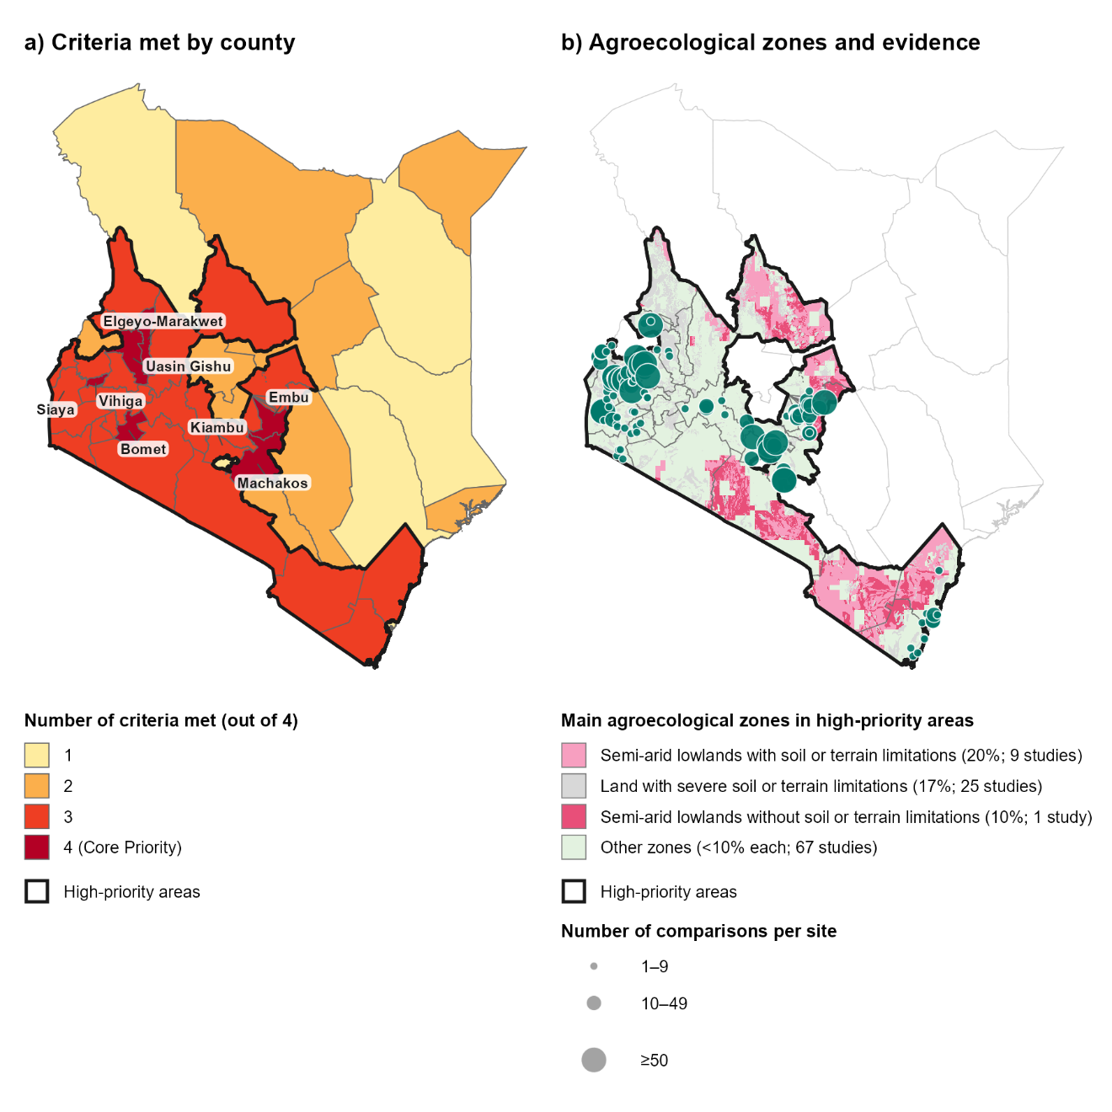

NOTES: a) Counties shaded by the number of the four screening criteria they meet (soil acidity (pH 5.5 or below) on active cropland; maize dominance over 50% of cereal harvested area; a declining maize yield trend in 2013–2021; and a synthetic fertilizer application rate in the top tertile of county means). Counties meeting three or four criteria form the high-priority areas, outlined in black in both panels. Core Priority counties and the counties with most comparisons are labelled. b) Main agroecological zones of the high-priority areas (those covering at least 10% of these areas), with other zones shown in light green, and the location of the 4,306 comparisons from 84 studies, shown as teal circles sized by the number of comparisons per site. Zone names are simplified from GAEZ v4 (see Table 2A.S2 for the original names). SOURCE: Agroecology Evidence Hub; scenario maps (del Río-Mena 2026); GAEZ v4 (FAO and IIASA 2021).

3.2.1.2 Promising AE/RA practices for soil fertility restoration
This section presents the effects of the AE/RA practices that are supported by strong evidence (Figure 2A.2). Results are described by food group, starting with cereals, the main staple of school meals in these areas, followed by pulses and legumes and the remaining food groups. All practices, including those supported by limited evidence, are given in Figure 2A.S3.
Organic matter raises cereal yields and restores soils. Adding organic matter to the soil, such as organic mulch, crop residues, compost or animal manure, helps restore soil fertility and raises cereal yields (Figure 2A.2a). In maize and wheat fields, covering the soil with organic mulch increased yields and soil moisture, and helped the crops use water more efficiently (Table 2A.S3). Incorporating residues into maize fields, instead of removing them, increased yields, especially when the residues came from nitrogen-fixing crops such as Crotalaria (Table 2A.S4a). Their effect on soil health was mixed, as residues from nitrogen-fixing crops and tree prunings increased soil nitrogen and organic carbon, while residues from other crops, such as maize stover, rarely did (Table 2A.S4b). Retaining crop residues or tree pruning in sorghum and maize, instead of removing them, also increased cereal yields (Table 2A.S5). Compost and manure increased maize and sorghum yields compared with no fertilizer, and improved soil health by increasing soil nutrients and organic matter (Table 2A.S6). Compost and manure also increased the abundance of soil macrofauna, such as earthworms, beetles, ants and termites, in cereal fields, in a single study. Mixed fertilizers, which combine manure or biochar with mineral fertilizer, increased maize and sorghum yields more consistently and raised soil nitrogen and soil moisture (Table 2A.S7). These benefits suggest that by returning organic matter to the soil, and by replacing synthetic fertilizer with compost or manure or combining it with them, farmers in these areas could restore soil fertility and reduce their dependence on costly synthetic fertilizer without compromising cereal yields.
Cereal–legume intercrops raise cereal yields and control pests. Intercropping cereals with legumes increased cereal yields while reducing weeds and insect pests (Figure 2A.2a). Intercrops of maize with pulses and legumes, such as common bean, groundnut, pigeon pea, cowpea or mung bean, maintained or increased maize yields compared with maize grown alone (Table 2A.S8a). Intercropping maize with green manure legumes, such as Crotalaria and velvet bean, also increased maize yields. Push-pull systems, in which finger millet, maize or sorghum are intercropped with Desmodium spp., forage legumes, gave the most consistent yield gains and reduced the number of Striga plants, a parasitic weed, and the damage caused by stem borers (Table 2A.S8b). Together, these AE/RA practices could support school-meal programmes by increasing the supply of cereals, and by adding pulses and legumes as a local source of plant protein. Legumes intercropped with cereals can also improve soil fertility by fixing nitrogen from the air (Muoni et al. 2022), and push-pull, which controls pests without chemicals, could reduce pesticide residues in food served to schoolchildren (Khan et al. 2011).
Other AE/RA practices give cereal yields similar to conventional practices. For biochar, agroforestry and reduced tillage, strong evidence showed cereal yields were higher in about half of the comparisons (Figure 2A.2a). Adding biochar to maize fields gave yields like those of fields without fertilizer, but maize yields increased in almost all comparisons when biochar was added to maize grown in rotation with soybean (Table 2A.S9a). Growing maize with trees gave mixed results (Table 2A.S9b). Maize yields increased in most comparisons with Croton macrostachyus, but in fewer than half of the comparisons with the nitrogen-fixing trees Gliricidia sepium and Sesbania sesban. Yields were lower in most comparisons with Leucaena leucocephala hedgerows and with Faidherbia albida, which shaded maize because the trees kept their leaves during the cropping season. Reducing tillage gave sorghum and maize yields similar to those under conventional tillage (Table 2A.S9c). Reduced tillage also tended to increase profitability of maize and sorghum by lowering production costs, in only two studies. Biochar and reduced tillage could be adopted without compromising cereal production, while the effect of trees on cereal yields depended on the tree species and its management. Evidence on the other benefits these practices may bring, such as soil protection or tree products, was too limited to draw conclusions.
Intercrops show a trade-off between maize and legume. Pulses and legumes, mainly pigeon pea, yielded less when intercropped with maize than when grown alone (Figure 2A.2b; Table 2A.S10a), which is expected as the legume is planted at a lower density and competes with maize for light, water and nutrients. Intercropping common bean with kale gave bean yields similar to those of beans grown alone, while kale yields were reduced. Incorporating crop residues into these maize–pigeon pea intercrops also reduced pigeon pea yields (Table 2A.S10b), while raising maize yields (Table 2A.S4a). Cereal-pulse intercrop could therefore supply both foods of a typical Kenyan school meal from the same field, as in githeri. This comes with a trade-off, as intercrops produce fewer pulses and legumes than sole stands, so intercropping alone may not be enough to increase the supply of plant protein for school meals.
Little evidence for vegetables, roots, nuts and fruits. Evidence for other food groups important for school meals, such as vegetables, nuts and seeds, and roots and tubers, was scattered across practices and outcomes, with no effect supported by strong evidence, and no study measured fruits (Figure 2A.S3c–e). For vegetables, supplemental drip irrigation increased the yields of kale and cabbage compared with rainfed production, in humid regions of Kiambu and Embu (Table 2A.S11). Evidence on other practices, such as organic fertilizers and intercropping, for these food groups was too limited to draw conclusions. This limits what can be concluded about how these practices contribute to diverse and nutritious diets. In general, most studies measured crop yields, while effects on profitability, labour demand, biodiversity and climate mitigation were rarely assessed, even though these could determine whether farmers can adopt the practices. Most comparisons were located outside the main agroecological zones of the high-priority areas, and few came from the semi-arid zones, so the results may not fully represent the conditions that prevail across most of these areas.

FIGURE 2A.2. Organic inputs and legume intercrop improved cereal productivity, while intercropped legumes yielded less.
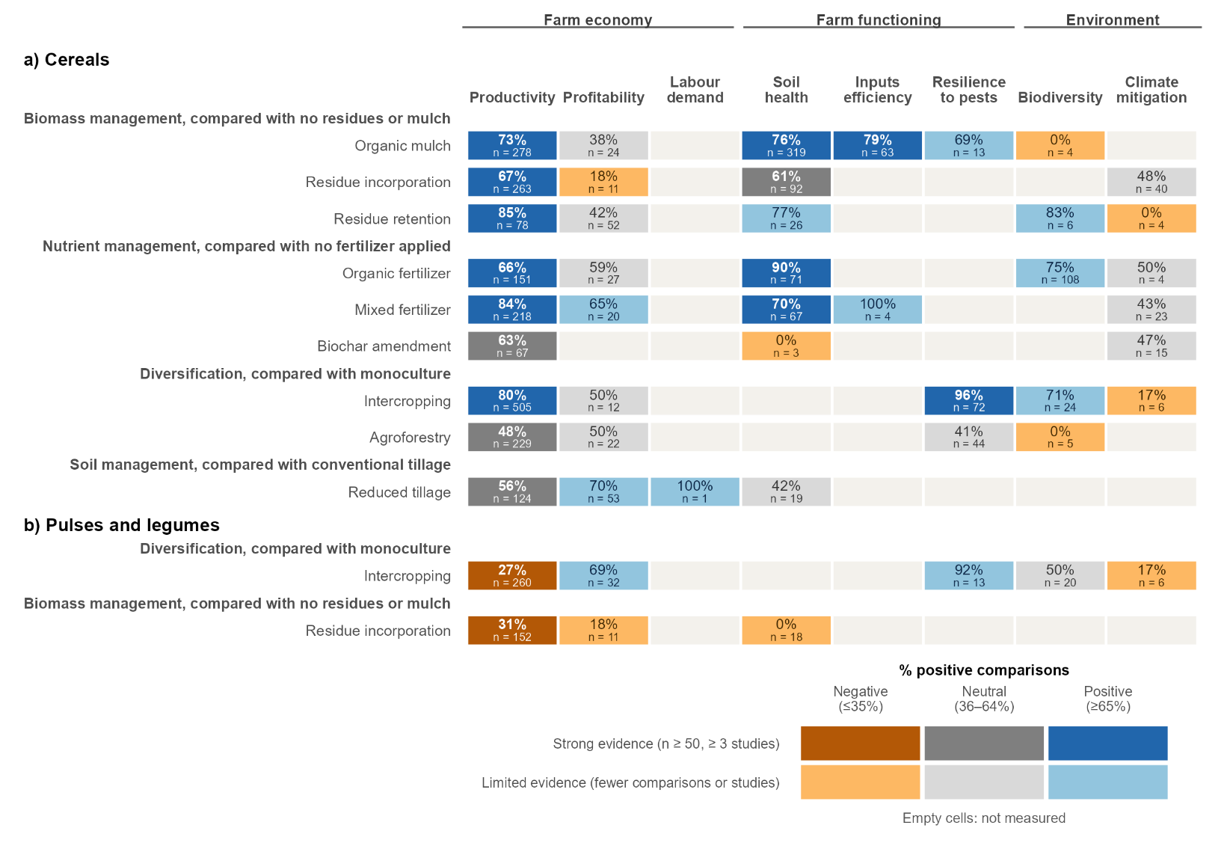

NOTES: Effects of AE/RA practices with strong evidence for at least one of the eight dimensions of farm performance for a) cereals, and b) pulses and legumes in the high-priority areas of Scenario 2A. Each row is an AE/RA practice compared with the conventional practice named in the bold heading above it, and each column is a dimension of farm performance. The percentage in each cell is the share of comparisons in which the AE/RA practice improved that dimension, and n is the number of comparisons. Blue cells show a positive effect (at least 65% of comparisons improved), grey cells a neutral effect (36–64% of comparisons improved) and orange cells a negative effect (35% or fewer comparisons improved). Darker shades show strong evidence (at least 50 comparisons from at least three studies) and lighter shades limited evidence. Empty cells mean that no study measured that dimension. The results for all practices and food groups are given in Figure 2A.S3. SOURCE: Agroecology Evidence Hub.

3.2.1.3 Matching promising AE/RA practices with local needs
The soil and socio-economic context of the high-priority areas (del Río-Mena 2026) shows where the promising AE/RA practices are more needed (Table 2A.1).
Organic matter is the priority in Vihiga and Machakos, and cereal–legume intercrops in the other Core Priority counties. Low organic carbon covers 64% of the acidic cropland in Vihiga and 99% in Machakos, while organic carbon is moderate in Bomet, Elgeyo-Marakwet, Embu and Uasin Gishu (Table 2A.1). Adding organic matter, such as organic mulch, compost or manure, increased cereal yields and improved soil health (Figure 2A.2a), and could therefore restore soil fertility where organic carbon is low. Intercropping cereals with legumes also increased cereal yields, and combined with compost or manure could maintain soil fertility where organic carbon is moderate. These intercrops, however, produced fewer legumes, and the evidence for Bomet, Uasin Gishu and Elgeyo-Marakwet was scarce.
Pulses and vegetables are more needed in the (list the six maize-belt counties) where child stunting is very high. In these maize-belt counties, 30% or more of children under five are stunted, which points to poor diets (Table 2A.1). Growing pulses with organic fertilizer, mixed fertilizer or biochar, and vegetables with supplemental drip irrigation, could support more diverse school meals in these counties by increasing their yields (Figure 2A.S3b–c). The evidence for pulses and vegetables, however, was limited, and no study measured fruits.
Farmers in the Core Priority counties are better placed to adopt AE/RA practices. In Bomet, Elgeyo-Marakwet, Embu, Machakos, Uasin Gishu and Vihiga, the multidimensional Poverty Index ranges from 0.06 to 0.14, most of their area is within an hour of a town, and young women and men both average more than nine years of schooling (del Río-Mena 2026). Being less poor, farmers could invest in practices that pay off over several seasons, such as compost, manure or agroforestry, and with more schooling they could more easily learn knowledge-intensive practices, such as push-pull (Table 2A.1). Access to towns could also allow them to buy inputs, and to sell legumes and vegetables, including to school-meal programmes.
TABLE 2A.1. Local needs of the high-priority areas of Scenario 2A in Kenya, and the AE/RA practices that could address them.
What is needed? | Where? | AE/RA practices that address it (evidence) | Trade-offs | What the evidence does not cover
Restore soil organic carbon on acidic cropland | Vihiga, Machakos (Core Priority), and Kakamega, Busia, Siaya, Homa Bay and Kwale | Organic mulch, compost, manure and mixed fertilizers raised cereal yields (66–84% of comparisons) and soil health (70–90%), strong | Residues incorporated into maize–pigeon pea intercrops lowered pigeon pea yields | Profitability and labour
Maintain soil fertility where organic carbon is moderate | Bomet, Elgeyo-Marakwet, Embu, and Uasin Gishu | Cereal–legume intercrops raised cereal yields (80%), and compost and manure raised them too (66%), strong | Intercropped legumes yielded less than sole legumes (27%) | Bomet and Elgeyo-Marakwet (no studies), Uasin Gishu (5 comparisons)
More diverse, nutrient-rich school meals where child stunting is very high | Six maize-belt counties (names to confirm with Trini) | Pulses: organic fertilizer, mixed fertilizer and biochar raised pulse yields in most comparisons (limited evidence). Vegetables: supplemental drip irrigation raised kale and cabbage yields (66%, limited evidence) | Intercropping increases maize yields but lowers legume yields (27%, strong) and vegetable yields (28%, limited evidence) | Too few evidence to confirm the effects on pulses and vegetables; no studies on fruits
Practices farmers can adopt and sell from, given their access to markets, inputs and schooling | Core Priority counties (Bomet, Elgeyo-Marakwet, Embu, Machakos, Uasin Gishu and Vihiga) | Intercropping and organic fertilizer raised the profitability of pulses, and reduced tillage and mixed fertilizer that of cereals (65–82%, limited evidence) | Organic mulch, residue retention and cereal intercrops gave profitability similar to conventional practices, and residue incorporation lowered it (limited evidence) | Profitability and labour for most practices; whether context makes adoption more likely (not tested)

NOTES: Each row is a need identified from the soil and socio-economic context of the high-priority areas, with the counties where it applies, the AE/RA practices whose evidence addresses it, their trade-offs, and what the evidence does not cover. Percentages are the share of comparisons in which the AE/RA practice improved the outcome compared with the conventional practice. Strong evidence refers to at least 50 comparisons from at least three studies, and limited evidence to fewer comparisons or studies. The links between the context and the adoption of practices are assumptions and were not tested in the evidence. SOURCE: Agroecology Evidence Hub; and del Río-Mena (2026).

3.2.2. Scenario 2B: Arid pastoral micro-gardens
Scenario 2B covers the arid and semi-arid lands of northern and eastern Kenya, where pastoralism is the main livelihood and diets rely heavily on livestock products. Severe water scarcity, recurrent food crises and conflict over water and grazing land limit crop production, leaving diets short of vegetables and other plant-based foods. To address this problem, the scenario calls for producing vegetables and plant-protein crops locally with very little water, in small plots close to households, which can supply school meals (Table 2.1).

KEY MESSAGES – SCENARIO 2B
- The evidence can guide food production in the humid areas of Embu and in the semi-arid lowlands with soil or terrain limitations that cover much of Embu, Garissa, Isiolo, Mandera and Turkana, but there is almost no evidence yet for the desert and arid land that covers about 40% of Garissa, Isiolo and Turkana, nor for the semi-arid lowlands without soil or terrain limitations that cover half of Mandera.
- Adding organic matter to the soil raised maize yields. Combining manure or biochar with mineral fertilizer raised maize yields in 95% of comparisons, in both humid and semi-arid areas, and also raised soybean yields.
- In the semi-arid lowlands, covering the soil with organic mulch raised maize yields and reduced water runoff, while incorporating crop residues into the soil lowered soil moisture.
- In the semi-arid lowlands, reducing tillage raised the yields of maize, pearl millet and sorghum.
- Intercrops of common bean with baby corn, sunflower or potato had fewer insect pests and twice as many predatory bugs that feed on them, but beans yielded less than when grown alone.
- Where some water is available, supplemental drip irrigation doubled cabbage yields and net returns compared with rainfed production.
- No study assessed how to produce vegetables and plant-protein crops with very little water or on saline soils, nor the crops proposed for this scenario, such as cowpea, amaranth, spider plant or moringa.
- Drip irrigation and organic mulch could be tested first along the Daua River in Mandera, contained beds and salt-tolerant crops on the saline soils of Garissa, Isiolo and Turkana, and practices based on on-farm inputs with practical training in the poorest and most isolated counties (Turkana, Mandera and West Pokot).

3.2.2.1 What evidence on AE/RA practices exists, and where
The high-priority areas of Scenario 2B cover six arid and semi-arid counties. Mandera is the only Core Priority County, meeting all five screening criteria, and Embu, Garissa, Isiolo, Turkana and West Pokot meet four (Figure 2B.1a). Evidence on AE/RA practices was available only for Embu, with 283 comparisons from 12 studies, while no evidence was available for Mandera, Garissa, Isiolo, Turkana or West Pokot (Figure 2B.1b; Table 2B.S1). Embu, however, is the least representative county of this scenario, as it is less poor, less isolated and has no schooling gap between women and men, unlike the other five high-priority counties (del Río-Mena 2026).
Although the evidence exceeded 100 comparisons, it was not representative of these areas. Three main agroecological zones cover the high-priority areas (Table 2B.S2), but only the semi-arid lowlands with soil or terrain limitations had studies (120 comparisons from 7 studies). The remaining comparisons came from small humid zones in western Embu, which together cover less than 1% of these areas. The evidence was therefore extended to cover the two main agroecological zones without studies, adding 4 comparisons (1 study) from semi-arid lowlands without soil or terrain limitations on the coast of Kenya, and 18 comparisons (2 studies) from the desert or arid zone and the semi-arid lowlands with soil or terrain limitations in Tanzania. In total, the analysis for this scenario was based on 305 comparisons from 15 studies. Most studies were recent, published after 2010 (Figure 2B.S1). The evidence covered five food groups, 9 AE/RA practices from five management domains, and six dimensions of farm performance (Figure 2B.S2).

FIGURE 2B.1. All evidence came from Embu, and none from the other five high-priority counties, including the Core Priority County of Mandera.
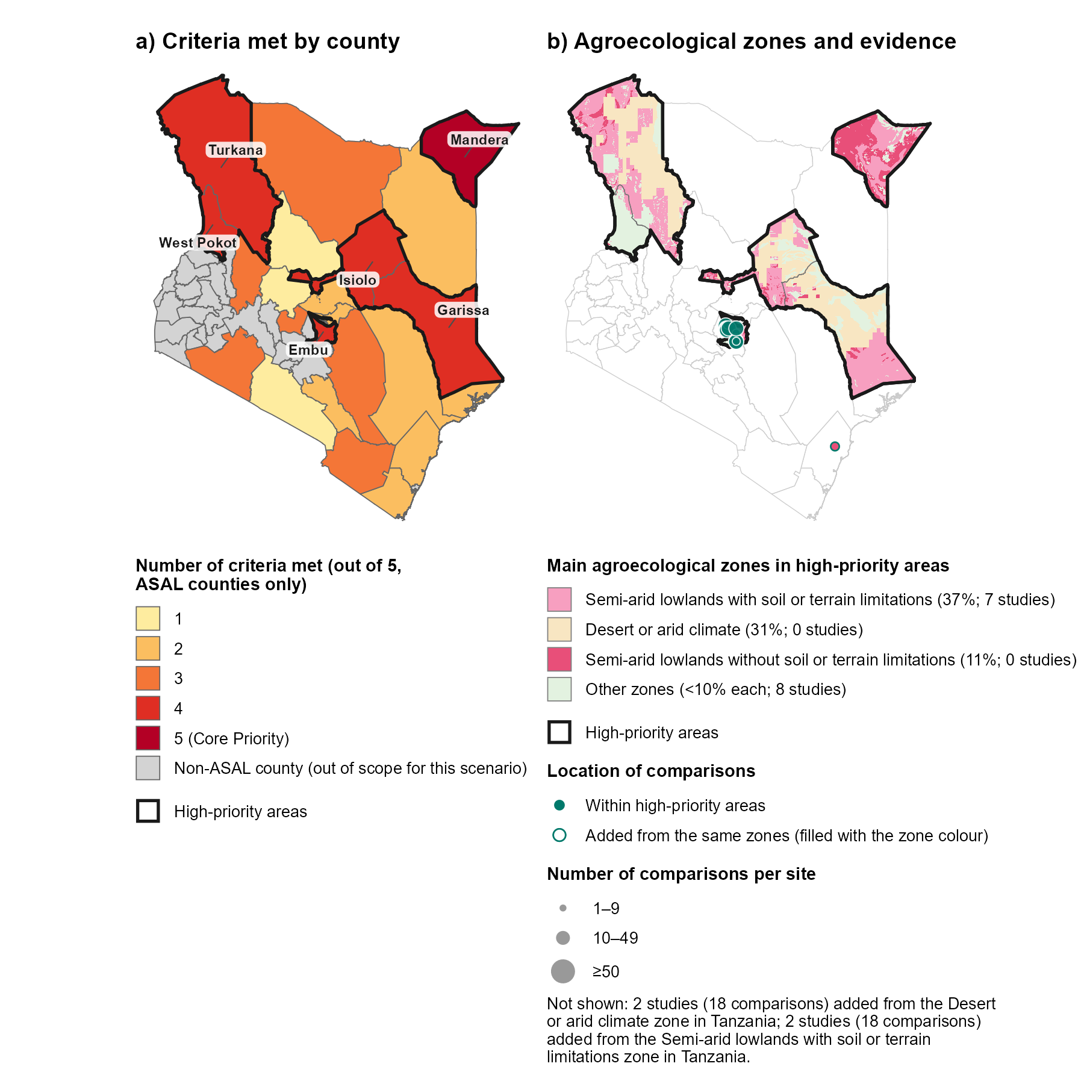

NOTES: a) Arid and semi-arid land (ASAL) counties shaded by the number of the five screening criteria they meet (high livestock density; severe agricultural water risk; a deficit in plant-based food production; acute food insecurity at IPC Phase 3 or above; and resource-conflict events). Non-ASAL counties, shown in grey, were not assessed for this scenario. Counties meeting four or five criteria form the high-priority areas, outlined in black in both panels. All high-priority counties are labelled. b) Main agroecological zones of the high-priority areas (those covering at least 10% of these areas), with other zones shown in light green, and the location of the 283 comparisons from 12 studies within the high-priority areas, shown as teal circles sized by the number of comparisons per site. Circles with a teal outline, filled with the colour of their zone, show the 4 comparisons from 1 study added from the semi-arid lowlands without soil or terrain limitations on the coast of Kenya. The 18 comparisons from 2 studies added from Tanzania, located in the desert or arid zone and the semi-arid lowlands with soil or terrain limitations, are outside the map and not shown. Zone names are simplified from GAEZ v4 (see Table 2B.S2 for the original names). SOURCE: Agroecology Evidence Hub; scenario maps (del Río-Mena 2026); GAEZ v4 (FAO and IIASA 2021).

3.2.2.2 Potential AE/RA practices for producing food in arid and semi-arid lands
No AE/RA practice was supported by strong evidence in this scenario, so this section describes the limited evidence available (Figure 2B.2), which should be read as indicative. None of the needs identified for this scenario was directly assessed, as no study tested production with very little water, on saline soils or with indigenous leafy vegetables. Results are presented by food group, starting with cereals, which have most of the evidence, followed by pulses and legumes and vegetables, the foods most needed in these areas, and the remaining food groups.
Organic inputs raised maize yields, but evidence from dry areas is scarce. Adding organic matter to the soil, such as crop residues, organic mulch, or manure and biochar, raised maize yields in most comparisons (Figure 2B.2a), with clearer benefits in the humid than in the semi-arid zones. Incorporating crop residues and tree pruning, such as Calliandra and tithonia, increased maize yields in humid zones, while in drier, semi-arid parts the effects on maize yield were unclear and soil moisture was often lower than in fields where residues were removed (Table 2B.S3). Covering the soil with organic mulch increased maize yields, mainly in the semi-arid parts of Embu, where it also reduced water runoff, but it did not increase soil carbon or nitrogen (Table 2B.S4). Mixed fertilizers, which combine manure or biochar with mineral fertilizer, increased maize yields in almost all comparisons, in both the humid and the semi-arid zones (Table 2B.S5). In the drier parts of these areas, farmers could leave crop residues on the soil surface as mulch instead of incorporating them, which helps keep water in the field, and combine manure with mineral fertilizer to raise maize yields. These practices still need to be tested in the arid counties, where most of the high-priority areas are.
Reduced tillage raised cereal yields. In the semi-arid lowlands, reducing tillage increased the yield of maize, pearl millet and sorghum compared with conventional tillage (Figure 2B.2a; Table 2B.S6a). In maize, it also increased the gross margin and reduced production costs and labour (Table 2B.S6b, c). For farmers in dry areas, reducing tillage could be worthwhile, as disturbing the soil less can help conserve soil moisture, while it maintained cereal yields with less labour. Its effect on soil moisture, however, was not measured in these studies.
Intercropping pulses with cereals, oilseeds or tubers reduced pests, while organic inputs raised soybean yields. In the humid lowlands, common bean intercropped with baby corn, sunflower or potato yielded less than beans grown alone, but the yields of the other crops were not measured, so the total production of these intercrops is unknown (Figure 2B.2b, Table 2B.S7a). These intercrops, however, had about fewer insect pests and twice as many predatory bugs that feed on them (Table 2B.S7b, c). In the same areas, adding biochar alone, or with mineral fertilizers and micronutrients, increased soybean yields compared with no fertilizer (Table 2B.S8). For farmers, intercropping beans could be worthwhile where insect pests cause heavy losses, as it controls them without pesticides and gives a second harvest from the same field, while biochar and mixed fertilizers could help raise soybean yields.
Drip irrigation raised vegetable yields and net returns. In the humid lowlands, supplemental drip irrigation increased cabbage yields and net returns compared with rainfed production, despite slightly higher total costs (Figure 2B.2d; Table 2B.S9). Where some water is available, drip irrigation could help farmers grow more vegetables and earn more from them. No other practice was assessed for vegetables in these areas.
Little evidence beyond cereals. Apart from cereals, the evidence was too scarce to show how to produce most of the plant-based foods needed for nutritious school meals in these areas. Evidence for roots and tubers was limited to a few comparisons (Figure 2B.2e), and no study measured fruits. None of the crops proposed for this scenario, such as cowpea, amaranth, spider plant or moringa, was assessed in these areas, and few studies measured profitability or labour demand, while none measured inputs efficiency or climate mitigation. Practices that showed benefits in Embu, such as organic mulch, mixed fertilizers and drip irrigation, could be tested on a small scale in the arid counties before being promoted more widely.

FIGURE 2B.2. Organic inputs and reduced tillage raised cereal yields, biochar raised soybean yields, and drip irrigation raised cabbage yields, all based on limited evidence.
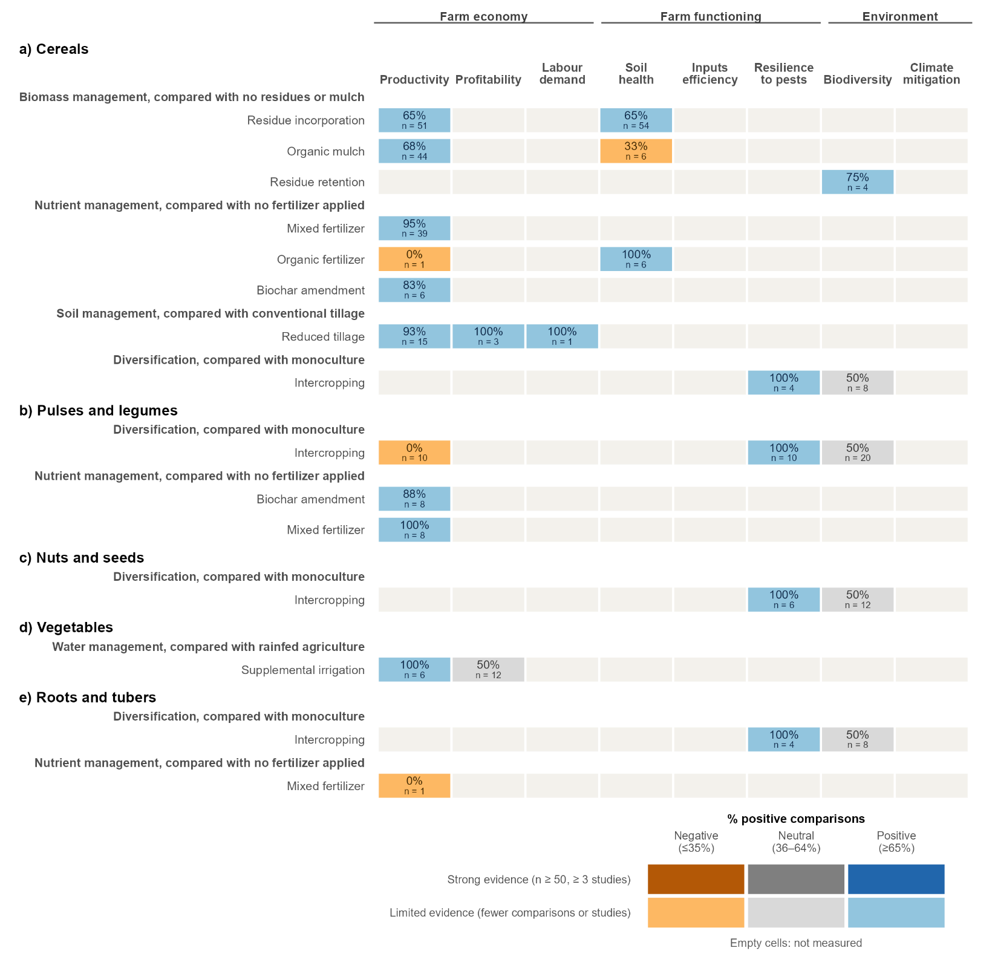

NOTES: Effects of all AE/RA practices on eight dimensions of farm performance for a) cereals, b) pulses and legumes, c) nuts and seeds, d) vegetables, and e) roots and tubers, using the comparisons located within the high-priority areas of Scenario 2B and those added from the same main agroecological zones elsewhere in Kenya and Tanzania. Each row is an AE/RA practice compared with the conventional practice named in the bold heading above it, and each column is a dimension of farm performance, grouped into farm economy, farm functioning and environment. The percentage in each cell is the share of comparisons in which the AE/RA practice improved that dimension, and n is the number of comparisons. Blue cells show a positive effect (at least 65% of comparisons improved), grey cells a neutral effect (36–64% of comparisons improved) and orange cells a negative effect (35% or fewer comparisons improved). Darker shades show strong evidence (at least 50 comparisons from at least three studies) and lighter shades limited evidence. No result for this scenario was supported by strong evidence. Empty cells mean that no study measured that dimension. SOURCE: Agroecology Evidence Hub.

3.2.2.3 Matching potential AE/RA practices with local needs
The soil and socio-economic context of the high-priority areas (del Río-Mena 2026) shows where the potential AE/RA practices are most needed, and which conditions the evidence has not yet covered (Table 2B.1).
Drip irrigation and organic mulch could be tested first in Mandera. All six high-priority counties face severe water risk, but in Mandera, crops are grown mainly along the Daua River, where the county is expanding irrigation (del Río-Mena 2026). Supplemental drip irrigation increased cabbage yields and net returns, and organic mulch increased maize yields and reduced water runoff (Figure 2B.2a, d), so both could help produce more food with little water in these riverine areas. Leaving crop residues on the soil surface as mulch could also help keep soil moisture, as incorporation often lowered it.
Contained beds and salt-tolerant crops could be tested on the saline soils of Garissa, Isiolo and Turkana. Salt in the soil limits crop growth on 53% of the area in Garissa, 39% in Isiolo and 38% in Turkana (Table 2B.1). No study in the evidence tested production on saline soils, so beds filled with compost and imported soil, or salt-tolerant crops such as cowpea, remain to be tested in these three counties (del Río-Mena 2026).
Practices based on on-farm inputs, supported by practical training, could be easier to adopt and sustain in Turkana, Mandera and West Pokot. In these three arid counties, poverty is high, more than half of the area is over one hour’s travel from a town, and schooling is low, especially for women (del Río-Mena 2026). Organic mulch uses crop residues from the farm, and reduced tillage needs no purchased inputs, so both could help farmers keep soil moisture and cereal yields at low cost. Mixed fertilizers need purchased mineral fertilizer, and drip irrigation raised total costs, so these practices by be hard to sustain without outside support. Given the low schooling, practical training and peer demonstrations, with women involved from the start, could help farmers adopt these practices.
Local vegetables and pulses could be tested in household gardens in Garissa and Turkana. None of the crops proposed for school meals in these areas, such as cowpea, amaranth, spider plant or moringa, was assessed in the evidence. Programme experience, however, suggests that household gardens are feasible in the region, as multi-storey sack gardens were taken up by more than 5,000 households in Dadaab, in Garissa (Corbett 2006), and a farmer group in Turkana scaled up moringa from a quarter of an acre to 17 acres (Daily Nation 2026). Field trials of these crops, grown with the practices that worked in the evidence, such as mulch and drip irrigation, are needed to confirm their yields under arid conditions. If local yields prove too low, school meals could instead source vegetables and pulses from more productive regions of Kenya.

TABLE 2B.1. Local needs of the high-priority areas of Scenario 2B in Kenya, and the AE/RA practices that could address them.
What is needed? | Where? | AE/RA practices that address it (evidence) | Trade-offs | What the evidence does not cover
Produce more food with little water | Mandera (Core Priority), on cropland along the Daua River | Organic mulch raised maize yields (68%) and reduced water runoff; supplemental drip irrigation raised cabbage yields and net returns (100%, limited evidence) | Incorporating crop residues often lowered soil moisture; drip irrigation raised total costs | Effects in Mandera and the other arid counties; vegetables other than cabbage
Grow crops on saline soils | Garissa (53% of the area), Isiolo (39%) and Turkana (38%) | None tested | - | Any practice or crop on saline soils, such as contained beds or salt-tolerant cowpea
Practices farmers can adopt despite high poverty, isolation and low schooling | Turkana, Mandera and West Pokot | Organic mulch (68%) and reduced tillage (93%) raised cereal yields with on-farm inputs (limited evidence) | Mixed fertilizers raised maize yields (95%) but need purchased fertilizer; drip irrigation needs repair services and spare parts | Profitability and labour for most practices; whether context makes adoption more likely (not tested)
Vegetables and pulses for school meals | Garissa and Turkana | Drip irrigation raised cabbage yields (100%) and biochar raised soybean yields (88%, limited evidence) | Intercropped beans yielded less than sole beans (0%) | Cowpea, amaranth, spider plant and moringa; fruits

NOTES: Percentages are the share of comparisons in which the AE/RA practice improved the outcome. All evidence is limited (fewer than 50 comparisons or fewer than three studies) and comes mostly from Embu. Soil salinity, poverty and cropland location are from del Río-Mena (2026). SOURCE: Agroecology Evidence Hub.

3.3. Ethiopia

TABLE 3.1. Scenarios identifying high-priority areas for nutritious and sustainable food systems in Ethiopia.
 | Scenario 3A: Hillside agroforestry | Scenario 3B: Surplus–stunting paradox | Scenario 3C: Pastoral water and conflict
Main problem
Where?
What is needed?
Food for school meals
Which AE/RA practices can help?
Trade-offs
What is still unknown?
Evidence base

3.3.1. Scenario 3A: Hillside agroforestry

KEY MESSAGES – SCENARIO 3A
- The evidence

3.3.1.1 What evidence on AE/RA practices exists, and where

3.3.1.2 Promising AE/RA practices for soil fertility restoration

3.3.1.3 Matching promising AE/RA practices with local needs

3.3.2. Scenario 3B: Surplus–stunting paradox

KEY MESSAGES – SCENARIO 3B
- The evidence

3.3.2.1 What evidence on AE/RA practices exists, and where

3.3.2.2 Promising AE/RA practices for soil fertility restoration

3.3.2.3 Matching promising AE/RA practices with local needs

3.3.3. Scenario 3C: Pastoral water and conflict

KEY MESSAGES – SCENARIO 3C
- The evidence

3.3.3.1 What evidence on AE/RA practices exists, and where

3.3.3.2 Promising AE/RA practices for soil fertility restoration

3.3.3.3 Matching promising AE/RA practices with local needs

3.4. Angola

3.5. Burundi

3.6. Malawi

3.7. Rwanda

3.8. Tanzania

3.9. Uganda

4. References
Agegnehu G, Amede T, Erkossa T, et al (2021) Extent and management of acid soils for sustainable crop production system in the tropical agroecosystems: a review. Acta Agriculturae Scandinavica, Section B — Soil & Plant Science 71:852–869. https://doi.org/10.1080/09064710.2021.1954239
Corbett M (2006) Multi-storey gardens to support food security. Field Exchange 29. Emergency Nutrition Network. https://www.ennonline.net/fex/29/en/multi-storey-gardens-support-food-security
Daily Nation (2026) Pastoralists turn to moringa ‘wonder crop’ to cushion climate shocks. https://nation.africa/kenya/climate/pastoralists-turn-to-moringa-wonder-crop-to-cushion-climate-shocks-5431132
del Río-Mena T (2026) Mapping nutritional gaps: a multi-dimensional framework for targeted policy interventions. CFRA progress report, October 2026. Alliance of Bioversity International and CIAT
FAO & IIASA (2021). Global Agro-Ecological Zones version 4 (GAEZ v4). Food and Agriculture Organization of the United Nations, Rome, and International Institute for Applied Systems Analysis, Laxenburg.
FAO (n.d.) Indicative Crop Classification (ICC), version 1.1. Food and Agriculture Organization of the United Nations, Rome. https://stats.fao.org/classifications/ICC/v1.1. Accessed 23 October 2026
FAO, IIASA, ISRIC, ISSCAS, JRC (2012) Harmonized World Soil Database (version 1.2). FAO, Rome, and IIASA, Laxenburg
Hengl T, Miller MAE, Križan J, et al (2021) African soil properties and nutrients mapped at 30 m spatial resolution using two-scale ensemble machine learning. Sci Rep 11:6130. https://doi.org/10.1038/s41598-021-85639-y
KNBS, ICF (2023) Kenya Demographic and Health Survey 2022. Volume 1. KNBS and ICF, Nairobi and Rockville, MD.
Local Burden of Disease Educational Attainment Collaborators (2020) Mapping disparities in education across low- and middle-income countries. Nature 577:235–238. https://doi.org/10.1038/s41586-019-1872-1
Nelson A, Weiss DJ, van Etten J, et al (2019) A suite of global accessibility indicators. Sci Data 6:266. https://doi.org/10.1038/s41597-019-0265-5
Corbeels M, Naudin K, Whitbread AM, et al (2020) Limits of conservation agriculture to overcome low crop yields in sub-Saharan Africa. Nat Food 1:447–454. https://doi.org/10.1038/s43016-020-0114-x
Jones SK, Sánchez AC, Juventia SD, Estrada-Carmona N (2021) A global database of diversified farming effects on biodiversity and yield. Sci Data 8:212. https://doi.org/10.1038/s41597-021-01000-y
Khan Z, Midega C, Pittchar J, et al (2011) Push—pull technology: a conservation agriculture approach for integrated management of insect pests, weeds and soil health in Africa: UK government’s Foresight Food and Farming Futures project. International Journal of Agricultural Sustainability 9:162–170. https://doi.org/10.3763/ijas.2010.0558
Muoni T, Jonsson M, Duncan AJ, et al (2022) Effects of management practices on legume productivity in smallholder farming systems in sub‐Saharan Africa. Food and Energy Security 11:e366. https://doi.org/10.1002/fes3.366
Paut R, Garreau L, Ollivier G, et al (2024) A global dataset of experimental intercropping and agroforestry studies in horticulture. Sci Data 11:5. https://doi.org/10.1038/s41597-023-02831-7
Rosenstock TS, Steward P, Joshi N, et al (2024) Effects of changing farming practices in African agriculture. Sci Data 11:958. https://doi.org/10.1038/s41597-024-03805-z
Sánchez AC, Kamau HN, Grazioli F, Jones SK (2022) Financial profitability of diversified farming systems: A global meta-analysis. Ecological Economics 201:107595. https://doi.org/10.1016/j.ecolecon.2022.107595

5. Supplementary information

Figure S1. Prisma diagram

TABLE S1. Agroecological or regenerative agricultural (AE/RA) practices included in the analysis, grouped by management domain, with a description of each practice and the conventional practices it was compared with. Conventional practices are those found as controls in the comparisons available at the time of this analysis. Not all practices were assessed in every scenario.
Management domains | AE/RA practice description
Biomass management: How crop residues, tree prunings and other plant material are managed in the field after harvest or pruning. | Organic mulch: Organic materials are spread on the soil surface and left there, without being incorporated or burnt. The materials include herbaceous plant residues from nitrogen-fixing (leguminous) or non-nitrogen-fixing plants, prunings (leaves and branches) of woody plants, and other organic materials such as wood shavings or sawdust. Plastic mulch is excluded. The mulch covers and protects the soil, conserves moisture, suppresses weeds and gradually returns organic matter and nutrients to the soil. Compared with no mulch, or with crop residues removed from the field, or burnt, or grazed by livestock.
 | Residues incorporation: Crop or tree residues (straw, stubble, prunings, leaves and other plant parts left after harvest or pruning) are mixed into the soil, usually by tillage. The residues can come from nitrogen-fixing (leguminous) or non-nitrogen-fixing plants, and can be produced in the field or brought from elsewhere (biomass transfer). Incorporation returns organic matter and nutrients to the soil. Compared with crop residues removed from the field, or burnt, or grazed by livestock.
 | Residues retention: Crop residues from nitrogen-fixing or non-nitrogen-fixing plants are kept in the field after harvest instead of being removed, but the studies did not specify whether they were left on the surface or incorporated into the soil. Compared with crop residues removed from the field.
Diversification (spatial): Growing more than one plant species in the same field at the same time. | Agroforestry: Woody perennials (trees, shrubs, palms or bamboos) are deliberately grown on the same land as crops and/or livestock, within or around plots, for example scattered trees, alley cropping, hedgerows, boundary plantings, windbreaks, shaded perennial systems or silvopasture. Trees provide products (fruit, timber, fodder, fuel) as well as services such as shade, microclimate regulation, soil protection, nutrient cycling and habitat.
 | Intercropping: Two or more crop species are grown in the same field at the same time, for all or a significant part of their growth cycles, in mixed, row, strip or relay arrangements. Complementarity between species is used to make better use of light, water and nutrients, increase total productivity per unit area, and reduce pest, disease and weed pressure.
Diversification (temporal): Changing the plants grown in a field over successive seasons or years. | Crop rotation: Different crop species are grown in a planned sequence on the same field over successive seasons or years, instead of repeating the same crop (monoculture) or an unplanned sequence. Rotations often combine cereals, legumes, root crops or green manures. They break pest, disease and weed cycles, improve soil fertility (especially when legumes fix nitrogen), balance the use of nutrients and water from different soil depths, improve soil structure and organic matter, and spread production risk.
 | Natural fallow: Cropland is left uncultivated for one or more seasons and vegetation (grasses, shrubs or trees) regrows spontaneously, without planting. The regrowth restores soil organic matter and fertility, recycles nutrients, protects the soil from erosion, breaks weed, pest and disease cycles and provides habitat for biodiversity. Includes grass, bush and forest fallows.
 | Improved fallow: During the fallow period, cropland is deliberately planted with fast-growing species, usually legumes such as trees, shrubs or herbaceous plants (e.g., Sesbania, Tephrosia, Gliricidia, Cajanus, Crotalaria, Mucuna), instead of being left to regrow naturally. This restores soil fertility faster than natural fallow through biological nitrogen fixation, biomass and nutrient inputs, and deep nutrient recycling. It also suppresses weeds (including Striga) and protects the soil. The fallow biomass is often cut and left on the surface or incorporated before the next crop.
Nutrient management: How crops are supplied with nutrients. | Biochar amendment: Biochar is added to the soil, either alone or mixed with compost, manure or fertilizers. Biochar is a carbon-rich solid made by heating biomass (crop residues, wood, manure or other organic waste) with little or no oxygen (pyrolysis). It improves soil structure, water-holding capacity, cation exchange capacity and pH (especially in acidic soils), increases nutrient retention and use efficiency, supports soil microbial activity and stores carbon in the soil for the long term.
 | Inoculation: Seeds, seedlings or soil are treated with beneficial microorganisms, such as rhizobia, arbuscular mycorrhizal fungi, or plant growth-promoting bacteria and fungi, to establish or boost useful plant–microbe associations. It improves biological nitrogen fixation, nutrient (especially P) uptake, root health and plant tolerance to stress, and can reduce the need for synthetic inputs.
 | Mixed fertilizers: Organic fertilizers or amendments (manure, compost, crop residues, green manure) are applied together with mineral fertilizers, in the same season or as a planned combination, to meet crop nutrient needs. The organic component builds soil organic matter, improves soil structure and nutrient retention, and increases how efficiently the mineral nutrients are used, while mineral fertilizers supply readily available nutrients.
 | Organic fertilizers: Nutrients are supplied to crops from materials of plant or animal origin, such as animal manure, compost, vermicompost, slurry, biosolids, green manure or plant-based preparations, instead of synthetic mineral fertilizers. Nutrients are released gradually as the materials decompose, while the added organic matter improves soil structure, water-holding capacity, biological activity and long-term fertility.
Pest management: How weeds, insect pests and diseases are controlled in the field. | Mechanical weeding: Weeds are removed by physical means, such as hand pulling, hoeing, slashing or animal- or tractor-drawn weeders, instead of controlling them with herbicides or leaving them unmanaged. Removing weeds reduces their competition with crops for light, water and nutrients without using herbicides.
Soil management: How the soil is prepared, disturbed or amended before and during cropping. | Liming: Agricultural lime, such as ground limestone (calcitic or dolomitic) or other calcium-rich materials, is applied to acidic soils to raise their pH. Lime neutralises soil acidity, reduces aluminium and manganese toxicity, makes phosphorus and other nutrients more available to crops, supplies calcium (and magnesium in the case of dolomitic lime), and supports root growth, nitrogen fixation by legumes and soil biological activity. Compared with no liming.
 | Reduced tillage: Soil disturbance is reduced compared with conventional tillage (e.g., mouldboard ploughing) by cutting the number, depth or intensity of tillage operations, or by tilling only part of the field (strip, zone or planting-hole tillage). It includes minimum tillage and no-till, where seeds are sown directly into untilled soil. Less disturbance protects soil structure and aggregates, reduces erosion and evaporation, slows organic matter decomposition, supports soil biological activity and cuts fuel and labour costs.
 | Zero tillage: Crops are sown directly into untilled soil, with no ploughing, harrowing or other soil preparation before planting. Disturbance is limited to the narrow opening made for the seed, and the soil surface and any crop residues are left in place. It protects soil structure and aggregates, reduces erosion and evaporation, slows organic matter decomposition, supports soil biological activity and cuts fuel, labour and time costs.
Variety management: Which crop varieties are grown. | Local variety: Crop varieties developed and maintained by farmers in a particular area are grown. These include traditional varieties, landraces and farmer-selected populations, usually multiplied from farm-saved or locally exchanged seed, instead of commercially bred improved varieties or hybrids. Local varieties are often genetically diverse and adapted to local soils, climate, pests and low-input conditions. They help with yield stability, resilience to stress, dietary and cultural preferences, seed autonomy and conservation of agrobiodiversity.
Water management: How crops are supplied with water beyond rainfall. | Contour bunding: Barriers or depressions are built across the slope, following the contour lines of the field, to slow down rainwater running off the land. They include permanent or semi-permanent ridges of soil or stone (contour, stone and semicircular bunds), rows of stones, ridges and furrows remade each season, tied ridges that form small basins, and trenches dug along the contour. By holding rainwater in the field, they reduce soil erosion and increase the water available to crops. Compared with fields without these structures.
 | Micro catchments: Small basins or pits are dug within the field to collect rainwater runoff and concentrate it around the plants. They include basins surrounded by small earth bunds with an infiltration pit at the lowest point, mainly used for trees or bushes, and small planting pits in which crops are sown directly, which in the case of zai pits are filled with manure or compost before the rainy season. By capturing and storing rainwater where the plants grow, they increase the water available to crops in dry areas. Compared with fields without these structures.
 | Grass strips: Strips of grass are planted within a field or farm, usually along the contour lines of the slope. The grass slows down rainwater running off the land and traps the soil it carries, which reduces erosion and helps keep water and nutrients in the field. Compared with fields without these strips.
 | Supplemental drip irrigation: Limited amounts of water are applied to mainly rainfed crops through a drip system (pipes with emitters that deliver water slowly to the root zone) at critical growth stages or during dry spells, when rainfall alone isn't enough. The aim is to stabilize yields rather than meet the full crop water demand. Water goes directly to the root zone, which reduces evaporation, runoff and deep percolation losses, increases water use efficiency, limits weed growth between rows, and lowers pest and disease pressure from wet foliage.

TABLE S2. Food groups used to classify the crops measured in the comparisons, based on the FAO Indicative Crop Classification (FAO n.d.) and adapted to the food groups of school meals. Each comparison was assigned to the food group of the crop on which the outcome was measured. Outcomes measured at the level of the cropping system, and counts of pests and weeds, were assigned to the food groups of all crops in the system. Crops classified as stimulants, spices, sugar, fibre or fodder crops were not assigned to a food group and were excluded from the analysis. Nutritional contributions are general descriptions of each food group and were not assessed in this analysis.
Food groups | Description | Crops included
Cereals | Grains of cereal crops eaten as staple foods (FAO group Cereals). Main source of energy, usually the base of the meal. | [to complete]
Fruits | Fruits eaten fresh or cooked (FAO group Fruit and nuts, except nuts). Source of vitamins (vitamin C, and vitamin A in orange-fleshed fruits), potassium, fibre, and energy. | [to complete]
Nuts and seeds | Tree nuts and edible oilseeds (FAO groups Fruit and nuts for nuts, and Oilseed crops except soybean). Energy-dense source of healthy fats, protein, vitamin E, magnesium and zinc. Small amounts improve the energy and protein content of meals. | [to complete]
Pulses and legumes | Grain legumes eaten as dry or fresh seeds (FAO group Leguminous crops), including soybean, which FAO classifies as an oilseed. Main plant source of protein, with iron, zinc, folate and fibre. | [to complete]
Roots and tubers | Starchy roots and tubers (FAO group Root tuber crops with high starch or inulin content). Source of energy, an alternative or complement to cereals. | [to complete]
Vegetables | Leafy, fruit-bearing, root and bulb vegetables (FAO group Vegetables and melons), including edible leaves of legumes and root crops and fresh peppers. Source of micronutrients and fibre. | [to complete]

Table S3. Dimensions of farm performance used to group the outcomes measured in the comparisons, with a description of each dimension and the outcome indicators it includes. An AE/RA practice improved a dimension when the indicator increased, except for indicators marked with an asterisk (*), for which a decrease is an improvement.
Dimension of farm performance | Description | Included outcomes
Productivity | The amount of crop produced per unit of land or time. | [to complete]
Profitability | The economic return of the cropping system, as the value of what is produced relative to the costs of producing it. | [to complete]
Labour demand | The amount of work needed to manage the cropping crop. | [to complete]
Soil health | The capacity of the soil to support crop growth, through its organic matter, nutrients, water and protection from erosion. | [to complete]
Inputs efficiency | How efficiently crops use water and nutrients to produce yield. | [to complete]
Resilience to pests | The capacity of the cropping system to keep insect pests, diseases and weeds at low levels and to limit the damage they cause to crops. | [to complete]
Biodiversity | The abundance and diversity of organisms living in the field, such as pollinators, soil fauna and natural enemies of pests. | [to complete]
Climate mitigation | The capacity of the cropping system to reduce greenhouse gas emissions or store carbon. | [to complete]

5.1 Zambia

5.2. Kenya

5.2.1. Scenario 2A: Soil fertility restoration

TABLE 2A.S1. Counties of the high-priority areas of Scenario 2A in Kenya, with the number of screening criteria each county meets and the number of studies and comparisons located within it. Counties meeting all four criteria are Core Priority counties, and those meeting three complete the high-priority areas. Counties are ordered by the number of comparisons. Some studies reported comparisons located in several sites, which can fall in different counties. These studies and comparisons are counted in each county where they have a site, so the sum of the rows can exceed the total.
County | Criteria met | Studies | Comparisons
Machakos | 4 | 9 | 838
Kiambu | 3 | 9 | 718
Siaya | 3 | 15 | 571
Kakamega | 3 | 10 | 372
Tharaka-Nithi | 3 | 7 | 316
Embu | 4 | 12 | 283
Vihiga | 4 | 7 | 277
Homa Bay | 3 | 12 | 272
Busia | 3 | 8 | 140
Murang'a | 3 | 2 | 86
Kisumu | 3 | 3 | 76
Trans Nzoia | 3 | 3 | 75
Nandi | 3 | 2 | 70
Nakuru | 3 | 4 | 61
Kilifi | 3 | 5 | 48
Kirinyaga | 3 | 2 | 43
Nyandarua | 3 | 2 | 37
Migori | 3 | 2 | 25
Kisii | 3 | 4 | 23
Nyamira | 3 | 1 | 9
Uasin Gishu | 4 | 2 | 5
Kwale | 3 | 1 | 4
Meru | 3 | 1 | 1
Bomet | 4 | 0 | 0
Elgeyo-Marakwet | 4 | 0 | 0
Baringo | 3 | 0 | 0
Kajiado | 3 | 0 | 0
Kericho | 3 | 0 | 0
Narok | 3 | 0 | 0
Samburu | 3 | 0 | 0
Taita Taveta | 3 | 0 | 0
West Pokot | 3 | 0 | 0
Total | - | 84 | 4306

TABLE 2A.S2. Agroecological zones of the high-priority areas of Scenario 2A in Kenya, with the share of the high-priority areas each zone covers and the number of studies and comparisons in each zone. Zones are those of the Global Agro-Ecological Zones (GAEZ v4), and main zones are those covering at least 10% of the high-priority areas. Zones covering less than 0.1% of the high-priority areas are shown only when they contain evidence. Studies and comparisons are shown for those located within the high-priority areas, and for those added from the same main zones elsewhere in Kenya and in neighbouring project countries. No comparisons were added from outside the high-priority areas for this scenario, because the evidence within them met both sufficiency criteria. Some studies reported comparisons located in several sites, which can fall in different zones. These studies and comparisons are counted in each zone where they have a site, so the sum of the rows can exceed the total.
Agroecological zone | Share of high-priority areas (%) | Main zone | Studies (High-priority areas) | Comparisons (High-priority areas) | Studies (Same zones, same country) | Comparisons (Same zones, same country) | Studies (Same zones, neighbouring countries) | Comparisons (Same zones, neighbouring countries)
Land with severe soil/terrain limitations | 17.2 | Yes | 25 | 591 | 0 | 0 | 0 | 0
Tropics, lowland; semi-arid, with soil/terrain limitations | 19.5 | Yes | 9 | 357 | 0 | 0 | 0 | 0
Tropics, lowland; semi-arid, no soil/terrain limitations | 10.4 | Yes | 1 | 4 | 0 | 0 | 0 | 0
Tropics, highland; sub-humid, with soil/terrain limitations | 5 | No | 20 | 1264 | 0 | 0 | 0 | 0
Tropics, lowland; humid, with soil/terrain limitations | 5.1 | No | 26 | 1010 | 0 | 0 | 0 | 0
Tropics, highland; humid, with soil/terrain limitations | 9.8 | No | 12 | 566 | 0 | 0 | 0 | 0
Tropics, lowland; humid, no soil/terrain limitations | 2.5 | No | 7 | 256 | 0 | 0 | 0 | 0
Dominantly hydromorphic soils | 1.3 | No | 4 | 141 | 0 | 0 | 0 | 0
Tropics, highland; humid, no soil/terrain limitations | 4.3 | No | 3 | 78 | 0 | 0 | 0 | 0
Tropics, highland; sub-humid, no soil/terrain limitations | 2.2 | No | 3 | 47 | 0 | 0 | 0 | 0
Tropics, lowland; sub-humid, with soil/terrain limitations | 9.3 | No | 3 | 36 | 0 | 0 | 0 | 0
Tropics, lowland; sub-humid, no soil/terrain limitations | 4.6 | No | 1 | 4 | 0 | 0 | 0 | 0
Dominantly water | 2.1 | No | 0 | 0 | 0 | 0 | 0 | 0
Desert/Arid climate | 2 | No | 0 | 0 | 0 | 0 | 0 | 0
Dominantly very steep terrain | 1.8 | No | 0 | 0 | 0 | 0 | 0 | 0
Tropics, highland; semi-arid, with soil/terrain limitations | 1.1 | No | 0 | 0 | 0 | 0 | 0 | 0
Tropics, highland; semi-arid, no soil/terrain limitations | 0.7 | No | 0 | 0 | 0 | 0 | 0 | 0
Ample irrigated soils | 0.5 | No | 0 | 0 | 0 | 0 | 0 | 0
Cold, no permafrost; wet, with soil/terrain limitations | 0.4 | No | 0 | 0 | 0 | 0 | 0 | 0
Total | 100 | - | 84 | 4306 | 0 | 0 | 0 | 0

FIGURE 2A.S1. Number of studies in the high-priority areas of Scenario 2A in Kenya, by year of publication.
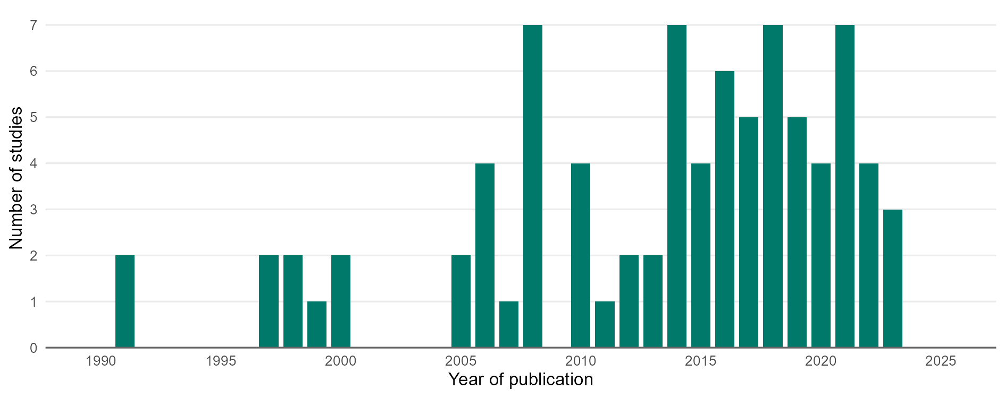

NOTES: The figure includes each study used in the analysis for the high-priority areas of Scenario 2A, counted once in the year it was published. A study that reports several sites, seasons or comparisons is counted as one study. The year of publication is not the year the experiment was carried out, which can be several years earlier. SOURCE: Agroecology Evidence Hub.

FIGURE 2A.S2. Number of comparisons and studies by a) food group, b) agroecological or regenerative agricultural (AE/RA) practice, and c) dimensions of farm performance in the high-priority areas of Scenario 2A in Kenya.
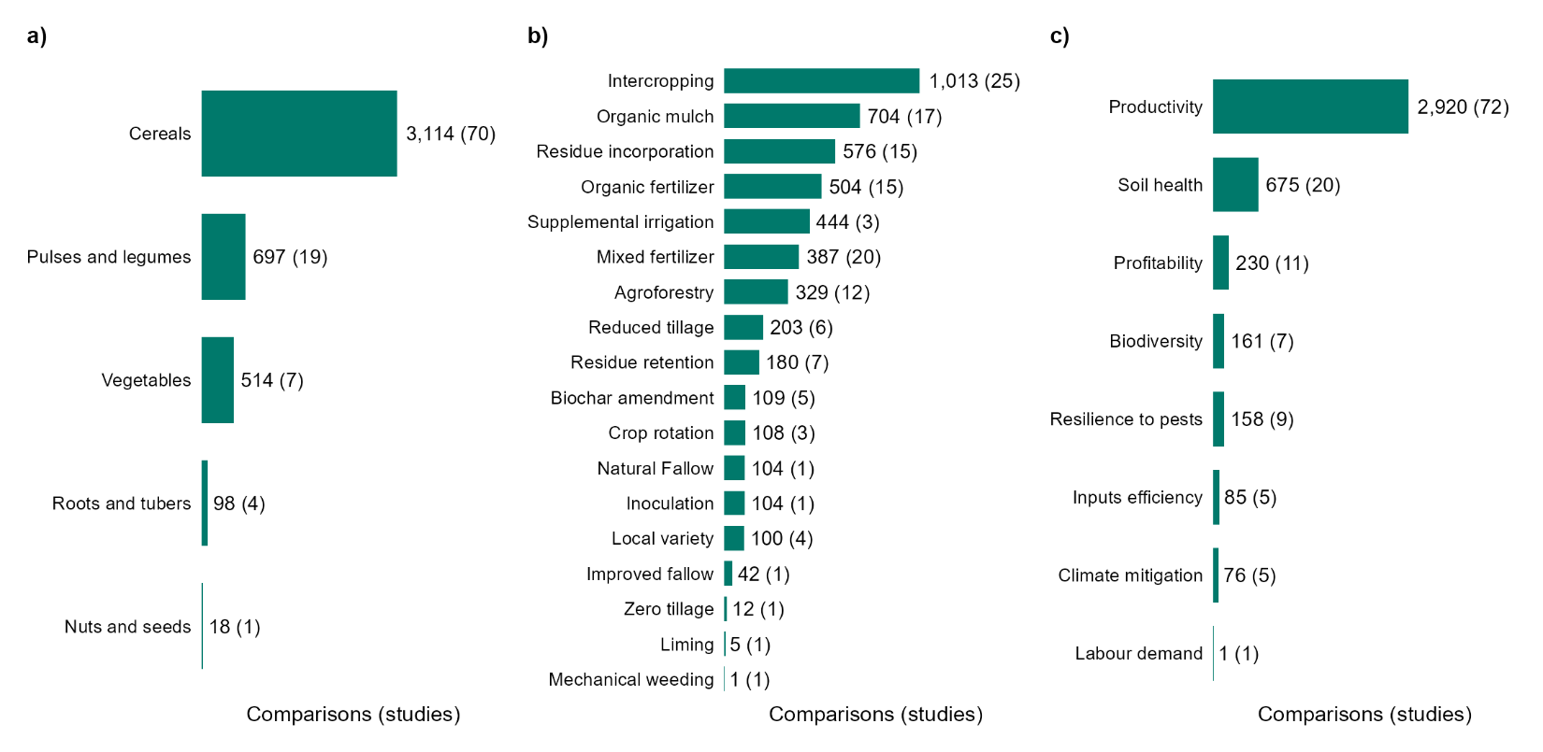

NOTES: Each bar shows the number of comparisons, with the number of studies in parentheses. Bars are ordered by the number of comparisons. One study can contribute to several bars, so the number of studies in the bars adds up to more than the total number of studies. The same applies to comparisons that test more than one practice, which are counted under each practice. Food groups refer to the crop measured, or to the crops of the system when the outcome is measured at system level. The figure includes all comparisons used in the analysis for the high-priority areas of Scenario 2A, whatever the strength of evidence. SOURCE: Agroecology Evidence Hub.

FIGURE 2A.S3. Effects of all AE/RA practices on eight dimensions of farm performance, by food group, in the high-priority areas of Scenario 2A in Kenya.
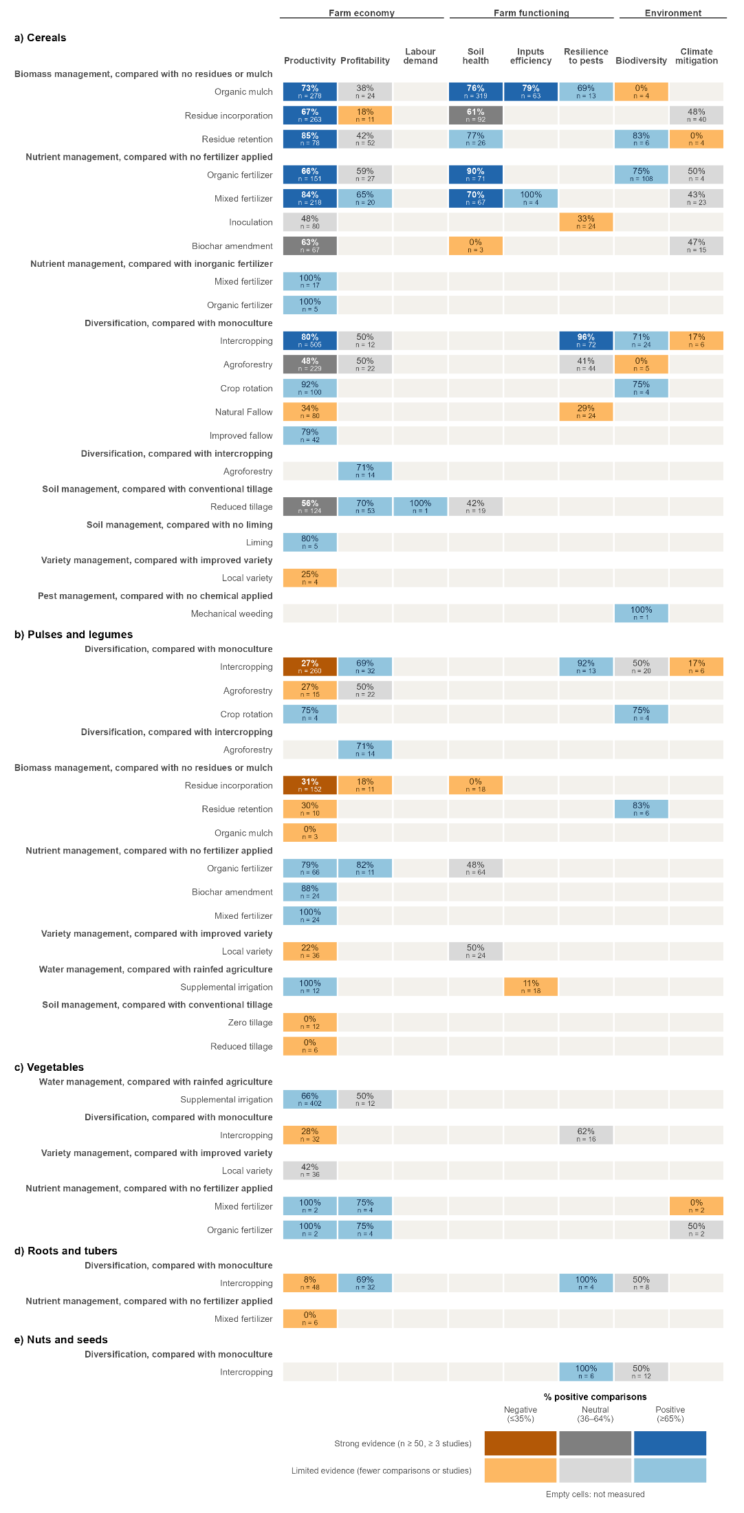

NOTES: Results for a) cereals, b) pulses and legumes, c) vegetables, d) roots and tubers, and e) nuts and seeds. Each row is an AE/RA practice compared with the conventional practice named in the bold heading above it, and each column is a dimension of farm performance, grouped into farm economy, farm functioning and environment. The percentage in each cell is the share of comparisons in which the AE/RA practice improved that dimension, and n is the number of comparisons. Blue cells show a positive effect (at least 65% of comparisons improved), grey cells a neutral effect (36–64% of comparisons improved) and orange cells a negative effect (35% or fewer comparisons improved). Darker shades show strong evidence (at least 50 comparisons from at least three studies) and lighter shades limited evidence. Empty cells mean that no study measured that dimension. Practices with strong evidence for at least one dimension are also shown in Figure 2A.2. SOURCE: Agroecology Evidence Hub.

TABLE 2A.S3. Effects of organic mulch compared with no mulch on a) cereal productivity, b) soil health in cereal systems, and c) inputs efficiency in cereal systems in the high-priority areas of Scenario 2A in Kenya. Positive, neutral and negative comparisons are those in which organic mulch improved, did not change or worsened the outcome compared with fields without mulch. Productivity results are shown by measured crop, and soil health and inputs efficiency results by main crop, in all cases with the companion species, the type of organic mulch and the outcome measured. A missing companion species indicates a sole crop.
a) Cereal productivity, by measured crop, companion species, type of organic mulch, and outcome measured.
Measured crop | Companion species | Organic mulch | Outcome measured | Studies | Comparisons | Positive comparisons | Neutral comparisons | Negative comparisons | % positive comparisons
Maize | - | Mulch (Other Materials) | Crop Yield | 1 | 32 | 10 | 0 | 22 | 31
Maize | - | Mulch (Unspecified Plants) | Crop Residue Yield | 1 | 2 | 2 | 0 | 0 | 100
Maize | - | Mulch (Unspecified Plants) | Crop Yield | 5 | 32 | 22 | 0 | 10 | 69
Maize | Crotalaria ochroleuca | Mulch Herb (N fixing) | Biomass Yield | 1 | 4 | 2 | 0 | 2 | 50
Maize | Velvet Bean | Mulch Herb (N fixing) | Crop Residue Yield | 1 | 4 | 1 | 0 | 3 | 25
Maize | - | Mulch Herb (N fixing) | Crop Yield | 1 | 72 | 66 | 0 | 6 | 92
Maize | Crotalaria ochroleuca | Mulch Herb (N fixing) | Crop Yield | 1 | 8 | 8 | 0 | 0 | 100
Maize | Velvet Bean | Mulch Herb (N fixing) | Crop Yield | 1 | 8 | 2 | 1 | 5 | 25
Maize | Common Bean | Mulch Herb (Non-N fixing) | Biomass Yield | 1 | 1 | 0 | 0 | 1 | 0
Maize | - | Mulch Herb (Non-N fixing) | Crop Yield | 2 | 62 | 41 | 0 | 21 | 66
Maize | Common Bean | Mulch Herb (Non-N fixing) | Crop Yield | 1 | 1 | 0 | 0 | 1 | 0
Maize | - | Tree Prunings Mulched (Non-N fixing) | Biomass Yield | 1 | 12 | 12 | 0 | 0 | 100
Maize | - | Tree Prunings Mulched (Non-N fixing) | Crop Yield | 1 | 12 | 10 | 2 | 0 | 83
Wheat | - | Mulch (Unspecified Plants) | Biomass Yield | 1 | 4 | 4 | 0 | 0 | 100
Wheat | - | Mulch (Unspecified Plants) | Crop Yield | 1 | 4 | 4 | 0 | 0 | 100
Wheat | - | Mulch (Unspecified Plants) + Plastic Mulch | Biomass Yield | 1 | 8 | 7 | 0 | 1 | 88
Wheat | - | Mulch (Unspecified Plants) + Plastic Mulch | Crop Yield | 1 | 8 | 8 | 0 | 0 | 100
Wheat | - | Mulch Herb (Non-N fixing) | Biomass Yield | 1 | 2 | 2 | 0 | 0 | 100
Wheat | - | Mulch Herb (Non-N fixing) | Crop Yield | 1 | 2 | 2 | 0 | 0 | 100
b) Soil health in cereal systems, by main crop, companion species, type of organic mulch, and outcome measured.
Main crop | Companion species | Organic mulch | Outcome measured | Studies | Comparisons | Positive comparisons | Neutral comparisons | Negative comparisons | % positive comparisons
Maize | - | Mulch (Unspecified Plants) | Runoff | 1 | 4 | 4 | 0 | 0 | 100
Maize | - | Mulch (Unspecified Plants) | Soil Moisture | 1 | 41 | 31 | 0 | 10 | 76
Maize | - | Mulch (Unspecified Plants) | Soil Organic Carbon | 1 | 4 | 0 | 0 | 4 | 0
Maize | - | Mulch (Unspecified Plants) | Soil Total Nitrogen | 1 | 4 | 0 | 0 | 4 | 0
Maize | - | Tree Prunings Mulched (Non-N fixing) | Soil Organic Carbon | 1 | 8 | 8 | 0 | 0 | 100
Maize | - | Tree Prunings Mulched (Non-N fixing) | Soil Total Nitrogen | 1 | 8 | 8 | 0 | 0 | 100
Wheat | - | Mulch (Unspecified Plants) | Soil Organic Carbon | 1 | 1 | 1 | 0 | 0 | 100
Wheat | - | Mulch (Unspecified Plants) | Soil Total Nitrogen | 1 | 1 | 1 | 0 | 0 | 100
Wheat | - | Mulch (Unspecified Plants) + Plastic Mulch | Soil Organic Carbon | 1 | 2 | 2 | 0 | 0 | 100
Wheat | - | Mulch (Unspecified Plants) + Plastic Mulch | Soil Total Nitrogen | 1 | 2 | 2 | 0 | 0 | 100
Wheat | - | Mulch Herb (Non-N fixing) | Soil Moisture | 1 | 244 | 186 | 2 | 56 | 76
c) Inputs efficiency in cereal systems, by main crop, companion species, type of organic mulch, and outcome measured.
Main crop | Companion species | Organic mulch | Outcome measured | Studies | Comparisons | Positive comparisons | Neutral comparisons | Negative comparisons | % positive comparisons
Maize | - | Mulch (Unspecified Plants) | Water Use Efficiency | 1 | 5 | 4 | 0 | 1 | 80
Maize | - | Mulch Herb (Non-N fixing) | Water Use Efficiency | 1 | 6 | 6 | 0 | 0 | 100
Wheat | - | Mulch (Unspecified Plants) | Water Use Efficiency | 1 | 16 | 12 | 0 | 4 | 75
Wheat | - | Mulch (Unspecified Plants) + Plastic Mulch | Water Use Efficiency | 1 | 32 | 24 | 0 | 8 | 75
Wheat | - | Mulch Herb (Non-N fixing) | Water Use Efficiency | 1 | 4 | 4 | 0 | 0 | 100

TABLE 2A.S4. Effects of residue incorporation compared with residue removal on a) cereal productivity, and b) soil health in cereal systems in the high-priority areas of Scenario 2A in Kenya. Positive, neutral and negative comparisons are those in which incorporating crop residues or tree prunings into the soil improved, did not change or worsened the outcome compared with fields where residues were removed or grazed by livestock. Productivity results are shown by measured crop, and soil health results by main crop, in all cases with the companion species, the type of residue and the outcome measured. Residues are classified by whether they came from a nitrogen-fixing plant. A missing companion species indicates a sole crop.
a) Cereal productivity, by measured crop, companion species, type of residue incorporated, and outcome measured.
Measured crop | Companion species | Residues type | Outcome measured | Studies | Comparisons | Positive comparisons | Neutral comparisons | Negative comparisons | % positive comparisons
Maize | Crotalaria ochroleuca | Crop Residue Incorporation (N fixing) | Biomass Yield | 1 | 4 | 3 | 1 | 0 | 75
Maize | Velvet Bean | Crop Residue Incorporation (N fixing) | Crop Residue Yield | 1 | 4 | 3 | 0 | 1 | 75
Maize | Crotalaria ochroleuca | Crop Residue Incorporation (N fixing) | Crop Yield | 1 | 8 | 8 | 0 | 0 | 100
Maize | Velvet Bean | Crop Residue Incorporation (N fixing) | Crop Yield | 1 | 8 | 5 | 1 | 2 | 62
Maize | - | Crop Residue Incorporation (N fixing) | Crop Yield | 1 | 2 | 2 | 0 | 0 | 100
Maize | Common Bean | Crop Residue Incorporation (Non-N fixing) | Biomass Yield | 1 | 1 | 1 | 0 | 0 | 100
Maize | - | Crop Residue Incorporation (Non-N fixing) | Crop Yield | 3 | 41 | 21 | 0 | 20 | 51
Maize | Common Bean | Crop Residue Incorporation (Non-N fixing) | Crop Yield | 1 | 1 | 0 | 0 | 1 | 0
Maize | Pigeon Pea | Crop Residue Incorporation (Unspecified) | Biomass Yield | 1 | 24 | 23 | 1 | 0 | 96
Maize | - | Crop Residue Incorporation (Unspecified) | Biomass Yield | 1 | 21 | 12 | 0 | 9 | 57
Maize | Pigeon Pea | Crop Residue Incorporation (Unspecified) | Crop Yield | 1 | 24 | 18 | 1 | 5 | 75
Maize | - | Crop Residue Incorporation (Unspecified) | Crop Yield | 1 | 21 | 12 | 0 | 9 | 57
Maize | - | Tree Prunings Incorporated (N fixing) | Crop Yield | 1 | 64 | 41 | 1 | 22 | 64
Maize | - | Tree Prunings Incorporated (Non-N fixing) | Crop Yield | 2 | 20 | 20 | 0 | 0 | 100
Maize | Common Bean + Leucaena leucocephala | Tree Prunings Incorporated (Unspecified) | Crop Residue Yield | 1 | 10 | 3 | 0 | 7 | 30
Maize | Common Bean + Leucaena leucocephala | Tree Prunings Incorporated (Unspecified) | Crop Yield | 1 | 10 | 3 | 0 | 7 | 30
b) Soil health in cereal systems, by main crop, companion species, type of residue incorporated, and outcome measured.
Main crop | Companion species | Residues type | Outcome measured | Studies | Comparisons | Positive comparisons | Neutral comparisons | Negative comparisons | % positive comparisons
Maize | - | Crop Residue Incorporation (N fixing) | Soil Organic Carbon | 1 | 2 | 2 | 0 | 0 | 100
Maize | - | Crop Residue Incorporation (N fixing) | Soil Total Nitrogen | 1 | 2 | 2 | 0 | 0 | 100
Maize | - | Crop Residue Incorporation (Non-N fixing) | Effective Cation Exchange Capacity | 1 | 4 | 3 | 0 | 1 | 75
Maize | - | Crop Residue Incorporation (Non-N fixing) | Soil Moisture | 1 | 4 | 2 | 0 | 2 | 50
Maize | - | Crop Residue Incorporation (Non-N fixing) | Soil NH4 | 1 | 4 | 1 | 0 | 3 | 25
Maize | - | Crop Residue Incorporation (Non-N fixing) | Soil NO3 | 1 | 4 | 4 | 0 | 0 | 100
Maize | - | Crop Residue Incorporation (Non-N fixing) | Soil Organic Carbon | 3 | 13 | 5 | 0 | 8 | 38
Maize | - | Crop Residue Incorporation (Non-N fixing) | Soil Total Nitrogen | 2 | 5 | 2 | 1 | 2 | 40
Maize | - | Crop Residue Incorporation (Unspecified) | Soil NH4 | 1 | 4 | 1 | 0 | 3 | 25
Maize | - | Crop Residue Incorporation (Unspecified) | Soil NO3 | 1 | 4 | 0 | 0 | 4 | 0
Maize | - | Tree Prunings Incorporated (N fixing) | Soil Organic Carbon | 1 | 3 | 3 | 0 | 0 | 100
Maize | - | Tree Prunings Incorporated (N fixing) | Soil Total Nitrogen | 1 | 3 | 3 | 0 | 0 | 100
Maize | - | Tree Prunings Incorporated (Non-N fixing) | Effective Cation Exchange Capacity | 1 | 4 | 4 | 0 | 0 | 100
Maize | - | Tree Prunings Incorporated (Non-N fixing) | Soil Moisture | 1 | 8 | 4 | 0 | 4 | 50
Maize | - | Tree Prunings Incorporated (Non-N fixing) | Soil NH4 | 1 | 8 | 4 | 2 | 2 | 50
Maize | - | Tree Prunings Incorporated (Non-N fixing) | Soil NO3 | 1 | 8 | 8 | 0 | 0 | 100
Maize | - | Tree Prunings Incorporated (Non-N fixing) | Soil Organic Carbon | 1 | 4 | 3 | 1 | 0 | 75
Maize | - | Tree Prunings Incorporated (Non-N fixing) | Soil Total Nitrogen | 1 | 8 | 5 | 3 | 0 | 62

TABLE 2A.S5. Effects of residue retention compared with residue removal on cereal productivity in the high-priority areas of Scenario 2A in Kenya. Positive, neutral and negative comparisons are those in which retaining crop residues or tree prunings in the field improved, did not change or worsened the outcome compared with fields where residues were removed or grazed by livestock. Residue retention covers studies that kept residues in the field without specifying whether they were left on the surface or incorporated into the soil. Results are shown by measured crop, companion species, type of residue and outcome measured. Residues are classified by whether they came from a nitrogen-fixing plant. Crop residue yield refers to the stover or straw produced, and a missing companion species indicates a sole crop.
Measured crop | Companion species | Residues type | Outcome measured | Studies | Comparisons | Positive comparisons | Neutral comparisons | Negative comparisons | % positive comparisons
Maize | - | Crop Residue Unresolved (Non-N fixing) | Crop Residue Yield | 1 | 4 | 2 | 0 | 2 | 50
Maize | - | Crop Residue Unresolved (Non-N fixing) | Crop Yield | 1 | 4 | 2 | 0 | 2 | 50
Maize | Leucaena leucocephala + Mung Bean | Tree Prunings Applied (N fixing) | Crop Yield | 1 | 6 | 6 | 0 | 0 | 100
Sorghum | - | Tree Prunings Applied (N fixing) | Crop Residue Yield | 1 | 40 | 32 | 0 | 8 | 80
Sorghum | - | Tree Prunings Applied (N fixing) | Crop Yield | 1 | 24 | 24 | 0 | 0 | 100

TABLE 2A.S6. Effects of organic fertilizers compared with no fertilizer on a) cereal productivity, and b) soil health in cereal systems in the high-priority areas of Scenario 2A in Kenya. Positive, neutral and negative comparisons are those in which organic fertilizer improved, did not change or worsened the outcome compared with unfertilized fields. Productivity results are shown by measured crop, and soil health results by main crop, in all cases with the companion species, the type of organic input and the outcome measured. Organic (Other) refers to sawdust, and a missing companion species indicates a sole crop.
a) Cereal productivity, by measured crop, companion species, type of organic input, and outcome measured.
Measured crop | Companion species | Organic input | Outcome measured | Studies | Comparisons | Positive comparisons | Neutral comparisons | Negative comparisons | % positive comparisons
Maize | - | Biosolids | Crop Yield | 1 | 3 | 3 | 0 | 0 | 100
Maize | - | Compost | Crop Yield | 2 | 33 | 32 | 0 | 1 | 97
Maize | - | Manure | Biomass Yield | 1 | 4 | 4 | 0 | 0 | 100
Maize | Common Bean + Leucaena leucocephala | Manure | Crop Residue Yield | 1 | 10 | 1 | 0 | 9 | 10
Maize | - | Manure | Crop Residue Yield | 1 | 2 | 1 | 0 | 1 | 50
Maize | - | Manure | Crop Yield | 6 | 17 | 15 | 1 | 1 | 88
Maize | Common Bean + Leucaena leucocephala | Manure | Crop Yield | 1 | 10 | 1 | 0 | 9 | 10
Maize | - | Organic (Other) | Crop Yield | 1 | 36 | 12 | 0 | 24 | 33
Sorghum | - | Manure | Crop Residue Yield | 2 | 22 | 18 | 0 | 4 | 82
Sorghum | - | Manure | Crop Yield | 2 | 14 | 12 | 0 | 2 | 86
b) Soil health in cereal systems, by main crop, companion species, type of organic input, and outcome measured.
Main crop | Companion species | Organic input | Outcome measured | Studies | Comparisons | Positive comparisons | Neutral comparisons | Negative comparisons | % positive comparisons
Maize | - | Compost | Soil NH4 | 1 | 10 | 10 | 0 | 0 | 100
Maize | - | Compost | Soil NO3 | 1 | 10 | 10 | 0 | 0 | 100
Maize | - | Compost | Soil Organic Carbon | 1 | 10 | 10 | 0 | 0 | 100
Maize | - | Compost | Soil Total Nitrogen | 1 | 10 | 10 | 0 | 0 | 100
Maize | - | Manure | Soil NH4 | 1 | 2 | 2 | 0 | 0 | 100
Maize | - | Manure | Soil NO3 | 1 | 2 | 2 | 0 | 0 | 100
Maize | - | Manure | Soil Organic Carbon | 3 | 8 | 8 | 0 | 0 | 100
Maize | - | Manure | Soil Organic Carbon (Change) | 1 | 1 | 1 | 0 | 0 | 100
Maize | - | Manure | Soil Total Nitrogen | 4 | 10 | 7 | 2 | 1 | 70
Sorghum | - | Manure | Soil Organic Carbon | 1 | 4 | 2 | 0 | 2 | 50
Sorghum | - | Manure | Soil Total Nitrogen | 1 | 4 | 2 | 1 | 1 | 50

TABLE 2A.S7. Effects of mixed fertilizers, which combine an organic input or biochar with mineral fertilizer, compared with no fertilizer on a) cereal productivity, and b) soil health in cereal systems in the high-priority areas of Scenario 2A in Kenya. Positive, neutral and negative comparisons are those in which mixed fertilizer improved, did not change or worsened the outcome compared with unfertilized fields. Productivity results are shown by measured crop, and soil health results by main crop, in all cases with the companion species, the type of mixed input and the outcome measured. Organic (Other) refers to sawdust, and a missing companion species indicates a sole crop.
a) Cereal productivity, by measured crop, companion species, type of mixed input, and outcome measured.
Measured crop | Companion species | Mixed input | Outcome measured | Studies | Comparisons | Positive comparisons | Neutral comparisons | Negative comparisons | % positive comparisons
Maize | - | Biochar + Inorganic Fertilizer | Crop Yield | 3 | 41 | 31 | 0 | 10 | 76
Maize | Soybean | Biochar + Inorganic Fertilizer + Inorganic Micronutrients Inputs | Crop Yield | 1 | 26 | 26 | 0 | 0 | 100
Maize | - | Inorganic Fertilizer + Inorganic Micronutrients Inputs + Manure | Crop Yield | 1 | 2 | 2 | 0 | 0 | 100
Maize | - | Inorganic Fertilizer + Manure | Biomass Yield | 3 | 26 | 25 | 1 | 0 | 96
Maize | - | Inorganic Fertilizer + Manure | Crop Yield | 6 | 35 | 34 | 0 | 1 | 97
Maize | - | Inorganic Fertilizer + Organic (Other) | Crop Yield | 1 | 36 | 22 | 0 | 14 | 61
Sorghum | - | Inorganic Fertilizer + Manure | Crop Residue Yield | 2 | 32 | 24 | 0 | 8 | 75
Sorghum | - | Inorganic Fertilizer + Manure | Crop Yield | 2 | 20 | 19 | 1 | 0 | 95
b) Soil health in cereal systems, by main crop, companion species, type of mixed input, and outcome measured.
Main crop | Companion species | Mixed input | Outcome measured | Studies | Comparisons | Positive comparisons | Neutral comparisons | Negative comparisons | % positive comparisons
Maize | - | Biochar + Inorganic Fertilizer | Soil Organic Carbon | 1 | 3 | 0 | 0 | 3 | 0
Maize | - | Inorganic Fertilizer + Manure | Soil Moisture | 1 | 41 | 30 | 0 | 11 | 73
Maize | - | Inorganic Fertilizer + Manure | Soil Organic Carbon | 3 | 7 | 6 | 0 | 1 | 86
Maize | - | Inorganic Fertilizer + Manure | Soil Organic Carbon (Change) | 1 | 1 | 1 | 0 | 0 | 100
Maize | - | Inorganic Fertilizer + Manure | Soil Total Nitrogen | 3 | 7 | 6 | 0 | 1 | 86
Sorghum | - | Inorganic Fertilizer + Manure | Soil Organic Carbon | 1 | 4 | 1 | 0 | 3 | 25
Sorghum | - | Inorganic Fertilizer + Manure | Soil Total Nitrogen | 1 | 4 | 3 | 0 | 1 | 75

TABLE 2A.S8. Effects of intercropping compared with monoculture on a) cereal productivity, and b) resilience to pests and weeds in cereal systems in the high-priority areas of Scenario 2A in Kenya. Positive, neutral and negative comparisons are those in which intercropping improved, did not change or worsened the outcome compared with the cereal grown alone. For resilience to pests and weeds, a decrease in the number of Striga plants or thrips, or in the damage caused by stem borers, was counted as an improvement. Productivity results are shown by measured crop, and resilience results by main crop, in all cases with the companion species, the intercrop type and the outcome measured. Companion species are the species grown with the cereal in the intercrop. Intercrops are classified as push-pull systems, in which cereals are intercropped with Desmodium spp. and sometimes bordered by Napier grass or Brachiaria, intercrops with another nitrogen-fixing species, and intercrops without a nitrogen-fixing species.
a) Cereal productivity, by measured crop, companion species, intercrop type, and outcome measured.
Measured crop | Companion species | Intercrop type | Outcome measured | Studies | Comparisons | Positive comparisons | Neutral comparisons | Negative comparisons | % positive comparisons
Finger Millet | Desmodium spp. | Push-pull | Crop Residue Yield | 1 | 3 | 3 | 0 | 0 | 100
Finger Millet | Desmodium spp. | Push-pull | Crop Yield | 1 | 4 | 4 | 0 | 0 | 100
Maize | Brachiaria hybrid + Desmodium spp. | Push-pull | Crop Yield | 1 | 56 | 56 | 0 | 0 | 100
Maize | Desmodium spp. | Push-pull | Crop Residue Yield | 1 | 1 | 1 | 0 | 0 | 100
Maize | Desmodium spp. | Push-pull | Crop Yield | 4 | 38 | 37 | 0 | 1 | 97
Maize | Desmodium spp. + Napier Grass | Push-pull | Crop Yield | 1 | 74 | 74 | 0 | 0 | 100
Maize | Common Bean | With a nitrogen-fixing species | Biomass Yield | 1 | 3 | 3 | 0 | 0 | 100
Maize | Common Bean | With a nitrogen-fixing species | Crop Residue Yield | 1 | 4 | 2 | 0 | 2 | 50
Maize | Common Bean | With a nitrogen-fixing species | Crop Yield | 4 | 46 | 36 | 7 | 3 | 78
Maize | Common Bean + Pearl Millet | With a nitrogen-fixing species | Crop Yield | 1 | 4 | 0 | 0 | 4 | 0
Maize | Common Bean + Pearl Millet + Sorghum | With a nitrogen-fixing species | Crop Yield | 1 | 4 | 0 | 0 | 4 | 0
Maize | Common Bean + Soybean | With a nitrogen-fixing species | Crop Yield | 1 | 9 | 9 | 0 | 0 | 100
Maize | Cowpea | With a nitrogen-fixing species | Crop Residue Yield | 1 | 2 | 2 | 0 | 0 | 100
Maize | Cowpea | With a nitrogen-fixing species | Crop Yield | 3 | 21 | 20 | 0 | 1 | 95
Maize | Crotalaria spp. | With a nitrogen-fixing species | Biomass Yield | 1 | 12 | 8 | 1 | 3 | 67
Maize | Crotalaria spp. | With a nitrogen-fixing species | Crop Yield | 2 | 40 | 38 | 1 | 1 | 95
Maize | Groundnut | With a nitrogen-fixing species | Crop Residue Yield | 1 | 4 | 3 | 0 | 1 | 75
Maize | Groundnut | With a nitrogen-fixing species | Crop Yield | 3 | 26 | 20 | 0 | 6 | 77
Maize | Mung Bean | With a nitrogen-fixing species | Crop Residue Yield | 1 | 2 | 0 | 0 | 2 | 0
Maize | Mung Bean | With a nitrogen-fixing species | Crop Yield | 2 | 20 | 15 | 1 | 4 | 75
Maize | Pigeon Pea | With a nitrogen-fixing species | Biomass Yield | 1 | 36 | 31 | 3 | 2 | 86
Maize | Pigeon Pea | With a nitrogen-fixing species | Crop Yield | 2 | 44 | 25 | 4 | 15 | 57
Maize | Velvet Bean | With a nitrogen-fixing species | Crop Residue Yield | 1 | 8 | 4 | 0 | 4 | 50
Maize | Velvet Bean | With a nitrogen-fixing species | Crop Yield | 1 | 16 | 7 | 2 | 7 | 44
Maize | Pearl Millet | Without a nitrogen-fixing species | Crop Yield | 1 | 4 | 0 | 0 | 4 | 0
Maize | Sorghum | Without a nitrogen-fixing species | Crop Yield | 1 | 4 | 1 | 0 | 3 | 25
Maize | Tomato | Without a nitrogen-fixing species | Crop Yield | 1 | 2 | 1 | 0 | 1 | 50
Pearl Millet | Common Bean + Maize | With a nitrogen-fixing species | Crop Yield | 1 | 4 | 0 | 0 | 4 | 0
Pearl Millet | Common Bean + Maize + Sorghum | With a nitrogen-fixing species | Crop Yield | 1 | 4 | 0 | 0 | 4 | 0
Pearl Millet | Maize | Without a nitrogen-fixing species | Crop Yield | 1 | 4 | 0 | 0 | 4 | 0
Sorghum | Desmodium spp. | Push-pull | Crop Yield | 1 | 6 | 6 | 0 | 0 | 100
b) Resilience to pests and weeds in cereal intercrops, by main crop, companion species, intercrop type, and outcome measured.
Main crop | Companion species | Intercrop type | Outcome measured | Studies | Comparisons | Positive comparisons | Neutral comparisons | Negative comparisons | % positive comparisons
Baby Corn | Common Bean | With a nitrogen-fixing species | Resilience to insect pests (thrips) | 1 | 2 | 2 | 0 | 0 | 100
Baby Corn | Common Bean + Sunflower | With a nitrogen-fixing species | Resilience to insect pests (thrips) | 1 | 2 | 2 | 0 | 0 | 100
Finger Millet | Desmodium spp. | Push-pull | Resilience to weeds (Striga) | 1 | 5 | 5 | 0 | 0 | 100
Maize | Desmodium spp. | Push-pull | Resilience to insect pests (stem borers) | 1 | 16 | 16 | 0 | 0 | 100
Maize | Desmodium spp. | Push-pull | Resilience to weeds (Striga) | 1 | 4 | 4 | 0 | 0 | 100
Maize | Desmodium spp. + Napier Grass | Push-pull | Resilience to insect pests (stem borers) | 1 | 13 | 13 | 0 | 0 | 100
Maize | Desmodium spp. + Napier Grass | Push-pull | Resilience to weeds (Striga) | 1 | 12 | 12 | 0 | 0 | 100
Maize | Cowpea | With a nitrogen-fixing species | Resilience to insect pests (stem borers) | 1 | 4 | 3 | 0 | 1 | 75
Maize | Cowpea | With a nitrogen-fixing species | Resilience to weeds (Striga) | 1 | 1 | 1 | 0 | 0 | 100
Maize | Tomato | Without a nitrogen-fixing species | Resilience to insect pests (thrips) | 1 | 4 | 2 | 0 | 2 | 50
Sorghum | Desmodium spp. | Push-pull | Resilience to insect pests (stem borers) | 1 | 6 | 6 | 0 | 0 | 100
Sorghum | Desmodium spp. | Push-pull | Resilience to weeds (Striga) | 1 | 3 | 3 | 0 | 0 | 100

TABLE 2A.S9. Effects of a) biochar amendment compared with no fertilizer, b) agroforestry compared with monoculture, and c) d) reduced tillage compared with conventional tillage on cereal productivity in the high-priority areas of Scenario 2A in Kenya. Positive, neutral and negative comparisons are those in which the AE/RA practice improved, did not change or worsened cereal productivity compared with the conventional practice. Results are shown by measured crop, companion species, type of practice and outcome measured. A missing companion species indicates a sole crop.
a) Biochar amendment compared with no fertilizer, by measured crop, companion species, type of biochar amendment, and outcome measured.
Measured crop | Companion species | Biochar amendment | Outcome measured | Studies | Comparisons | Positive comparisons | Neutral comparisons | Negative comparisons | % positive comparisons
Maize | - | Biochar | Crop Yield | 3 | 41 | 18 | 0 | 23 | 44
Maize | Soybean | Biochar | Crop Yield | 1 | 26 | 24 | 0 | 2 | 92
b) Agroforestry compared with monoculture, by measured crop, companion species, agroforestry type, and outcome measured.
Measured crop | Companion species | Agroforestry type | Outcome measured | Studies | Comparisons | Positive comparisons | Neutral comparisons | Negative comparisons | % positive comparisons
Maize | Cordia africana + Faidherbia albida + Grevillea robusta + Vachellia seyal + Vachellia xanthophloea | Alleycropping (N fixing and Non-N fixing) | Crop Yield | 1 | 3 | 2 | 0 | 1 | 67
Maize | Sesbania sesban | Alleycropping (N fixing) | Biomass Yield | 1 | 60 | 29 | 0 | 31 | 48
Maize | Sesbania sesban | Alleycropping (N fixing) | Crop Yield | 1 | 20 | 9 | 0 | 11 | 45
Maize | Gliricidia sepium | Alleycropping (N fixing) | Crop Yield | 1 | 14 | 6 | 0 | 8 | 43
Maize | Faidherbia albida + Mung Bean | Alleycropping (N fixing) | Crop Yield | 1 | 12 | 1 | 0 | 11 | 8
Maize | Leucaena leucocephala + Mung Bean | Alleycropping (N fixing) | Crop Yield | 1 | 6 | 6 | 0 | 0 | 100
Maize | Croton macrostachyus | Alleycropping (Non-N fixing) | Crop Residue Yield | 1 | 16 | 12 | 0 | 4 | 75
Maize | Markhamia lutea | Alleycropping (Non-N fixing) | Crop Residue Yield | 1 | 16 | 12 | 0 | 4 | 75
Maize | Cowpea + Grevillea robusta | Alleycropping (Non-N fixing) | Crop Residue Yield | 1 | 4 | 0 | 0 | 4 | 0
Maize | Croton macrostachyus | Alleycropping (Non-N fixing) | Crop Yield | 1 | 16 | 14 | 0 | 2 | 88
Maize | Markhamia lutea | Alleycropping (Non-N fixing) | Crop Yield | 1 | 16 | 8 | 1 | 7 | 50
Maize | Cordia africana | Alleycropping (Non-N fixing) | Crop Yield | 1 | 3 | 2 | 0 | 1 | 67
Maize | Faidherbia albida | Alleycropping (N fixing) | Crop Yield | 1 | 3 | 2 | 0 | 1 | 67
Maize | Common Bean + Leucaena leucocephala | Living Fences or Hedgerows | Crop Residue Yield | 1 | 20 | 4 | 0 | 16 | 20
Maize | Common Bean + Leucaena leucocephala | Living Fences or Hedgerows | Crop Yield | 1 | 20 | 4 | 0 | 16 | 20
c) Reduced tillage compared with conventional tillage, by measured crop, companion species, tillage practice, and outcome measured.
Measured crop | Companion species | Tillage practice | Outcome measured | Studies | Comparisons | Positive comparisons | Neutral comparisons | Negative comparisons | % positive comparisons
Maize | - | Reduced or Minimum Tillage | Biomass Yield | 1 | 3 | 0 | 0 | 3 | 0
Maize | Common Bean | Reduced or Minimum Tillage | Biomass Yield | 1 | 2 | 0 | 0 | 2 | 0
Maize | - | Reduced or Minimum Tillage | Crop Yield | 3 | 7 | 4 | 0 | 3 | 57
Maize | Common Bean | Reduced or Minimum Tillage | Crop Yield | 1 | 2 | 0 | 0 | 2 | 0
Sorghum | - | Reduced or Minimum Tillage | Crop Residue Yield | 2 | 68 | 41 | 0 | 27 | 60
Sorghum | - | Reduced or Minimum Tillage | Crop Yield | 2 | 42 | 25 | 1 | 16 | 60

TABLE 2A.S10. Effects of a) intercropping compared with monoculture, and b) residue incorporation compared with residue removal on the productivity of pulses and legumes in the high-priority areas of Scenario 2A in Kenya. Positive, neutral and negative comparisons are those in which the AE/RA practice improved, did not change or worsened the outcome compared with the conventional practice. Results are shown by measured crop, companion species and outcome measured, together with the intercrop type in a), and the type of residue in b). In a), the Area Time Equivalent Ratio measures the productivity of the whole intercrop and not of the legume alone. In b), the conventional practice includes fields where residues were removed or grazed by livestock. A missing companion species indicates a sole crop.
a) Intercropping compared with sole pulse or legume crops, by measured crop, companion species, intercrop type, and outcome measured.
Measured crop | Companion species | Intercrop type | Outcome measured | Studies | Comparisons | Positive comparisons | Neutral comparisons | Negative comparisons | % positive comparisons
Common Bean | Baby Corn | With a nitrogen-fixing species | Crop Yield | 1 | 2 | 0 | 0 | 2 | 0
Common Bean | Baby Corn + Sunflower | With a nitrogen-fixing species | Crop Yield | 1 | 2 | 0 | 0 | 2 | 0
Common Bean | Kale | With a nitrogen-fixing species | Crop Yield | 1 | 2 | 1 | 0 | 1 | 50
Common Bean | Maize | With a nitrogen-fixing species | Crop Yield | 1 | 4 | 2 | 0 | 2 | 50
Common Bean | Maize + Pearl Millet | With a nitrogen-fixing species | Crop Yield | 1 | 4 | 2 | 0 | 2 | 50
Common Bean | Maize + Pearl Millet + Sorghum | With a nitrogen-fixing species | Crop Yield | 1 | 4 | 2 | 0 | 2 | 50
Common Bean | Potato | With a nitrogen-fixing species | Area Time Equivalent Ratio | 1 | 4 | 2 | 0 | 2 | 50
Common Bean | Potato | With a nitrogen-fixing species | Crop Yield | 2 | 4 | 0 | 0 | 4 | 0
Common Bean | Potato + Sunflower | With a nitrogen-fixing species | Crop Yield | 1 | 2 | 0 | 0 | 2 | 0
Common Bean | Sunflower | With a nitrogen-fixing species | Crop Yield | 1 | 2 | 0 | 0 | 2 | 0
Lablab purpureus | Lablab + Potato | With a nitrogen-fixing species | Crop Yield | 1 | 2 | 0 | 0 | 2 | 0
Lablab purpureus | Potato | With a nitrogen-fixing species | Area Time Equivalent Ratio | 1 | 4 | 2 | 0 | 2 | 50
Pigeon Pea | Maize | With a nitrogen-fixing species | Biomass Yield | 1 | 108 | 33 | 2 | 73 | 31
Pigeon Pea | Maize | With a nitrogen-fixing species | Crop Yield | 1 | 108 | 27 | 6 | 75 | 25
Soybean | Maize | With a nitrogen-fixing species | Crop Yield | 1 | 8 | 0 | 0 | 8 | 0
b) Crop residue incorporation compared with residue removal, by measured crop, companion species, type of residue, and outcome measured.
Measured crop | Companion species | Type of residue | Outcome measured | Studies | Comparisons | Positive comparisons | Neutral comparisons | Negative comparisons | % positive comparisons
Common Bean | Leucaena leucocephala | Crop Residue Incorporation (N fixing) | Crop Yield | 1 | 3 | 0 | 0 | 3 | 0
Common Bean | Maize | Crop Residue Incorporation (Non-N fixing) | Biomass Yield | 1 | 2 | 1 | 0 | 1 | 50
Common Bean | Maize | Crop Residue Incorporation (Non-N fixing) | Crop Yield | 1 | 1 | 1 | 0 | 0 | 100
Common Bean | Leucaena leucocephala + Maize | Tree Prunings Incorporated (Unspecified) | Biomass Yield | 1 | 1 | 1 | 0 | 0 | 100
Common Bean | Leucaena leucocephala + Maize | Tree Prunings Incorporated (Unspecified) | Crop Yield | 1 | 1 | 0 | 0 | 1 | 0
Pigeon Pea | Maize | Crop Residue Incorporation (Unspecified) | Biomass Yield | 1 | 72 | 24 | 0 | 48 | 33
Pigeon Pea | Maize | Crop Residue Incorporation (Unspecified) | Crop Yield | 1 | 72 | 20 | 3 | 49 | 28

TABLE 2A.S11. Effects of supplemental drip irrigation compared with rainfed agriculture on the productivity of vegetables in the high-priority areas of Scenario 2A. Positive, neutral and negative comparisons are those in which supplemental drip irrigation improved, did not change or worsened the outcome compared with rainfed agriculture. Results are shown by measured crop, companion species, irrigation method and outcome measured. A missing companion species indicates a sole crop.
Measured crop | Companion species | Irrigation method | Outcome measured | Studies | Comparisons | Positive comparisons | Neutral comparisons | Negative comparisons | % positive comparisons
Cabbage | - | Supplemental drip irrigation | Crop Yield | 1 | 6 | 6 | 0 | 0 | 100
Kale | - | Supplemental drip irrigation | Crop Yield | 1 | 396 | 261 | 17 | 118 | 66

5.2.2. Scenario 2B: Arid pastoral micro-gardens

TABLE 2B.S1. Counties of the high-priority areas of Scenario 2B in Kenya, with the number of screening criteria each county meets and the number of studies and comparisons located within it. Only the 23 arid and semi-arid land (ASAL) counties were assessed. Counties meeting all five criteria are Core Priority counties, and those meeting four complete the high-priority areas. Counties are ordered by the number of comparisons. Some studies reported comparisons located in several sites, which can fall in different counties. These studies and comparisons are counted in each county where they have a site, so the sum of the rows can exceed the total.
County | Criteria met | Studies | Comparisons
Embu | 4 | 12 | 283
Mandera | 5 | 0 | 0
Garissa | 4 | 0 | 0
Isiolo | 4 | 0 | 0
Turkana | 4 | 0 | 0
West Pokot | 4 | 0 | 0
Total | - | 12 | 283

TABLE 2B.S2. Agroecological zones of the high-priority areas of Scenario 2B in Kenya, with the share of the high-priority areas each zone covers and the number of studies and comparisons in each zone. Zones are those of the Global Agro-Ecological Zones (GAEZ v4), and main agroecological zones are those covering at least 10% of the high-priority areas. Zones covering less than 0.1% of the high-priority areas are shown only when they contain evidence. Studies and comparisons are shown for those located within the high-priority areas, and for those added from the same main agroecological zones elsewhere in Kenya and in neighbouring countries. Comparisons were added for this scenario because the evidence within the high-priority areas did not include studies in each main agroecological zone. They were added from the semi-arid lowlands without soil or terrain limitations elsewhere in Kenya, and from the desert or arid zone in Tanzania, as no Kenyan study was located in this zone. Some studies reported comparisons located in several sites, which can fall in different zones. These studies and comparisons are counted in each zone where they have a site, so the sum of the rows can exceed the total.
Agroecological zone | Share of high-priority areas (%) | Main agro ecological zone | Studies (High-priority areas) | Comparisons (High-priority areas) | Studies (Same zones, same country) | Comparisons (Same zones, same country) | Studies (Same zones, neighbouring countries) | Comparisons (Same zones, neighbouring countries)
Tropics, lowland; semi-arid, with soil/terrain limitations | 37.2 | Yes | 7 | 120 | 0 | 0 | 2 | 18
Desert/Arid climate | 31.5 | Yes | 0 | 0 | 0 | 0 | 2 | 18
Tropics, lowland; semi-arid, no soil/terrain limitations | 11 | Yes | 0 | 0 | 1 | 4 | 0 | 0
Tropics, lowland; humid, with soil/terrain limitations | 0.5 | No | 6 | 146 | 0 | 0 | 0 | 0
Tropics, highland; humid, with soil/terrain limitations | 0.3 | No | 2 | 17 | 0 | 0 | 0 | 0
Land with severe soil/terrain limitations | 7 | No | 0 | 0 | 0 | 0 | 0 | 0
Dominantly hydromorphic soils | 7 | No | 0 | 0 | 0 | 0 | 0 | 0
Tropics, lowland; sub-humid, with soil/terrain limitations | 2.6 | No | 0 | 0 | 0 | 0 | 0 | 0
Dominantly water | 1.3 | No | 0 | 0 | 0 | 0 | 0 | 0
Dominantly very steep terrain | 0.8 | No | 0 | 0 | 0 | 0 | 0 | 0
Tropics, lowland; sub-humid, no soil/terrain limitations | 0.5 | No | 0 | 0 | 0 | 0 | 0 | 0
Tropics, lowland; humid, no soil/terrain limitations | 0.1 | No | 0 | 0 | 0 | 0 | 0 | 0
Total | 100 | - | 12 | 283 | 1 | 4 | 2 | 18

FIGURE 2B.S1. Number of studies used in the analysis of Scenario 2B in Kenya, by year of publication.
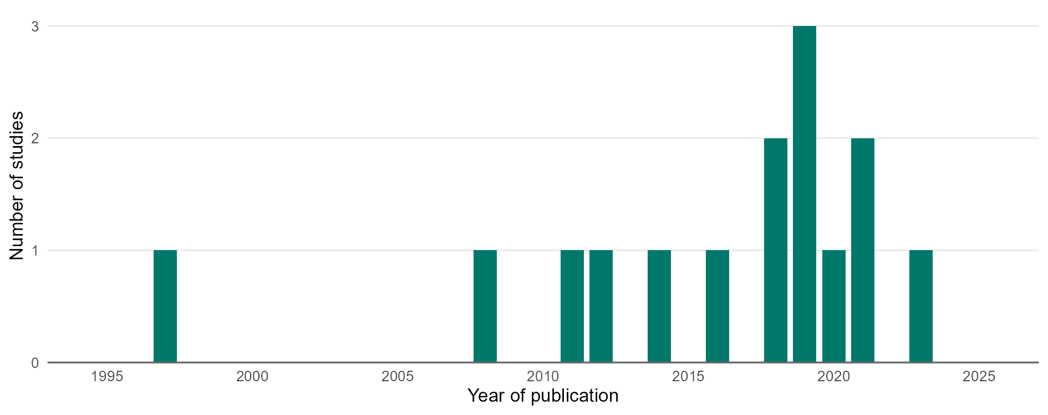

NOTES: The figure includes each study used in the analysis of Scenario 2B, counted once in the year it was published, including the studies located within the high-priority areas and those added from the same main agroecological zones elsewhere in Kenya and Tanzania. A study that reports several sites, seasons or comparisons is counted as one study. The year of publication is not the year the experiment was carried out, which can be several years earlier. SOURCE: Agroecology Evidence Hub.

FIGURE 2B.S2. Number of comparisons and studies by a) food group, b) agroecological or regenerative agricultural (AE/RA) practice, and c) dimension of farm performance used in the analysis of Scenario 2B in Kenya.
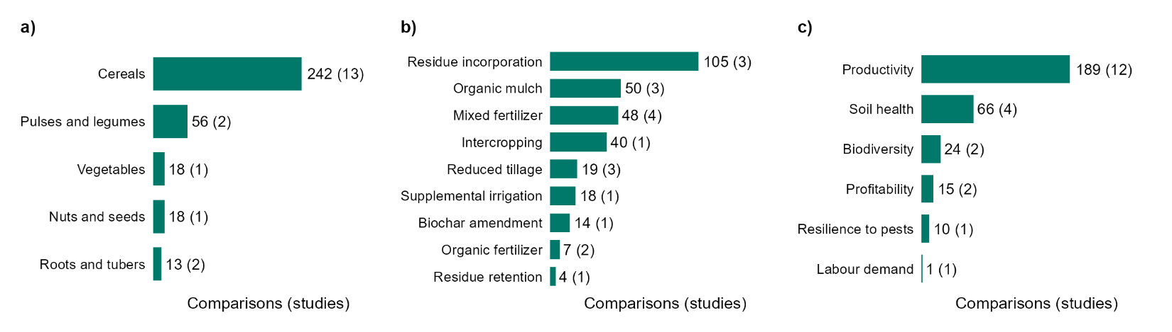

NOTES: Each bar shows the number of comparisons, with the number of studies in parentheses. Bars are ordered by the number of comparisons. One study can contribute to several bars, so the number of studies in the bars adds up to more than the total number of studies. The same applies to comparisons that test more than one practice, which are counted under each practice. Food groups refer to the crop measured, or to the crops of the system when the outcome is measured at system level. The figure includes all comparisons used in the analysis of Scenario 2B, located within the high-priority areas or added from the same main agroecological zones elsewhere in Kenya and Tanzania, whatever the strength of evidence. SOURCE: Agroecology Evidence Hub.

TABLE 2B.S3. Effects of residue incorporation compared with residue removal on a) cereal productivity, and b) soil health in cereal systems in the high-priority areas of Scenario 2B in Kenya. Positive, neutral and negative comparisons are those in which residue incorporation improved, did not change or worsened the outcome compared with fields where residues were removed. Productivity results are shown by measured crop, and soil health results by main crop, in all cases with the companion species, the type of residue incorporated and the outcome measured. A missing companion species indicates a sole crop.
a) Cereal productivity, by measured crop, companion species, type of residue incorporated, and outcome measured.
Measured crop | Companion species | Residues type | Outcome measured | Studies | Comparisons | Positive comparisons | Neutral comparisons | Negative comparisons | % positive comparisons
Maize | - | Crop Residue Incorporation (N fixing) | Crop Yield | 1 | 2 | 2 | 0 | 0 | 100
Maize | - | Crop Residue Incorporation (Non-N fixing) | Crop Yield | 2 | 17 | 10 | 0 | 7 | 59
Maize | - | Tree Prunings Incorporated (N fixing) | Crop Yield | 1 | 32 | 21 | 1 | 10 | 66
b) Soil health in cereal systems, by main crop, companion species, type of residue incorporated, and outcome measured.
Main crop | Companion species | Residues type | Outcome measured | Studies | Comparisons | Positive comparisons | Neutral comparisons | Negative comparisons | % positive comparisons
Maize | - | Crop Residue Incorporation (N fixing) | Soil Organic Carbon | 1 | 2 | 2 | 0 | 0 | 100
Maize | - | Crop Residue Incorporation (N fixing) | Soil Total Nitrogen | 1 | 2 | 2 | 0 | 0 | 100
Maize | - | Crop Residue Incorporation (Non-N fixing) | Soil Moisture | 1 | 4 | 2 | 0 | 2 | 50
Maize | - | Crop Residue Incorporation (Non-N fixing) | Soil NH4 | 1 | 4 | 1 | 0 | 3 | 25
Maize | - | Crop Residue Incorporation (Non-N fixing) | Soil NO3 | 1 | 4 | 4 | 0 | 0 | 100
Maize | - | Crop Residue Incorporation (Non-N fixing) | Soil Organic Carbon | 1 | 1 | 1 | 0 | 0 | 100
Maize | - | Crop Residue Incorporation (Non-N fixing) | Soil Total Nitrogen | 2 | 5 | 2 | 1 | 2 | 40
Maize | - | Tree Prunings Incorporated (Non-N fixing) | Soil Moisture | 1 | 8 | 4 | 0 | 4 | 50
Maize | - | Tree Prunings Incorporated (Non-N fixing) | Soil NH4 | 1 | 8 | 4 | 2 | 2 | 50
Maize | - | Tree Prunings Incorporated (Non-N fixing) | Soil NO3 | 1 | 8 | 8 | 0 | 0 | 100
Maize | - | Tree Prunings Incorporated (Non-N fixing) | Soil Total Nitrogen | 1 | 8 | 5 | 3 | 0 | 62

TABLE 2B.S4. Effects of organic mulch compared with no mulch on a) cereal productivity, and b) soil health in cereal systems in the high-priority areas of Scenario 2B in Kenya. Positive, neutral and negative comparisons are those in which organic mulch improved, did not change or worsened the outcome compared with fields without mulch. Productivity results are shown by measured crop, and soil health results by main crop, in all cases with the companion species, the type of organic mulch and the outcome measured. Mulch (Other Materials) refers to sawdust, and a missing companion species indicates a sole crop.
a) Cereal productivity, by measured crop, companion species, type of organic mulch, and outcome measured.
Measured crop | Companion species | Organic mulch | Outcome measured | Studies | Comparisons | Positive comparisons | Neutral comparisons | Negative comparisons | % positive comparisons
Maize | - | Mulch (Other Materials) | Crop Yield | 1 | 16 | 8 | 0 | 8 | 50
Maize | - | Mulch (Unspecified Plants) | Crop Yield | 1 | 4 | 4 | 0 | 0 | 100
Maize | - | Mulch Herb (Non-N fixing) | Crop Yield | 1 | 24 | 18 | 0 | 6 | 75
b) Soil health in cereal systems, by main crop, companion species, type of organic mulch, and outcome measured.
Main crop | Companion species | Organic mulch | Outcome measured | Studies | Comparisons | Positive comparisons | Neutral comparisons | Negative comparisons | % positive comparisons
Maize | - | Mulch (Unspecified Plants) | Runoff | 1 | 2 | 2 | 0 | 0 | 100
Maize | - | Mulch (Unspecified Plants) | Soil Organic Carbon | 1 | 2 | 0 | 0 | 2 | 0
Maize | - | Mulch (Unspecified Plants) | Soil Total Nitrogen | 1 | 2 | 0 | 0 | 2 | 0

TABLE 2B.S5. Effects of mixed fertilizers, which combine an organic input or biochar with mineral fertilizer, compared with no fertilizer on cereal productivity in the high-priority areas of Scenario 2B in Kenya. Positive, neutral and negative comparisons are those in which mixed fertilizers improved, did not change or worsened cereal productivity compared with no fertilizer. Results are shown by measured crop, companion species, type of mixed input and outcome measured. A missing companion species indicates a sole crop.
Measured crop | Companion species | Mixed input | Outcome measured | Studies | Comparisons | Positive comparisons | Neutral comparisons | Negative comparisons | % positive comparisons
Maize | Soybean | Biochar + Inorganic Fertilizer + Inorganic Micronutrients Inputs | Crop Yield | 1 | 6 | 6 | 0 | 0 | 100
Maize | - | Inorganic Fertilizer + Manure | Biomass Yield | 1 | 16 | 15 | 1 | 0 | 94
Maize | - | Inorganic Fertilizer + Manure | Crop Yield | 2 | 17 | 16 | 0 | 1 | 94

TABLE 2B.S6. Effects of reduced tillage compared with conventional tillage on a) cereal productivity, b) profitability of cereal systems, and c) labour demand in cereal systems in the high-priority areas of Scenario 2B in Kenya. Positive, neutral and negative comparisons are those in which reduced tillage improved, did not change or worsened the outcome compared with conventional tillage. For profitability, lower variable costs count as an improvement, and for labour demand, fewer labour hours count as an improvement. Productivity results are shown by measured crop, and profitability and labour demand results by main crop, in all cases with the companion species, the tillage practice and the outcome measured. A missing companion species indicates a sole crop.
a) Cereal productivity, by measured crop, companion species, tillage practice, and outcome measured.
Measured crop | Companion species | Tillage practice | Outcome measured | Studies | Comparisons | Positive comparisons | Neutral comparisons | Negative comparisons | % positive comparisons
Maize | - | Reduced or Minimum Tillage | Crop Yield | 3 | 7 | 6 | 0 | 1 | 86
Pearl Millet | - | Reduced or Minimum Tillage | Crop Yield | 1 | 4 | 4 | 0 | 0 | 100
Sorghum | - | Reduced or Minimum Tillage | Crop Yield | 1 | 4 | 4 | 0 | 0 | 100
b) Profitability of cereal systems, by main crop, companion species, tillage practice, and outcome measured.
Main crop | Companion species | Tillage practice | Outcome measured | Studies | Comparisons | Positive comparisons | Neutral comparisons | Negative comparisons | % positive comparisons
Maize | - | Reduced or Minimum Tillage | Gross Margin | 1 | 1 | 1 | 0 | 0 | 100
Maize | - | Reduced or Minimum Tillage | Gross Return | 1 | 1 | 1 | 0 | 0 | 100
Maize | - | Reduced or Minimum Tillage | Variable Cost | 1 | 1 | 1 | 0 | 0 | 100
c) Labour demand in cereal systems, by main crop, companion species, tillage practice, and outcome measured.
Main crop | Companion species | Tillage practice | Outcome measured | Studies | Comparisons | Positive comparisons | Neutral comparisons | Negative comparisons | % positive comparisons
Maize | - | Reduced or Minimum Tillage | Labour Person Hours | 1 | 1 | 1 | 0 | 0 | 100

TABLE 2B.S7. Effects of intercropping compared with monoculture on a) productivity, b) resilience to pests, and c) biodiversity in pulse and legume systems in the high-priority areas of Scenario 2B in Kenya. Positive, neutral and negative comparisons are those in which intercropping improved, did not change or worsened the outcome compared with pulses and legumes grown alone. Fewer insect pests count as an improvement, and more natural enemies of pests count as an improvement. Productivity results are shown by measured crop, and resilience to pests and biodiversity results by main crop, in all cases with the companion species, the intercrop type and the outcome measured. A missing companion species indicates a sole crop.
a) Pulse and legume productivity, by measured crop, companion species, intercrop type, and outcome measured.
Measured crop | Companion species | Intercrop type | Outcome measured | Studies | Comparisons | Positive comparisons | Neutral comparisons | Negative comparisons | % positive comparisons
Common Bean | Baby Corn | With a nitrogen-fixing species | Crop Yield | 1 | 2 | 0 | 0 | 2 | 0
Common Bean | Baby Corn + Sunflower | With a nitrogen-fixing species | Crop Yield | 1 | 2 | 0 | 0 | 2 | 0
Common Bean | Potato | With a nitrogen-fixing species | Crop Yield | 1 | 2 | 0 | 0 | 2 | 0
Common Bean | Potato + Sunflower | With a nitrogen-fixing species | Crop Yield | 1 | 2 | 0 | 0 | 2 | 0
Common Bean | Sunflower | With a nitrogen-fixing species | Crop Yield | 1 | 2 | 0 | 0 | 2 | 0
b) Resilience to pests in pulse and legume intercrops, by main crop, companion species, intercrop type, and outcome measured.
Main crop | Companion species | Intercrop type | Outcome measured | Studies | Comparisons | Positive comparisons | Neutral comparisons | Negative comparisons | % positive comparisons
Common Bean | Baby Corn | With a nitrogen-fixing species | Resilience to insect pests (thrips) | 1 | 2 | 2 | 0 | 0 | 100
Common Bean | Baby Corn + Sunflower | With a nitrogen-fixing species | Resilience to insect pests (thrips) | 1 | 2 | 2 | 0 | 0 | 100
Common Bean | Potato | With a nitrogen-fixing species | Resilience to insect pests (thrips) | 1 | 2 | 2 | 0 | 0 | 100
Common Bean | Potato + Sunflower | With a nitrogen-fixing species | Resilience to insect pests (thrips) | 1 | 2 | 2 | 0 | 0 | 100
Common Bean | Sunflower | With a nitrogen-fixing species | Resilience to insect pests (thrips) | 1 | 2 | 2 | 0 | 0 | 100
c) Biodiversity in pulse and legume intercrops, by main crop, companion species, intercrop type, and outcome measured.
Main crop | Companion species | Intercrop type | Outcome measured | Studies | Comparisons | Positive comparisons | Neutral comparisons | Negative comparisons | % positive comparisons
Common Bean | Baby Corn | With a nitrogen-fixing species | Abundance of natural enemies of pests (Ceranisus spp.) | 1 | 2 | 0 | 0 | 2 | 0
Common Bean | Baby Corn | With a nitrogen-fixing species | Abundance of natural enemies of pests (Orius spp.) | 1 | 2 | 2 | 0 | 0 | 100
Common Bean | Baby Corn + Sunflower | With a nitrogen-fixing species | Abundance of natural enemies of pests (Ceranisus spp.) | 1 | 2 | 0 | 0 | 2 | 0
Common Bean | Baby Corn + Sunflower | With a nitrogen-fixing species | Abundance of natural enemies of pests (Orius spp.) | 1 | 2 | 2 | 0 | 0 | 100
Common Bean | Potato | With a nitrogen-fixing species | Abundance of natural enemies of pests (Ceranisus spp.) | 1 | 2 | 0 | 0 | 2 | 0
Common Bean | Potato | With a nitrogen-fixing species | Abundance of natural enemies of pests (Orius spp.) | 1 | 2 | 2 | 0 | 0 | 100
Common Bean | Potato + Sunflower | With a nitrogen-fixing species | Abundance of natural enemies of pests (Ceranisus spp.) | 1 | 2 | 0 | 0 | 2 | 0
Common Bean | Potato + Sunflower | With a nitrogen-fixing species | Abundance of natural enemies of pests (Orius spp.) | 1 | 2 | 2 | 0 | 0 | 100
Common Bean | Sunflower | With a nitrogen-fixing species | Abundance of natural enemies of pests (Ceranisus spp.) | 1 | 2 | 0 | 0 | 2 | 0
Common Bean | Sunflower | With a nitrogen-fixing species | Abundance of natural enemies of pests (Orius spp.) | 1 | 2 | 2 | 0 | 0 | 100

TABLE 2B.S8. Effects of a) biochar amendment and b) mixed fertilizers, which combine an organic input or biochar with mineral fertilizer, compared with no fertilizer on the productivity of pulses and legumes in the high-priority areas of Scenario 2B in Kenya. Positive, neutral and negative comparisons are those in which the AE/RA practice improved, did not change or worsened productivity compared with no fertilizer. Results are shown by measured crop, companion species, type of input and outcome measured. A missing companion species indicates a sole crop.
a) Biochar amendment compared with no fertilizer, by measured crop, companion species grown in rotation, type of biochar amendment, and outcome measured.
Measured crop | Companion species | Biochar amendment | Outcome measured | Studies | Comparisons | Positive comparisons | Neutral comparisons | Negative comparisons | % positive comparisons
Soybean | Maize | Biochar | Crop Yield | 1 | 8 | 7 | 0 | 1 | 88
b) Mixed fertilizers compared with no fertilizer, by measured crop, companion species, type of mixed input, and outcome measured.
Measured crop | Companion species | Mixed input | Outcome measured | Studies | Comparisons | Positive comparisons | Neutral comparisons | Negative comparisons | % positive comparisons
Soybean | Maize | Biochar + Inorganic Fertilizer + Inorganic Micronutrients Inputs | Crop Yield | 1 | 8 | 8 | 0 | 0 | 100

TABLE 2B.S9. Effects of supplemental drip irrigation compared with rainfed agriculture on a) vegetable productivity, and b) profitability of vegetable systems in the high-priority areas of Scenario 2B in Kenya. Positive, neutral and negative comparisons are those in which supplemental drip irrigation improved, did not change or worsened the outcome compared with rainfed agriculture. For profitability, lower total costs count as an improvement. Results are shown by measured crop, companion species, irrigation method and outcome measured. A missing companion species indicates a sole crop.
a) Vegetable productivity, by measured crop, companion species, irrigation method, and outcome measured.
Measured crop | Companion species | Irrigation method | Outcome measured | Studies | Comparisons | Positive comparisons | Neutral comparisons | Negative comparisons | % positive comparisons
Cabbage | - | Supplemental drip irrigation | Crop Yield | 1 | 6 | 6 | 0 | 0 | 100
b) Profitability of vegetable systems, by main crop, companion species, irrigation method, and outcome measured.
Main crop | Companion species | Irrigation method | Outcome measured | Studies | Comparisons | Positive comparisons | Neutral comparisons | Negative comparisons | % positive comparisons
Cabbage | - | Supplemental drip irrigation | Net Return | 1 | 6 | 6 | 0 | 0 | 100
Cabbage | - | Supplemental drip irrigation | Total Cost | 1 | 6 | 0 | 0 | 6 | 0

5.3. Ethiopia

5.3.1. Scenario 3A: Hillside agroforestry

TABLE 3A.S1. Counties of the high-priority areas of Scenario 3A in Ethiopia, with the number of screening criteria each county meets and the number of studies and comparisons located within it. Counties meeting all four criteria are Core Priority counties, and those meeting three complete the high-priority areas. Counties are ordered by the number of comparisons. Some studies reported comparisons located in several sites, which can fall in different counties. These studies and comparisons are counted in each county where they have a site, so the sum of the rows can exceed the total.

TABLE 3A.S2. Agroecological zones of the high-priority areas of Scenario 3A in Ethiopia, with the share of the high-priority areas each zone covers and the number of studies and comparisons in each zone. Zones are those of the Global Agro-Ecological Zones (GAEZ v4), and main zones are those covering at least 10% of the high-priority areas. Zones covering less than 0.1% of the high-priority areas are shown only when they contain evidence. Studies and comparisons are shown for those located within the high-priority areas, and for those added from the same main zones elsewhere in Kenya and in neighbouring project countries. No comparisons were added from outside the high-priority areas for this scenario, because the evidence within them met both sufficiency criteria. Some studies reported comparisons located in several sites, which can fall in different zones. These studies and comparisons are counted in each zone where they have a site, so the sum of the rows can exceed the total.

5.3.2. Scenario 3B: Surplus–stunting paradox

5.3.3. Scenario 3C: Pastoral water and conflict

