CFRA Project- Agroecology Evidence Hub Report

1. Introduction
Short introduction about the project and the WP2.
Why it is important this analysis as part of wp2?
The aim of this analysis is to build an evidence-based portfolio of promising AE/RA practices to produce foods relevant to school-meal programmes in each project country, specifying the crops and contexts in which they deliver positive outcomes. Using the priority areas identified by the subnational policy archetypes developed within the project (see XX Report) as the contexts of interest, the analysis synthesises primary studies comparing AE/RA with conventional practices to (i) identify the practices associated with positive effects on yield, profitability, soil health, resilience, biodiversity and climate mitigation; (ii) identify practice and crop combinations that deliver positive outcomes across several of these dimensions simultaneously; and (iii) assess the strength of the evidence supporting each practice; (iv) highlight where evidence is lacking.

2. Methodology

2.1 Evidence base
We drew on the Agroecology Evidence Hub, a living systematic review database that reuses primary-study data already extracted by published meta-analyses and harmonises it into a common first-order structure. The current data release combines four source meta-datasets (Jones et al. 2021; Sánchez et al. 2022; Paut et al. 2024; Rosenstock et al. 2024). After de-duplication, screening and harmonisation, this data includes [n] primary studies and [n] comparisons of agroecological or regenerative agricultural (AE/RA) practices with conventional practices across agronomic, economic, environmental and social outcomes.
The paired comparison is the unit of analysis. Each paired comparison contrasts a control (i.e., a conventional practice) and a treatment (i.e., an AE/RA practice) within one primary study, and is described by site location, year of assessment, management practices in the control and treatment, crops, and outcome. A single study can contribute several comparisons when it reports several outcomes, compares several treatments against a common control, or measures the same contrast across sites, years, crops or soil depths.

2.1.1 Evidence selection
To be included, a comparison had to (i) come from a study conducted in one of the nine project countries; (ii) compare an AE/RA practice with a conventional practice, with the management practices described clearly enough to distinguish the treatment and control; (iii) concern a crop belonging to a school-meal food group (cereals, pulses and legumes, nuts and seeds, roots and tubers, vegetables or fruits), thereby excluding fodder, stimulant, spice and fibre crops; (iv) report an outcome related to productivity, profitability, soil health, inputs efficiency, resilience to pests, labour demand, biodiversity or climate mitigation; (v) report the geographic coordinates of the study site; and (vi) report the mean or median outcome value for both the control and the treatment. After applying these criteria, the evidence base comprised [n] studies with [n] comparisons across the project countries (Fig. SX).

2.1.2 Classification of practices, outcomes and crops
To compare evidence across studies, practices and outcomes were harmonised into common categories. Practices were classified by management domain into biomass management, diversification (spatial or temporal), nutrient management, pest management, planting management, soil management, variety management, water management, and harvest (Table S1). Outcomes were grouped according to the dimension of farm performance they measured into yield, profitability, soil health, input efficiency, resilience to pests, labour demand, biodiversity, and climate mitigation (see Table S2).
To relate the evidence to school-meal programmes, each comparison was assigned to a food group: cereals, pulses and legumes, nuts and seeds, roots and tubers, vegetables or fruits (Table S3). The assignment followed a dietary rather than a production classification of the FAO crop groups. For outcomes measured on a single crop (yield, inputs efficiency and resilience to pests), the food group was that of the crop on which the outcome was measured. For outcomes that reflect the whole cropping system (soil health, profitability, biodiversity, climate mitigation and labour demand), the food groups were those of all crops in the treatment system.
A comparison could belong to more than one category, in two cases. First, when the treatment differed from the control in more than one management domain, the comparison was assigned to each of those domains. For instance, a comparison of intercropping combined with organic fertilizer against monoculture combined with chemical fertilizers was counted under both diversification and nutrient management. Second, for cropping system-level outcomes, when the crops of the treatment system belonged to more than one food group, the comparison was assigned to each of those food groups. For instance, a comparison measuring soil organic carbon in a maize–bean intercrop was counted under both cereals and pulses and legumes. As a result, the numbers of comparisons are not additive across management domains or food groups.

2.2 Policy archetypes
Within the project, subnational policy archetypes were developed for each project country (see XX Report). Each archetype identifies priority areas, where a common food-system problem occurs, and proposes AE/RA alternatives to address it.
The archetypes identified these priority areas by mapping a set of screening criteria derived from biophysical, agronomic, nutritional and socio-economic geospatial datasets. Areas were either ranked by the number of screening criteria they met, or grouped into policy tiers according to the area and proportion of priority cropland they contained. The resulting maps classify areas from high to low priority. The highest-priority areas meet all criteria or fall in the top tier, followed by areas meeting all but one criterion or falling in the second tier, down to areas meeting few or none.

2.2.1 Linking evidence to archetypes
For each archetype, we considered as high-priority areas the two highest priority classes.
We first selected the comparisons located within these high-priority areas using the geographic coordinates of study sites. Because the high-priority areas of different archetypes can overlap, a comparison could be assigned to more than one archetype. We then checked whether these comparisons were sufficient to describe each archetype, both in number and in the representativeness of the conditions in these areas. To check the representativeness, we used the agro-ecological zones, which group areas with similar climate and soil characteristics (GAEZ v4; FAO & IIASA, 2021). The main agro-ecological zones of each archetype were those covering at least 10% of its high-priority areas. The evidence was considered sufficient when the archetype had at least 100 comparisons in total, and at least one study in each main agro-ecological zone within the high-priority areas. In cases where the evidence was sufficient, only the comparisons located within the high-priority areas were used for the synthesis.
When the evidence was not sufficient, we kept the comparisons located within the high-priority areas (if any), and added other comparisons from outside these areas, but from the same main agro-ecological zones. When an archetype had fewer than 100 comparisons, we added comparisons from its main agro-ecological zones elsewhere in the country, and then from neighbouring project countries if there were still fewer than 100 comparisons. Neighbouring project countries were defined as project countries sharing a border with the country of the archetype. When a main agro-ecological zone had no study, we added comparisons from that zone only, first from elsewhere in the same country and, only if no study was found, from neighbouring project countries. Main agro-ecological zones that still had no study were reported as evidence gaps. Archetypes with fewer than 100 comparisons after these steps were described without quantitative synthesis.

2.3 Data analysis

2.3.1 Direction of effects
The direction of each comparison was determined by comparing the mean outcome value of the treatment (i.e., AE/RA practice) with that of the control (i.e., conventional practice). A comparison was classed as positive when the treatment value was higher, negative when it was lower, and neutral when both were equal. For outcomes in which a decrease is desirable, such as costs, emissions, pest damage, erosion or labour requirements, the direction was reversed, so that a positive effect always indicates an improvement under the AE/RA practice.

2.3.2 Evidence synthesis
For archetypes meeting the threshold of at least 100 comparisons, the evidence was synthesised using a vote-counting approach based on the direction of effects. For each country, comparisons were grouped by archetype, food group, practice domain, specific practice comparison (treatment versus control practice) and outcome dimension. Each resulting combination describes the effect of one AE/RA practice, on one food group, on one outcome, within one archetype. For each combination, we calculated the share of comparisons with a positive effect, and recorded the number of contributing comparisons and studies. Combinations were classed as: negative when ≤35% of comparisons were positive, neutral when 36–64% were positive, and positive when ≥65% were positive. The evidence was considered strong when a combination was supported by at least 50 comparisons and limited otherwise.
For each archetype, the practices that delivered positive effects were described in detail, including the crops and management practices involved and the outcomes they improved, with particular attention to those with positive effects across several outcomes.
For archetypes not meeting the minimum threshold we ….

3. Results

3.1 Ethiopia

3.2 Kenya

3.2.1 Archetype 2A: Soil restoration
Archetype 2A (Yield Stagnation Amelioration and Regenerative Soil Restoration) targets the maize belt of western Kenya and the Rift Valley, and extends into central and eastern Kenya. Its high-priority areas comprise 32 counties, including six Core Priority counties meeting all four screening criteria (Uasin Gishu, Elgeyo-Marakwet, Vihiga, Machakos, Embu and Bomet), and 26 counties meeting three criteria (Fig. 2A.1a).
In these high-priority areas, the food-system problem is the stagnation of staple production in one of Kenya’s main food-producing regions. Continuous maize cropping and sustained use of synthetic fertilizers have further acidified soils that are naturally acidic under high rainfall. As a result, maize yields are declining despite heavily subsidised fertilizer use, and both the government and smallholders invest in inputs with diminishing returns. The focus on maize production also results in diets low in plant protein and micronutrients. To address these problems, the archetype proposes AE/RA practices that restore soil fertility and produce plant protein that can be procured for home-grown school-feeding programmes.
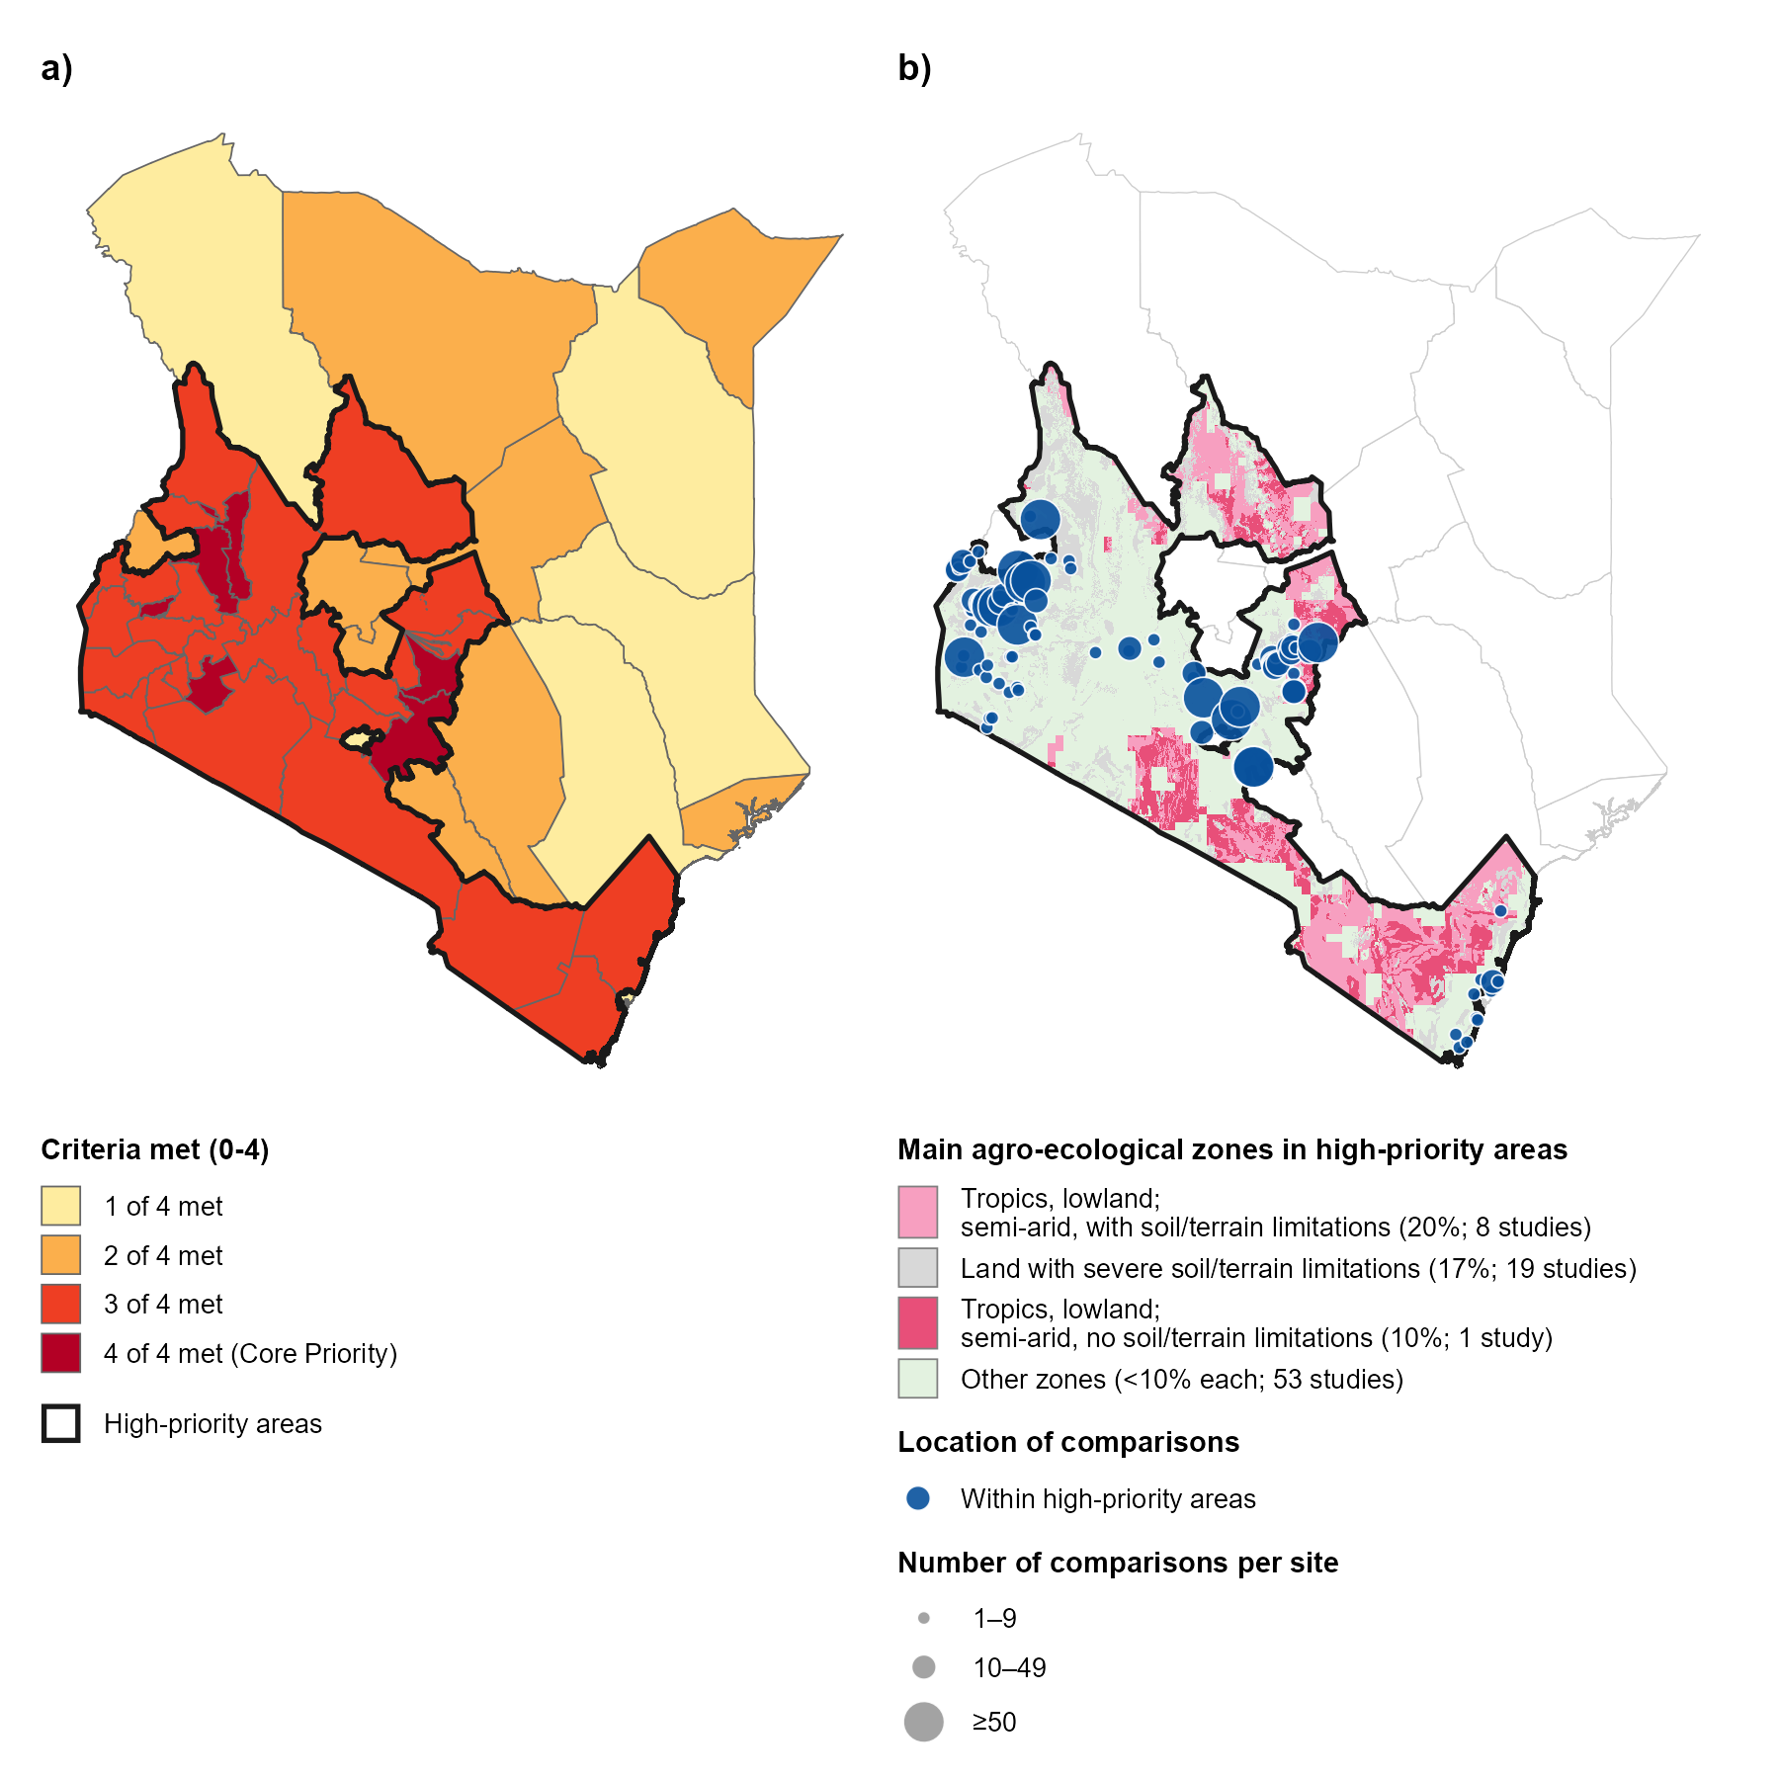

Figure 2A.1. a) High-priority areas of Archetype 2A in Kenya, and b) their main agro-ecological zones with the study sites of the comparisons used in the synthesis. In panel a, counties are shaded by the number of the four screening criteria they meet (i.e., severe soil acidity on active cropland; maize dominance over 50% of cereal harvested area; a declining maize yield trend in 2013–2021; and a synthetic fertilizer application rate in the top tertile of county means). Counties meeting three or four criteria form the high-priority areas, outlined in black. In panel b, colours show the GAEZ v4 agro-ecological zones covering at least 10% of the high-priority areas (main agro-ecological zones), and the legend gives the percentage of the high-priority areas each zone covers and the number of studies located in it. Other zones, each covering less than 10% of the high-priority areas, are shown in light green. Circles show the study sites of the 2,950 comparisons from 67 studies, all located within the high-priority areas, sized by the number of comparisons per site. Studies with sites in more than one zone are counted in each.

3.2.1.1 Evidence distribution and gaps
Within the high-priority areas of Archetype 2A, the evidence base comprised 2,950 comparisons from 67 studies. This evidence was sufficient for the synthesis, as it exceeded 100 comparisons and included at least one study in each of the three main agro-ecological zones of these areas (Table S4). The synthesis was therefore based only on comparisons located within the high-priority areas. Most studies (53 of 67) were located in smaller zones, each covering less than 10% of the high-priority areas, in particular the humid and sub-humid zones of western and central Kenya (Fig. 2A.1b). The comparisons came from 22 of the 32 high-priority counties, four of them Core Priority counties and 18 meeting three criteria. The two Core Priority counties with no comparisons were Bomet and Elgeyo-Marakwet. The studies were published between 1991 and 2023, and 52 of the 67 since 2010 (Fig. SX).
The evidence covered five food groups, 16 AE/RA practices from six management domains, and eight outcome dimensions. Cereals were the best represented food group (Fig. 2A.2a), with most comparisons on maize and sorghum (1,755 comparisons, 52 studies). Data on pulses and legumes came mostly from common bean, pigeon pea and soybean (581 comparisons, 13 studies), and data on vegetables almost entirely from kale (398 comparisons, 2 studies). Roots and tubers were represented by potato, nuts and seeds by sunflower, and no study assessed fruits. Intercropping, organic fertilizer, supplemental irrigation, residues incorporation and mixed fertilizer contributed the most comparisons (Fig. 2A.2b). Natural and improved fallow, inoculation, zero tillage and residues retention contributed the fewest, each from a single study. No comparison assessed liming, cover crops or soil and water conservation structures, despite their relevance to the acid and degraded soils of these areas.
Yield was the best represented outcome dimension (Fig. 2A.2c), mostly measured as crop yield (1,818 comparisons, 60 studies), with fewer data on biomass and crop residue yield. Data on soil health came mostly from soil organic carbon, total nitrogen and moisture (261 comparisons, 15 studies), and data on biodiversity mostly from the abundance of soil macrofauna in a single study. Profitability was assessed mostly as gross margin (36 comparisons, 5 studies), inputs efficiency as water use efficiency (64 comparisons, 3 studies), and climate mitigation as greenhouse gas emissions (41 comparisons, 4 studies). Resilience to pests and labour demand were each assessed in fewer than 20 comparisons.
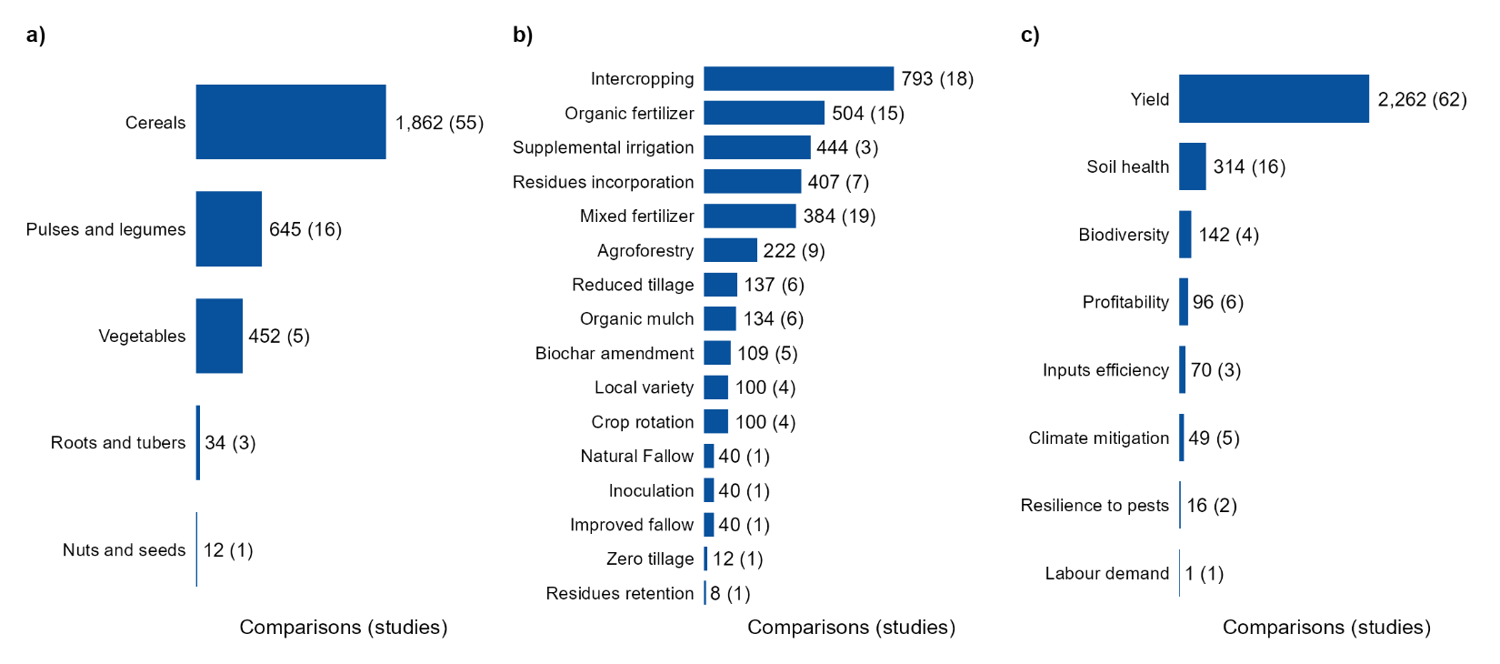

Figure 2A.2. Number of comparisons and studies (in parentheses) by a) food group, b) agroecological or regenerative agricultural (AE/RA) practice, and c) outcome dimension in the high-priority areas of Archetype 2A in Kenya. Bars are ordered by the number of comparisons.

3.2.1.2 Evidence synthesis on the effect of AE/RA practices
In these high-priority areas, the synthesis showed that nutrient management practices that add organic inputs consistently increased cereal yields relative to unfertilized controls and improved several other outcomes, all supported by strong evidence (Fig. 2A.3a). The application of organic fertilizers, mainly compost and animal manure, increased maize and sorghum yields in 99 comparisons (10 studies; Table S5a). Organic fertilizers also improved soil health in 64 comparisons (5 studies), particularly by increasing soil organic carbon and nitrogen (Table S5b), and increased the abundance of soil macrofauna in 81 comparisons (1 study; Table S5c). Mixed fertilizers, combining organic inputs with mineral fertilizer, increased maize and sorghum yields in 180 comparisons (13 studies), and improved soil health in 47 comparisons (6 studies) through higher soil moisture and nitrogen (Table S6). Incorporating crop residues instead of removing them improved soil health in 35 comparisons (2 studies), reflecting higher soil nitrate and organic carbon (Table S7).
Intercropping increased cereal yields relative to monoculture in 333 of 470 comparisons (from 13 studies), supported by strong evidence (Fig. 2A.3a). Positive effects were concentrated in intercrops that included a nitrogen-fixing species (Table S8). Intercrops of maize with a single food legume (common bean, groundnut, pigeon pea, cowpea or mung bean), increased maize yields in 158 comparisons (8 studies). Intercrops of finger millet, maize and sorghum with Desmodium, a forage legume used to control Striga and stem borers, increased cereal yields in all 88 comparisons (5 studies), and intercrops of maize with green manure legumes (Crotalaria, velvet bean and tick clover) in 40 comparisons (3 studies). Maize intercropped with the nitrogen-fixing tree Gliricidia sepium increased maize yields in 45 comparisons (1 study). By contrast, cereal yields increased in only 2 comparisons (2 studies) from intercrops with a non-nitrogen-fixing species, either another cereal or a vegetable.
For pulses and legumes, organic fertilizers increased legume yields in 52 of 66 comparisons (2 studies), mostly through the application of compost to common bean (Fig. 2A.3b; Table S9a). For vegetables, supplemental drip irrigation increased yields in 267 of 402 comparisons (2 studies), although almost all came from a single study on kale (Fig. 2A.3c; Table S10). Intercropping, residues incorporation and local varieties, however, reduced legume yields in most comparisons, supported by strong evidence. Legume yields were lower in intercrops than in sole legume crops in 168 of 242 comparisons (4 studies), although almost all came from a single study on pigeon pea intercropped with maize (Table S9b). Residues incorporation reduced the yields of common bean and pigeon pea in 99 of 149 comparisons (3 studies; Table S9c), and local varieties of cowpea and soybean yielded less than improved varieties in 49 of 72 comparisons (3 studies; Table S9d). Evidence for other food groups important for school meals, such as nuts and seeds and roots and tubers, was scattered across practices and outcomes, with no effect supported by strong evidence (Fig. 6d-e).
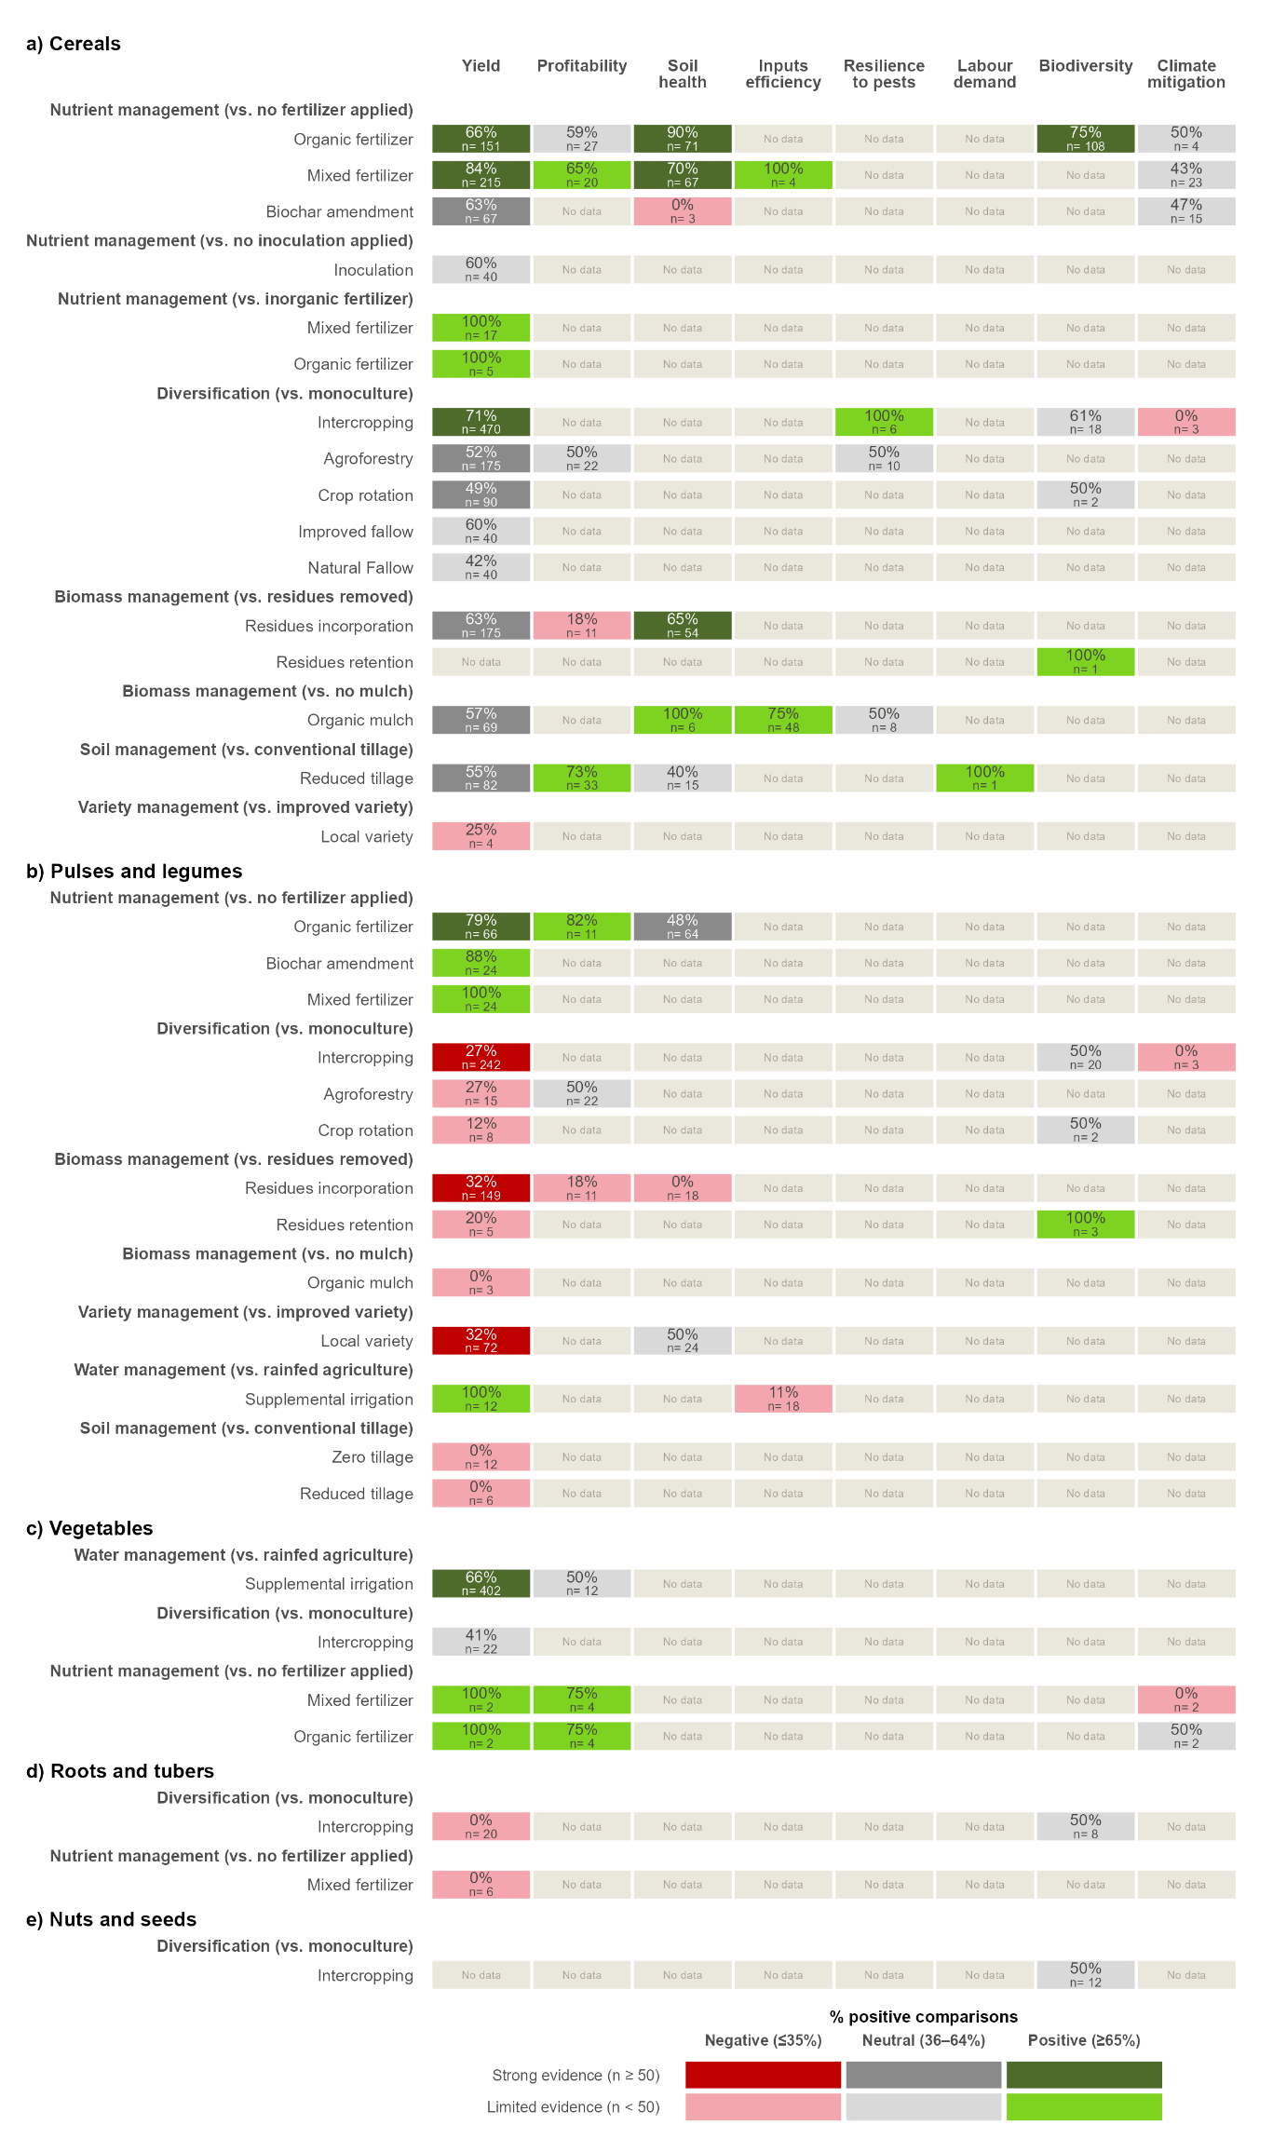

Figure 2A.3. Evidence synthesis on the effects of AE/RA practices on eight farm outcome dimensions for a) cereals, b) pulses and legumes, c) vegetables, d) roots and tubers, and e) nuts and seeds in the high-priority areas of Archetype 2A. Each row compares an AE/RA practice with the control named in the bold heading above it. AE/RA practices are grouped by practice domain. Each cell shows the percentage of comparisons with a positive effect and the number of comparisons. Colours show the direction of the effect, positive (≥65% of comparisons positive), neutral (36–64%) or negative (≤35%), and the strength of the evidence, strong (≥50 comparisons, darker shades) or limited (<50, lighter shades). Food groups, management domains and practices are ordered by the number of positive effects with strong evidence. No data means that no study assessed that outcome.

3.2.1.3 Promising practices
The evidence identifies three groups of AE/RA practices that can address the declining maize yields, soil degradation and low plant-protein supply identified in Archetype 2A, namely organic and mixed fertilizers, intercropping of maize with food legumes, and Desmodium intercrops. Organic inputs increased both yields and soil health, suggesting that they can help restore the fertility of degraded soils. In the acid, high-rainfall soils of these areas, they can reduce aluminium toxicity, keep more phosphorus available to crops and limit the leaching of nutrients by rain, so that crops take up a larger share of the mineral fertilizer already applied (Agegnehu et al. 2021). Combining organic inputs with mineral fertilizer, as in mixed fertilizers, is consistent with long-term experiments in Kenya in which manure with mineral nitrogen sustained maize yields (Laub et al. 2023). Intercropping maize with food legumes increased maize yields and added a protein-rich crop to the system, while the legumes can contribute to soil fertility through biological nitrogen fixation (Muoni et al. 2022). Desmodium intercrops offer gave the most consistent cereal yield gains while controlling pest biologically. Together, these practices could support school-meal programmes by stabilising the supply of maize, the staple of most school meals, by increasing the local supply of legumes, a source of plant protein that is currently lacking in the diets of these areas, and by reducing the use of synthetic pesticides in cereal production.
The lower legume yields observed under intercropping, residues incorporation and local varieties point to trade-offs for legume production. Lower legume yields in intercrops are expected, because the legume is grown at a lower density than in a sole crop and competes with the cereal for light, water and nutrients. Promoting local varieties for school meals would mean accepting lower legume yields in exchange for benefits, such as agrobiodiversity conservation and adaptation to local conditions, that were not assessed in this synthesis. Liming, the main intervention proposed by the archetype, was not covered by the studies; and evidence on soybean, the legume it recommends, was limited. Several results also rested on a single study, and the scarcity of evidence for vegetables, nuts and seeds and roots and tubers, together with the absence of data on fruits, limits what can be concluded about the contribution of these practices to diet diversity.

3.2.2 Archetype 2B: Arid pastoral micro-gardens
Archetype 2B (Arid pastoral micro-gardens) targets the arid and semi-arid lands (ASAL) of northern and eastern Kenya, where pastoralism is the main livelihood and cropland is scarce. Its high-priority areas comprise six arid and semi-arid counties. Mandera is the only Core Priority county, meeting all five screening criteria, and Embu, Garissa, Isiolo, Turkana and West Pokot meet four (Fig. 2B.1a).
In these high-priority areas, the food-system problem is the shortage of plant-based foods in diets that rely heavily on livestock. High livestock numbers and access to animal products mask deficits in vegetables, legumes and the micronutrients they provide. Severe water scarcity, recurrent food crises and conflict over water and grazing resources limit food production. Mandera, Garissa, Isiolo and Turkana are in acute food crisis, classified as Phase 3 (Crisis) or above under the Integrated Food Security Phase Classification (IPC), whereas Embu and West Pokot have the same structural risks without an acute crisis. Existing cultivation is limited to small patches near rivers, boreholes and seasonal water points, such as the 3,291 ha of cropland along the Daua River in Mandera.
To address these problems, the archetype proposes household micro-gardens that produce vegetables with little water, such as keyhole gardens irrigated with filtered household greywater and drip kits. These gardens would grow drought-tolerant indigenous leafy vegetables, such as amaranth and spider plant, together with cowpea and moringa as sources of plant protein.
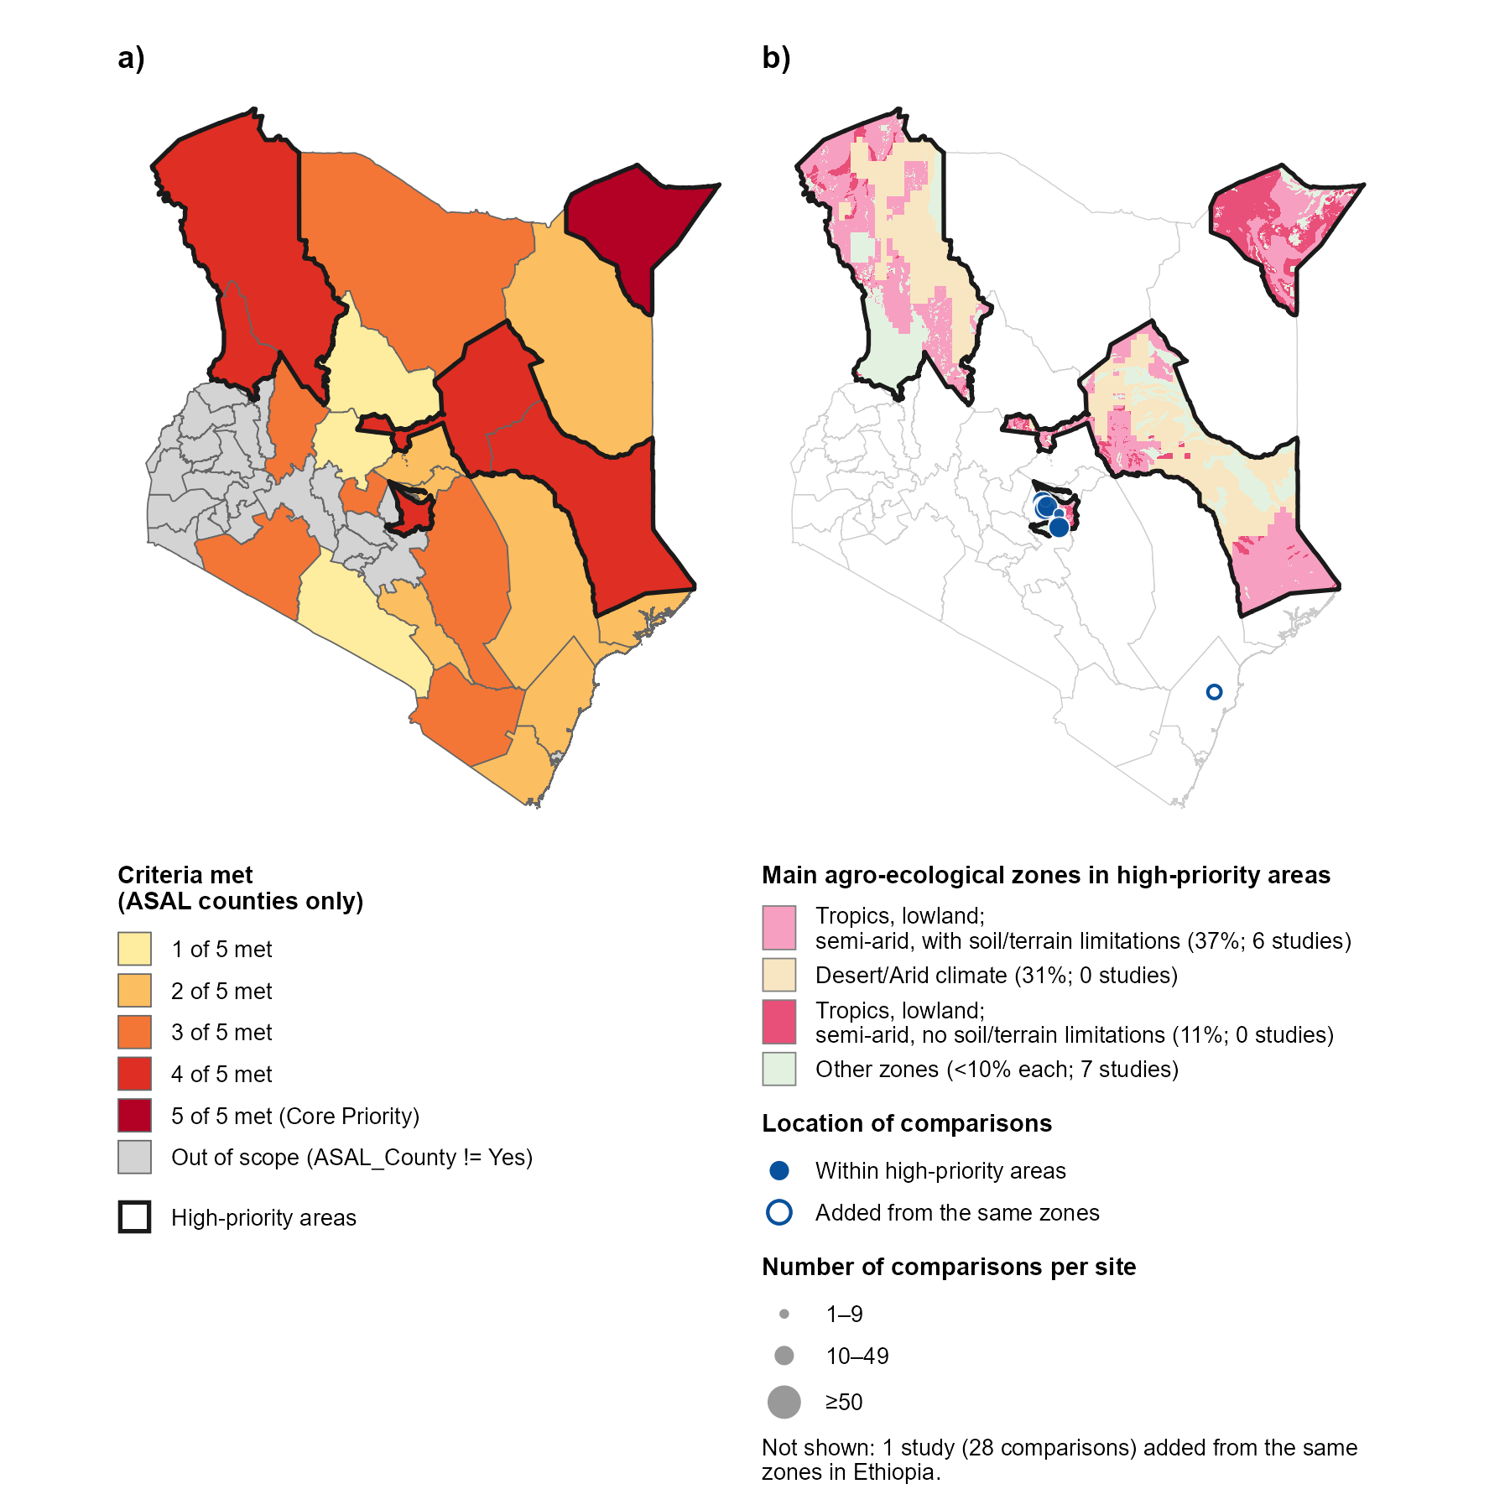

Figure 2B.1. a) High-priority areas of Archetype 2B in Kenya, and b) their main agro-ecological zones with the study sites of the comparisons used in the synthesis. In panel a, the 23 arid and semi-arid land (ASAL) counties are shaded by the number of the five screening criteria they meet (i.e., high livestock density; severe agricultural water risk; plant-based food deficit; acute food insecurity, IPC Phase 3 or above; and resource-conflict events), and non-ASAL counties are shown in grey as out of scope. Counties meeting four or five criteria form the high-priority areas, outlined in black. In panel b, colours show the GAEZ v4 agro-ecological zones covering at least 10% of the high-priority areas (main agro-ecological zones), and the legend gives the percentage of the high-priority areas each zone covers and the number of studies located in it. Other zones, each covering less than 10% of the high-priority areas, are shown in light green. Filled circles show the study sites of the 235 comparisons from 10 studies located within the high-priority areas. The open circle shows the site of the comparison added from the same zones elsewhere in Kenya, and the 28 comparisons from one study added from the desert/arid zone in Ethiopia are not shown. Circles are sized by the number of comparisons per site. Studies with sites in more than one zone are counted in each.

3.2.2.1 Evidence distribution and gaps
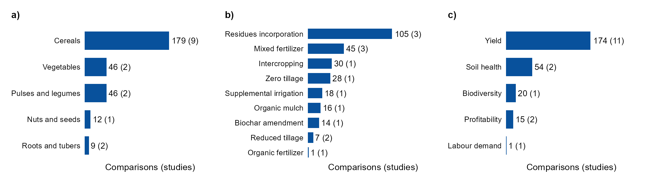

Figure 2B.2. Number of comparisons and studies (in parentheses) by a) food group, b) agroecological or regenerative agricultural (AE/RA) practice, and c) outcome dimension for Archetype 2B in Kenya, including the comparisons located within the high-priority areas and those added from the same main agro-ecological zones. Bars are ordered by the number of comparisons.

3.2.2.2 Evidence synthesis on the effect of AE/RA practices
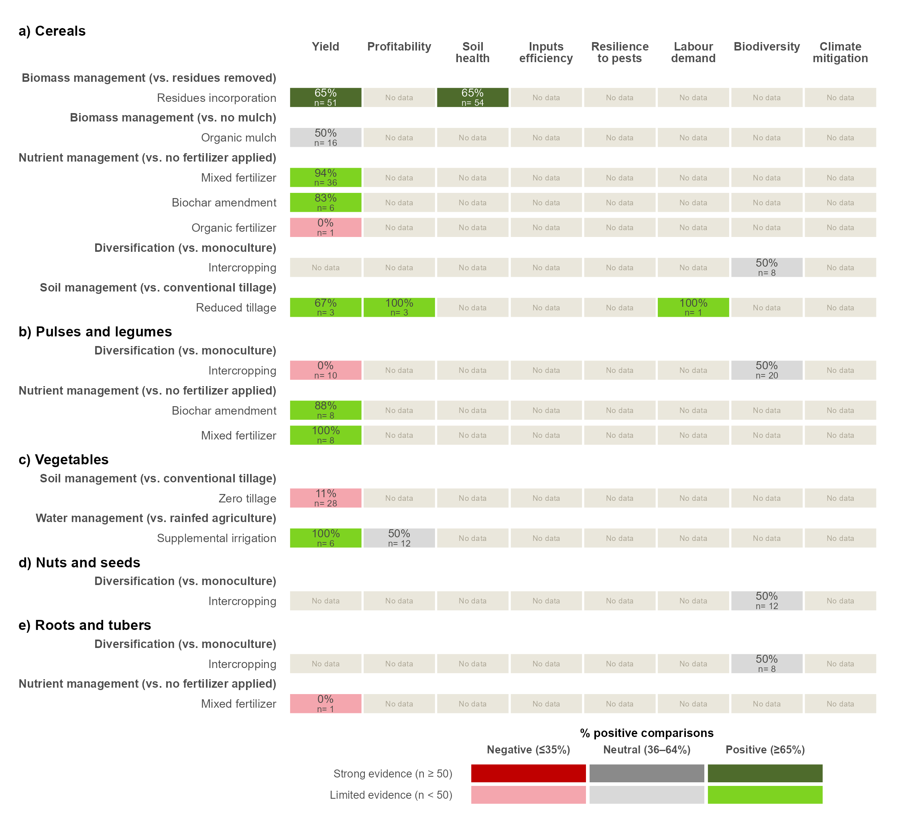

Figure 2B.3. Evidence synthesis on the effects of AE/RA practices on eight farm outcome dimensions for a) cereals, b) pulses and legumes, c) vegetables, d) nuts and seeds, and e) roots and tubers for Archetype 2B in Kenya, including the comparisons located within the high-priority areas and those added from the same main agro-ecological zones. Each row compares an AE/RA practice with the control named in the bold heading above it. AE/RA practices are grouped by practice domain. Each cell shows the percentage of comparisons with a positive effect and the number of comparisons. Colours show the direction of the effect, positive (≥65% of comparisons positive), neutral (36–64%) or negative (≤35%), and the strength of the evidence, strong (≥50 comparisons, darker shades) or limited (<50, lighter shades). Food groups, management domains and practices are ordered by the number of positive effects with strong evidence. No data means that no study assessed that outcome.

3.3 Zambia

The evidence available in the priority areas: number of studies and effect sizes.
Element | 2A-Soil restoration | 2B- Arid micro-gardens
Main problems | Soil acidity, falling yields, heavy fertilizer use | Water scarcity, too few plant foods, food crises
Context | Humid/sub-humid highlands, maize-based systems, smallholders | Arid/semi-arid, pastoral, very little cropland
Candidate practices | Liming, legume intercropping, improved fallows, biomass transfer, integrated soil fertility management | Home or keyhole gardens, water harvesting, drip irrigation, drought-tolerant crops, agroforestry (moringa)
Priority outcomes | Yield, soil health, profitability | Water-use efficiency, diet diversity, resilience
Food group linked to the diet gap | Pulses and protein | Vegetables and protein

4. References
FAO & IIASA (2021). Global Agro-Ecological Zones version 4 (GAEZ v4). Food and Agriculture Organization of the United Nations, Rome, and International Institute for Applied Systems Analysis, Laxenburg.
Agegnehu G, Amede T, Erkossa T, et al (2021) Extent and management of acid soils for sustainable crop production system in the tropical agroecosystems: a review. Acta Agriculturae Scandinavica, Section B — Soil & Plant Science 71:852–869. https://doi.org/10.1080/09064710.2021.1954239
Jones SK, Sánchez AC, Juventia SD, Estrada-Carmona N (2021) A global database of diversified farming effects on biodiversity and yield. Sci Data 8:212. https://doi.org/10.1038/s41597-021-01000-y
Laub M, Corbeels M, Mathu Ndungu S, et al (2023) Combining manure with mineral N fertilizer maintains maize yields: Evidence from four long-term experiments in Kenya. Field Crops Research 291:108788. https://doi.org/10.1016/j.fcr.2022.108788
Muoni T, Jonsson M, Duncan AJ, et al (2022) Effects of management practices on legume productivity in smallholder farming systems in sub‐Saharan Africa. Food and Energy Security 11:e366. https://doi.org/10.1002/fes3.366
Paut R, Garreau L, Ollivier G, et al (2024) A global dataset of experimental intercropping and agroforestry studies in horticulture. Sci Data 11:5. https://doi.org/10.1038/s41597-023-02831-7
Rosenstock TS, Steward P, Joshi N, et al (2024) Effects of changing farming practices in African agriculture. Sci Data 11:958. https://doi.org/10.1038/s41597-024-03805-z
Sánchez AC, Kamau HN, Grazioli F, Jones SK (2022) Financial profitability of diversified farming systems: A global meta-analysis. Ecological Economics 201:107595. https://doi.org/10.1016/j.ecolecon.2022.107595

5. Supplementary information

Figure SX. Prisma diagram

Table S1. Agroecological or regenerative agricultural (AE/RA) practices included in the analysis, grouped by management domain, with a description of each practice.
Management domains | AE/RA practice description
Biomass management | Organic mulch: A layer of organic material (crop or tree residues, prunings, leaves, weeds, cut grass or straw, produced on-site or brought in) is spread over the soil surface without being mixed in. It conserves soil moisture, buffers soil temperature, suppresses weeds, protects against erosion and gradually recycles nutrients to the soil.
 | Residues incorporation: Crop or tree residues (straw, stubble, prunings, leaves and other plant parts left after harvest or pruning) are mixed into the soil, usually by tillage, instead of being removed, burned or left on the surface. A form of crop residue management that returns organic matter and nutrients to the soil.
 | Residues retention: Crop or tree residues left after harvest or pruning are kept in the field where they fall, standing or laid on the surface, instead of being removed or burned. A form of crop residue management that keeps a protective surface cover to reduce wind and water erosion, conserve water and reduce evaporation, while returning organic matter and nutrients to the soil.
Diversification (spatial) | Agroforestry: Woody perennials (trees, shrubs, palms or bamboos) are deliberately grown on the same land as crops and/or livestock, within or around plots, for example scattered trees, alley cropping, hedgerows, boundary plantings, windbreaks, shaded perennial systems or silvopasture. Trees provide products (fruit, timber, fodder, fuel) as well as services such as shade, microclimate regulation, soil protection, nutrient cycling and habitat.
 | Intercropping: Two or more crop species are grown in the same field at the same time, for all or a significant part of their growth cycles, in mixed, row, strip or relay arrangements. Complementarity between species is used to make better use of light, water and nutrients, increase total productivity per unit area, and reduce pest, disease and weed pressure.
Diversification (temporal) | Crop rotation: Different crop species are grown in a planned sequence on the same field over successive seasons or years, instead of repeating the same crop (monoculture) or an unplanned sequence. Rotations often combine cereals, legumes, root crops or green manures. They break pest, disease and weed cycles, improve soil fertility (especially when legumes fix nitrogen), balance the use of nutrients and water from different soil depths, improve soil structure and organic matter, and spread production risk.
 | Natural fallow: Cropland is left uncultivated for one or more seasons and vegetation (grasses, shrubs or trees) regrows spontaneously, without planting. The regrowth restores soil organic matter and fertility, recycles nutrients, protects the soil from erosion, breaks weed, pest and disease cycles and provides habitat for biodiversity. Includes grass, bush and forest fallows.
 | Improved fallow: During the fallow period, cropland is deliberately planted with fast-growing species, usually legumes such as trees, shrubs or herbaceous plants (e.g., Sesbania, Tephrosia, Gliricidia, Cajanus, Crotalaria, Mucuna), instead of being left to regrow naturally. This restores soil fertility faster than natural fallow through biological nitrogen fixation, biomass and nutrient inputs, and deep nutrient recycling. It also suppresses weeds (including Striga) and protects the soil. The fallow biomass is often cut and left on the surface or incorporated before the next crop.
Nutrient management | Biochar amendment: Biochar is added to the soil, either alone or mixed with compost, manure or fertilizers. Biochar is a carbon-rich solid made by heating biomass (crop residues, wood, manure or other organic waste) with little or no oxygen (pyrolysis). It improves soil structure, water-holding capacity, cation exchange capacity and pH (especially in acidic soils), increases nutrient retention and use efficiency, supports soil microbial activity and stores carbon in the soil for the long term.
 | Inoculation: Seeds, seedlings or soil are treated with beneficial microorganisms, such as rhizobia, arbuscular mycorrhizal fungi, or plant growth-promoting bacteria and fungi, to establish or boost useful plant–microbe associations. It improves biological nitrogen fixation, nutrient (especially P) uptake, root health and plant tolerance to stress, and can reduce the need for synthetic inputs.
 | Mixed fertilizers: Organic fertilizers or amendments (manure, compost, crop residues, green manure) are applied together with mineral fertilizers, in the same season or as a planned combination, to meet crop nutrient needs. The organic component builds soil organic matter, improves soil structure and nutrient retention, and increases how efficiently the mineral nutrients are used, while mineral fertilizers supply readily available nutrients.
 | Organic fertilizers: Nutrients are supplied to crops from materials of plant or animal origin, such as animal manure, compost, vermicompost, slurry, biosolids, green manure or plant-based preparations, instead of synthetic mineral fertilizers. Nutrients are released gradually as the materials decompose, while the added organic matter improves soil structure, water-holding capacity, biological activity and long-term fertility.
Soil management | Reduced tillage: Soil disturbance is reduced compared with conventional tillage (e.g., mouldboard ploughing) by cutting the number, depth or intensity of tillage operations, or by tilling only part of the field (strip, zone or planting-hole tillage). It includes minimum tillage and no-till, where seeds are sown directly into untilled soil. Less disturbance protects soil structure and aggregates, reduces erosion and evaporation, slows organic matter decomposition, supports soil biological activity and cuts fuel and labour costs.
 | Zero tillage: Crops are sown directly into untilled soil, with no ploughing, harrowing or other soil preparation before planting. Disturbance is limited to the narrow opening made for the seed, and the soil surface and any crop residues are left in place. It protects soil structure and aggregates, reduces erosion and evaporation, slows organic matter decomposition, supports soil biological activity and cuts fuel, labour and time costs.
Variety management | Local variety: Crop varieties developed and maintained by farmers in a particular area are grown. These include traditional varieties, landraces and farmer-selected populations, usually multiplied from farm-saved or locally exchanged seed, instead of commercially bred improved varieties or hybrids. Local varieties are often genetically diverse and adapted to local soils, climate, pests and low-input conditions. They help with yield stability, resilience to stress, dietary and cultural preferences, seed autonomy and conservation of agrobiodiversity.
Water management | Supplemental drip irrigation: Limited amounts of water are applied to mainly rainfed crops through a drip system (pipes with emitters that deliver water slowly to the root zone) at critical growth stages or during dry spells, when rainfall alone isn't enough. The aim is to stabilize yields rather than meet the full crop water demand. Water goes directly to the root zone, which reduces evaporation, runoff and deep percolation losses, increases water use efficiency, limits weed growth between rows, and lowers pest and disease pressure from wet foliage.

Table S2. Outcome dimensions.

Table S3. Food groups.

5.1 Ethiopia

5.2 Kenya

5.2.1 Archetype 2A – Soil restoration

Table S4. Agro-ecological zones of the high-priority areas of Archetype 2A in Kenya, with the number of studies and comparisons in each zone. Zones are those of the Global Agro-Ecological Zones (GAEZ v4), and main zones are those covering at least 10% of the high-priority areas. Studies and comparisons are shown for those located within the high-priority areas, and for those added from the same main zones elsewhere in Kenya and in neighbouring project countries. No comparisons were added for this archetype, because the evidence within the high-priority areas met both sufficiency criteria. Comparisons with sites in more than one zone are counted in each, so totals can be lower than the sum of the rows.
Agro-ecological zone | Share of high-priority areas (%) | Main zone | Studies (High-priority areas) | Comparisons (High-priority areas) | Studies (Same zones, same country) | Comparisons (Same zones, same country) | Studies (Same zones, neighbouring countries) | Comparisons (Same zones, neighbouring countries)
Tropics, lowland; semi-arid, with soil/terrain limitations | 19.5 | Yes | 8 | 219 | 0 | 0 | 0 | 0
Land with severe soil/terrain limitations | 17.2 | Yes | 19 | 424 | 0 | 0 | 0 | 0
Tropics, lowland; semi-arid, no soil/terrain limitations | 10.4 | Yes | 1 | 1 | 0 | 0 | 0 | 0
Tropics, highland; humid, with soil/terrain limitations | 9.8 | No | 11 | 485 | 0 | 0 | 0 | 0
Tropics, lowland; sub-humid, with soil/terrain limitations | 9.3 | No | 2 | 13 | 0 | 0 | 0 | 0
Tropics, lowland; humid, with soil/terrain limitations | 5.1 | No | 18 | 591 | 0 | 0 | 0 | 0
Tropics, highland; sub-humid, with soil/terrain limitations | 5 | No | 16 | 865 | 0 | 0 | 0 | 0
Tropics, lowland; sub-humid, no soil/terrain limitations | 4.6 | No | 1 | 1 | 0 | 0 | 0 | 0
Tropics, highland; humid, no soil/terrain limitations | 4.3 | No | 3 | 50 | 0 | 0 | 0 | 0
Tropics, lowland; humid, no soil/terrain limitations | 2.5 | No | 6 | 225 | 0 | 0 | 0 | 0
Tropics, highland; sub-humid, no soil/terrain limitations | 2.2 | No | 2 | 19 | 0 | 0 | 0 | 0
Dominantly water | 2.1 | No | 1 | 5 | 0 | 0 | 0 | 0
Desert/Arid climate | 2 | No | 0 | 0 | 0 | 0 | 0 | 0
Dominantly very steep terrain | 1.8 | No | 0 | 0 | 0 | 0 | 0 | 0
Dominantly hydromorphic soils | 1.3 | No | 2 | 30 | 0 | 0 | 0 | 0
Tropics, highland; semi-arid, with soil/terrain limitations | 1.1 | No | 0 | 0 | 0 | 0 | 0 | 0
Tropics, highland; semi-arid, no soil/terrain limitations | 0.7 | No | 0 | 0 | 0 | 0 | 0 | 0
Ample irrigated soils | 0.5 | No | 0 | 0 | 0 | 0 | 0 | 0
Cold, no permafrost; wet, with soil/terrain limitations | 0.4 | No | 0 | 0 | 0 | 0 | 0 | 0
Dominantly built-up land | 0 | No | 1 | 64 | 0 | 0 | 0 | 0
Total | 100 |  | 67 | 2950 | 0 | 0 | 0 | 0

Figure SX. Number of studies by year of publication in the high-priority areas of Archetype 2A in Kenya.
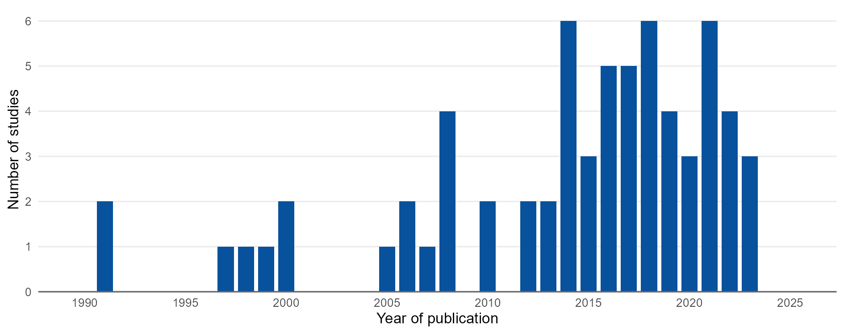

Table S5. Effects of organic fertilizers relative to no fertilizer on a) cereal yield, b) soil health in cereal systems and c) biodiversity in cereal systems in the high-priority areas of Archetype 2A. Positive, neutral and negative comparisons are those in which the outcome under organic fertilizer was higher than, equal to or lower than in the unfertilized control. Yield results are shown by measured crop, soil health results by main crop, and soil macrofauna results by measured taxa and cropping system, in all cases together with the type of organic input and the outcome measured. Organic (Other) refers to sawdust, and a missing companion species indicates a sole crop.
a) Cereal yields, by measured crop, companion species and type of organic input.
Measured crop | Companion species | Organic input | Outcome measured | Studies | Comparisons | Positive comparisons | Neutral comparisons | Negative comparisons | % positive comparisons
Maize | - | Biosolids | Yield | 1 | 3 | 3 | 0 | 0 | 100
Maize | - | Compost | Yield | 2 | 33 | 32 | 0 | 1 | 97
Maize | - | Manure | Yield | 6 | 23 | 20 | 1 | 2 | 87
Maize | Common Bean + Leucaena leucocephala | Manure | Yield | 1 | 20 | 2 | 0 | 18 | 10
Maize | - | Organic (Other) | Yield | 1 | 36 | 12 | 0 | 24 | 33
Sorghum | - | Manure | Yield | 2 | 36 | 30 | 0 | 6 | 83
b) Soil health in cereal systems, by main crop, companion species and type of organic input.
Main crop | Companion species | Organic input | Outcome measured | Studies | Comparisons | Positive comparisons | Neutral comparisons | Negative comparisons | % positive comparisons
Maize | - | Compost | Soil NH4 | 1 | 10 | 10 | 0 | 0 | 100
Maize | - | Compost | Soil NO3 | 1 | 10 | 10 | 0 | 0 | 100
Maize | - | Compost | Soil Organic Carbon | 1 | 10 | 10 | 0 | 0 | 100
Maize | - | Compost | Soil Total Nitrogen | 1 | 10 | 10 | 0 | 0 | 100
Maize | - | Manure | Soil NH4 | 1 | 2 | 2 | 0 | 0 | 100
Maize | - | Manure | Soil NO3 | 1 | 2 | 2 | 0 | 0 | 100
Maize | - | Manure | Soil Organic Carbon | 3 | 8 | 8 | 0 | 0 | 100
Maize | - | Manure | Soil Organic Carbon (Change) | 1 | 1 | 1 | 0 | 0 | 100
Maize | - | Manure | Soil Total Nitrogen | 4 | 10 | 7 | 2 | 1 | 70
Sorghum | - | Manure | Soil Organic Carbon | 1 | 4 | 2 | 0 | 2 | 50
Sorghum | - | Manure | Soil Total Nitrogen | 1 | 4 | 2 | 1 | 1 | 50
c) Biodiversity in cereal systems, by measured taxa, cropping system and type of organic input.
Measured taxa | Cropping system | Organic input | Outcome measured | Studies | Comparisons | Positive comparisons | Neutral comparisons | Negative comparisons | % positive comparisons
Araneae | Maize | Compost | Abundance | 1 | 10 | 8 | 2 | 0 | 80
Araneae | Maize | Manure | Abundance | 1 | 2 | 2 | 0 | 0 | 100
Blattodea | Maize | Compost | Abundance | 1 | 10 | 3 | 7 | 0 | 30
Blattodea | Maize | Manure | Abundance | 1 | 2 | 0 | 2 | 0 | 0
Chilopoda | Maize | Compost | Abundance | 1 | 10 | 7 | 3 | 0 | 70
Chilopoda | Maize | Manure | Abundance | 1 | 2 | 1 | 1 | 0 | 50
Coleoptera | Maize | Compost | Abundance | 1 | 10 | 10 | 0 | 0 | 100
Coleoptera | Maize | Manure | Abundance | 1 | 2 | 2 | 0 | 0 | 100
Diplopoda | Maize | Compost | Abundance | 1 | 10 | 2 | 8 | 0 | 20
Diplopoda | Maize | Manure | Abundance | 1 | 2 | 0 | 2 | 0 | 0
Hymenoptera | Maize | Compost | Abundance | 1 | 10 | 10 | 0 | 0 | 100
Hymenoptera | Maize | Manure | Abundance | 1 | 2 | 2 | 0 | 0 | 100
Isoptera | Maize | Compost | Abundance | 1 | 10 | 10 | 0 | 0 | 100
Isoptera | Maize | Manure | Abundance | 1 | 2 | 2 | 0 | 0 | 100
Oligochaeta | Maize | Compost | Abundance | 1 | 10 | 10 | 0 | 0 | 100
Oligochaeta | Maize | Manure | Abundance | 1 | 2 | 2 | 0 | 0 | 100
Orthoptera | Maize | Compost | Abundance | 1 | 10 | 9 | 1 | 0 | 90
Orthoptera | Maize | Manure | Abundance | 1 | 2 | 1 | 1 | 0 | 50

Table S6. Effects of mixed fertilizers, combining an organic input with mineral fertilizer, relative to no fertilizer on a) cereal yield, and b) soil health in cereal systems in the high-priority areas of Archetype 2A. Positive, neutral and negative comparisons are those in which the outcome under mixed fertilizer was higher than, equal to or lower than in the unfertilized control. Results are shown by measured crop for yield and by main crop for soil health, together with the companion species, the type of mixed input and the outcome measured. Organic (Other) refers to sawdust, and a missing companion species indicates a sole crop.
a) Cereal yields, by measured crop, companion species and type of mixed input.
Measured crop | Companion species | Mixed input | Outcome measured | Studies | Comparisons | Positive comparisons | Neutral comparisons | Negative comparisons | % positive comparisons
Maize | - | Biochar + Inorganic Fertilizer | Yield | 3 | 41 | 31 | 0 | 10 | 76
Maize | Soybean | Biochar + Inorganic Fertilizer + Inorganic Micronutrients Inputs | Yield | 1 | 26 | 26 | 0 | 0 | 100
Maize | - | Inorganic Fertilizer + Inorganic Micronutrients Inputs + Manure | Yield | 1 | 2 | 2 | 0 | 0 | 100
Maize | - | Inorganic Fertilizer + Manure | Yield | 6 | 58 | 56 | 1 | 1 | 97
Maize | - | Inorganic Fertilizer + Organic (Other) | Yield | 1 | 36 | 22 | 0 | 14 | 61
Sorghum | - | Inorganic Fertilizer + Manure | Yield | 2 | 52 | 43 | 1 | 8 | 83
b) Soil health in cereal systems, by main crop, companion species and type of mixed input.
Main crop | Companion species | Mixed input | Outcome measured | Studies | Comparisons | Positive comparisons | Neutral comparisons | Negative comparisons | % positive comparisons
Maize | - | Biochar + Inorganic Fertilizer | Soil Organic Carbon | 1 | 3 | 0 | 0 | 3 | 0
Maize | - | Inorganic Fertilizer + Manure | Soil Moisture | 1 | 41 | 30 | 0 | 11 | 73
Maize | - | Inorganic Fertilizer + Manure | Soil Organic Carbon | 3 | 7 | 6 | 0 | 1 | 86
Maize | - | Inorganic Fertilizer + Manure | Soil Organic Carbon (Change) | 1 | 1 | 1 | 0 | 0 | 100
Maize | - | Inorganic Fertilizer + Manure | Soil Total Nitrogen | 3 | 7 | 6 | 0 | 1 | 86
Sorghum | - | Inorganic Fertilizer + Manure | Soil Organic Carbon | 1 | 4 | 1 | 0 | 3 | 25
Sorghum | - | Inorganic Fertilizer + Manure | Soil Total Nitrogen | 1 | 4 | 3 | 0 | 1 | 75

Table S7. Effects of residues incorporation relative to residue removal on soil health in cereal systems in the high-priority areas of Archetype 2A. Positive, neutral and negative comparisons are those in which the outcome under residues incorporation was higher than, equal to or lower than under residue removal. Results are shown by main crop, companion species, type of residue and outcome measured. Residues are classified by whether they came from a nitrogen-fixing crop. A missing companion species indicates a sole crop.
Main crop | Companion species | Residues type | Outcome measured | Studies | Comparisons | Positive comparisons | Neutral comparisons | Negative comparisons | % positive comparisons
Maize | - | Crop Residue Incorporation (N fixing) | Soil Organic Carbon | 1 | 2 | 2 | 0 | 0 | 100
Maize | - | Crop Residue Incorporation (N fixing) | Soil Total Nitrogen | 1 | 2 | 2 | 0 | 0 | 100
Maize | - | Crop Residue Incorporation (Non N fixing) | Soil Moisture | 1 | 4 | 2 | 0 | 2 | 50
Maize | - | Crop Residue Incorporation (Non N fixing) | Soil NH4 | 1 | 4 | 1 | 0 | 3 | 25
Maize | - | Crop Residue Incorporation (Non N fixing) | Soil NO3 | 1 | 4 | 4 | 0 | 0 | 100
Maize | - | Crop Residue Incorporation (Non N fixing) | Soil Organic Carbon | 1 | 1 | 1 | 0 | 0 | 100
Maize | - | Crop Residue Incorporation (Non N fixing) | Soil Total Nitrogen | 2 | 5 | 2 | 1 | 2 | 40
Maize | - | Tree Prunings Incorporated (Non N fixing) | Soil Moisture | 1 | 8 | 4 | 0 | 4 | 50
Maize | - | Tree Prunings Incorporated (Non N fixing) | Soil NH4 | 1 | 8 | 4 | 2 | 2 | 50
Maize | - | Tree Prunings Incorporated (Non N fixing) | Soil NO3 | 1 | 8 | 8 | 0 | 0 | 100
Maize | - | Tree Prunings Incorporated (Non N fixing) | Soil Total Nitrogen | 1 | 8 | 5 | 3 | 0 | 62

Table S8. Effects of intercropping relative to monoculture on cereal yield in the high-priority areas of Archetype 2A. Positive, neutral and negative comparisons are those in which the cereal yield under intercropping was higher than, equal to or lower than under monoculture. Results are shown by measured cereal, intercrop type and companion species, the latter being the species grown with the measured cereal in the intercrop. Intercrops are classified by whether they included a nitrogen-fixing species, and push-pull systems.
Measured crop | Companion species | Intercrop type | Outcome measured | Studies | Comparisons | Positive comparisons | Neutral comparisons | Negative comparisons | % positive comparisons
Finger Millet | Desmodium intortum | With a nitrogen-fixing species | Yield | 1 | 7 | 7 | 0 | 0 | 100
Maize | Brachiaria hybrid + Desmodium intortum | Push-pull | Yield | 1 | 56 | 56 | 0 | 0 | 100
Maize | Common Bean | With a nitrogen-fixing species | Yield | 5 | 51 | 39 | 7 | 5 | 76
Maize | Common Bean + Pearl Millet | With a nitrogen-fixing species | Yield | 1 | 4 | 0 | 0 | 4 | 0
Maize | Common Bean + Pearl Millet + Sorghum | With a nitrogen-fixing species | Yield | 1 | 4 | 0 | 0 | 4 | 0
Maize | Cowpea | With a nitrogen-fixing species | Yield | 2 | 19 | 18 | 0 | 1 | 95
Maize | Crotalaria ochroleuca | With a nitrogen-fixing species | Yield | 1 | 18 | 14 | 1 | 3 | 78
Maize | Crotalaria ochrolueca | With a nitrogen-fixing species | Yield | 1 | 16 | 16 | 0 | 0 | 100
Maize | Desmodium intortum | With a nitrogen-fixing species | Yield | 2 | 19 | 19 | 0 | 0 | 100
Maize | Gliricidia sepium | With a nitrogen-fixing species | Yield | 1 | 84 | 45 | 0 | 39 | 54
Maize | Groundnut | With a nitrogen-fixing species | Yield | 3 | 30 | 23 | 0 | 7 | 77
Maize | Mung Bean | With a nitrogen-fixing species | Yield | 2 | 22 | 15 | 1 | 6 | 68
Maize | Pigeon Pea | With a nitrogen-fixing species | Yield | 2 | 96 | 63 | 7 | 26 | 66
Maize | Tick Clover sp | With a nitrogen-fixing species | Yield | 1 | 4 | 3 | 0 | 1 | 75
Maize | Velvet Bean | With a nitrogen-fixing species | Yield | 1 | 12 | 7 | 0 | 5 | 58
Maize | Pearl Millet | Without a nitrogen-fixing species | Yield | 1 | 4 | 0 | 0 | 4 | 0
Maize | Sorghum | Without a nitrogen-fixing species | Yield | 1 | 4 | 1 | 0 | 3 | 25
Maize | Tomato | Without a nitrogen-fixing species | Yield | 1 | 2 | 1 | 0 | 1 | 50
Pearl Millet | Common Bean + Maize | With a nitrogen-fixing species | Yield | 1 | 4 | 0 | 0 | 4 | 0
Pearl Millet | Common Bean + Maize + Sorghum | With a nitrogen-fixing species | Yield | 1 | 4 | 0 | 0 | 4 | 0
Pearl Millet | Maize | Without a nitrogen-fixing species | Yield | 1 | 4 | 0 | 0 | 4 | 0
Sorghum | Desmodium intortum | With a nitrogen-fixing species | Yield | 1 | 6 | 6 | 0 | 0 | 100

Table S9. Effects of a) organic fertilizers relative to no fertilizer, b) intercropping relative to sole legume crops, c) crop residue incorporation relative to residue removal and d) local relative to improved varieties on the yield of pulses and legumes in the high-priority areas of Archetype 2A. Positive, neutral and negative comparisons are those in which the legume yield under the AE/RA practice was higher than, equal to or lower than under the control. Results are shown by measured crop and outcome measured, together with the type of organic input, the companion species, the type of residue and the variety compared, respectively. A missing companion species indicates a sole crop.
a) Organic fertilizers relative to no fertilizer, by measured crop, companion species and type of organic input.
Measured crop | Companion species | Organic input | Outcome measured | Studies | Comparisons | Positive comparisons | Neutral comparisons | Negative comparisons | % positive comparisons
Common Bean | - | Compost | Yield | 1 | 64 | 50 | 0 | 14 | 78
Common Bean | Leucaena leucocephala + Maize | Manure | Yield | 1 | 2 | 2 | 0 | 0 | 100
b) Intercropping relative to sole legume crops, by measured crop, companion species and intercrop type.
Measured crop | Companion species | Intercrop type | Outcome measured | Studies | Comparisons | Positive comparisons | Neutral comparisons | Negative comparisons | % positive comparisons
Common Bean | Maize | With a nitrogen-fixing species | Yield | 1 | 4 | 2 | 0 | 2 | 50
Common Bean | Maize + Pearl Millet | With a nitrogen-fixing species | Yield | 1 | 4 | 2 | 0 | 2 | 50
Common Bean | Maize + Pearl Millet + Sorghum | With a nitrogen-fixing species | Yield | 1 | 4 | 2 | 0 | 2 | 50
Common Bean | Baby Corn | With a nitrogen-fixing species | Yield | 1 | 2 | 0 | 0 | 2 | 0
Common Bean | Baby Corn + Sunflower | With a nitrogen-fixing species | Yield | 1 | 2 | 0 | 0 | 2 | 0
Common Bean | Potato | With a nitrogen-fixing species | Yield | 1 | 2 | 0 | 0 | 2 | 0
Common Bean | Potato + Sunflower | With a nitrogen-fixing species | Yield | 1 | 2 | 0 | 0 | 2 | 0
Common Bean | Sunflower | With a nitrogen-fixing species | Yield | 1 | 2 | 0 | 0 | 2 | 0
Pigeon Pea | Maize | With a nitrogen-fixing species | Yield | 1 | 216 | 60 | 8 | 148 | 28
Soybean | Maize | With a nitrogen-fixing species | Yield | 1 | 4 | 0 | 0 | 4 | 0
c) Crop residue incorporation relative to residue removal, by measured crop, companion species and type of residue.
Measured crop | Companion species | Type of residue | Outcome measured | Studies | Comparisons | Positive comparisons | Neutral comparisons | Negative comparisons | % positive comparisons
Common Bean | Maize | Crop Residue Incorporation (Non N fixing) | Yield | 1 | 3 | 2 | 0 | 1 | 67
Common Bean | Leucaena leucocephala + Maize | Tree Prunings Incorporated (Unspecified) | Yield | 1 | 2 | 1 | 0 | 1 | 50
Pigeon Pea | Maize | Crop Residue Incorporation (Unspecified) | Yield | 1 | 144 | 44 | 3 | 97 | 31
d) Local relative to improved varieties, by measured crop, companion species and local variety.
Measured crop | Companion species | Local variety | Outcome measured | Studies | Comparisons | Positive comparisons | Neutral comparisons | Negative comparisons | % positive comparisons
Cowpea | - | Cowpea (Accession 20) | Yield | 1 | 12 | 4 | 0 | 8 | 33
Cowpea | - | Cowpea (Accession 25) | Yield | 1 | 12 | 11 | 0 | 1 | 92
Cowpea | - | Cowpea (Accession 6) | Yield | 1 | 12 | 0 | 0 | 12 | 0
Soybean | - | Soybean (Nyala) | Yield | 2 | 36 | 8 | 0 | 28 | 22

Table S10. Effects of supplemental drip irrigation relative to rainfed agriculture on the yield of vegetables in the high-priority areas of Archetype 2A. Positive, neutral and negative comparisons are those in which the vegetable yield under supplemental irrigation was higher than, equal to or lower than under rainfed conditions. Results are shown by measured crop, companion species, irrigation method and outcome measured. A missing companion species indicates a sole crop.
Measured crop | Companion species | Irrigation method | Outcome measured | Studies | Comparisons | Positive comparisons | Neutral comparisons | Negative comparisons | % positive comparisons
Cabbage | - | Drip Irrigation | Yield | 1 | 6 | 6 | 0 | 0 | 100
Kale | - | Drip Irrigation | Yield | 1 | 396 | 261 | 17 | 118 | 66

