7.2 Proposed Country-Specific Policy Archetypes

Leveraging these methodological enhancements, the model will aim to generate distinct, highly targeted subnational policy archetypes for each deep-dive country:

3. Ethiopia: Disentangling the Production-Malnutrition Paradox
Archetype 3A: Safety Net Agroforestry for Watershed Restoration
Ethiopia’s large-scale public labor initiatives to combat highland degradation frequently plant non-edible timber. The objective here is to redirect community public labor toward multi-strata, edible agroforestry systems that combine deep-rooted edible canopy trees with fast-yielding creeping legumes.
Overlaying 10-meter cropland extent data on topographic and environmental models identifies the hillsides where farmers are cultivating crops on steep, actively degrading gradients (≥ 15°). These physical risk factors are cross-referenced with socioeconomic indicators, specifically multidimensional poverty and staple-food deficits (cereals, pulses, and roots). This nutritional dimension matters because carbohydrate deficits are a key driver of continued cultivation on these slopes: households till steep land for subsistence even where it accelerates erosion. Transitioning these plots to perennial, starch-rich canopy crops (such as enset where it is traditionally grown, mainly in the southern and south-western highlands, and fodder or fruit trees in the northern highlands where it is not) under-sown with protein-rich legumes would remove the need for seasonal plowing, securing the community’s caloric base while stabilizing the watershed.
This is not a departure from existing practice for Ethiopia's highlands: PSNP-linked soil and water conservation works and enset-based multi-strata agroforestry both already have a documented, large-scale track record in the country (discussed further in Section 8). PSNP eligibility itself is determined by chronic food insecurity across six regions, not by slope or erosion criteria, so a district's PSNP status does not by itself confirm it is one of this archetype's own flagged priority areas. (Throughout the Ethiopia sections, “district” refers to the woreda, Ethiopia's third-level administrative unit below the region and the zone.)
Three refinements to this practice would likely increase its effectiveness, environmental sustainability, and contribution to healthy diets, each grounded in evidence from the same Ethiopian highland systems this archetype targets.
First, on effectiveness: a propensity-score-matched study of 334 households in Southern Tigray found that PSNP participation alone had no significant impact on households' soil and water conservation practices (Alemaw et al., 2024). This suggests Archetype 3A's public-works mechanism should be paired with dedicated technical extension and follow-up support, not simply construction, to ensure the agroforestry systems it funds are actually established and maintained rather than assuming labor participation alone converts into durable land-use change. This need is not uniform across the archetype's footprint: adding the male-female educational gap for the 338 districts that contain at least one hectare of this archetype's priority cropland shows that the gap there averages 1.1 years, somewhat narrower than Ethiopia's 1.3-year national average, but a handful of Critical Intervention Zones depart sharply from that pattern, including Misrak Belesa in North Gondar (2.3 years), Agarfa in Bale (1.8 years), and Adaba in West Arsi (1.6 years), where extension outreach should explicitly prioritize reaching women.
Second, on environmental sustainability: enset is vulnerable to bacterial wilt (Xanthomonas campestris pv. musacearum), a major constraint on enset production; an inoculation study of 15 local clones found that Gudiro, Maziya and Nobo showed a resistant or tolerant reaction, while Arkia, Ataro, Yeko, Chikaro and Ogisso were the most susceptible (Haile et al., 2020). Scaling enset-based agroforestry under this archetype should therefore specify a mix of disease-resistant clones rather than whichever planting material is locally available, so that steep-slope stabilization does not rest on a single wilt-vulnerable clone.
Third, on healthy diets: because enset itself is a starch source, the archetype's nutritional benefit depends on the legume it is under-sown with; a three-season trial at Holetta found that mixing faba bean — widely reported at roughly 25–30% protein by weight — into a full-rate barley crop used land 5 to 23 percent more efficiently than growing either crop alone (land equivalent ratios of 1.05–1.23), with the best results when faba bean was mixed at 37.5% of its sole seed rate (Agegnehu et al., 2006). Faba bean should not, however, be the default under-sown legume everywhere: faba bean gall disease has spread across Ethiopia's highlands above about 1,800 m since 2010/11, with the highest severity in Amhara and yield losses that can reach 100% (Meresa & Gebremedhin, 2020), and in Meket (North Wollo, about 2,800 m), one of this archetype's priority districts, it infected 92% of local faba bean plants (Bimrew et al., 2025). Rotating in other legumes is therefore not just a way to sidestep the disease but a productivity gain in its own right: at 2,824 m in northern Ethiopia, a wheat crop following dekeko field pea, field pea or lentil yielded 52%, 41% and 35% more than continuous wheat, close to the 71% gain after faba bean itself (Mesfin et al., 2023), so building the rotation around these gall-free legumes still delivers most of faba bean's soil-fertility benefit to the following cereal, while breaking the disease's host cycle. Archetype 3A's design should therefore specify the legume by agro-ecological zone rather than leaving the ‘creeping legume’ component generic: dekeko or field pea in the cool highlands above about 2,500 m, rotating in faba bean only as less gall-susceptible varieties such as Walki; lentil in the drier northern highlands of Wag Himra and North Gondar; and common bean in the moist enset belt of the south. Across zones, vetch can serve as a ground-cover and fodder legume, fixing up to about 186 kg of nitrogen per hectare when supplied with phosphorus (Regassa & Elias, 2022), and tree lucerne hedgerows can be used to stabilize terrace bunds; seedlings need protection from free grazing to establish, since fencing measurably improves their survival and growth (Mekonnen et al., 2019). Together, these choices ensure the system delivers a real protein contribution alongside its starch base.

Proposed Spatial Variables: Active Cropland (ESA WorldCereal, 10 m; fallow or inactive cropland excluded) + Topographic Slope ≥ 15° (SRTM) + Land Degradation on at least one SDG 15.3.1 sub-indicator (Trends.Earth) + Multidimensional Poverty Index ≥ 0.30 + Staple Food Deficit in Cereals, Roots or Pulses (SSR < 0.95). Cross-checked against ESA WorldCover 2021.

Archetype 3B: Compounding Crises and the Stunting/Surplus Paradox
Ethiopia subsidizes chemical fertilizer imports through prioritized foreign exchange (FX) allocations to drive cereal production in its high-potential agricultural belts. While this policy generates substantial production volume, communities within these same surplus-producing districts also register high rates of child stunting and poverty. The objective of this spatial index is to identify these zones to support a policy shift away from pure production subsidies toward localized market retention and targeted social interventions. Operating at a continuous 5km resolution, the model calculates a compounding vulnerability index that identifies where this paradox coincides with acute food insecurity, low maternal education, and market extraction, where high logistics and FX costs cause bulk grain to bypass local consumption entirely.
This is not an unfamiliar policy space for Ethiopia: national institutions for managing exactly this tension between agricultural surplus and local food security already exist and operate at scale, including the Emergency Food Security Reserve Administration's strategic grain reserve and the FEWS NET/WFP price-monitoring systems this archetype's own market-price criterion draws on (discussed further in Section 8). This is institutional rather than geographic precedent: EFSRA operates only seven strategic warehouses nationally, sited for transport-logistics access rather than for alignment with any specific surplus-deficit market zone this archetype flags.
Three refinements to this practice would likely increase its effectiveness, gender-inclusive reach, and contribution to healthy diets, each grounded in evidence from Ethiopia's own grain-market and cooperative systems.
First, on effectiveness: the same evidence on Ethiopia's strategic reserve cautions against a government buffer-stock or price-stabilization response to the Stunting/Surplus Paradox, since raising stock levels for that purpose tends to work against both grain markets and reserve performance (Rashid & Lemma, 2011); Archetype 3B's market-retention component should therefore prioritize demand-side and local-retention mechanisms in the highest-priority districts, where a cereal surplus coincides with three or all four shocks, over a new central buffer-stock scheme.
Second, on gender-inclusive reach: because this archetype already screens on low absolute female educational attainment, its market-retention interventions should be designed with this in mind; nationally, women make up only about 20% of cooperative members and even fewer hold management positions, a gap driven by gender biases within households, communities and cooperatives that favor educated male household heads and landowners over resource-poor women (Woldu et al., 2013), so cooperative-based market interventions in these highest-priority districts should set explicit women's-inclusion targets rather than assuming existing cooperative structures will reach women on the same terms as men.
Third, on healthy diets: a study of 218 children aged 12–36 months in rural southern Ethiopia, where maize supplied more than half of their protein, estimated that replacing conventional maize with quality protein maize (QPM), biofortified for lysine and tryptophan, would cut inadequate intake of utilizable protein among children no longer breastfeeding from 34% to 19% in the lean season, although household food stores lasted a median of only three months, so the benefit depends on access to QPM beyond the household's own harvest (Gunaratna et al., 2019). Paired with this archetype's market-retention push, promoting QPM varieties specifically in the flagged high-surplus, high-stunting districts would give the retained grain a direct nutritional edge over the conventional maize it would otherwise displace.
Proposed Spatial Variables: Cereal Surplus (SSR ≥ 1.2; only surplus areas are scored) + Severe Child Stunting (highest DHS stunting class) + Maize or Teff Price Shock (FEWS NET; WFP) + Low Absolute Female Educational Attainment (below 6 years; IHME) + Acute Food Insecurity (IPC Phase 2+).

Archetype 3C: Pastoral Resource Conflict and Strategic Water Infrastructure
In the arid and semi-arid lowlands of eastern and southern Ethiopia (e.g., Somali, Afar, and Borena zones), pastoralist livelihoods are under sustained pressure from compounding climate shocks. Historically, herders migrated seasonally to balance grazing and water resources. Prolonged droughts have instead concentrated large herds around a shrinking number of viable water points, degrading the surrounding landscape and raising the risk of resource-driven conflict.
The objective of this spatial framework is to move beyond emergency response and target the underlying drivers of pastoral instability. Mapping the intersections where large livestock populations, water depletion, and active resource conflict overlap identifies priority corridors for intervention. This gives the Ministry of Water and Energy and international donors a spatial basis for deploying deep-well boreholes, solar-powered water infrastructure, and drought-tolerant fodder banks where they are likely to have the greatest effect on conflict mitigation and herd survival.
This is not an unfamiliar delivery model for Ethiopia's pastoral lowlands: the World Bank-supported Pastoral Community Development Program, a 15-year community-driven program whose third phase (2013–2019) financed community water infrastructure, disaster-risk mechanisms and savings and credit cooperatives across 113 pastoral and agro-pastoral districts in the Afar, Somali, Oromiya, and SNNP regions this archetype targets (World Bank, 2016; Independent Evaluation Group, 2020; discussed further in Section 8). PCDP's own selection approach is community-demand-driven rather than criteria-screened, so a district's inclusion reflects proposed and funded community sub-projects more than a match to this archetype's four-criteria vulnerability convergence.
Three refinements to this practice would likely increase its effectiveness, environmental sustainability, and contribution to healthy diets, each grounded in evidence from comparable Ethiopian pastoral and rural water contexts.
First, on effectiveness: a mixed-methods study of community-managed rural water points in a comparable Ethiopian district found that 93% of households experienced annual service breakdowns and that post-construction community participation was minimal (9%), despite 95% of households being willing to pay a formal tariff that simply did not exist, with women, who bear most of the water-collection burden, underrepresented in the governance structures meant to prevent exactly these failures (Alemu et al., 2026). New boreholes and water infrastructure under Archetype 3C should therefore be budgeted with a dedicated operations-and-maintenance financing mechanism and an explicit requirement for women's representation on local water-point committees, rather than treating construction as the deliverable. This governance risk is spatially concentrated, not uniform: adding the male-female educational gap shows that the grid cells where all four vulnerability criteria converge, this archetype's Critical Priority Zones, carry a mean male-female schooling gap of 2.0 years, about a quarter wider than the 1.6-year average across the rest of the pastoral lowlands, reinforcing that the water-point committees most in need of a binding women's-representation requirement sit within the same Afar and Somali footprint the model already flags as highest priority.
Second, on environmental sustainability: research on Borana's five customary grazing territories (dheeda) found that customary grazing management is being undermined chiefly by the absence of legal recognition (cited by 85% of respondents), the exclusion of local communities from decision-making (74%) and recurrent drought (72%) (Bora et al., 2026). Siting new water infrastructure under this archetype should therefore be done jointly with the relevant dheeda customary authority, rather than by hydrological criteria alone, so that new water points strengthen rather than bypass customary grazing management.
Third, on healthy diets: a dry-season livestock-support program in Ethiopia's Somali region found that keeping core milking animals fed near the homestead increased young children's milk consumption and stabilized their nutritional status, which declined more steeply in comparison sites; in high-coverage areas the additional milk could meet about a quarter of a two-year-old's daily energy needs and nearly all of their protein needs (Sadler et al., 2012). Archetype 3C's water and fodder infrastructure should therefore be explicitly prioritized to keep milking animals, not just herd survival in general, watered and fed through the dry season, since this is the specific mechanism linking the intervention to child nutrition outcomes.

Proposed Spatial Variables (scored only within the pastoral lowlands of Afar, Somali, Borena, Guji and South Omo): Livestock Density (top half of the pastoral area, ≥ 11.1 TLU/km²; FAO GLW4); Overall Water Risk (High to Extremely High; WRI Aqueduct 4.0, default weighting); Water-Conflict Corridors (water-related conflict events since 2019, smoothed to within about 145 km of each event); Household Access to Improved Water (below 55%; DHS, regional level)

8. Preliminary Results: Deep-Dive Countries
Archetype 3A: Safety Net Agroforestry for Watershed Restoration

This is not a departure from existing practice for Ethiopia's highlands: PSNP-linked soil and water conservation works and enset-based multi-strata agroforestry both already have a documented, large-scale track record in the country (discussed further below).
The spatial evaluation of Archetype 3A (Figure 20) identifies zones of overlapping environmental and socioeconomic vulnerability across the Ethiopian highlands. The model’s multi-criteria output was aggregated to the district (ADM3) level (Figure 20, left) using a dual-variable matrix that evaluates both the absolute magnitude of priority hectares and their density (the share of the district's area they cover), rather than raw hectare counts or flat percentages alone, which can introduce the Modifiable Areal Unit Problem (MAUP) and bias funding toward larger administrative units.
This produces a set of policy tiers, with the highest tier, "Critical Intervention Zones," identifying the districts where public works funding would have the greatest effect. Five tiers are used: Critical Intervention Zones (at least 1,000 ha of priority cropland covering at least 1% of the district), high priority (at least 500 ha or at least 1%), moderate (50–500 ha), scattered (1–50 ha) and no priority area. Thirty-one districts qualify as Critical Intervention Zones and together hold about 84,000 ha, 61% of all priority area; the largest are Bugna (North Wollo), Dehana (Wag Himra), Misrak Belesa (North Gondar), Adaba (West Arsi), Meket (North Wollo), Agarfa (Bale) and Sekota (Wag Himra).

The framework also retains its 10-meter resolution to guide localized implementation. The precision inset (Figure 20, right), shown over a hybrid satellite and 3D topographic basemap (SRTM), identifies individual smallholder plots rather than broad administrative estimates. It shows the core mechanism behind Archetype 3A: farmers cultivating steep gradients (≥ 15°) to meet subsistence caloric needs, a practice that accelerates soil loss on these slopes. Mapping these plots at 10-meter resolution allows agricultural extension programs and the PSNP (Productive Safety Net Programme) to target seasonal plowing for replacement with multi-strata agroforestry systems, such as enset or tree legumes, that keep the slope under permanent cover.

The 10-meter evaluation quantifies the scale of this overlap across the Ethiopian highlands: 13,833,646 pixels meet all five vulnerability thresholds simultaneously (active cropland in the current season, slope of at least 15°, land degraded on at least one SDG 15.3.1 sub-indicator, multidimensional poverty of at least 0.30, and a cereal, root or pulse deficit). Cropland that WorldCereal classifies as inactive or fallow is excluded by design.

This corresponds to about 138,500 hectares of actively cultivated, high-risk hillsides. A cross-check against ESA WorldCover 2021 finds that about 72,300 ha (52%) of this area is also classified as cropland; most of the remainder is mapped as grassland (37%) or shrubland (10%), with less than 1% as tree cover, consistent with the mosaic of small cultivated plots, fallow and grazing land on steep, degraded highland slopes.
The 138,500 ha should therefore be read as an upper estimate and the 72,300 ha confirmed by both sources as a conservative one; agreement is weakest in North Gondar and North and South Wollo. This acreage, together with the localized targeting maps, gives policymakers a basis for calculating seed procurement and labor requirements and for phasing PSNP public works to restore ecosystem cover on these slopes and support local food supply.

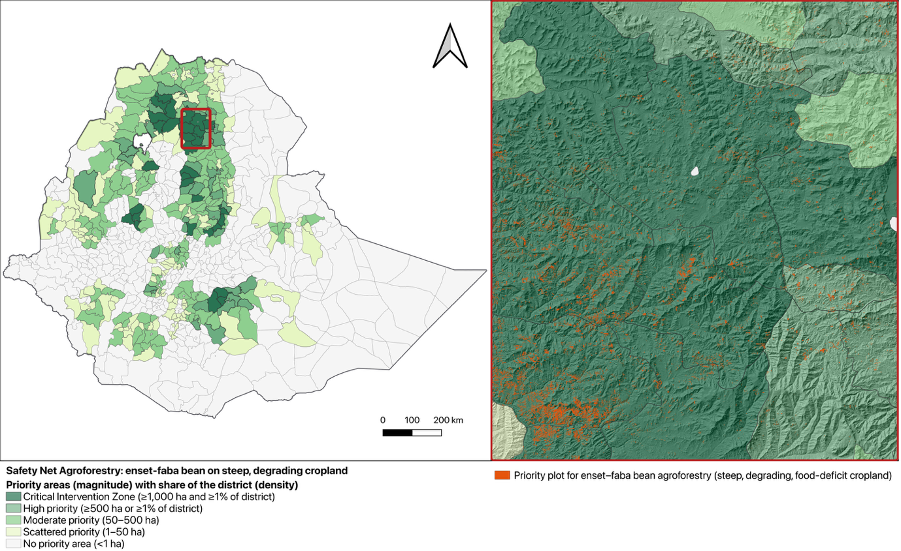
Figure 20. Priority Districts and Plots for Enset and Legume Agroforestry through PSNP Public Works (Archetype 3A). (Left) District-level (ADM3) priority tiers combining the magnitude of priority cropland (hectares) with its density (share of the district's area): Critical Intervention Zones (at least 1,000 ha and at least 1% of the district; 31 districts), high priority (at least 500 ha or at least 1%), moderate (50–500 ha), scattered (1–50 ha) and no priority area (less than 1 ha). (Right) 10-meter inset of the area outlined in red, over a 3D SRTM hillshade, showing priority plots in orange: actively cultivated land on slopes of at least 15° that is also degraded, poor and in a staple-food deficit. Priority area is derived from ESA WorldCereal and is an upper estimate; 52% of it is also classified as cropland by ESA WorldCover 2021.

Independent evidence from Ethiopia supports both the delivery mechanism and the agronomic logic behind Archetype 3A. On the delivery side, mass-labor mobilization and flagship programs, including PSNP public works, have restored about 28 million hectares of degraded land in Ethiopia over the past two decades, through soil and water conservation structures such as terraces, bunds and check-dams on 22.5 million hectares and area closures on more than 2 million hectares; the PSNP alone accounts for about 5 million hectares of project-supported restoration, demonstrating that the programme already has the organizational capacity to redirect labor toward slope-stabilizing interventions at the scale Archetype 3A would require (Elias et al., 2025).
On the agronomic side, a comparative field study in the Gurage, Hadiya and Kambata zones of central Ethiopia found that enset-based systems hold significantly more soil organic matter, total nitrogen and exchangeable nutrients than adjacent cropland, and significantly more soil organic carbon (0–40 cm) under enset-coffee (137.8 vs 93.5 Mg/ha) and enset-coffee-fruit systems (127.3 vs 92.3 Mg/ha), though not under enset-dominated plots, confirming that the perennial, multi-strata systems this archetype proposes for steep slopes measurably rebuild the same soil properties eroded by continuous plowing (Umer et al., 2026). Read together, this evidence indicates that Archetype 3A is not asking the PSNP to adopt an unfamiliar practice, but to redirect an already-proven public-works mechanism toward an already-proven agroforestry system.
Layering this same education-gap variable over the archetype's full priority screen confirms the pattern is not incidental: across the 338 districts with at least one hectare of priority cropland the gap averages 1.1 years versus Ethiopia's 1.3-year national mean, so most of Archetype 3A's footprint sits at or below the typical gender gap in schooling.
The exceptions are concentrated enough to name directly: six Critical Intervention Zones, Misrak Belesa (North Gondar, 2.3 years), Abe Dongoro (Horo Guduru, 1.9), Agarfa (Bale, 1.8), Adaba (West Arsi, 1.6), Jardega Jarte and Jima Genete (both Horo Guduru, 1.6), combine the highest intervention priority with a gender gap of 1.5 years or more, as do the high-priority districts of Wenbera (Metekel, 2.1) and Dodola (West Arsi, 1.9), and should be where PSNP-linked extension outreach under the first refinement above concentrates its effort to reach women.

Archetype 3B: Compounding Crises and the Stunting/Surplus Paradox

The spatial evaluation of Archetype 3B (Figure 21) maps the Stunting/Surplus Paradox across Ethiopia's high-potential cereal belts. Operating at a continuous 5km resolution, the model tracks the convergence of five vulnerability criteria: high cereal surplus (44.6% of Ethiopia's area), severe child stunting (23.3%), IPC Phase 2+ crisis classification (65.5%), low absolute female educational attainment (below 6 years of schooling; 98.4%), and hyper-inflated market prices for maize and teff (6.6%). Because the paradox can only exist where there is a surplus, only cereal-surplus areas are scored, and they are ranked by how many of the four shocks are present. Low female educational attainment holds across almost the whole country and therefore barely differentiates locations; it is retained for comparability with Kenya's Archetype 2A.

Core Priority cells (dark indigo in Figure 21), representing complete system failure, mark the locations where a high commercial cereal surplus coincides with all four external socio-economic shocks simultaneously. The next class combines a cereal surplus with three of the four shocks. In total, 3,865 grid cells (8% of Ethiopia) reach one of these two classes, three-quarters of them in Amhara's Wollo, Gondar and Wag Himra highlands and North Shewa, with smaller clusters in SNNP (Segen Peoples, Gamo Gofa, Selti) and West Hararghe; all 173 Core Priority cells are in Amhara (Oromiya Special Zone, South and North Wollo, Argoba and North Shewa). These are largely the same highlands where Archetype 3A's largest priority districts lie.
Two data properties shape how these results should be read: cereal surplus is derived from zone-level production statistics, so it applies to whole zones rather than to individual cells, while hyper-inflated market prices affect only 6.6% of Ethiopia's area, making that criterion a sharp discriminator — districts that clear it alongside the other four shocks represent the clearest cases where market extraction, rather than agronomic failure, drives the stunting/surplus paradox.
These results give policymakers a spatial basis to identify where a shift away from pure production subsidies toward localized market retention and targeted social interventions would have the greatest impact, distinguishing genuine production failures from districts where surplus grain is failing to reach the people who grew it.
Independent evidence on Ethiopia's own grain-market institutions supports treating market extraction, not production, as the lever for the Stunting/Surplus Paradox. A review of the Emergency Food Security Reserve Administration (EFSRA) attributed its success to three factors: an institutional design that, unlike similar agencies in other countries, keeps it independent of price stabilization (it does not buy or sell grain on the market), coordination with food-based safety-net programs, and keeping stocks to a minimum; it also found that raising stock levels for price stabilization would harm both grain markets and the reserve's own performance (Rashid & Lemma, 2011).
This corroborates Archetype 3B's own framing: the paradox this archetype targets is a market-retention and social-protection problem, not a production or central-reserve problem, and the spatial evaluation's emphasis on local price extraction and social indicators rather than production volume is consistent with the institutional evidence on how Ethiopia's own grain-market interventions actually work.

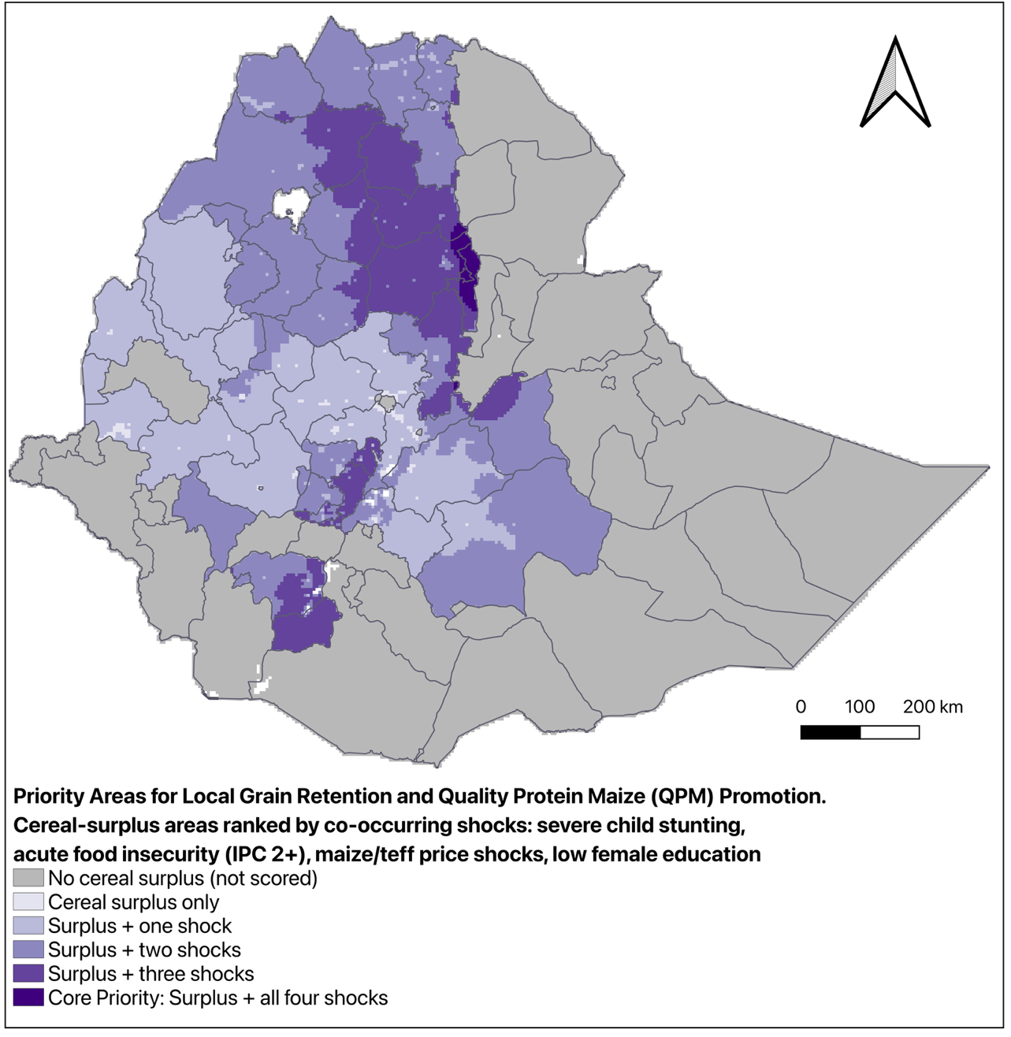
Figure 21. Priority Areas for Local Grain Retention and Quality Protein Maize (QPM) Promotion (Archetype 3B, the Stunting/Surplus Paradox). A multi-criteria evaluation at 5 km resolution, with administrative boundaries for context. Only cells with a cereal surplus (SSR ≥ 1.2; 44.6% of Ethiopia's area) are scored, ranked by how many of four co-occurring shocks are present: severe child stunting (23.3%), IPC Phase 2+ acute food insecurity (65.5%), maize or teff price shocks (6.6%) and low absolute female educational attainment (below 6 years of schooling; 98.4%). Core Priority cells (dark indigo; 173 cells) combine a surplus with all four shocks, and a further 3,692 cells combine it with three. Grey areas have no cereal surplus and are not scored. Percentages are shares of Ethiopia's area.

Archetype 3C: Pastoral Resource Conflict and Strategic Water Infrastructure

The spatial evaluation of Archetype 3C (Figure 22) maps the intersection of compounding hydrological, infrastructural, and socio-political risks across Ethiopia’s eastern and southern pastoral corridors. The model highlights "Critical Priority Zones" (shown in dark red), concentrated in the arid and semi-arid lands (ASALs) of the Afar and Somali regions, where Afar Zones 1 to 5 and Somali's Fafan, Jarar and Siti zones account for every cell meeting all four criteria. In these districts, the model shows a convergence of high overall water risk, high livestock density (TLU), significant deficits in household WASH infrastructure, and elevated risk of resource-driven conflict.
The model is restricted to the pastoral and agro-pastoral lowlands (all of Afar and Somali, plus Borena, Guji and South Omo), and a cell counts as having high livestock density when it is in the top half of that area (at least 11.1 TLU per km²). Within it, 1,408 grid cells meet all four criteria and a further 5,073 meet three, concentrated in Doolo, Shabelle and Siti in Somali and in Afar Zones 1 to 4. The southern lowlands (Borena, Guji and South Omo) reach at most two criteria, because no qualifying water-conflict events were recorded there from 2019 onward and region-level DHS data rate household water access there as adequate; this reflects the limits of the conflict and water-access data rather than an absence of need.

Because Archetype 3C operates at a 5-kilometer macro-resolution, and because the required interventions (e.g., deep boreholes, solar water pumps, or livestock watering pans) are localized, point-based infrastructure, the highlighted areas should not be interpreted as absolute acreage requiring total surface intervention.

Instead, these zones represent priority search areas rather than a direct hectare-based intervention target. The model isolates the macro-regions where water scarcity is the primary driver of compounding vulnerability, giving the Ministry of Water and Energy and humanitarian actors a defined area within which to site new infrastructure. Within these zones, planners can deploy hydro-engineers to identify optimal micro-locations for boreholes, siting infrastructure where it can simultaneously address malnutrition, sustain livestock, and reduce resource-driven conflict.
Independent evidence supports both the delivery mechanism and the governance design this archetype's water infrastructure would require. On delivery, the World Bank-financed Pastoral Community Development Program built community-driven water conservation schemes and disaster-risk mechanisms over 15 years across the same Afar, Somali, Oromiya, and SNNP districts this archetype flags; its third phase alone (2013–2019) reached more than 6.2 million direct beneficiaries, 48% of them women, and created 857 pastoral savings and credit cooperatives (World Bank, 2016; Independent Evaluation Group, 2020).
On governance, however, a mixed-methods study of community-managed rural water points in a comparable Ethiopian district found that 93% of households experienced annual service breakdowns, that post-construction community participation was minimal (9%), and that no formal tariff mechanism existed despite 95% of households being willing to pay one, even though women, who bear most of the burden of water collection, remained underrepresented in the water-point decision-making structures meant to prevent exactly these failures (Alemu et al., 2026). Read together, this evidence indicates that Archetype 3C's infrastructure investment has a delivery model already proven at scale, but that its long-term functionality depends on pairing new water points with dedicated maintenance financing and inclusive, women-represented governance from the outset, not treating construction itself as the endpoint.
Adding the male-female educational gap to this same priority screen shows the governance risk above is not evenly distributed: the 1,408 grid cells classified as Critical Priority Zones, where water scarcity, livestock density, WASH deficits, and conflict corridors all converge, carry a mean gender education gap of 2.0 years, concentrated in Afar and Somali, compared with 1.6 years across the rest of the pastoral lowlands. Because these are the same cells this archetype already flags as the highest-priority search areas for new infrastructure, they are also where the women's-representation requirement on water-point committees, called for in the effectiveness refinement above, matters most.

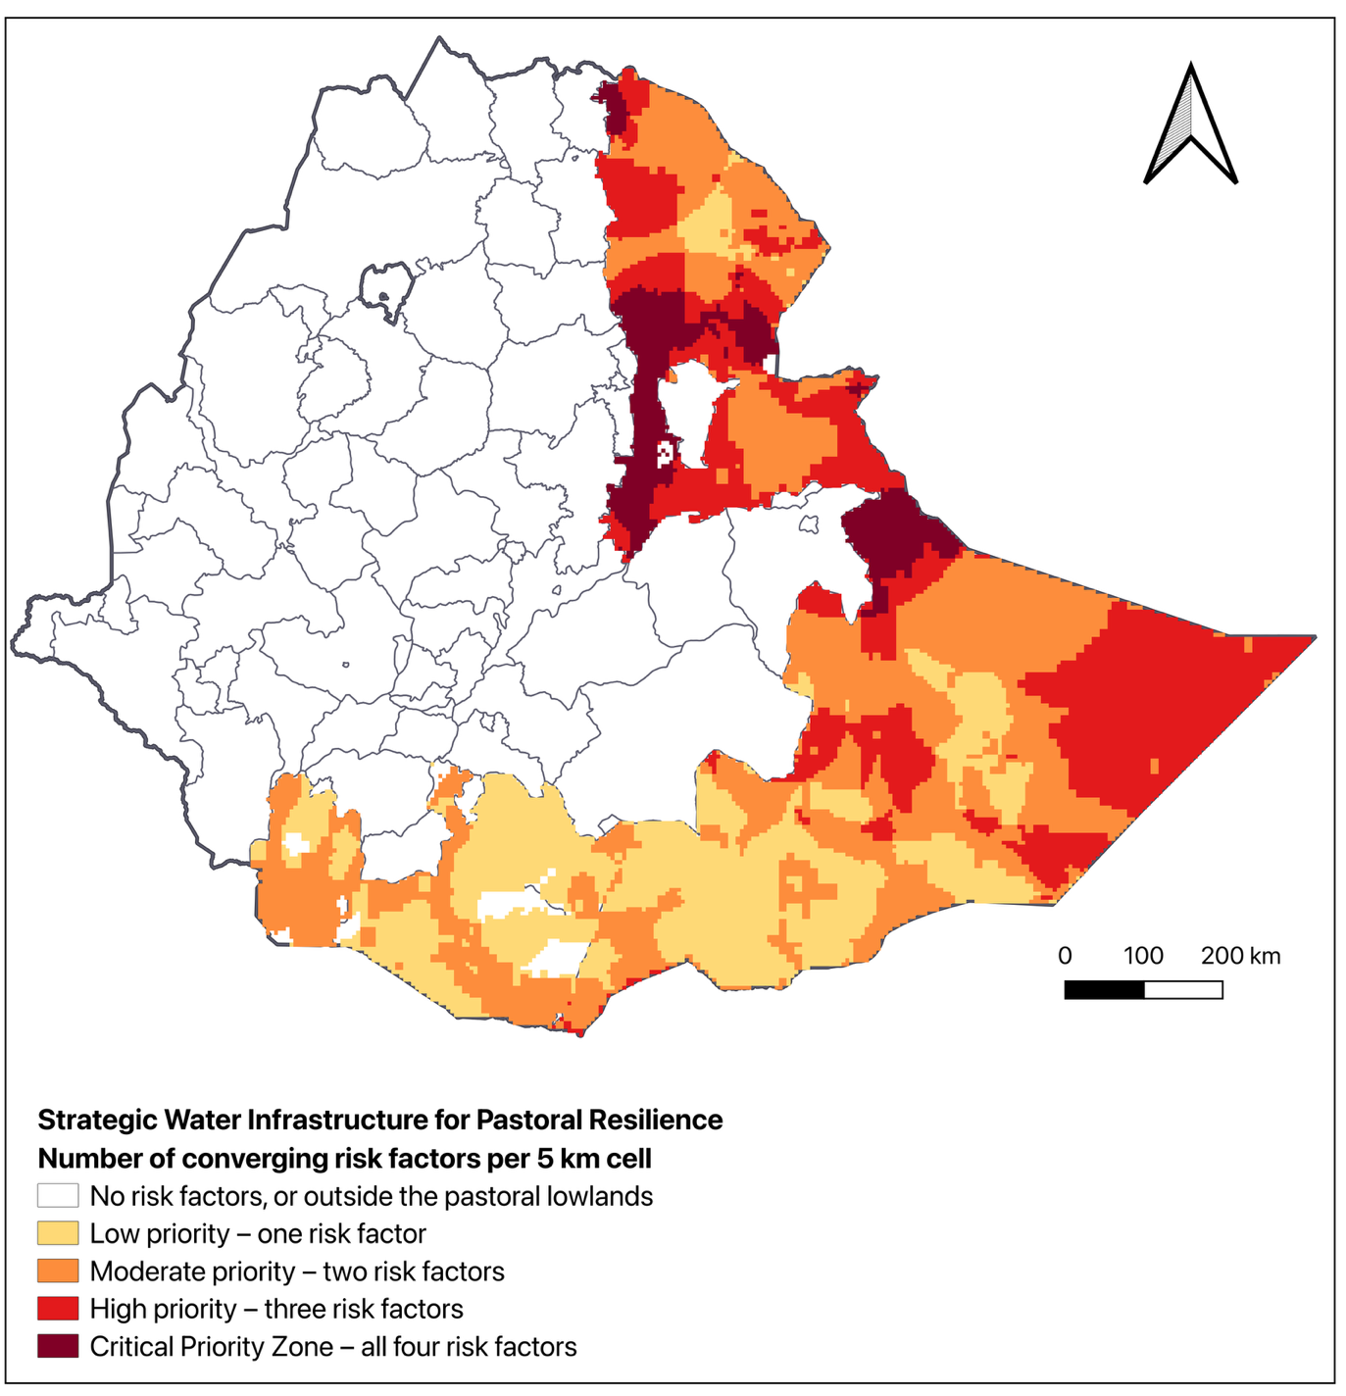
Figure 22. Strategic Water Infrastructure Targeting in Ethiopia (Archetype 3C). Number of converging risk factors per 5 km cell, scored only within the pastoral lowlands (Afar, Somali, Borena, Guji and South Omo): high overall water risk (WRI Aqueduct 4.0, High or Extremely High), high livestock density (top half of the pastoral area, at least 11.1 TLU/km²; FAO GLW4), low household access to improved water (below 55%; DHS, regional level) and water-conflict corridors (ACLED-derived water-conflict events since 2019, smoothed to within about 145 km of each event). Grey cells meet no criteria or lie outside the pastoral lowlands. Dark red "Critical Priority Zones" (1,408 cells) indicate areas where all four risk factors converge, marking the highest-priority search areas for targeted public water infrastructure.

References
Agegnehu, G., Ghizaw, A., & Sinebo, W. (2006). Yield performance and land-use efficiency of barley and faba bean mixed cropping in Ethiopian highlands. European Journal of Agronomy, 25(3), 202–207. https://doi.org/10.1016/j.eja.2006.05.002
Alemaw, A. T., Kahisu, H. R., Michael, T., Gebre, G. L., Adhana, H. N., Hailu, A. M., & Zelelew, S. G. (2024). Impacts of productive safety net program (PSNP) on soil and water conservation in Southern Tigray region, Ethiopia. Cogent Social Sciences, 10(1), 2375822. https://doi.org/10.1080/23311886.2024.2375822
Alemu, A. M., Addisu, T., Tolosa, D., Abduro, S., Fetene, S., & Bekele, B. (2026). Reliability, functionality, and governance of community-managed rural water points in Ginir district, Ethiopia. Utilities Policy, 101, 102205. https://doi.org/10.1016/j.jup.2026.102205
Bimrew, S., Abera, M., Belay, B., & Nigir, B. (2025). Management of faba bean gall (Physoderma viciae) through integration of host resistance with fungicides in Meket district, North Eastern Ethiopia. Discover Agriculture, 3, 94. https://doi.org/10.1007/s44279-025-00253-0
Bora, Z., Wang, Y., Angassa, A., Zhu, A. L., You, Y., Zhou, N., Reda, K. W., & Tilahun, M. (2026). Landscape-based traditional grazing management systems for the sustainability of southern Ethiopia's Borana rangelands. Regional Environmental Change, 26(1), 37. https://doi.org/10.1007/s10113-026-02520-2
Elias, E., Aneseyee, A. B., Mekeberiaw, A., Hailu, H., Hundie, H., Hernik, J., & Yohannes, H. (2025). From degradation to restoration: Addressing the environmental challenges in the Ethiopian highlands. Environmental Monitoring and Assessment, 198(1), 58. https://doi.org/10.1007/s10661-025-14914-6
Gunaratna, N. S., Moges, D., & De Groote, H. (2019). Biofortified maize can improve quality protein intakes among young children in southern Ethiopia. Nutrients, 11(1), 192. https://doi.org/10.3390/nu11010192
Haile, B., Fininsa, C., Terefe, H., Chala, A., & Hussen, S. (2020). Evaluation of enset (Ensete ventricosum) clones for resistance reaction against pathogenic Xanthomonas campestris pv. musacearum isolates from Southwestern Ethiopia. Cogent Food & Agriculture, 6(1), 1773094. https://doi.org/10.1080/23311932.2020.1773094
Independent Evaluation Group. (2020). Implementation Completion Report (ICR) review: Pastoral Community Development III (P130276) (Report No. ICRR0022035). World Bank. https://documents1.worldbank.org/curated/en/972731589551371865/pdf/Ethiopia-Pastoral-Community-Development-III.pdf
Mekonnen, K., Jogo, W., Bezabih, M., Mulema, A., & Thorne, P. (2019). Determinants of survival and growth of tree lucerne (Chamaecytisus palmensis) in the crop-livestock farming systems of the Ethiopian highlands. Agroforestry Systems, 93(1), 279–293. https://doi.org/10.1007/s10457-016-0066-1
Meresa, B. K., & Gebremedhin, H. M. (2020). Faba bean gall (Olpidium viciae K.) as a priority biosecurity threat for producing faba bean in Ethiopia: Current status and future perspectives. International Journal of Agronomy, 2020, 4629230. https://doi.org/10.1155/2020/4629230
Mesfin, S., Gebresamuel, G., Haile, M., & Zenebe, A. (2023). Potentials of legumes rotation on yield and nitrogen uptake of subsequent wheat crop in northern Ethiopia. Heliyon, 9(6), e16126. https://doi.org/10.1016/j.heliyon.2023.e16126
Rashid, S., & Lemma, S. (2011). Strategic grain reserves in Ethiopia: Institutional design and operational performance (IFPRI Discussion Paper 1054). International Food Policy Research Institute. https://hdl.handle.net/10568/154938
Regassa, H., & Elias, E. (2022). Dry matter production, nitrogen yield and estimation of nitrogen fixation of legumes on vertisols of the Ethiopian highlands. Heliyon, 8(12), e12523. https://doi.org/10.1016/j.heliyon.2022.e12523
Sadler, K., Mitchard, E., Abdi, A., Shiferaw, Y., Bekele, G., & Catley, A. (2012). Milk matters: The impact of dry season livestock support on milk supply and child nutrition in Somali Region, Ethiopia. Feinstein International Center, Tufts University and Save the Children. https://fic.tufts.edu/publication-item/milk-matters/
Umer, S., Tolossa, A. R., Nigussie, A., & Addisu, S. (2026). Soil fertility improvement through Enset-based farming systems in central Ethiopia. Scientific Reports, 16(1), 20577. https://doi.org/10.1038/s41598-026-49794-4
Woldu, T., Tadesse, F., & Waller, M.-K. (2013). Women's participation in agricultural cooperatives in Ethiopia (ESSP II Working Paper 57). International Food Policy Research Institute and Ethiopian Development Research Institute. https://hdl.handle.net/10568/153545
World Bank. (2016, October 11). Empowering Ethiopia's pastoral and agro-pastoral communities. https://www.worldbank.org/en/news/feature/2016/10/11/empowering-ethiopias-pastoral-and-agro-pastoral-communities

