7.2 Proposed Country-Specific Policy Archetypes

Leveraging these methodological enhancements, the model will aim to generate distinct, highly targeted subnational policy archetypes for each deep-dive country:

2. Kenya: Addressing the Agro-Ecological Divide
Archetype 2A: Yield Stagnation Amelioration and Regenerative Soil Restoration
In the western region and Rift Valley, despite heavy synthetic fertilizer subsidies, soils are increasingly exhausted. The historical over-reliance on continuous maize cultivation and acidifying fertilizers (such as DAP) has driven soil pH to critical lows, effectively locking nutrients away from crop roots and leading to a paradox of high input costs but declining harvests. The objective of this archetype is to target districts locked in this cycle of yield stagnation for the deployment of regenerative agroecological systems.

Filtering high-resolution iSDAsoil acidity data (30m) through the Digital Earth Africa Cropland Extent mask (10m) identifies active smallholder plots affected by severe soil degradation. These plots are flagged for the gradual replacement of synthetic fertilizer subsidies with soil-restoring legume intercropping and localized extension services. Integrating acid-tolerant, nitrogen-fixing pulses into these maize systems can buffer soil chemistry while producing plant protein that can be procured for local Home-Grown School Feeding (HGSF) programs, addressing regional micronutrient deficiencies.

This is not a novel intervention for Kenya's highland maize belt: soil-acidity liming and lime-phosphate amendment already have a documented, on-farm track record in the country, including a 2025 nine-county survey and controlled field trials directly covering several of the counties this archetype identifies (discussed further in Section 8).
Three refinements to this practice would likely increase its effectiveness, environmental sustainability, and contribution to healthy diets, each grounded in evidence from comparable acid-soil, smallholder contexts. First, on effectiveness: a 2025 continent-wide analysis found that liming is profitable across roughly 6.2 to 8.8 million hectares of Sub-Saharan African cropland, but that profitability is unevenly distributed and crop-specific (Silva et al., 2025), and Rwanda's own national liming program, evaluated against 261 households, found that liming maize and beans, the staple pairing that also dominates Archetype 2A's target counties, was only profitable for smallholders once lime was subsidized by 50%, whereas Irish potato returned a profit unsubsidized (Jaleta et al., 2024). Archetype 2A's practice should therefore be paired with a partial lime subsidy channeled through Kenya's existing synthetic fertilizer subsidy infrastructure, rather than treating lime as a cost smallholders are expected to absorb unassisted. Second, on sustainability: rather than a general reference to soil-restoring legume intercropping, the archetype's regenerative component can specifically incorporate the improved-fallow and biomass-transfer system (Sesbania sesban, Crotalaria grahamiana, Tithonia diversifolia) developed by ICRAF, KARI, KEFRI, and TSBF and adopted by thousands of farmers in Vihiga and Siaya, two of this archetype's own Core Priority counties, where farmer-to-farmer dissemination measured maize yield gains of two- to three-fold (Kiptot et al., 2006). Third, on healthy diets: naming soybean specifically, rather than pulses generically, as the intercropped legume gives the archetype a direct dietary-protein pathway; Kenyan trial evidence shows that soybean nodulation and nitrogen fixation increase significantly when lime is combined with rhizobial inoculation, particularly on the strongly acidic soils this archetype targets (Bakari et al., 2020).

Proposed Spatial Variables: Declining Cereal Yield Trends (EarthStat; FAO) + High Synthetic Fertilizer Application Rates (IFDC; World Bank) + Severe Soil Acidity (iSDAsoil pH rasters) + Maize Crop Dominance derived from Harvested Area (IFPRI) + Active Cropland Extent Mask (10m ESA/DE Africa) + Acute Food Insecurity Trajectories (IPC Phase 3+).

Archetype 2B: Arid Pastoral Micro-Gardens
In the arid northern counties, high livestock and animal-protein access can mask plant-based micronutrient gaps. The objective is to target these pastoral zones for decentralized, water-smart household agricultural infrastructure, such as greywater keyhole gardens, cultivating drought-tolerant indigenous greens (e.g., amaranth, spider plant) rather than water-intensive conventional vegetables, to close micronutrient deficits without straining depleted aquifers. Because agriculture is sparse across these areas, the model uses 10-meter cropland mapping to detect small, isolated patches of existing cultivation, typically clustered near seasonal water points or boreholes. These existing micro-oases serve as candidate sites for introducing and scaling micro-garden infrastructure.

This is not an untested concept for Kenya's arid counties: small-scale, low-water household food production already has a documented track record in the region, most notably a UNHCR/WFP-supported multi-storey garden programme that reached more than 5,000 households in Dadaab, one county over from Mandera, alongside Mandera's own active government-led irrigation expansion along the Daua River (discussed further in Section 8).
Three refinements to this practice would likely increase its effectiveness, environmental safety, and contribution to healthy diets, each grounded in evidence from comparable arid, low-water contexts. First, on effectiveness: low-head drip irrigation kits (the MoneyMaker line and similar, already commercially available in Kenya) have been shown to raise water-use efficiency by roughly 80% over conventional hand-watering (Ngigi, 2008), which matters directly in Mandera and its neighboring near-miss counties, where the archetype's own screening criteria confirm water risk is severe; separate field evaluation in Kenya has also found that the cheapest kits are built from materials that shorten their working life to under three years against a claimed seven, so scaling drip components alongside keyhole gardens should be paired with local spare-parts and repair access, not a one-time kit handout (Kulecho & Weatherhead, 2006). Second, on environmental safety: the practice currently specifies ‘greywater’ without qualifying its source, but the evidence is source-specific: kitchen greywater carries oils, food residue, and higher pathogen loads that make it unsuitable for direct food-crop irrigation, while bathroom and laundry greywater, run through a simple household-scale sand-and-gravel or biochar filter, is a substantially safer choice for edible gardens (Hamidi, 2025). Archetype 2B's design should specify bathroom- and laundry-sourced, filtered greywater rather than treating all household greywater as interchangeable. Third, on healthy diets: pairing the existing amaranth-and-spider-plant palette with moringa, introduced as a drought-resilient, income-generating tree crop under World Vision's IMARA climate-resilience programme in Turkana, one of this archetype's own near-miss counties, where a farmer group has scaled a moringa enterprise from a quarter-acre to 17 acres (Daily Nation, 2026), and where the same programme also reaches two of the archetype's other near-miss counties, Isiolo and West Pokot, under the same livelihood-diversification model (World Vision International, n.d.); and with cowpea, a dual-purpose drought-tolerant legume whose leaves carry substantially more protein (11–35% of dry matter) than the leafy greens currently proposed, would give the garden a direct route to closing the protein gap the archetype's own plant-food-deficit criterion is built to detect, not just a micronutrient one (Owade et al., 2020).

Proposed Spatial Variables: High Livestock Density (FAO TLU) + Severe Overall Water Risk (WRI Aqueduct) + Plant-Based Food Deficits (Inverted SSR) + Acute Food Insecurity Classifications (IPC Phase 3+) + Geo-located Resource Conflict Events (ACLED) + Active Cropland Extent Mask (10m ESA/DE Africa).

8. Preliminary Results: Deep-Dive Countries

Archetype 2A: Yield Stagnation Amelioration and Regenerative Soil Restoration
This is not a novel intervention for Kenya's highland maize belt: soil-acidity liming and lime-phosphate amendment already have a documented, on-farm track record in the country, including a 2025 nine-county survey and controlled field trials directly covering several of the counties this archetype identifies (discussed further below).

The spatial evaluation of Archetype 2A (Figure 17) identifies the western Kenya and Rift Valley counties where soil acidity, active cropland, declining maize yields, and high synthetic fertilizer rates converge. Screening all 47 counties against these four hard criteria, the model flags six as Core Priority: Uasin Gishu, Elgeyo-Marakwet, Vihiga, Machakos, Embu, and Bomet each meet all four conditions simultaneously. A further 26 counties meet three of the four criteria, 9 meet two, and 6 meet only one, giving the map a graduated screening score rather than a blunt in/out classification.

Downscaling severe soil acidity through the 10-meter WorldCereal cropland mask confirms the expected geographic pattern: acidic, actively farmed cropland concentrates heavily in the western maize belt, led by Kakamega (33,839 ha), Bungoma (27,136 ha), Nakuru (20,947 ha), Kericho (12,547 ha), and Busia (11,950 ha). This spatial clustering validates the underlying biophysical assumption behind Archetype 2A: the same high-rainfall, historically maize-dominant counties that received the heaviest subsidized fertilizer application are now the ones showing the most acidified, active farmland.

Acute food insecurity (IPC Phase 3+) is retained as contextual information rather than a screening filter, because Kenya's IPC analysis covers only 23 arid and semi-arid counties and does not assess the western maize belt at all. None of the six Core Priority counties currently carry an IPC classification, which is consistent with the archetype's underlying logic: this is a chronic soil-degradation and yield-stagnation problem in food-producing counties, rather than an acute food-crisis one.

A newly added gender-disaggregated educational lens (IHME LMIC Education, 2000–2017) tests each county's absolute level of female educational attainment against a fixed threshold of 6 years, corresponding to primary-school completion, per the enhancement described in Section 7.1. Ten of Kenya's 47 counties fall below this threshold, all of them in the arid and semi-arid periphery: West Pokot, Samburu, Garissa, Isiolo, Lamu, Mandera, Marsabit, Tana River, Turkana, and Wajir. None of the six Archetype 2A Core Priority counties are among them; female mean years of schooling among 20–24-year-olds in Uasin Gishu, Elgeyo-Marakwet, Vihiga, Machakos, Embu, and Bomet ranges from 9.3 to 10.3 years, comfortably above the threshold. Archetype 2A's yield-stagnation problem therefore appears to be a technical one, rooted in soil acidity and fertilizer misapplication in the historically better-educated highland maize belt, rather than one compounded by educational or gender inequity in the same counties. This finding is reported as context rather than a screening criterion, consistent with how IPC is treated above; Figure 17 marks the ten low-female-education counties with a bold blue outline as an independent lens layered over the same criteria-met shading, not a revised classification.

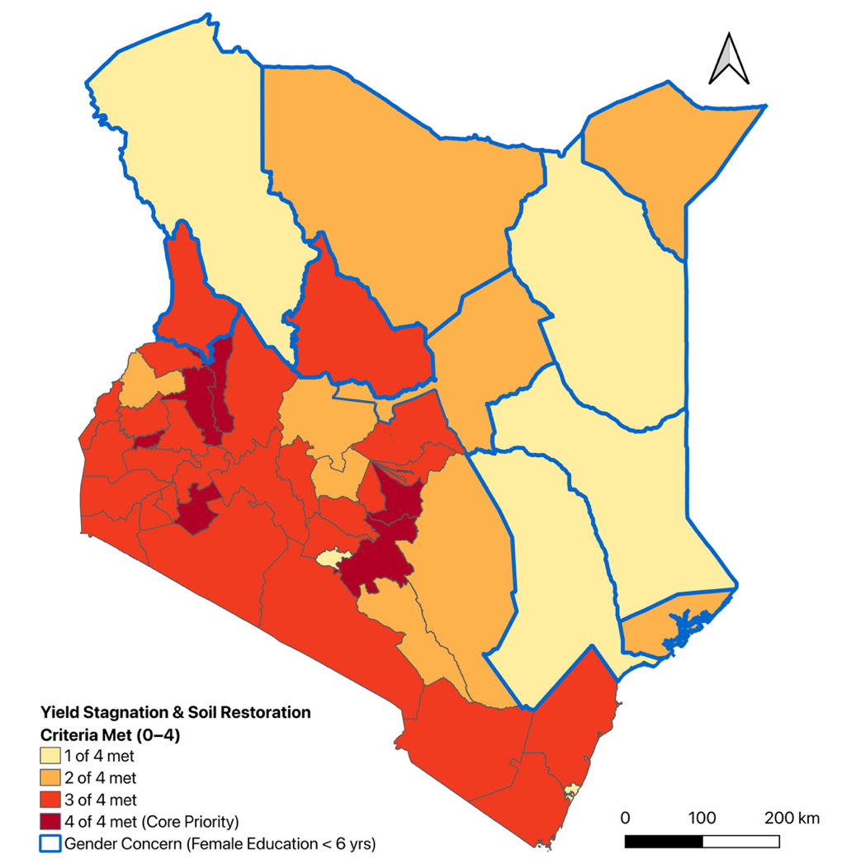
Figure 17. Yield Stagnation & Soil Restoration, County Screening Score (Kenya). Counties are shaded by how many of the four Archetype 2A hard-filter criteria they meet: severe soil acidity coinciding with active cropland (10m WorldCereal mask), maize crop dominance (over 50% of cereal harvested area), a declining maize yield trend (2013–2021), and a high synthetic fertilizer application rate (top tertile of NPKGRIDS county means). Dark red counties, Uasin Gishu, Elgeyo-Marakwet, Vihiga, Machakos, Embu, and Bomet, meet all four criteria and are flagged Core Priority. A bold blue outline marks the ten counties with female mean years of schooling below 6 years (West Pokot, Samburu, Garissa, Isiolo, Lamu, Mandera, Marsabit, Tana River, Turkana, and Wajir), an independent gender-education lens that does not overlap with any Core Priority County.

Independent field and survey evidence from Kenya corroborates both the geographic pattern and the intervention logic underlying Archetype 2A. A 2025 nine-county survey led by the Strathmore Agri-Food Innovation Centre, covering Bungoma, Trans-Nzoia, Kakamega, Nakuru, Bomet, Embu, Narok, Kitui, and Makueni, found that farmers who limed acidic plots harvested 63% more maize on average and earned over KES 12,000 more per acre than farmers on unlimed land (Strathmore Agri-Food Innovation Centre, 2025), directly implicating two of the model's six Core Priority counties, Bomet and Embu, in documented, on-farm yield gains from the very intervention Archetype 2A proposes. A controlled field trial at Kuinet in Uasin Gishu, another Core Priority county, found that combining diammonium phosphate with agricultural lime raised maize yields from 1.36 t/ha on untreated plots to 6.19 t/ha, more than a fourfold increase (Nekesa et al., 2011). Machakos, the model's sixth Core Priority county, has its own documented history of on-farm legume cover-cropping and sub-soiling trials aimed at rebuilding degraded soil fertility for maize production (Food and Agriculture Organization of the United Nations, n.d.). At the national scale, government and press reporting places the soil-acidity problem across 29 counties and roughly 63% of Kenya's arable land, with Vihiga, another of the six Core Priority counties, among the most severely affected at 93% acidic land, and cites the cost and availability of lime, rather than a lack of awareness of the remedy, as the principal barrier to wider adoption (Business Daily Africa, 2019). Read together, this evidence suggests that Archetype 2A is not proposing an untested intervention in unfamiliar counties, but rather proposing to scale, target, and better fund a remedy already proven, county by county, in the very landscape the model identifies.

Beyond confirming that Archetype 2A's practice is already validated locally, this evidence also points to three concrete refinements that would strengthen it. A 2025 continent-wide analysis found that liming is profitable across 6.2 to 8.8 million hectares of Sub-Saharan African cropland, but that profitability is unevenly distributed and depends on which crop is limed (Silva et al., 2025); Rwanda's own national liming program, evaluated against 261 households, found that liming maize and beans, the staple pairing that also dominates Archetype 2A's target counties, was only profitable for smallholders once lime was subsidized by 50%, whereas Irish potato returned a profit unsubsidized (Jaleta et al., 2024). This suggests Archetype 2A's design should explicitly bundle a partial lime subsidy into Kenya's existing fertilizer-subsidy channel, rather than treating lime procurement as a cost smallholders are expected to absorb on top of the input costs the archetype is otherwise trying to redirect. On the archetype's regenerative component, the currently general reference to legume intercropping can be sharpened using a directly relevant, already-proven local precedent: an ICRAF, KARI, KEFRI, and TSBF program of improved short-duration fallows (Sesbania sesban, Crotalaria grahamiana) and Tithonia diversifolia biomass transfer was tested and adopted by thousands of farmers in Vihiga and Siaya, two of the model's six Core Priority counties, where farmer-to-farmer dissemination measured two- to three-fold maize yield increases (Kiptot et al., 2006). Finally, naming soybean specifically as the intercropped legume, rather than leaving the crop choice generic, gives Archetype 2A a direct route to improving household dietary protein intake alongside soil restoration: Kenyan trial evidence shows soybean nodulation and nitrogen fixation rise significantly when lime is combined with rhizobial inoculation on strongly acidic soils, the exact condition this archetype screens for (Bakari et al., 2020). Together, these refinements would convert Archetype 2A from a general soil-acidity intervention into a fully specified, subsidy-supported, dietary-protein-linked practice with a documented adoption record in its own target counties.

Archetype 2B: Arid Pastoral Micro-Gardens

This is not an untested concept for Kenya's arid counties: small-scale, low-water household food production already has a documented track record in the region, most notably a UNHCR/WFP-supported multi-storey garden programme that reached more than 5,000 households in Dadaab, one county over from Mandera, alongside Mandera's own active government-led irrigation expansion along the Daua River (discussed further below).

The spatial evaluation of Archetype 2B (Figure 18) screens Kenya's 23 officially designated Arid and Semi-Arid Land (ASAL) counties against five hard-filter criteria: high livestock density, severe agricultural water risk, plant-based food deficits (using the internationally comparable SSR < 1.0 threshold), acute food insecurity (IPC Phase 3+), and geo-located resource-conflict events. Only Mandera meets all five conditions simultaneously and is flagged Core Priority, combining hyper-aridity with substantial river-valley livestock populations and an active IPC Phase 3 classification.

A further five counties meet four of the five criteria, splitting into two distinct near-miss profiles. Garissa, Isiolo, and Turkana are already at IPC Phase 3 and show severe water risk, plant-food deficits, and conflict events, but their livestock density falls short of the ASAL-relative threshold, since sparse nomadic herds ranging across vast rangeland register a lower density than the settled herds of higher-carrying-capacity semi-arid margins, even though the underlying crisis is real. Embu and West Pokot show the opposite pattern: high livestock density, severe water risk, plant-food deficits, and conflict events are all present, but both counties currently sit at IPC Phase 2 (Stressed) rather than Phase 3+, meaning the structural risk factors are in place without (yet) a triggering acute food crisis. Kiambu and Machakos coincidentally clear four of the five numeric thresholds as well, but neither is IPC-assessed as an ASAL county, so both are treated as out of scope regardless of score.

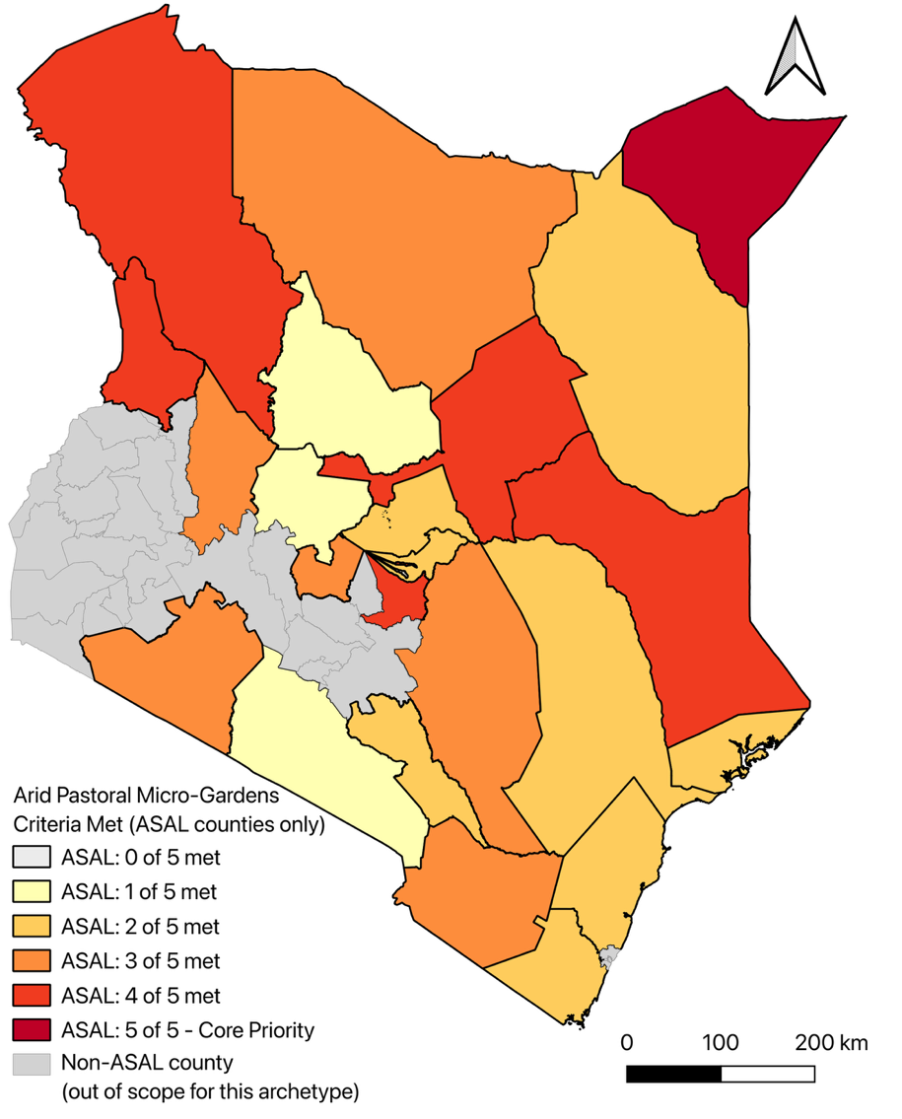
Figure 18. Archetype 2B: Arid Pastoral Micro-Gardens, Criteria Met (0–5, ASAL Counties Only). The 23 officially designated Arid and Semi-Arid Land (ASAL) counties are shaded by how many of the five Archetype 2B hard-filter criteria they meet: high livestock density, severe agricultural water risk, plant-based food deficits (SSR < 1.0), acute food insecurity (IPC Phase 3+), and geo-located resource-conflict events. Mandera (dark red) meets all five criteria and is flagged Core Priority. Garissa, Isiolo, Turkana, Embu, and West Pokot (orange-red) meet four of five, falling short on livestock density (Garissa, Isiolo, Turkana) or on the acute-crisis IPC threshold (Embu, West Pokot). Grey counties fall outside Kenya's ASAL classification and are out of scope for this archetype regardless of their coincidental score.

Within Mandera, the 10-meter WorldCereal active cropland mask identifies 3,291 hectares of active farmland, consistent with the county's known riverine irrigation belts along the Dawa River. This cropland layer is used descriptively rather than as a screening criterion, isolating the small, scattered “micro-oasis” patches of existing cultivation that represent the most viable candidate sites for keyhole-garden infrastructure.
These modeled cultivation patterns align with real, ongoing investment in Mandera's irrigation infrastructure. County and national government reporting describes an active irrigation expansion program along the Daua/Dawa River, including 7.1 kilometers of newly built or rehabilitated concrete canals across six irrigation schemes and roughly 2,145 additional acres of farmland opened through bush clearing (Kenya News Agency, 2025), alongside a second phase of the Yabicho A Irrigation Project adding 100 further acres for 200 farming households displaced by recurrent flash floods along the river (County Government of Mandera, 2026). Both efforts target the same riverine micro-oasis pattern the 10-meter WorldCereal mask detects, reinforcing that Mandera's existing 3,291 hectares of active cropland are concentrated in a small number of intensively managed, floodplain-adjacent sites rather than spread evenly across the county, precisely the kind of compact, already-irrigated footprint that keyhole-garden infrastructure could extend into surrounding households at comparatively low marginal cost. A parallel household-scale precedent already operates one county over: in Dadaab, Garissa County, the project's own highest-scoring near-miss county for Archetype 2B, a UNHCR/WFP-supported multi-storey garden (MSG) programme, delivered through GTZ with Canadian government financing, was taken up by more than 5,000 refugee households growing leafy vegetables, tomatoes, okra, and eggplant in stacked cereal-sack planters irrigated with as little as five litres of water twice daily (Corbett, 2006). The same low-water, small-footprint logic, applied to Mandera's existing irrigated micro-oases, would extend a design already validated at household scale in the immediately adjacent ASAL landscape rather than introducing an unfamiliar technology.

Beyond confirming that Archetype 2B's practice already has a validated household-scale precedent in the immediately adjacent Dadaab landscape, this evidence also points to three concrete refinements. On effectiveness, low-head drip irrigation kits, commercially available in Kenya through suppliers such as KickStart, raise water-use efficiency by roughly 80% over hand-watering (Ngigi, 2008), directly relevant given the severe water risk that qualifies Mandera and its near-miss counties for this archetype in the first place; however, separate field evaluation in Kenya found that the cheapest kits are built from materials that cut their working life to under three years against a claimed seven, so any scale-up should budget for local repair and spare-parts access rather than a one-time distribution (Kulecho & Weatherhead, 2006). On environmental safety, the practice's current ‘greywater’ framing should be made source-specific: kitchen greywater carries oils, food residue, and higher pathogen loads unsuitable for direct food-crop irrigation, whereas bathroom and laundry greywater, passed through a simple household-scale sand-and-gravel or biochar filter, is markedly safer for edible gardens (Hamidi, 2025), a distinction the design should state explicitly rather than leaving ‘greywater’ undifferentiated. On healthy diets, the amaranth-and-spider-plant palette can be extended with moringa, which World Vision's IMARA climate-resilience programme has introduced as a drought-resilient, income-generating tree crop in Turkana, one of this archetype's own five near-miss counties, where a farmer group has scaled production from a quarter-acre to 17 acres (Daily Nation, 2026), and the same programme also reaches two of the archetype's other near-miss counties, Isiolo and West Pokot (World Vision International, n.d.); and with cowpea, a dual-purpose drought-tolerant legume whose leaves carry substantially more protein, 11 to 35% of dry matter, than the currently proposed leafy greens (Owade et al., 2020). Both additions target the archetype's own plant-based food-deficit screening criterion more directly than micronutrient-rich greens alone, since that criterion is built around a staple/protein self-sufficiency ratio, not a micronutrient one.

References
Agricultural Research Information System (AGRIS), Food and Agriculture Organization of the United Nations (FAO). (n.d.). Effects of legume cover crops and sub-soiling on soil properties and maize growth in Machakos District, Kenya. https://agris.fao.org/search/ru/records/68d2a397b3b40a20d618896b
Bakari, R., Mungai, N., Thuita, M., & Masso, C. (2020). Impact of soil acidity and liming on soybean (Glycine max) nodulation and nitrogen fixation in Kenyan soils. Acta Agriculturae Scandinavica, Section B: Soil and Plant Science, 70(8), 667–678. https://doi.org/10.1080/09064710.2020.1833976
Business Daily Africa. (2019). Soil acidity spells doom for future of Kenya agriculture. https://www.businessdailyafrica.com/bd/data-hub/soil-acidity-spells-doom-for-future-of-kenya-agriculture-2268334
Corbett, M. (2006). Multi-storey gardens to support food security. Field Exchange, Issue 29. Emergency Nutrition Network (ENN). https://www.ennonline.net/fex/29/en/multi-storey-gardens-support-food-security
County Government of Mandera. (2026). Mandera Launches Phase II of Yabicho A Irrigation Project. https://mandera.go.ke/mandera-launches-phase-ii-of-yabicho-a-irrigation-project/
Daily Nation. (2026). Pastoralists turn to moringa 'wonder crop' to cushion climate shocks. https://nation.africa/kenya/climate/pastoralists-turn-to-moringa-wonder-crop-to-cushion-climate-shocks-5431132
Hamidi, M. N. (2025). Greywater reuse for irrigation: A critical review of suitability, treatment, and risks. Science of the Total Environment, 975, 179272. https://doi.org/10.1016/j.scitotenv.2025.179272
Jaleta, M., Silva, J. V., Ruganzu, V., Mvuyekure, S. M., Mujanama, E., Voss, R., Chamberlin, J., & Baudron, F. (2024). Is agricultural lime a profitable investment for African smallholders? Evidence from Rwanda. African Journal of Agricultural and Resource Economics, 19(1). https://afjare.org/is-agricultural-lime-a-profitable-investment-for-african-smallholders-evidence-from-rwanda/
Kenya News Agency. (2025). Mandera implements transformative irrigation projects to combat climate change. https://www.kenyanews.go.ke/mandera-implements-transformative-irrigation-projects-to-combat-climate-change/
Kiptot, E., Franzel, S., Hebinck, P., & Richards, P. (2006). Sharing seed and knowledge: Farmer to farmer dissemination of agroforestry technologies in western Kenya. Agroforestry Systems, 68, 167–179. https://doi.org/10.1007/s10457-006-9007-8
Kulecho, I. K., & Weatherhead, E. K. (2006). Adoption and experience of low-cost drip irrigation in Kenya. Irrigation and Drainage, 55(4), 435–444. https://doi.org/10.1002/ird.261
Nekesa, A.O., Okalebo, J.R., Othieno, C.O., Thuita, M.N., Bationo, A., & Waswa, B.S. (2011). The Potential of Increased Maize and Soybean Production in Uasin Gishu District, Kenya, Resulting from Soil Acidity Amendment Using Minjingu Phosphate Rock and Agricultural Lime. In Innovations as Key to the Green Revolution in Africa (pp. 343-348). Springer, Dordrecht. https://doi.org/10.1007/978-90-481-2543-2_34
Ngigi, S. N. (2008). Technical evaluation and development of low-head drip irrigation systems in Kenya. Irrigation and Drainage, 57(4), 450–462. https://doi.org/10.1002/ird.360
Owade, J. O., Abong', G., Okoth, M., & Mwang'ombe, A. W. (2020). A review of the contribution of cowpea leaves to food and nutrition security in East Africa. Food Science & Nutrition, 8(1), 36–47. https://doi.org/10.1002/fsn3.1337
Silva, J. V., Aramburu-Merlos, F., Baudron, F., et al. (2025). Soil acidity remediation in sub-Saharan Africa requires targeted investments. Nature Food, 6, 799–808. https://doi.org/10.1038/s43016-025-01194-z
Strathmore Agri-Food Innovation Centre (SAFIC). (2025). The Lime That Brought Life: How a Simple Soil Fix is Transforming Maize Farming in Kenya. Strathmore University. https://safic.strathmore.edu/the-lime-that-brought-life-how-a-simple-soil-fix-is-transforming-maize-farming-in-kenya/
World Vision International. (n.d.). Integrated Management of Natural Resources for Resilience in Arid and Semi-Arid Lands (IMARA) – Kenya. https://www.wvi.org/kenya/integrated-management-natural-resources-resilience-arid-and-semi-arid-lands-imara

