Supplementary material

Appendix I – Experimental field lay-out
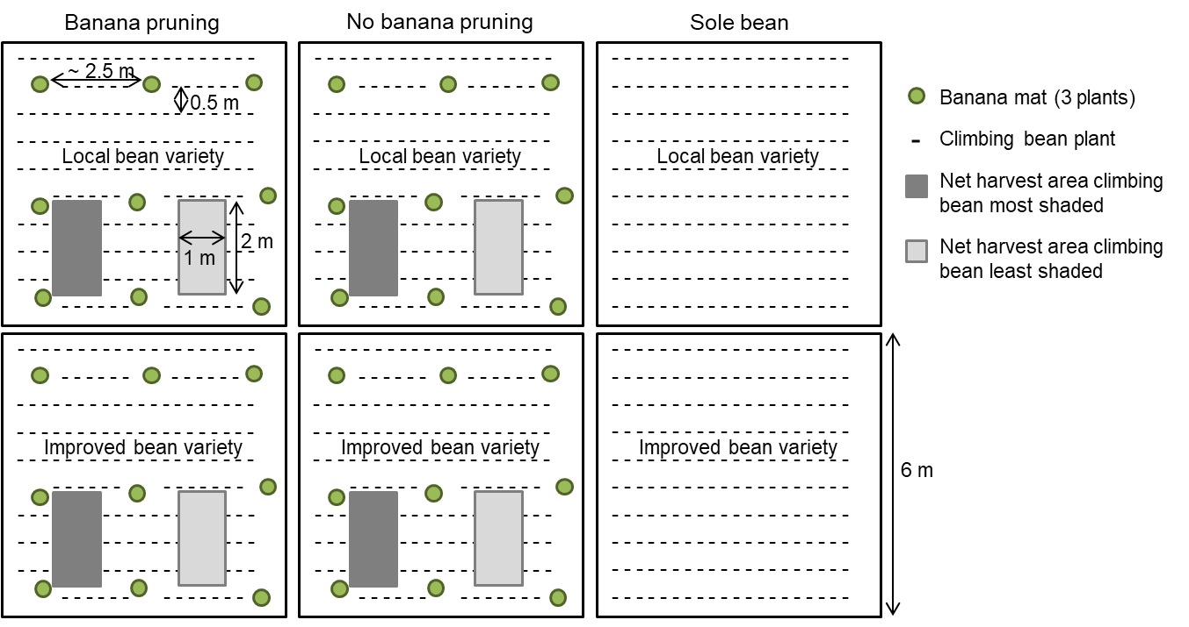
Figure I. Layout of the experimental field with six subplots. Banana mats were somewhat irregularly spaced at approximately 2.5 x 2.5 m, shading some portions of the subplot more than other.

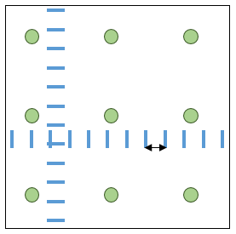
Appendix II – Transects of PAR readings
PAR reading
Banana plant
0.5 m
Figure II. PAR readings below the banana canopy along two transects per subplot.

of the banana mats.

Appendix III – Light transmission profiles per farm
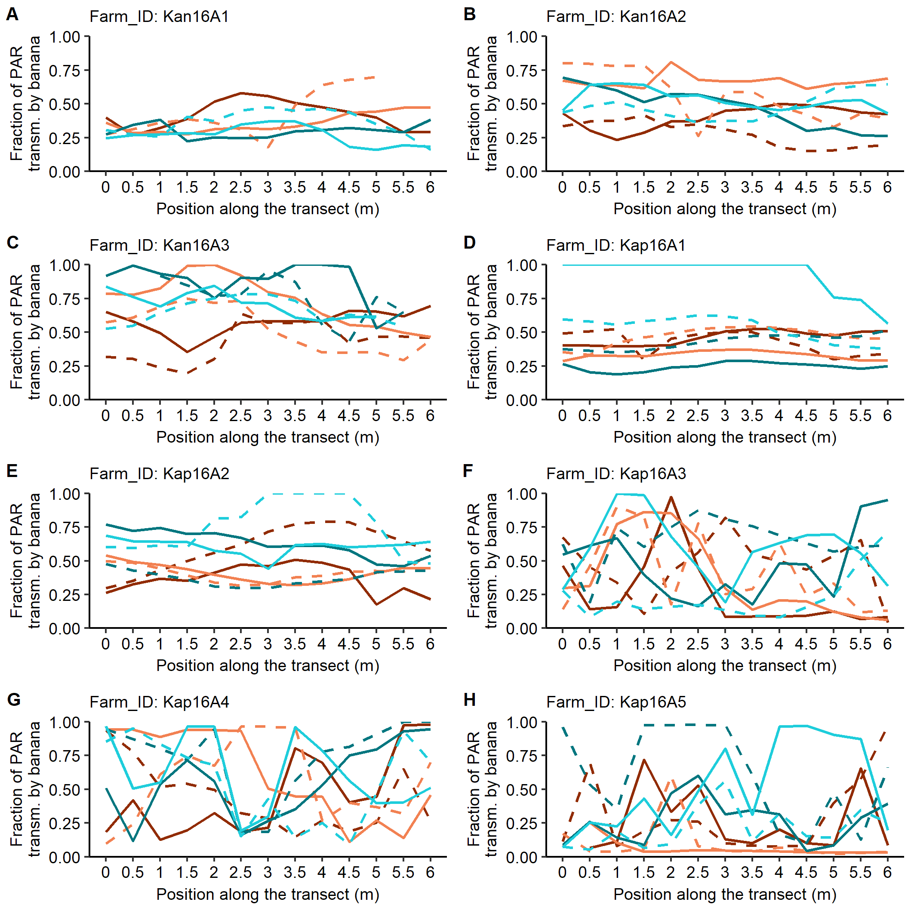
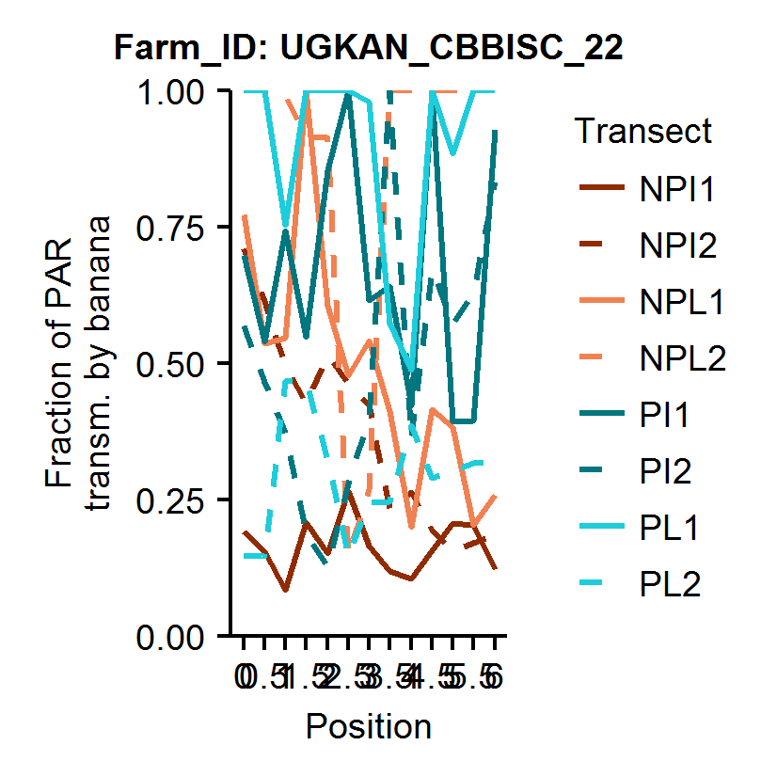


Figure I.1. Fractions of incident PAR transmitted by the banana canopy and available for intercropped beans at thirteen positions on six-meter transects (two per treatment) in Kanungu and Kapchorwa in season 2016A. P = pruning, NP = no pruning, L = local bean variety Mubano (Kanungu) and Atawa (Kapchorwa), I = improved bean variety Nabe 12C.




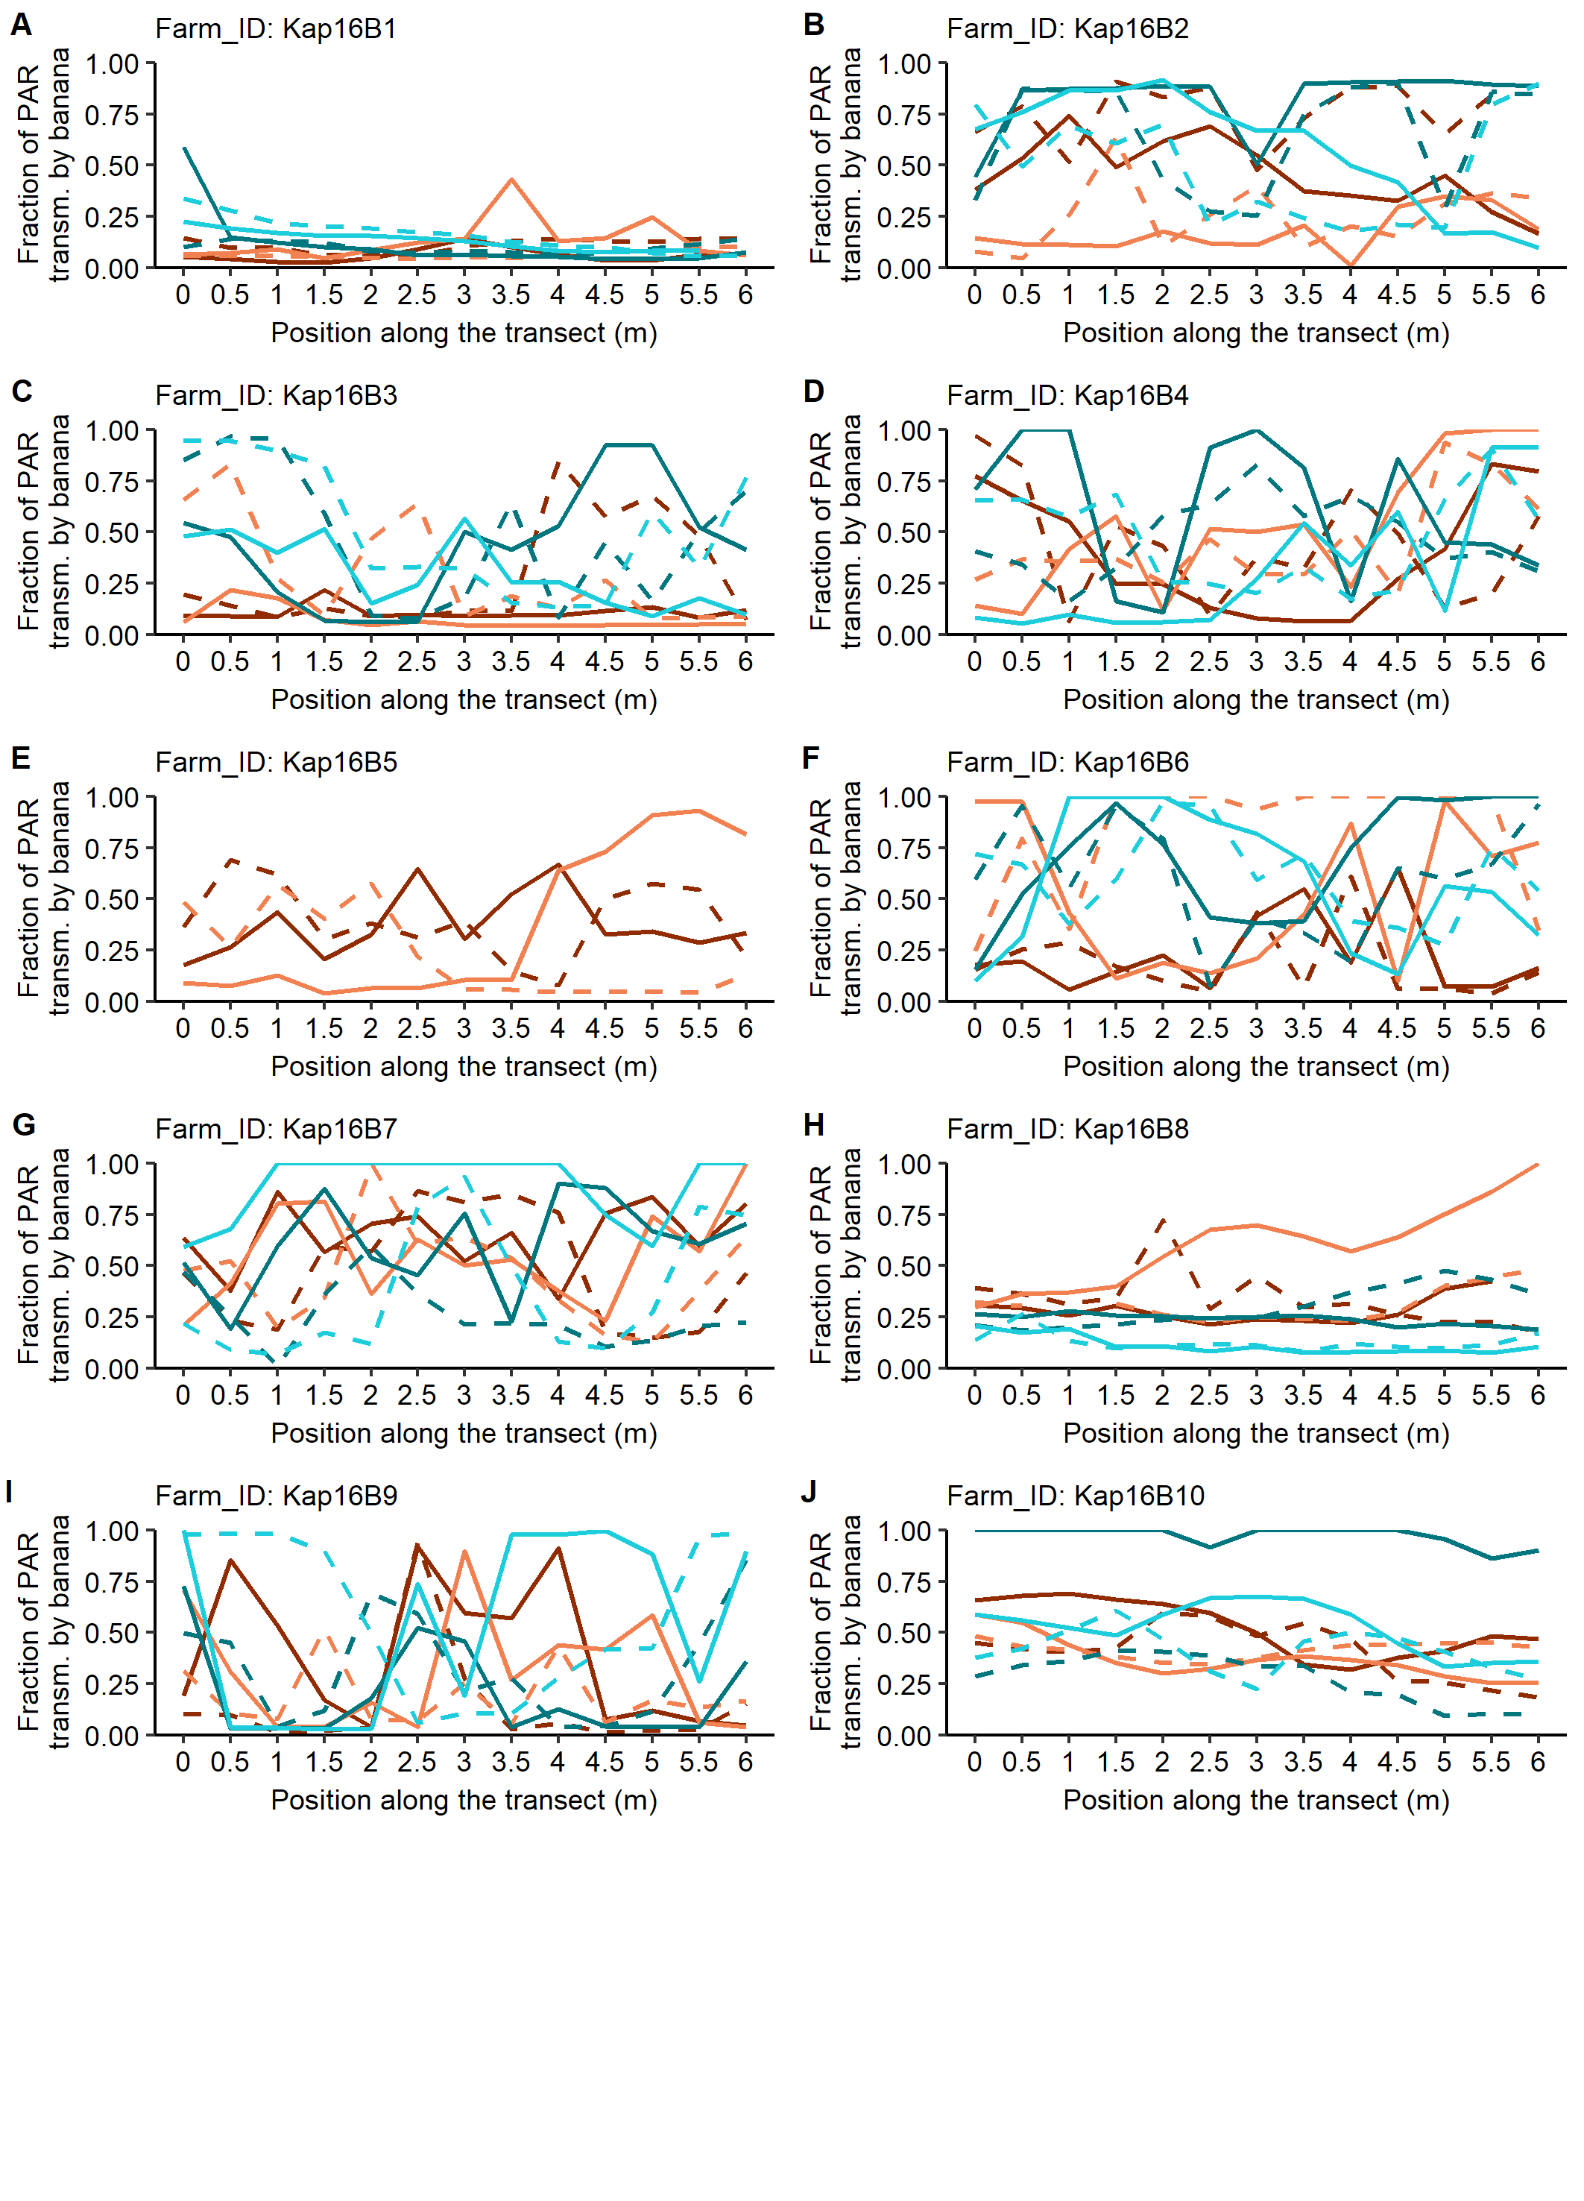
Figure I.2. Fractions of incident PAR transmitted by the banana canopy and available for intercropped beans at thirteen positions on six-meter transects (two per treatment) in Kapchorwa in season 2016B. P = pruning, NP = no pruning, L = local bean variety Atawa, I = improved bean variety Nabe 12C.




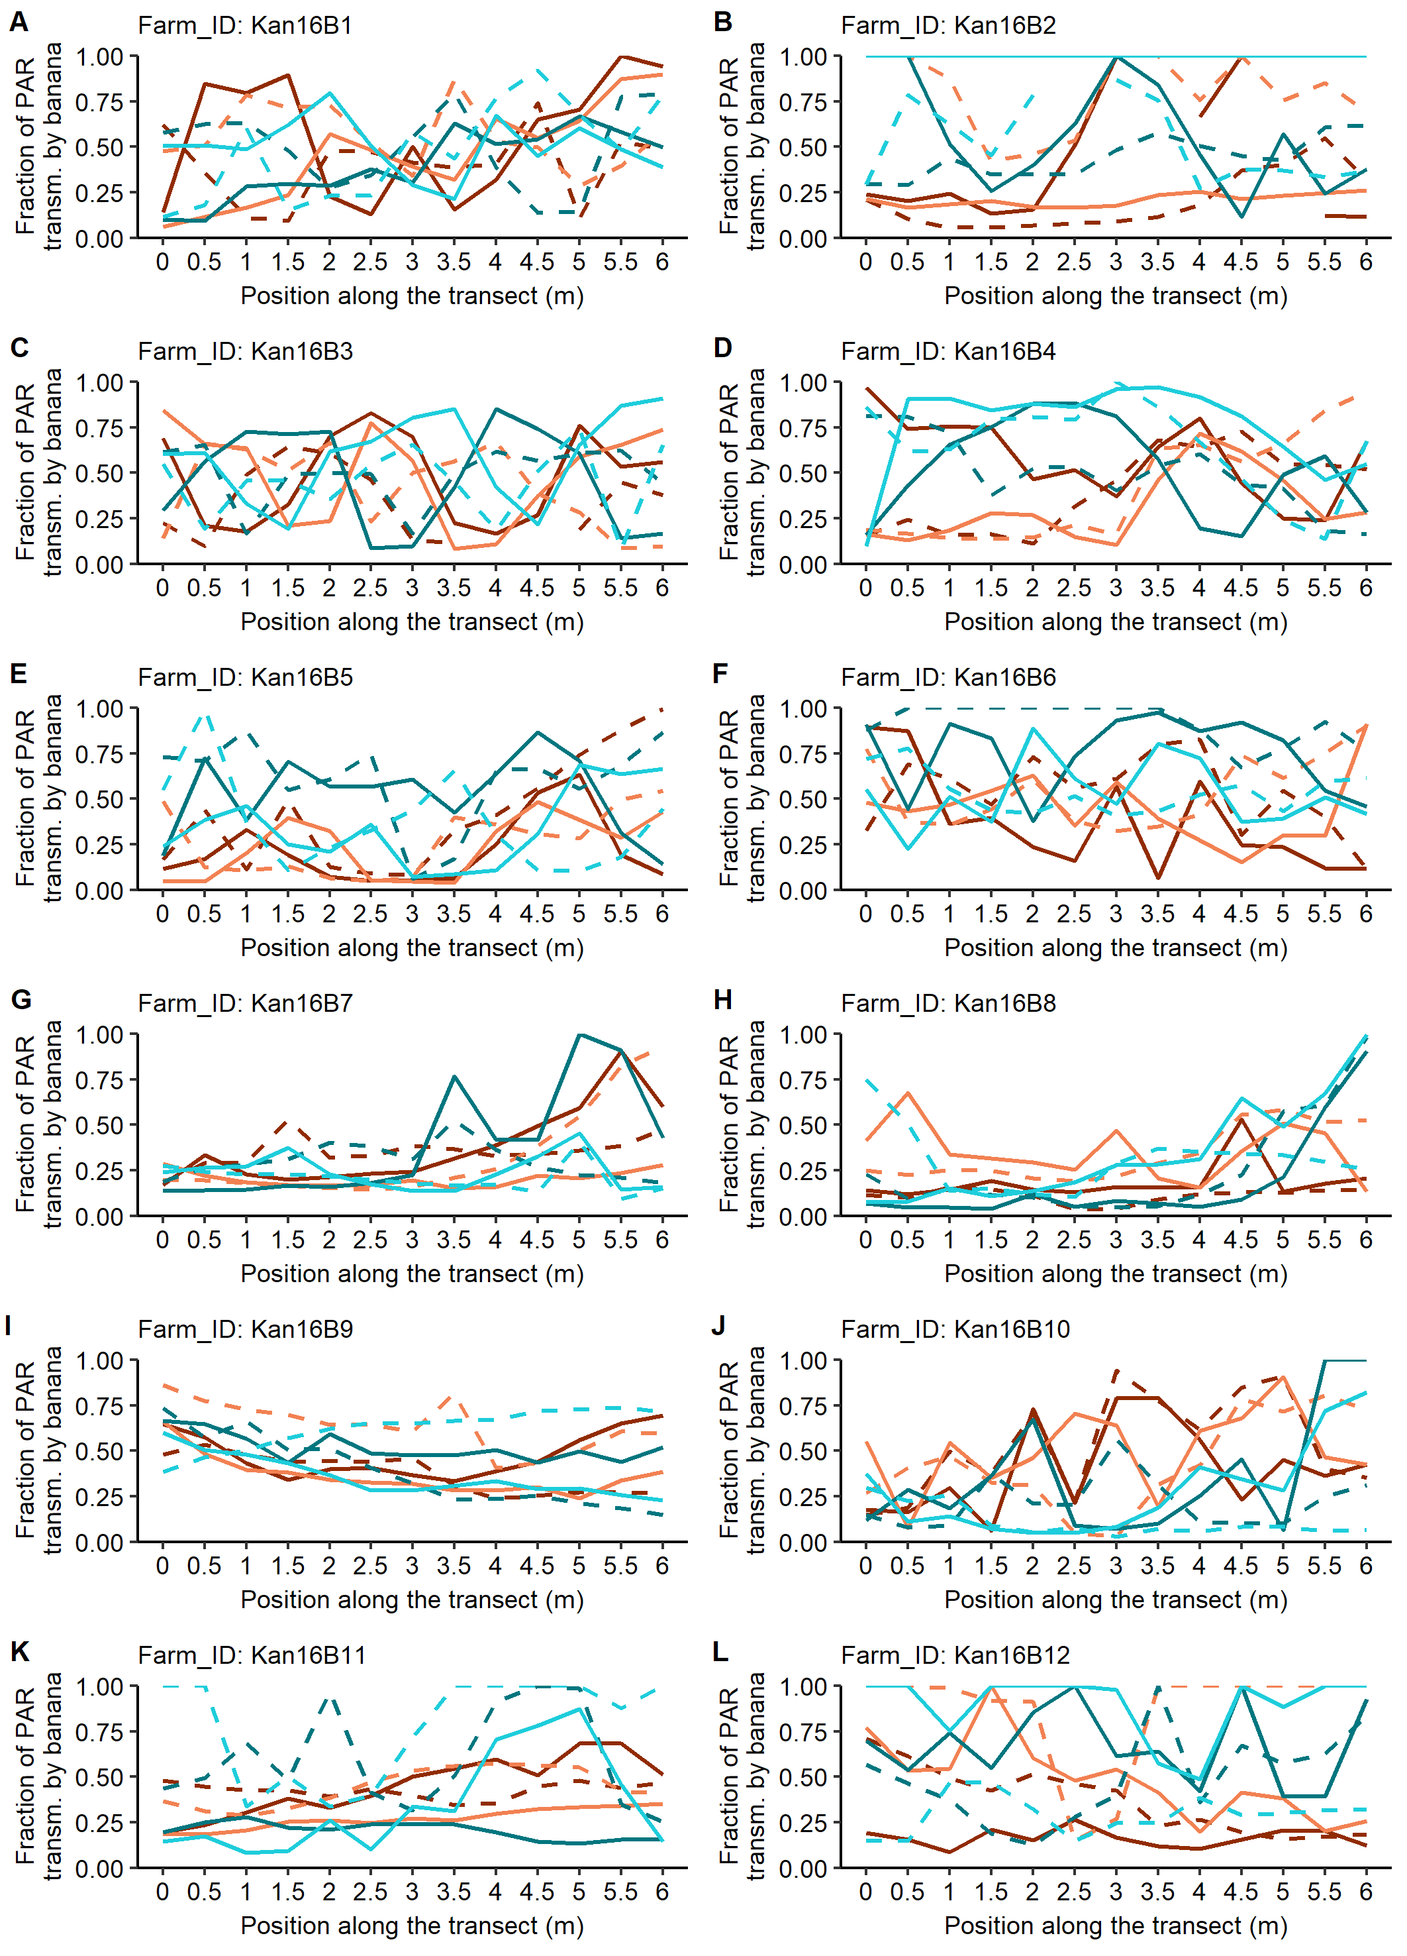
Figure I.3. Fractions of incident PAR transmitted by the banana canopy and available for intercropped beans at thirteen positions on six-meter transects (two per treatment) in Kanungu in season 2016B. P = pruning, NP = no pruning, L = local bean variety Kabweseri, I = improved bean variety Nabe 12C.

