7.2 Proposed Country-Specific Policy Archetypes

1. Zambia: Assessing Input Subsidy Distortions and Agronomic Constraints
Archetype 1A: Input Program Diversification and Agroecological Conservation Practices
Zambia's Farmer Input Support Programme (FISP) has historically prioritized synthetic fertilizer and hybrid maize seed nationwide. Continuous synthetic fertilizer applications without complementary organic inputs are a documented driver of soil acidification across sub-Saharan African cropland, maize systems included (Uwiragiye et al., 2023), which limits the crop’s uptake of the very nutrients being applied (Burke et al., 2019); where this overlaps with already-vulnerable communities, it can coincide with persistent childhood stunting, maternal anemia, and seasonal acute hunger.
The objective of this spatial index is to identify the specific districts caught in this cycle. The framework flags "Core Priority" districts: areas receiving high government fertilizer subsidies that concurrently show soil-acidity-driven yield failures, elevated childhood stunting or maternal anemia, and acute food insecurity (IPC Phase 2+).
Mapping these overlapping factors across a continuous 5km grid provides a spatial basis to redirect FISP e-vouchers within these zones away from maize-only input bundles and toward a diversified package: acid-tolerant legume seeds and nitrogen-fixing agroforestry trees (such as Faidherbia albida) intercropped directly into existing maize fields, rather than grown in place of maize. Downscaling this policy map through a 10-meter satellite cropland mask further allows policymakers to determine the net agricultural acreage affected, supporting budget calculations for seed procurement and Home-Grown School Feeding (HGSF) rollout.
This is not an unproven pivot for Zambia's maize belt: redirecting government input-support subsidies toward diversified, soil-restoring inputs and integrating nitrogen-fixing fertilizer trees into maize systems both already have a documented track record in the country. The government's own FISP e-voucher reform, which lets farmers redeem inputs from registered agro-dealers rather than receive fixed maize-fertilizer bundles, is already rolling out nationwide (discussed further in Section 8). Separately, on-farm agroforestry trials at Kasisi (Lusaka Province) and Chisamba (Central Province) have already demonstrated the nitrogen and yield benefits of integrating Faidherbia albida into maize systems; these are established research stations rather than sites chosen to represent this archetype's own flagged districts, so they show the intervention works under Zambian conditions generally rather than confirming it in the specific districts this spatial index identifies.
Three refinements to this practice would likely increase its effectiveness, environmental safety, and contribution to healthy diets, each grounded in evidence from comparable agroforestry and livestock-feed contexts. First, on effectiveness: field trials in Ethiopia's Faidherbia parkland system found that partial (50%) canopy pruning maintained or improved maize yield and profitability relative to full pollarding, by balancing the tree's nutrient and microclimate benefits against the light competition that heavier pruning is meant to relieve (Dilla et al., 2019). Since the Kasisi/Chisamba trials underpinning this archetype evaluated unpruned trees of a given age rather than pruning regimes, Archetype 1A's agroforestry component should specify a partial-pruning management practice rather than leaving pruning intensity to farmer discretion, to avoid inadvertently sacrificing the nutrient-deposition gains the archetype depends on. Second, on environmental safety: Faidherbia's defining “reverse phenology,” in which the tree draws much of its dry-season water from deep soil layers rather than the shallow zone occupied by crop roots, is what allows it to be safely interplanted with maize without depressing dry-season soil moisture (Roupsard et al., 1999). Because this water-partitioning mechanism depends on the tree reaching deep, permeable soil, new Faidherbia establishment under this archetype should be prioritized on the maize belt's deeper, better-drained soils rather than shallow or compacted plots, where the practice's safety cannot be assumed. Third, on healthy diets: a 2025 Tanzanian feeding trial found that Faidherbia dry pods, supplemented as a dry-season protein source for goats, produced significantly higher weight gain than unsupplemented browsing, at low cost to the household (Karumuna et al., 2025). Pairing the FISP e-voucher reform with modest support for smallholder goat-keeping in the districts this archetype targets would let households capture this pod-based dry-season protein source directly, extending the pivot's nutritional benefit beyond the maize grain itself.
As a complementary option rather than a replacement, intercropping pigeon pea (Cajanus cajan) alongside maize on FISP-supported plots offers a further dietary-diversification pathway: in a comparable drought-prone, low-input smallholder maize system in semi-arid Dodoma, Tanzania, maize–pigeonpea intercropping was no more prone to yield loss under drought than sole maize and consistently produced the same food on less land (Land Equivalent Ratio >1), while adding a protein-rich grain legume to the harvest (Renwick et al., 2020).
Proposed Spatial Variables: District-level FISP fertilizer allocation volumes + Severe Soil Acidity (5–15cm Active Root Zone; ISRIC) + Severe Anemia or Stunting prevalence (DHS) + Acute Food Insecurity (IPC Phase 2+) + High-Resolution Cropland Extent Mask (10m; DE Africa/ESA WorldCereal).

Archetype 1B: The Northern Cassava Belt Pivot
Northern Zambia features inherently acidic, heavily leached soils (Agro-Ecological Region III) where maize naturally struggles, yet historical policy has continuously pushed its cultivation. While smallholder farmers in these regions frequently adapt by producing a climate-resilient cassava surplus, this creates a severe dietary imbalance: the local food system provides ample caloric energy but fundamentally lacks sufficient protein and vital micronutrients.
The objective of this spatial framework is to build on this existing cassava base by targeting the introduction of acid-tolerant, underutilized legumes (e.g., Bambara groundnuts, cowpeas, or pigeon peas) as intercrops to close the regional protein gap.
The 10-meter Digital Earth Africa (ESA WorldCereal) cropland mask restricts these calculations to active, seasonal agricultural footprints, excluding bushland and natural forest. This allows procurement economists to isolate the net hectares of active farmland requiring intercropping intervention and calculate the legume seed tonnage needed for the pivot.
This is not an unfamiliar cropping pattern for northern Zambia: intercropping cassava with grain legumes on acidic, nutrient-exhausted soils already has a documented, replicated field-research record in the same agro-ecological zone this archetype targets (discussed further in Section 8). The underlying field trial (Kaluba et al., 2022) was conducted at Mansa, Luapula Province, within this same acidic, cassava-growing agro-ecological zone.
Three refinements to this practice would likely increase its effectiveness, environmental sustainability, and contribution to healthy diets, each grounded in evidence from comparable smallholder legume systems in the region. First, on effectiveness: a 2025 multi-site trial across Zimbabwe's main soybean-growing areas found that several indigenous Bradyrhizobium strains matched the yield performance of both the current commercial inoculant and applied mineral nitrogen fertilizer (Tumbure et al., 2025). Since the Kaluba et al. (2022) Northern Province trial underpinning this archetype tested lime, fertilizer, and legume intercropping but not inoculation, pairing the legume component with a locally adapted rhizobium inoculant would let the intercrop fix more of its own nitrogen on these acidic, nutrient-exhausted soils, reducing dependence on purchased fertilizer without sacrificing yield. Second, on environmental sustainability: continent-wide analysis finds that liming acid cropland in Africa is already profitable in the year of application on roughly a fifth of the affected area, and profitable over the longer term on a larger share still, yet only a fraction of this profitable potential is currently realized because smallholders cannot access or afford the tonnage lime requires (Silva et al., 2025). Archetype 1B's legume-intercropping pivot should therefore be paired with a lime-access subsidy or bulk-transport scheme targeted to the Northern Province districts this archetype identifies, so that the acid-soil remediation this evidence shows to be profitable actually reaches these smallholders. Third, on healthy diets: on-farm trials across Zambia's Eastern and Southern Provinces found that maize-legume intercropping systems delivered substantially higher energy and protein yield at the cropping-system level than sole maize, with clear benefits for household nutrition, even though individual crop yields did not differ (Thierfelder et al., 2024). Because Archetype 1B's cassava-legume intercrop follows the same cropping-system logic as the maize-legume systems this trial tested, the legume component should be explicitly promoted for home consumption rather than treated only as a soil-fertility input, so that the archetype's protein and micronutrient benefits reach the household diet and not only the market.
Beyond the cassava- and legume-intercropping options above, two further edible complements could improve dietary quality without replacing the core proposal: orange-fleshed sweet potato (OFSP), whose targeted promotion in a comparable rural Mozambique setting measurably increased children's vitamin A intake and serum retinol levels (Low et al., 2007); and Bambara groundnut (Vigna subterranea), an underutilized African legume valued across the continent as a low-cost source of protein, unsaturated fats, and minerals that also improves soil fertility through nitrogen fixation (Tan et al., 2020).
Proposed Spatial Variables: High Roots SSR (Cassava Surplus) + Extreme Soil Acidity (5-15cm Active Root Zone; ISRIC) + Pulse SSR (Regional Protein Deficit) + Digital Earth Africa (ESA WorldCereal) Cropland Extent Mask (10m).

Archetype 1C: The Agro-Pastoral Valley Water-Resource Pivot
Zambia's low-rainfall semi-arid valleys, spanning the Barotse Floodplain of Western Province and the Zambezi–Luangwa valley and escarpment system running through Southern, Central, and Lusaka Provinces (Agro-Ecological Region I, this project’s ‘Agro-Pastoral/Valley’ dietary profile group), face a water-resource constraint that is the mirror image of Archetypes 1A and 1B's high-rainfall, acidic-soil north. Communities in this zone already depend on drought-resilient pulses, nuts, and livestock rather than continuous cereal cropping, but the underlying water-management reality differs sharply between its two halves. In the seasonally flooded Barotse Floodplain, the binding constraint is not water access but land-use pressure on an already water-rich wetland: Lozi communities already practice flood-recession cultivation, in locally recognized eco-types such as Sitapa, Litongo, and Sishanjo depending on flood exposure and soil moisture, once the annual Zambezi flood recedes, yet a documented “hungry season” persists from November to January before that recession harvest comes in. In the Zambezi/Kariba valley districts of Southern Province and the adjoining Luano Valley and Rufunsa escarpment zone further east (the game-management buffer bordering Lower Zambezi National Park, and part of the same Zambezi-Luangwa trough), water scarcity is the direct and primary constraint, and livestock, not crops, dominates the local economy.
The objective of this spatial index is to identify priority districts within each of these two sub-contexts and route them to the intervention already evidenced as fitting their specific hydrology, rather than applying a single water-scarcity template to both. In the floodplain, the framework points toward scaling the agroecological diversification households already practice rather than intensive monoculture or cash-crop expansion. In the valley districts, it points toward small, multi-use water infrastructure, serving combined domestic, irrigation, and livestock demand, following an approach already active as national policy rather than a novel import.
This is not an unfamiliar or untested pivot for either half of this archetype's zone. Peer-reviewed research combining local ecological knowledge with remote sensing has already mapped the Barotse Floodplain's cultivable eco-types in detail (Del Rio et al., 2018), and separate research found that conventional intensive agriculture and cash-crop expansion are poorly suited to the floodplain, recommending instead the agroecological intensification and crop diversification, at least 17 neglected and underutilized species are already grown locally as a risk buffer, that Lozi communities already practice (Estrada-Carmona et al., 2020). In the Southern Province valley districts, more than 3,000 small multi-use dams have already been built nationally for combined domestic, farming, and livestock use, and a 2025 study of one recent example in Namwala District found it meaningfully improved dry-season water access while also surfacing concrete design lessons, on demand-based sizing and siltation management, that this archetype's own deployment guidance should incorporate (Serrao et al., 2025). Namwala District itself registers only marginally on this archetype's own five-criteria screen, so this evidence demonstrates that Zambia's small-dam program works and generates transferable design lessons, not that the program has already targeted this archetype's own highest-priority districts.
Three refinements to this practice would likely increase its effectiveness, environmental sustainability, and contribution to healthy diets, each grounded in evidence from the same Southern Province valley system and Barotse floodplain this archetype targets. First, on effectiveness: a 2025 study of community water-management practices in the Ngwezi River Basin, in the same Southern Province valley system as this archetype's target districts, found that state- and NGO-led water infrastructure programs frequently bypassed customary water-governance structures, reducing the effectiveness and equity of the resulting dams and boreholes, and that durable water security instead required hybrid governance integrating local ecological knowledge and customary authority into formal management (Wankie et al., 2025). Any water-point investment under Archetype 1C should therefore be designed around existing customary water-sharing institutions in the target districts, rather than defaulting to a purely engineering-led approach. Second, on environmental sustainability: a review of Zambia's protected-area network found that the Game Management Areas bordering its national parks function largely as open-access land, where local communities hold little formal, devolved right over the land or wildlife resources they depend on, a structural gap that drives habitat encroachment (Lindsey et al., 2014). Because Luano and Rufunsa, two of this archetype's highest-priority valley districts, sit directly against the Lower Zambezi National Park buffer, any livestock-water intervention there should be paired with formal, community-level water and grazing-rights agreements rather than infrastructure alone, to avoid drawing additional unregulated grazing pressure into the park buffer. Third, on healthy diets: participatory research across ten Barotse floodplain communities documented a pronounced hunger season running from roughly August to January, during which food and nutrition security deteriorate sharply ahead of the flood-recession harvest this archetype's floodplain pathway already depends on, and used a seasonal food-availability calendar to identify under-used, locally available foods that could narrow this gap if better promoted and stored (Pasqualino, Kennedy and Nowak, 2015). Archetype 1C's floodplain-side targeting should therefore be paired with support for storing and promoting these already-available seasonal foods through the hunger season, rather than treating flood-recession cropping alone as the solution to the floodplain's nutrition gap.
As a further, non-replacing dietary option, amaranth (Amaranthus spp.) is increasingly recognized across sub-Saharan Africa as a drought-tolerant, nutrient-dense leafy vegetable well suited to smallholder conditions, offering a low-cost complement to the seasonal foods already highlighted in this archetype (Mkpuma et al., 2026).
Proposed Spatial Variables: WRI Aqueduct Overall Water Risk (High to Extreme; Kuzma et al., 2023) + Weighted Livestock Density (Moderate to Extreme; FAO GLW4, TLU-standardized) + SSR Vegetables (High to Extreme Deficit) + Child Stunting and Maternal Anemia (Low, isolating the masked-deficit pattern) + Acute Food Insecurity (IPC Phase 2+), applied outside an IUCN Protected Area Mask (excluding Lower Zambezi, Kafue, and Sioma Ngwezi National Parks).

Archetype 1D: The School-Linked Fruit & Vegetable Deficit Pivot
The case for treating this as a distinct, dedicated pivot rather than an extension of Archetypes 1A–1C rests on a documented national gap: an estimated 90% of Zambians do not meet the fruit-and-vegetable intake levels recommended in the country’s own Food-Based Dietary Guidelines, whose technical basis further notes that the crops grown nationally cluster in similar nutritional categories, cereals, roots, and starches, rather than spanning the dietary diversity a health-supporting food system requires (National Food and Nutrition Commission of Zambia [NFNC], 2021). Whether increasing the sheer diversity of what a household grows translates into what its children eat is not automatic: a nationally representative panel study of over 7,900 rural households found agricultural diversification positively associated with household dietary diversity, but the relationship was not statistically significant on its own, pointing toward the need for a demand-side pull, a guaranteed local buyer, rather than production diversification alone (Nkonde et al., 2021). Zambia’s own decentralized Home-Grown School Feeding (HGSF) procurement model is precisely that demand-side pull already operating nationally: because schools, not central depots, purchase fresh produce directly from surrounding smallholders, a district with strong farmer-to-school relationships can convert a production-side fruit-and-vegetable deficit into a nutrition-side improvement more directly than a purely supply-side seed-distribution programme could.
This is not an unfamiliar market for Zambia’s smallholder vegetable and fruit growers: the programme already procures fresh vegetables directly from smallholder farmers on a decentralized, school-by-school basis rather than through centralized commodity purchasing, reaching an estimated 4 million children across 70 districts and giving the country’s roughly 1.6 million smallholder growers of indigenous leafy greens and fruit vegetables access to a market previously closed to them (Mwanza, 2025). The objective of this archetype is to identify the districts where Zambia’s underlying fruit-and-vegetable production deficit most directly coincides with child malnutrition and acute food insecurity, so that this already-functioning school-procurement channel can be deliberately extended toward the areas where it would close the largest nutrition gap, rather than growing wherever local supply already happens to exist.
Two structural risks are worth flagging before this pivot is scaled. First, women-led cooperatives in Kazungula, Southern Province, are already given contracting preference for supplying schools on a rotational basis, a model worth replicating deliberately in this archetype’s own priority districts rather than assuming it will emerge spontaneously (Mwanza, 2025). Second, national efforts to scale biofortified fruit-and-vegetable varieties, such as vitamin-A orange sweet potato, through the same school market have so far been constrained by limited production at the farm level, meaning the demand side of this pivot is more mature than its supply side, and Phase 1 investment should weight seed and extension support accordingly rather than assuming procurement alone will resolve the deficit (Mwanza, 2025).
Proposed Spatial Variables: SSR Vegetables (High to Extreme Deficit) + SSR Fruits (High to Extreme Deficit) + Child Stunting (top-tertile, i.e., the highest-ranking third, of the national distribution) + Acute Food Insecurity (IPC Phase 2+), applied outside an IUCN Protected Area Mask (Strict No-Go zones only) and refined against a 5-kilometer buffer around GRID3-mapped public schools (including community schools).

8. Preliminary Results: Deep-Dive Countries
Archetype 1A: Input Program Diversification and Agroecological Conservation Practices

This is not an unproven pivot for Zambia's maize belt: redirecting government input-support subsidies toward diversified, soil-restoring inputs and integrating nitrogen-fixing fertilizer trees into maize systems both already have a documented track record in the country, including the government's own nationwide FISP e-voucher reform and independent on-farm agroforestry trials elsewhere in Zambia (discussed further below).
The Archetype 1A spatial evaluation identifies districts, concentrated in Luapula Province with smaller pockets in Copperbelt, Muchinga, Eastern, and Northern Province, where large-scale government fertilizer subsidies (FISP) overlap with high soil acidity and acute food insecurity (IPC Phase 2+). Mapping this overlap across a continuous 5km grid, rather than relying on district-wide averages, isolates the specific areas where a policy shift toward acid-tolerant legumes, redirecting e-vouchers away from synthetic maize inputs, would have the greatest impact. Four of these Core Priority districts (Lunte District, Chipili, Mpulungu, and Lupososhi) also rank among Archetype 1B’s cassava-belt priority districts, so in that shared zone the maize-focused input diversification proposed here and the cassava-soil rehabilitation proposed under Archetype 1B can be sequenced together rather than treated as competing programs.
To support procurement budgeting, the framework also applies a 10-meter resolution ESA WorldCereal cropland mask, which identifies the specific active smallholder farming plots within these risk zones rather than the full administrative area. The localized results, shown against satellite imagery in the precision inset, illustrate the core mechanism behind Archetype 1A: farmers in these plots continue applying nitrogen fertilizer to acidic, low-pH soils that chemically bind and limit nutrient uptake. Mapping these plots at 10-meter resolution allows procurement officials to target seed distribution directly, intercropping climate-resilient pulses such as groundnuts or cowpeas alongside the existing maize crop to rehabilitate soil while supplying the Home-Grown School Feeding (HGSF) program.
The 10-meter evaluation quantifies the scale of this overlap across the Zambian maize belt. While the gross administrative boundaries of these Core Priority districts span 5,928,746 hectares, downscaling through the active cropland mask narrows this to a confirmed baseline of at least 3,562 hectares of intensive, seasonal smallholder plots requiring intervention, concentrated in 30 of Zambia's 115 districts. Because satellite classification tends to under-count cropland in highly fragmented smallholder landscapes, this 3,562-hectare figure is treated as a conservative floor rather than a ceiling for Phase 1 deployment. Nchelenge and Kawambwa hold the largest Core Priority acreage (989 ha and 946 ha respectively), followed by Lufwanyama (624 ha), Chama (293 ha), Mansa (228 ha), Mwansabombwe (166 ha), Chasefu (86 ha), and Mporokoso (81 ha), together accounting for the large majority of the confirmed floor. This acreage gives the Ministry of Agriculture a basis for estimating legume seed tonnages and targeting the procurement pivot without allocating funds to non-agricultural land.
Three of these Core Priority districts (Nchelenge, Kawambwa, and Chama) also rank among Archetype 1D’s highest-priority districts for school-linked fruit-and-vegetable production (Section 8 below), so in these overlap areas the input-diversification pivot proposed here and the school-procurement pivot proposed under Archetype 1D can be coordinated through the same district agricultural offices rather than run as separate, uncoordinated programmes.

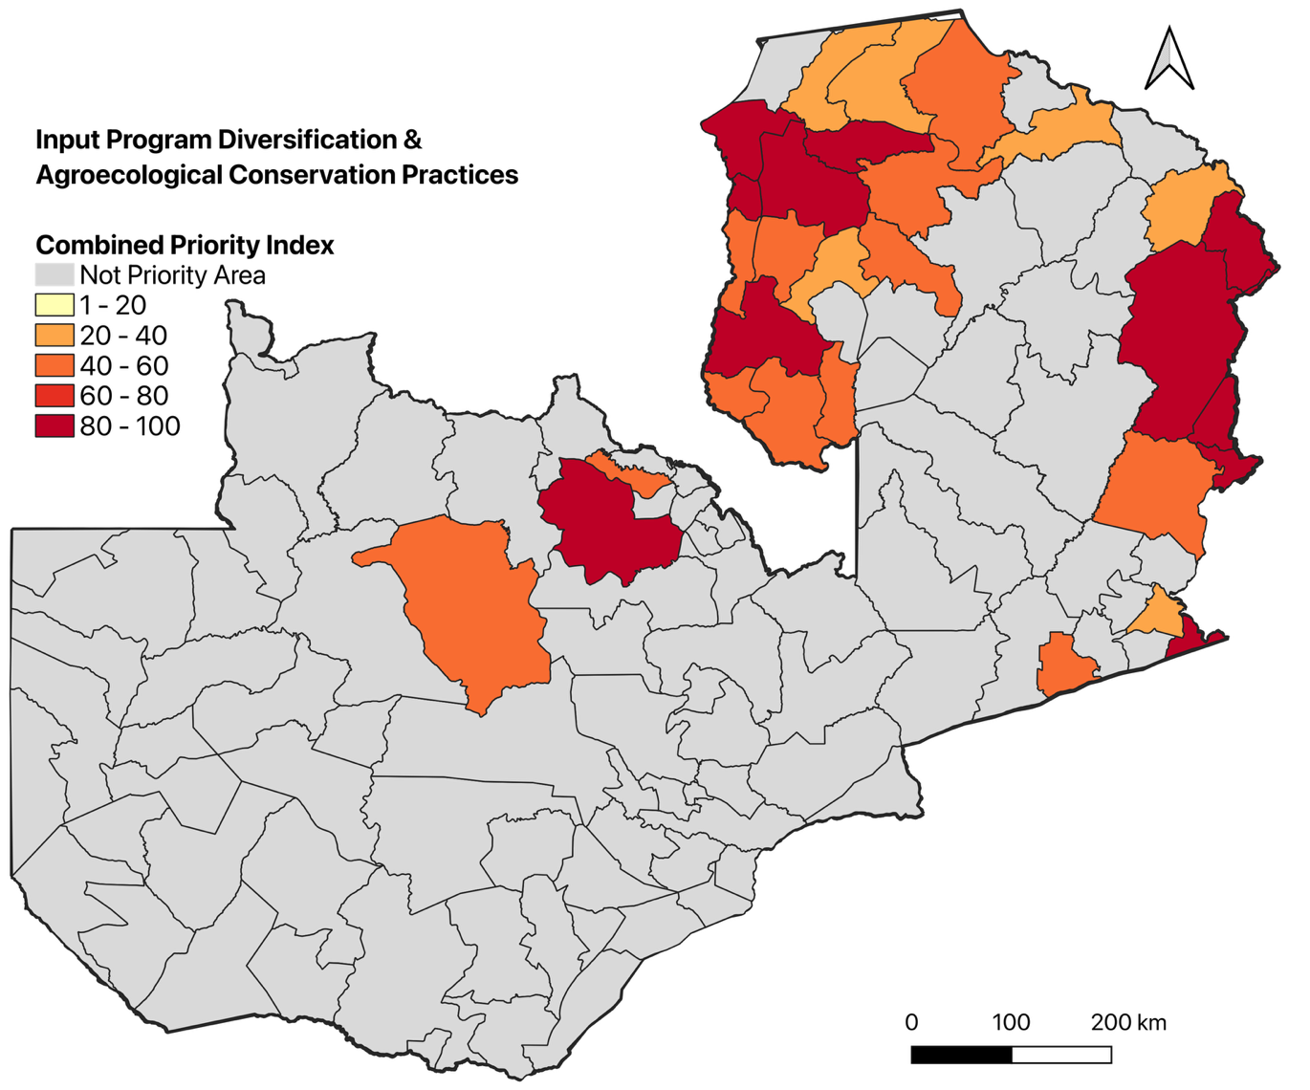
Figure 15. Spatial distribution of Archetype 1A (Input Program Diversification and Agroecological Conservation Practices) across Zambia. The map shows the subnational overlap of agricultural subsidy allocation with ecological and public health indicators. Dark red "Core Priority" zones identify administrative regions where all evaluated vulnerabilities coincide: high historical allocations of synthetic fertilizer (FISP), soil acidification in the active root zone, high prevalence of chronic childhood stunting or maternal anemia, and acute food insecurity (IPC Phase 2+). Orange "High-Risk Zones" indicate districts where at least three of these factors intersect. These zones provide the geographic basis for redirecting agricultural procurement away from maize monoculture and toward acid-tolerant legume seeds to supply local Home-Grown School Feeding (HGSF) programs.

Independent evidence from Zambia corroborates both components of the Archetype 1A pivot. On the input-subsidy side, the Government of Zambia has already begun redirecting FISP away from the fixed maize-and-fertilizer pack this archetype identifies as the underlying driver of soil acidification: the e-voucher system, which lets farmers redeem inputs directly from registered agro-dealers rather than receive standardized bundles from central depots, expanded from roughly 220,000 farmers in the 2023–2024 season to about 740,000 farmers across all 74 districts by 2024–2025, with the 2025–2026 season extending coverage to every remaining district and over 1 million farmers nationally. An independent survey found that most participating farmers reported higher yields and a wider choice of inputs under the new system, and that 86% of surveyed agro-dealers hired additional staff to meet the resulting demand (World Bank, 2026). On the agroforestry side, field trials at Kasisi (Chongwe District, Lusaka Province) and Chisamba (Central Province), several hundred kilometers from the Luapula-centered districts this archetype actually flags though within Zambia’s same broad maize-growing system, found that Faidherbia albida fertilizer trees deposit 34 to 83 kilograms of nitrogen per hectare annually through leaf litterfall and that maize yields under the tree canopy were 7 to 12 times higher than in the open field across the two growing seasons studied, with the gap most pronounced in the trial's driest season (2015/16) (Yengwe et al., 2018). Together, this evidence indicates that both halves of the Archetype 1A pivot, redirecting FISP support and establishing fertilizer-tree agroforestry, are already operating and measurably effective in Zambia, though not yet demonstrated specifically within the Luapula-centered districts this model flags as Core Priority, which remains a priority for Phase 1 monitoring.

Archetype 1B: The Northern Cassava Belt Pivot

This is not an unfamiliar cropping pattern for northern Zambia: intercropping cassava with grain legumes on acidic, nutrient-exhausted soils already has a documented, replicated field-research record in the same agro-ecological zone this archetype targets (discussed further below).
The spatial evaluation of Archetype 1B identifies the districts of northern Zambia where a resilient cassava production surplus coincides with a structural regional protein deficit and inherently acidic subsoil conditions. This is the precise agronomic signature that justifies a targeted legume-intercropping pivot. Two of the three underlying indicators, the Roots and Pulses Self-Sufficiency Ratios, are compiled at the district (ADM2) level rather than as continuous spatial surfaces. Because of this, the model's multi-criteria output is most defensibly interpreted, and reported, at the district level rather than as a uniform 10-meter gradient across the country.
Downscaling through the 10-meter ESA WorldCereal cropland mask nonetheless serves a distinct and necessary function: within each district that clears the surplus/deficit threshold, it isolates the specific active farm parcels that also sit on extremely acidic soil (pH ≤ 5.5 in the 5–15cm active root zone), rather than flagging the district’s full land area, much of which is bushland, forest, or otherwise non-agricultural. This produces a “Core Priority” layer restricted to farmland where all three conditions are simultaneously present: the actual target population for legume seed procurement. Partial-match tiers, where one or two of the three criteria are present, are retained separately as a secondary watch list for districts trending toward the pattern but not yet fully qualifying.
The evaluation identified 512,719 hectares of Core Priority farmland nationally, concentrated in 42 of Zambia's 115 districts under the corrected GADM4.1 boundary, essentially unchanged in total scale from the earlier estimate (516,003 ha) despite the higher district count, which reflects GADM4.1's more granular administrative subdivision rather than any change in the underlying land base. Lunte District holds the largest Core Priority acreage (78,692 ha), followed by Chipili (59,750 ha), Mpulungu (56,856 ha), Lupososhi (34,422 ha), Solwezi (33,015 ha), Mwinilunga (31,384 ha), Chiengi (23,450 ha), and Kalumbila (23,394 ha). Mporokoso, previously identified as the single largest Core Priority district (81,389 ha) under the old boundary, is no longer the top-ranked district: much of that acreage now falls within Lunte District, split from Mporokoso in 2017. Lupososhi, split from Luwingu in 2018, likewise ranks among the new top districts. This acreage gives the Ministry of Agriculture a basis for estimating legume seed tonnages and targeting the procurement pivot by district, using an administrative boundary consistent with the one applied elsewhere in this report. Four of these districts (Lunte District, Chipili, Mpulungu, and Lupososhi) also rank among Archetype 1A’s Core Priority districts, reflecting the shared acid-soil, food-insecure belt that spans Zambia’s north and northeast; in those overlap areas, procurement teams can coordinate legume seed sourcing across both interventions rather than sizing each independently.

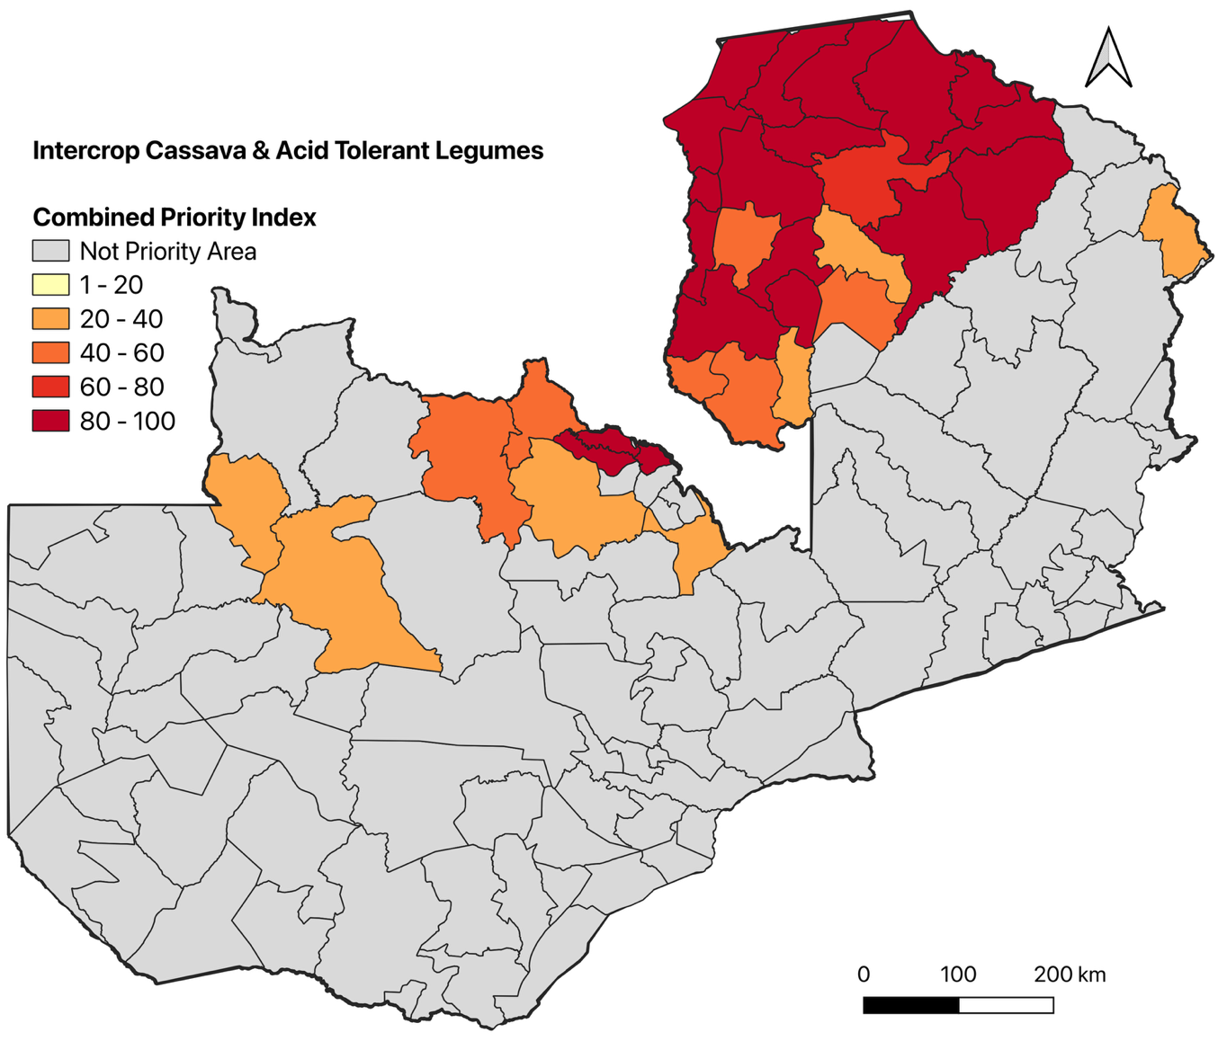
Figure 16. District-level distribution of Archetype 1B (The Northern Cassava Belt Pivot) Core Priority farmland across Zambia. Shading reflects confirmed hectares of active cropland where a cassava production surplus, a regional pulse/protein deficit, and extreme soil acidity (5–15cm active root zone) are simultaneously present, restricted to active agricultural footprints via the 10-meter ESA WorldCereal cropland mask. Darker shading indicates districts with the greatest concentration of validated intervention-ready farmland.

Independent agronomic research supports the legume-intercropping pivot targeted by Archetype 1B. A two-season, replicated field trial conducted on exhausted cassava land in Luapula Province tested combinations of agricultural lime, inorganic fertilizer, and grain-legume intercropping, common beans, cowpea, and soybean, against sole cassava, directly addressing the pattern the model identifies: farmers in the region have long grown cassava intercropped with legumes on acidic soils with little or no fertilizer input, a practice that depletes soil nutrients over time and drags current yields down to roughly 6 t/ha against a regional potential of 20 to 25 t/ha, eventually forcing land abandonment (Kaluba et al., 2022). Pairing lime amendment with legume intercropping on the same acid, exhausted soils that the model's 5–15cm active-root-zone acidity layer flags shows that the combined lime-and-legume approach Archetype 1B proposes is already an active line of on-farm research in the same province and agro-ecological zone, rather than an untested import.

Archetype 1C: The Agro-Pastoral Valley Water-Resource Pivot

The evaluation identified 6,733,714 hectares of Core Priority land nationally, spanning 39 of Zambia's 115 districts, split across this archetype's two hydrological pathways. On the floodplain side, Mitete carries the largest share of its own area (499,156 ha, 78.2%), consistent with its position within the Barotse Floodplain. On the valley/escarpment side, Luano carries by far the largest share of its own area (921,676 ha, 99.04%; published district profiles describe roughly two-thirds of Luano as valley terrain along the Lunsemfwa-to-Luangwa trough, directly adjoining the Lower Zambezi National Park buffer zone), followed by Mkushi (683,002 ha, 80.87%), Itezhi-tezhi (676,690 ha, 41.78%), Rufunsa (586,576 ha, 61.13%), and the confirmed Southern Province valley districts of Chirundu (84.00%), Pemba (82.09%), Siavonga (76.08%), and Gwembe (74.61%). Ngabwe (79.13%) sits at the margin of the Lukanga Swamp, a separate large wetland whose seasonal flooding produces a broadly comparable water-stress signature even though it is a distinct basin from the Zambezi valley. One district in this list does not fit the pattern: Chisamba (68.82%, 364,087 ha) is described in published sources as flat, well-watered commercial farmland rather than valley or escarpment terrain, and its inclusion here is more likely a boundary-adjacency effect from bordering Luano than a genuine agro-pastoral valley signal; it should be treated as provisional pending local verification, not a confirmed target district on the same footing as the others above. Because this archetype screens at 5km resolution rather than the 10-meter cropland precision used for Archetypes 1A and 1B, Core Priority here identifies whole grid cells meeting all five screening criteria and lying outside strict protected areas, not individually delineated farm parcels.

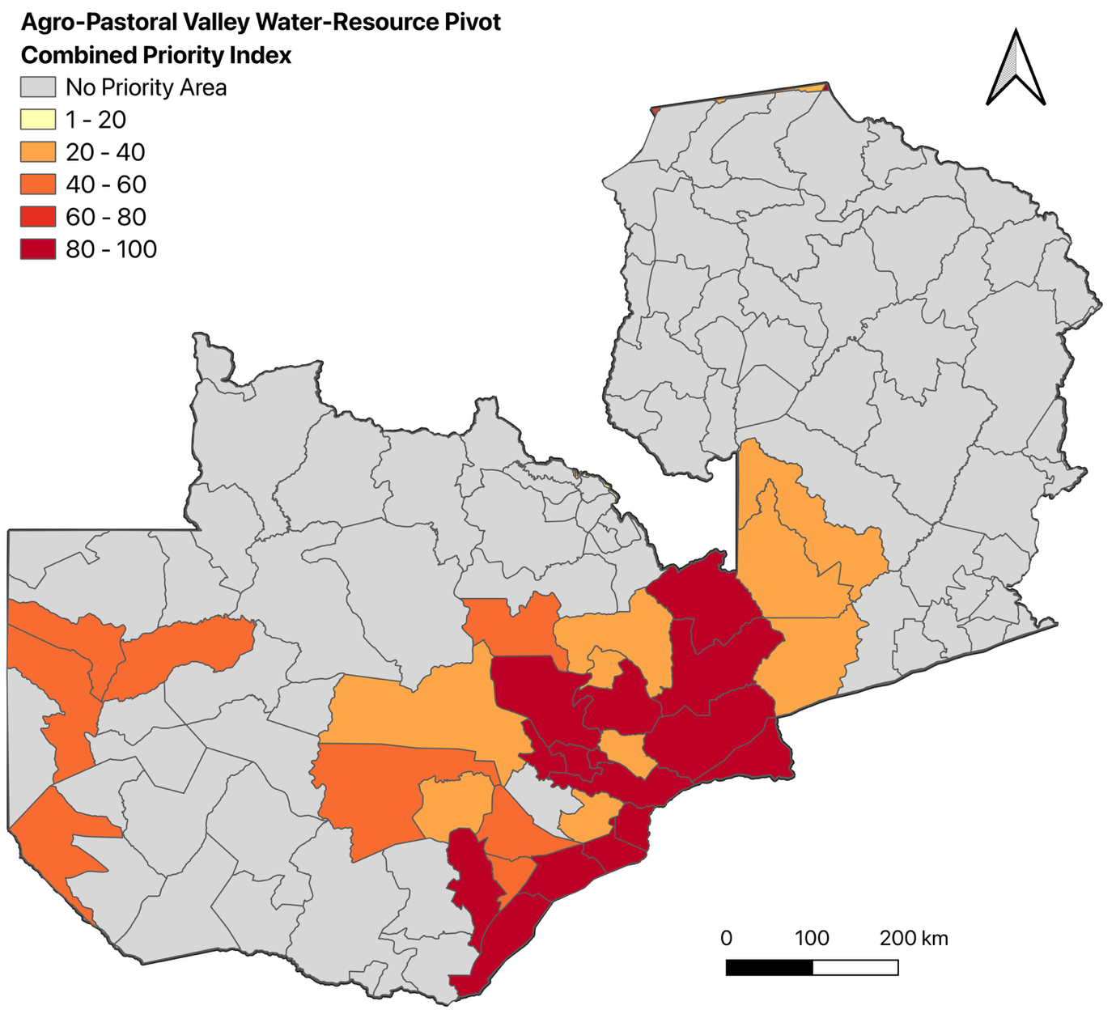
Figure 17. District-level distribution of Archetype 1C (The Agro-Pastoral Valley Water-Resource Pivot) Core Priority land across Zambia, shaded by share of district area meeting all five screening criteria (WRI Aqueduct Overall Water Risk, Weighted Livestock Density, SSR Vegetables Deficit, low chronic child stunting and maternal anemia, and IPC Phase 2+), outside IUCN strict-protection zones. Luano District (99.04% of its area) and the Southern Province valley districts of Chirundu, Pemba, Siavonga, and Gwembe (74–84%) show the highest concentrations; Chisamba (68.82%) is flagged as a likely false positive pending local verification (see discussion above).

Archetype 1D: The School-Linked Fruit & Vegetable Deficit Pivot

The Archetype 1D spatial evaluation identifies districts where a structural deficit in both vegetable and fruit self-sufficiency coincides with high chronic child stunting and acute food insecurity (IPC Phase 2+). Because this archetype’s proposed intervention combines extending Zambia’s existing HGSF farmer-to-school procurement model, paired with seed and extension support for smallholder fruit-and-vegetable diversification, with direct school and community garden investment, rather than open-market farmland redirection, the coarse screen is refined against a 5-kilometer buffer around Zambia’s mapped public schools (GRID3, including community schools) rather than an active-cropland mask: a 10-meter land-cover classifier reliably distinguishes cropland from bushland at field scale but cannot reliably detect the small, often fenced or intercropped plots typical of smallholder vegetable gardens and school and community gardens alike, so a cropland mask would systematically under-credit exactly the production this archetype is meant to support. Unlike Archetypes 1A–1C, whose Core Priority land concentrates in specific provinces or valley systems, Archetype 1D’s footprint remains geographically broad: it spans a contiguous belt across Northern, Muchinga, Luapula, and Eastern Provinces, with smaller pockets in Central and Western Provinces, reflecting how widely the underlying fruit-and-vegetable deficit and child-nutrition signal co-occur across Zambia’s northern and eastern border regions rather than clustering around a single agro-ecological driver the way soil acidity or water scarcity do in the other three archetypes. Because implementation happens school by school, the headline metric for this archetype is the share of each district’s own public schools that fall within the Core Priority zone rather than a hectare total: a district where most of its schools sit inside the zone is one where an HGSF-linked procurement-and-garden programme could scale across nearly its whole school network, while a district where only a few schools qualify would need a more targeted, phased rollout. The GRID3 schools dataset dates roughly 70% of its records to 2010, so the school counts reported below should be read as an approximation of the current school network rather than a real-time facilities inventory.
The evaluation found that 1,487 of the 7,105 GRID3-mapped public schools matched to a GADM4.1 district (20.9%) fall within the Core Priority zone nationally; a further 27 schools could not be matched to any district polygon and were excluded from the district totals below. Core Priority schools are present in 48 of Zambia’s 115 districts, with 21 districts reaching Critical Priority status (at least 80% of their own public schools inside the zone). Five districts, Kawambwa, Mambwe, Chifunabuli, Mporokoso, and Mwansabombwe, return every one of their public schools inside the Core Priority zone (100%), with Mungwi close behind (98.98%, 97 of 98 schools). By absolute count rather than share, Chama holds the largest number of Core Priority schools (102, 88.70% of its 115 schools), followed by Mansa (100 of 102, 98.04%). This concentration gives the Ministry of Agriculture and HGSF programme administrators a basis for prioritizing which districts’ school networks are best positioned to support garden-linked procurement first.

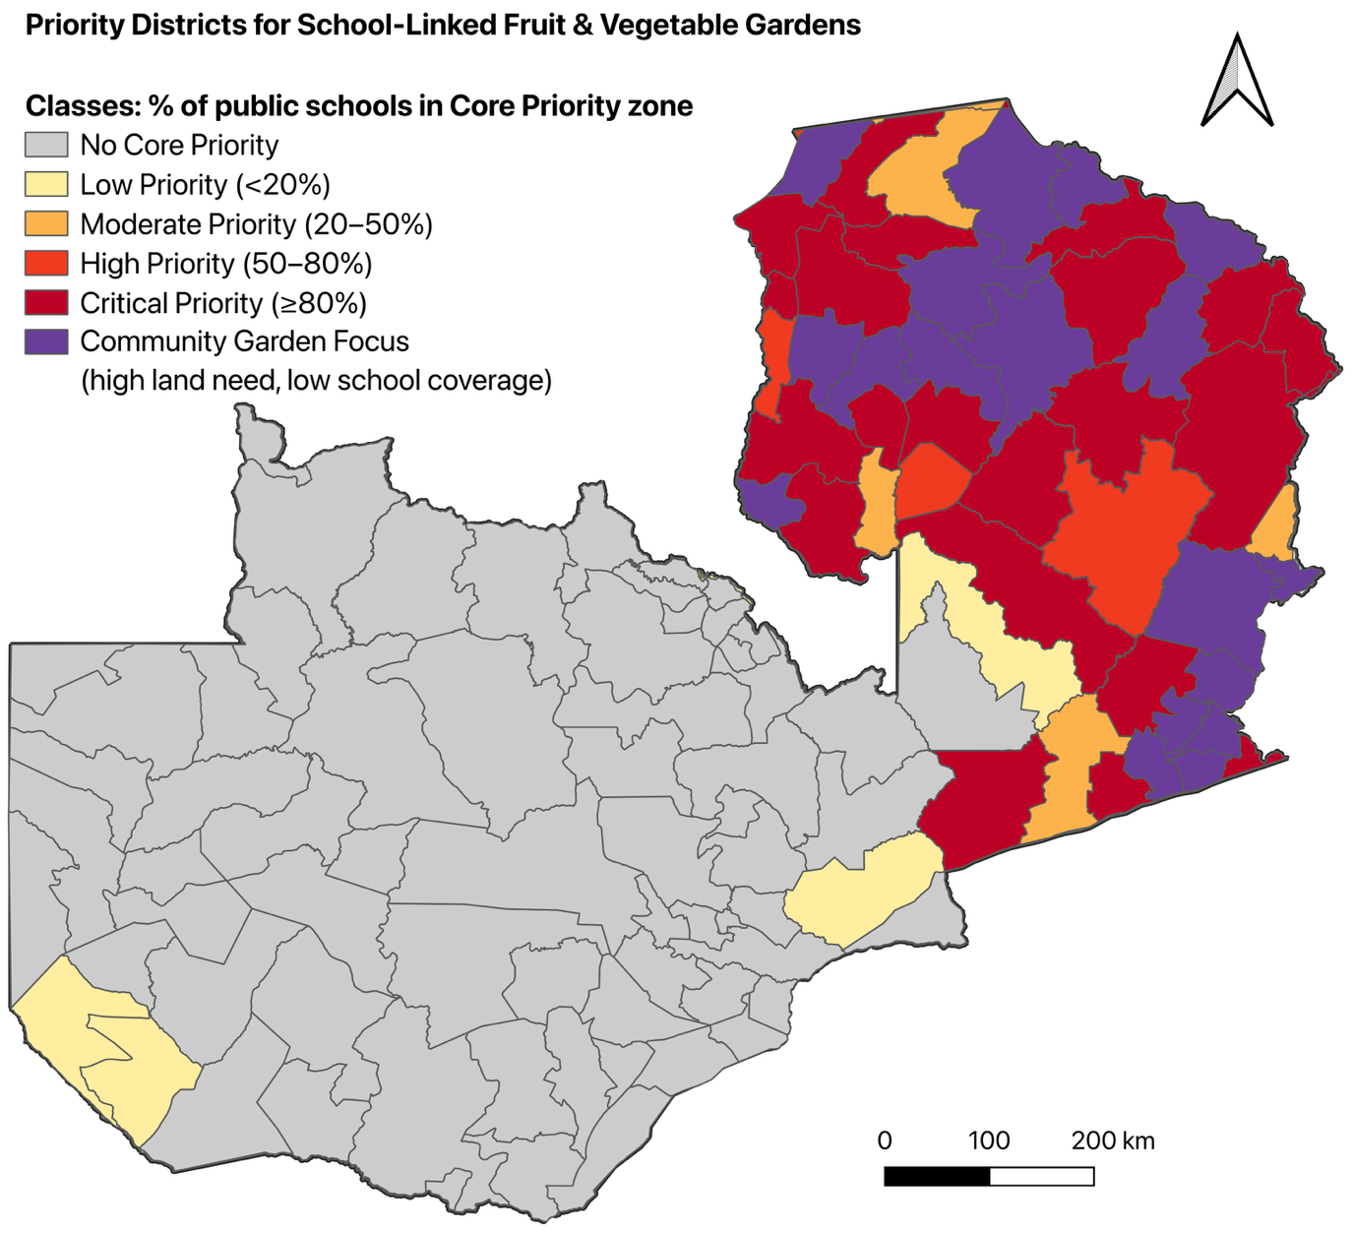
Figure 18. District-level distribution of Archetype 1D (School-Linked Fruit & Vegetable Production) Core Priority land across Zambia, shaded by the share of each district’s own public schools falling within the Core Priority zone (meeting all four screening criteria: SSR Vegetables Deficit, SSR Fruits Deficit, high chronic child stunting, and IPC Phase 2+ food insecurity), refined to a 5km buffer around GRID3-mapped public schools and outside IUCN strict-protection zones. Core Priority schools are concentrated across Northern, Muchinga, Luapula, and Eastern Provinces, with Kawambwa, Mambwe, Chifunabuli, Mporokoso, and Mwansabombwe (100% each) and Mungwi (98.98%) showing the highest shares of public schools in the Core Priority zone. Districts shaded purple (“Community Garden Focus”) meet all four criteria across at least half their land area but register under 20% school coverage in the metric above, including two districts, Chipangali and Chipata, with no Core Priority schools at all; because community gardens do not require an existing school site, these 18 districts should be prioritized for standalone community-garden investment, or for expanding the mapped school network, rather than read as lower-priority.

The results corroborate the case made above for treating fruit-and-vegetable deficit as a distinct dietary gap requiring its own dedicated pivot rather than an assumed byproduct of the maize-, cassava-, and water-focused archetypes above. Cross-checking against this archetype’s earlier cropland-based screen, which used the same four underlying criteria but refined by active-cropland extent rather than school proximity, shows seven of the ten previously highest-ranked districts persisting under the school-based refinement (Mungwi, Senga Hill, Mafinga, Isoka, Chama, Nchelenge, and Kawambwa), indicating the underlying deficit-and-stunting pattern is structurally robust and not an artifact of which refinement layer is used. Three districts, Nchelenge, Kawambwa, and Chama, also rank among Archetype 1A’s own named Core Priority districts, meaning in these overlap areas the input-diversification procurement pivot proposed under 1A and the school-linked fruit-and-vegetable procurement pivot proposed here can be coordinated through the same district agricultural offices rather than run as separate, uncoordinated programmes. Mporokoso is the one district in 1D’s top tier with a documented, though likely diminished, connection to Archetype 1B’s cassava-belt ranking: it was the single largest Core Priority district under 1B’s original administrative boundary before losing most of that acreage to Lunte District in a 2017 boundary split, so whether it still carries material Core Priority farmland under Archetype 1B today should be re-checked locally rather than assumed either way; the remainder of 1D’s top-ranked districts fall outside Archetype 1B’s list, indicating the two dietary deficits are largely, though not entirely, separate geographic problems even though both concentrate in Zambia’s north. At the same time, the mechanism this archetype proposes, deliberately extending Zambia’s already-decentralized HGSF procurement model into these specific districts, is not a novel import: the same rotational, cooperative-based supply model already operating in Kazungula, Southern Province demonstrates the mechanism works, though Kazungula itself registers no Core Priority schools on this archetype’s own screen, so this evidence demonstrates the procurement model’s feasibility rather than confirmation that HGSF has already targeted Archetype 1D’s own highest-priority districts (Mwanza, 2025). Because national efforts to scale biofortified fruit-and-vegetable varieties through the same school market remain constrained by limited farm-level production nationally (Mwanza, 2025), Phase 1 deployment in these districts should pair school-procurement outreach with seed and extension support for school and community gardens specifically, rather than assuming existing local supply, or existing farmland-based production, is sufficient to meet school demand once a buyer relationship is established.
A land-based cross-check against this archetype’s coarse four-criteria screen, run before the school-proximity refinement is applied, adds an important caveat to the ranking above and is now mapped directly in Figure 18 as a sixth class, “Community Garden Focus” (shown in purple): any district where at least half its modeled land meets all four criteria (SSR Vegetables Deficit, SSR Fruits Deficit, top-tertile stunting, and IPC Phase 2+) but under 20% of its public schools register as Core Priority. Eighteen districts meet this rule. Two of them, Chipangali and Chipata, show their entire modeled land area meeting all four criteria yet register zero Core Priority schools, meaning both were previously absent from the ranking above despite carrying land-based need on par with the highest-ranked districts; because a direct school or community garden does not depend on an existing farmer-to-school procurement relationship the way the HGSF-linked model above does, these two districts should not be read as lower-priority simply because no GRID3-mapped school happens to fall inside their flagged land, and should instead be prioritized for garden investment specifically, run in parallel with efforts to build the smallholder-to-school supply relationships that are largely absent there today. The reverse case, Chitambo and Rufunsa, register Core Priority schools with no matching raw-critical cell in this district-level summary, which is best read as a boundary-assignment artifact between the point-based school-to-district join used in the ranking above and the raster-based zonal count used here, a known limitation at 5km resolution near district boundaries, rather than a conflict between the two results.
The remaining sixteen districts in the Community Garden Focus class, Chinsali, Lumezi, Kasama, Lunte District, Chipili, Mpulungu, Lupososhi, Luwingu, Kasenengwa, Katete, Mbala, Nakonde, Chiengi, Chembe, Lundazi, and Chadiza, already appear in the school-based ranking above but understate their true land-based exposure there: each has 100% of its modeled land area meeting all four criteria, yet only 1% to 17% of its public schools register as Core Priority, since full land-based need does not guarantee a mapped school sits inside the specific buffered cells. By land area these sixteen districts carry the same underlying problem as Chama or Mungwi, even though the school-share metric alone would rank them far lower; because a thin existing school-procurement linkage is precisely what that low percentage is measuring, these eighteen Community Garden Focus districts overall should be weighted toward direct school and community garden investment first, with smallholder diversification and farmer-to-school selling arrangements built up alongside rather than relied on as the initial delivery channel, reversing the sequencing appropriate for the Critical and High Priority districts above, where an existing procurement relationship already justifies leading with HGSF-linked demand-side expansion instead. Separately, the coarse screen’s single-deficit (“Priority”) tier returns effectively 0 hectares nationally: in this archetype’s SSR data, a vegetable deficit and a fruit deficit do not occur independently of one another, so the three-tier design built for this archetype collapses in practice to a binary both-or-neither pattern rather than a graduated scale.

References
Burke, W. J., Frossard, E., Kabwe, S., & Jayne, T. S. (2019). Understanding fertilizer adoption and effectiveness on maize in Zambia. Food Policy, 86, 101721. https://doi.org/10.1016/j.foodpol.2019.05.004
Del Rio, T., Groot, J. C. J., DeClerck, F., & Estrada-Carmona, N. (2018). Integrating local knowledge and remote sensing for eco-type classification map in the Barotse Floodplain, Zambia. Data in Brief, 19, 2297–2304. https://doi.org/10.1016/j.dib.2018.07.009
Dilla, A. M., Smethurst, P. J., Barry, K., Parsons, D., & Denboba, M. A. (2019). Tree pruning, zone and fertiliser interactions determine maize productivity in the Faidherbia albida (Delile) A. Chev parkland agroforestry system of Ethiopia. Agroforestry Systems, 93(5), 1897–1907. https://doi.org/10.1007/s10457-018-0304-9
Estrada-Carmona, N., Attwood, S., Cole, S. M., Remans, R., & DeClerck, F. (2020). A gendered ecosystem services approach to identify novel and locally-relevant strategies for jointly improving food security, nutrition, and conservation in the Barotse Floodplain. International Journal of Agricultural Sustainability, 18(4), 351–375. https://doi.org/10.1080/14735903.2020.1787618
Kaluba, P., Mwamba, S., Moualeu-Ngangue, D. P., Chiona, M., Munyinda, K., Winter, E., Stützel, H., & Chishala, B. H. (2022). Performance of cassava under lime, fertilizer, and legume intercropping on exhausted land in Northern Zambia. International Journal of Agronomy, 2022, Article 3649355. https://doi.org/10.1155/2022/3649355
Karumuna, F., Nguluma, A., & Mbaga, S. (2025). Effects of Faidherbia albida dry pods supplementation on feed intake, digestibility, and growth performance of Boer x Gogo and Malya x Gogo crossbreed goats. International Journal of Animal Science and Technology, 9(3), 155–166. https://doi.org/10.11648/j.ijast.20250903.14
Kuzma, S., Bierkens, M.F.P., Lakshman, S., Luo, T., Saccoccia, L., Sutanudjaja, E.H., Van Beek, R., 2023. Aqueduct 4.0: Updated Decision-Relevant Global Water Risk Indicators. World Resources Institute. https://doi.org/10.46830/writn.23.00061. Dataset availeble: https://www.wri.org/data/aqueduct-global-maps-30-data
Lindsey, P. A., Nyirenda, V. R., Barnes, J. I., Becker, M. S., McRobb, R., Tambling, C. J., Taylor, W. A., Watson, F. G., & t'Sas-Rolfes, M. (2014). Underperformance of African protected area networks and the case for new conservation models: Insights from Zambia. PLOS ONE, 9(5), e94109. https://doi.org/10.1371/journal.pone.0094109
Low, J. W., Arimond, M., Osman, N., Cunguara, B., Zano, F., & Tschirley, D. L. (2007). A food-based approach introducing orange-fleshed sweet potatoes increased vitamin A intake and serum retinol concentrations in young children in rural Mozambique. Journal of Nutrition, 137(5), 1320–1327. https://doi.org/10.1093/jn/137.5.1320
Mkpuma, K. C., Mwangi, G., Kidaha, M., Houdegbe, A. C., Njiru, E., Ozimati, A. A., N’Danikou, S., Oselebe, H., Dinssa, F., Abukutsa-Onyango, M., Schafleitner, R., & Achigan-Dako, E. G. (2026). Amaranth as an opportunity crop in Africa: Drought–nutrient interactions and breeding perspectives for climate resilience. Frontiers in Plant Science, 17, 1841633. https://doi.org/10.3389/fpls.2026.1841633
Mwanza, F. (2025). Home Grown School Feeding: How Zambia is Turning the Page. Global Child Nutrition Foundation (GCNF). https://gcnf.org/home-grown-school-feeding-how-zambia-is-turning-the-page/
National Food and Nutrition Commission of Zambia (NFNC). (2021). Zambia Food-Based Dietary Guidelines: Technical Recommendations. Food and Agriculture Organization of the United Nations (FAO). https://openknowledge.fao.org/3/cb7674en/cb7674en.pdf
Nkonde, C., Audain, K., Kiwanuka-Lubinda, R. N., & Marinda, P. (2021). Effect of agricultural diversification on dietary diversity in rural households with children under 5 years of age in Zambia. Food Science & Nutrition, 9(11), 6274–6285. https://doi.org/10.1002/fsn3.2587
Pasqualino, M., Kennedy, G., & Nowak, V. (2015). Seasonal food availability: Barotse floodplain system. CGIAR Research Program on Aquatic Agricultural Systems. Bioversity International. https://hdl.handle.net/20.500.12348/526
Renwick, L. L. R., Kimaro, A. A., Hafner, J. M., Rosenstock, T. S., & Gaudin, A. C. M. (2020). Maize–pigeonpea intercropping outperforms monocultures under drought. Frontiers in Sustainable Food Systems, 4, 562663. https://doi.org/10.3389/fsufs.2020.562663
Roupsard, O., Ferhi, A., Granier, A., Pallo, F., Depommier, D., Mallet, B., Joly, H. I., & Dreyer, E. (1999). Reverse phenology and dry-season water uptake by Faidherbia albida (Del.) A. Chev. in an agroforestry parkland of Sudanese west Africa. Functional Ecology, 13(4), 460–472. https://doi.org/10.1046/j.1365-2435.1999.00345.x
Serrao, L., Caridi, S., Farrokhi, A., Avesani, D., Kamamba, M., Galli, M., Chibwe, C., Medici, F., Treccani, S., Kabika, J., Banda, K., Bezzi, M., Zortea, M., Ng’ambi, M., & Zolezzi, G. (2025). Sustainability of small dams for livestock and farming, a case study from Chitongo dam, rural Zambia. Frontiers in Water, 7, 1603004. https://doi.org/10.3389/frwa.2025.1603004
Silva, J. V., Aramburu-Merlos, F., Baudron, F., et al. (2025). Soil acidity remediation in sub-Saharan Africa requires targeted investments. Nature Food, 6, 799–808. https://doi.org/10.1038/s43016-025-01194-z
Tan, X. L., Azam-Ali, S., Goh, E. V., Mustafa, M., Chai, H. H., Ho, W. K., Mayes, S., Mabhaudhi, T., Azam-Ali, S., & Massawe, F. (2020). Bambara groundnut: An underutilized leguminous crop for global food security and nutrition. Frontiers in Nutrition, 7, 601496. https://doi.org/10.3389/fnut.2020.601496
Thierfelder, C., Mhlanga, B., Nyagumbo, I., Kalala, K., Simutowe, E., Chiduwa, M., MacLaren, C., Silva, J. V., & Ngoma, H. (2024). Two crops are better than one for nutritional and economic outcomes of Zambian smallholder farms, but require more labour. Agriculture, Ecosystems & Environment, 361, 108819. https://doi.org/10.1016/j.agee.2023.108819
Tumbure, A., Kanonge, G., Mukungurutse, C. S., Mushangwe, C., Tauro, T. P., & Chiduwa, M. S. (2025). Soybean (Glycine max L.) grain yield response to inoculation with novel Bradyrhizobia strains across different soil fertility conditions in Zimbabwe. Nitrogen, 6(3), 59. https://doi.org/10.3390/nitrogen6030059
Uwiragiye, Y., Ngaba, M. J. Y., Yang, M., Elrys, A. S., Chen, Z., & Zhou, J. (2023). Spatially explicit soil acidification under optimized fertilizer use in Sub-Saharan Africa. Agronomy, 13(3), 632. https://doi.org/10.3390/agronomy13030632
Wankie, R., Chisola, M., Nyanga, P., & Sichigabula, H. (2025). Community water scarcity practices in Ngwezi River Basin, Southern Zambia. Frontiers in Water, 7, 1620903. https://doi.org/10.3389/frwa.2025.1620903
World Bank. (2026). A smarter way to support farmers in Zambia. https://www.worldbank.org/en/news/feature/2026/02/22/a-smarter-way-to-support-farmers-in-zambia
Yengwe, J., Amalia, O., Lungu, O. I., & De Neve, S. (2018). Quantifying nutrient deposition and yield levels of maize (Zea mays) under Faidherbia albida agroforestry system in Zambia. European Journal of Agronomy, 99, 148–155. https://doi.org/10.1016/j.eja.2018.07.004

