HOLPA farm-household indicator calculation

2024-04-18

## Specify settings to use for data analysis

In this section, the user needs to specify which country to analyse, where the cleaned HOLPA survey data are stored on their computer, and any country/landscape specific conversion parameters. This is the only section of the script that needs user input. Subsequent code chunks can be run without making changes.

## Import data

Run this chunk to import the relevant HOLPA datasets.

## Calculate agroecology indicator scores

Agroecology adherence indicator scores are pre-calculated in another code (which needs transferring to here).

## `summarise()` has grouped output by 'kobo_farmer_id'. You can override using  
## the `.groups` argument.  
## Joining with `by = join_by(kobo_farmer_id, module, indicator, score,  
## indicator_order)`

## Calculate Key Performance Indicator scores

Key performance indicator scores are calculated here from survey responses.

## Warning: There was 1 warning in `mutate()`.  
## ℹ In argument: `score = ifelse(...)`.  
## Caused by warning in `ifelse()`:  
## ! NAs introduced by coercion

## `stat_bin()` using `bins = 30`. Pick better value with `binwidth`.

## Warning: Removed 2 rows containing non-finite outside the scale range  
## (`stat_bin()`).

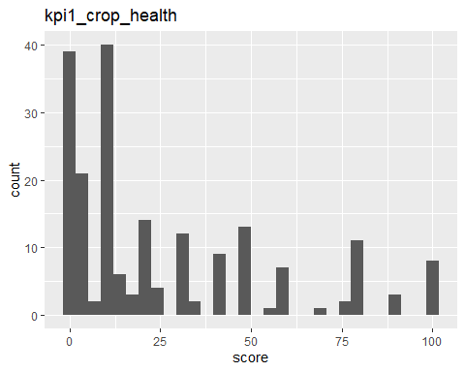

## `summarise()` has grouped output by 'kobo_farmer_id'. You can override using  
## the `.groups` argument.  
## Joining with `by = join_by(kobo_farmer_id, country, indicator, subindicator,  
## subindicator_label, score, indicator_order)`  
## `stat_bin()` using `bins = 30`. Pick better value with `binwidth`.

## Warning: Removed 19 rows containing non-finite outside the scale range  
## (`stat_bin()`).

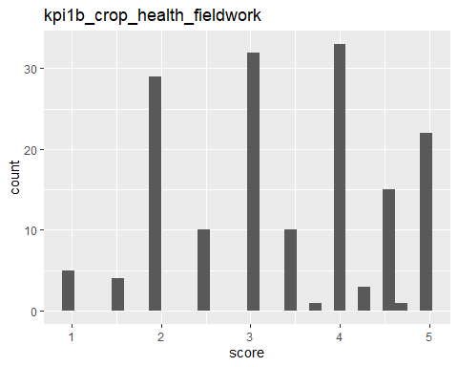

## `stat_bin()` using `bins = 30`. Pick better value with `binwidth`.

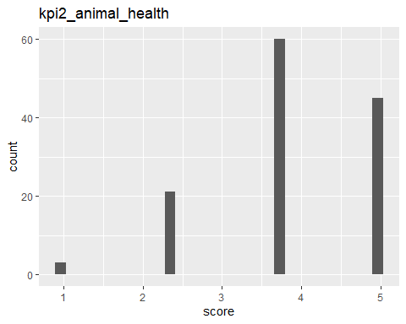

## `summarise()` has grouped output by 'kobo_farmer_id'. You can override using  
## the `.groups` argument.  
## `stat_bin()` using `bins = 30`. Pick better value with `binwidth`.

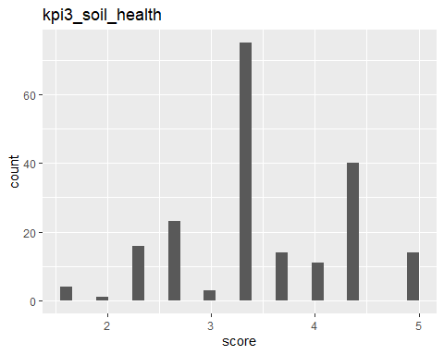

## [1] "Kilograms" "Liters"

## [1] "Kilograms"

## [1] "Kilograms"

## `stat_bin()` using `bins = 30`. Pick better value with `binwidth`.

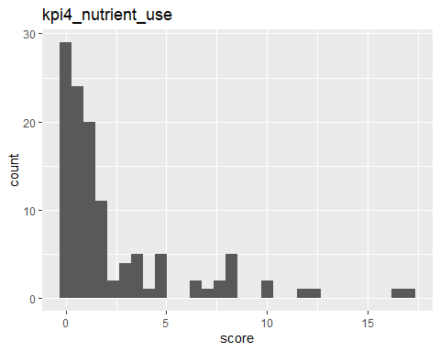

## `summarise()` has grouped output by 'kobo_farmer_id'. You can override using  
## the `.groups` argument.  
## `stat_bin()` using `bins = 30`. Pick better value with `binwidth`.

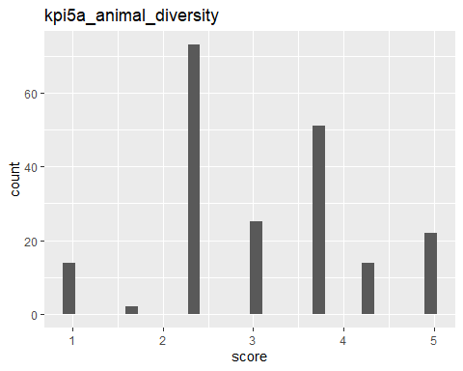

## `summarise()` has grouped output by 'kobo_farmer_id'. You can override using  
## the `.groups` argument.  
## `stat_bin()` using `bins = 30`. Pick better value with `binwidth`.

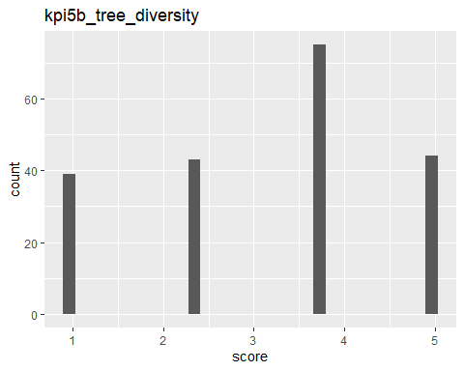

## Joining with `by = join_by(kobo_farmer_id, country, indicator)`  
## Joining with `by = join_by(kobo_farmer_id, country, indicator, index)`  
## `stat_bin()` using `bins = 30`. Pick better value with `binwidth`.

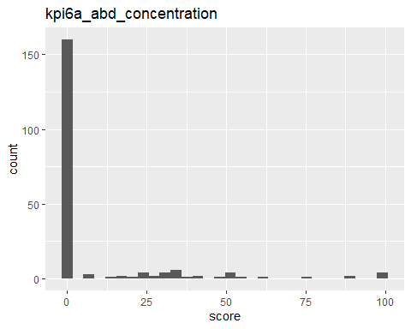

## `stat_bin()` using `bins = 30`. Pick better value with `binwidth`.

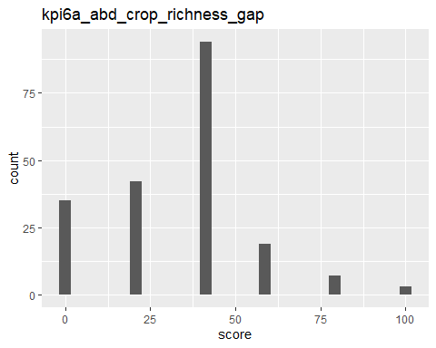

## Joining with `by = join_by(kobo_farmer_id, country, indicator, subindicator,  
## subindicator_label, score)`  
## `stat_bin()` using `bins = 30`. Pick better value with `binwidth`.

## Warning: Removed 1 row containing non-finite outside the scale range  
## (`stat_bin()`).

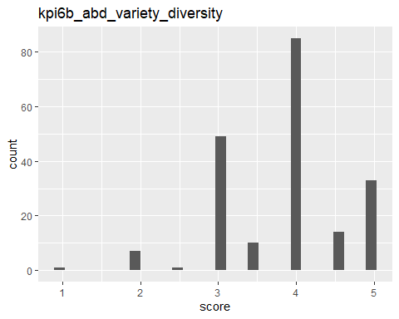

## Joining with `by = join_by(kobo_farmer_id, country, indicator, subindicator,  
## subindicator_label, score)`  
## `stat_bin()` using `bins = 30`. Pick better value with `binwidth`.

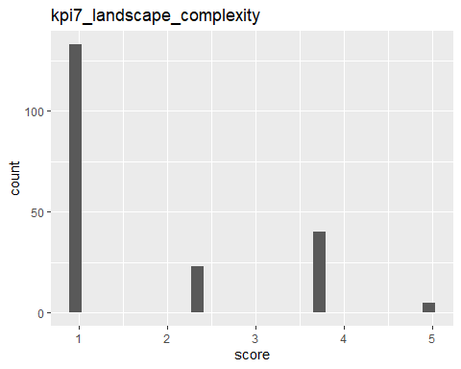

## [1] "1_recycling"   
## [2] "10_fairness"   
## [3] "11_connectivity"   
## [4] "12_governance"   
## [5] "13_participation"   
## [6] "2_input_reduction"   
## [7] "3_soil_health"   
## [8] "4_animal_health"   
## [9] "5_biodiversity"   
## [10] "6_synergy"   
## [11] "7_economic_diversification"   
## [12] "8_knowledge"   
## [13] "9_social_values"   
## [14] "accessibility"   
## [15] "age_community"   
## [16] "age_dob"   
## [17] "agricultural_all"   
## [18] "agroecology_knowledge"   
## [19] "animal_health"   
## [20] "biodiversity_abundance"   
## [21] "biodiversity_agrobiodiversity"   
## [22] "biodiversity_climate_mitigation"   
## [23] "biodiversity_cover"   
## [24] "biodiversity_diversity"   
## [25] "climate_drought"   
## [26] "climate_flood"   
## [27] "climate_rainfall_change"   
## [28] "climate_rainfall_timing"   
## [29] "climate_resilience_adaptative_capacity"   
## [30] "climate_resilience_assets"   
## [31] "climate_resilience_basic_services"   
## [32] "climate_resilience_shocks"   
## [33] "climate_resilience_social_network"   
## [34] "climate_temp"   
## [35] "consent"   
## [36] "context_all"   
## [37] "credit_access"   
## [38] "crop_health"   
## [39] "economic_all"   
## [40] "education"   
## [41] "energy"   
## [42] "enumerator"   
## [43] "environmental_all"   
## [44] "ethnicity"   
## [45] "extra_economic_diversification/economic"  
## [46] "extra_participation"   
## [47] "farmer_agency"   
## [48] "farmer_relation"   
## [49] "gender"   
## [50] "hh_head_relation"   
## [51] "household_labour"   
## [52] "housing"   
## [53] "id_site"   
## [54] "income"   
## [55] "inputs"   
## [56] "kpi1_crop_health"   
## [57] "kpi1b_crop_health_fieldwork"   
## [58] "kpi2_animal_health"   
## [59] "kpi3_soil_health"   
## [60] "kpi4_nutrient_use"   
## [61] "kpi5a_animal_diversity"   
## [62] "kpi5b_tree_diversity"   
## [63] "kpi6a_abd_concentration"   
## [64] "kpi6a_abd_crop_richness_gap"   
## [65] "kpi6b_abd_variety_diversity"   
## [66] "kpi7_landscape_complexity"   
## [67] "labour_productivity"   
## [68] "land_tenure_security"   
## [69] "landscape_complexity"   
## [70] "literacy"   
## [71] "location"   
## [72] "marital_status"   
## [73] "membership"   
## [74] "name"   
## [75] "nutrient_use"   
## [76] "nutrition"   
## [77] "personal_factors"   
## [78] "primary_occupation"   
## [79] "production_end_use"   
## [80] "production_systems"   
## [81] "productivity_crops"   
## [82] "productivity_livestock"   
## [83] "project_involvement"   
## [84] "score_ae_overall"   
## [85] "secondary_occupation"   
## [86] "social_all"   
## [87] "societal_factor"   
## [88] "soil_health"   
## [89] "structure"   
## [90] "training"   
## [91] "water"   
## [92] "wellbeing"

##   
## _3_3_4_1 _3_3_4_1_1/4 _3_3_4_1_2/1 _3_3_4_1_2/2   
## 200 7 1 1   
## _3_3_4_1_2/5 _3_3_4_1_3 _3_3_4_1_3_2 _3_3_4_3_1/0   
## 5 7 8 13   
## _3_3_4_3_1/1 _3_3_4_3_1/10 _3_3_4_3_1/11 _3_3_4_3_1/12   
## 8 155 127 33   
## _3_3_4_3_1/2 _3_3_4_3_1/3 _3_3_4_3_1/4 _3_3_4_3_1/5   
## 10 13 13 13   
## _3_3_4_3_1/6 _3_3_4_3_1/7 _3_3_4_3_1/8 _3_3_4_3_1/9   
## 10 9 19 75   
## _3_3_4_3_2/0 _3_3_4_3_2/1 _3_3_4_3_2/10 _3_3_4_3_2/11   
## 47 14 98 97   
## _3_3_4_3_2/12 _3_3_4_3_2/2 _3_3_4_3_2/3 _3_3_4_3_2/4   
## 30 19 14 2   
## _3_3_4_3_2/5 _3_3_4_3_2/6 _3_3_4_3_2/7 _3_3_4_3_2/8   
## 3 4 5 22   
## _3_3_4_3_2/9 _3_3_4_3_3/0 _3_3_4_3_3/1 _3_3_4_3_3/10   
## 38 5 23 179   
## _3_3_4_3_3/11 _3_3_4_3_3/12 _3_3_4_3_3/2 _3_3_4_3_3/3   
## 160 69 9 9   
## _3_3_4_3_3/4 _3_3_4_3_3/5 _3_3_4_3_3/6 _3_3_4_3_3/7   
## 13 19 37 81   
## _3_3_4_3_3/8 _3_3_4_3_3/9 _3_3_4_4/2 _3_3_4_4/3   
## 145 172 39 5   
## _3_3_4_4/5 _3_3_4_4/6 _3_3_4_4/other _3_3_4_4_1   
## 85 5 23 23   
## _3_4_1_2_7_2_2_1/10 _3_4_1_2_7_2_2_1/11 _3_4_1_2_7_2_2_1/4 _3_4_1_2_7_2_2_1/5   
## 6 5 2 6   
## _3_4_1_2_7_2_2_1/6 _3_4_1_2_7_2_2_1/7 _3_4_1_2_7_2_2_1/8 _3_4_1_2_7_2_2_1/9   
## 7 7 7 7

##   
## Do you irrigate your cropland?   
## 200   
## During which months of the year do you find it difficult to access enough water for your agricultural needs (e.g. growing crops, drinking water for livestock): During a drought year   
## 921   
## During which months of the year do you find it difficult to access enough water for your agricultural needs (e.g. growing crops, drinking water for livestock): During a flood year   
## 393   
## During which months of the year do you find it difficult to access enough water for your agricultural needs (e.g. growing crops, drinking water for livestock): During a normal year   
## 498   
## Select the months in wich cropland is irrigated during this season   
## 47   
## Specify other places where do you source your water for drinking water for livestock?   
## 23   
## Specify the number of seasons in which cropland is irrigated:   
## 7   
## What methods of irrigation do you use   
## 7   
## What percentage of your cropland do you irrigate during this season?   
## 8   
## Where do you source your water for drinking water for livestock?   
## 157   
## Where do you source your water for irrigation?   
## 7

##   
## 0 1 10   
## 258 59 438   
## 11 12 2   
## 389 132 80   
## 20 3 30   
## 2 41 2   
## 4 40 5   
## 37 2 131   
## 50 6 7   
## 1 63 102   
## 8 9 Borehole   
## 193 292 3   
## Community borehole Deep well Deep Well near homestead   
## 1 1 1   
## Fetch water for them other Well   
## 2 23 15

##   
## 1 2 Apr   
## 6 1 30   
## Aug Dam/lake Dec   
## 193 1 132   
## Feb Groundwater Hose-pipe   
## 38 40 7   
## Jan Jul Jun   
## 45 102 58   
## Mar May No   
## 36 41 193   
## None Nov Oct   
## 65 389 438   
## Other (please specify) Piped regional water Rivers   
## 23 5 90   
## Sep Wetland Yes   
## 292 5 7

## Joining with `by = join_by(kobo_farmer_id, country, module, theme, indicator,  
## subindicator, score, indicator_order)`  
## `stat_bin()` using `bins = 30`. Pick better value with `binwidth`.

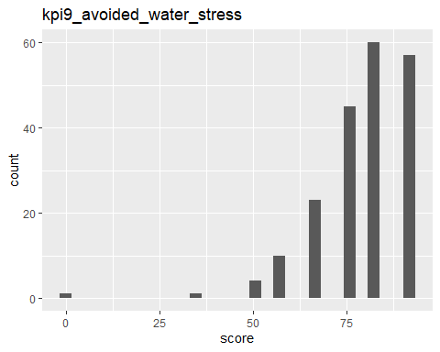

## `stat_bin()` using `bins = 30`. Pick better value with `binwidth`.

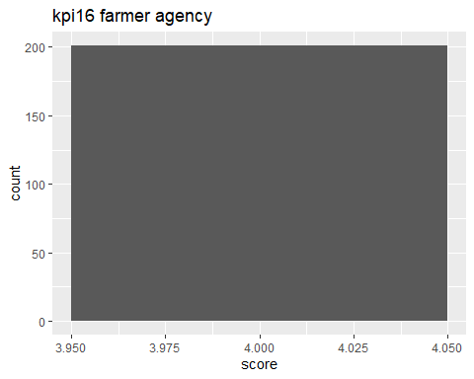

## `stat_bin()` using `bins = 30`. Pick better value with `binwidth`.

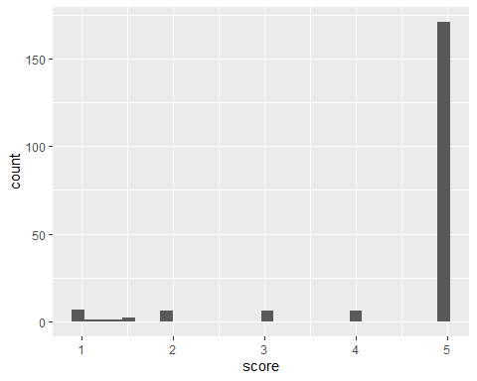

## `stat_bin()` using `bins = 30`. Pick better value with `binwidth`.

## Warning: Removed 1 row containing non-finite outside the scale range  
## (`stat_bin()`).

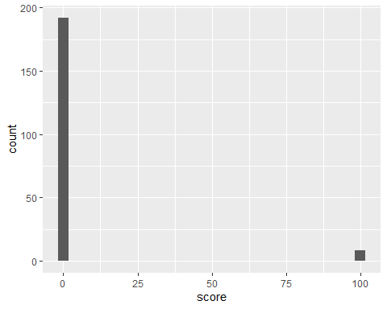

## `summarise()` has grouped output by 'kobo_farmer_id', 'country'. You can  
## override using the `.groups` argument.  
## `stat_bin()` using `bins = 30`. Pick better value with `binwidth`.

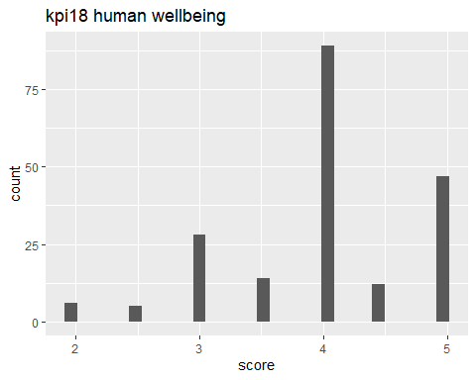

### Transfrom KPIs to unform 1 to 100 scale

## Joining with `by = join_by(kobo_farmer_id, indicator, subindicator,  
## subindicator_label, score, indicator_order)`

## Extract context indicators of interest

HOLPA collects data on multiple context, agroecology, and performance themes. For the context module, there are several indicators per theme and several measurements per indicator. We need to separate and name the indicators and measurements to include them into the analysis.

## Warning: There was 1 warning in `mutate()`.  
## ℹ In argument: `score = ifelse(...)`.  
## Caused by warning in `ifelse()`:  
## ! NAs introduced by coercion  
## There was 1 warning in `mutate()`.  
## ℹ In argument: `score = ifelse(...)`.  
## Caused by warning in `ifelse()`:  
## ! NAs introduced by coercion  
## There was 1 warning in `mutate()`.  
## ℹ In argument: `score = ifelse(...)`.  
## Caused by warning in `ifelse()`:  
## ! NAs introduced by coercion  
## There was 1 warning in `mutate()`.  
## ℹ In argument: `score = ifelse(...)`.  
## Caused by warning in `ifelse()`:  
## ! NAs introduced by coercion