NOTE su SparseMatrixVector multiplication, openMP CUDA

OMP

ACCELERATING THE S P MV KERNEL ON STANDARD CPU S BY EXPLOITING THE PARTIALLY DIAGONAL STRUCTURES

PRE PRINT!!
focus:
revisione algoritmi per SpMV con CSR,DIA → HDC
blocking tecq per DIA → HDC
HDC MODIFICATO!
Qualche perf model

DIA → HDC utili per SpMV con matrici prevalentemente diagonali NN GENERAL PURPOSE
si nota che molte ricerche recenti vanno in direzione di algoritmi specializzati sulla base dell’input
e.g. diagonal spMat importance:
we focus on the diagonally structured sparsity pattern, which often appears in a sparse matrix derived by the FEM or FDM discretization based on a structured grid; a typical example is a heptadiagonal matrix obtained by the FDM discretization for 3-dimensional Poisson’s equation

CSR PARALLEL SPMV
Storage: lo sanno anche i sassi! xD
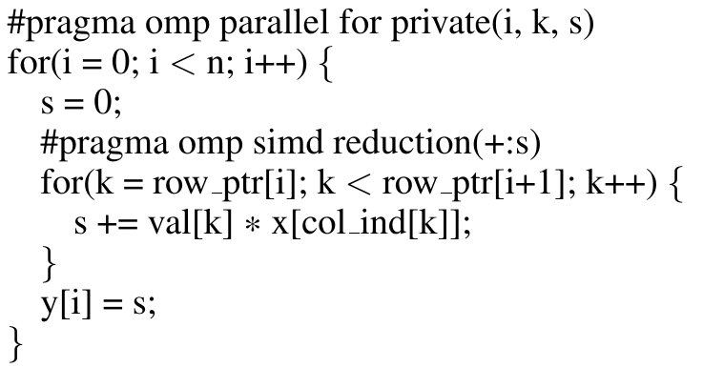

DIA FORMAT – SPMV
Storage core:
Si salvano contiguamente elementi mat[i][j] con stesso offset:=i-j ⇒ elementi sulle diagonali
ad ogni diagonale si associa un offset rispetto alla diagonale principale (negativo se sotto la principale)
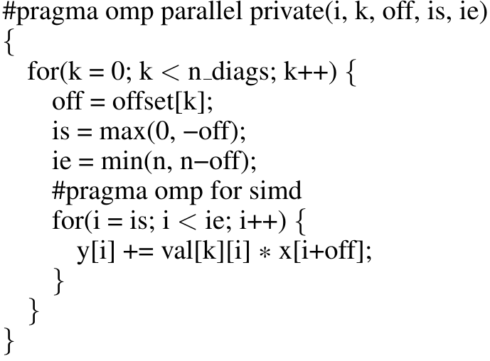

CSR VS DIA
Pattern NNZ diagonale ⇒ ZERO esplicitamente salvati ↘
⇒ DIA.overhead calcolo (rispetto a nessun 0 esplicito in CSR) associato ↘
→ costo accesso DIA.offset << costo accesso CSR.JA
⇐ dato che ∀ diagonale l’offset è costante, ( viceversa CSR necessita di colIdx ∀ elemento! )
Pattern MEM ACCESS in-out vectors
CSR ha una maggiore località temporale in outVector y
⇐ accesso per righe mi fa scrivere riga-riga ⇒ elementi consecutivi
accesso a x dipende da patternSparsità matrice ⇒ accessi a elementi y relativi
Vicerversa DIA ha una scarsa località temporale in entrambi i vettori x,y
località temporale ↘ ⇒ uso inefficiente caches def in n ⇒ perf ↘ ↘

⇒ RISOLUZIONE PROBLEMI DIA ⇒ BLOCKING

HDC FORMAT – SPMV
Hybrid DIA CSR
salvo le diagonali con più elementi come DIA, il resto come CSR
determinazione (del paper) se diagonale va in formato DIA:
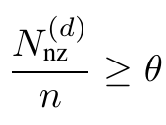 con N_{nz}^{(d)} = #NZ in diagonale con offset d ∈ [-n+1,n-1] , θ = userThreshold
RISPETTO A DIA → ZERO esplicitamente salvati ↘ ↘

CPU-GPU

A UNIFIED SPARSE MATRIX DATA FORMAT FOR EFFICIENT GENERAL SPARSE MATRIX-VECTOR MULTIPLICATION ON MODERN PROCESSORS WITH WIDE SIMD UNITS
Intro: note su MEM BOUND di SpMV, X86 ne soffre maggiormente →
It has to be stressed that standard ×86-based server microprocessors are usually so bandwidth-starved even with scalar code (i.e., they have a low machine balance) that a strongly memory-bound loop kernel such as spMVM does not benefit very much from SIMD vectorization unless the working set is small enough to fit into a cache. However, SIMD does make a difference in designs with many very slow cores (such as the Intel Xeon Phi) and certainly the massively threaded GPGPUs. Moreover it can be shown that efficient (i.e., SIMD-vectorized) single-core code can yield substantial energy savings on standard multicore processors by reaching the bandwidth saturation point with fewer cores [7, 20].
Target: formato unico per CPU-SIMD ↔ GPU SELL-C-σ → sorted, sliced EllPACK

ANY CSR con SIMD
Cache friendly ⇐ accessi consecutivi a dati e indici
Vettorizzazione SIMD richiede accessi consecutivi
XXX-way modulo unrolling: loop unrolling per consentire uso di SIMD instr
XXX ≡ | SIMD Reg | / sizeof(*data)
NB necessario initial loop peeling per vincoli di allineamento
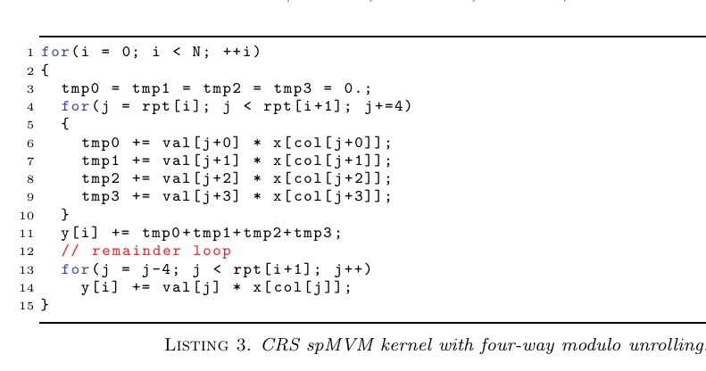
OSS: SIMD-vectorization richiede “reduce” ≈ somma orrizzontale di vettore calcolato dato che è relativo ad 1! elemento del vettore output (riga 11)
… PROBLEMI CON REMAINDER LOOP …

NECESSARIO X SIMD PERF ↗ : AVG #NNZ per riga >>> | SIMD Reg|

ANY ELLPACK → SELL-C-σ
ELLPACK padding overhead → sliced ellpack per paddare in rows chunk della matrice
elementi salvati in column major, chunk consecutivi, padding ultimo chunk per lunghezza comune
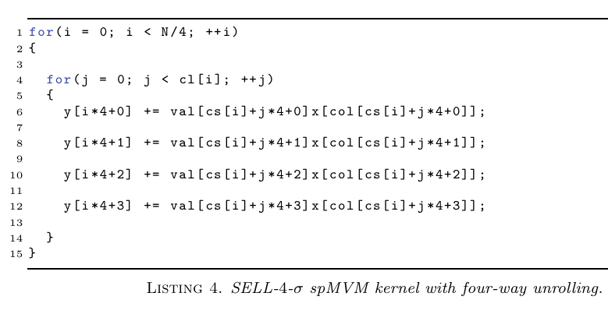
OSS qui NN è richiesta riduzione associata alla vettorizzazione dato che column-major mi vincola ad accedere un sotto vettore di outVector y

Problemi generali
Vettorizzazione Instruction Overhead
tranne che per arch MIC → intelPhy nn c’è una instr gather
necessarie 5 instr: one to load the four consecutively stored indices and four to fill the vector registers with the values of x; in practice, the number is even larger since the individual slots of a SIMD register can usually not be freely addressed
MIC.intelPhy.gather:
fetch multiple data items residing in the same cache line from memory to a vector register even if the addresses are not consecutive, actual benefit depends on the locality of the matrix entries in a single row. In the worst case, i.e., if all gathered items reside in different cache lines, one gather instruction per load is required and the whole operation is basically scalar again.
NB problema visibile solo in assenza di altri colli di bottiglia!
RightHandSide _{(invector x)} irregular access:
da patter sparsità matrice deriva accesso input vector
→ accessi irregolari ⇒ cattivo uso cache / NO load coalescing ⇒ perf ↘
⇒ reduce the matrix bandwidth by applying a bandwidth reduction algorithm
→ “reverse Cuthill McKee” [5], visibile in perfModel

HW notes
Intel SNB: Intel Xeon Sandy Bridge-EP system stands for the class of classic cache-based ×86 multicore processors with a moderate number of powerful cores, moderate SIMD acceleration, and still rather high clock fre- quency.
Intel Xeon Phi 5110P, based on Intel’s MIC architecture. It is a PCIe based accelerator card comprising 60 rather simple cores (based on the P54C design, which was launched in 1994) with four hardware (SMT) threads each. The hardware threading is intended to compensate the deficiencies of the in-order core architecture. Each core is extended by a 512-bit wide SIMD unit
Nvidia Tesla K20c is based on the Kepler architecture. It has 13 streaming multiprocessors (SMX), each with 192 single-precision CUDA cores, for a total of 2496 CUDA cores

