# Supplementary Information

# Correlates of Substitution Rate Variation in a Robust Procellariiform Seabird Phylogeny

Andrea Estandía, R. Terry Chesser, Helen F. James, Max A. Levy, Joan Ferrer Obiol, Vincent Bretagnolle, Jacob González-Solís, Andreanna J. Welch

**This pdf file includes:**

Supplementary Information Text

Figures S1-S7

**SUPPLEMENTARY INFORMATION TEXT**

**Fossil calibration**

**Node between Sphenisciformes/Procellariiformes**

**Minimum age:** 60.5 Ma

**Calibration:** Lognormal distribution, offset 60.5 Ma, mean 2, S 1.5(see supplementary_material/xml/random.xml)

**Taxon and specimen:** *Waimanu manneringi* (Slack et al. 2006); CM zfa35 (Canterbury Museum, Christchurch, New Zealand), holotype comprising thoracic vertebrae, caudal vertebrae, pelvis, femur, tibiotarsus, and tarsometatarsus.

**Locality:** Basal Waipara Greensand, Waipara River, New Zealand.

**Phylogenetic justification:** *Waimanu* has been resolved as the basal penguin taxon using morphological data (Slack et al. 2006), as well as combined morphological and molecular datasets (Ksepka et al. 2006, Clarke et al. 2007).Morphological and molecular phylogenies agree on the monophyly of Sphenisciformes and Procellariiformes (Livezey & Zusi 2007, Prum et al. 2015). *Waimanu manneringi*waspreviously used by Prum et al. (2015) to calibrate Sphenisiciformes, and see Ksepka & Clarke (2015) for a review of the utility of this fossil as a robust calibration point.

**Age justification:** The top of the Waipara Greensand marks the Paleocene-Eocene boundary, and calcareous nanofossils further constrain age of this fossil to 60.5-61.6 Ma (Cooper 2004, Slack et al. 2006, Ksepka & Clarke 2015). The younger species *Waimanu tuatahi* dated to ~58-60 Ma is represented by multiple specimens that overall comprise almost a complete skeleton (Slack et al. 2006), providing further evidence of the presence of Sphenisciformes in the Paleocene after this time.

**References**

Clarke, J. A. et al. Paleogene equatorial penguins challenge the proposed relationship between biogeography, diversity, and Cenozoic climate change. Proceedings of the National Academy of Sciences 104, 11545 (2007).

Cooper, R.A. 2004. *The New Zealand Geological Timescale*. Institute of Geological and Nuclear Sciences, Lower Hutt.

Ksepka, D.T. and Clarke, J.A. The basal penguin (Aves: Sphenisciformes) *Perudyptes devriesi* and a phylogenetic evaluation of the penguin fossil record. Bulletin of the American Museum of Natural History, 337:1-77 (2010)

Ksepka, D. T. & Clarke, J. Phylogenetically vetted and stratigraphically constrained fossil calibrations within Aves. Palaeontologia Electronica 18.1.3FC, 1-25 (2015).

Ksepka, D. T., Bertelli, S. & Giannini, N. P. The phylogeny of the living and fossil Sphenisciformes (penguins). Cladistics 22, 412-441 (2006).

Kuroda, N. (1954). *On the classification and phylogeny of the order tubinares, particularly the shearwaters* (*Puffinus*). Tokyo: N. Kuroda. 179 pp.

Livezey, B.C. and Zusi, R.L. 2007. Higher-order phylogeny of modern birds (Theropoda, Aves: Neornithes) based on comparative anatomy: II. Analysis and discussion. *Zoological Journal of the Linnean Society*, 149:1-95.

Olson SL.The fossil record of birds. In: Farner DS, King JR, Parkes KC, eds. *Avian biology*, Vol. 8. New York: Academic Press, 79–238 (1985)

Parham, J. F. et al. (2012) Best Practices for Justifying Fossil Calibrations. Systematic Biology. 61:346-359.

Prum, R.O. et al. (2015) A comprehensive phylogeny of birds (Aves) using targeted next-generation DNA sequencing. *Nature*. **526**: 569–73.

Slack, K. E. et al. Early penguin fossils, plus mitochondrial genomes, calibrate avian evolution. Molecular Biolology and Evolution 23, 1144-1155 (2006).

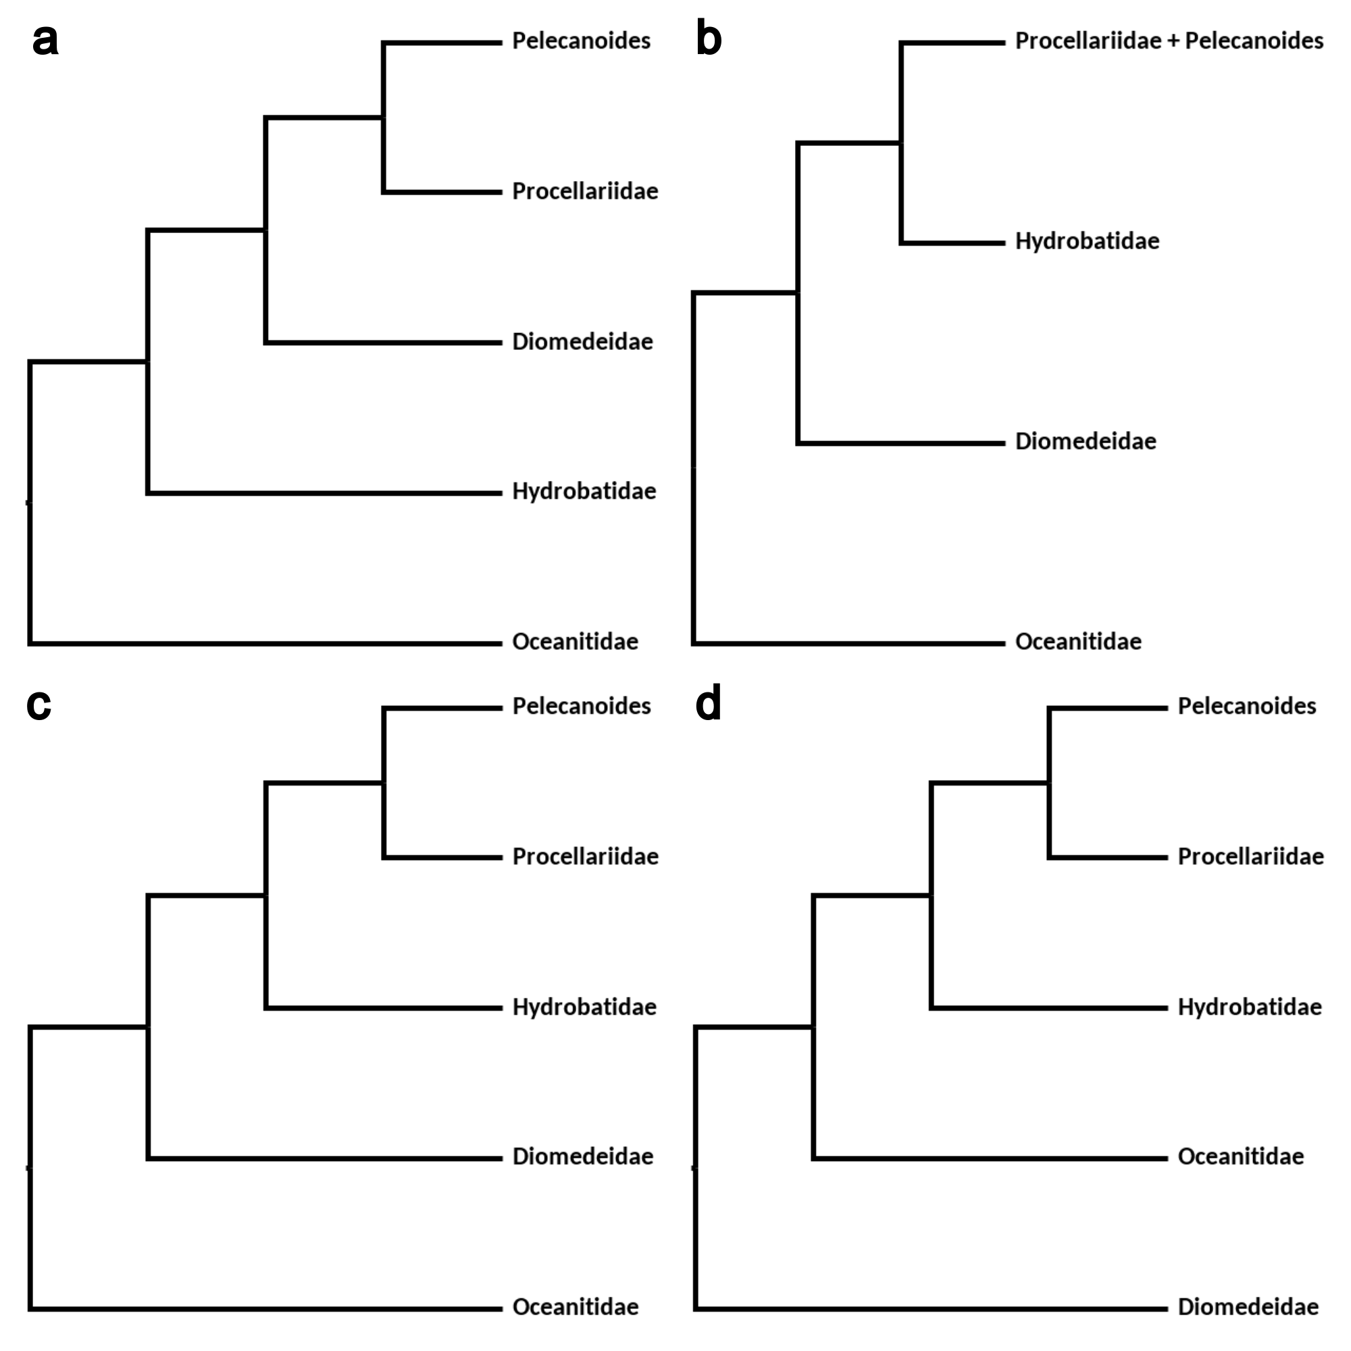

**Figure S1.** Most relevant previously published phylogenetic relationships among the main procellariiform lineages according to (a) Nunn and Stanley 1998, (b) Kennedy and Page 2002 (c) Hackett et al. 2008 and (d) Prum et al. 2015 and Reddy et al. 2017.

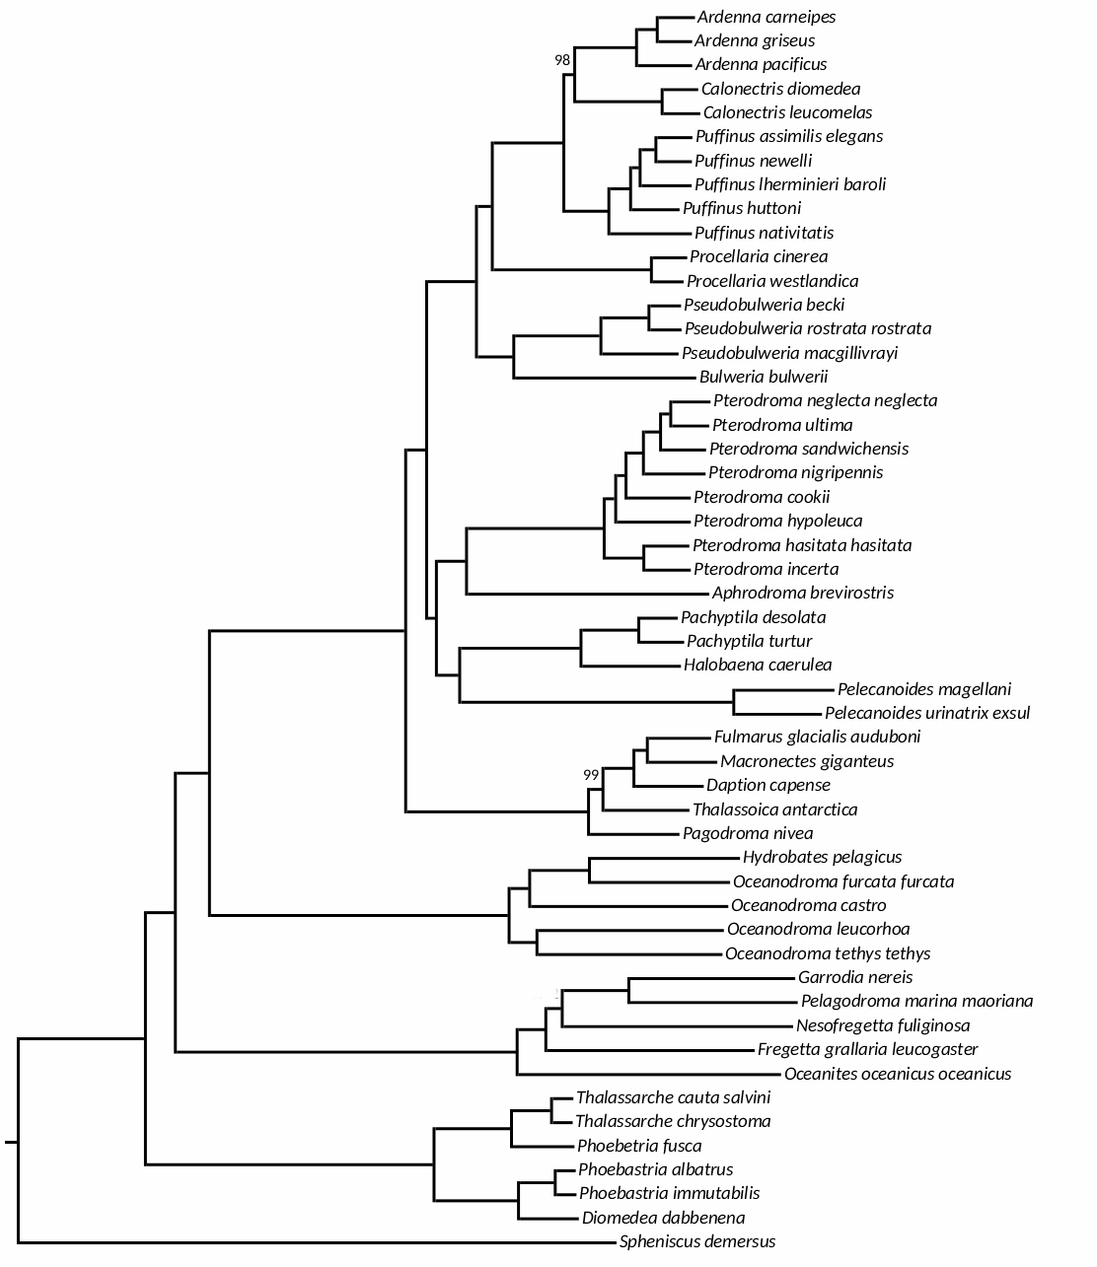

**Figure S2.** Topology resulting fromIQ-tree. All nodes are supported by values of 100, except where indicated.

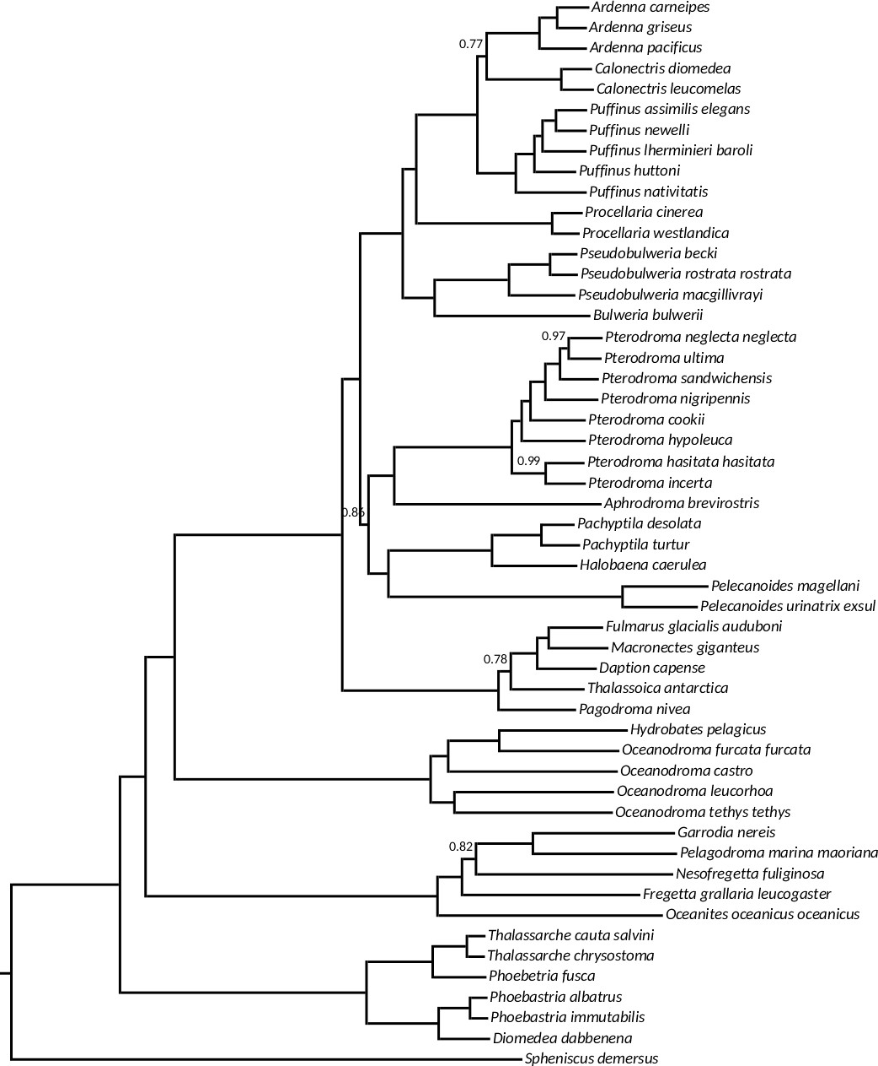

**Figure S3.** Species tree (ASTRAL-III). All nodes supported by values of 1 except for those indicated in the figure.

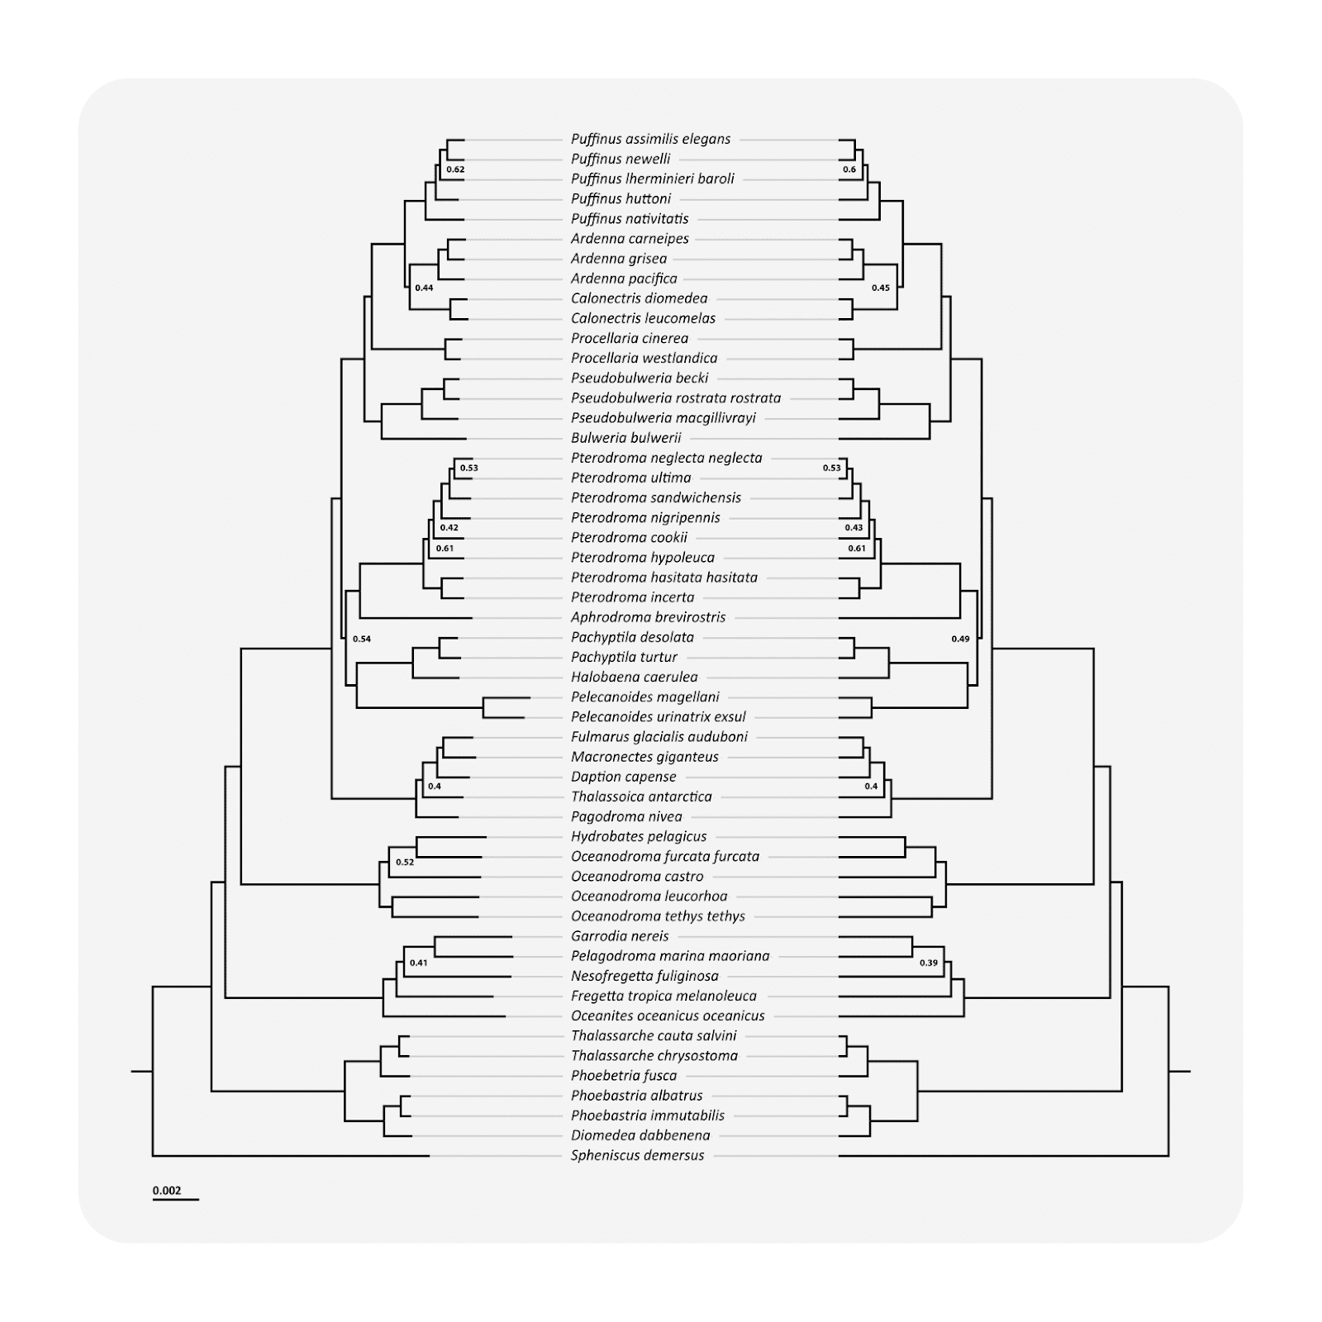

**Figure S4.** Comparison between the BEAST phylogeny under a relaxed clock model (left) and a strict clock model (right). The topology remains the same, but note the differences in branch lengths, particularly the short branches within the Diomedeidae (*Thalassarche*, *Phoebetria*, *Phoebastria*, and *Diomedea*) and the long branch leading to *Pelecanoides*. All nodes are supported by at least a posterior probability of 0.7 unless otherwise indicated.

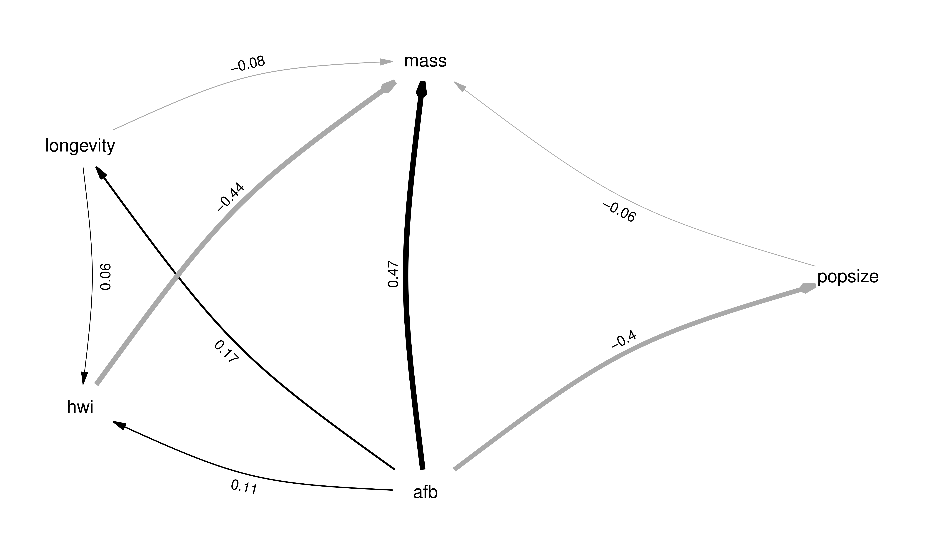

**Figure S5.** Best-fitting phylogenetic path model.

**Figure S5.** Phylogenetic path results showing the correlations between the different variables tested in Coevol 1.4b.

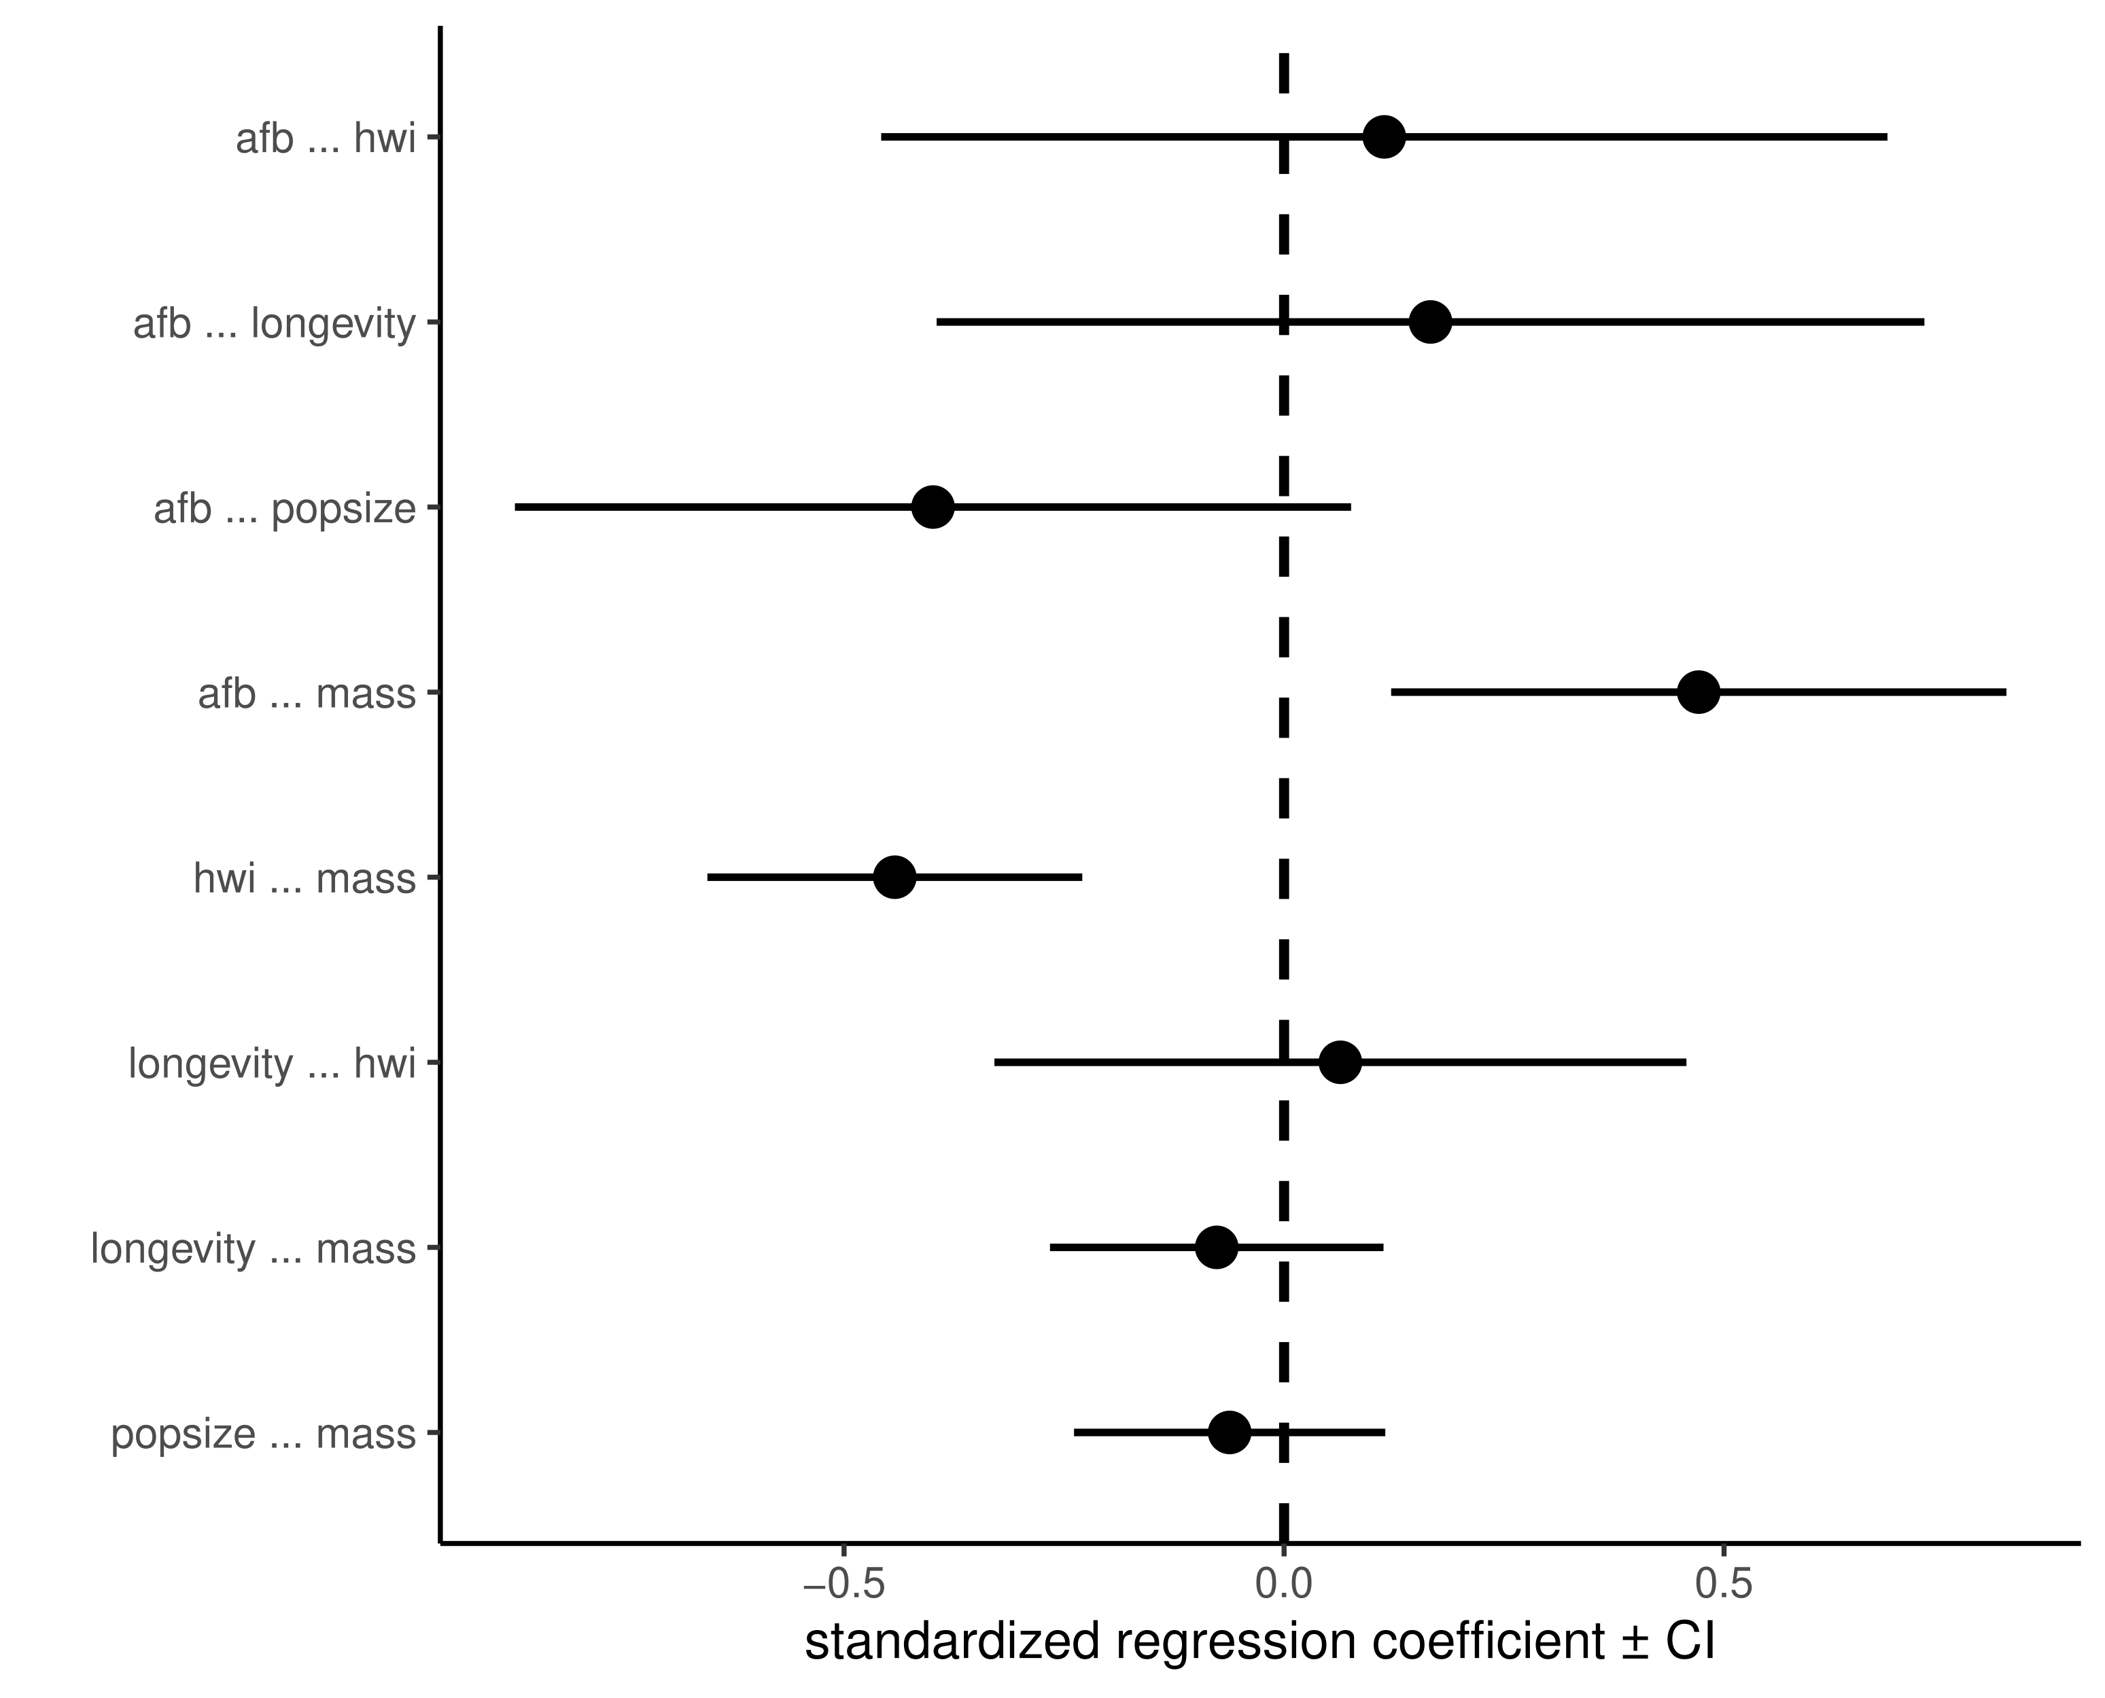

**Figure S6.** Phylogenetic path analysis results. The only significant correlations are between AFB and body mass, and HWI and body mass as the confidence interval does not overlap zero.

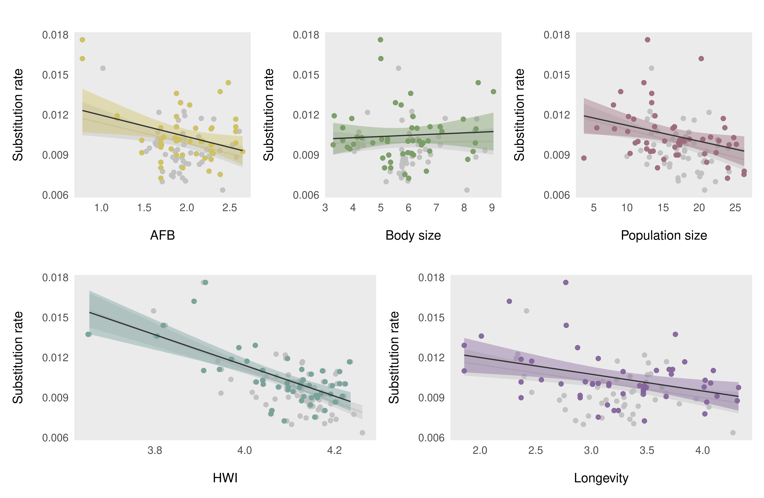**Fig S7.** Correlations between substitution rate and log-transformed variables. Each point represents a tip (in colour) or a reconstructed node by Coevol 1.4b.