ENDOGENOUS SORTING – choose your partners by giving a rank

In the first part we need to

1. Let subjects play a one shot pgg (done); N players overall, in groups of 3.
2. Get contribution levels from the pgg (done)
3. Display others’ contributions and IDs, sorted following an increasing order of contributions (partially done; I have to find a way to display contributions in an ordered table) – see figure 1
4. Subjects rank others’ contributions: each subject sees the contributions of ALL subjects in the session, and inserts as input a rank to express his preference – see figure 1
   1. Ranking goes from 1 to N (ex. I give 1 to player 8 who contributed 100, 2 to Player 3 who contributed 65 and so on)
   2. Need to check if ranks given are correct or subjects do not make mistakes in giving ranks (in the sense that all N ranks are being used with no repetition)
5. Compute overall score for each subject (the sum of received ranks)
6. Create a final ranking with subjects ordered according to their overall score
7. Cut the ranking in groups of 3 starting from the top (N subjects must be a multiple of 3)

Second part:

1. Another 10 rounds of PGG with groups formed in 7-
2. Final results at the end of both part 1 and part 2

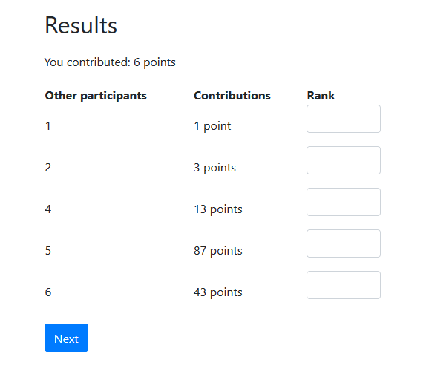Screenshots:

Figure - ranking page