MongoDb

1. Vertical scaling is buying a better server or adding more power to your current machine while horizonal scaling is buying more servers.

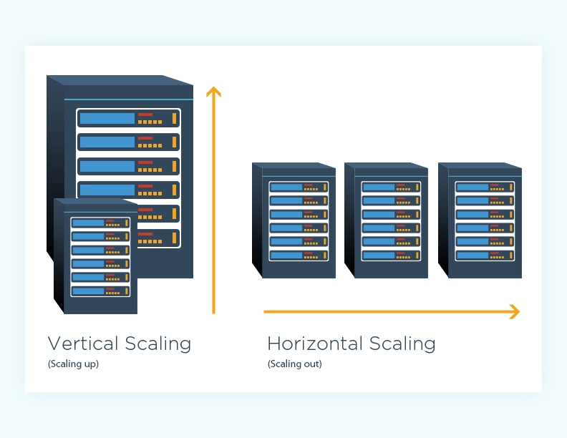

Photo from: <https://www.cloudzero.com/blog/horizontal-vs-vertical-scaling>

1. Comparisons:
2. In mongo you have different collections which compares to SQL tables.
3. In mongo db you have documents which compares to SQL rows in the way
4. For SQL you have it labeled in the columns and each row is a different piece of data.
5. For mongodb you have documents as different “rows” but each piece of data is easier to access since it is labeled within the document.
6. According to mongodb - Unstructured data is information that is not arranged according to a pre-set data model or schema, and therefore cannot be stored in a traditional relational database or RDBMS. Text and multimedia are two common types of unstructured content. Many business documents are unstructured, as are email messages, videos, photos, webpages, and audio files.

NoSQL databases relate to unstructured data since they do not have a data model that they follow.

1. Text parsing is a way to look through text to fetch a certain type of data example : “{firstName: “Andrea”, lastName: “Espinoza”} ” you would parse the text and look for lastName to find the last name

You Do: Designing For Scale

1. I can see that some files can get very very large if a user or a document with information ends up with a lot of information. It is not as organized as SQL so at some points it might take longer to access some information if the file is very large.

Collection: Blog Space

Document Schema would be structured like below:

{  
 "title": "My First Blog Post",  
 "Author": "Andreas K",  
 "Body": "Blog posts are very important to me because they let me talk at length. And",  
 "Comments": [  
 "this was such a great blog post! Thank you!",  
 "This is a pretty simple post, looking forward to more advanced ones!"  
 ]  
}