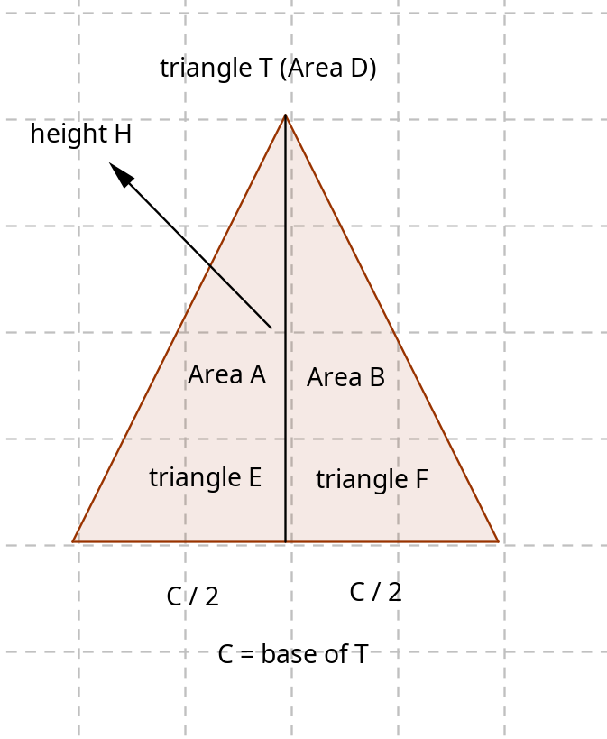

Area Triangle = \( \frac{base}{2} * height \)

2 * Area Triangle = \( base * height \)

\(Area\, D * 2 = base * height \)

\(base * height \) is the double of triangle area?

Area A + Area B = Area D

(Area A + Area B) * 2 = \( base * height \)

Triangle T (with area D) has at least two triangles

Area A, has how many triangles?

Area A = C/4 * height

\( 2 * Area A = \frac{C}{2} * height \)

\( 4 * Area A = C * height \)

C / 4 * height + C/ 4 * height = Area D

Area D = \( \frac{base * height}{2} = \frac{C}{4} * height + \frac{C}{4} P height \)

H is the same for Area A and Area B, so Area D uses height, bur i have height / 2 , it will not be erqual to Area of triangle T

