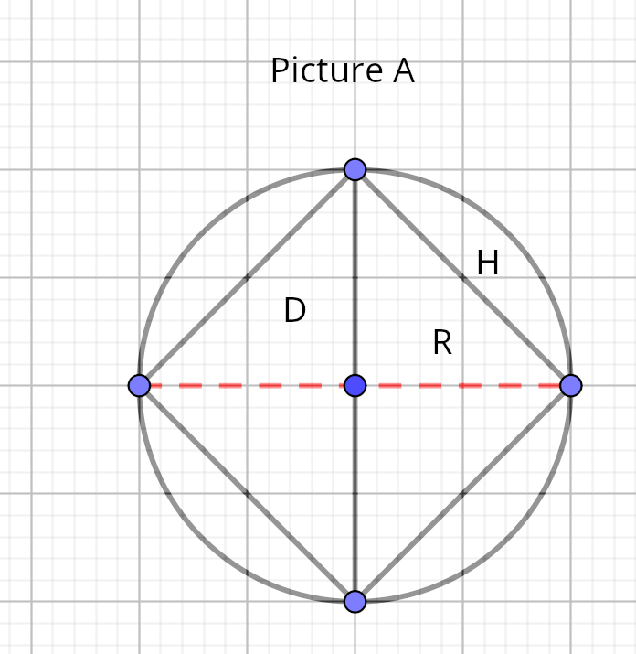

On picture A.
H = s . Its a circle chord
D = d. Red line on picture A
R = radius

new formula for hipotenuse

Math formula for diagonal of square

(1)

d = diagonal of square
s = side of square

H is hipotenuse (and chord)

Using math formula, (1) above, dividing all sides by

We get

D, the diameter , is 2*radius so

Final formula for hipotenuse

r is the base of triangle

Other considerations

new formula for radius

side of square is H (check above picture).

using pythagoras

other formula for radius

new formula for area of circle

considering new radius formula (r was calculated before).

square r

new formula for perimeter of circle

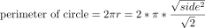

develop fraction on right side.

