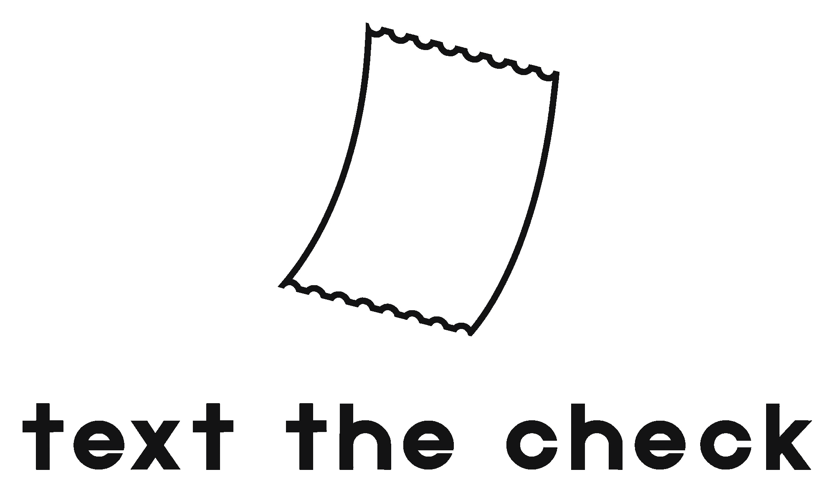
Brand & Design Manual
──────────────────────────────
The visual identity contract for the unified ecosystem
One Brand · Dark + Light Modes · Two Product Modes

February 2026 — v1.0
Andrea López Palomeque & Imanol Corimayo

1. Brand Identity

1.1 Brand Overview
Element | Definition
Name | Text the Check
Tagline (ES) | Tu plata, a un mensaje
Tagline (EN) | Your money, one message away
Domain | textthecheck.app
Instagram | @textthecheck
Language | Argentine Spanish (vos, lunfardo). English for global copy.
Personality | Approachable, clear, modern. A financially savvy friend, not a bank.

1.2 Brand Personality
- Approachable: We speak like a friend, not a financial institution. We use “vos”, casual language, and emojis where appropriate.
- Clear: Money is sensitive. We are always transparent, accurate, and unambiguous. Numbers are never confusing.
- Modern: We feel like a product built today, not 10 years ago. Clean UI, dark mode, fast interactions.
- Conversational: Our primary interface is a WhatsApp chat. Everything should feel like a natural conversation.
- Local-first: Built for Argentina and Latin America. We understand pesos, blue dollar, CBU, Mercado Pago, and real slang.

1.3 Voice & Tone
Text the Check speaks like a financially savvy friend. Not a bank, not a robot, not a startup trying too hard.
We Say | We Don't Say
“Listo, gasto registrado ✔️” | “Su transacción ha sido procesada exitosamente.”
“Te deben $4.500 — podés pedirle a Gonza” | “El saldo pendiente de cobro asciende a $4.500.”
“Mandá un mensaje y listo” | “Utilice nuestra plataforma para gestionar sus finanzas.”

2. Logo System

2.1 Primary Logo
The primary logo consists of two elements: the receipt icon (symbol) and the “text the check” wordmark in lowercase geometric sans-serif type (Outfit SemiBold 600). Both elements can be used together or independently.

2.2 Logo Anatomy
Element | Description & Rules
Receipt Icon | The curved receipt with organic zigzag edges. NOT a rigid rectangle — it has natural paper movement and a slight curvature that makes it feel human. This organic quality is essential; never straighten or flatten the curves.
Zigzag Edges | Top and bottom edges are torn/perforated receipt edges. They are detailed and characterful — they say “real receipt” not “generic document icon.”
Wordmark | All lowercase: “text the check”. Geometric sans-serif typeface (Outfit SemiBold 600, letter-spacing 3px). Never capitalize. The lowercase is intentional — it signals approachability.
Monochrome | Logo works in a single color on any background. Default: dark gray (#313133) on light, white on dark. Can be rendered in the brand primary color (#4A90D9) for accented usage.

2.3 Logo Usage Rules
- Minimum clear space: the height of the letter “t” in the wordmark on all sides
- Minimum size: 100px wide (digital), 25mm wide (print)
- Never stretch, rotate, add effects, or apply gradients to the logo
- Never change the proportions between the icon and wordmark
- Never use the logo on busy/patterned backgrounds without sufficient contrast
- Accepted color variations: monochrome dark, monochrome white, brand primary (#4A90D9)

2.4 Logo Variants
Variant | When to Use | Details
Full logo (icon + wordmark) | Default. Landing page, headers, documents. | Icon stacked above wordmark, centered. Tagline optional below.
Horizontal logo | Navigation bars, tight headers. | Icon to the left, wordmark to the right, vertically centered.
Symbol only | App icon, favicon, small spaces. | Receipt icon alone. Works at small sizes because the shape is recognizable.
Wordmark only | When icon is already present or space is extremely limited. | “text the check” in Outfit SemiBold (600), letter-spacing 3px. Can accent “the” in primary color.

3. Color System
Text the Check uses a dual-theme color system: Dark Mode (primary) and Light Mode (secondary). Both themes are fully defined and must be implemented. Dark mode is the default experience.

🌙 DARK MODE IS PRIMARY
The default and primary interface is dark. It’s premium, modern, reduces eye strain, and aligns with user expectations for fintech apps. Dark mode gets designed first, light mode adapts from it.

3.1 Dark Mode Palette (Primary)
The “Deep Trust” palette: dark foundation with warm blue accent. The blue is slightly warmer than corporate blue to match the logo’s friendly personality.
Token | Hex | Swatch | Usage
bg | #0C1017 | #0C1017 | Page background, root container
surface | #131920 | #131920 | Headers, navigation bars, elevated surfaces
card | #1A222C | #1A222C | Cards, list items, modals
border | #242E3C | #242E3C | Dividers, card borders, separators
primary | #4A90D9 | #4A90D9 | Brand accent, active states, buttons, amounts, logo accent
primary-light | #6BA8ED | #6BA8ED | Hover states, links, secondary accents
secondary | #A78BFA | #A78BFA | Tags, badges, secondary categories
accent | #34D399 | #34D399 | Positive amounts (“te deben”), success states
text | #E2E8F0 | #E2E8F0 | Primary text, headings, labels
text-muted | #7B8FA6 | #7B8FA6 | Secondary text, timestamps, helper text
text-dim | #4A5A6E | #4A5A6E | Placeholders, disabled text
danger | #EF4444 | #EF4444 | Negative amounts (“debés”), errors, urgent due dates

3.2 Light Mode Palette (Secondary)
Clean, high-contrast adaptation for users who prefer light interfaces. Same semantic tokens, different values.
Token | Hex | Swatch | Usage
bg | #F8FAFB | #F8FAFB | Page background
surface | #FFFFFF | #FFFFFF | Headers, navigation
card | #FFFFFF | #FFFFFF | Cards (use shadow for elevation instead of color)
border | #E2E7ED | #E2E7ED | Dividers, borders
primary | #3B7DD8 | #3B7DD8 | Brand accent (slightly darker for contrast on white)
accent | #059669 | #059669 | Positive amounts (darker green for readability)
text | #1A2030 | #1A2030 | Primary text
text-muted | #5A6B80 | #5A6B80 | Secondary text
danger | #DC2626 | #DC2626 | Negative amounts, errors (darker for contrast)

⚠️ IMPLEMENTATION NOTE
Use CSS custom properties (--color-bg, --color-primary, etc.) or Tailwind’s dark: prefix. Both themes must use the SAME semantic token names. Components never reference hex values directly — they reference tokens. This ensures both themes work from day one.

4. Typography

4.1 Font Pairing
Role | Font | Usage & Notes
Logo Wordmark | Outfit (600 SemiBold) | Logo wordmark “text the check” in all contexts: headers, navigation bars, horizontal layouts. Geometric sans-serif with clean, wide-set letterforms and flat terminals. Use exclusively at 600 weight with letter-spacing 3px.
Display / Headings | Nunito (800 ExtraBold) | Headings, amounts, group names, mode labels. Rounded terminals match the logo’s warm personality. Use 800 for headings, 700 for subheadings. NOT used for the logo wordmark (that’s Outfit).
Body | DM Sans (400 Regular) | Body text, descriptions, timestamps, form labels, buttons. Clean and readable without stealing attention from Nunito headings. Use 400 for body, 500 for labels, 700 for button text.
Mono | DM Mono (400) | Currency codes, technical data, WhatsApp command references. Optional — only if monospace is needed.

All four fonts (Outfit, Nunito, DM Sans, DM Mono) are free on Google Fonts for commercial use. No licensing concerns. Outfit 600 is the logo wordmark, Nunito 800 is for display headings and amounts, DM Sans 400 is for body text, DM Mono 400 is optional for monospace contexts.

💡 WHY THESE FONTS?
Outfit SemiBold (600) is the closest match to the original Looka logo typeface — a geometric sans-serif with flat terminals and wide letterforms. Use it exclusively for the “text the check” wordmark. Nunito 800 provides warm, rounded headings that complement Outfit’s precision — its rounded terminals create visual cohesion between the logo and all UI headings. DM Sans is clean and readable at small sizes — essential for financial data on mobile screens.

4.2 Type Scale
Based on a 4px grid. All sizes in rem (1rem = 16px base).
Name | Size | Weight | Font | Usage
hero | 2rem (32px) | 800 | Nunito | Landing page hero, balance amounts
h1 | 1.5rem (24px) | 800 | Nunito | Page titles: “Brasil 2026”, “Febrero 2026”
h2 | 1.25rem (20px) | 700 | Nunito | Section titles, card headers
h3 | 1rem (16px) | 700 | Nunito | Subsection titles, amounts in lists
body | 0.875rem (14px) | 400 | DM Sans | Primary body text, descriptions
small | 0.75rem (12px) | 400 | DM Sans | Timestamps, secondary labels, meta info
caption | 0.6875rem (11px) | 600 | DM Sans | Section dividers, all-caps labels (letter-spacing: 1px)
tagline | 0.625rem (10px) | 500 | DM Sans | Below logo: “TU PLATA, A UN MENSAJE” (letter-spacing: 3px)

5. Spacing & Layout

5.1 Spacing Scale
4px base grid. Use Tailwind’s default spacing scale. Never eyeball spacing.
Token | Pixels | Tailwind | Usage
xs | 4px | p-1, m-1 | Tight spacing between inline elements
sm | 8px | p-2, gap-2 | Inside compact components, between icon and text
md | 12px | p-3, gap-3 | Card internal padding (compact), between list items
base | 16px | p-4, gap-4 | Default card padding, section content padding
lg | 20px | p-5, gap-5 | Page padding (mobile), generous card padding
xl | 24px | p-6, gap-6 | Section gaps, page padding (tablet+)
2xl | 32px | p-8, gap-8 | Major section separators

5.2 Border Radius
Rounded corners to match the logo’s friendly, organic personality. Never use sharp corners.
Element | Radius | Tailwind Class
Buttons | 8px | rounded-lg
Cards, list items | 12px | rounded-xl
Modals, sections | 16px | rounded-2xl
Avatars, badges | 50% | rounded-full
Tags, pills | 6px | rounded-md
App icon | 22% of size | rounded-[22%] (iOS standard)

6. Design Principles
These six principles are the contract between both founders. Every component, page, and feature decision must align with them.

01 YOUR LOGO IS THE FOUNDATION
The curved receipt icon + geometric lowercase wordmark (Outfit 600) sets the personality: approachable, clear, modern. Every design choice must feel like it lives in the same family. If a component feels too corporate or too playful compared to the logo, it’s wrong.

02 NUMBERS ARE THE HERO
Amounts, balances, and dates should be the most visually prominent elements. Use Nunito (display font) at large sizes with the primary color for financial data. Everything else — descriptions, timestamps, labels — is supporting context at smaller sizes in muted colors.

03 WHATSAPP-NATIVE FEELING
The app is an extension of a WhatsApp conversation. Rounded corners on cards (12-16px), conversational copy, quick interactions. If something feels like a banking dashboard instead of a chat companion, simplify it.

04 DARK MODE FIRST, LIGHT MODE SUPPORTED
The primary interface is dark — premium, modern, expected by fintech users. Light mode is fully supported and must feel intentional, not an afterthought. Both themes use the same semantic tokens.

05 CLARITY OVER DECORATION
No gradients, no glassmorphism, no decorative illustrations. Every pixel serves a purpose. Users are dealing with money — trust comes from clarity. A clean card with clear numbers is more powerful than a fancy animation.

06 TWO MODES, ONE DESIGN LANGUAGE
Viajes and Finanzas must feel like the same app, not two products stitched together. Same spacing, same card styles, same typography scale, same component library. The only difference between modes is the data — never the design. This is the non-negotiable contract between Andrea and Imanol.

7. Component Patterns
Shared component patterns that both modes must follow. These ensure visual consistency across Viajes and Finanzas.

7.1 Cards (Expense / Payment Items)
- Background: card token (#1A222C dark / #FFFFFF light)
- Border: 1px solid border token. No shadows in dark mode. Light shadow in light mode.
- Border radius: 12px (rounded-xl)
- Padding: 14px (3.5 in Tailwind, or p-3.5)
- Layout: Flexbox row, space-between. Description left, amount right.
- Description: DM Sans 14px/600 in text color. Secondary info (payer, date) in DM Sans 11px/400 muted.
- Amount: Nunito 16px/700 in primary color. Positive amounts in accent, negative in danger.
- Spacing between cards: 8px gap

7.2 Navigation / Header
- Background: surface token (#131920 dark / #FFFFFF light)
- Height: 48-56px
- Logo: receipt icon (28px) + wordmark (14px font). “the” in primary color.
- Bottom border: 1px solid border token

7.3 Mode Switch (Viajes / Finanzas)
- Container: below navigation, same surface background
- Active tab: primary color text, primary/18 background, rounded-lg, DM Sans 12px/600
- Inactive tab: text-dim color, transparent background
- Bottom border: 1px solid border token

7.4 Buttons
- Primary: bg-primary, text-white, DM Sans 14px/600, rounded-lg, py-2.5 px-4
- Secondary: bg-transparent, border-primary, text-primary, same sizing
- Hover: darken primary 10% (dark mode) or lighten 10% (light mode)
- FAB (floating action button): 48x48, rounded-2xl, bg-primary, shadow

7.5 Balance / Summary Cards
- Background: primary/10 (10% opacity of primary)
- Border: 1px solid primary/22
- Amount: Nunito hero size (32px/800), accent color for positive, danger for negative
- Label: DM Sans 11px/400, text-muted

──────────────────────────────
This manual is the visual source of truth for Text the Check.
Every component, color, and spacing decision references this document.
Last updated: February 2026 — v1.0

