  - Bug
  - Question
  - Enhaments
    - Cannot delete account
    - This button is non-functional
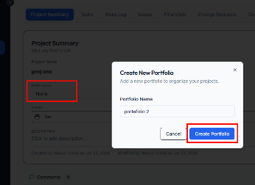
  - When creating a task on the task list page it doesn't refresh the page
  - When creating a project by converting an Intake
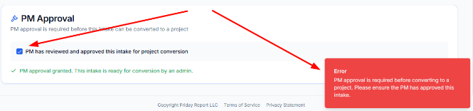
  - This buttons are non-functional
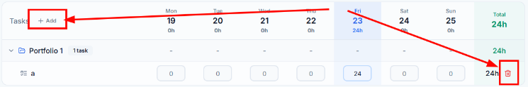
  - Portfolio
    - Add the ability to sort and filter
    - Issues
      - Add the ability to sort and filter
      - Rows should interactive, redirecting to the respective item
    - Risks
      - Add the ability to sort and filter
      - Rows should interactive, redirecting to the respective item
    - Projects
      - Add the ability to sort and filter
      - Rows should interactive redirecting to the respective item
  - Quick Add doesn't match the respective add function
  - Big names:
