波士顿房价分析
实验任务：
一、应用朴素贝叶斯分类器来解决这样一个分类问题：给出一个商场顾客数据库 (训练样本集合)，现有一测试实例x:(age<=30,income=medium,student=yes,credit ratings=fair),
问:这一实例是否会买电脑?
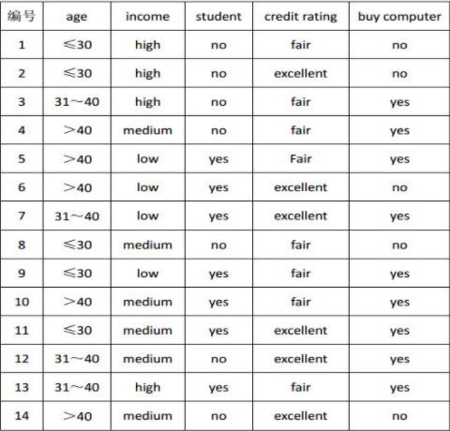
1、请编写程序计算
2、程序需要定义函数
import pandas as pd
from collections import defaultdict

# 定义训练数据
df = pd.read_csv('naive_bayes_data.csv')

# 定义测试实例
test_instance = {'age': '<=30', 'income': 'medium', 'student': 'yes', 'credit_rating': 'fair'}

# 朴素贝叶斯分类器实现
class NaiveBayesClassifier:
def __init__(self):
self.classes = None
self.prior = {}
self.conditional = defaultdict(lambda: defaultdict(dict))

def fit(self, data, target):
self.classes = data[target].unique()
total_count = len(data)

# 计算先验概率 P(C)
for cls in self.classes:
cls_count = len(data[data[target] == cls])
self.prior[cls] = cls_count / total_count

# 计算条件概率 P(X|C)
features = data.columns.drop(target)
for cls in self.classes:
cls_data = data[data[target] == cls]
cls_total = len(cls_data)
for feature in features:
feature_values = cls_data[feature].unique()
for value in data[feature].unique():
count = len(cls_data[cls_data[feature] == value])
# 使用拉普拉斯平滑
self.conditional[cls][feature][value] = (count + 1) / (cls_total + len(data[feature].unique()))

def predict(self, instance):
probabilities = {}
for cls in self.classes:
prob = self.prior[cls]
for feature, value in instance.items():
prob *= self.conditional[cls][feature].get(value, 1e-6) # 避免概率为0
probabilities[cls] = prob
# 返回概率最高的类别
return max(probabilities, key=probabilities.get), probabilities

# 训练模型
nb = NaiveBayesClassifier()
nb.fit(df, 'buy_computer')

# 预测测试实例
prediction, probs = nb.predict(test_instance)
print(f"预测结果: {prediction}")
print(f"各类别的后验概率: {probs}")


二、请分别使用ID3算法、C4.5算法构建下列数据的决策树
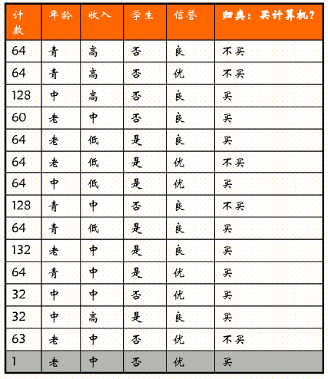
1、请编写程序计算，不能使用sklearn
2、请分析、对比2种算法的计算结果
3、最终结果需要可视化
import math
from collections import Counter
import matplotlib.pyplot as plt
import networkx as nx
plt.rcParams['font.sans-serif'] = ['SimHei'] #用来正常显示中文标签
plt.rcParams['axes.unicode_minus'] = False #用来正常显示负号
# 定义训练数据
df = pd.read_csv('decision_tree_data.csv')

# 计算熵
def entropy(data_subset):
total = sum(data_subset['count'])
counter = Counter()
for _, row in data_subset.iterrows():
counter[row['buy_computer']] += row['count']
ent = 0.0
for count in counter.values():
p = count / total
ent -= p * math.log2(p) if p > 0 else 0
return ent

# 计算信息增益
def info_gain(data_subset, feature):
total_entropy = entropy(data_subset)
values = data_subset[feature].unique()
total = sum(data_subset['count'])
feature_entropy = 0.0
for value in values:
subset = data_subset[data_subset[feature] == value]
weight = sum(subset['count']) / total
feature_entropy += weight * entropy(subset)
return total_entropy - feature_entropy

# 计算信息增益比
def gain_ratio(data_subset, feature):
ig = info_gain(data_subset, feature)
# 计算固有值
values = data_subset[feature].unique()
total = sum(data_subset['count'])
intrinsic = 0.0
for value in values:
subset = data_subset[data_subset[feature] == value]
p = sum(subset['count']) / total
intrinsic -= p * math.log2(p) if p > 0 else 0
return ig / intrinsic if intrinsic != 0 else 0

# ID3算法
def id3(data_subset, features, target='buy_computer'):
# 如果所有样本属于同一类别，返回该类别
classes = data_subset[target].unique()
if len(classes) == 1:
return classes[0]
# 如果没有特征可分割，返回出现次数最多的类别
if not features:
return data_subset[target].mode()[0]
# 选择信息增益最大的特征
gains = {feature: info_gain(data_subset, feature) for feature in features}
best_feature = max(gains, key=gains.get)
tree = {best_feature: {}}
for value in data_subset[best_feature].unique():
subset = data_subset[data_subset[best_feature] == value]
if subset.empty:
tree[best_feature][value] = data_subset[target].mode()[0]
else:
subtree = id3(subset, [f for f in features if f != best_feature], target)
tree[best_feature][value] = subtree
return tree

# C4.5算法
def c45(data_subset, features, target='buy_computer'):
# 如果所有样本属于同一类别，返回该类别
classes = data_subset[target].unique()
if len(classes) == 1:
return classes[0]
# 如果没有特征可分割，返回出现次数最多的类别
if not features:
return data_subset[target].mode()[0]
# 选择信息增益比最大的特征
gains = {feature: gain_ratio(data_subset, feature) for feature in features}
best_feature = max(gains, key=gains.get)
tree = {best_feature: {}}
for value in data_subset[best_feature].unique():
subset = data_subset[data_subset[best_feature] == value]
if subset.empty:
tree[best_feature][value] = data_subset[target].mode()[0]
else:
subtree = c45(subset, [f for f in features if f != best_feature], target)
tree[best_feature][value] = subtree
return tree

# 构建决策树
features = ['age', 'income', 'student', 'credit']
tree_id3 = id3(df, features)
tree_c45 = c45(df, features)

print("ID3 决策树:")
print(tree_id3)
print("\nC4.5 决策树:")
print(tree_c45)

def plot_tree(tree, title):
G = nx.DiGraph()
labels = {}
node_id = 0

def add_nodes_edges(tree, parent=None, edge_label=''):
nonlocal node_id
current_id = node_id
if isinstance(tree, dict):
for feature, branches in tree.items():
for value, subtree in branches.items():
node_id += 1
G.add_edge(current_id, node_id)
labels[node_id] = f"{feature}={value}"
add_nodes_edges(subtree, current_id, f"{feature}={value}")
else:
node_id += 1
G.add_edge(current_id, node_id)
labels[node_id] = f"Class: {tree}"

add_nodes_edges(tree)
pos = nx.spring_layout(G)
plt.figure(figsize=(12,8))
nx.draw(G, pos, with_labels=False, arrows=True)
for node, label in labels.items():
plt.text(pos[node][0], pos[node][1], label, fontsize=12)
plt.title(title)
plt.show()

# 可视化ID3决策树
plot_tree(tree_id3, "ID3 决策树")

# 可视化C4.5决策树
plot_tree(tree_c45, "C4.5 决策树")
代码结果：
ID3 决策树:
{'age': {'青': {'income': {'高': '不买', '中': '不买', '低': {'credit': {'良': '买', '优': '不买'}}}}, '中': '买', '老': {'credit': {'良': '买', '优': {'income': {'低': '不买', '中': {'student': {'否': '不买'}}}}}}}}

C4.5 决策树:
{'age': {'青': {'student': {'否': '不买', '是': {'credit': {'良': '买', '优': '不买'}}}}, '中': '买', '老': {'credit': {'良': '买', '优': {'income': {'低': '不买', '中': {'student': {'否': '不买'}}}}}}}}
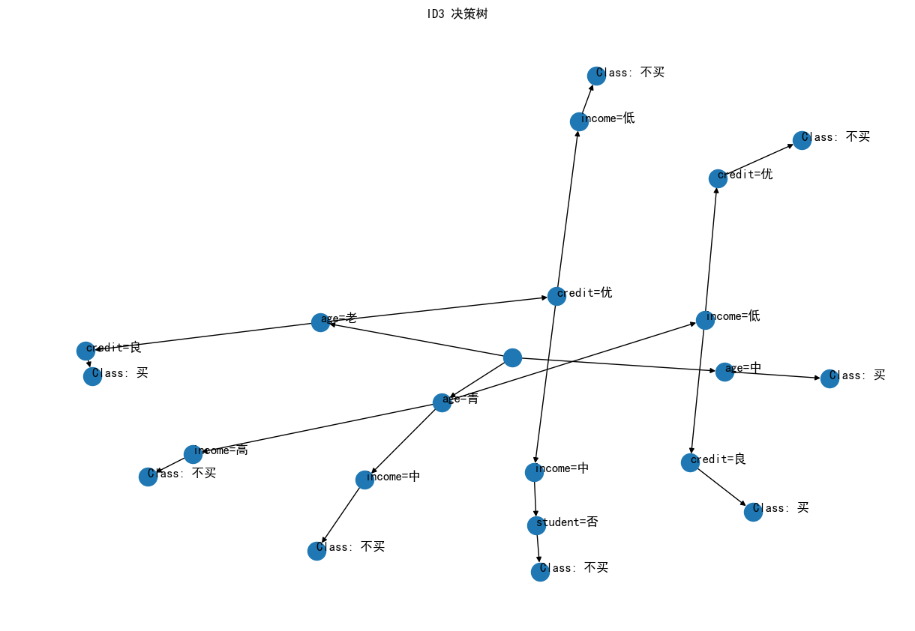
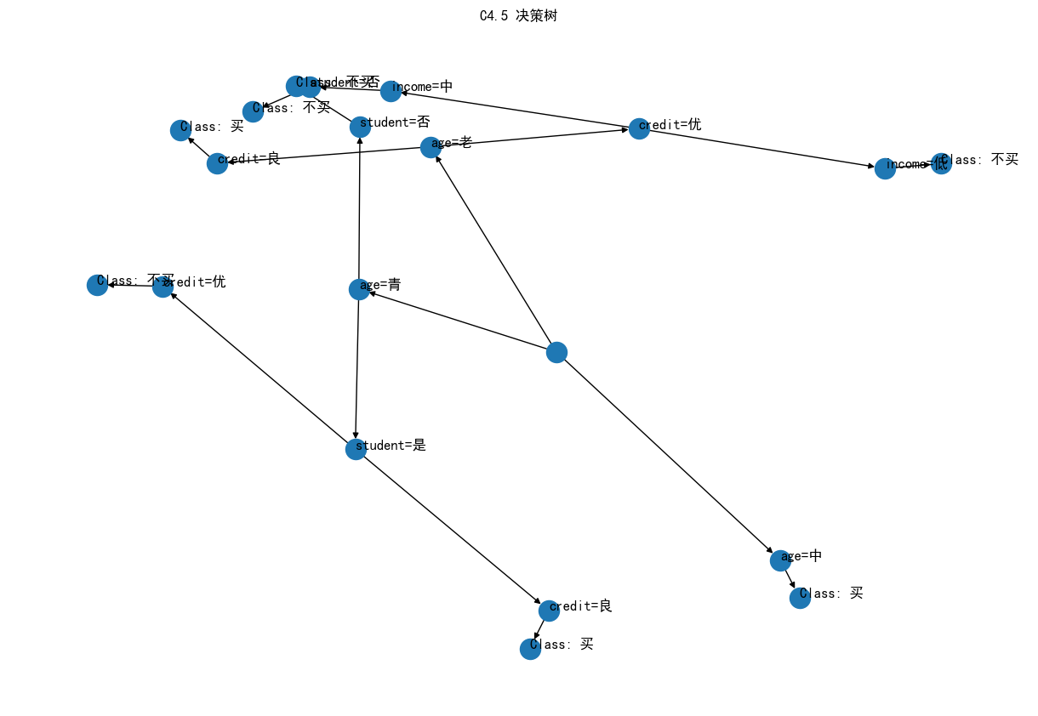
实验要求：
1、全文格式统一，格式占总成绩50%。
2、图文并茂。
3、关键代码要有详细注释。
4、抄袭者期末总成绩扣20分。

