

实 验 报 告

实验课程： | 网络游戏编程技术
实验项目： | 基础连接及通信
指导教师：
学生姓名:
学生学号：
班 级：
分 数：

2024 年 11 月 18 日
成都信息工程大学 计算机学院

问题描述
1.编写一个服务器，使用TCP协议监听10002号端口的客户端连接申请，并能将收到的某客户端传来的数据包转发给所有客户端。
2. 使用Unity创建一个客户端，并组织相应的UI元素，使该客户端可以：
1）连接1. 中编写的服务器；
2）可以编辑字符串，将该字符串转换为二进制串并发送给服务器；
3）可以接收服务器发来的二进制串，并将二进制串转换为字符串进行显示。

解决方案阐述
利用socket通信，实现服务端与 客户端的交互，利用回调函数和异步，实现消息之间的传递。

算法实现（即完整源程序，带注解）

服务端：

package socket;
import java.io.*;
import java.net.*;
import java.util.*;
public class ChatServer {
private static final int PORT = 10002;
private static final Set<ClientHandler> clientHandlers = new HashSet<>();
public static void main(String[] args) {
startServer();
listenForMessages();
}
public static void startServer() {
System.out.println("服务器启动，监听端口：" + PORT);
new Thread(() -> {
try (ServerSocket serverSocket = new ServerSocket(PORT)) {
while (true) {
Socket clientSocket = serverSocket.accept();
ClientHandler handler = new ClientHandler(clientSocket);
synchronized (clientHandlers) {
clientHandlers.add(handler);
System.out.println("客户端已添加，当前数量为" + clientHandlers.size());
}
handler.start();
}
} catch (IOException e) {
e.printStackTrace();
}
}).start();
}
public static void listenForMessages() {
new Thread(() -> {
try (Scanner scanner = new Scanner(System.in)) {
while (true) {
String message = scanner.nextLine();
sendMessageToAllClients(message);
}
}
}).start();
}
public static void sendMessageToAllClients(String message) {
synchronized (clientHandlers) {
System.out.println("当前连接的客户端数量: " + clientHandlers.size());
for (ClientHandler handler : clientHandlers) {
handler.sendMessage(message);
// 打印客户端信息
System.out.println("消息发送到客户端: " + handler.getId());
}
}
}
private static class ClientHandler extends Thread {
private Socket socket;
private PrintWriter out;
private BufferedReader in;
public ClientHandler(Socket socket) {
this.socket = socket;
System.out.println("新客户端连接: " + socket.getInetAddress().getHostAddress() + ":" + socket.getPort());
try {
in = new BufferedReader(new InputStreamReader(socket.getInputStream()));
out = new PrintWriter(socket.getOutputStream(), true);
} catch (IOException e) {
e.printStackTrace();
}
}
public void run() {
try {
String message;
while ((message = in.readLine()) != null) {
System.out.println("收到消息: " + message);
//这会把消息重新发送给客户端
// broadcast(message);
}
} catch (IOException e) {
e.printStackTrace();
} finally {
try {
synchronized (clientHandlers) {
clientHandlers.remove(this);
System.out.println("客户端数量为" + clientHandlers.size());
}
socket.close();
} catch (IOException e) {
e.printStackTrace();
}
}
}
public void sendMessage(String message) {
out.println(message);
}
private void broadcast(String message) {
synchronized (clientHandlers) {
for (ClientHandler handler : clientHandlers) {
handler.sendMessage(message);
}
}
}
}
}

客户端：

using System;

using System.Collections;

using System.Collections.Generic;

using System.IO;

using System.Net.Sockets;

using System.Text;

using TMPro;

using UnityEngine;

using UnityEngine.UI;

public class NetWork1 : MonoBehaviour

{

TMP_Text recvText;

TMP_InputField inputField;

Socket clientSocket;

byte[] recvBuff = new byte[1024];

string recvStr;

byte[] sendBuff;

NetworkStream networkStream;

StreamWriter writer;

StreamReader reader;

bool isConnected = false;

// Start is called before the first frame update

void Start()

{

recvText = GameObject.Find("Canvas/outputText").GetComponent<TMP_Text>();

inputField = GameObject.Find("Canvas/inputField").GetComponent<TMP_InputField>(); // 获取 InputField 组件

Debug.Log(inputField);

Debug.Log(recvText);

}

public void ButtonClicked()

{

clientSocket = new Socket(AddressFamily.InterNetwork, SocketType.Stream, ProtocolType.Tcp);

try

{

clientSocket.Connect("localhost", 10002);

networkStream = new NetworkStream(clientSocket);

writer = new StreamWriter(networkStream, Encoding.UTF8);

reader = new StreamReader(networkStream, Encoding.UTF8);

isConnected = true;

StartCoroutine(ReceiveData());

}

catch (System.Exception)

{

throw;

}

}

public void SendBtnClicked()

{

if (isConnected && writer != null) {

try

{

string sendStr = inputField.text;

writer.WriteLine(sendStr);

writer.Flush();

Debug.Log("发送消息" + sendStr);

}

catch (Exception e)

{

Debug.Log("消息发送失败" + e.Message);

}

}

}

private IEnumerator ReceiveData()

{

while (isConnected)

{

if (networkStream.DataAvailable)

{

try

{

recvStr = reader.ReadLine();

if (!string.IsNullOrEmpty(recvStr))

{

recvText.text = recvStr;

Debug.Log("收到服务器消息: " + recvStr);

}

}

catch (Exception e)

{

Debug.LogError("接收消息失败: " + e.Message);

isConnected = false;

}

}

yield return null;

}

}

// Update is called once per frame

void Update()

{

}

}

实验结果测试与分析
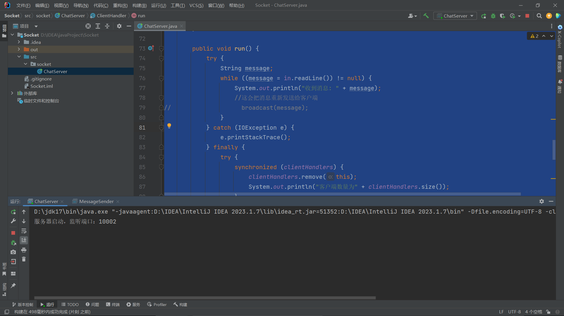
客户端与服务端连接：
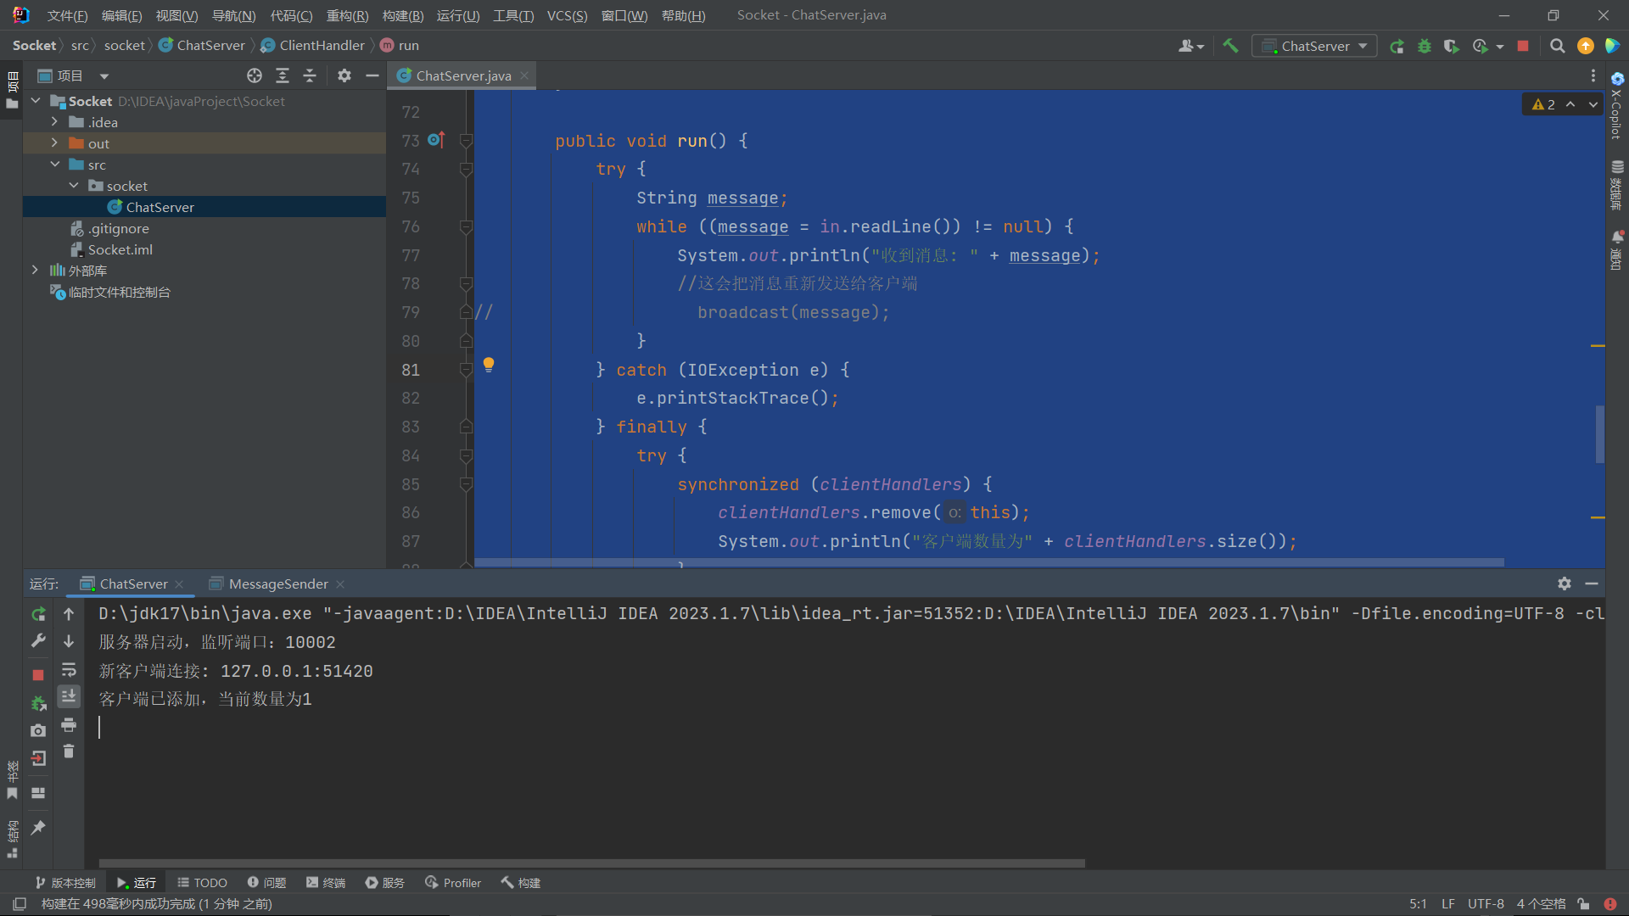
客户端收到服务端传的信息：
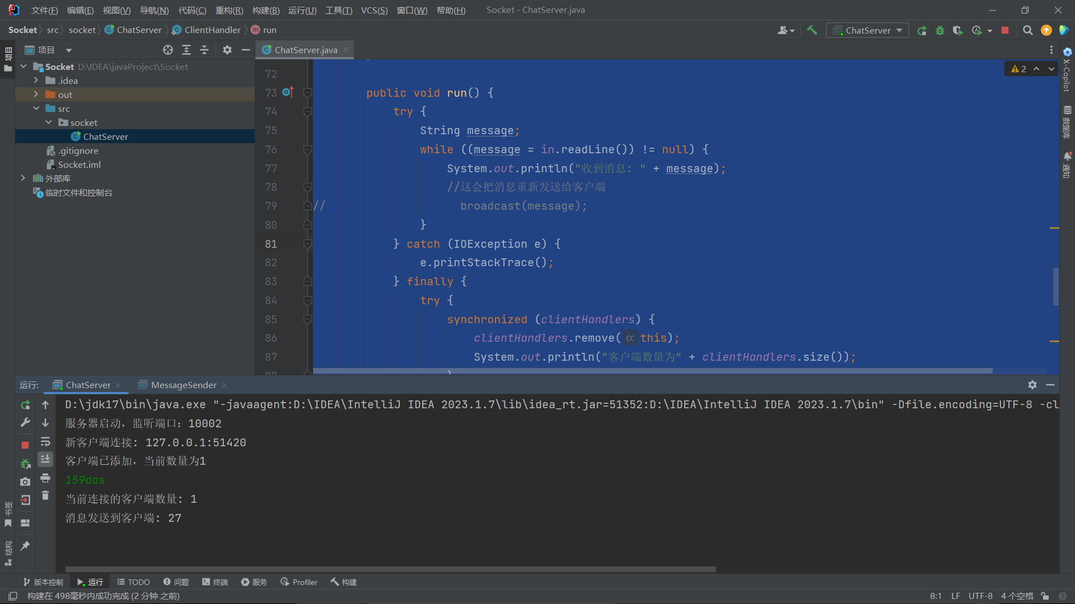

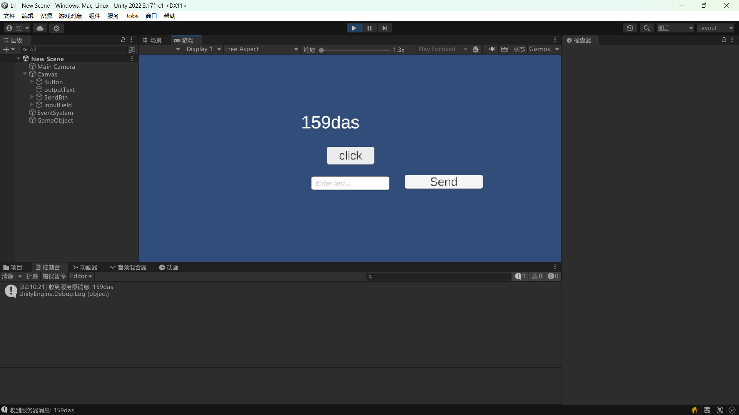
服务端收到客户端传的信息并转发回客户端：
