知识点课堂练习

(1) A 256*256 gray level image has 256 different gray levels. It will take __________ bits to store.
(2) We can use___________(Lowpass filter / Highpass filter) to smooth the image.
(3) Considering the following figure, compute the City-block distance between two black pixels:
(4) List two typical image noise: and salt and pepper noise.

(1) 256*256*8=512k;
(2) lowpass
(3) 6
(4) Gaussian noise

- Give an intensity transformation function for spreading the intensities of an image so that the range is from (0, 20) to (0, 30) , from (20, 30) to (30, 50) , from (30, 60) to (50, 60) and plot the function. (8%)

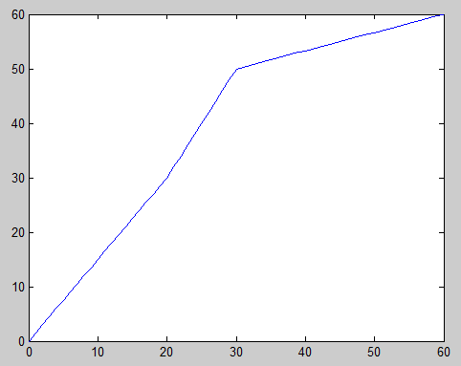

- The original image as following:
6 | 11
9 | 5
If we enlarge the image [2*2] times with nearest neighbor interpolation Algorithm

6 | 6 | 11 | 11
6 | 6 | 11 | 11
9 | 9 | 5 | 5
9 | 9 | 5 | 5

- The original image are shown as Fig.1 ,
7 | 1 | 7 | 3
0 | 0 | 5 | 5
1 | 2 | 4 | 0
2 | 2 | 2 | 7
Fig.1 the original image
If the output image is the result of a 3 × 3 median filter shown as Fig.2, please
complete the blanks of Fig.2 .

* | * | * | *
* | 2 | 3 | *
* | 2 | 2 | *
* | * | * | *

