1. True of False
(1) Ideal lowpass filter passes without attenuation all frequencies within a circle of radius $D_{0}$ from the origin and “cut off” all frequencies outside this circle. ( T )
(2) Image enhancement is an objective process and its results can be quantitative. ( F )
(3) For the image restoration, if we know the degradation function, we can recover the undegraded image exactly. ( T )
(4) A mean filter smooths local variations in an image, and noise is reduced as a result of blurring. ( T )
(5) Because the Laplacian is a derivative operator, it highlights sharp intensity transitions in an image. ( T )
(6) The low frequency components correspond to edges or abrupt intensity changes of objects in the image. ( F )
(7) The Otsu’s method is optimum in the sense that it maximizes the between-class variance. ( T )
(8) Hough transform can be used to detect straight lines. ( T )

- Outline the basic steps of basic global thresholding segmentation algorithm (iterative algorithm) for two classes.
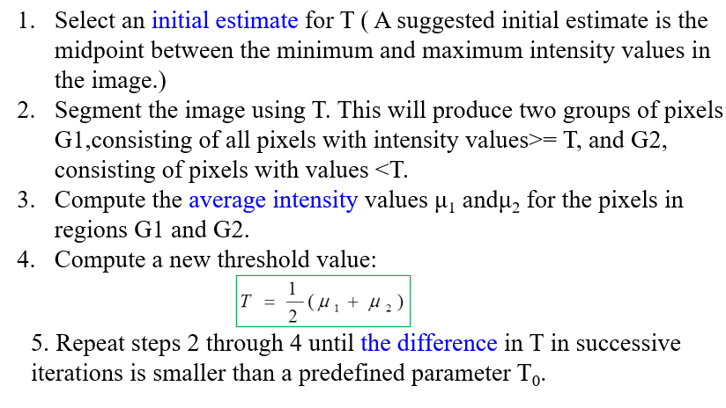
- If we use nearest neighbor interpolation and bilinear interpolation respectively to get the value of new pixels, please give the values of the points of P1 and P2(both methods).
Nearest neighbor interpolation: P1=12 ,P2=36; (4%)
bilinear interpolation:
P1=14 (3%)
P2=28 (3%)

- Please write out the basic step of region growing algorithm.
Step 1: Seeding
Step 2: Selection of similarity criteria
Step3: Stopping rule
No more pixels satisfy the criteria and the prior knowledge such as concept of size and the shape of the region.

5. The three images shown as Fig. 3 are an original image, a weighted average filter and the output image which is the result of smoothing with the filter in Fig.3(b).
(1) Please complete the gap of Fig.3(c) .
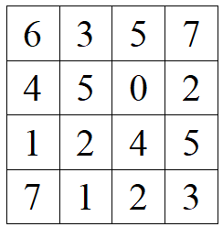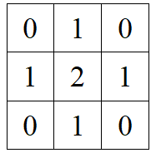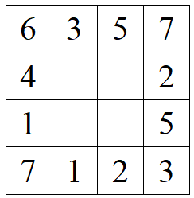
(a) (b) (c)
Figure 3
(2) If the output image is the result of a 3 × 3 median filter, please complete the gap of Fig.4 .
Figure 4
- (5%)
6 | 3 | 5 | 7
4 | 19 | 16 | 2
1 | 15 | 17 | 5
7 | 1 | 2 | 3
- (5%)
6 | 3 | 5 | 7
4 | 4 | 4 | 2
1 | 2 | 2 | 5
7 | 1 | 2 | 3

6. The Prewitt operator $\left[\begin{matrix}-1 & 0 & 1 \\ -1 & 0 & 1 \\ -1 & 0 & 1\end{matrix}\right]$and the Sobel operator $\left[\begin{matrix}-1 & 0 & 1 \\ -2 & 0 & 2 \\ -1 & 0 & 1\end{matrix}\right]$are the first order operators.
(1) If these two operators are used to detect lines in an image, lines in which direction can be detected by the two operators respectively?
First template: Vertical direction
Second template: Vertical direction
(2) Please write out one example of the second order operator.
Eg. $\left[\begin{matrix}0 & 1 & 0 \\ 1 & -4 & 1 \\ 0 & 1 & 0\end{matrix}\right]$ Laplacian

- Dilation is one of the basic operation of the morphological image processing, do the dilation processing to the following image.

(a) Original image （b）Structure Element ( Larger Black dot denotes origin)

Result:
8.
(a) Explain the mean of line3.
(b) Explain the mean of line 11.
(c) Explain the mean of line 12.
(d) Explain the function of these codes.

1 Im=imread(‘lena.tif’);
2 Im=im2double(Im)
3 Threshold=mean2(Im);
4 sign=1;
5 while sign
6 seg=Im> Threshold;
7 Threshold_new=0.5*(mean(Im(seg))+mean(Im(~seg)));
8 sign=abs(Threshold_new-Threshold)<0.005;
9 Threshold=Threshold_new;
10 end
11 bwim=im2bw(Im,Threshold_new);
12 imshow(bwim);

(a) Get the mean of Im
(b) Segment the image of Im by the threshold of Threshold.
(c) Show the output binary image.
(d) Implement the Basic Global Thresholding

9.
There is a MATLAB code, please explain the meaning of line 1 and 5.
I=imread('Lena.tif'); ___________Read an image____________________.
I=rgb2gray(I);
I=im2double(I);
subplot(1,2,1),imshow(I);
F=fft2(I); _Implement two-dimensional Discrete Fourier Transform (2D-DFT)__________
F=fftshift(F);
Fm=abs(F);
T=log(Fm+1);
subplot(1,2,2),imshow(T,[]);

