Updating indicators for DG INTPA
(November 2025)

Contents
Summary 2
Overall objective – Impact 1 | 1. Proportion of forest area under long-term management plan (ha) 3
Overall objective – Impact 1 | 2. Area of natural ecosystems reported in protected area or other effective conservation measures (%) 4
Specific objective – Outcome 1 | 1. Proportion of forest area in data-reliability tier 3 8
References 10

Summary

The table below presents a summary of the information to update the target indicators. Further details on the computation methods are described in the subsequent sections.
Target | Value | Last update | Source
Proportion of forest area under long-term management plan (ha) | 2,129,285,000 ha | 2025 | FAO Forest Resource Assessment 2025
Area of natural ecosystems reported in protected area or other effective conservation measures (%) | 19.04% | 2025 | Computed using WDPA-WDOECM Jan-2025 and ESA LC 2022
Proportion of forest area in data-reliability tier 3 | 52% | 2025 | FAO Forest Resource Assessment 2025

Overall objective – Impact 1 | 1. Proportion of forest area under long-term management plan (ha)

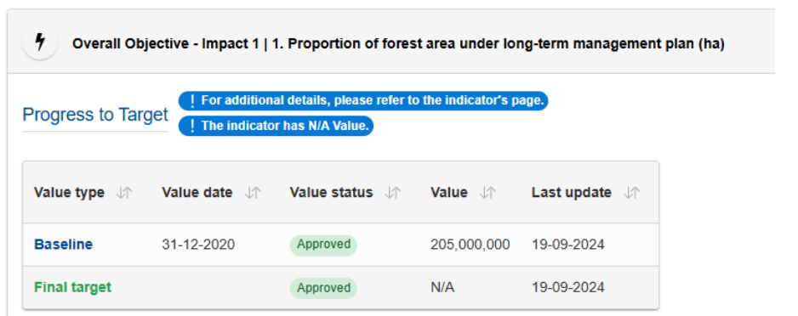
The baseline value of 2,049,817,000 ha (wrongly rounded to 205,000,000) is extracted from FAO Forest Resource Assessment (FRA) 2020 (FAO, 2020) - Table 63, pag. 73.
The same indicator is reported in FAO FRA 2025 (FAO, 2025) - Table 74, pag.88 - as follows:
Forest area with long-term management plans, by region and subregion, 2025
World: 2,129,285,000 ha

Overall objective – Impact 1 | 2. Area of natural ecosystems reported in protected area or other effective conservation measures (%)

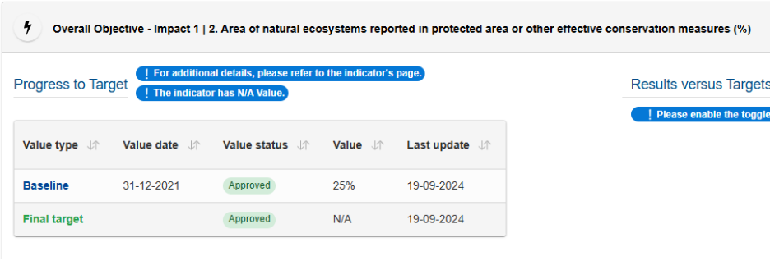
Following UNEP-WCMC & UNDP (2024), robust for Juffe-Bignoli et al. (2024), assuming that the ~25 % value is a baseline estimate (not a measured one), it is proposed to calculate the indicator by spatially intersecting the following geographic datasets: the World Database on Protected Areas (WDPA) together with the World Database on Other Effective Area-Based Conservation Measures (WD-OECM) + Land Cover (LC) classes attributable to Natural Ecosystems. These datasets are already processed by the Global Biodiversity Data Viewer (GBDV) from the Knowledge Centre for Biodiversity (KCBD).
As for the first dataset, UNEP-WCMC & IUCN (2025) was used, which integrates both WDPA and OECM.
For the second dataset, the following are available:
Land Cover Datasets
Product | Spatial resolution | Temporal coverage | Number of classes
Copernicus Global Land Cover 10m (Copernicus Land Monitoring Service (CLMS), 2021) | 10 m | 2020 (global) | 11
Copernicus Global Land Cover 100m - Copernicus Global Land Service — Land Cover 100 m, Collection 3 (2015–2019) (Buchhorn et al., 2020) | 100 m | 2015–2019 (annual) | 23
ESA CCI Land Cover 300 m (Copernicus Climate Change Service (C3S), 2023) | ~300 m | 1992–2022 (annual) | 22

Preference was given to the 300 m CCI Land Cover dataset because it provides annual global coverage over a 30-year period (1992–2022), allowing a long-term temporal perspective on the extent of natural ecosystems. Shorter-term or single-year products (10 m, 100 m) do not allow this temporal perspective and cannot capture historical baselines or trends. Both the 100 m and 300 m datasets are already integrated into the GBDV, while the 10 m dataset would require a new import and processing. Although 10 m increases spatial resolution, it does not improve temporal coverage or thematic richness (number of classes) compared with the 100 m and 300 m products. The 300 m dataset remains globally consistent, sufficiently detailed to separate natural ecosystems from cropland and artificial areas and fully documented for the Kunming-Montreal Global Biodiversity Framework (GBF) indicator reporting.
In LC 300 m, classes attributable to Natural Ecosystem could be (in green):
lc_code | lc_class | is_natural
0 | "No data" | false
10 | "Cropland, rainfed" | false
11 | "Herbaceous cover" | false
12 | "Tree or shrub cover" | false
20 | "Cropland, irrigated or post-flooding" | false
30 | "Mosaic cropland (>50%) / natural vegetation (tree, shrub, herbaceous cover) (<50%)" | false
40 | "Mosaic natural vegetation (tree, shrub, herbaceous cover) (>50%) / cropland (<50%) " | true
50 | "Tree cover, broadleaved, evergreen, closed to open (>15%)" | true
60 | "Tree cover, broadleaved, deciduous, closed to open (>15%)" | true
61 | "Tree cover, broadleaved, deciduous, closed (>40%)" | true
62 | "Tree cover, broadleaved, deciduous, open (15-40%)" | true
70 | "Tree cover, needleleaved, evergreen, closed to open (>15%)" | true
71 | "Tree cover, needleleaved, evergreen, closed (>40%)" | true
72 | "Tree cover, needleleaved, evergreen, open (15-40%)" | true
80 | "Tree cover, needleleaved, deciduous, closed to open (>15%)" | true
81 | "Tree cover, needleleaved, deciduous, closed (>40%)" | true
82 | "Tree cover, needleleaved, deciduous, open (15-40%)" | true
90 | "Tree cover, mixed leaf type (broadleaved and needleleaved)" | true
100 | "Mosaic tree and shrub (>50%) / herbaceous cover (<50%)" | true
110 | "Mosaic herbaceous cover (>50%) / tree and shrub (<50%)" | true
120 | "Shrubland" | true
121 | "Shrubland evergreen" | true
122 | "Shrubland deciduous" | true
130 | "Grassland" | true
140 | "Lichens and mosses" | true
150 | "Sparse vegetation (tree, shrub, herbaceous cover) (<15%)" | true
151 | "Sparse tree (<15%)" | true
152 | "Sparse shrub (<15%)" | true
153 | "Sparse herbaceous cover (<15%)" | true
160 | "Tree cover, flooded, fresh or brakish water" | true
170 | "Tree cover, flooded, saline water" | true
180 | "Shrub or herbaceous cover, flooded, fresh/saline/brakish water" | true
190 | "Urban areas" | false
200 | "Bare areas" | false
201 | "Consolidated bare areas" | false
202 | "Unconsolidated bare areas" | false
210 | "Water bodies" | false
220 | "Permanent snow and ice" | true

According to Biodiversity Indicators Partnership (2024) and IUCN Global Ecosystems Typology (2024), LC class 210 (Water Bodies) should be excluded by default, with only exceptions included (areas that are non-intensively modified and natural-dominated). However, the LC ESA mapping does not distinguish freshwater from coastal/marine waters, nor anthropogenic from natural water bodies, making it impossible to directly apply these exceptions.

Calculation of Land-based Natural Ecosystems Indicators (1995–2020)

- Land and Protected Areas Index
  - Built land index (all land) and land index_prot (land protected areas) from:

    - the 2020 country land (GISCO) and 20251 protected and conserved areas (WDPA+OECM) datasets
    - The 2021 country land (GAUL) and 202101 protected and conserved areas (WDPA+OECM)
These tables define the total land area per country and the total protected area.
- Crosswalk of Land Cover to Natural Ecosystems

  - Used ESA / Copernicus CCI Land Cover 300 m data for 2015 and 2022.
  - Applied a predefined crosswalk (lc_ne) to identify “natural” land cover classes. Water bodies (class 210) are excluded by default, following BIP 2024 and GET 2024 guidance.
- Calculation of Land Ecosystem Extent
- For each epoch, summed the areas of each LC class within the land index to produce country-level NE extent (land_ne_sqkm_*), combining:
    - 2021 country/protection with 2015 Land Cover
    - 2025 country/protection with 2022 Land Cover.
- Derived percentages relative to total land and relative to protected areas.
- Protected Natural Ecosystems
- Intersected NE areas with the protected area index to compute land_ne_prot_sqkm_* and corresponding percentages.
- Aggregation Across Countries
- Summed country-level values to obtain global totals.
According to the calculations, the area of natural ecosystems covered by protected and conserved areas is 19.04 % globally. The results (by country and global) are reported in the attached table AM_20251104_natural_ecosystems.xlsx.
The SQL code used is in the attached AM_20251104_natural_ecosystems_2015.sql, AM_20251104_natural_ecosystems_2022.sql.

Specific objective – Outcome 1 | 1. Proportion of forest area in data-reliability tier 3

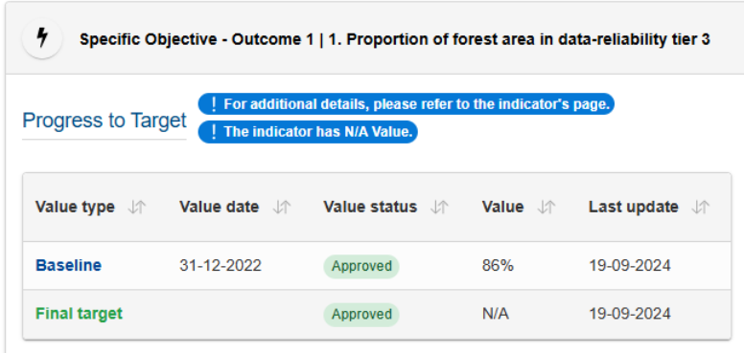
FAO Forest Resource assessments for 2020 and 2025 use two different indicators for Forest Area, namely Status and Trend. Classes are named and defined differently in the two assessments, as shown in the table below.
Indicator | FAO FRA 2020 | FAO FRA 2025
Forest Area Status | Tier 3: Data from 2013 or more recent Source: national forest inventories (NFIs), remote sensing surveys or wall-to-wall mapping | Tier High: Data sources recent – i.e. data not older than 5 years from year of submission of report (2023) for FAO Global Forest Resources Assessment (FRA) 2025 country reports. Data obtained from national forest inventory or remote sensing (sample-based survey or wall-to-wall mapping) with accuracy assessment/field data calibration
Forest Area Trend | Tier 3: Multiple sets of consistent data (in terms of methods and classes), 2013 or more recent, including change estimates from (e.g.) REDD+ forest reference (emission) levels | Tier High: Estimates based on repeated compatible (i.e. in terms of methods, categories and definitions used) national forest inventories, the most recent of which is not older than 5 years; and/or remote-sensing change assessments conducted using multitemporal analysis for a period ending not more than 5 years ago (e.g. REDD+ forest reference [emission] levels)

Additionally, in FRA 2020 tiers were assessed by the Center for International Forestry Research (CIFOR) and Wageningen University, while tiers were self-assessed by countries in FRA 2025.
The baseline value of 86% is extracted from FAO Forest Resource Assessment 2020 as the Forest Area Trend indicator for 2020 (Table 87, pag. 121), so it refers to Forest Area Trend indicator of the mentioned table.
For the FAO FRA 2025 the Forest Area Trend is 52%, and the Forest Area Statues is 75%.

References

Biodiversity Indicators Partnership (2024, September 1). A.2 Extent of natural ecosystems — Metadata factsheet. Retrieved from https://gbf-indicators.org/metadata/headline/A-2
Buchhorn, M., Lesiv, M., Tsendbazar, N.-E., Herold, M., Bertels, L., & Smets, B. (2020). Copernicus Global Land Service: Land Cover 100 m — Collection 3: Epoch 2019: Globe (Version 3.0) [Data set]. Copernicus Land Monitoring Service / European Environment Agency. https://land.copernicus.eu/en/products/global-dynamic-land-cover/copernicus-global-land-service-land-cover-100m-collection-3-epoch-2019-globe . https://doi.org/10.5281/zenodo.3938963
Copernicus Climate Change Service (C3S) (2023). Copernicus Climate Change Service (C3S) Land Cover CCI v2.1.1 time series (1992–2022) [Data set]. European Centre for Medium-Range Weather Forecasts (ECMWF) on behalf of the European Commission. https://cds.climate.copernicus.eu/datasets/satellite-land-cover
Copernicus Land Monitoring Service (CLMS) (2021). Copernicus WorldCover 2020 v100 [Data set]. European Space Agency (ESA) for the European Commission. https://esa-worldcover.org/en/data-access
FAO (2020). Global Forest Resources Assessment 2020: Main report. Rome. https://doi.org/10.4060/ca9825en
FAO (2025). Global Forest Resources Assessment 2025. Rome. https://doi.org/10.4060/cd6709en
IUCN Global Ecosystems Typology (2024). GlobalEcosystems.org. Retrieved from https://globalecosystems.org//
Juffe-Bignoli, D., Mandrici, A., Delli, G., Niamir, A., & Dubois, G. (2024). Delivering Systematic and Repeatable Area-Based Conservation Assessments: From Global to Local Scales. Land, 13(9), 1506. https://doi.org/10.3390/land13091506
UNEP-WCMC & IUCN (2025). World Database on Protected Areas (WDPA) and World Database on Other Effective Area-Based Conservation Measures (WD-OECM), version 202501 [Data set]. UNEP-WCMC & IUCN, Cambridge, UK. https://www.protectedplanet.net/en/thematic-areas/wdpa-oecm
UNEP-WCMC & UNDP (2024). Using Spatial Data to Support the Development of Plans for National Monitoring Systems for the Kunming-Montreal Global Biodiversity Framework. Cambridge, UK: UN Environment Programme World Conservation Monitoring Centre & United Nations Development Programme. ISBN 978-92-807-4051-5. Available at: https://unbiodiversitylab.org/wp-content/uploads/2024/05/ENG_Guidance-Using-Spatial-Data-to-Support-GBF.pdf

