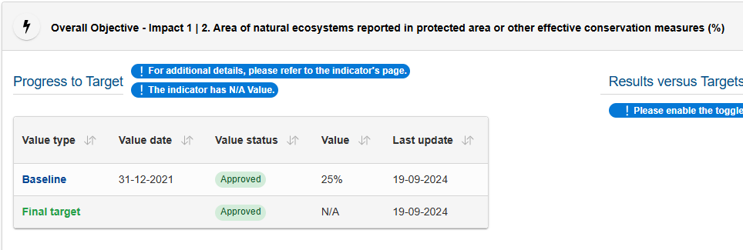
Overall Objective-Impact 1 12. Area of natural ecosystems reported in protected area or other effective conservation measures (%)
Following UNEP-WCMC & UNDP (2024), robust for Juffe-Bignoli et al. (2024), assuming that the ~25 % value is a baseline estimate (not a measured one), I propose to calculate the indicator by spatially intersecting the following geographic datasets (already processed by the KCBD-GBD): WDPA-OECM + Land Cover classes attributable to Natural Ecosystems.
As for the first dataset, we use UNEP-WCMC & IUCN. (2025), which integrates both WDPA and OECM.
For the second dataset, the following are available:
Land Cover Datasets
Product | Spatial resolution | Temporal coverage | Number of classes
Copernicus Global Land Cover 10m - Copernicus Land Monitoring Service (CLMS). (2021) | 10 m | 2020 (global) | 11
Copernicus Global Land Cover 100m - Copernicus Global Land Service — Land Cover 100 m, Collection 3 (2015–2019) | 100 m | 2015–2019 (annual) | 23
ESA CCI Land Cover 300 m - Copernicus Climate Change Service (C3S). (2023). | ~300 m | 1992–2022 (annual) | 22

I prefer the 300 m CCI Land Cover dataset because it provides annual global coverage over a 30-year period (1992–2022), allowing a long-term temporal perspective on the extent of natural ecosystems. Shorter-term or single-year products (10 m, 100 m) do not allow this temporal perspective and cannot capture historical baselines or trends. Both the 100 m and 300 m datasets are already integrated into KCBD-GBD, while the 10 m dataset would require a new import and processing. Although 10 m increases spatial resolution, it does not improve temporal coverage or thematic richness (number of classes) compared with the 100 m and 300 m products. The 300 m dataset remains globally consistent, sufficiently detailed to separate natural ecosystems from cropland and artificial areas, and fully documented for GBF indicator reporting.
In LC 300 m, classes attributable to Natural Ecosystem could be:
lc_code | lc_class | is_natural
0 | "No data" | false
10 | "Cropland, rainfed" | false
11 | "Herbaceous cover" | false
12 | "Tree or shrub cover" | false
20 | "Cropland, irrigated or post-flooding" | false
30 | "Mosaic cropland (>50%) / natural vegetation (tree, shrub, herbaceous cover) (<50%)" | false
40 | "Mosaic natural vegetation (tree, shrub, herbaceous cover) (>50%) / cropland (<50%) " | true
50 | "Tree cover, broadleaved, evergreen, closed to open (>15%)" | true
60 | "Tree cover, broadleaved, deciduous, closed to open (>15%)" | true
61 | "Tree cover, broadleaved, deciduous, closed (>40%)" | true
62 | "Tree cover, broadleaved, deciduous, open (15-40%)" | true
70 | "Tree cover, needleleaved, evergreen, closed to open (>15%)" | true
71 | "Tree cover, needleleaved, evergreen, closed (>40%)" | true
72 | "Tree cover, needleleaved, evergreen, open (15-40%)" | true
80 | "Tree cover, needleleaved, deciduous, closed to open (>15%)" | true
81 | "Tree cover, needleleaved, deciduous, closed (>40%)" | true
82 | "Tree cover, needleleaved, deciduous, open (15-40%)" | true
90 | "Tree cover, mixed leaf type (broadleaved and needleleaved)" | true
100 | "Mosaic tree and shrub (>50%) / herbaceous cover (<50%)" | true
110 | "Mosaic herbaceous cover (>50%) / tree and shrub (<50%)" | true
120 | "Shrubland" | true
121 | "Shrubland evergreen" | true
122 | "Shrubland deciduous" | true
130 | "Grassland" | true
140 | "Lichens and mosses" | true
150 | "Sparse vegetation (tree, shrub, herbaceous cover) (<15%)" | true
151 | "Sparse tree (<15%)" | true
152 | "Sparse shrub (<15%)" | true
153 | "Sparse herbaceous cover (<15%)" | true
160 | "Tree cover, flooded, fresh or brakish water" | true
170 | "Tree cover, flooded, saline water" | true
180 | "Shrub or herbaceous cover, flooded, fresh/saline/brakish water" | true
190 | "Urban areas" | false
200 | "Bare areas" | false
201 | "Consolidated bare areas" | false
202 | "Unconsolidated bare areas" | false
210 | "Water bodies" | false
220 | "Permanent snow and ice" | true

According to BIP (2024) and GET (2024), LC class 210 (Water Bodies) should be excluded by default, with only exceptions included (areas that are non-intensively modified and natural-dominated). However, the LC ESA mapping does not distinguish freshwater from coastal/marine waters, nor anthropogenic from natural water bodies, making it impossible to directly apply these exceptions.

Calculation of Land-based Natural Ecosystems Indicators (2015 and 2022)

- Land and Protected Areas Index
  - Built land index (all land) and land index_prot (land protected areas) from:
    - the 2020 country land (GISCO) and 20251 protected areas (WDPA+OECM) datasets
    - The 2021 country land (GAUL) and 202101 protected areas (WDPA+OECM)
These tables define the total land area per country and the total protected area.
- Crosswalk of Land Cover to Natural Ecosystems
  - Used ESA / Copernicus CCI Land Cover 300 m data for 2015 and 2022.
  - Applied a predefined crosswalk (lc_ne) to identify “natural” land cover classes. Water bodies (class 210) are excluded by default, following BIP 2024 and GET 2024 guidance.
- Calculation of Land Ecosystem Extent
  - For each epoch, summed the areas of each LC class within the land index to produce country-level NE extent (land_ne_sqkm_*), combining:
    - 2021 country/protection with 2015 Land Cover
    - 2025 country/protection with 2022 Land Cover.
  - Derived percentages relative to total land and relative to protected areas.
- Protected Natural Ecosystems
  - Intersected NE areas with the protected area index to compute land_ne_prot_sqkm_* and corresponding percentages.
- Aggregation Across Countries
  - Summed country-level values to obtain global totals.

The results (by country and global) are reported in the table AM_20251104_natural_ecosystems.xlsx.
The SQL code used is in AM_20251104_natural_ecosystems_2015.sql, AM_20251104_natural_ecosystems_2022.sql.
References
- UNEP-WCMC & UNDP (2024). Using Spatial Data to Support the Development of Plans for National Monitoring Systems for the Kunming-Montreal Global Biodiversity Framework. Cambridge, UK: UN Environment Programme World Conservation Monitoring Centre & United Nations Development Programme. ISBN 978-92-807-4051-5. Available at: https://unbiodiversitylab.org/wp-content/uploads/2024/05/ENG_Guidance-Using-Spatial-Data-to-Support-GBF.pdf
- Juffe-Bignoli, D., Mandrici, A., Delli, G., Niamir, A., & Dubois, G. (2024).
Delivering Systematic and Repeatable Area-Based Conservation Assessments: From Global to Local Scales. Land, 13(9), 1506. https://doi.org/10.3390/land13091506
- WDPA + WD-OECM (version 202501)
UNEP-WCMC & IUCN. (2025). World Database on Protected Areas (WDPA) and World Database on Other Effective Area-Based Conservation Measures (WD-OECM), version 202501 [Data set]. UNEP-WCMC & IUCN, Cambridge, UK.
https://www.protectedplanet.net/en/thematic-areas/wdpa-oecm
- Copernicus WorldCover 2020 (10 m)
Copernicus Land Monitoring Service (CLMS). (2021). Copernicus WorldCover 2020 v100 [Data set]. European Space Agency (ESA) for the European Commission.
https://esa-worldcover.org/en/data-access
- Copernicus Global Land Service — Land Cover 100 m, Collection 3 (2015–2019)
Buchhorn, M., Lesiv, M., Tsendbazar, N.-E., Herold, M., Bertels, L., & Smets, B. (2020). Copernicus Global Land Service: Land Cover 100 m — Collection 3: Epoch 2019: Globe (Version 3.0) [Data set].
Copernicus Land Monitoring Service / European Environment Agency.
https://land.copernicus.eu/en/products/global-dynamic-land-cover/copernicus-global-land-service-land-cover-100m-collection-3-epoch-2019-globe
https://doi.org/10.5281/zenodo.3938963
- Copernicus Climate Change Service (C3S) — Land Cover CCI v2.1.1 (300 m, 1992–2022)
Copernicus Climate Change Service (C3S). (2023). Copernicus Climate Change Service (C3S) Land Cover CCI v2.1.1 time series (1992–2022) [Data set]. European Centre for Medium-Range Weather Forecasts (ECMWF) on behalf of the European Commission.
https://cds.climate.copernicus.eu/datasets/satellite-land-cover
- Biodiversity Indicators Partnership (BIP; 2024, September 1). A.2 Extent of natural ecosystems — Metadata factsheet. Retrieved from https://gbf-indicators.org/metadata/headline/A-2
- IUCN Global Ecosystems Typology (2024). Global-Ecosystems.org. Retrieved from https://global-ecosystems.org//

