Goal: Create an ABM to simulate population monitoring through camera trapping

Results: Somewhat of a backbone that still needs milk to grow

Question 1: Could individuals be assigned an ID, placed on a landscape and find their initial x and y locations?

Yes, table in output folder as initialpoploc.csv

After cameras were placed on landscape, we ran a code that seems to allow us to find the same place on the landscape where both camera and individual are found in the same cell, thus considered "captured".

Question 2: Were individuals able to be "captured" by the cameras?

This plot is meant to give the x location and y locations in which individuals and cameras were in the same cell. (Code needs tweaking).

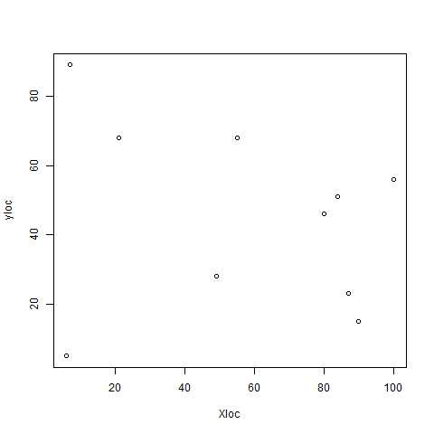

Figure 1: Locations were individuals and cameras were present in the same location on the landscape.

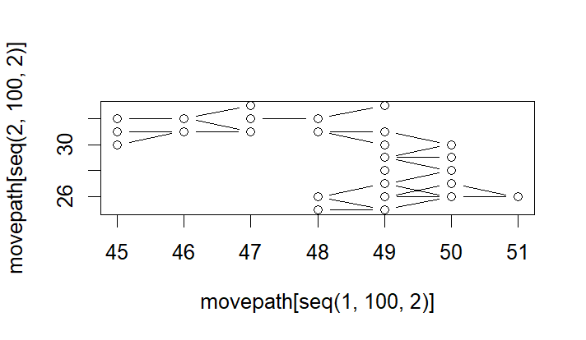

This figure depicts movement of an individual on a landscape although seems to not be correct because it looks funky.

Model results: We were able to ID individuals, find their initial location, and find their locations after completing 50 steps. We were also able to find camera locations. See output folder for tables. Tracking individuals was difficult to code. The code that meant to match the location of the cameras with the location of the individuals seemed to not be doing what we intended. Next step is to find an R package that can help with this step.