HDSDAJAN19A

**National College of Ireland**

Andrea Mussap, 9999

Fabio Mussap, 999

James Hedderman, 999

Lucas Morato, 999

DATA VISUALISATION

Continuous assessment – CA1

Table of Contents

Introduction 2

Scope of this project 2

Exploratory Data Analysis 3

Problem definition 3

Data Preparation 3

Implementation of the analysis 3

Deployment of the analysis 3

About the Dataset 3

Interactive Visualisation 5

Objective 5

Theme 6

Visualisations 7

1. Sales by region of origin 7

2. Sales by grape variety 9

3. Sales per Month 10

4. Sales by Occupation (Top 10) 11

5. Sales by Age group 12

Dashboard 13

General visualisations 14

Outliers 14

Infographic 16

References 17

Appendix 18

Dataset 18

Metadata 18

# Introduction

This analysis was conducted as part of a group project CA-1 for the Data Visualization module, Higher Diploma in Science in Data Analytics, National College of Ireland.

The goal of this project is to use a large dataset in order to create deliverables using visualization techniques learned in class and in our research.

According to Myatt (2007), a large range of disciplines, from biology to economics, and medical to social research, use data to understand the information available and validate or refute hypotheses.

# Scope of this project

To create the required deliverables:

* Report the exploration and understanding of the data with visual EDA.
* Interactive data visualization (included in the project submission and also available at <https://public.tableau.com/profile/lucas.morato#!/vizhome/WineSales-InteractiveVisualisation/WineSalesOverviewfor2018>)
* Infographic (included in the project submission and available at <link here>)

# Exploratory Data Analysis

Exploratory Data Analysis (EDA) provides a structured approach to data analysis. Regardless the particularities of a dataset and research, any EDA should include at least the following general steps:

## Problem definition

The problem that is expected to be solved, and the definition of all the deliverables of the project.

## Data Preparation

The process of collecting, cleaning, and transforming data prior to any analysis or data mining. This is the most time-consuming step, and accordingly with Ruiz (2017) it normally takes around 80% of the working time of a data analyst.

## Implementation of the analysis

Having defined the problem, expected deliverables, and prepared the data, you can now start the analysis using mathematical and visual tools and appropriate techniques based on the goals of the project.

## Deployment of the analysis

In this last step, the results are made available to intended audience of the research.

This report follows these four major stages as them provide a logically organized sequence.

# About the Dataset

This project is based on an artificial dataset, originally called Black Friday, created for the educational website Analytics Vidhya, and made available on Kaggle under a CC0: Public Domain license.

After performing some initial EDA on the original dataset, about Black Friday purchases, the group agreed that the original data and datatypes would not generate good visualizations. For example, Occupation, Marital Status, and Product Category variables are represented by numeric values, City_Category is represented by only a letter.

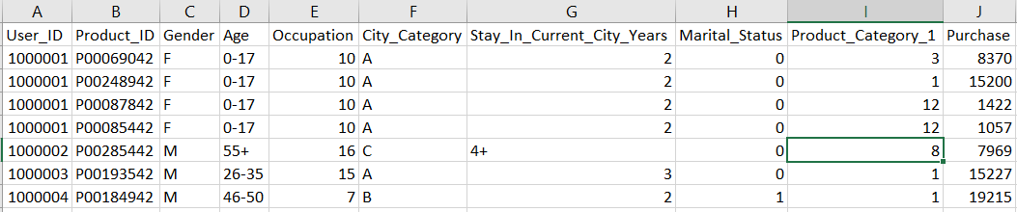

Hence, we decided to create a backstory for our project. The story is about wine sales in 2018.

Wine is one of the most popular types of alcohol sold in the world, and France represents more than 10% of world wine consumption and more than 20% of world wine production (Wine Institute, 2019).

(one or two more short paragraphs about wine – James can help ??)

* We are a specialist importer of French wine.
* We wish to illustrate our sales data for 2018 – this will be included in our annual report to executive, investors, shareholders, and so on.
* We wish to convey information about the relative popularity of our wines and the breakdown of our customers.

Our wines come from three regions in France, and there are 20 varieties of grapes from what the wines are made of.

This story would make the data more interesting and provide a theme (for example, color palettes, icons, images) which could be applied across all visualisations.

We then modified the dataset so that it would represent our sales for 2018 by adding a sale date, mapping category to grape variety, city to wine-region and so on.

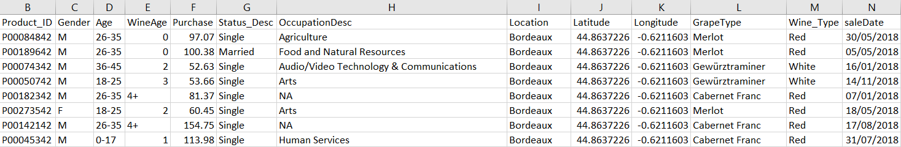

The final dataset, WineSales.csv is included in the project submission, together with the code used to transform the data into the final dataset, file DataPreparation.R.

# Interactive Visualisation

Once we were satisfied that our data was suitably prepared, we created our initial deliverable, an interactive visualisation. This was done in 4 steps:

* Identify the objective and audience.
* Pick a theme (color palette, images)
* Create visualisations (worksheets)
* Create the dashboard and apply filters

We’ve used Tableau to generate the interactive visualization because it is a powerful tool and it permits to easily publish the dashboard online, as you can check [here](https://public.tableau.com/profile/lucas.morato#!/vizhome/WineSales-InteractiveVisualisation/WineSalesOverviewfor2018) or through this link:

[https://public.tableau.com/profile/lucas.morato#!/vizhome/WineSales-InteractiveVisualisation/WineSalesOverviewfor2018](https://public.tableau.com/profile/lucas.morato" \l "!/vizhome/WineSales-InteractiveVisualisation/WineSalesOverviewfor2018)

## Objective

The objective of the visualisation is to provide an overview of our company’s sales for 2018.

The visualisation has been created with the company directors in mind as a strategic tool which allows them to view:

* The total value of sales for each month.
* The value of sales by region of origin and by variety of grape.
* The profile of our customers by age, gender and occupation.

We believe this provides the audience with valuable information such as:

* Most popular types of wine by gender, occupation or area.
* Most popular regions based on different customer preferences and profile.
* Value of sales based on preferences of different group ages.

## Theme

Having researched other wine related graphical materials, we identified colour schemes commonly associated with wines such as reds, purples, yellows, browns, and greens. Based on these we created a custom palette comprised of the following:

|  |  |  |
| --- | --- | --- |
| Color | Hex Number | Tableau description |
| #290101 color image | #290101 | Very Dark Brown |
| #420101 color image | #420101 | Dark Brown |
| #52151c color image | #52151C | Dark Red |
| #690b22 color image | #690B22 | Dark Red |
| #be2740 color image | #BE2740 | Red |
| #ea7472 color image | #EA7472 | Red |
| #fbda90 color image | #FBDA90 | Light Yellow |
| #caa181 color image | #CAA181 | Light Brown |

## Visualisations

We then created individual visualisations.

### Sales by region of origin

The following map shows the 3 regions from which our products are sourced: Bordeaux, Loire Valley, and Rhône Valley.

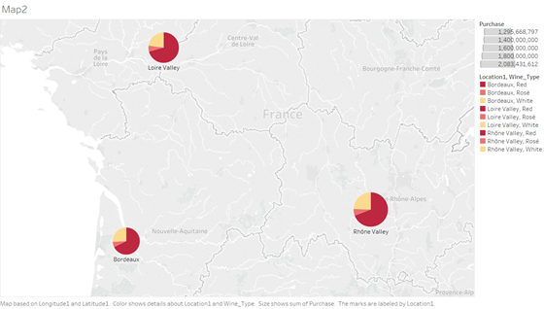

We considered displaying each as a pie-chart, however decided that a simple dot with tooltips for detail provided a clearer image.

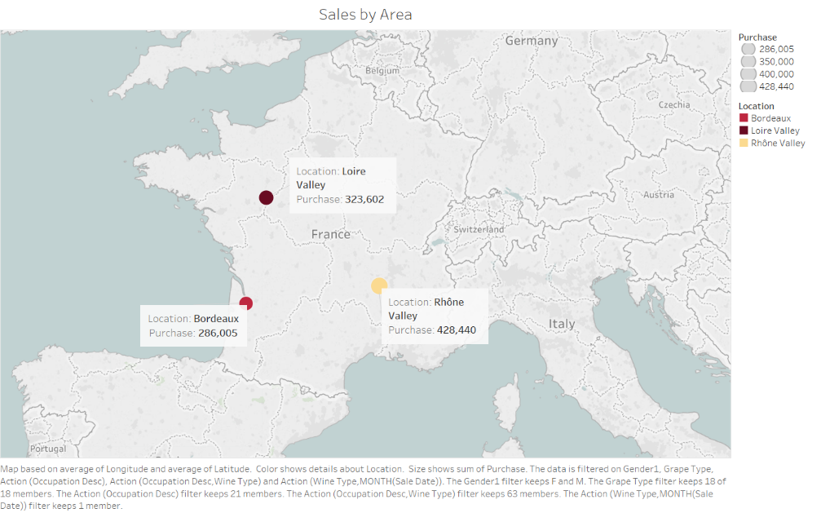

### Sales by grape variety

We used a bubble plot to show the relative popularity of the various grape varieties. We chose this format - cluster of bubbles – because it resembles a grapevine.

The user can clearly identify the most popular grapes - Cabernet Franc, Merlot, and Gewürztraminer.

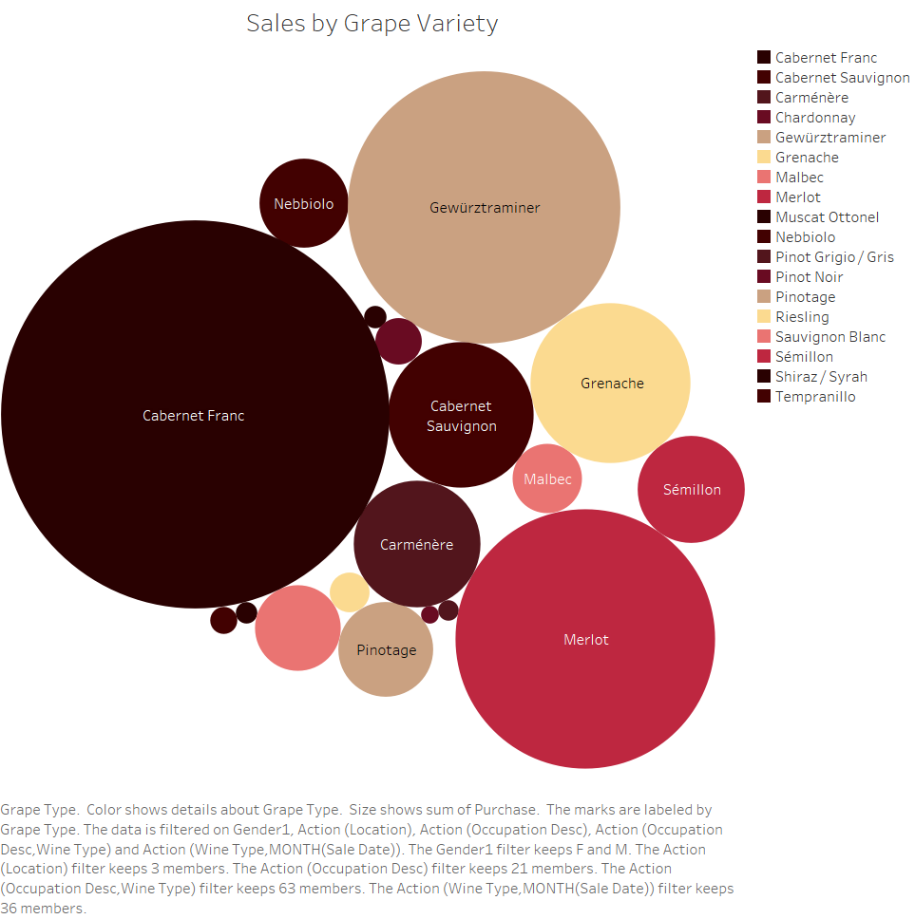

### Sales per Month

We’ve used a bar chart shows the sales for each month of 2018 stacked by type. An interesting insight is that we expected to see seasonal variation in the sales of wine types (for example, red during Christmas, rosé in the Summer). However, the Sales-Per-Month chart shows that all types sell consistently across the year, so that assumption was incorrect.

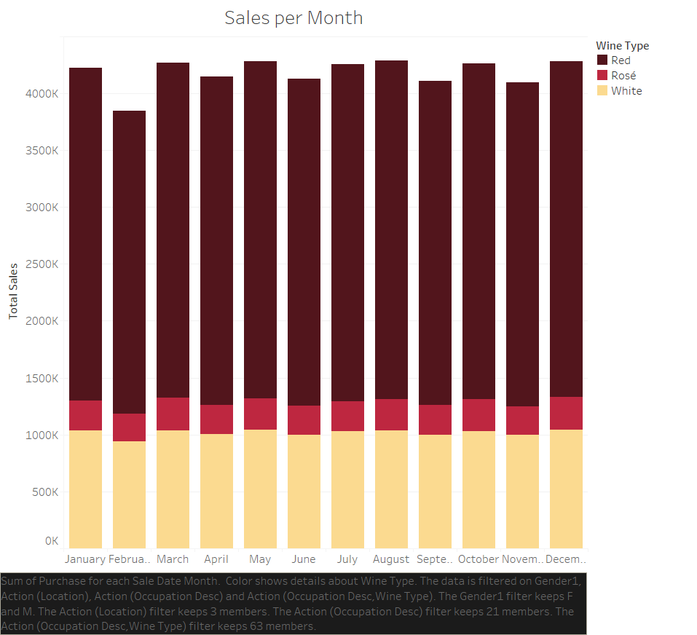

### Sales by Occupation (Top 10)

The company directors are interested to know more about the type of people who purchase our products as this informs marketing strategy. This bar chart shows the sales by employment sector. A heat map was initially created however this contained more detail than our audience require so a horizontal bar chart limited to the top 10 was more appropriate.

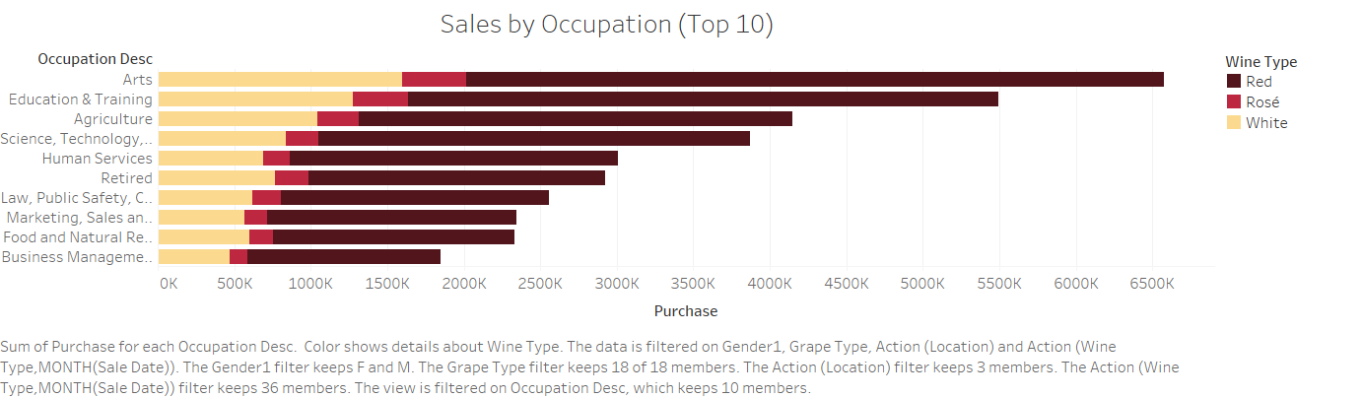

### Sales by Age group

We also charted the sales by age group as a stacked bar chart - our products are surprisingly popular among the 26-35 age-range!

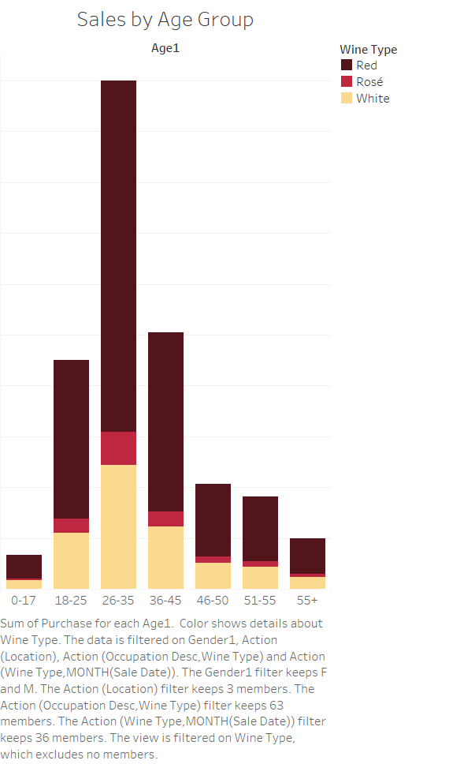

# Dashboard

Once the individual sheets were created, we compiled a dashboard in Tableau by arranging on a canvas:

The challenge when creating an interactive dashboard is to connect all the sheets - which makes a consistent theme and narrative essential.

Tableau offers different kinds of interactive filters. The ones we applied in this dashboard were:

* Gender and Wine type boxes: they work independently from each other and can be used within any of the other filters.
* Select filter applied on Sales by designation of origin sheet. To apply the filter, it is needed to select and click on the area desired, then the other 4 sheets will display information regarding just that area.
* Hover filter applied on Sales per Month. This filter works similarly to the one above, the difference here is there is no need to select and click. Just to hoover the mouse already change other sheets.

The advantage of an interactive visualization is that it allows the user change the data displayed based on the desired criteria, offering immediate response to different questions.

# General visualisations

some text about the general visualisations.

I think Lucas already covered A LOT in the ‘interactive viz’ and we still have the infographic to add. I wonder how many more we should add here. I’m getting worried that the report is becoming too long !

## Outliers

<Andrea – to add some context here>

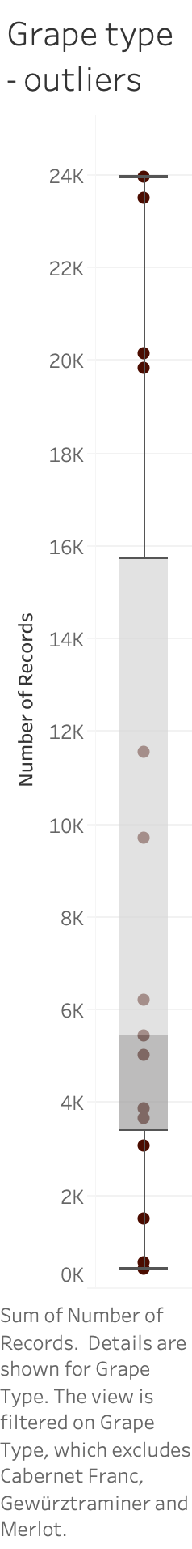

# Infographic

<some text about why adding an infographic to the report>

<infographic image>

# References

Wine Institute (2019). ‘World Wine Consumption’. *Wine Institute*. Available at: <https://www.wineinstitute.org/files/World_Consumption_by_Country_2017.pdf> [Accessed 11 June 2019].

Ruiz, A. (2017) ‘The 80/20 data science dilemma’. *Infoworld*,26 September. Available at <https://www.infoworld.com/article/3228245/the-80-20-data-science-dilemma.html> [Accessed 6 June 2019].

Datanovia (2018) *Ggplot colors best tricks you will love.* Available at: <https://www.datanovia.com/en/blog/ggplot-colors-best-tricks-you-will-love/> [Accessed 9 June 2019].

# Appendix

## Dataset

The final dataset, WineSales.csv is included in the project submission, together with the code used to transform the data into the final dataset, file DataPreparation.R.

## Metadata

Description of the variables of the Wine sales dataset. (verify that this is correct !!)

* User_ID = Unique identifier for each customer.
* Product_ID = Unique product identifier.
* Gender = M for Male, F for female.
* Age = 5 groups: 0-17, 18-25, 26-35, 36-45, 46-50, 51-55, 55+
* WineAge = How many years the wine has been “aged”.
* Purchase = Value of each purchase in Euro.
* Status_Desc = Buyer marital status (Single or Married).
* OccupationDesc = Profession of the buyer.
* Location = The region from where the wine was sauced.
* Latitude = Latitude, used for mapping Location.
* Longitude = Longitude, used for mapping Location.
* GrapeType = Variety of grape used in the wines.
* Wine_Type = Classification of the wine (Red, Rosé, or White).
* saleDate = date of the sale of the wine. Format YYYY/MM/DD.