

**The University of Manila**

546 M.V. De Los Santos Street,

Sampaloc Manila, 1008 Metro Manila

College of Engineering and Computer Science

**Boom! Color Crash**

A Thesis Presented to

**Mr. Joselito Borces**

Faculty of Computer Science

Submitted by:

AMA Glanzent

Francisco, Mark Herbert P.

Petilla, Aileen Joy A.

Rafael, Andrea Mae Nicole B.

**Table of Contents**

Acknowledgement ………………………......…………………………… 2

Statement of the Problem ……………………………………………….. 3

Solution to the Problem ……………………………………………….. 3

Software and Hardware Used in Development ……………………….. 4

Software and Hardware Requirements ……………………………….. 5

Video Game Mechanics/Controls ……………………………….. 6

Screenshot of the Software ……………………………………….. 7

Conclusion ……………………………………………………………….. 8

Team Composition ……………………………………………………….. 8

# **Acknowledgement**

First and foremost, praises and thanks to God, the Almighty, for his showers of blessing throughout this thesis.

We would like to express our deep and sincere gratitude to our CS20 professor, Mr. Joselito Borces for giving us the opportunity to do this thesis and providing invaluable guidance throughout this thesis. We would also like to thank our respective panelists for taking time today with us.

To our family, friends and classmates, we thank them for supporting us in creating this thesis; for always being there to encourage us.

We wish to extend our special thanks to Google and all software that we used for providing us the tools that we needed to complete this thesis. Without them, this thesis wouldn’t be possible.

**Statement of the Problem**

* **Boredom**
  + Getting used to everyday rotation activity and bring dullness.
* **Inattentiveness**
  + Other games have been found not thrilling that players would pay less attention to it.
* **Limited Resources**
  + Players tend to use low specifications for the personal computers.
* **Hassle Maintenance** 
  + Games nowadays will have the user to update the game themselves and that causes hassle.
* **Portability**
  + There are games that would only run on a specific operating system.

**Solution to the Problem**

* Create a new game, “Boom! Color Crash”. An easy game that makes your time pass.
* Create a new game that will make the player focus and develop attention skills with tracking fast-moving objects.
* Create a game that helps the player to play regardless of low PC specifications.
* Create a game that new updates get automatically configured and would only cost little storage to update.
* Create a game that can be played smoothly on various operating systems and browsers.

**Software and Hardware Used in Development**

The following software and hardware was used for the development of the game.

**Hardware**

* **Laptop**
  + Asus X455L
    - Processor : Intel Core i5-5200U Processor 2.2GHz
    - Operating System : Windows 10
    - Memory : 4GB 1x DRAM DDR3
* USB mouse

**Software**

* Visual Studio Code
  + Visual Studio Code, also commonly referred to as VS Code, is a source-code editor made by Microsoft for Windows, Linux and macOS. Features include support for debugging, syntax highlighting, intelligent code completion, snippets, code refactoring, and embedded Git.
* Microsoft Word any Edition
  + Microsoft Word is a word processor developed by Microsoft. It was first released on October 25, 1983 under the name Multi-Tool Word for Xenix systems.
* Google Chrome
  + Google Chrome is a [cross-platform](https://en.wikipedia.org/wiki/Cross-platform) [web browser](https://en.wikipedia.org/wiki/Web_browser) developed by [Google](https://en.wikipedia.org/wiki/Google). It was first released in 2008 for [Microsoft Windows](https://en.wikipedia.org/wiki/Microsoft_Windows), built with [free software](https://en.wikipedia.org/wiki/Free_software) components from [Apple WebKit](https://en.wikipedia.org/wiki/Apple_WebKit) and [Mozilla Firefox](https://en.wikipedia.org/wiki/Mozilla_Firefox). It was later [ported](https://en.wikipedia.org/wiki/Ported) to [Linux](https://en.wikipedia.org/wiki/Linux), [macOS](https://en.wikipedia.org/wiki/MacOS), [iOS](https://en.wikipedia.org/wiki/IOS), and [Android](https://en.wikipedia.org/wiki/Android_(operating_system)), where it is the default browser. The browser is also the main component of [Chrome OS](https://en.wikipedia.org/wiki/Chrome_OS), where it serves as the platform for [web applications](https://en.wikipedia.org/wiki/Web_application).

**Software and Hardware Requirements**

This game requires the following for the players to play.

OS: Linux, Mac OS, Windows 7, Windows 8, Windows 10, and/or Windows 11.

Browser: Firefox, Google Chrome, Microsoft Edge, Apple Safari.

Additional Requirements: Monitor, Mouse, Keyboard

**Minimum**

* + Processor: Intel Pentium 4 or AMD Athlon XP 2000+
  + Memory: 2GB RAM
  + Storage: 4GB Available Space

**Recommended**

* + Processor: Intel Celeron N4000 or AMD A4-9125
  + Memory: 4GB RAM
  + Storage: 8GB Available Space

**Video Game Mechanics/Controls**

Boom! Color Crash is a [fixed shooter](https://en.wikipedia.org/wiki/Fixed_shooter) in which the player moves a [white](https://en.wikipedia.org/wiki/Laser_cannon) block horizontally across the bottom of the screen and fires at the shooting color blocks overhead. The player will be given 3 lives. If the player is hit by the falling color blocks. The player will lose 1 life and will be invincible for 2 seconds. The goal in this game is to avoid blocks of colors that are falling, and the player should fire and hit the color blocks (opponents) to have a 15 score in every color block.

Use the Left and Right arrows to move or “A” to move Left and “D” to move Right. Spacebar to shoot/fire. If the game’s over, click or press the spacebar to play again. If you want to pause the game just click the screen, the same if you want to resume the game.

**Screenshot of the Software**

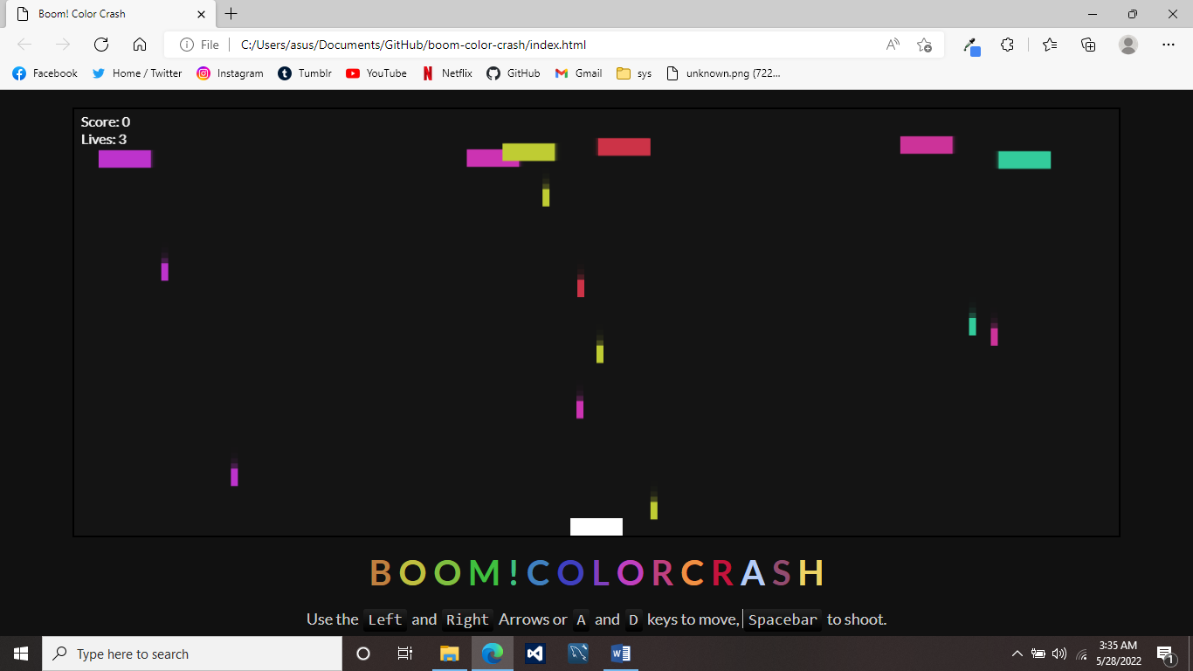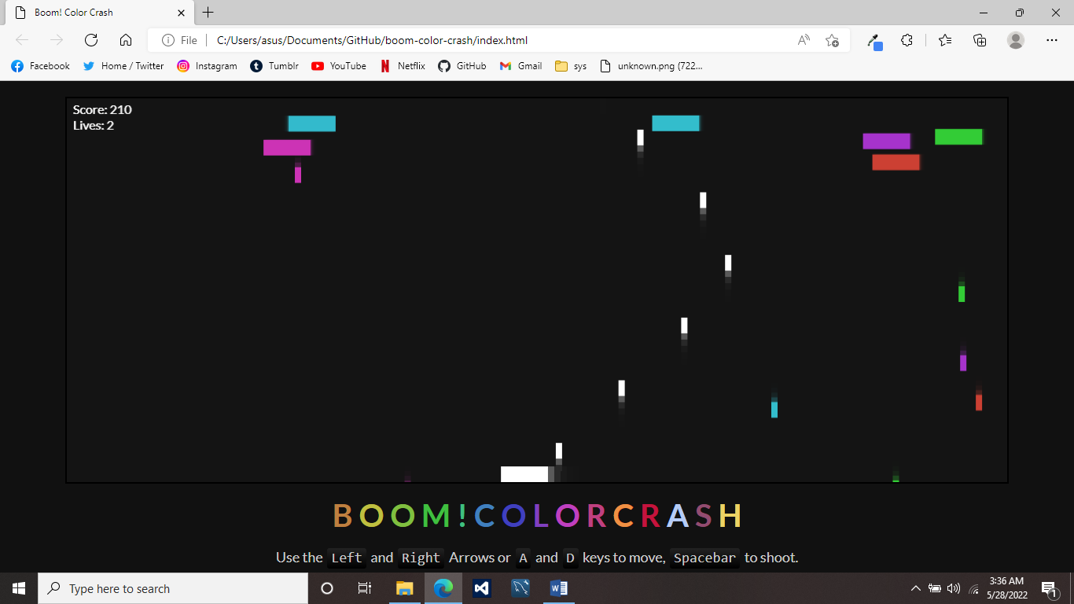

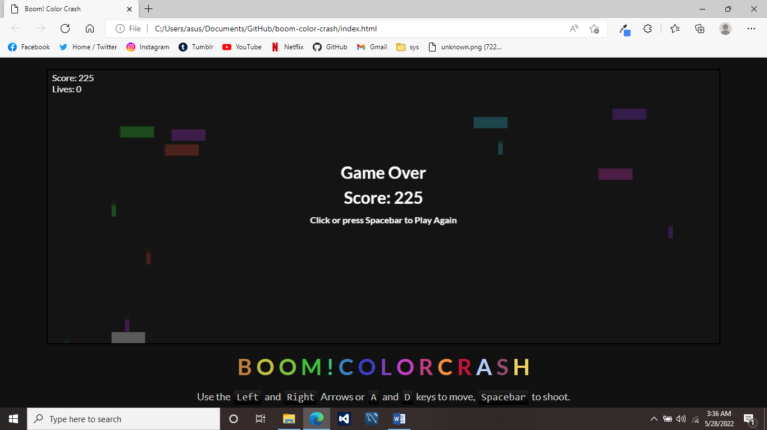

**Team Composition**

Francisco, Mark Herbert P. - Programmer

Petilla, Aileen Joy A. - Researcher

Rafael, Andrea Mae Nicole B. – Leader/Programmer

**Conclusion**

The game is easy to play, and the graphics make the game look good. Web games are played in moderation and mindfulness as they are a viable source of stress relief. The player actively contributions to the level of satisfaction they attain from this medium and thus is more invested and willing to engage in the elements of the game.