

**The University of Manila**

546 M.V. De Los Santos Street,

Sampaloc Manila, 1008 Metro Manila

College of Engineering and Computer Science

**Practicum Attendance Monitoring System  
using Barcode**

A Thesis Presented to  
**Mr. Rogelio T. Plaza Jr.**   
Faculty of Computer Science

In Partial Fulfillment of the Requirements  
for Software Engineering 1 for the Degree of  
Bachelor of Science in Computer Science

Presented by:   
Beloro, Danilo R.   
Orot, Rico S.   
Rafael, Andrea Mae Nicole B.   
Simpas, Elaine Marie  
Sullera, Real

**Table of Contents**

Acknowledgment ……..…………………………………............................... 2

Introduction …………...……………………………………………………….. 3

Background of the Study ……………………………………………………. 4

Statement of the Problem ………………………………………………..…... 5

Objective of the Study …………………………………………………..... 6

Review of Related Literature …………………………………….……………… 7

Old System ………………..…………………………………………………... 9

Old System Flowchart …………………………………..………………... 10

Data Gathering ………………………………..…………………………... 11

New System ……………………………….…………………………………… 12

Data Flow Diagram ………………………………………….………………… 17

System Flowchart …………………………………….……………………… 18

Definition of Terms ……………………………………………….…………… 19

Hardware and Software Requirements ………………………………….… 20

Conclusion …………………………….……………………………………… 22

Summary ………………………………………….………………………… 23

Recommendation ………………………………………….………………… 24

# **Acknowledgment**

First and foremost, praises and thanks to God, the Almighty, for his showers of blessing throughout this thesis.

We would like to express our deep and sincere gratitude to our Software Engineering 1 Professor, Mr. Rogelio T. Plaza Jr., for giving us the opportunity to do this thesis and for providing invaluable guidance throughout this thesis.

A special thanks to our family. Words cannot express how grateful we are for all of the sacrifices that you’ve made on our behalf.

To our classmates and friends, thank you for supporting us in everything, we can’t thank you enough for encouraging us throughout this experience.

And finally, we would like to extend our special thanks to Google and all software that we used for providing us with the tools that we needed to complete this thesis. Without you, this thesis wouldn’t be possible.

**Introduction**

In our life today, computer is one of many inventions that greatly affect our way of living. In fact, it is noted as an essential tool in many areas including business, government, industry, sciences, education, school, home, and in almost any company and establishment that existed. It can perform process data rapidly, accurately and reliable and by using these machines, spending a lot of time and effort in doing a certain task is minimized.

Computer nowadays has become the most needs of data and information processing. Computers have been very effective in many fields of work and study. It certainly helps man to make his task much easier and with great precision. In schools and universities, computers are used to maintain the basic flow of data and information and checking the credit status of the students. The computer is very useful in performing a great task in data and information processing, securing files, data, and information of the schools and people belong to it. Computer programmers now a day try to build and develop high-quality systems that are very useful. A computerized management system maintains the standard flow of data and information with highly secured and make data processing faster and easier. These computerized systems help one person, company, organization or any type of management agency throughout the world to enhance and develop its general profile.

This project, “Practicum Attendance Monitoring System using Barcode” allows employer to automate timesheet of each practicum for easy monitoring. The system will be used by the on-the-job trainees or practicum to serve as their daily time in and out using the Barcode generated by the system. The entire system will be managed by the administrator.

Monitoring the practicum’s attendance helps in ensuring that the trainees maintain their required work of hours. Traditionally, the attendance are entered and stored manually in a logbook which is prone to human error and tampering. The manual method of monitoring timesheet is extremely complex to manage and record keeping requires physical storage. Employers need a tool to efficiently and conveniently monitor on-the-job practicum attendance.

**History**

On October 5, 1913, a group of four young men and a woman, with ages from fifteen to twenty-one met for breakfast at the Palma de Mallorca, a popular restaurant beside the Sto. Domingo Church in Intramuros, Manila.

The five were Dr. Apolinario G. de los Santos, his brother, Dr. Mariano V. de los Santos, his sister, Maria de los Santos, and two friends Dr. Buenaventura J. Bello and Atty. Antonio Rivero. They were only college students then, who were more daring than their contemporaries for they were determined to pursue their dream of putting up a school suited to the needs of the Filipino youth.

These impecunious young people, as they were called by the university historian, encountered many challenges in realizing their dream of establishing an institution whose motto was “Patria, Scientia, et Virtus. They named their school Instituto de Manila, after the city of their affection and Apolinario de los Santos was elected as the first director of the school.

The doors of the Instituto de Manila were first opened in school year 1914-1915. The forerunner of this institution offered only elementary and high school courses in a leased building located at the corner of Madrid and Peñarubia streets, Binondo District. However, in school year 1919-1920, in order to accommodate its growing populace and to provide them with better facilities, the Instituto de Manila started conducting classes in its own building at the Sampaloc District.

**Mission and Vision**

**Mission**

**ACE**—to accomplish something with complete success

**A —** anchor in the hearts of the youth the love of country, science and virtue.  
**C —** create an atmosphere of academic excellence and competence  
**E —** empower the youth with modern scientific technological skills in braving the challenges of the global society.

**Vision**

To impart to the future generations the University of Manila trilogy of ideals: love of country, love of science and love of virtue, in making the lives of others, better, brighter, lighter and more livable, by making quality education accessible to all.

**Background of the Study**

The University of Manila is a well-established university located in Sampaloc, Manila. The University offers different programs for bachelor's degree, graduate school degree, and law degree. UM has always aimed to impart knowledge to its students through the sublime trilogy of Patria, Scientia, and Virtus. So, UM can be compared to a fertile ground where you can grow and feed your dreams. It also provides an in-house internship program for the students who needs to take their On-the-Job Training.

At present, in-house internships at the university use only a manual attendance system. Interns need to log-in manually on an attendance sheet or logbook for their attendance record. The objective of the project team is to diminish the errors made by using the manual system. The Attendance Monitoring System is a computerized system that will provide a new and easier way to track the trainees’ attendance. AMS aims to avoid different cheating strategies of the students possibly done with using a manual attendance system.

**Statement of the Problem**

After our research and interview with the practicums, we list the problem with their manual system, and these are the followings:

* Paper Dependency
  + The use of bond papers and folders in recording time and information about the practicum.
* Access Time
  + Writing is time-consuming and can cause delays. Hence, practicums will have to wait in line for their turn to write their logged time.
* Lack of Security
  + It can be accessible to all including unauthorized staff.
* Space Consuming
  + Storing files can take up so much space in the cabinet or room.
* Incorrect Information
  + The instances of cheating by putting different time and calculating total hours.

**Objectives of the Study**

After being cognizant of the problem with their manual system, we came up to make a system that contains the following:

* To develop a system that will reduce paper dependency and automate the current manual process of the attendance system.
* To develop a system that will ease up recording, storing and monitoring of the practicum’s record of rendered hours in their training
* To develop a system that will be used for timesheet monitoring using barcode.
* To develop a system that will generate accurate and reliable timesheets.
* To improve working methods by replacing the existing manual system with a computer-based information system.

**Review of Related Literature**

**Foreign Literature**

The system project was Bar Code Scanner Based Student Attendance System (SAS). The project was developed on January 2013 at Universiti Selangor, UNISEL, Malaysia by Hema Subramaniam, Marina Hassan, and Setyawan Widyarto. Student attendance play significant role in order to justify academic outcome of a student and school as overall. Unfortunately, there is no automated attendance record keeping application available in Malaysia’s secondary schools. A preliminary study has been conducted in one of secondary schools in Selangor, Malaysia in order to understand the manual attendance record keeping process. Through interview session, Student Attendance System (SAS) development team, have identified that teachers and school management face problems in recording and managing attendance of their students. Therefore, SAS has been proposed and developed. Need for a tool to systematically keep the students attendance record increased due to increasing number of school students. Upon completion of SAS, user acceptance testing conducted among potential end users. Result of UAT shows most of the user satisfied with the system with some minor changes required.

**Local Literature**

On July 6, 2019, it was reported that the Badio Elementary School (BES), a rural school in the second district of Ilocos Norte, has adopted a convenient and safer way to monitor children’s attendance in school. According to Principal Aileen Rambaud, “Once a child enters the school, the teacher scans his/her ID and a text message will be sent to the mobile phone number of parent or guardian which informs that the child is in school that time.”

The Department of Education in Ilocos Norte, led by Schools Division Superintendent Vilma Eda, has been encouraging school heads in the province to come up with learning innovations to promote 21st-century schools. The BES is among the first public schools in the province to adopt such technology. Aside from introducing the electronic ID system, they are also planning to acquire fast Internet connectivity and virtual reality box units for learners, Rambaud said. But this can only be made possible should there be full cooperation among school stakeholders, Rambaud added.

Using a unique bar code for each of the 193 pupils of BES, teachers can now easily monitor their students' attendance and for parents to know if their child entered the school on the same day. Powered by Scan Attendance Manager, this is a free downloadable app that is able to scan a student ID's barcode and has the ability to send SMS (short message service), using a mobile phone number associated with the registered student. Launched last July 1, the electronic ID system with SMS is making BES students eager to go to school while their parents lauded the school initiative to protect their children.

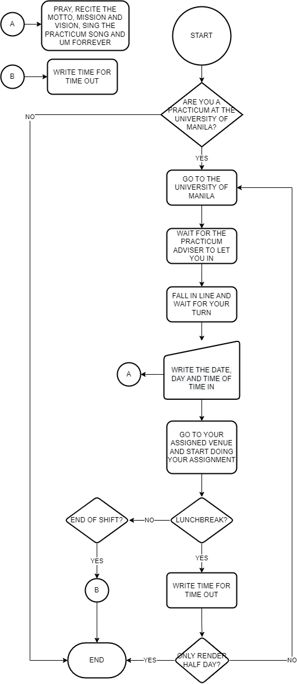**Old System Flowchart**

**New System**

**Data Flow Diagram**

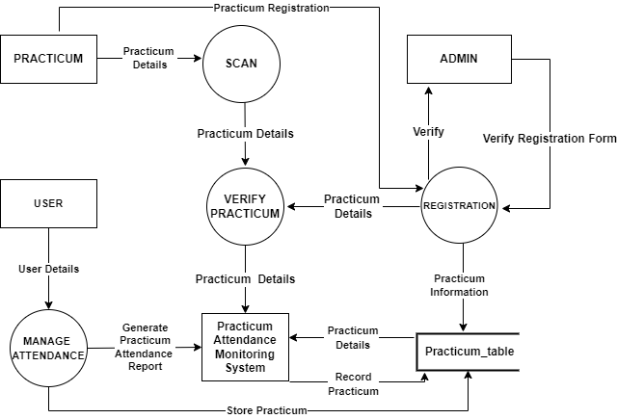

**System Flowchart**

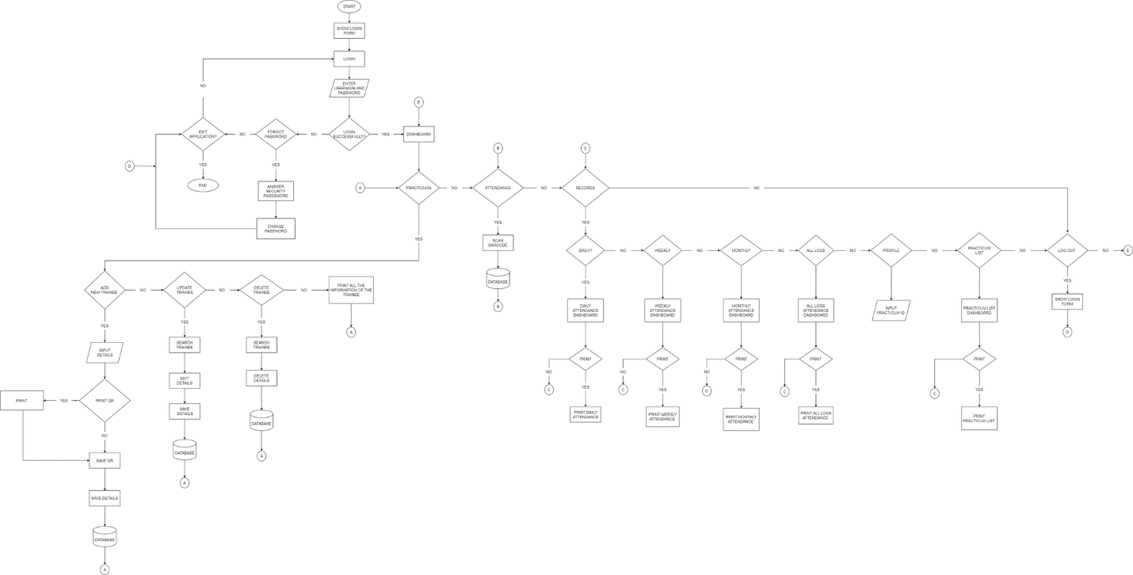

**Definition of Terms**

This section presents the definition of terms used in the project documentation and in the Practicum Attendance Monitoring System using Barcode itself.

**AMS** – operationally define as an Attendance Monitoring System that is used to monitor the attendance of an individual in a specific time and place.

**Automate** – the application of technology, programs, robotics, or processes to achieve outcomes with minimal human input.

**Barcode** – a machine-readable code in the form of numbers and a pattern of parallel lines of varying widths, printed on and identifying a product.

**Computer-Based Information System** – an organised integration of hardware and software technologies and human elements designed to produce timely, integrated, accurate and useful information for decision making purposes.

**Manual** - done, operated, worked, etc., by the hand or hands rather than by an electrical or electronic device.

**Practicum** – an undergraduate or graduate-level course, often in a specialized field of study, that is designed to give students supervised practical application of a previously or concurrently studied field or theory.

**Process** – a series of actions or steps taken in order to achieve a particular end.

**Security** – the protection of computer systems and information from harm, theft, and unauthorized use.

**Software** – is the program or application that is used in the computer. It is the bridge between the Hardware and the user.

**Technology** – machinery and equipment developed from the application of scientific knowledge.

**Hardware and Software Requirements**

This system requires the following for the usage of end users.

OS: Linux, Windows 7, 8, 10, and/or 11.

Additional Requirements: Monitor, Mouse, Keyboard

**Minimum**

* Processor: Intel Pentium 4 or AMD Athlon XP 2000+
* Memory: 2GB RAM
* Storage: 4GB Available Space

**Recommended**

* Processor: Intel Celeron N4000 or AMD A4-9125
* Memory: 4GB RAM
* Storage: 8GB Available Space

**Software**

* Microsoft Visual Studio Express 2012
* Microsoft Visual Studio Express is a set of integrated development environments (IDEs) that Microsoft developed and released free of charge. They are a function-limited version of the non-free Visual Studio and require mandatory registration. Express editions started with Visual Studio 2005. Microsoft Visual Basic is Microsoft's implementation of the VB.NET language and associated tools and language services. It was introduced with Visual Studio .NET (2002). Microsoft has positioned Visual Basic for Rapid Application Development. Visual Basic can be used to author both console applications as well as GUI applications.
* MySQL
* MySQL is an open-source relational database management system (RDBMS). Its name is a combination of "My", the name of co-founder Michael Widenius's daughter, and "SQL", the abbreviation for Structured Query Language. A relational database organizes data into one or more data tables in which data types may be related to each other; these relations help structure the data. SQL is a language programmers use to create, modify and extract data from the relational database, as well as control user access to the database. In addition to relational databases and SQL, an RDBMS like MySQL works with an operating system to implement a relational database in a computer's storage system, manages users, allows for network access, and facilitates testing databases.

**Conclusion**

Therefore, we conclude, in this generation the scope of technology has become wider they can easily solve the problems with the use of application in the computer. The attendance of the student in OJT at The University of Manila needs to adapt technological methods to monitor easily the attendance. It means updating their ways these days and replacing human efforts with machines to keep track of technologies. It reduces human errors and processing time; thus, it can boost productivity and results in high-quality production. This can result in a system well-integrated process that can perform much faster and more accurately than manual systems.

Also, the researchers concluded that the developed system is an effective system to ease up checking and recording of the practicum’s attendance. The implementation of the Barcode-based attendance system will ease up student attendance recording and monitoring. The system will eliminate the errors and problems encountered in the manual attendance system. By implementing the system, the recording of attendance will be efficient, timely, convenient, and accurate.

**Summary**

The computer is highly helpful in processing data and information, protecting school files, and performing other significant tasks. The consistent flow of data and information is maintained with the help of a computerized attendance tracking and identification system, which also makes data processing quicker and simpler. The researchers found that some schools still use the manual method to check and record student attendance. The study proposed a well-developed attendance monitoring and identification system using barcode that will handle all the data of the student who undergo OJT. The system will eliminate the errors and problems encountered in the manual attendance system. The system will help the coordinator to monitor the progress of the student trainee. It can perform process data rapidly, accurately and reliable and by using these system, spending a lot of time and effort in doing a certain task is minimized.

**Recommendation**

Based on the findings and conclusion of the studies there are few options of input devices that can be used to replace the barcode scanner.

1. QR code is slightly similar to the bar code scanner. It is a machine-scannable image that can instantly be read using a Smartphone camera. Every QR code consists of a number of black squares and dots which represent certain pieces of information. When your Smartphone scans this code, it translate that information into something that can be easily understand by humans.

2. Biometrics is also an option. Biometrics is unique physical characteristics, such as fingerprints, that can be used for automated recognition.

3. Smart card can also replace the bar code scanner .Smart cards provide ways to securely identify and authenticate the holder and third parties who want access to the card. For example, a cardholder can use a PIN code or biometric data for authentication. They also provide a way to securely store data on the card and protect communications with encryption.