Patient Wellbeing Project
Detailed Project Documentation and Flowchart
A full-stack Data + AI portfolio project using SQL Server, PHP, JavaScript, TypeScript, Node.js, and OpenAI

1. Project Purpose
The Patient Wellbeing Project is a complete portfolio application that converts natural-language patient questions into structured analytics. The system supports multiple query intents through an AI interpretation layer, intent-aware backend routing, SQL Server analytics, and a polished dynamic dashboard.

2. Core Project Capabilities
- Added support for multiple query intents.
- Added a Node.js / TypeScript AI layer to interpret user prompts.
- Added intent-aware routing from the AI layer to PHP.
- Added a richer dashboard UI with summary cards and dynamic result tables.
- Added the continuation prompt: Ask another question? Yes / No.

3. Technology Stack
Layer | Technology
Frontend | HTML, CSS, JavaScript
AI Middleware | Node.js, TypeScript
LLM | OpenAI
Backend API | PHP
Database | SQL Server / PatientWellbeingDB
Version Control | Git + GitHub
Documentation | Word (.docx) + PNG flowchart

4. Clean Repository Structure
The clean repository is organized into a frontend root, a PHP API folder, and an AI agent folder:
ai-agent/
src/
LLMClient.ts
server.ts
package.json
package-lock.json
tsconfig.json
api/
auth.php
db.php
high-blood-pressure.php
patients.php
session.php
.gitignore
Dashboard.html
Dashboard.css
dashboard.js
index.html
README.md
start-project.bat
style.css

5. End-to-End Workflow
- The user logs in and opens Dashboard.html.
- The user enters a natural-language patient inquiry.
- dashboard.js sends the inquiry to the Node.js endpoint.
- LLMClient.ts asks OpenAI to extract a structured intent and parameters.
- server.ts routes the request based on the detected intent.
- PHP executes the corresponding backend logic and returns JSON.
- The dashboard receives the results and renders cards, tables, and labels.
- The user may continue with another prompt using the Yes / No continuation controls.

6. Supported Intents
Intent | Purpose | Typical Parameters | Rendered Output
WELLBEING_FOLLOWUP | Patients with multiple risk indicators and overdue checkups | minimumAge, minimumIndicators, monthsSinceCheckup | Checkup status, indicator count, indicators present
HIGH_BLOOD_PRESSURE | Patients meeting elevated/high blood pressure thresholds | minimumAge, minimumSystolic, minimumDiastolic, highSystolic, highDiastolic | Blood pressure, BMI, condition, last checkup, risk level

7. Flowchart
Figure 1 shows the detailed architecture and request/response flow for the completed system.
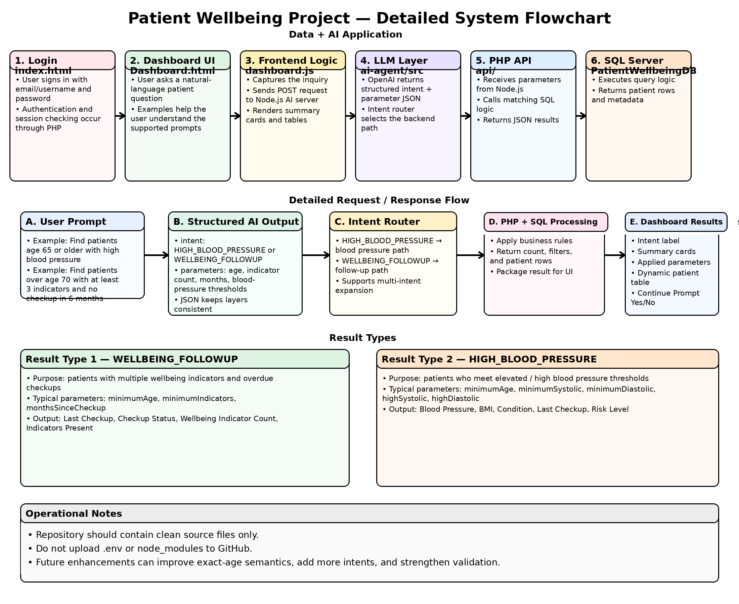
Figure 1. Detailed Patient Wellbeing Project flowchart.

8. Testing Highlights
- Tested follow-up queries using different ages, indicator thresholds, and month values.
- Tested high-blood-pressure queries using slightly varied and imperfect natural language.
- Verified repeated prompting through the continuation flow.
- Verified GitHub repository creation and clean PowerShell-based upload.

9. Security and Publishing Notes
- Never upload .env to GitHub.
- Keep node_modules local only.
- PowerShell + Git preserves folders better than browser-only drag-and-drop for this project.
- The clean public repository should contain source files, configuration files, and documentation only.

10. Potential Future Enhancements
- Improve age semantics such as exact age vs minimum age.
- Add more intents, such as HIGH_BMI or broader wellbeing categories.
- Strengthen data-quality checks and future-date filtering.
- Expand README setup steps and automated build guidance.

11. Conclusion
The Patient Wellbeing Project is complete and portfolio-ready. It demonstrates a working multi-intent Data + AI workflow, clean repository organization, natural-language interpretation, backend routing, SQL analytics, and dynamic presentation of results. The architecture also provides a strong foundation for optional future enhancements.

