**Name** Andrea Ordonio

**Date** March 1, 2023

**Course** IT FDN 130 A Wi 23

**Assignment 7**

[**GitHub Link**](https://github.com/andreaord23/DBFoundations-Module07)

**Functions**

**Introduction**

In Module 7, I dove further in the function explorations. Functions are diverse and can calculate, replace, format, convert, validate, or transform data to create report queries. Whether we desire a scalar value or a complex report, we rely on functions for SQL.

**When to Use SQL UDF**

Sometimes, we want to customize functions available to accurately encapsulate our data. In this case, we will use User Defined Functions or UDFs. There are two types of functions: scalar and tabular. We create scalar UDFs when we want a single value or tabular UDFs when we want a list. Tabular functions can be treated as tables too.

Furthermore, we can use UDFs to check our constraints when we cannot reference a column in another table.

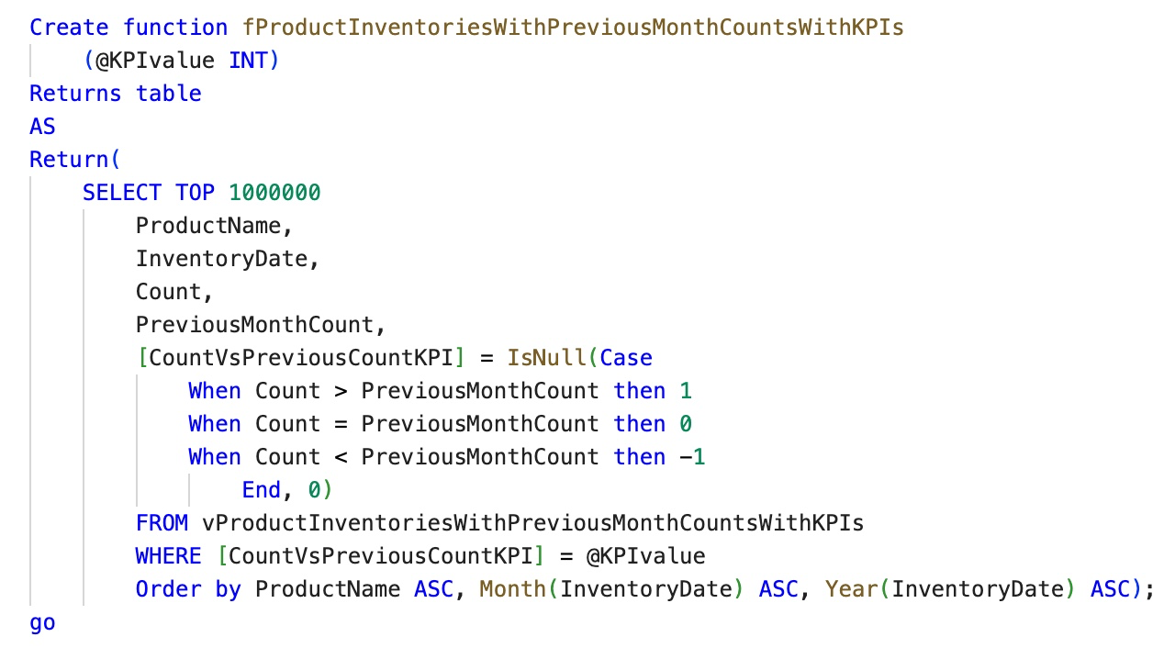

*Fig. 1.1 Example of UDF in Assignment 7. To call the function, use Select statement similar to showing a table.*

**Differences between Scalar, Inline, and Multi-Statement Functions**

Scalar, inline, and multi-statement functions are all UDFs and require the use of Select statement to build and call the function.

Scalar Function: In SQL, scalar functions yield one value and not multiple or sets of values. Parameters provide use in scalar functions.

Inline Function: In SQL, inline table-valued functions yield a result set and accept parameters. You must delineate that you want results as a table.

Inline and multi-statement functions are table-valued functions.

Multi-statement Function: In SQL, multi-statement table-valued functions are embedded with functions for processing and returns a data table per delineated. Fig. 1.1 exemplifies this type of function.

**Conclusion**

In this Assignment, I was able to critically think what functional tool to use to achieve my desired results. There are a lot. With the multitude of functions, we can create distinct and handy reports.