**44th ANNUAL**

**WASHINGTON STATE**

**INTERNATIONAL**

**KARATE CHAMPIONSHIPS**

# SATURDAY, MAY 12, 2012

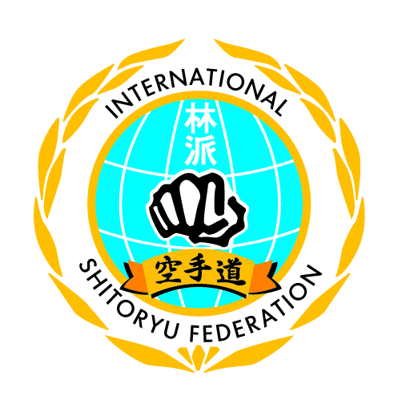

**Edmonds Community College Gym**

**20000 - 68th. West, Lynnwood, Washington**

**Beginning at 10:00 a.m.**

**Tickets Available at Door $5.00**

**Sponsored by:**

**Washington Karate Association**

**(425)641-8123 or (206)784-3171**