**International Hayashi-Ha Shito Ryu Karate-Do Federation**

Technical Seminars

October 7-9, 2011

Bellevue, WA

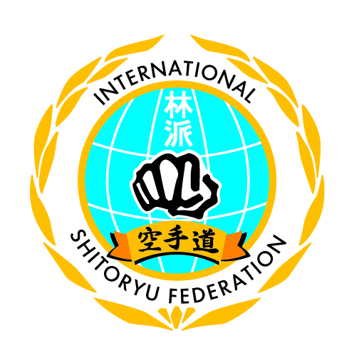

**Schedule of Events:**

**Friday, October 7:**

11:00-1:00pm – Instructor/Committee Meetings

4:00- 5:00pm: Age 9 and under, all levels (Kata)

5:00-6:00pm: Age 9 and under, all levels (Kumite)

6:00-8:00pm: Ages 10 & above, all levels ( Kata)

**Saturday, October 8:**

9:30-10:30am: Age 9 and under, all levels (Kata)

10:30-11:30am: Age 9 and under, all levels (Kumite)

12:00-2:00pm: Age 10 and above, all levels (Kata)

2:30-4:30pm: Age 10 and above, all levels (Kumite)

7:00pm – 10:00pm – Washington Karate Association

45th Anniversary Banquet

**Sunday, October 9:**

10:30-12:30pm: Age 10 and above, all levels (Kata)

1:00- 3:00pm: Age 10 and above, all levels (Kumite)

3:00-5:00pm: Weapons (experience necessary)

**Cost**:

9 & under - $150/all or $100/seminar, 10 & above - $250/all or $150/seminar

(Family discount - $50 off for 2 members, $100 off for 3 members)

**Host Hotel:**

Residence Inn by Marriott 14455 NE 29th Place, Bellevue, WA 98007

(425)882-1222 bellevuesales@ih-corp.com

Mention “Washington Karate” to get special rate: $149/night 2br/2ba penthouse suite or $99/night studio suite