WASHINGTON KARATE ASSOCIATION

45TH ANNIVERSARY BANQUET

*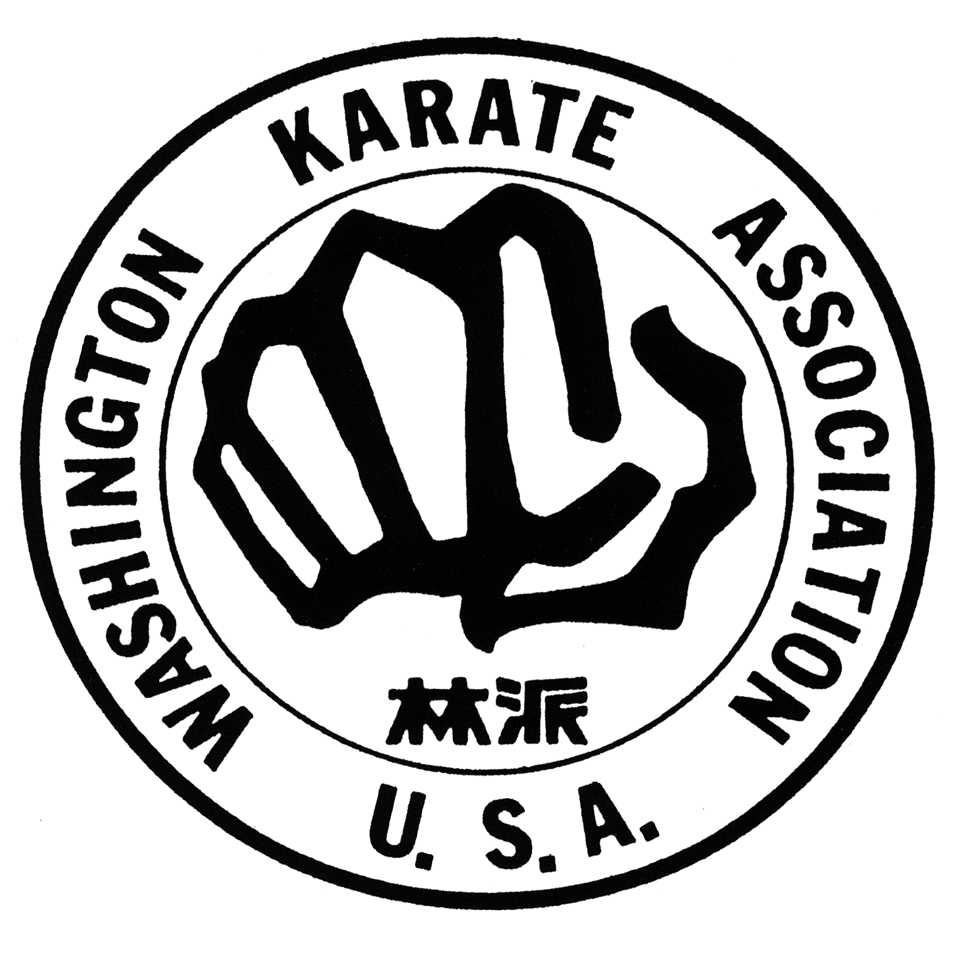Saturday, October 8th.*

*7pm – 10 pm*

*The Bellevue Club*

*11200 SE 6th St,*

*Bellevue WA*

***Please join us as we come together to celebrate our 45th anniversary of the Washington Karate Association. Families, friends and alumni will gather as we remember the past and celebrate the future.***

**NAME(S) : ___________________**

(PLEASE LIST NAMES OF ALL WHO WILL ATTEND)

**PHONE NUMBER: _______________E-MAIL ADDRESS: _____ _**

**ADDRESS: __**

**CITY: STATE: ZIP:**

**SENSEI’S NAME: _____ _____**

**Non-refundable Tickets: Please enter the quantity of tickets you would like to purchase**

**Adults ($75.00 each) _______ Children 12 & under ($40 each) ______**

** Check Enclosed. I wish to charge the above to my credit card:  Visa  MasterCard  Discover  Am.Express**

**Credit Card #: Expiration Date:**

**Print Cardholder’s Name: Cardholder’s Signature:**

**Please mail to WKA Bellevue Dojo: 14906 Bel-Red Road, Bellevue, WA 98007 by September 25th to reserve your spot.**