**43rd ANNUAL**

**WASHINGTON STATE**

**INTERNATIONAL**

**KARATE CHAMPIONSHIPS**

# 

# SATURDAY, MAY 14

**Beginning at 10:00 a.m.**

**Edmonds Community College Gym**

**20000 - 68th. West, Lynnwood, Washington**

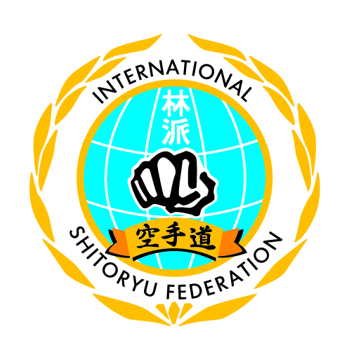

**PRESENTED BY:**

**Washington Karate Association**

**(425) 641-8123**

**Tickets Available at Door $5.00**