IT 214-Section 009

Andrea Perez

G01169101

11/18/2018

Homework 10

Note: BEST_SELLER column asked in the exercises below is BESTSELLER in the screenshots. I realized it after doing it.

**1.Create a MYSTERY table with structure shown in Figure 6-19**

CREATE TABLE MYSTERY (BOOK_CODE CHAR(4) NOT NULL PRIMARY KEY, TITLE CHAR(40), PUBLISHER_CODE CHAR(3), PRICE DECIMAL(4,2));

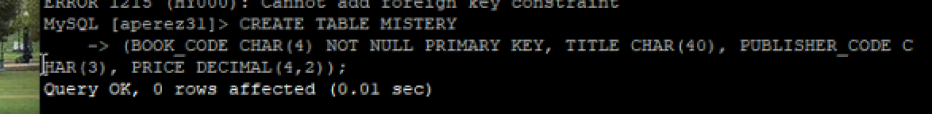

**2. Insert into the MYSTERY table the book code, book title, publisher code, and price from the BOOK table for only those books having type MYS**

INSERT INTO MYSTERY (BOOK_CODE,TITLE,PUBLISHER_CODE,PRICE) SELECT BOOK_CODE,TITLE,PUBLISHER_CODE,PRICE FROM BOOK WHERE TYPE=”MYS”;

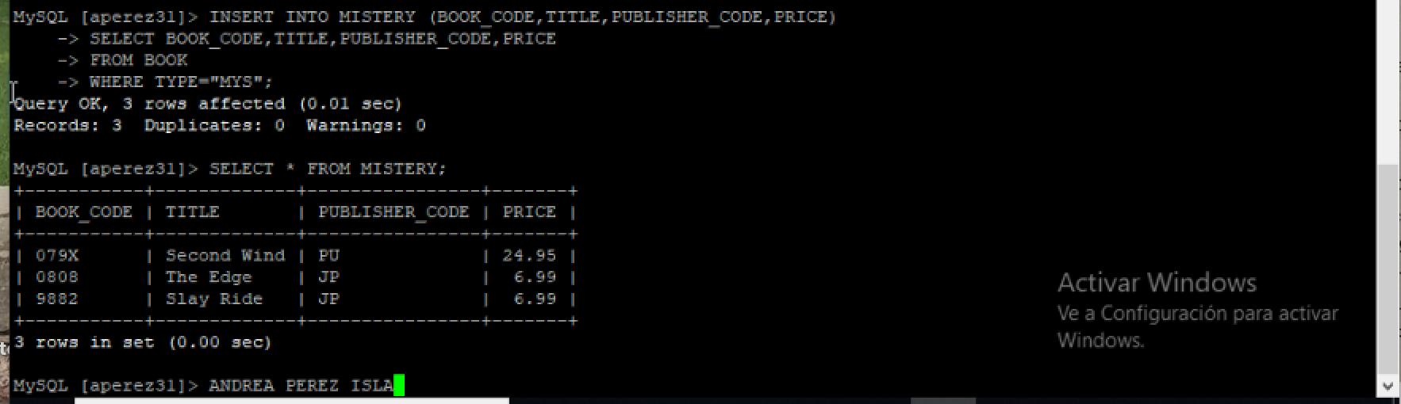

**3.The publisher with code JP has decreased the price of its mystery books by 4%. Update the prices in the MYSTERY table accordingly**

UPDATE MYSTERY SET PRICE = PRICE *0.96 WHERE PUBLISHER_CODE=”JP”;

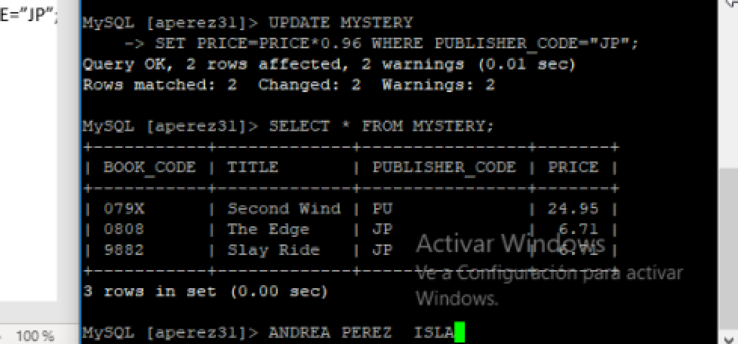

**4. Insert a new book into the MYSTERY table. The book code is 9946, the title is *Like Me*, the publisher is MP, and the price is 11.95**

INSERT INTO MYSTERY VALUES (‘9946’,’Like Me’,’MP’,11.95);

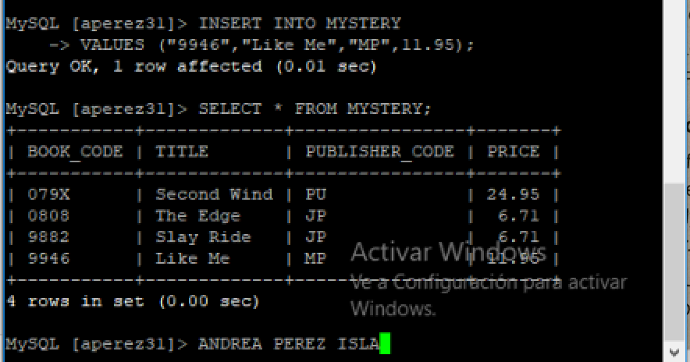

**5. Delete the book in the MYSTERY table having the book code 9882**

DELETE FROM MYSTERY WHERE BOOK_CODE=’9882’;

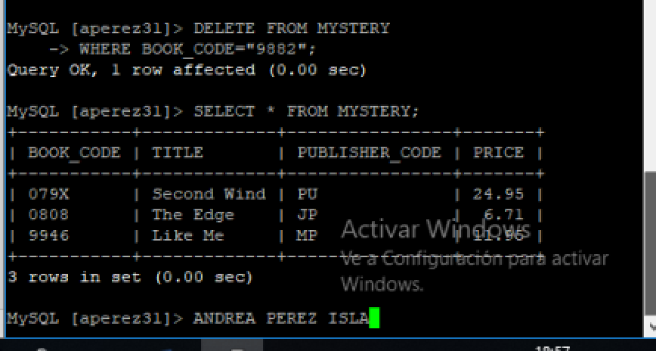

**6. The price of the book entitled *The Edge* has been increased to an unknown amount. Change the value in the MYSTERY to reflect this change**

UPDATE MYSTERY SET PRICE=NULL WHERE TITLE=”The Edge”; 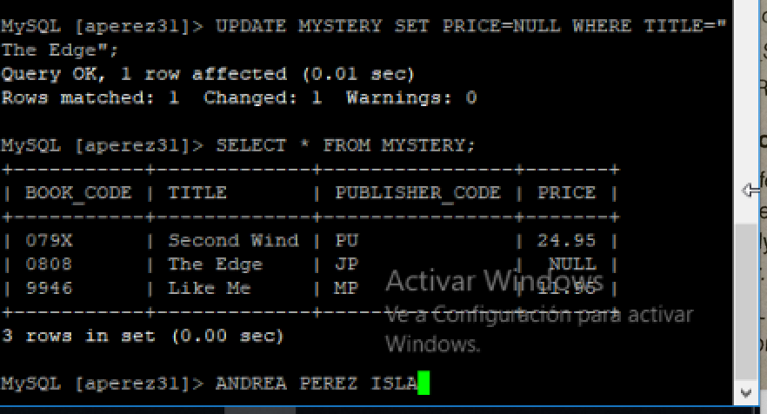

**7. Add to the MYSTERY table a new character column named BEST_SELLER that is one character in length. Then set the default value for all columns to N.**

ALTER TABLE MYSTERY ADD BESTSELLER CHAR(1);

UPDATE MYSTERY SET BESTSELLER=’N’;

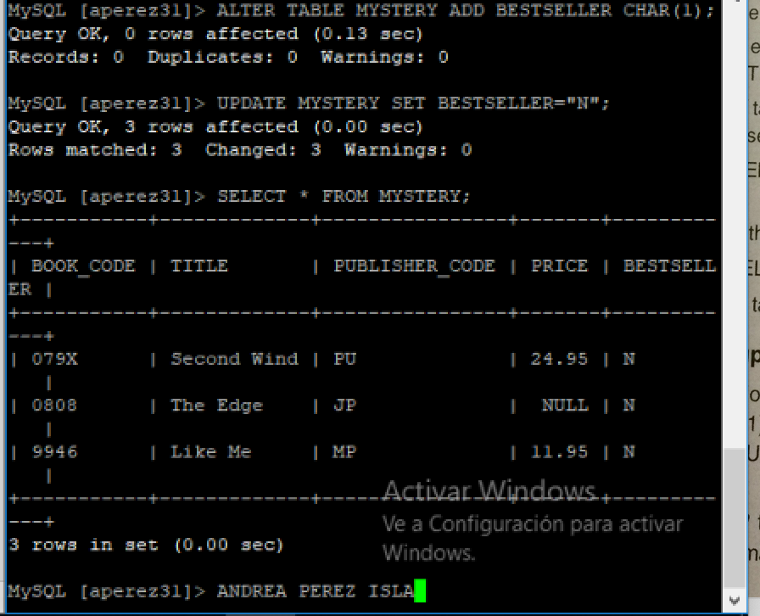SELECT * FROM MYSTERY;

**8. Change the BEST_SELLER column in the MYSTERY table to Y for the book entitled *Second Wind***

UPDATE MYSTERY SET BESTSELLER=’Y’ WHERE TITLE=”Second Wind”;

SELECT * FROM MYSTERY;

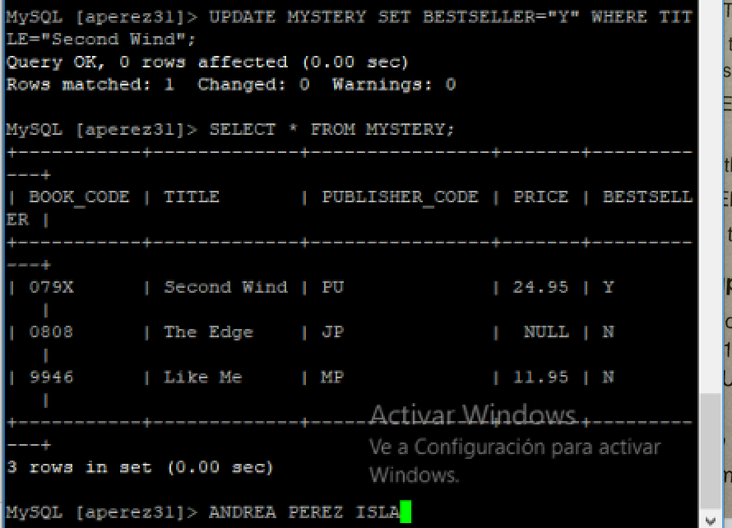

**9. Change the length of the TITLE column in the MYSTERY table to 50 characters**

ALTER TABLE MYSTERY MODIFY TITLE CHAR(50);

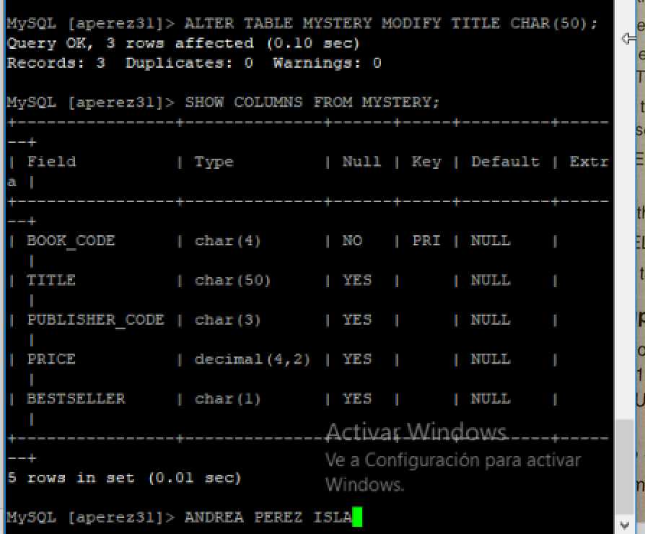SHOW COLUMNS FROM MYSTERY;

**10. Change the BEST_SELLER column in the MYSTERY table to reject nulls**

ALTER TABLE MYSTERY MODIFY BESTSELLER CHAR(1) NOT NULL;

SHOW COLUMNS FROM MYSTERY;

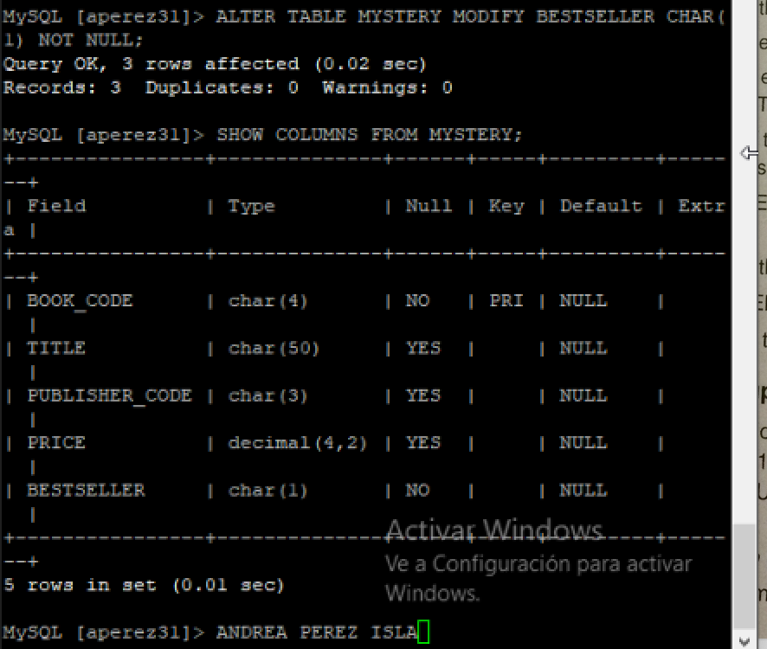

**11. Delete the MYSTERY table from the database.**

DROP TABLE MYSTERY;

