IT 214 SECTION 9

1st MS Visio Assignment

ANDREA PEREZ ISLA

G01169101

Step 1: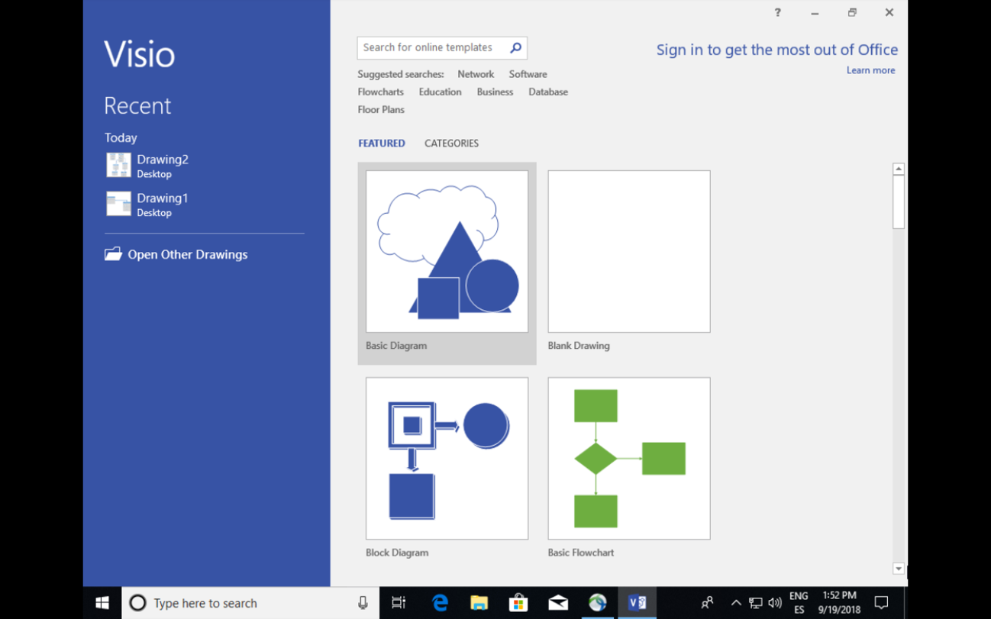

Step 2:

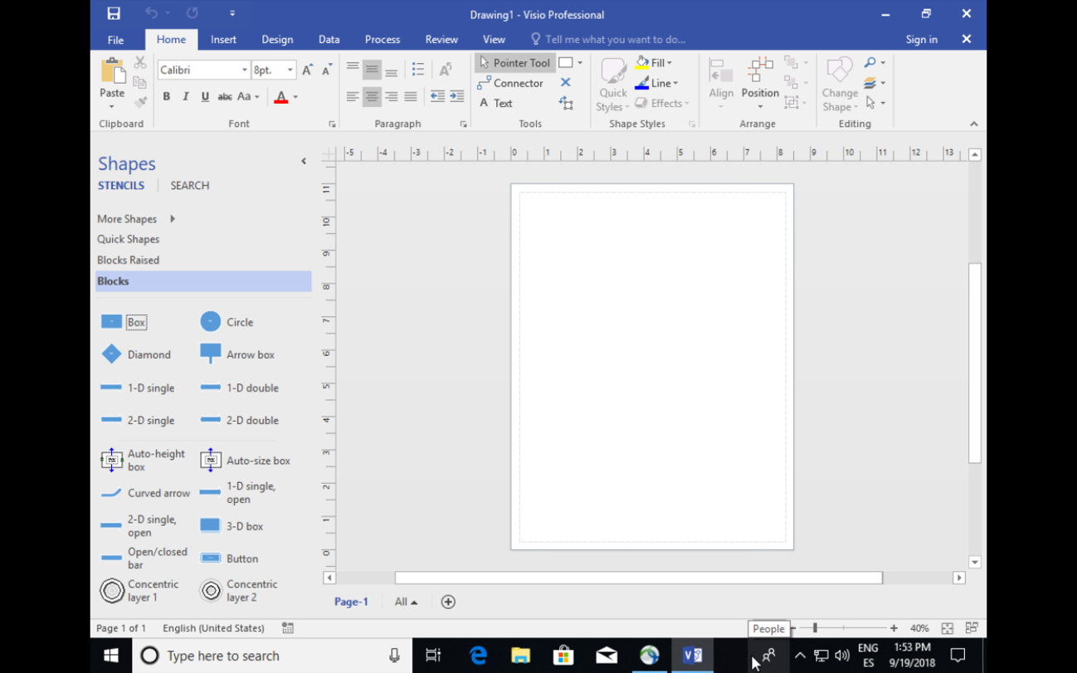

Step 3:

