IT 214 SECTION 9

Assignment: Confirm Access to MySQL

ANDREA PEREZ ISLA

G01169101

Step1:

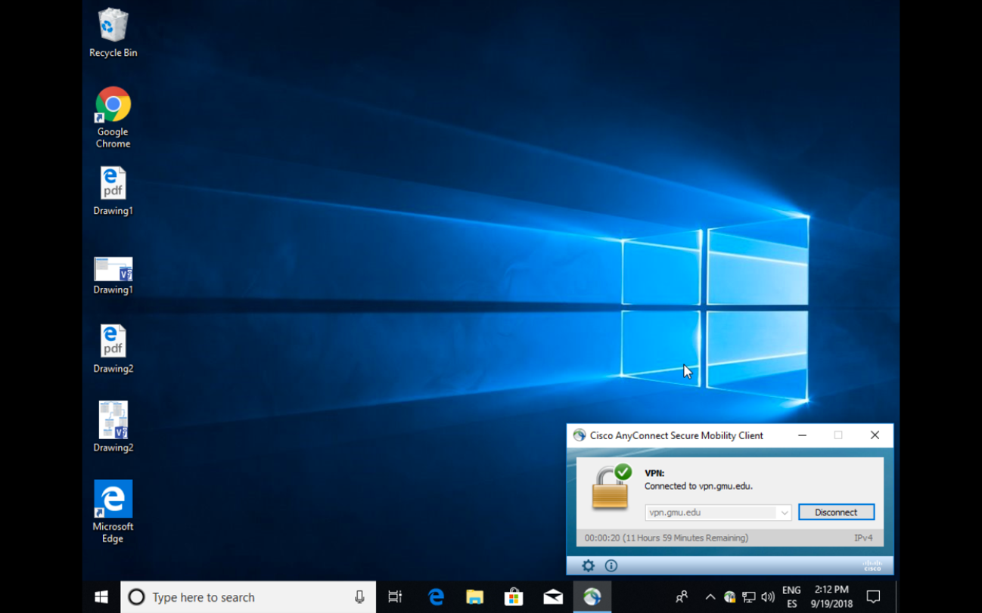

Step2: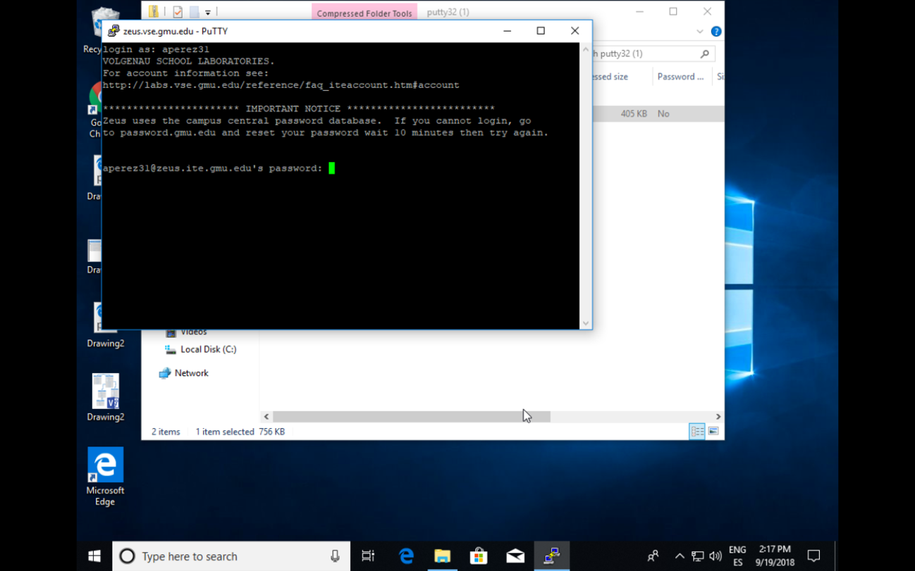

Step 3:

