ANDREA PEREZ ISLA

G01169101

09/14/2018

IT 214 – DATABASE FUNDAMENTALS

ASSIGNMENT 1

**QUESTION 1**

Consider the following tables:

CUSTOMER (**CUS_CODE**, CUS_LNAME, CUS_FNAME, CUS_PHONE)

CAR (**CAR_VIN**, CAR_LPLATE, CAR_MODEL, CUS_CODE)

For the tables given above, work on the problems below:

1. For each table, identify the primary key.

2. For each table, identify the foreign key(s).

3. Identify at least one candidate key. If there are no candidate keys, give an example of an attribute that could be used as a candidate key.

4. For one of the tables, give examples of a superkey and a secondary key.

5. For the given tables, explain how entity integrity and referential integrity could be violated. Give specific examples.

6. Use Visio to create a detailed Crow's Foot ERD. The diagram must include all entities, attributes, and relationships. Primary keys and foreign keys must be clearly identified on the diagram.

**1.**

The primary key in the first table is CUS_CODE.

The primary key in the second table is CAR_VIN.

**2.**

The foreign key is CUS_CODE.

**3.**

One candidate key could be CUS_CODE or CUS_PHONE in the first table or CAR_VIN or CAR_LPLATE.

**4.**

For the first table, one superkey could be CUS_CODE and CUS_LNAME and a secondary key could be CUS_LNAME

**5.**

Entity integrity could be violated if, for example, in the first table we choose CUS_CODE as PK and there’s two customers with the same code. On the other hand, referential integrity could be also violated if we choose as foreign key, for instance, CUS_DOB (it’s not referenced in the first table).

**6.**

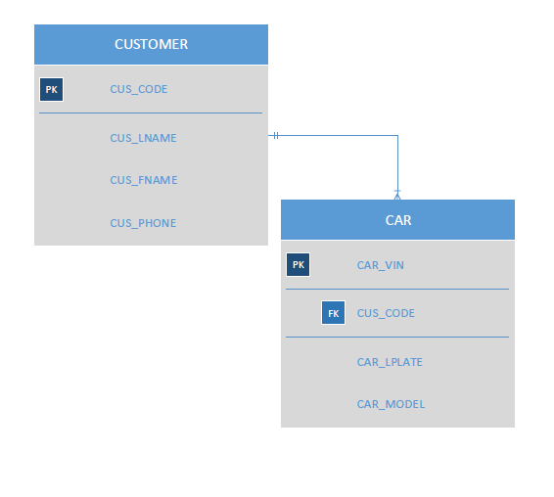

**QUESTION 2**

1. Consider the following tables:

JOB (**JOB_CODE**, JOB_TITLE, JOB_DESCRIPTION, JOB_RATE)

EMPLOYEE (**EMP_CODE**, EMP_LNAME, EMP_FNAME, EMP_PHONE, JOB_CODE)

For the tables given above, work on the problems below:

1. For each table, identify the primary key.

2. For each table, identify the foreign key(s).

3. Identify at least one candidate key. If there are no candidate keys, give an example of an attribute that could be used as a candidate key.

4. For one of the tables, give examples of a superkey and a secondary key.

5. For the given tables, explain how entity integrity and referential integrity could be violated. Give specific examples.

6. Use Visio to create a detailed Crow's Foot ERD. The diagram must include all entities, attributes, and relationships. Primary keys and foreign keys must be clearly identified on the diagram.

**1.**

The primary key in the first table is JOB_CODE.

The primary key in the second table is EMP_CODE.

**2.**

The foreign key is JOB_CODE.

**3.**

One candidate key could be JOB_CODE or JOB_TITLE in the first table or EMP_CODE or EMP_LNAME.

**4.**

For the first table, one superkey could be JOB_CODE and JOB_TITLE and a secondary key could be JOB_TITLE

**5.**

Entity integrity could be violated if, for example, in the first table we choose JOB_CODE as PK and there’s two customers with the same code. On the other hand, referential integrity could be also violated if we choose as foreign key, for instance, JOB_COMPANY (it’s not referenced in the first table).

**6.**

