**IT 214 –** Section 9

Andrea Perez Isla

G01169101

Assignment 4

**QUESTION 1**

1. 1. To keep track of vendors and products they supply, XYZ Corp. uses the table structure shown below. Assuming that the sample data are representative, draw a dependency diagram in Visio that shows all functional dependencies including both partial and transitive dependencies. (*Hint:* Look at the sample values to determine the nature of the relationships.)

|  |  |  |  |  |  |
| --- | --- | --- | --- | --- | --- |
| **PART_CODE** | **PART_DESC** | **VEND_NAME** | **VEND_ADDRESS** | **VEND_TYPE** | **PRICE** |
| 1234 | Logic Chip | Fast Chips | Cupertino | Non-profit organization | 25.00 |
| 1234 | Logic Chip | Smart Chips | Phoenix | Non-profit organization | 22.00 |
| 5678 | Memory Chip | Fast Chips | Cupertino | Profit organization | 18.00 |
| 5678 | Memory Chip | Quality Chips | Austin | Profit organization | 15.00 |
| 5678 | Memory Chip | Smart Chips | Phoenix | Profit organization | 19.00 |

1. Using the initial dependency diagram drawn in question 1, remove all partial dependencies, draw the new dependency diagrams in Visio, and identify the normal forms for each table structure you created.
2. Using the table structures you created in question 2, remove all transitive dependencies, and draw the new dependency diagrams in Visio. Also identify the normal forms for each table structure you created.  If necessary, add or modify attributes to create appropriate determinants or to adhere to the naming conventions.
3. Using the results of question 3, draw the fully labeled Crow's Foot ERD in Visio. The diagram must include all entities, attributes, and relationships. Primary keys and foreign keys must be clearly identified on the diagram.

1.

This dependency diagram represents 1NF (all key attributes are defined; no repeating groups and all attributes are dependent on primary key).

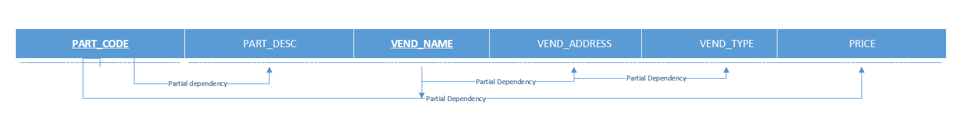

2.

These diagrams are 2NF because they are in 1NF and they don’t include any partial dependencies.

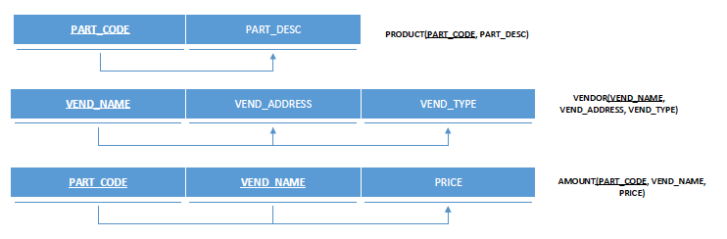

3.

In my case, there isn’t any transitive dependency, so the last section also shows 3NF.

4.

