IT 214 – Section 009

Andrea Perez Isla

Homework 7

G01169101

Note: The commands' results are different because I already created the tables in class for the lab.

* The Alexamara Marina Group: Problem 1 (p. 90). When creating tables, include FKs.

CREATE TABLE MARINA (MARINA_NUM CHAR(4) PRIMARY KEY NOTNULL, NAME CHAR(20), ADDRESS CHAR(15), CITY CHAR(15), STATE CHAR(2), ZIP CHAR(5));

CREATE TABLE OWNER (OWNER_NUM CHAR(4) PRIMARY KEY NOT NULL, LAST_NAME CHAR(50), FIRST_NAME CHAR(20), ADDRESS CHAR(15), CITY CHAR(15), STATE CHAR(2), ZIP CHAR(5));

CREATE TABLE MARINA_SLIP (SLIP_ID DECIMAL(4,0) PRIMARY KEY NOT NULL, MARINA_NUM CHAR(4), SLIP_NUM CHAR(4), LENGTH DECIMAL(4,0), RENTAL_FEE DECIMAL(8,2), BOAT_NAME CHAR(50), BOAT_TYPE CHAR(50), OWNER_NUM CHAR(4), FOREIGN KEY (MARINA_NUM) REFERENCES MARINA (MARINA_NUM), FOREIGN KEY (OWNER_NUM) REFERENCES OWNER (OWNER_NUM));

CREATE TABLE SERVICE_CATEGORY (CATEGORY_NUM DECIMAL(4,0) PRMARY KEY NOT NULL, CATEGORY_DESCRIPTION CHAR(255));

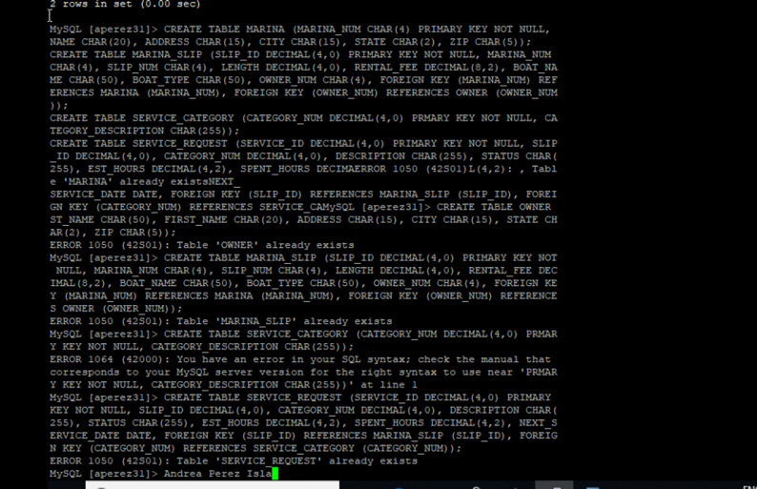CREATE TABLE SERVICE_REQUEST (SERVICE_ID DECIMAL(4,0) PRIMARY KEY NOT NULL, SLIP_ID DECIMAL(4,0), CATEGORY_NUM DECIMAL(4,0), DESCRIPTION CHAR(255), STATUS CHAR(255), EST_HOURS DECIMAL(4,2), SPENT_HOURS DECIMAL(4,2), NEXT_SERVICE_DATE DATE, FOREIGN KEY (SLIP_ID) REFERENCES MARINA_SLIP (SLIP_ID), FOREIGN KEY (CATEGORY_NUM) REFERENCES SERVICE_CATEGORY (CATEGORY_NUM));

* The Alexamara Marina Group: Problem 2 (p. 90). Add any two records to the MARINA table. After inserting data, use the SELECT* command to show the content of the table.

INSERT INTO MARINA VALUES ('1', 'Alexamara East','108 2nd Ave','Brinman','FL','32273');

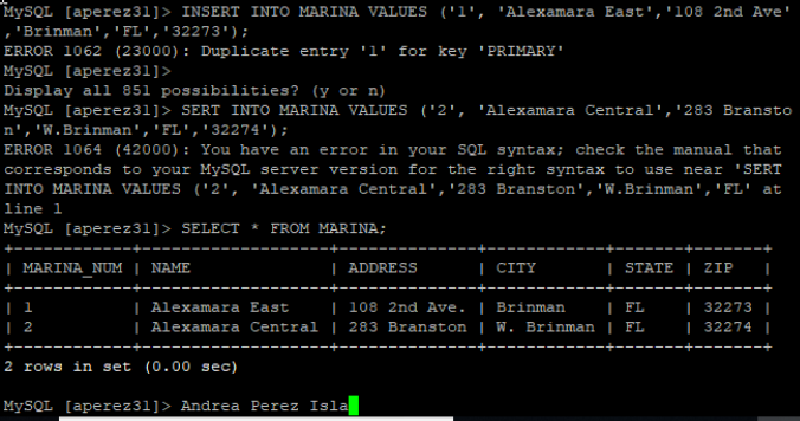INSERT INTO MARINA VALUES ('2', 'Alexamara Central','283 Branston','W.Brinman','FL','32274');

* The Alexamara Marina Group: Problem 3 (p. 90). Add any two records to the OWNER table. After inserting data, use the SELECT* command to show the content of the table.

INSERT INTO OWNER VALUES ('AD57','Adney','Bruce and Jean','208 Citrus','Bowton','FL','31313');

INSERT INTO OWNER VALUES ('AN75','Anderson','Bill','108 Wilcox','Glander Bay','FL','31044');

INSERT INTO OWNER VALUES ('BL72','Blake','Mary','2672 Commodore','Bowton','FL','31313');

INSERT INTO OWNER VALUES ('EL25','Elend','Sandy and Bill','462 Riverside','Rivard','FL','31062');

INSERT INTO OWNER VALUES ('FE82','Feenstra','Daniel','7822 Coventry','Kaleva','FL','32521');

INSERT INTO OWNER VALUES ('JU92','Juarez','Maria','8922 Oak','Rivard','FL','31062');

INSERT INTO OWNER VALUES ('KE22','Kelly','Alyssa','5271 Waters','Bowton','FL','31313');

INSERT INTO OWNER VALUES ('NO27','Norton','Peter','2811 Lakewood','Lewiston','FL','32765');

INSERT INTO OWNER VALUES ('SM72','Smeltz','Becky and Dave','922 Garland','Glander Bay','FL','31044');

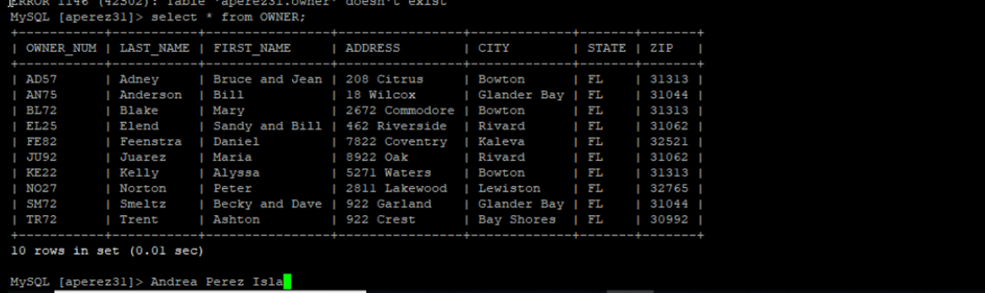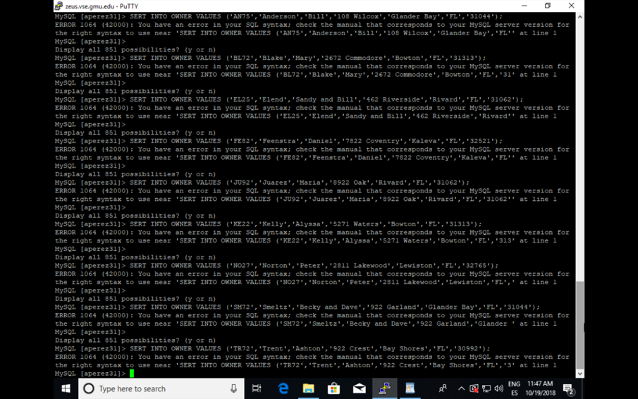INSERT INTO OWNER VALUES ('TR72','Trent','Ashton','922 Crest','Bay Shores','FL','30992');

* The Alexamara Marina Group: Problem 4 (p. 90). Add any two records to the MARINA_SLIP table. Make sure records you chose do not violate referential integrity rules (in other words, foreign key values in the MARINA_SLIP table are consistent with the primary key values in the MARINA table and the OWNER table). After inserting data, use the SELECT* command to show the content of the table.

INSERT INTO MARINA_SLIP VALUES (1,'1','A1','40',3800.00,'Anderson II','Sprite 4000','AN75');

INSERT INTO MARINA_SLIP VALUES (2,'1','A2',40,3800.00,'Our Toy','Ray 4025','EL25');

INSERT INTO MARINA_SLIP VALUES (3,'1','A3',40,3600.00,'Escape','Sprite 4000','KE22');

INSERT INTO MARINA_SLIP VALUES (4,'1','B1',30,2400.00,'Gypsy','Dolphin 28','JU92');

INSERT INTO MARINA_SLIP VALUES (5,'1','B2',30,2600.00,'Anderson III','Sprite 3000','AN75');

INSERT INTO MARINA_SLIP VALUES (6,'2','1',25,1800.00,'Bravo','Dolphin 25','AD57');

INSERT INTO MARINA_SLIP VALUES (7,'2','2',25,1800.00,'Chinook','Dolphin 22','FE82');

INSERT INTO MARINA_SLIP VALUES (8,'2','3',25,2000.00,'Listy','Dolphin 25','SM72');

INSERT INTO MARINA_SLIP VALUES (9,'2','4',30,2500.00,'Mermaid','Dolphin 28','BL72');

INSERT INTO MARINA_SLIP VALUES (10,'2','5',40,4200.00,'Axxon II','Dolphin 40','NO27');

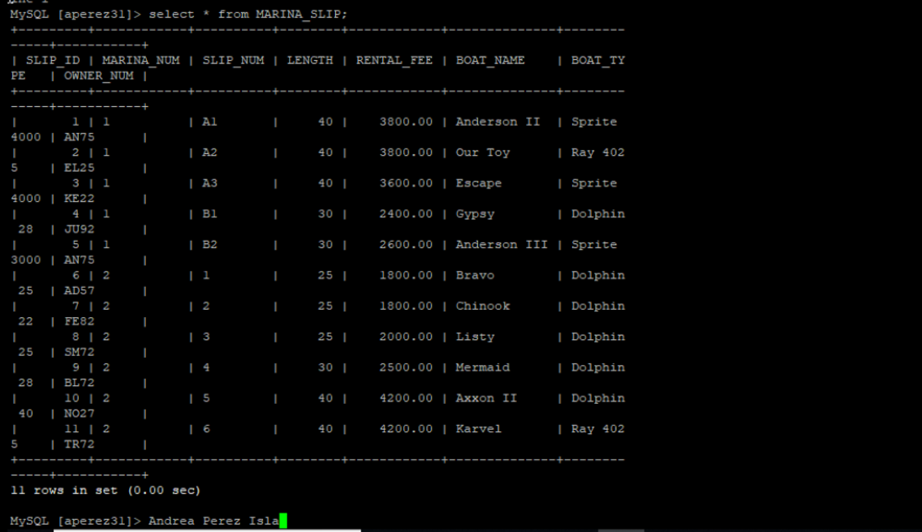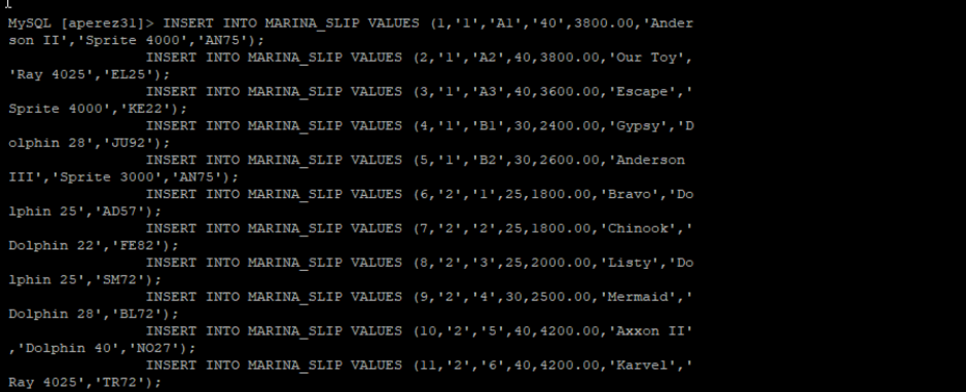INSERT INTO MARINA_SLIP VALUES (11,'2','6',40,4200.00,'Karvel','Ray 4025','TR72');

* The Alexamara Marina Group: Problem 5 (p. 90). Add any two records to the SERVICE_CATEGORY table. After inserting data, use the SELECT* command to show the content of the table.

INSERT INTO SERVICE_CATEGORY VALUES (9,'Seating Map');

INSERT INTO SERVICE_CATEGORY VALUES (10,'Medical Assistance');

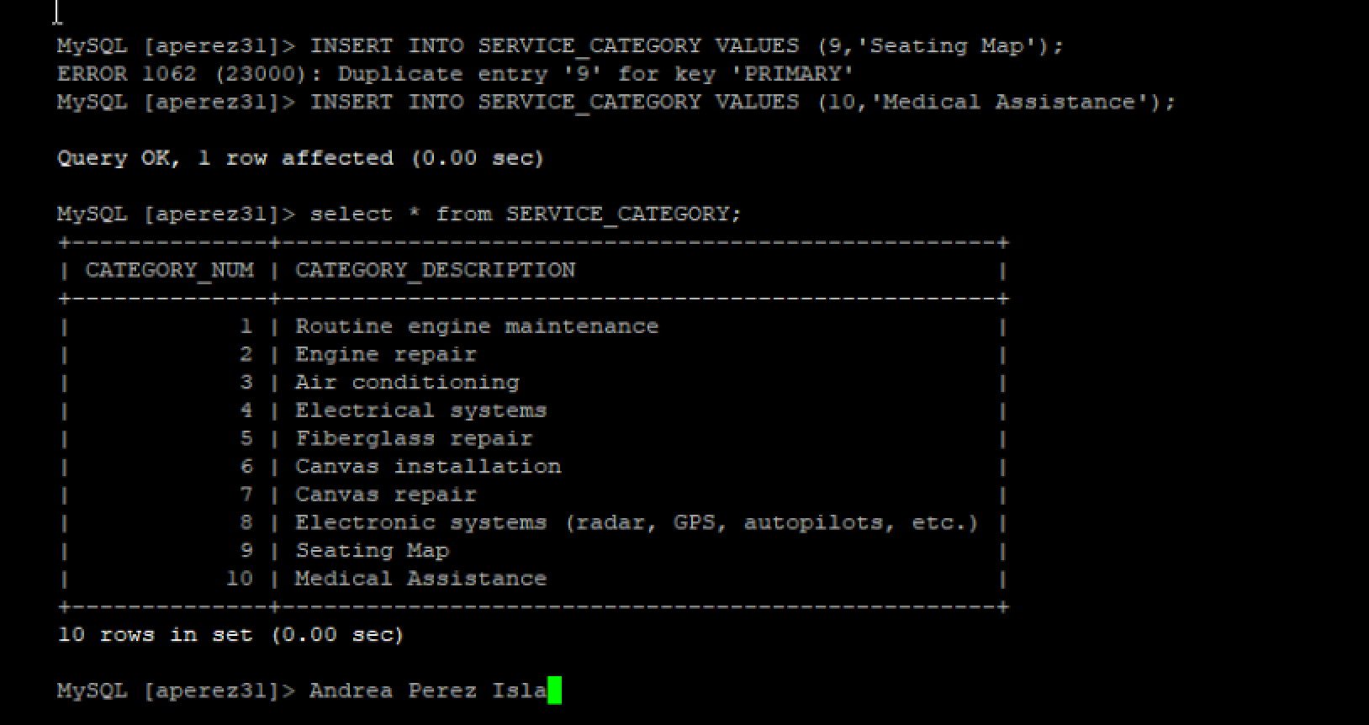

* The Alexamara Marina Group: Problem 6 (p. 90). Add any two records to the SERVICE_REQUEST table. Make sure records you chose do not violate referential integrity rules (in other words, foreign key values in the SERVICE_REQUEST table are consistent with the primary key values in the SERVICE_CATEGORY table and the MARINA_SLIP table). After inserting data, use the SELECT* command to show the content of the table.

INSERT INTO SERVICE_REQUEST VALUES (11,7,8,'Install new amazing features .','Scheduled','4','1','2007-07-19');

INSERT INTO SERVICE_REQUEST VALUES (12,2,3,'Repair the wheels from the front side','Scheduled','6','4','2007-08-12');

