IT 214 – Section 009

Andrea Perez Isla

G01169101

Homework 8

11/01/18

ALEXAMARA EXERCISES

14. Calculate the total rental fees Alexamara receives each year based on the length of the slip.

SELECT LENGTH, SUM(RENTAL_FEE) FROM MARINA_SLIP GROUP BY LENGTH;

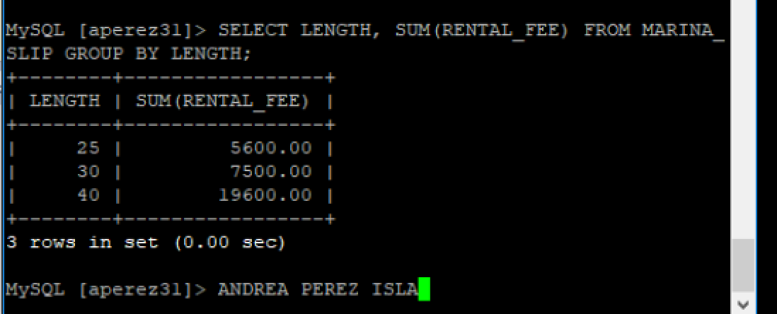

2. List the complete MARINA table (all rows and columns).

SELECT * FROM MARINA;

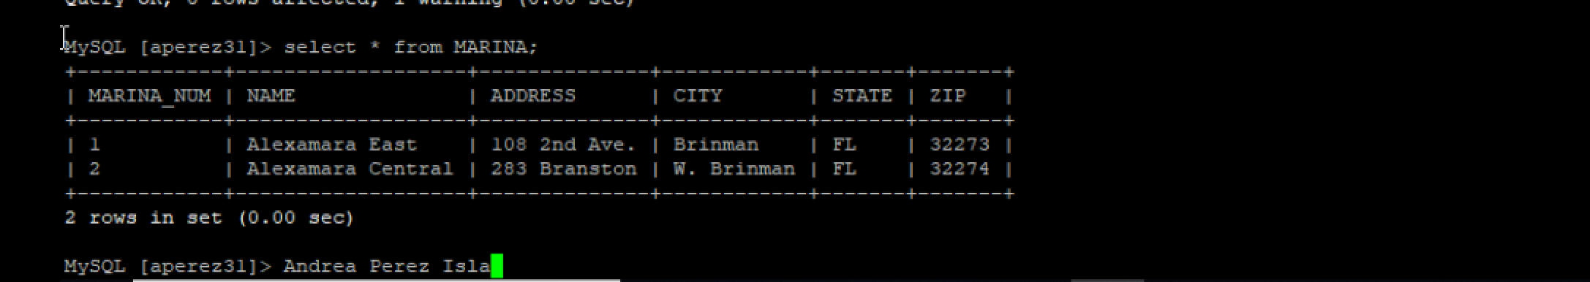

6. List the marina number and slip number for every boat with the type Dolphin 28.

SELECT MARINA_NUM, SLIP_NUM FROM MARINA_SLIP WHERE BOAT_TYPE = 'Dolphin 28';

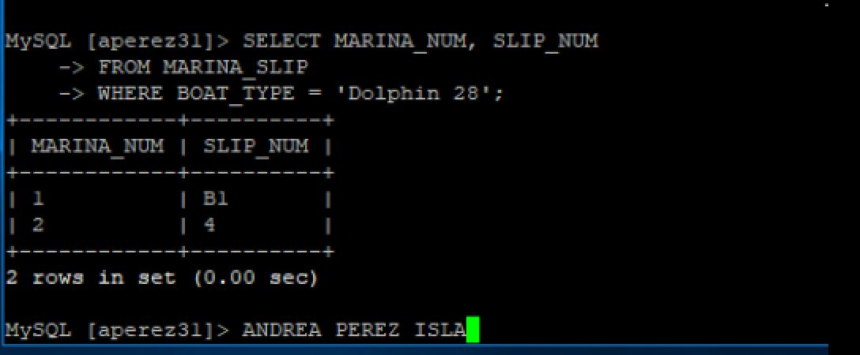

8. List the boat name for each boat located in a slip whose length is between 25 and 30 feet.

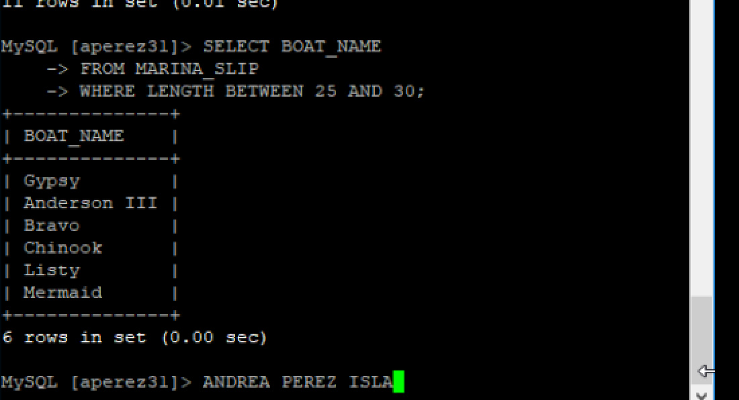 SELECT BOAT_NAME FROM MARINA_SLIP WHERE LENGTH BETWEEN 25 AND 30;

11. List the marina number and slip number for all slips containing a boat with the type Sprite 4000, Sprite 3000, or Ray 4025.

SELECT MARINA_NUM, SLIP_NUM FROM MARINA_SLIP WHERE BOAT_TYPE IN ('Sprite 4000','Sprite 3000','Ray 4025');

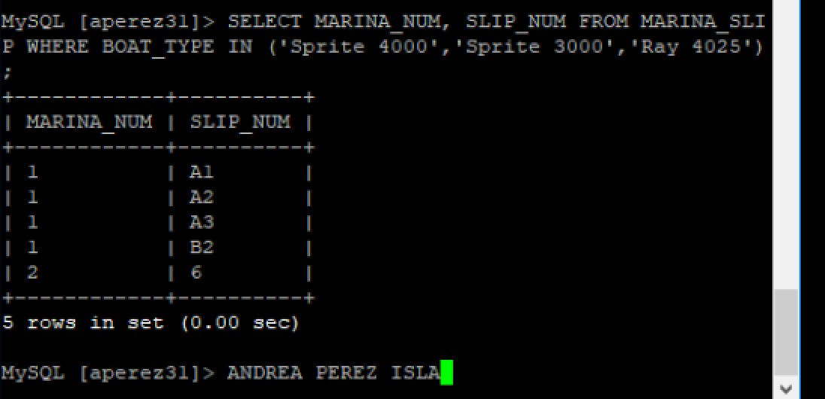

12. List the marina number, slip number, and boat name for all boats. Sort the results by boat name within marina number.

SELECT MARINA_NUM, SLIP_NUM, BOAT_NAME FROM MARINA_SLIP ORDER BY BOAT_NAME, MARINA_NUM;

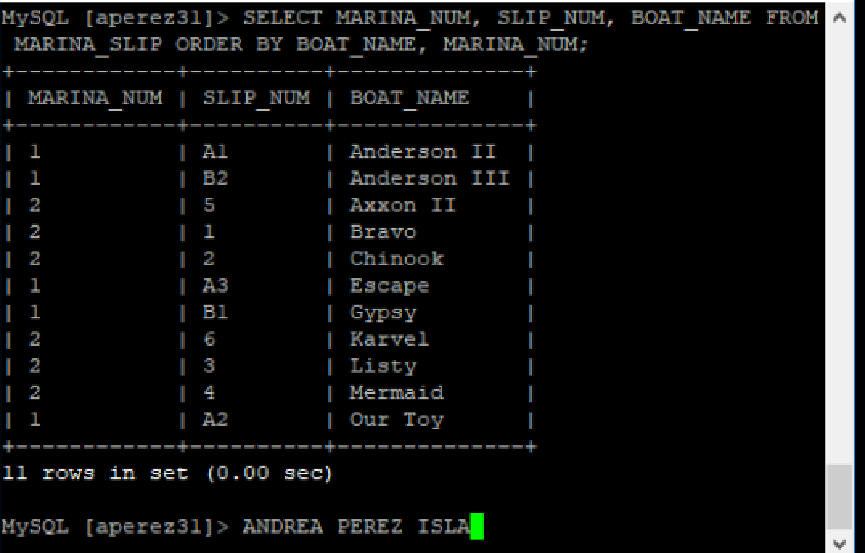

PREMIERE EXERCISES

9. List the part number, part description, and on-hand value (units on hand * unit price) of each part in item class AP. Assign the name ON_HAND_VALUE to the computation.

SELECT PART_NUM, DESCRIPTION, (ON_HAND * PRICE) AS ON_HAND_VALUE FROM PART WHERE CLASS = 'AP';

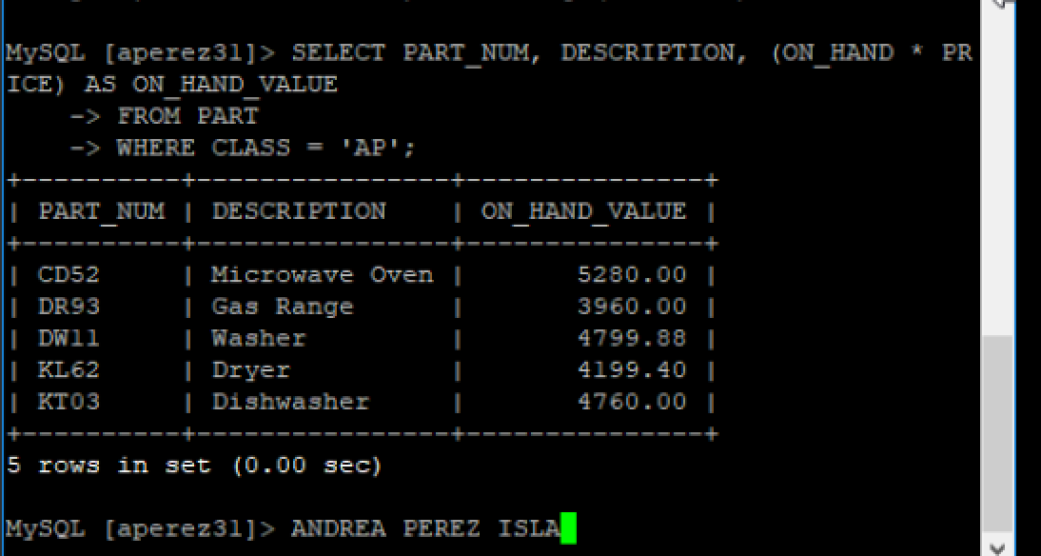

3. List the names of customers with credit limits of $7,500 or less

SELECT CUSTOMER_NAME, CREDIT_LIMIT FROM CUSTOMER WHERE CREDIT_LIMIT <= 7500;

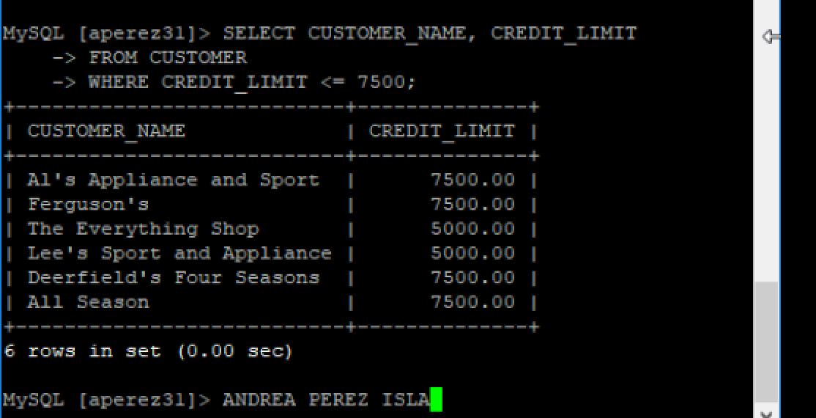

20. List the sum of the balances of all customers for each sales rep, but restrict the output to those sales reps for which the sum is more than $10,000.

SELECT REP_NUM, SUM(BALANCE) FROM CUSTOMER GROUP BY REP_NUM HAVING SUM(BALANCE) > 10000 ORDER BY REP_NUM;

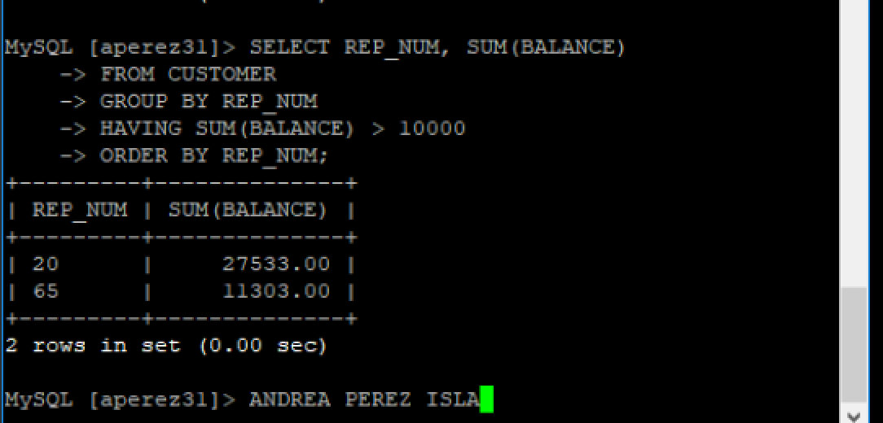

2. List all rows and columns for the complete ORDERS table.

SELECT * FROM ORDERS;

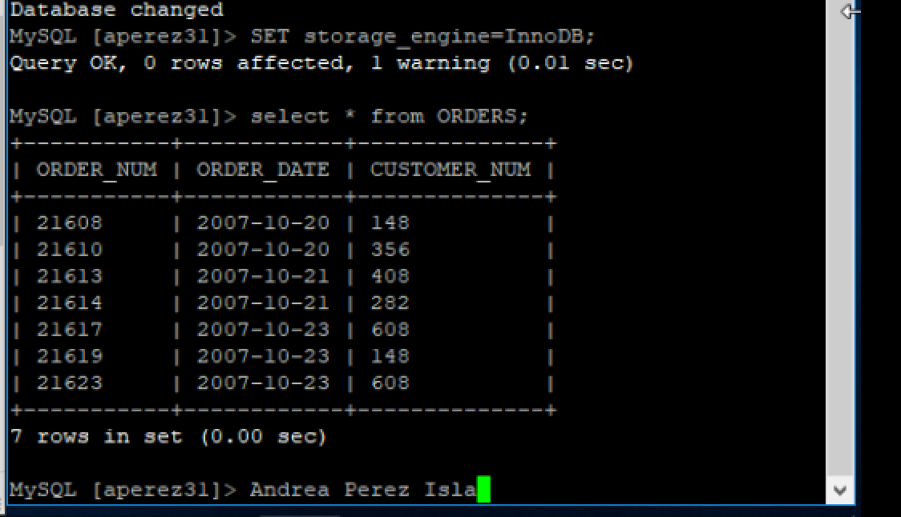

12. List all details about all parts. Order the output by part description.

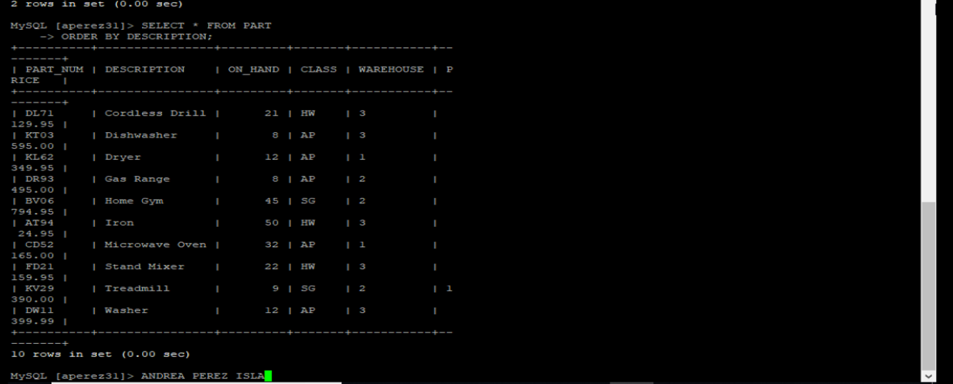 SELECT * FROM PART ORDER BY DESCRIPTION;

10. Use the IN operator to list the part number and part description or each part in item class AP or SG.

SELECT PART_NUM, DESCRIPTION FROM PART WHERE CLASS IN ('AP', 'SG');

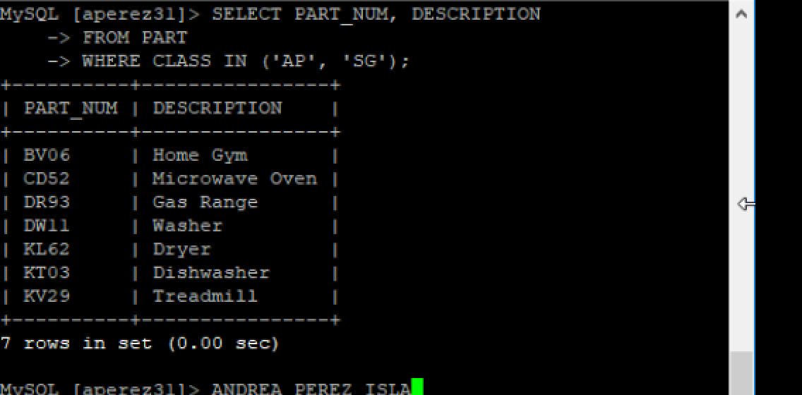

18.What is the part number, description, and price of the most expensive part in the database? (Hint: Use a subquery).

SELECT PART_NUM, DESCRIPTION, PRICE FROM PART WHERE PRICE = (SELECT MAX(PRICE) FROM PART);

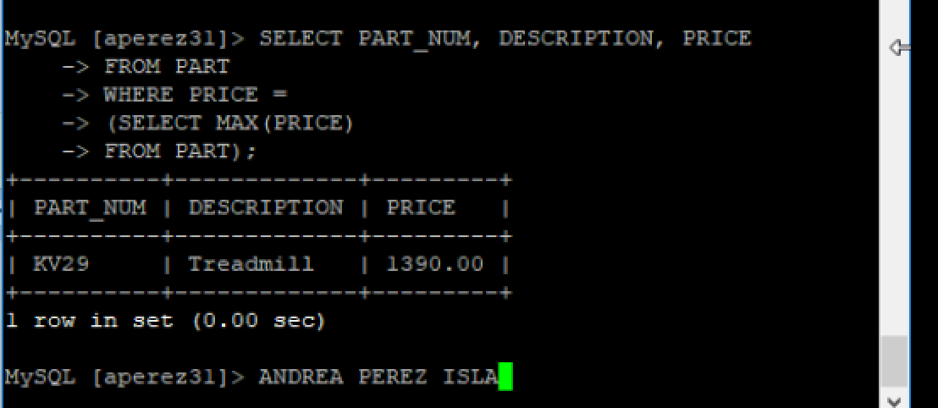

7. List the part number, description, and number of units on hand for each part that has between 10 and 25 units on hand, including both 10 and 25. Do this two ways.

SELECT PART_NUM, DESCRIPTION, ON_HAND FROM PART WHERE ON_HAND >= 10 AND ON_HAND <= 25;

SELECT PART_NUM, DESCRIPTION, ON_HAND FROM PART WHERE ON_HAND BETWEEN 10 AND 25;

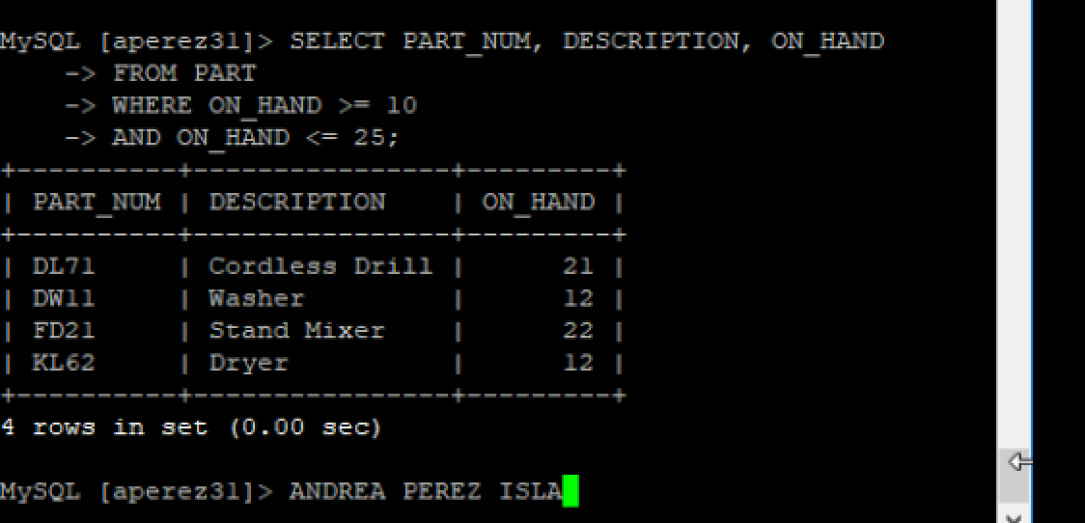

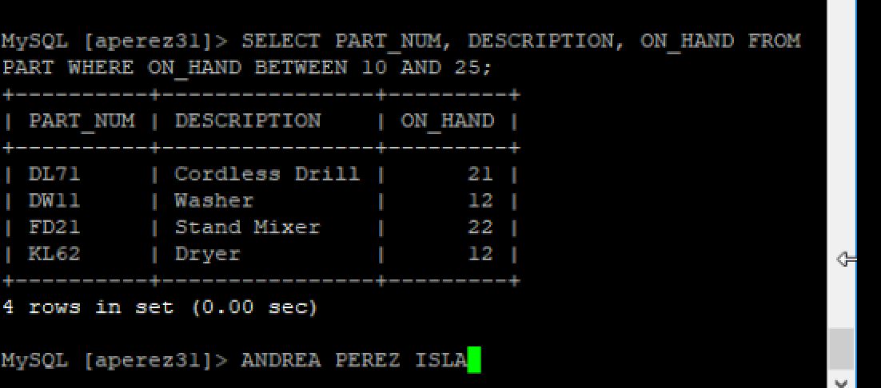

HENRY EXERCISES

19. Repeat Exercise 18, but consider only paperback books.

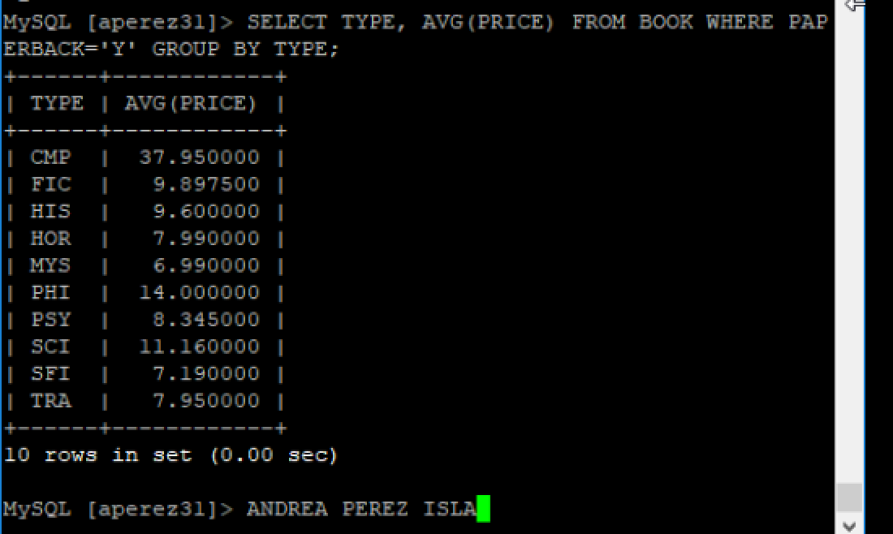 SELECT TYPE, AVG(PRICE) FROM BOOK WHERE PAPERBACK='Y' GROUP BY TYPE;

3. List the name of each publisher located in Boston.

SELECT PUBLISHER_NAME FROM PUBLISHER WHERE CITY = 'Boston';

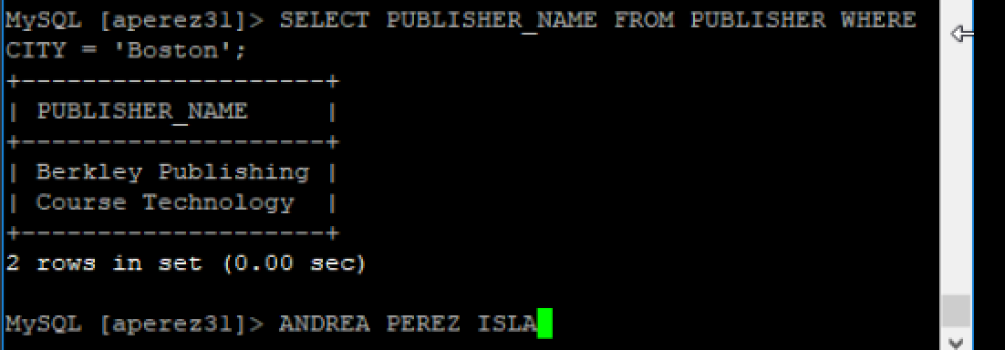

13. List the book code and book title of each book that has the type SFO, MYS, or ART. Use the IN operator in your command.

SELECT BOOK_CODE, TITLE FROM BOOK WHERE TYPE IN ('SFO','MYS','ART');

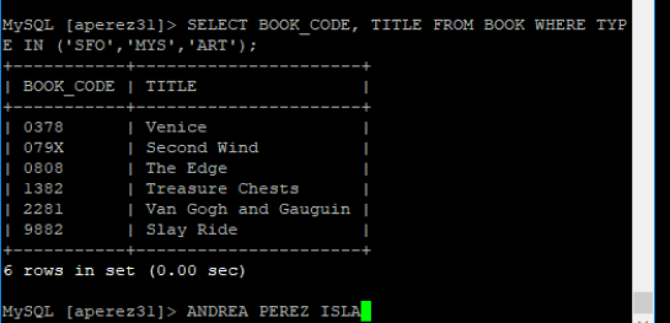

17. How many books have the type SFI?

SELECT COUNT(*) FROM BOOK WHERE TYPE='SFI';

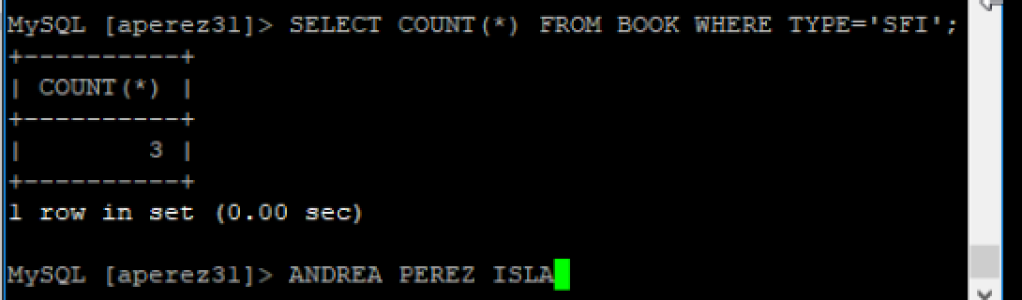

8. List the book code and book title of each book that has the type SFI or is published by the publisher with the publisher code SC.

SELECT BOOK_CODE, TITLE FROM BOOK WHERE TYPE ='SFI' OR PUBLISHER_CODE='SC';

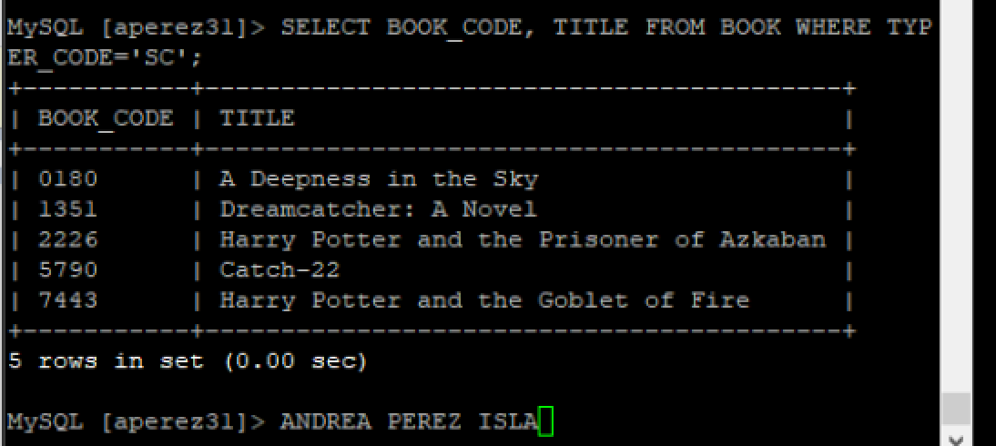

4. List the name of each publisher not located in Boston.

SELECT PUBLISHER_NAME FROM PUBLISHER WHERE CITY <> 'Boston';

