Is a Small Wind Turbine Worth It Where I Live?
A feasibility study for Modena, Italy
Andrea Piciuolo · independent engineering project · June 2026

Summary
I live in Modena, and I wanted to know whether a small wind turbine on a house here would actually be worth it. Instead of guessing, I built a model in Python that takes the real wind conditions in my city and works out how much electricity a small turbine could make in a year. I also designed the turbine blade myself using basic aerodynamics, so the efficiency in my model comes from a real calculation and not from a number I picked out of the air.
The short answer is no. Modena sits in the Po Valley, where the wind is very weak, around 2 meters per second near the ground. Even the best turbine I could fit on a normal house would make roughly 793 kilowatt hours a year, which is about 29 percent of what an average Italian home uses. A small set of solar panels on the same roof would make about five times more. So if someone in Modena wants clean electricity at home, they should put up solar, not wind. The part I find interesting is that the turbine itself is not really the point. The location decides almost everything, and a bit of math up front can stop someone from wasting their money.

Why I did this
The idea started with something I kept seeing online. You can buy small wind turbines for a few hundred euros, with photos of them spinning happily on top of houses and descriptions promising free electricity. I always wondered if they really work or if they are mostly decoration. Modena does not feel windy. On most days the air is completely still, and in winter the fog sits over the whole plain for days without moving. That made me doubt that a turbine here would turn much at all.
Rather than argue about it, I decided to treat it as an engineering problem and get a real number. I also wanted a reason to learn how engineers actually model this kind of thing, because I am planning to study mechanical engineering and I had never built a working physical model in code before. So the project had two goals. Answer the question for my own city, and teach myself the method from the ground up.

The question, stated carefully
I had to be careful about what I was asking, because "is wind worth it" is too vague to answer. I narrowed it down to this. For a small turbine that a normal household could realistically put up, meaning a rotor a few meters across on a tower no taller than the building rules and the neighbors would accept, how many kilowatt hours would it produce in an average year in Modena? And how does that compare to what a home actually uses, and to the obvious alternative, which is solar panels?
Asking it this way gave me something I could compute, and something I could check against common sense at every step.

Some physics I had to learn first
Before writing any code I had to understand where the energy in wind comes from. The power you can get from moving air passing through a circle of area A is one half times the density of the air, times that area, times the wind speed cubed, times a number called the power coefficient that says what fraction the turbine can actually take. The detail that surprised me most is that the wind speed is cubed. If the wind doubles, the power goes up eight times. This single fact ended up explaining my whole result, because it means a slow site is punished extremely hard.
There is also a hard ceiling. A physicist named Albert Betz showed about a hundred years ago that no turbine can ever capture more than about 59 percent of the energy in the wind. The reasoning is clever. If a turbine took all the energy, the air behind it would have to stop completely, and stopped air would block the wind still coming from behind. So there is a best amount to take, and it works out to roughly 0.593. Real turbines do worse than this because of friction and other losses, and good small ones reach somewhere around 40 to 45 percent. I kept the Betz number in mind the whole time as a check. If my code ever claimed a value above 0.593, I would know I had a bug.
The last piece was describing the wind itself. Wind is never steady, so a single average speed throws away most of the story. Engineers describe a site with a Weibull distribution, which is just a curve showing how often each wind speed shows up over a year. It has two settings. A scale value, which is close to the average speed, and a shape value, which says how spread out the speeds are. Once I had those two numbers for Modena, I could treat the wind properly instead of pretending it blows at one speed all the time.

Finding out how much wind Modena really gets
Getting the wind data was the first real task, and it also gave me my first hint of the answer. I used two free sources that researchers actually rely on. The Global Wind Atlas, made by the Technical University of Denmark together with the World Bank, gives wind statistics for any point on the map. NASA runs a project called POWER that provides long term weather data for any coordinates, which I used as a cross check.
The numbers came back low, even lower than I expected, and I already thought Modena was calm. The average wind speed near the ground is around 2 meters per second. For comparison, the places where real wind farms get built usually average above 6 or 7. The reason is geography. Modena is in the Po Valley, a wide flat basin closed in by the Alps to the north and the Apennines to the south. Air gets trapped there, and in winter temperature inversions hold it still for long stretches. Reading about this made the data make sense to me. The same closed in geography that gives us our famous fog is what kills the wind. For the model I set the Weibull scale to about 2.25 and the shape to about 1.8, which matches both the measured average and the gusty, often calm behavior you get in a closed basin.

Turning wind into energy
With the wind described, I could build the part that turns it into electricity. I wrote everything in Python inside a free Google notebook, partly so that anyone could rerun my work without buying special software.
First I built a power curve, which is the graph of how much power the turbine makes at each wind speed. A real turbine produces nothing below a cut in speed of about 3 meters per second, because there is not enough force to overcome friction and start it turning. Above that it follows the cube law and climbs quickly. At its rated speed, around 11 meters per second, it reaches full power and then stays flat, because beyond that the machine limits itself instead of making more. At very high speeds, around 25, it shuts down so it does not damage itself. Figure 1 shows this whole shape.
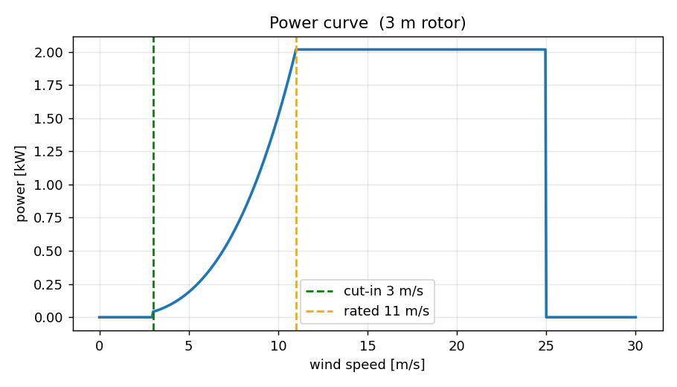
Figure 1. The power curve of the turbine I modeled. It makes nothing below the cut in speed near 3 m/s, climbs steeply through the cube law, then holds flat at its rated power.
Knowing the power at each speed is not enough on its own, because the turbine only meets each speed for part of the year. So I combined the power curve with the Weibull wind curve. For every wind speed I multiplied the power the turbine makes at that speed by the number of hours per year the wind actually blows at that speed, then added it all up across the 8760 hours in a year. That total is the annual energy in kilowatt hours, and it is the single most useful number in the project, because it is the thing you would see on an electricity bill.
When I plotted Modena's wind curve next to the turbine's cut in speed, the problem jumped straight out at me. Figure 2 shows it. Most of the wind in Modena is below 3 meters per second, which is below the speed where the turbine even starts to turn. The turbine spends most of the year standing still. I also added the effect of tower height, since wind moves faster higher up, using the standard power law that scales speed with height. Going taller helps, but not enough to get around the basic problem.
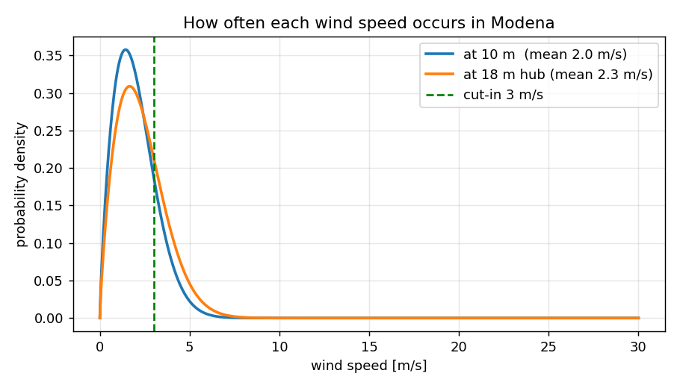
Figure 2. How often each wind speed happens in Modena, at ground level and at an 18 m tower. Most of the wind sits to the left of the cut in line, so the turbine is idle for much of the year.

Designing the blade
Up to this point I had used a guessed efficiency of 35 percent, and that bothered me. It meant the most important part of the turbine, the blade, was just a number I had typed in. So I decided to actually design the blade and calculate its efficiency, and this turned into my favorite part of the whole project.
A turbine blade is really a long thin wing. Each slice of it makes lift the same way an airplane wing does. There is a known way to find the ideal shape. For the blade to capture the most energy, each point along it should meet the wind at a particular angle, and from that angle you can work out how wide the blade should be and how much it should be twisted at every position from the root to the tip. I coded these equations and got a blade that is wide and steeply twisted near the center, then thin and almost flat at the tip. Figure 3 shows it. When I saw the shape my code drew, I recognized it right away, because it looks exactly like the blades on real wind turbines. That was a good moment, because it told me the math was behaving the way it should.
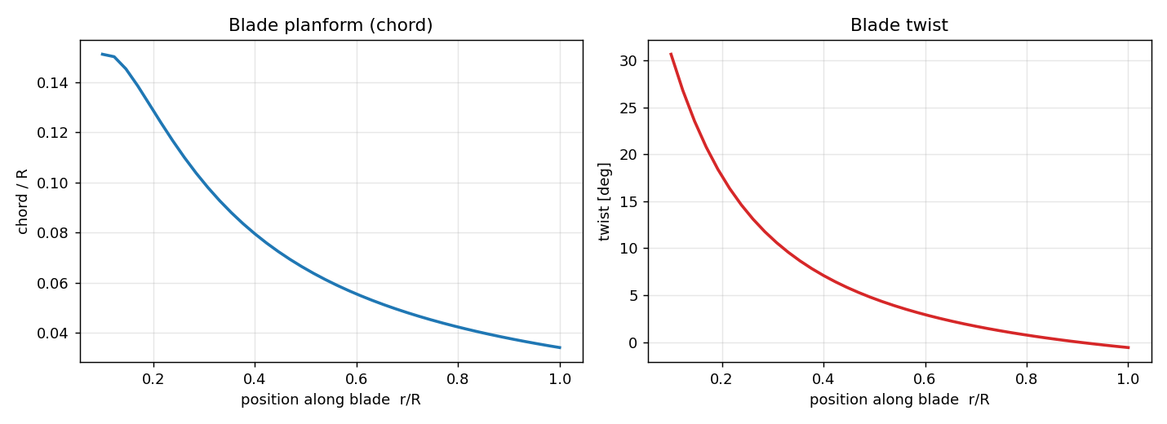
Figure 3. The blade shape produced by the design equations: wide and twisted near the root, thin and nearly flat at the tip. This is the same shape used on real turbines.
Designing the shape is one thing, but I still needed to know how efficient that shape really is. For that I used a method called Blade Element Momentum theory, which is the standard tool for this. The idea is to cut the blade into many thin rings, work out the aerodynamic forces on each ring including drag, and balance them against the momentum the air loses as it passes through and slows down. The equations cannot be solved in one shot. You have to repeat the calculation until the numbers settle, which is exactly the kind of patient work a computer is good at and a person is not.
The result is a curve of efficiency against tip speed ratio, which is how fast the blade tips move compared to the wind. Figure 4 shows it. My blade peaks at an efficiency of about 0.428, reached when the tips move about seven times faster than the wind. I was happy with this for two reasons. It is below the Betz limit of 0.593, which it has to be, so the model is not cheating. And it lands right in the range that real small turbines reach, so it is believable. I then fed this real efficiency back into the energy model in place of my earlier guess. It pushed the energy up a little, from 284 to about 347 kilowatt hours for a typical 3 meter rotor, but it did not change the story. Even a well designed blade cannot make energy out of wind that is not there.
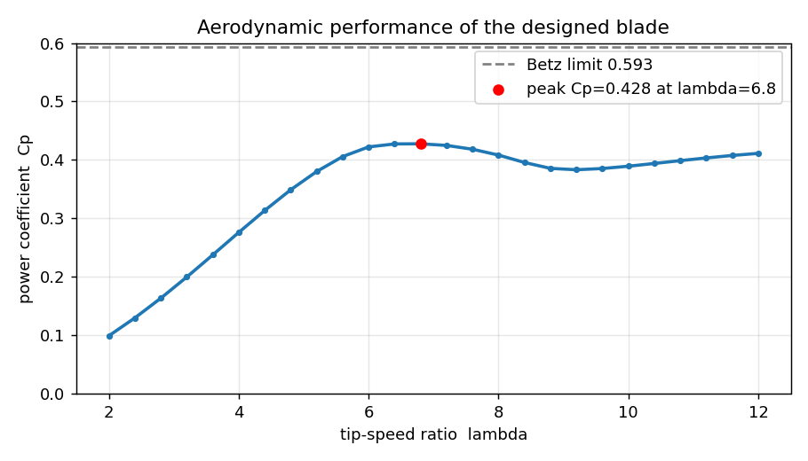
Figure 4. Efficiency of the designed blade against tip speed ratio. It peaks near 0.428, comfortably below the Betz limit of 0.593, which is the sign of a sensible result.

Finding the best turbine the site allows
The last design question was how big to make the turbine. I had two main choices, the rotor diameter and the tower height. A bigger rotor catches more wind, and a taller tower reaches faster wind, but both cost more and both run into practical limits on a house. So I had the code try every combination of diameter from 1 to 6 meters and height from 10 to 30 meters, calculate the annual energy for each one, and pick the best combination that still fit limits I thought were reasonable for a home, which I set at a rotor no wider than 4 meters and a tower no taller than 24 meters. Figure 5 shows the whole map of results.
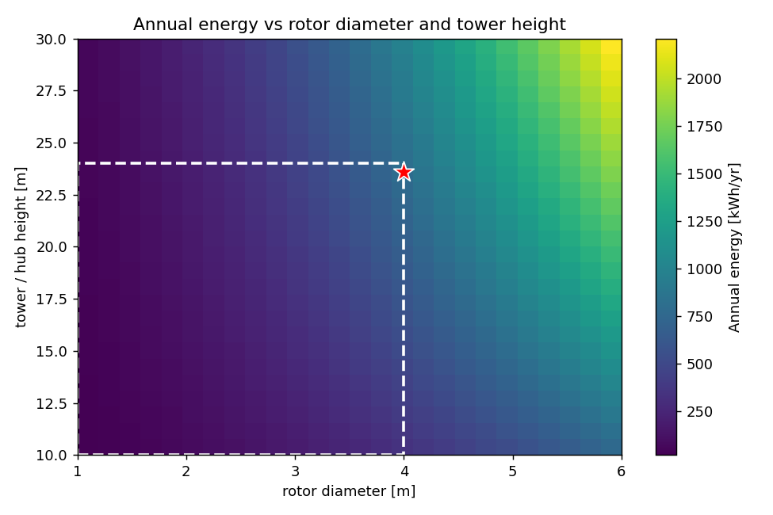
Figure 5. Annual energy for every rotor size and tower height. The dashed box is what I judged acceptable on a normal house, and the star is the best design inside it.
The winner was a 4 meter rotor on a 24 meter tower, making about 793 kilowatt hours a year. The interesting thing is where that best point sits. It sits in the corner, pressed right up against both of the limits I set. In a normal optimization you expect the best answer to be somewhere in the middle, where two effects balance. Here there is no balance, because bigger and taller is always better. The model is telling me that I am not limited by my design choices at all. I am limited by the wind. No clever turbine fixes a site with no wind in it.
To put 793 kilowatt hours in context, an average Italian home uses about 2700 kilowatt hours of electricity a year. So the best turbine I could reasonably build would cover about 29 percent of one home and keep roughly 246 kilograms of carbon dioxide out of the air each year, based on how the Italian grid is currently powered. That is not nothing. But it is also not the free energy the advertisements suggest, and getting there would still mean buying a real turbine, putting up a tower, and wiring in an inverter.

The honest comparison: wind versus solar
Any real feasibility study has to compare against the alternative, and in Italy the obvious alternative is solar. Modena has weak wind, but it gets a decent amount of sun. Using public solar data for the city, a small rooftop system of 3 kilowatts, which is a normal size for a house, would make around 4050 kilowatt hours a year. That is about five times what my best wind turbine could do, on the same roof, for less money, and with no moving parts to wear out. Figure 6 puts the two side by side.
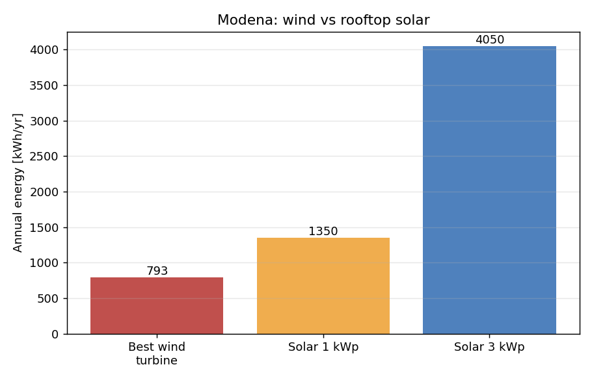
Figure 6. The best Modena wind turbine next to an ordinary rooftop solar array. Solar produces roughly five times more energy at the same location.
This was the result that made the whole project feel worth doing. The turbine is not broken and my design is not bad. It is simply the wrong tool for this place. The comparison only became clear because I had built both numbers myself and could lay them next to each other.

What I conclude
My conclusion for Modena is simple. A small wind turbine is not worth it here. The wind in the Po Valley is too weak and too often below the speed a turbine needs, and even a well sized, well designed machine is beaten about five to one by ordinary rooftop solar. If I wanted to add clean energy to a house in Modena, I would put up panels and not think twice.
I want to be clear that this is not an argument against small wind everywhere. The exact same turbine I designed would do well on a coast, on a ridge, or on an open plain where the average wind is above 5 or 6 meters per second, and in a place like that it would make several thousand kilowatt hours a year. The real lesson is about matching the machine to the site. Where you put a turbine matters far more than how good the turbine is.

What this model gets wrong
A model is only as honest as the assumptions behind it, so I want to be open about what mine leaves out. I described the wind with a single Weibull curve instead of measurements taken on the actual spot, and Po Valley wind is irregular enough that a few weeks of data from a real sensor could move my energy number up or down. I used a simple mathematical airfoil rather than wind tunnel data for a specific blade profile, so my efficiency curve is realistic but not exact. My aerodynamic method, while standard, ignores some three dimensional and time changing effects that a professional study would include. I also assumed the turbine always spins at its best speed, which a cheap fixed turbine does not. And I did not work out cost, payback time, noise, vibration, or whether local rules would even permit a 24 meter tower in a residential street.
The reason I am comfortable with these gaps is that none of them touch the main reason for my result. The result is driven by the cube law acting on a weak wind resource, and that is a large effect that a more detailed model would only sharpen, not reverse. If anything, the true numbers would probably be a little worse for the turbine, not better.

What I would do next
If I keep working on this, the first thing I would do is borrow or build a small wind sensor and record real wind at a spot near my house for a few weeks, then compare it against what my model assumed. After that I would add a cost model so I could talk about payback time in euros, since that is what actually matters to a family deciding what to install. The extension I find most interesting, though, is to run the exact same code for many locations across Italy and draw a map of where small wind finally beats solar. That would turn a single answer for one city into a tool that works anywhere, and I think that is a more useful thing to have built.

What I learned
I started this wanting a yes or no answer, and I got one, but the things I will keep are the skills. I had never written code that models something real before, and now I have. I learned what a Weibull distribution is and why engineers bother with it. I learned how a blade is actually shaped and why, and I can explain the twist now instead of just noticing it in photos. I learned to use the Betz limit as a sanity check on my own work. And I learned that a careful calculation done early can answer a question that people usually settle with opinions, and that sometimes the most useful result is the one that tells you not to build the thing.

Data sources and references
Global Wind Atlas, Technical University of Denmark and the World Bank. Wind speed and Weibull parameters for Modena. globalwindatlas.info
NASA POWER project, NASA Langley Research Center. Long term wind speed data used as a cross check. power.larc.nasa.gov
PVGIS, European Commission Joint Research Centre. Solar yield for Modena used in the comparison. pvgis.com
ARERA, the Italian energy regulator. Typical household electricity use of about 2700 kWh per year.
Italian electricity grid carbon intensity, about 0.31 kg CO2 per kWh, 2024 figures.
Manwell, McGowan and Rogers, Wind Energy Explained: Theory, Design and Application. Source for the blade design equations and Blade Element Momentum method.
Betz, A. (1920). The maximum theoretical fraction of wind energy a turbine can capture, about 0.593.

