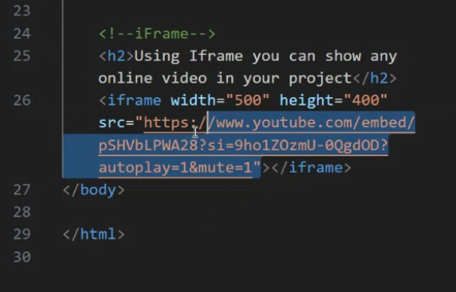



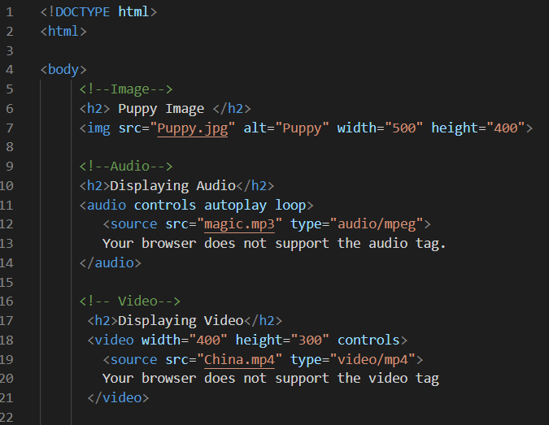

<https://www.youtube.com/embed/uiAeCFYJBvU?si=gurEOf4dH9aU_hJX>

