INSTRUCTIONS
FBLAconnect+

INSTALL APP

- Export APK (Android)
- Go to settings, security and enable the option to "Install unknown apps"
- Install APK: Open the following link https://drive.google.com/file/d/1p8vaHXUIlOfkFz6wReuSeK8rt2l6tzcP/view?usp=drive_link
- Tap the downloaded file
- Accept the permissions and tap install

- ios
- Due to financial resource limitations, the app could not be tested on iOS as it requires publication

FIRST USE
- Create Account
- Open the app
- Select Sign Up
- Enter:
- Name
- Email
- Password
- Chapter
- Accept Terms and Policies

- Login
- Enter:
- Email
- Password

- View Announcements

- Open Home Screen
- Click " " to like the announcement
- Tap "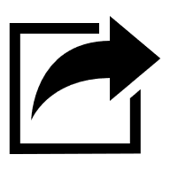" to share the ad on the social network of choice
- Tap an ad to see more details
- Press "See more" to open the official news if you wish

- Use the Calendar

- Press calendar icon "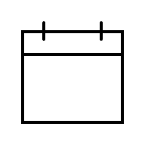" on the nav bar
- Press "Month" for the monthly view of the calendar
- Press "Week" for the seminal view of the calendar
- Press "+" to create a new event
- See upcoming events in "Coming Up"
- View past events in "Past Due"

- View Resources

- Press the book icon "" on the nav bar
- Search for a resource using the search engine
- Filter documents with the main list
- Press "See more" to view the document

- View Profile

- Press the person icon "" on the nav bar
- View information
- Press "Edit profile" to edit profile information or delete account
- Press "Change password" to change the password
- Press "Log Out" to log out

