reproduce-fat-exosome-microrna

jonathan dreyfuss

2016-10-21 16:04:59

## Purpose

To reproduce qPCR analyses, including statements in text and output, from Thomou et al. article.

## Adipose Tissue is a Major Source of Circulating Exosomal miRNAs

## There were 709 miRNAs profiled of which 653 were detected.

Compared to control, ADicerKO mice exhibited significant alterations in 422 circulating miRNAs. Of these, only 3 miRNAs had a significant increase, while 419 had significant decreases (Figures 1c-d, S1d and Supplemental Table 1) with 88% reduced by >4-fold and 13% reduced by >32-fold

## :-)

## :-)

## :-)

## :-)

## :-)

write supp table 1

Heatmap Fig 1c  
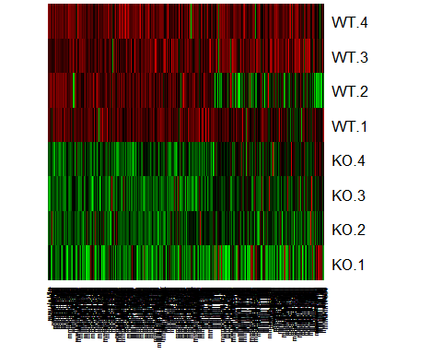

PCA in S1d  
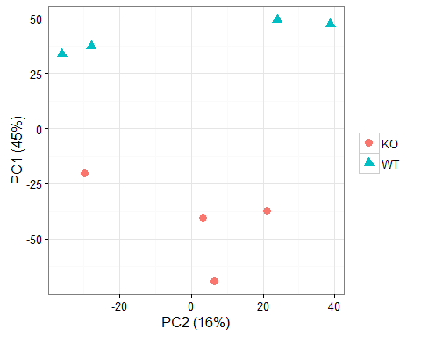

Indeed, in sample of 80 miRNAs of which 79 were detected there was a 50-75% reduction in total serum miRNAs in ADicerKO serum when compared to total serum of WT mice (Extended Data Figure 2a)

## There were 80 miRNAs profiled of which 79 were detected.

## :-)

## :-)

## [1] FALSE

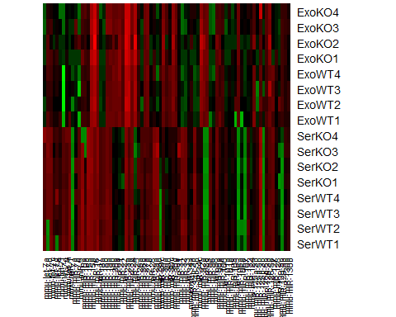

Thus, brown preadipocytes isolated from Dicer-floxed animals and recombined by transduction with Ad-Cre exhibited marked reductions of at least 2 fold difference in 380 miRNAs profiled of which 359 were detectable in 91% of the exosomal miRNAs released in culture supernatants when compared to control Ad-GFP transduced cells (Extended Data Figure 2b).

## There were 380 miRNAs profiled of which 359 were detected.

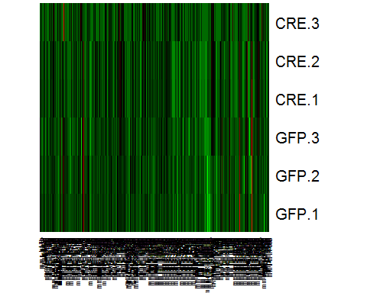

Genome-wide qPCR profiling of 572 miRNAs in human sera revealed 119 significantly different between control and HIV lipodystrophy subjects and 213 significantly different between control and CGL subjects (Figures 1e-f, Extended Data Figure 3b, Supplemental Tables 2 and 3).

## :-)

## :-)

## :-)

heatmap 1e  
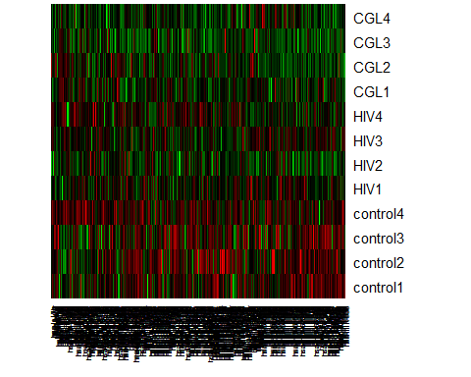

PCA S3b  
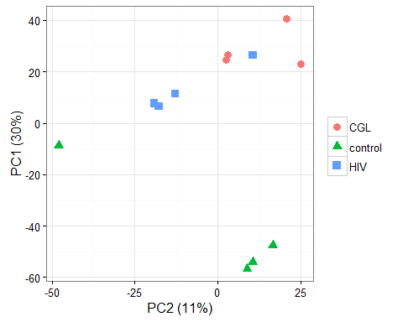

write supp tables 2 & 3

Of these, only 5% (29 miRNAs) were upregulated in either HIV or CGL patients, while 217 (38%) were robustly decreased in either CGL or HIV lipodystrophy, and 75 were decreased in both lipodystrophy groups (Figure 1g, Supplemental Table 4)

## :-)

## :-)

## :-)

## :-)

## :-)

Thirty of the miRNAs that were decreased in serum of both patient cohorts were also decreased in the serum of the ADicerKO mice (Supplemental Table 5).

## :-)

## There were 380 miRNAs profiled of which 373 were detected.

miRNA profiling of circulating exosomes from 4 week-old ADicerKO mice (Extended Data Figure 3c) demonstrated that of the 380 profiled miRNAs, 373 miRNAs were detectable, of which 43% (or 202 miRNAs) were down-regulated in ADicerKO mice and only 4% (23 miRNAs) were up-regulated when compared to Lox littermate controls.

## :-)

## :-)

## :-)

## Adipose Tissue Transplantation Reconstitutes Circulating miRNAs in Lipodystrophic Mice

## There were 380 miRNAs profiled of which 371 were detected.

## There were 329 miRNAs profiled of which 321 were detected.

miRNA profiling of subcutaneous inguinal (Ing) WAT, intraabdominal epididymal (Epi) WAT, and interscapular BAT from the normal donor mice taken at the time of transplantation revealed distinct, depot-specific signatures consistent with previous studies (Figure 2b).

Using mean normalization from [Mestdagh et al, 2009](https://genomebiology.biomedcentral.com/articles/10.1186/gb-2009-10-6-r64).

## There were 380 miRNAs profiled of which 371 were detected.

## There were 329 miRNAs profiled of which 321 were detected.

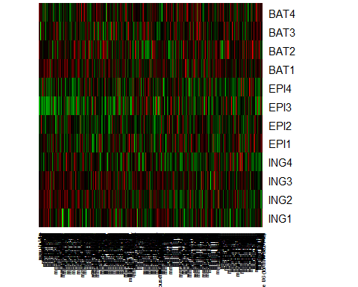

Venn of mirs over u6 (fig 2b), independent of global avg.  
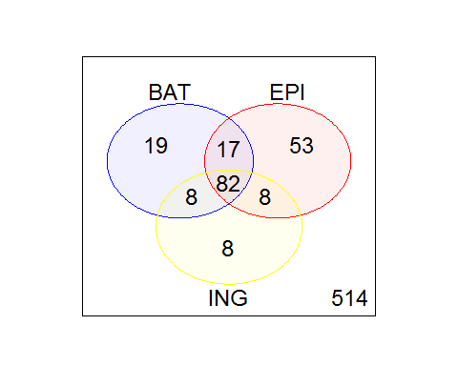

Considering only the miRNAs that were expressed in at least one fat depot, 126 were highly expressed in BAT, 106 in Ing-WAT, and 160 in Epi-WAT, with 82 of these miRNAs expressed in all three depots (Figures 2b, Extended Data 4a; Supplemental Table 6).

## :-)

with 82 of these miRNAs expressed in all three depots.

## :-)

PCA S2a  
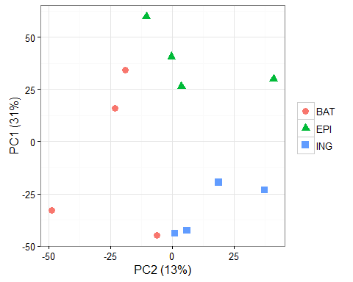

### Transplant (not depot) data

## TT question: we keep 375 mirs that have enough WT expression.

## There were 375 miRNAs profiled

As in the first cohort, in the sham operated ADicerKO mice circulating exosomal miRNAs were markedly reduced compared to controls (Figure 2c). By comparison, ADicerKO mice that received BAT and Ing-WAT transplants showed remarkable restoration of circulating exosomal miRNAs, with lower restoration in mice receiving Epi-WAT (Figures 2c and Extended Data Figure 5a; Supplemental Tables 7 and 8).  
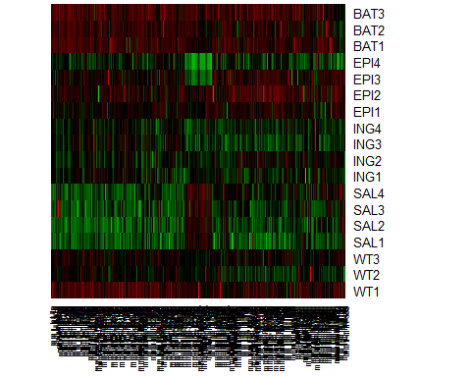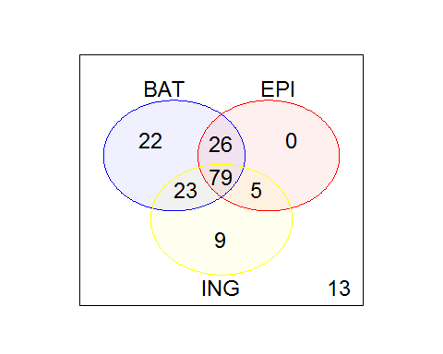

PCA S5a  
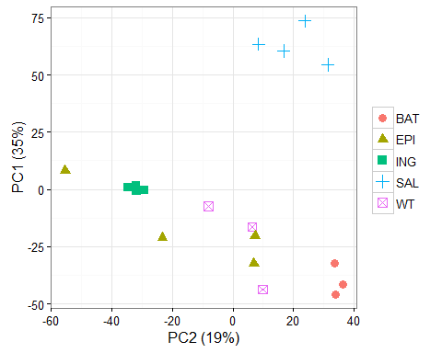

Indeed, of the circulating exosomal miRNAs profiled, 375 revealed detectable levels of expression (Ct<34), and most of which were significantly decreased in ADicerKO serum, fat transplantation restored the levels of 150, 110, and 116 at least 50% of the way to normal in mice receiving BAT, Epi-WAT and Ing-WAT transplants, respectively.

## :-)

## :-)

Four miRNA candidates were identified (miR-99a, miR-99b, miR-100, and miR-466i), and three of these (miR-99a, -99b, and -100) were decreased by 75-80% in the serum of ADicerKO mice compared to controls.

## BAT.avg EPI.avg ING.avg SAL.avg WT.avg SALvsWT.p  
## mmu-miR-99a 6.060000 4.4025 4.115 -0.5425 4.923333 1.352823e-05  
## mmu-miR-99b 3.193333 1.8150 1.800 -0.6125 1.840000 1.205406e-02  
## mmu-miR-100 4.583333 3.7775 2.390 -3.2425 3.526667 1.677365e-05  
## mmu-miR-466i 2.430000 -2.8775 -0.980 4.1175 1.170000 1.150642e-01  
## SALvsWT.FDR SALvsWT.logFC SALvsWT.FC BATvsSAL.p  
## mmu-miR-99a 0.0001014617 -5.465833 -44.195676 1.352434e-06  
## mmu-miR-99b 0.0332373075 -2.452500 -5.473638 4.464796e-04  
## mmu-miR-100 0.0001186815 -6.769167 -109.074244 2.965917e-06  
## mmu-miR-466i 0.1970277075 2.947500 7.714112 3.544264e-01  
## BATvsSAL.FDR BATvsSAL.logFC BATvsSAL.FC EPIvsSAL.p  
## mmu-miR-99a 9.584262e-06 6.602500 97.174104 1.764992e-05  
## mmu-miR-99b 1.395249e-03 3.805833 13.985242 8.016095e-03  
## mmu-miR-100 1.917618e-05 7.825833 226.887502 4.373445e-06  
## mmu-miR-466i 4.386466e-01 -1.687500 -3.220981 5.695578e-04  
## EPIvsSAL.FDR EPIvsSAL.logFC EPIvsSAL.FC INGvsSAL.p  
## mmu-miR-99a 1.272831e-04 4.9450 30.803022 3.463242e-05  
## mmu-miR-99b 1.867103e-02 2.4275 5.379604 8.336388e-03  
## mmu-miR-100 4.432545e-05 7.0200 129.786813 5.498807e-05  
## mmu-miR-466i 2.321567e-03 -6.9950 -127.557154 6.633533e-03  
## INGvsSAL.FDR INGvsSAL.logFC INGvsSAL.FC  
## mmu-miR-99a 0.0002749503 4.6575 25.237551  
## mmu-miR-99b 0.0225066859 2.4125 5.323961  
## mmu-miR-100 0.0004043240 5.6325 49.607969  
## mmu-miR-466i 0.0194341784 -5.0975 -34.237371

## BAT EPI ING  
## mmu-miR-99a TRUE TRUE TRUE  
## mmu-miR-99b TRUE TRUE TRUE  
## mmu-miR-100 TRUE TRUE TRUE

## Session Info

## R version 3.3.1 (2016-06-21)  
## Platform: x86_64-w64-mingw32/x64 (64-bit)  
## Running under: Windows 7 x64 (build 7601) Service Pack 1  
##   
## locale:  
## [1] LC_COLLATE=English_United States.1252   
## [2] LC_CTYPE=English_United States.1252   
## [3] LC_MONETARY=English_United States.1252  
## [4] LC_NUMERIC=C   
## [5] LC_TIME=English_United States.1252   
##   
## attached base packages:  
## [1] stats graphics grDevices utils datasets methods base   
##   
## other attached packages:  
## [1] ggplot2_2.1.0 limma_3.28.6 gplots_3.0.1   
##   
## loaded via a namespace (and not attached):  
## [1] Rcpp_0.12.5 knitr_1.13 magrittr_1.5   
## [4] munsell_0.4.3 colorspace_1.2-6 stringr_1.0.0   
## [7] plyr_1.8.4 caTools_1.17.1 tools_3.3.1   
## [10] grid_3.3.1 gtable_0.2.0 KernSmooth_2.23-15  
## [13] htmltools_0.3.5 gtools_3.5.0 yaml_2.1.13   
## [16] digest_0.6.9 formatR_1.4 bitops_1.0-6   
## [19] evaluate_0.9 rmarkdown_1.0 labeling_0.3   
## [22] gdata_2.17.0 stringi_1.1.1 scales_0.4.0