Name: Caden Sampsel Mark _____________________/50

[**Instructions**: Remove everything that is not a heading below and fill in with your own diagrams, etc.]

**1. Brief introduction __/3**

The feature that I am responsible for is the enemies. The enemies play an important role in the game because they are what creates a challenge for the player. The different levels of the game will have different enemies in them, but they should mostly do the same things. This includes tracking/following the player and damaging/attacking the player.

**2. Use case diagram with scenario __14**

**Use Case Diagrams**

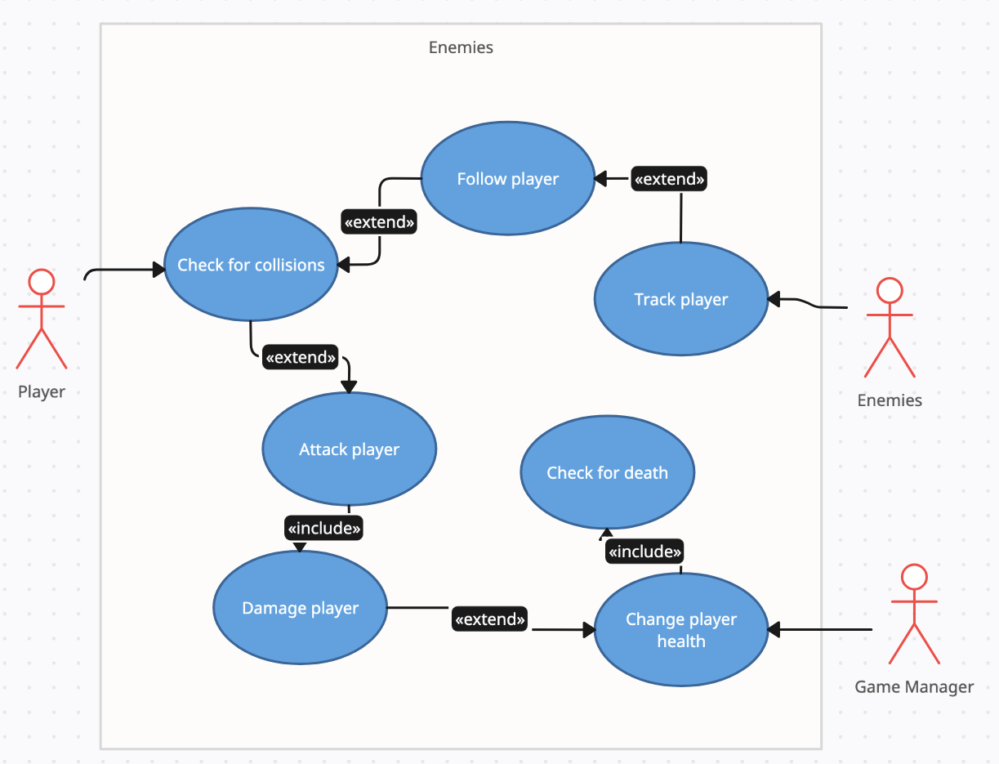

**Scenarios**

**Name:** Track Player

**Summary:** The enemies track the position of the player and move towards them. If they collide, they will do damage to the player.

**Actors:** Player

**Preconditions:** Character and enemies have been initialized.

**Basic sequence:**

**Step 1:** Get the current position of enemy and player.

**Step 2:** Start moving towards the player.

**Step 3:** Check to see if the enemy has collided with the player.

**Step 4:** Attack and damage the player.

**Step 5:** Change the player's health and check if the player has died.

**Exception**

**Step 1:** The enemy is colliding with the environment. Find a path to move around obstacles.

**Post conditions:** The player is damaged and could possibly die.

**Priority:** 2*

**ID:** C01

*The priorities are 1 = must have, 2 = essential, 3 = nice to have

**3. Data Flow diagram(s) from Level 0 to process description for your feature _______14**

**Data Flow Diagrams**

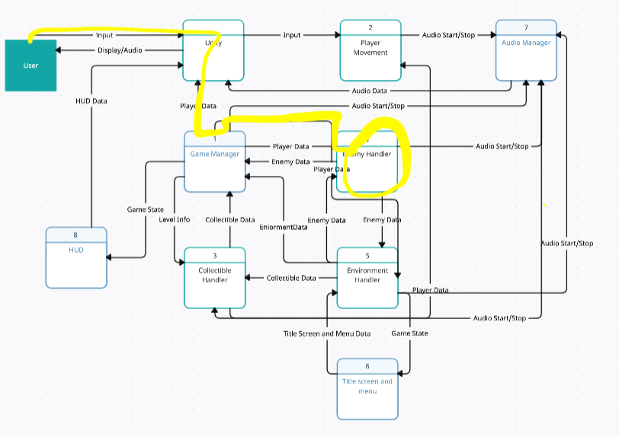

**Process Descriptions**

Follow Player:

WHILE game running

Get player position

Move towards Player

Update positions

END WHILE

Check for Collision:

WHILE game running

IF touching player

Damage player

Check if player is dead

Update player health/status

END IF

IF touching environment

Move around obstacle

END IF

END WHILE

**4. Acceptance Tests ________9**

Test player/enemy collision

* Recognize and distinguish collisions between player/enemy and obstacle/enemy
* Assure correct animation/sound plays

Test changing player health

* Make sure player health stat can be changed
* Assure player dies after dropping the player health to zero
* Give a death screen when player dies

**5. Timeline _________/10**

**Work items**

| Task | Duration (PWks) | Predecessor Task(s) |
| --- | --- | --- |
| 1. Enemy Design | 2 | - |
| 1. Asset Creation | 2 | 1 |
| 1. Basic Pathing | 3 | 2 |
| 1. Player Interactions | 3 | 3 |
| 1. Environment Collision | 2 | 3 |
| 1. Testing | 3 | 4,5 |
| 1. Installation | 1 | 6 |



|  |  | **Gantt timeline** | | | | |  |  |  |  |  |  |  |  |
| --- | --- | --- | --- | --- | --- | --- | --- | --- | --- | --- | --- | --- | --- | --- |
| 1 |  |  |  |  |  |  |  |  |  |  |  |  |  |  |
|  |  |  |  |  |  |  |  |  |  |  |  |  |  |
| 2 |  |  | 1 |  |  |  |  |  |  |  |  |  |  |  |
| 3 |  |  |  |  | 2 |  |  |  |  |  |  |  |  |  |
| 4 |  |  |  |  |  |  |  | 3 |  |  |  |  |  |  |
| 5 |  |  |  |  |  |  |  | 3 |  |  |  |  |  |  |
| 6 |  |  |  |  |  |  |  |  |  |  | 6 |  |  |  |
| 7 |  |  |  |  |  |  |  |  |  |  |  |  |  | 7 |
| 1 | | 2 | 3 | 4 | 5 | 6 | 7 | 8 | 9 | 10 | 11 | 12 | 13 | 14 |