Recommendation Challenge

1. **Check out from repository**

The project can be found at:

<http://cvs/svn/IRML/trunk/RecommenderStreamEval/>

Use eclipse to check out the project to your local machine.

1. **Start the Application**

Since the project uses the playframework (version 2.2.3), eclipse will not be able to compile the project directly. In order to compile the project, please open the play console for initializing the project and for resolving the dependencies. The play framework is included in the svn project. Having checked out the project, you have to execute the following steps:

1. Open a console (e.g. cmd or bash) and navigate to the project directory.
2. Start there the play console by entering$> play (you may have to set the x flag on Unix systems, chmod a+x play).
3. Type ‘eclipse’ in the play console in order to enable eclipse support. In some case the class 'SimpleRegression' cannot be found. The required library is located in the lib directory ‘lib/’. If the eclipse does not find the library automatically, you have to configure it manually in project properties. After that can you retype ‘eclipse’. Now there should be no error more.
4. Type ‘run’ to start the application.
5. Open http://localhost:9000 with your web browser.

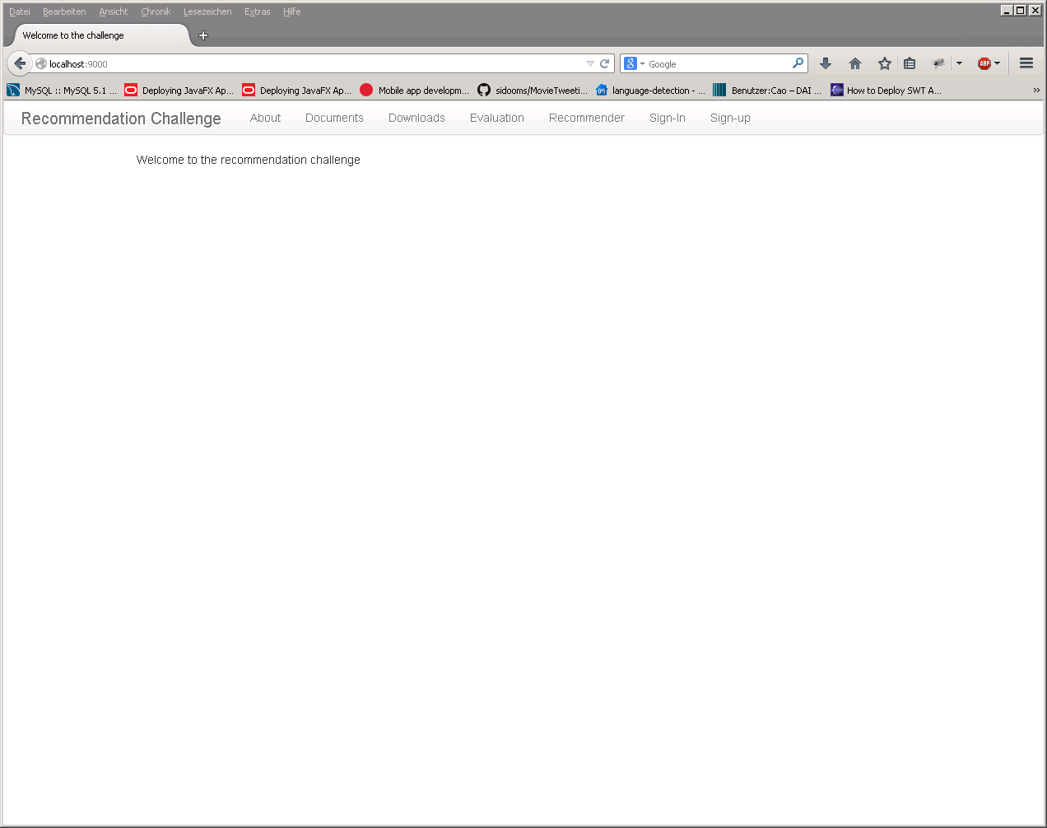

Picture 1: Recommendation challenge homepage.

1. **Using Application.**
2. **Homepage**

See picture 1

1. **Sign-Up**

Here can you create new account. This will be saved in one properties data.

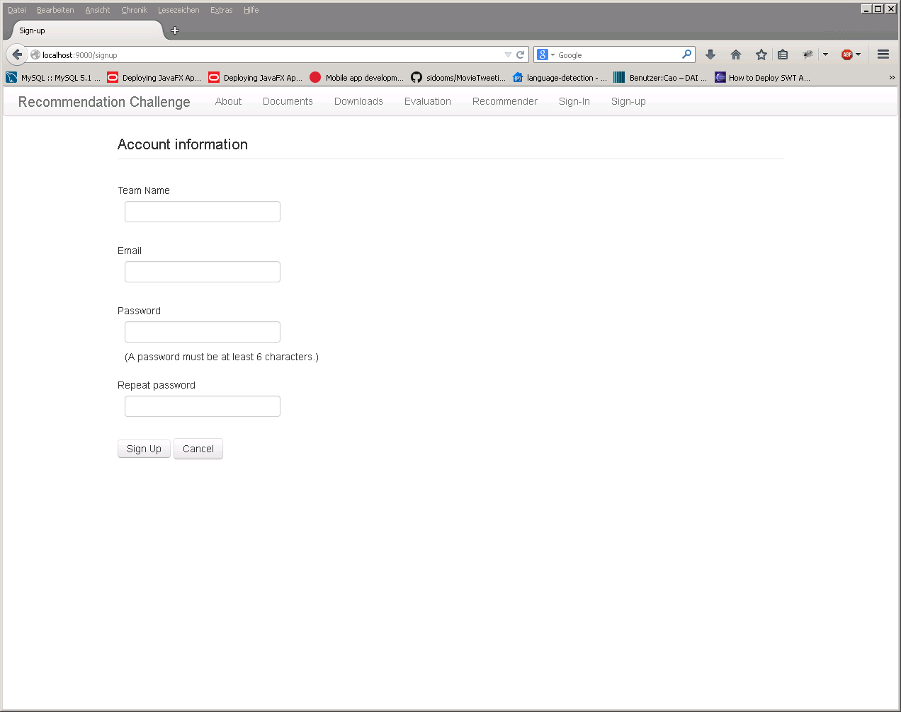

Picture 2: sing-up

1. **Sign-In**

If you have already an account, you can sign in here with your email and password. After you login, the web portal shows you the ID and how to get the request.

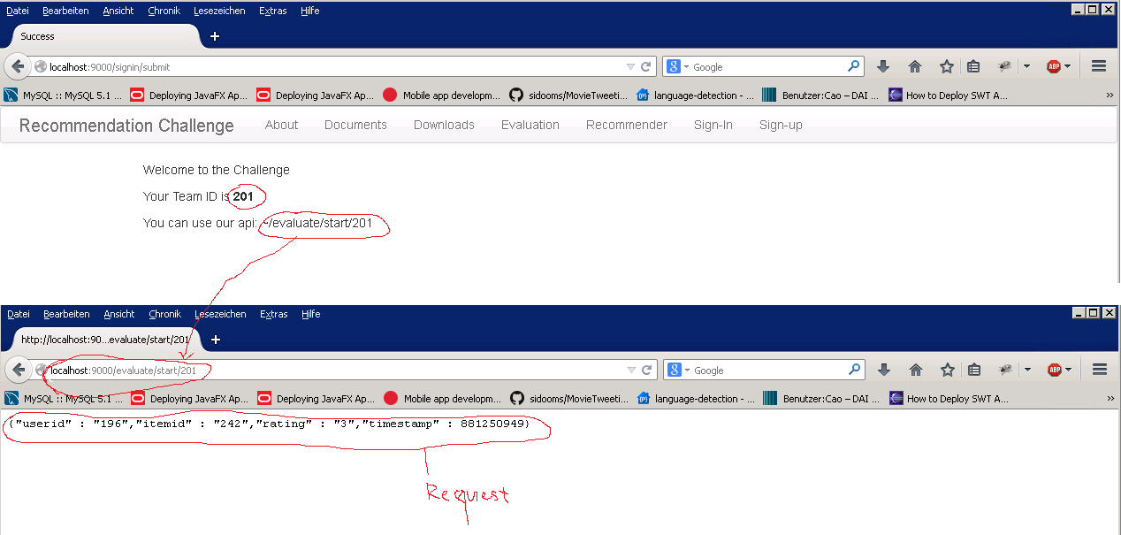

Figure 3: Sign-In and Request

You can recall the api (F5) to get new request. The rating score in every fifth request will be hidden (see figure 4). The challenge of recommender is to predict this rating score.

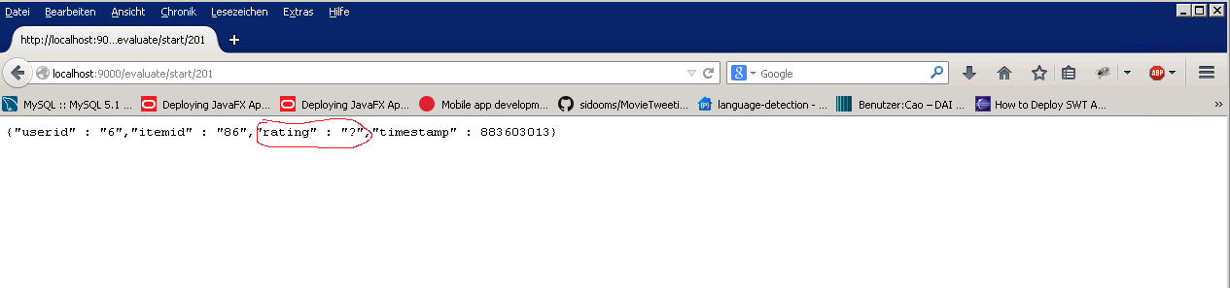

Figure 4: Hiding Rating

1. **About**

That is description about recommendation challenge. You can change it under app/views/about.scala.html

1. **Documents**

That is description how to get request from server. That can be changed under app/views/document.scala.html

1. **Download**

Here can you save the data to your computer. At right site, you can choose the time interval to query new data that you really need. For example, you want only download the data which were released from 1.Mai to 1.June. You have to choose ‘start date’ is 1.Mai and ‘end date’ is 1.June then click on ‘Query’ button. When the process finished, you must restart the site or click on ‘refresh the list’ to see new files at left site.

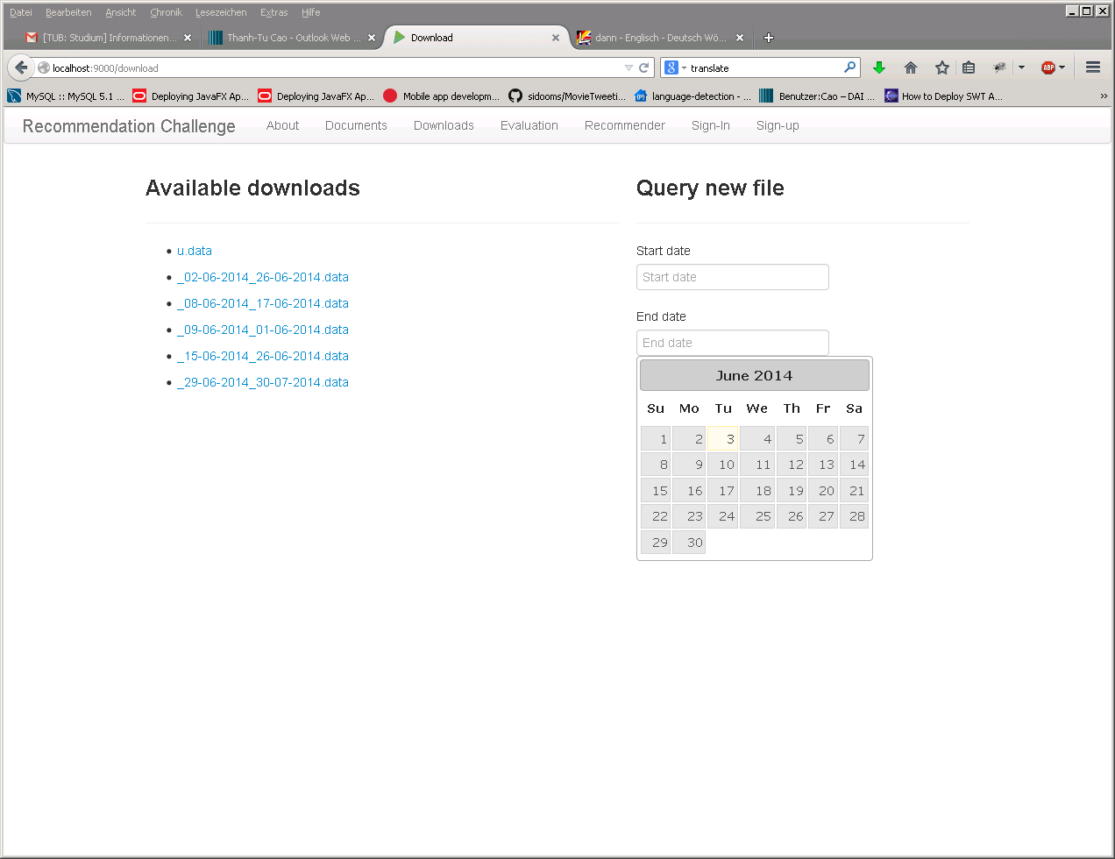

1. **Recommender**

Here can you evaluate the given recommender with the choosing team and database. For example, the picture 5 shows some regression values when I try to evaluate the RecommenderTest.

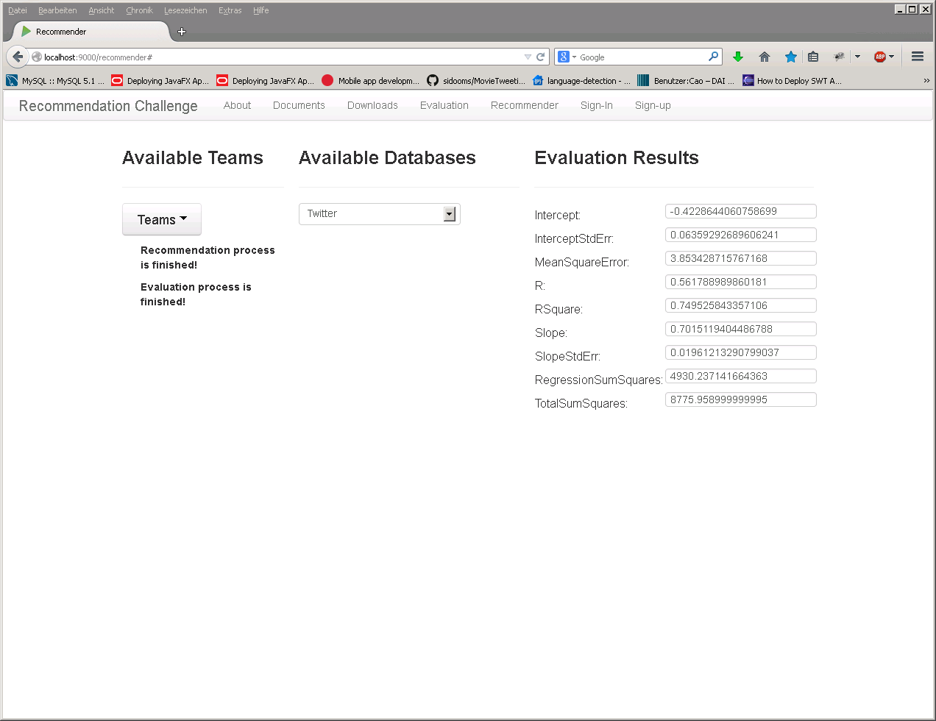

Figure 5: Evaluation results of the executed recommender-test

Currently, two databases are available. MovieLens and Twitter.

1. **Evaluation**

TODO! Not implement now.