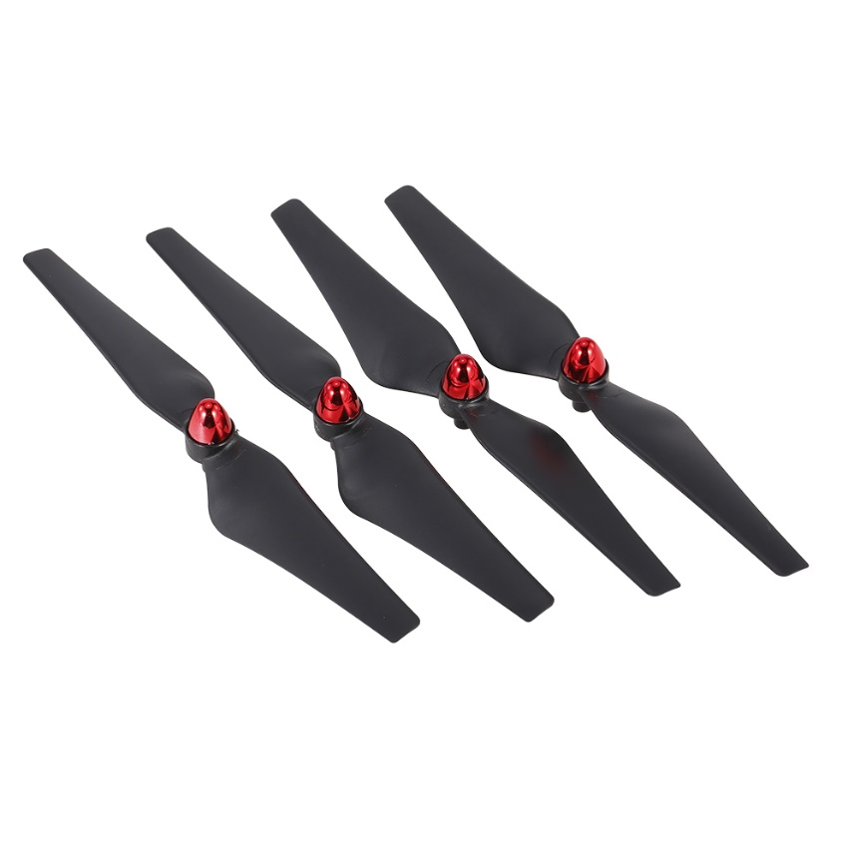

**Propeller CW CCW untuk FQ02W Utoghter 69508 FPV Quadcopter**

**Fitur:**  
Cocok untuk FQ02W, Utoghter 69508   
Keseimbangan luar biasa dan kebisingan rendah   
Sangat ringan dan tahan lama   
Terbuat dari plastik yang diperkuat, membuatnya kuat dan terbentuk dengan sangat baik   
  
**Spesifikasi:**  
Bahan Utama:   
Rotasi ABS : CW dan CCW   
Quantity: 8pcs (4 pasang)   
Cocok untuk: FQ02W, Utoghter 69508   
  
**Informasi**  
Paket: Ukuran paket: 17 * 7 * 7cm / 6.7 * 2.8 * 2.8in   
Berat Paket: 41g / 1.4oz

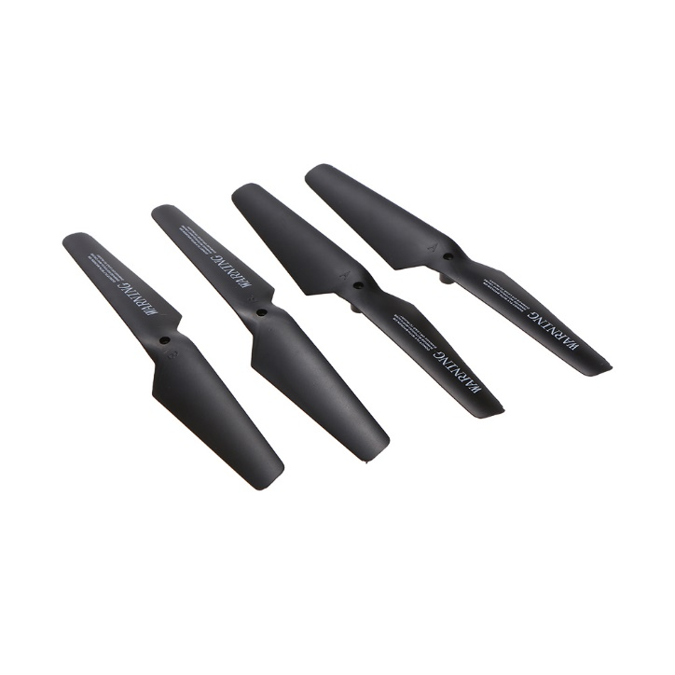Paket Polybag

**Original JJRC H31-005 Propeller untuk JJRC H31 RC Quadcopter**

**Fitur:**  
Set Propeller JJRC Asli.   
Material plastik rekayasa yang kuat, kualitas tinggi dan daya tahan digunakan.   
Instalasi mudah.   
Cocok untuk JJRC H31.   
  
**Spesifikasi:**  
Merek: JJRC   
Nama Item: H31-005 Propeller set   
Bahan: ABS   
Cocok untuk: JJRC H31   
Item dimensi: 136 * 29 * 40mm   
Item Berat: 6g

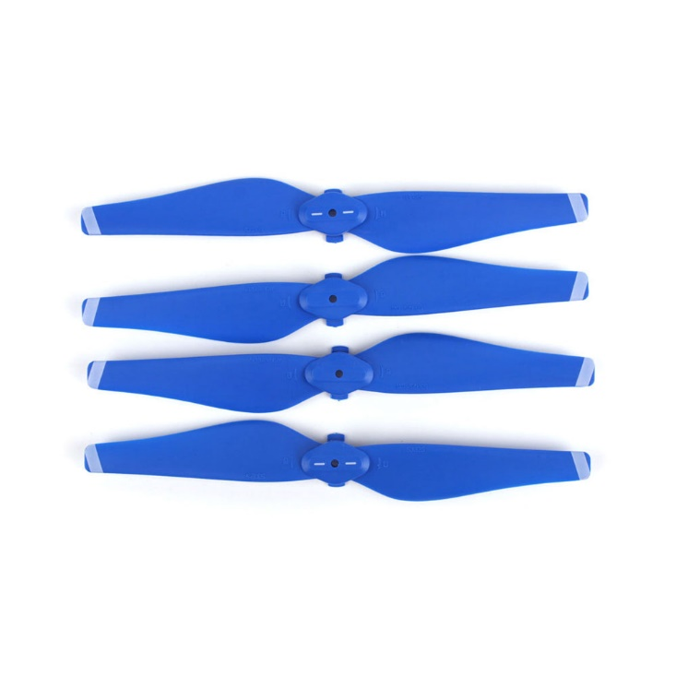**2Pairs FPV Drone 5332S Quick-release Propeller for DJI Mavic AIR RC Drone**

**Fitur:**

Mudah dipasang.

Baling-baling cepat dirilis, nyaman untuk dibawa.

Terbuat dari bahan berkualitas tinggi.

2 pasang -tiga warna berbeda untuk opsi.

Dirancang khusus untuk drone DJI Mavic AIR RC.

**Spesifikasi:**

Nama Item: 5332S Propeller Cepat-release

Warna: Biru Merah dan Putih Opsional

Bahan: PVC

**Informasi paket:**

Ukuran paket: 14,5 * 5 * 1,4 cm / 5,7 * 2 * 0,6 inci

Paket berat: 18g / 0.6oz

Paket kotak hadiah

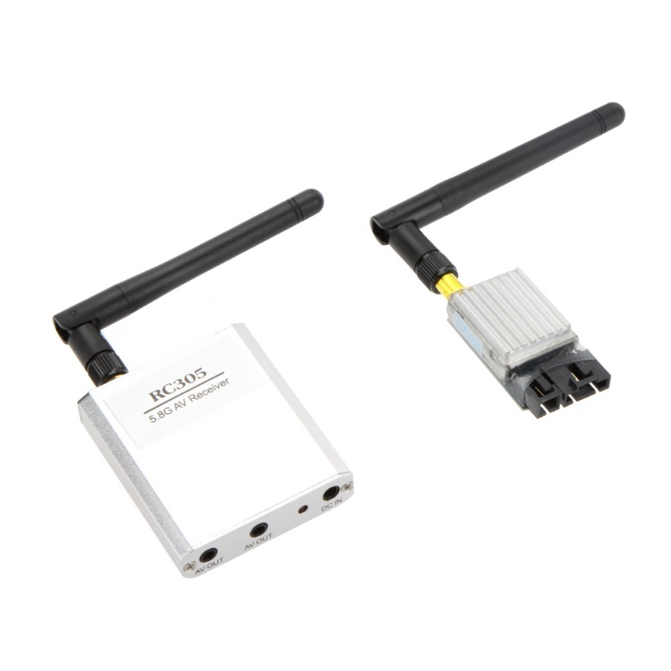5.8G 200mW FPV Video Audio 8CH AV Transmitter TX 5.8GHz RX Receiver Set 2KM 2000M

**Features:**  
Small size and lightweight.  
High output power, low power consumption, and low harmonic radiation of the transmitter.  
Easy 8 channels for selection via the micro dip switches.  
Can reach up to 2 kilometers in the open area.  
Ideal for FPV, wireless remote control aircraft, wireless remote control vehicle and son on.  
  
**Specifications:**

|  |  |
| --- | --- |
| **Wireless transmitter** |  |
| Model no. | TS58200 5.8G 200mW 8 channel AV transmitter |
| Modulation | Wideband FM modulation |
| Video format | NTSC / PAL |
| Output impedance | 50Ohm |
| Output power | 22dBm (21~23dBm) |
| Channel frequency | CH1 5.705/ CH2 5.685/ CH3 5.665/ CH4 5.645 CH5 5.885/ CH6 5.905/ CH7 5.925/ CH8 5.945 GHz |
| Operating voltage | 12V (7.0-15V) |
| Supply current | 150mA |
| Operating temperature | -10 ~ +85℃ |
| Video band width | 8.0MHz |
| Audio carrier frequency | 6.5MHz |
| Video input level | 1.0Vp-p (0.8~1.2Vp-p) |
| Video input impedance | 75ohm |
| Audio input level | 0.5~2.0Vp-p |
| Audio input impedance | 10Kohm |
| Antenna connector | RP-SMA connector |
| Product size | Approx. 5.6 * 2.6 * 1.9cm / 2.2 * 1.0 * 0.7in (No including antenna) |
| Product weight | Approx. 25g / 0.88oz (No including antenna) |
| **Wireless receiver** |  |
| Model no. | RC305 |
| Receiving frequency | 5705 ~ 5945MHz; 8 Channels |
| Receiving sensitivity | -90dBm |
| Frequency control | Built-in frequency and phrase lock loop |
| Double lines AV output | Analog AV signal output |
| Video output | 1Vp-p 75ohm |
| Audio output | 1Vp-p 600ohm |
| Antenna connectors | Inside the needle |
| Power supply voltage | 6.5V ~ 12V |
| Supply current | 150mA |
| Operating temperature | -10 ~ +50℃ / +14 ~ +122℉ |
| Storage temperature | -20 ~ +60℃ / -4 ~ +140℉ |
| Operating humidity | 85% RH |
| Housing material | Aluminium alloy |
| Product size | Approx.6.9 * 5.2 * 1.4cm / 2.7 * 2.0 * 0.6in (No including antenna) |
| Product weight | Approx. 44g / 1.55oz (No including antenna) |
| Total information |  |
| Package size | Approx. 10 * 7 * 5.5cm / 3.9 * 2.8 * 2.2in |
| Package weight | Approx. 154g / 5.43oz |

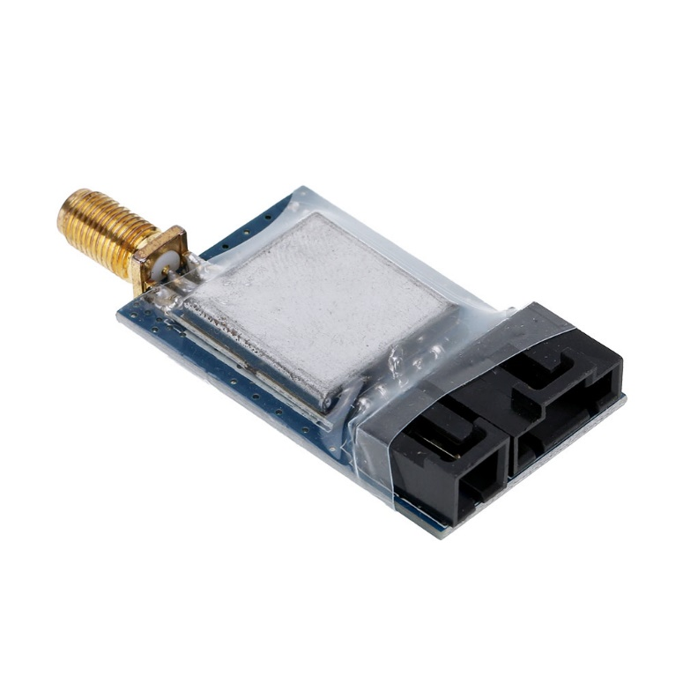**TS350 5.8G 20mW 8CH Wireless AV Transmitter for FPV Aerial Photography**

**Description:**  
Video format: NTSC/PAL  
Output impedance: 50ohm  
Output power: 11-13dBm  
Operating voltage: 7-12V  
Supply current: 110-130mA  
Video band width: 0~8MHz  
Audio carrier frequency: 6.5MHz  
Video input level:  0.8-1.2Vp-p  
Video input impedance: 75ohm  
Audio input level: 0.5-2.0Vp-p  
Audio input impedance: 10Kohm  
Antenna connector: RP-SMA-K  
  
**Frequency Range:**  
CH1: 5705MHz  
CH2: 5685MHz  
CH3: 5665MHz  
CH4: 5645MHz  
CH5: 6885MHz  
CH6: 5905MHz  
CH7: 5925MHz  
CH8: 5945MHz  
  
**Package Information:**  
Package size: 9.5 * 6.5 * 5.5cm / 3.7 * 2.6 * 2.2  
Package weight: 51g / 1.8oz  
White box package

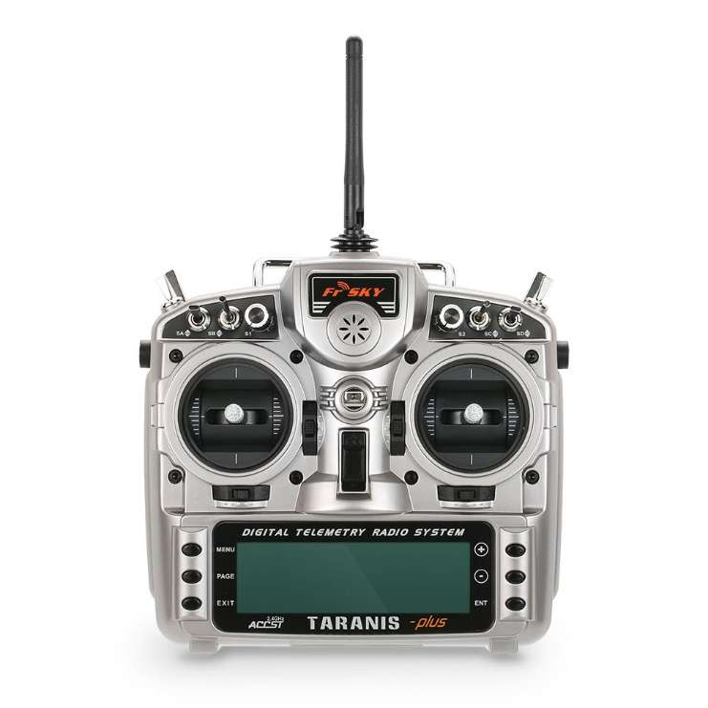**Original FrSky Taranis X9D Plus 2.4G ACCST 16CH Telemetry Radio Transmitter Open TX Mode 2 & X8R Receiver**

**Features:**  
Haptic feedback - vibration  
60 model memories, expandable via a SD card  
64 mixers, 9 flight modes  
16 custom curves with 3-17 points each, 32 logic switches  
Utilizes Voice Alerts from an internal speaker  
USB and SD card slot for unlimited memory, and firmware upgrades, sound editing  
Long range system capable of up to 3 times the range of current systems  
State-of-the-art open source software  
Large 212*64 backlit LCD screen (2 backlight color options)  
Real-time data logging  
Super low latency for ultra-quick response (9ms)  
Eight digital potentiometers, two analog potentiometers  
6 3-position lever, 2 2-position lever  
Smart port supported  
Open source firmware  
With Frsky X8R receiver  
  
**Specifications:**  
Remote Controller:  
Brand: FrSky  
Item NO: Taranis X9D Plus  
Stick mode: Mode 2 (left hand throttle)  
Operating voltage range: 6-15V (suggestion 2s, 3s LiPo battery)  
Operating current: 260mA maximum (both RF module and backlit are on)  
Operating temperature: -10 to 60℃  
Backlit LCD screen: 212*64, 2 color combinations for selection  
Model memories: 60 (expandable by SD card)  
Battery: 7.2V 2000mAh NiMh battery  
Compatibility: FrSky X series, D series and V8-II series receivers  
  
Receiver:  
Brand: Frsky  
Item NO: X8R  
Channel: 8ch, 16ch  
Operating voltage range: 4-10V  
Operating current: 100mA at 5V  
Operating range: >1.5km (full range)  
Antenna: PCB high gain antenna  
Compatibility:  
FrSky DFT/DJT/DHT/DHT-U in D_mode  
FrSky Taranis X9D puls/XJT in D8 mode  
FrSky Taranis X9D puls/XJT in D16 mode  
Size: 45 * 26 * 15mm  
Weight: 17g  
  
**Package Information:**  
Package size: 30 * 28 * 12.5cm / 11.8 * 11 * 5in  
Package weight: 1485g / 3.27lb  
Yellow box package

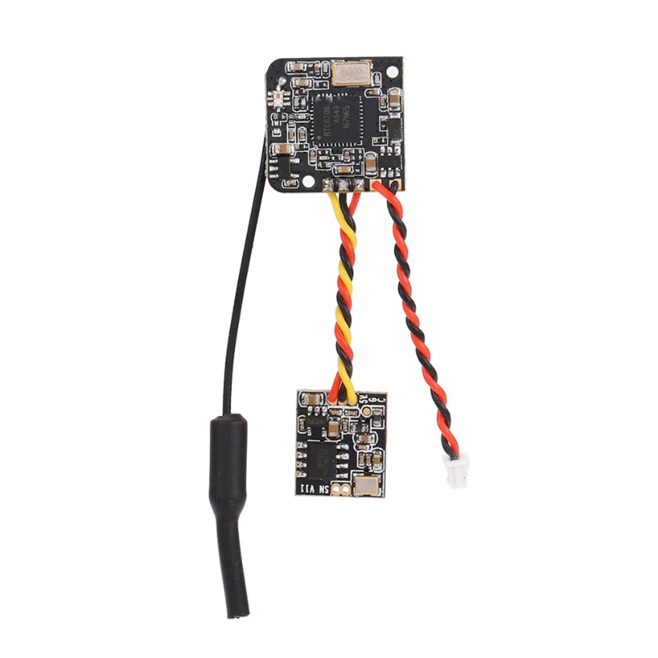**Turbowing TX-25mW 5.8G 48CH 700TVL FPV Transmitter Camera for Blade Inductrix QX90 Tiny Micro FPV Racing Quadcopter**

**Features:**  
48 channel 5.8G 25mW wireless FPV transmitter.  
700TVL camera with 120° FOV wide angle view.  
3.7g super lightweight.  
One key channel switch and LED indicator.  
  
**Specifications:**  
Frequency: 5362-5945MHz  
Channel: 48  
Modulation: FM  
Channel Indicate: CHI-CH8 Channel indication with 4 LEDS and A~B frequency group Indicate with 3 LEDS  
Transmit power: 13±1dBm  
Frequency control: PLL  
All harmonic: Max-50dBm  
Frequency Stability: ±100KHz(Typ.)  
Frequency precision: ±200KHz(Typ.)  
Channel Carrier error: 1dB  
Antenna Port: 50Ω  
Input format: NTSC/PAL  
Camera resolution: 700TVL  
LENS ANGEL: H:120°/ V:100°  
Base -band interface: P1.27 * 2  
Power consumption: 200~215mA @5V DCIN  
Supply Voltage: 2.9-5.5v  
Operating Temperature: -10℃~+60℃  
Profile dimension: 14 * 12mm(Cam), 18 * 18mm(TX)  
  
**Package information:**  
Package size: 7 * 5 * 2cm / 2.8 * 2.0 * 0.8in  
Package weight: 6g / 0.2oz  
Polybag package