# Instructions

**DecOps with Docker**

**Mooc.fi**

Running and stopping containers

# EXERCISE 1.4: MISSING DEPENDENCIES

# 

Student: Andreas Zelios

# Part 1.4

1. First, I start the container and name it ubuntu

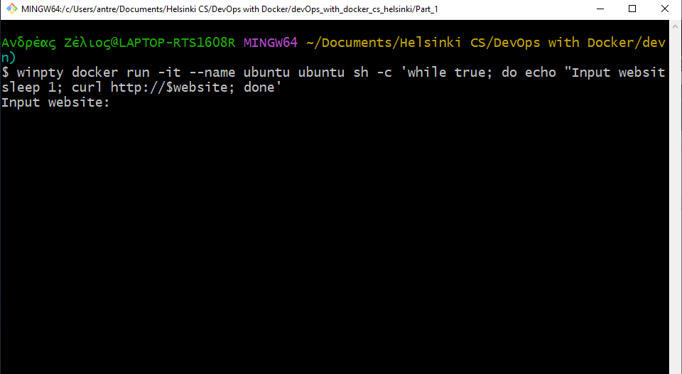

1. 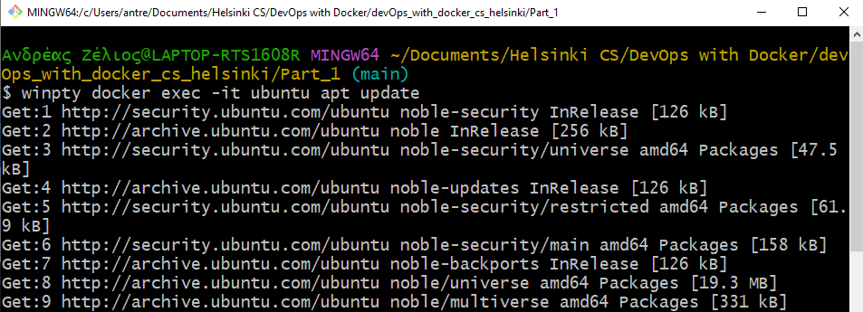Then, I open a new terminal and type winpty docker exec -it ubuntu apt update (I’m on windows) and winpty docker exec -it ubuntu apt install -y curl

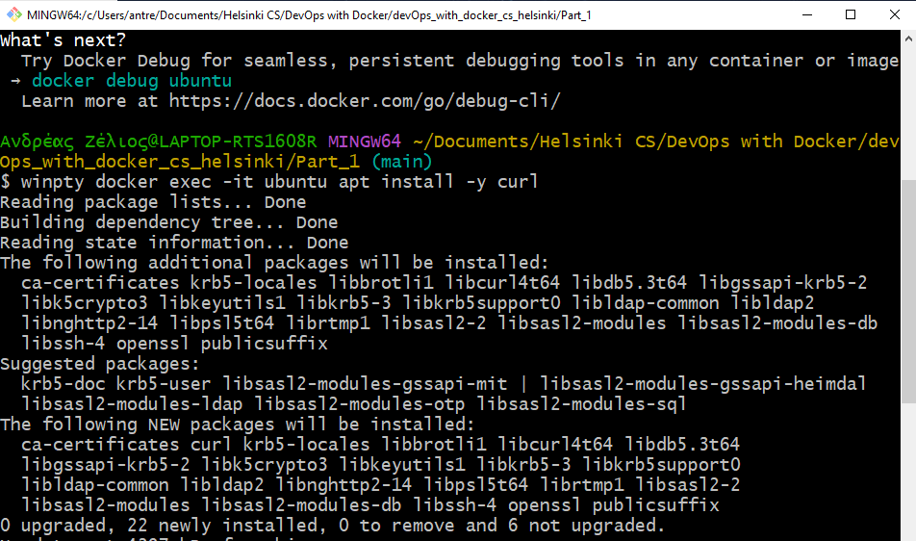

1. Then I verify that the program runs as intended:

