
DecOps with Docker
Mooc.fi

Interacting with the container via volumes and ports

EXERCISE 1.15: Homework

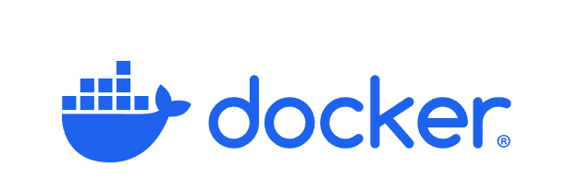

Student: Andreas Zelios

Part 1.9
text.log file of my working directory:

I decided to containerize my https://github.com/andreasZel/sorting-algorithms-vs repo, this project is built with vite + react + typescript. So my Dockerfile does the same as 1.12 but it also runs
npm run dev
in the end to run the development environment.
My docker build instruction worked locally but I could’t upload my image to dockerHub because of invalid characters in command line, so I created a yml file to compose it. My yml file looks like this:
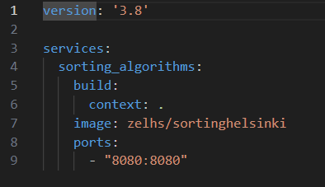
Port to run on
I build the image from the Dockerfile in the same directory
Name of image
After my image is built and runed in detached mode by typing:
docker-compose up -d
, I use:
docker push zelhs/sortinghelsinki
and the push now works

I also provide a readme file in the same directory as well as yml and Dockerfile.

